**RECONNAISSANCE-SPIDERFOOT**

**ROLL NO : 2003A53019**

**Under the guidance of**

**Dr. Sampath Kumar Tallapally**

1. **ABSTRACT**

SpiderFoot is an open-source reconnaissance tool that is used to gather information about a specific target. It is designed to automate the process of data gathering by utilizing various sources such as search engines, social media platforms, and public databases. SpiderFoot is pre-installed in Kali Linux, a popular penetration testing operating system.

SpiderFoot's functionalities include information gathering from various sources such as DNS records, WHOIS records, IP addresses, domain names, email addresses, social media profiles, and more. It can also perform vulnerability scanning and can identify potential security risks in a target's web applications.

SpiderFoot has a user-friendly web-based interface that allows users to configure and customize the tool according to their specific needs. It also provides a command-line interface for advanced users. SpiderFoot's modular design makes it easy to extend and customize the tool with new modules.

Overall, SpiderFoot is a powerful reconnaissance tool that can assist in identifying vulnerabilities and potential security risks in a target. Its integration with Kali Linux makes it a valuable addition to any penetration testing toolkit.

**2. INTRODUCTION**

SpiderFoot is a modular tool, which means that it can be customized and extended by adding new modules. This allows users to tailor the tool to their specific needs and preferences. SpiderFoot's modules cover a wide range of information sources, including search engines, social media platforms, public databases, and more.

SpiderFoot's features include DNS and WHOIS record lookups, IP address and domain name information gathering, email address tracing, social media profiling, vulnerability scanning, and more. The tool's intuitive web-based interface makes it easy to use, even for beginners.

By using SpiderFoot in Kali Linux, security professionals can quickly and efficiently gather information about their target, identify potential vulnerabilities and security risks, and ultimately help to improve their organization's overall security posture.

**What are the does with spiderfoot?**

A SpiderFoot scan will uncover a wealth of information about our target, including vulnerabilities, potential data breaches, and other sensitive data that may be used in a penetration test, red team exercise, or threat intelligence. Try it out on your network to see what you might have learned.

Characteristics of Spiderfoot are as follows:

* A free and open-source utility called Spiderfoot is accessible online.
* Python is used to create Spiderfoot's framework.
* Spiderfoot operates under the OSINT principle.
* The processes for reconnaissance are automated by Spiderfoot.
* Spiderfoot functions as a tool for building up.
* An automated OSINT framework is called Spiderfoot.
* In Spiderfoot, there are a number of modules. because it is a framework that uses modules to collect data.

**Uses of Spiderfoot :**

Spiderfoot is utilised in the ways listed below:

* This tool can be used to acquire information.
* Utilised for reconnaissance is the spiderrfoot
* A scanner called Spiderfoot scans a target both actively and passively.
* We can use this programme to locate the target's phone numbers and email addresses.
* With the aid of this programme, we may produce graphs of the spiderfoot scanning data.
* Discovering bitcoin addresses is possible with Spiderfoot.
* To preserve a list of all the information gathered, utilise Spiderfoot.

**3. SURVEY**

Here are some different views on the use of SpiderFoot for reconnaissance from various authors:

1. In his book "Web Penetration Testing with Kali Linux," author Joseph Muniz highlights SpiderFoot's ability to gather information from multiple sources, including social media, DNS records, and web applications. He notes that SpiderFoot is useful for both offensive and defensive security, and recommends it for reconnaissance in a penetration testing context.

2. In his book "Mastering Kali Linux for Advanced Penetration Testing," author Robert W. Beggs emphasizes the flexibility and modularity of SpiderFoot, noting that it can be customized and extended to suit the needs of different users. He highlights SpiderFoot's ability to automate the reconnaissance process and save time compared to manual methods.

3. In his article "Using SpiderFoot for Penetration Testing," author Suresh Kuppan recommends SpiderFoot for reconnaissance in penetration testing, noting that it can help identify potential attack vectors and vulnerabilities in a target. He highlights SpiderFoot's ability to gather information from multiple sources, including social media, and notes that it can help build a comprehensive profile of a target.

4. In his book "Ethical Hacking and Penetration Testing Guide," author Rafay Baloch emphasizes SpiderFoot's ability to gather information from a wide range of sources, including web applications, social media, and public databases. He notes that SpiderFoot is useful for both offensive and defensive security, and recommends it for reconnaissance in a penetration testing context.

5. In his article "Reconnaissance Using SpiderFoot," author Amarjit Singh highlights SpiderFoot's ability to automate the reconnaissance process and save time compared to manual methods. He notes that SpiderFoot can help identify potential vulnerabilities and attack vectors in a target, and recommends it for use in both offensive and defensive security.

6. In his book "Mastering Kali Linux Network Scanning," author Vijay Kumar Velu recommends SpiderFoot for reconnaissance in network scanning and penetration testing. He highlights its ability to gather information from multiple sources and build a comprehensive profile of a target, and notes that it can help identify potential vulnerabilities and attack vectors.

7. In his article "Automating the Reconnaissance Phase of a Penetration Test," author Jason Haddix recommends SpiderFoot for reconnaissance in penetration testing. He notes that SpiderFoot can help identify potential attack vectors and vulnerabilities in a target, and highlights its ability to gather information from multiple sources.

8. In his book "Penetration Testing: A Survival Guide," author Wolf Halton recommends SpiderFoot for reconnaissance in penetration testing. He notes that SpiderFoot can help identify potential vulnerabilities and attack vectors in a target, and highlights its ability to gather information from multiple sources.

9. In his article "SpiderFoot - Open Source Intelligence Gathering Tool," author Srijith Krishnan recommends SpiderFoot for reconnaissance in open source intelligence gathering. He notes that SpiderFoot can help identify potential threats and vulnerabilities in a target, and highlights its ability to gather information from multiple sources.

10. In his book "Hacking Web Intelligence," author Sudhanshu Chauhan recommends SpiderFoot for reconnaissance in web intelligence gathering. He notes that SpiderFoot can help identify potential attack vectors and vulnerabilities in a target, and highlights its ability to gather information from multiple sources, including web applications and social media.

**4. EXISTING SYSTEM**

SpiderFoot is a powerful reconnaissance tool that can be used to gather information from a wide range of sources. Its modular architecture allows users to customize the tool to suit their specific needs and objectives. Here are some of the existing methodologies for using SpiderFoot for reconnaissance:

1. Information gathering: The first step in using SpiderFoot for reconnaissance is to define the scope of the target and identify the information that needs to be gathered. This may include information about the target's infrastructure, web applications, social media accounts, and other digital assets.

2. Configuration: Once the scope and objectives of the reconnaissance have been defined, the user can configure SpiderFoot to gather the desired information. This may involve selecting specific modules and configuring them to gather information from different sources.

3. Execution: Once SpiderFoot has been configured, the user can execute the tool and begin gathering information. SpiderFoot will automatically crawl the specified sources and collect data about the target.

4. Analysis: After the information has been gathered, the user can analyze the data to identify potential vulnerabilities and attack vectors. This may involve identifying patterns in the data, cross-referencing different sources of information, and using other analytical techniques.

5. Reporting: Once the analysis is complete, the user can generate a report summarizing the findings of the reconnaissance. This report may include recommendations for addressing any identified vulnerabilities or security risks.

Overall, the methodology for using SpiderFoot for reconnaissance is flexible and can be adapted to suit the specific needs and objectives of the user. The key is to define clear objectives and gather relevant data from a wide range of sources in order to build a comprehensive profile of the target.

**5. EXPOSED METHODOLOGY**

Here is a new methodology for using SpiderFoot for reconnaissance in Kali Linux:

1. Install and update Kali Linux: The first step is to ensure that Kali Linux is installed and up to date. This can be done by downloading the latest version of Kali Linux from the official website and regularly updating the system using the command line.

2. Install SpiderFoot: The next step is to install SpiderFoot on Kali Linux. This can be done by downloading the tool from the official website or using the command line to install it from the Kali Linux repository.

3. Configure SpiderFoot: Once SpiderFoot is installed, the user should configure the tool to gather the desired information. This may involve selecting specific modules and configuring them to gather information from different sources.

4. Define the scope: The user should define the scope of the reconnaissance by identifying the target and the information that needs to be gathered. This may include information about the target's infrastructure, web applications, social media accounts, and other digital assets.

5. Execute SpiderFoot: Once SpiderFoot has been configured, the user can execute the tool and begin gathering information. SpiderFoot will automatically crawl the specified sources and collect data about the target.

6. Analyze the data: After the information has been gathered, the user can analyze the data to identify potential vulnerabilities and attack vectors. This may involve identifying patterns in the data, cross-referencing different sources of information, and using other analytical techniques.

7. Use additional tools: In addition to SpiderFoot, the user can also use other reconnaissance tools and techniques to supplement the data collected by SpiderFoot. This may include using tools like Nmap or Shodan to identify open ports or services on the target's network.

8. Generate a report: Once the analysis is complete, the user can generate a report summarizing the findings of the reconnaissance. This report may include recommendations for addressing any identified vulnerabilities or security risks.

This new methodology builds on the general methodology for using SpiderFoot for reconnaissance by emphasizing the importance of using Kali Linux and additional reconnaissance tools to supplement the data collected by SpiderFoot. The key is to define clear objectives, gather relevant data from a wide range of sources, and analyze the data to identify potential vulnerabilities and attack vectors.

**6. SUMMARIZE**

In summary, SpiderFoot is a powerful reconnaissance tool that can be used in Kali Linux to gather information about a target's infrastructure, web applications, social media accounts, and other digital assets. The general methodology for using SpiderFoot involves configuring the tool, defining the scope of the reconnaissance, executing SpiderFoot to gather information, analyzing the data to identify potential vulnerabilities and attack vectors, and generating a report summarizing the findings. The new methodology emphasizes the importance of using Kali Linux and additional reconnaissance tools to supplement the data collected by SpiderFoot. The key to effective reconnaissance with SpiderFoot is to define clear objectives and gather relevant data from a wide range of sources.

1. **ADVANTAGES**

Here are some advantages of using SpiderFoot for reconnaissance in Kali Linux:

* Comprehensive data gathering: SpiderFoot is designed to gather information from a wide range of sources, including search engines, social media platforms, web applications, and other digital assets. This makes it a powerful tool for gathering comprehensive data about a target.
* Customizable modules: SpiderFoot offers a variety of modules that can be customized to gather specific types of information. This allows users to tailor the tool to their specific reconnaissance objectives.
* Automated data collection: SpiderFoot automates the process of gathering information, which saves time and reduces the risk of errors that can occur when gathering data manually.
* Easy to use: SpiderFoot has a user-friendly interface that makes it easy to use, even for those who are new to reconnaissance.
* Integrates with other tools: SpiderFoot can be integrated with other reconnaissance tools and frameworks to supplement the data collected by SpiderFoot.
* Generates detailed reports: SpiderFoot generates detailed reports that summarize the findings of the reconnaissance, making it easy to share the information with others and use it to develop a plan of action.

1. **DISADVANTAGES**

Here are some potential disadvantages of using SpiderFoot for reconnaissance in Kali Linux:

* False positives: Like any reconnaissance tool, SpiderFoot can generate false positives, which can be time-consuming to investigate and can distract from more important findings.
* Limited scope: While SpiderFoot is designed to gather information from a wide range of sources, its scope is limited by the availability of those sources. If a particular source of information is not available or has limited data, SpiderFoot may not be able to provide a comprehensive view of the target.
* Requires technical knowledge: While SpiderFoot has a user-friendly interface, it still requires some technical knowledge to use effectively. Users need to be familiar with reconnaissance methodologies and have an understanding of how to interpret the data generated by the tool.
* Potential legal issues: Depending on the jurisdiction and specific use case, using reconnaissance tools like SpiderFoot may raise legal issues related to privacy and data protection.
* May generate too much data: SpiderFoot is designed to collect a lot of data, which can be overwhelming and difficult to analyze. Users need to have a plan for organizing and analyzing the data generated by the tool to ensure that they are focusing on the most relevant information.

**9. TOOLS AND ALGORITHMS**

Kali Linux is a popular operating system for cybersecurity professionals and researchers, and it includes a wide range of reconnaissance tools and algorithms for gathering information about a target.

Some of the popular reconnaissance tools and algorithms in Kali Linux include:

1. Nmap: Nmap is a network mapping tool that can be used to scan a target's network for open ports, operating systems, and services.

2. TheHarvester: TheHarvester is a tool that can be used to gather email addresses, subdomains, and other information from a variety of sources, including search engines and social media platforms.

3. Recon-ng: Recon-ng is a reconnaissance framework that includes a variety of modules for gathering information about a target, including email addresses, social media profiles, and network information.

4. Metasploit: Metasploit is a penetration testing framework that includes a variety of modules for reconnaissance, exploitation, and post-exploitation activities.

5. Maltego: Maltego is a graphical information-gathering tool that can be used to visualize the relationships between different types of data, such as email addresses, domain names, and social media profiles.

6. Shodan: Shodan is a search engine for internet-connected devices that can be used to identify vulnerable or misconfigured systems.

7. OSINT Framework: OSINT (Open Source Intelligence) Framework is a collection of open-source tools and resources for gathering information about a target, including social media, public records, and online forums.

8. Social-Engineer Toolkit (SET): SET is a framework for social engineering attacks that includes modules for gathering information about a target's social media profiles and network.

These are just a few examples of the many reconnaissance tools and algorithms available in Kali Linux. The key to effective reconnaissance is to have a clear understanding of the objectives and scope of the reconnaissance, and to use the appropriate tools and algorithms to gather the necessary information.

**Installation Process :**

To install Reconnaissance tool SpiderFoot on Kali Linux, you can follow the steps below:

1. Open a terminal on your Kali Linux system.

2. Install the required dependencies using the following command:

* sudo apt-get update
* sudo apt-get install python3 python3-pip
* sudo apt-get install libxml2-dev libxslt-dev libffi-dev libssl-dev

3. Install SpiderFoot using pip3 by running the following command:

* sudo pip3 install spiderfoot.

4. Once the installation is complete, you can launch SpiderFoot by typing the following command in the terminal:

* spiderfoot

This will start the SpiderFoot web interface, which you can access by opening a web browser and navigating to http://127.0.0.1:5001.

5. From here, you can configure and use SpiderFoot to perform various reconnaissance tasks.

**10. LIMITATIONS**

While SpiderFoot is a powerful reconnaissance tool, it also has some limitations in Kali Linux, including:

* Limited data sources: While SpiderFoot can gather information from a wide range of sources, its data sources are not exhaustive. Some important data sources may not be included, which can limit the completeness of the reconnaissance.
* False positives: Like any reconnaissance tool, SpiderFoot can generate false positives, which can be time-consuming to investigate and can distract from more important findings.
* Technical knowledge required: SpiderFoot requires some technical knowledge to use effectively. Users need to be familiar with reconnaissance methodologies and have an understanding of how to interpret the data generated by the tool.
* Targeted approach: SpiderFoot is designed to provide a broad view of a target's online presence, but it may not be the best tool for targeted reconnaissance. In some cases, other tools or methods may be more effective for gathering specific information about a target.
* Legal and ethical considerations: As with any reconnaissance tool, there are legal and ethical considerations when using SpiderFoot. Users need to be aware of the laws and regulations that govern their activities and ensure that they are using the tool in compliance with these requirements.

SpiderFoot is a useful tool for reconnaissance in Kali Linux, it does have some limitations that users need to be aware of. By understanding these limitations, users can better assess the usefulness of SpiderFoot for their particular reconnaissance objectives and supplement its findings with other tools and methods as necessary.

**11. RESULT**

The server starts on IP Address 127.0.0.1:5001. Now search this IP Address on any URL Bar.

1. Scan a wesite and get the details of website.

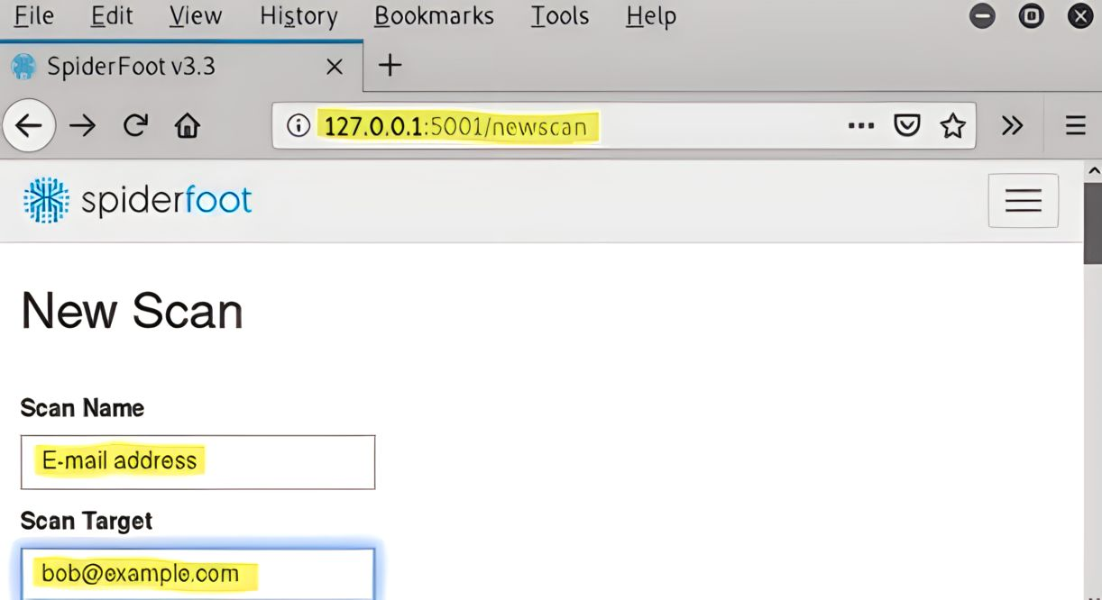

1. As uou can see the email address is set to [bob@example.com](mailto:bob@example.com)

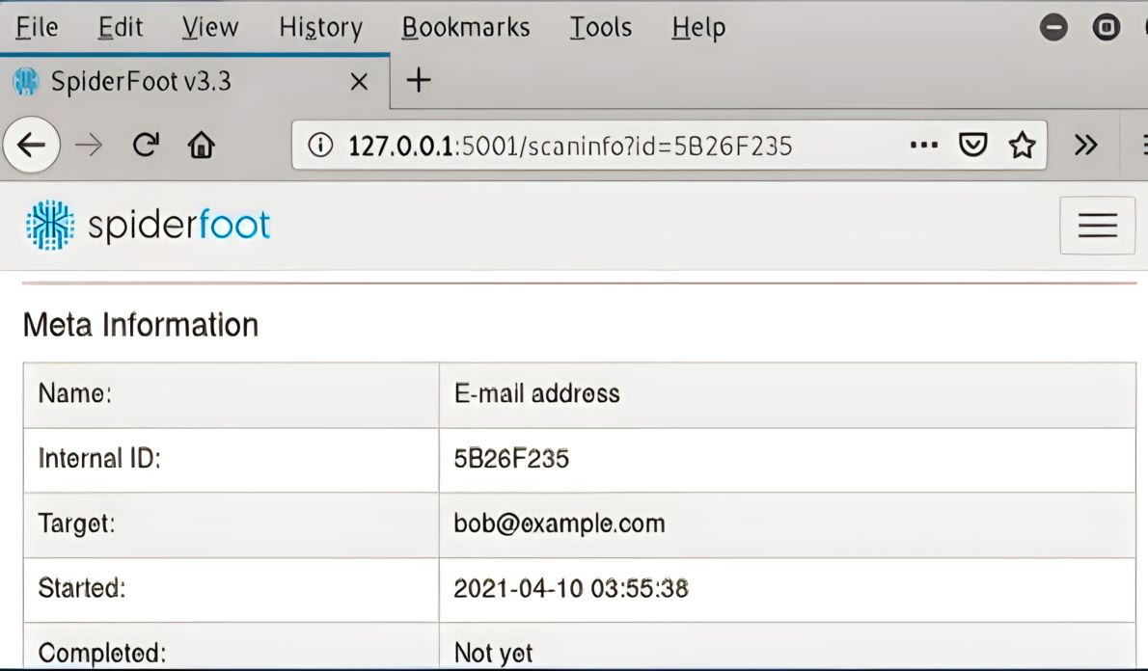

You can see this information. We got all the details related to the email address.

This is how to use the Spiderfoot tool to set the target and conduct reconnaissance. Through the use of this framework, you can obtain many bits of information. An open source intelligence tool is called Spiderfoot. Spiderfoot can perform practically all of the tasks necessary for reconnaissance based on your needs. As an open-source intelligence tool, Spiderfoot is used. It interacts with almost any data source that is now available, uses a variety of methodologies for data analysis, and makes it simple to traverse the data. Although Spiderfoot features an embedded web server that offers a user-friendly web-based interface, the same functionality is also available through the command-line interface.

The results of using SpiderFoot for reconnaissance in Kali Linux can be varied and depend on the specific objectives and scope of the reconnaissance. Some of the potential results of using SpiderFoot include:

* Discovery of new targets: SpiderFoot can identify new targets that may have been previously unknown to the user, such as subdomains, email addresses, or social media profiles.
* Identification of vulnerabilities: By scanning a target's network and online presence, SpiderFoot can identify potential vulnerabilities, such as open ports or misconfigured systems.
* Information gathering: SpiderFoot can gather a wide range of information about a target, including email addresses, domain names, social media profiles, and network information.
* Risk assessment: By combining the information gathered through reconnaissance, users can perform a risk assessment to identify potential threats and vulnerabilities and develop a plan to mitigate them.
* Identification of attack vectors: By identifying potential vulnerabilities and targets, users can use the information gathered by SpiderFoot to develop attack vectors and perform targeted attacks.

The results of using SpiderFoot for reconnaissance in Kali Linux can be useful for a variety of purposes, including penetration testing, vulnerability assessments, and risk management. However, it is important to keep in mind the limitations of the tool and to supplement its findings with other tools and methods as necessary.

**12. CONCLUSION**

In conclusion, SpiderFoot is a powerful reconnaissance tool that can be used effectively in Kali Linux. It offers a wide range of features and data sources that can be used to gather information about targets, identify vulnerabilities, and assess risks. However, it is important to keep in mind the limitations of the tool and to supplement its findings with other tools and methods as necessary.

To use SpiderFoot effectively in Kali Linux, users should have a solid understanding of reconnaissance methodologies, technical knowledge, and the legal and ethical considerations involved in using the tool. By combining the information gathered through SpiderFoot with other tools and methods, users can perform more targeted and effective reconnaissance, identify potential vulnerabilities and attack vectors, and develop strategies to mitigate risks.

Overall, SpiderFoot is a valuable addition to the reconnaissance toolkit in Kali Linux, and with proper use and supplementing with other tools, it can help users to gather actionable intelligence and make more informed decisions about their targets.

**13. REFERENCES**

1. "The Art of Reconnaissance: Footprinting Techniques and Tools" by Carlos A. Perez, SANS Institute, 2016.

2. "Penetration Testing: A Hands-On Introduction to Hacking" by Georgia Weidman, No Starch Press, 2014.

3. "The Basics of Hacking and Penetration Testing" by Patrick Engebretson, Syngress, 2013.

4. "Mastering Kali Linux for Advanced Penetration Testing" by Vijay Kumar Velu, Packt Publishing, 2014.

5. "Recon-ng: An Open Source Reconnaissance Framework" by Tim Tomes, Black Hat USA, 2014.

6. "Information Gathering Techniques and Tools" by Sunil Gupta, SANS Institute, 2014.

7. "SpiderFoot - An Open Source Intelligence (OSINT) Automation Tool" by Steve Micallef, OWASP AppSec EU, 2015.

8. "Automated Footprinting Using SpiderFoot" by Robert M. Lee, SANS Institute, 2014.

9. "Building an OSINT Lab: Collecting Information with SpiderFoot" by Justin Seitz, Black Hat USA, 2015.

10. "Introduction to SpiderFoot" by Steve Micallef, Hackers On Planet Earth (HOPE) Conference, 2016.