**TASK NO 1**

#include <iostream>

#include <fstream>

int main()

{

std::ofstream file("filename.txt");

if (file.is_open())

{

file << "This is a sample file.\n";

file << "Line 1: Hello, World!\n";

file << "Line 2: File handling in C++.\n";

file.close();

std::cout << "File 'filename.txt' created and written successfully.\n";

} else

{

std::cout << "Error opening file.\n";

}

return 0;

}

**OUTPUT**

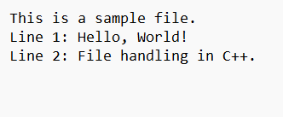

**TASK NO 2**

#include <iostream>

#include <fstream>

int main()

{

std::ofstream file("output.txt");

if (file.is_open())

{

file << "Output File\n";

file << "Line 1: Writing to a file.\n";

file << "Line 2: File handling is essential for data manipulation.\n";

file.close();

std::cout << "File 'output.txt' created and written successfully.\n";

}

else

{

std::cout << "Error opening file.\n";

}

return 0;

}

**OUTPUT**

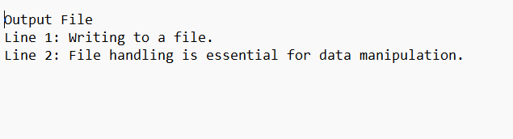

**TASK NO 3**

#include <iostream>

#include <fstream>

#include <string>

int main()

{

std::ofstream logFile("UserLog.txt");

if (logFile.is_open())

{

logFile << "User 'John' logged in.\n";

logFile << "User 'Jane' accessed the dashboard.\n";

logFile << "User 'Bob' performed a file operation.\n";

logFile.close();

std::cout << "User activities logged in 'UserLog.txt'.\n";

}

else

{

std::cout << "Error opening file for writing.\n";

return 1;

}

std::ifstream readFile("UserLog.txt");

if (readFile.is_open())

{

std::string line;

std::cout << "User Activities Log:\n";

while (getline(readFile, line))

{

std::cout << line << '\n';

}

readFile.close();

} else

{

std::cout << "Error opening file for reading.\n";

}

return 0;

}

**OUTPUT**

