**LAB NO 11**

**TASK 1 PASS BY VALUE**

#include <iostream>

using namespace std;

void swap(inta,int b)

{

int temp= a;

a = b;

b = temp;

cout << "Inside swap function a ="<<a<<", b = "<< b<< endl;

}

int main()

{

int x, y;

cout<< "Enter the first number (x)";

cin>> x;

cout<< "Enter the second number (y)";

cin>> y;

cout << "Before swap: x = " <<x<< ", y = " << y << endl;

swap(x, y);

cout << "After swap (in main): x = " <<x<< ", y = "<< y << endl;

return 0;

}

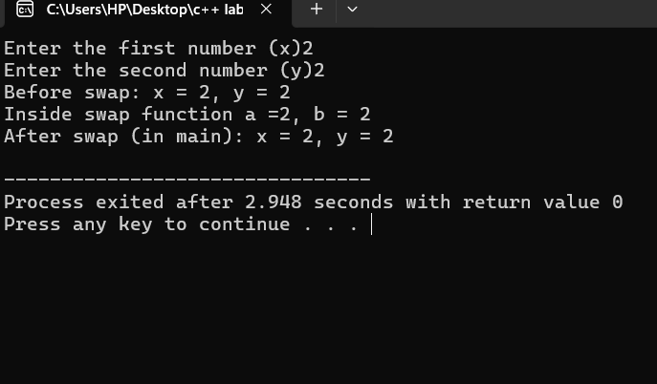

**TASK 1 PASS BY REFERENCE**

#include <iostream>

using namespace std;

void swap(int&a,int &b)

{

int temp = a;

a = b;

b = temp;

}

int main()

{

int x, y;

cout<< "Enter the first number (x)";

cin>> x;

cout<< "Enter the second number (y)";

cin>> y;

cout<<"Before swap: x = "<< x << ", y ="<< y << endl;

swap(x, y);

cout<<"After swap: x = "<< x <<", y = "<< y<<endl;

return 0;

}

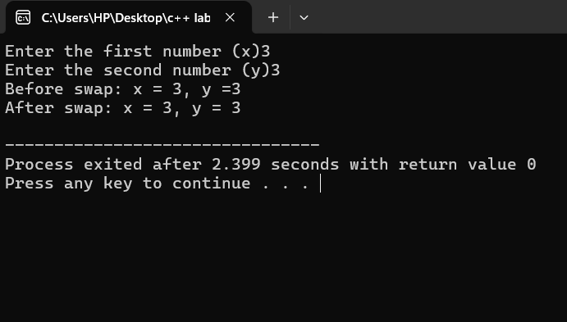

**TASK 2 PASS BY VALUE**

#include <iostream>

using namespace std;

int findLargest( int a,int b, int c)

{

if (a >=b&& a>= c)

{

return a;

}

else if (b >= a && b >= c)

{

return b;

}

else {

return c;

}

}

int main()

{

int x, y, z;

cout<< "Enter three integers: ";

cin >> x >> y >> z;

int largest = findLargest(x, y, z);

cout<<"The largest integer is: " << largest << endl;

return 0;

}

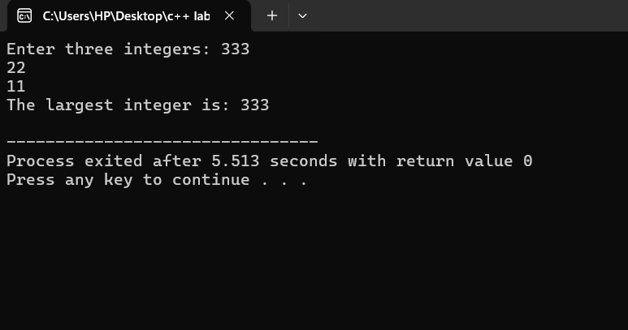

**TASK 2 PASS BY REFERENCE**

}

else if (b >= a && b >= c)

{

cout<< "The largest integer is" << b << endl;

}

else {

cout<< "The largest integer is" << c << endl;

}

}

int main()

{

int x, y, z;

cout<<"Enter three integers: ";

cin>> x >> y >> z;

findLargest(x, y, z);

return 0;

}

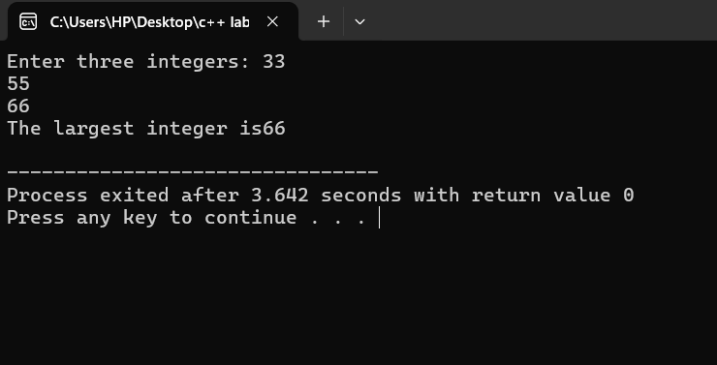

**TASK 3 PASS BY VALUE**

**#include <iostream>**

**using namespace std;**

**int cube(int n)**

**{**

**return n *n* n;**

**}**

**int main()**

**{**

**int num;**

**cout<< "Enter an integer (0 to quit)";**

**cin>> num;**

**while (num!= 0)**

**{**

**cout<< "The cube of " << num << " is" << cube(num) << endl;**

**cout << "Enter an integer (0 to quit)";**

**cin >> num;**

**}**

**cout<< "Program terminated." << endl;**

**return 0;**

**}**

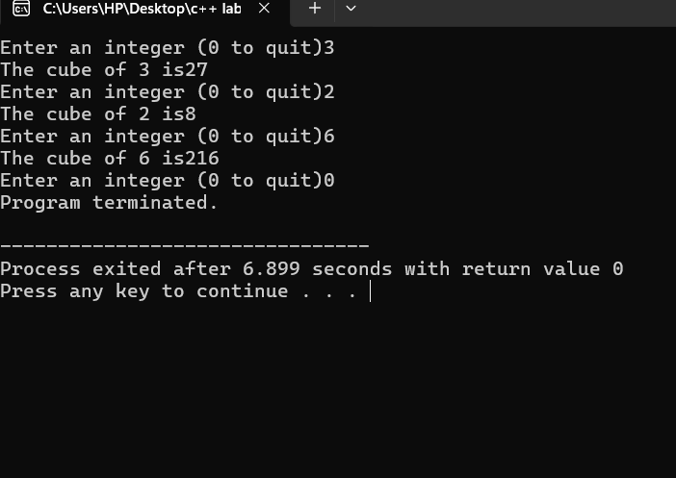

**TASK 3 PASS BY REFERENCE**

#include<iostream>

using namespace std;

void cube(int &n)

{

n = n *n* n;

}

int main()

{

int num;

cout<< "Enter an integer (0 to quit): ";

cin>> num;

while (num!= 0)

{

cube(num);

cout<< "The cube of the entered number is: " << num << endl;

cout<< "Enter an integer (0 to quit): ";

cin>> num;

}

cout << "Program terminated." << endl;

return 0;

}

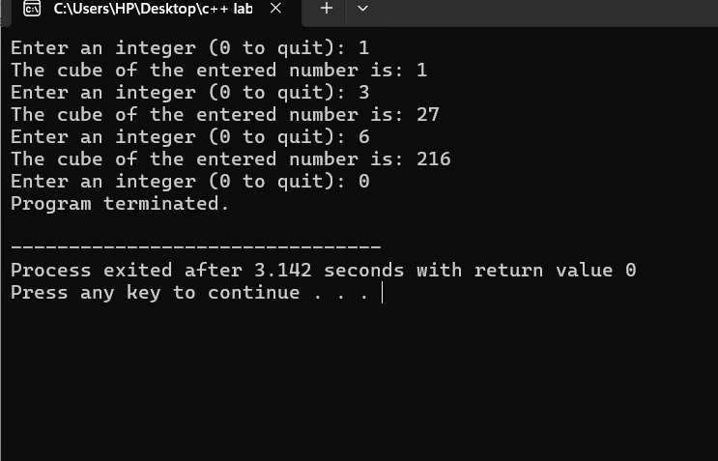

**TASK 4 PASS BY VALUE**

#include <iostream>

using namespace std;

void printTempOpinion(int temp)

{

if (temp < 10)

{

cout<<"Cold" << endl;

}

else if (temp >= 20 && temp<= 30)

{

cout<< "OK" << endl;

}

else if (temp > 30)

{

cout << "Hot" << endl;

}

}

int main()

{

int temperature;

cout<< "Enter the temperature: ";

cin>> temperature;

printTempOpinion(temperature);

return 0;

}

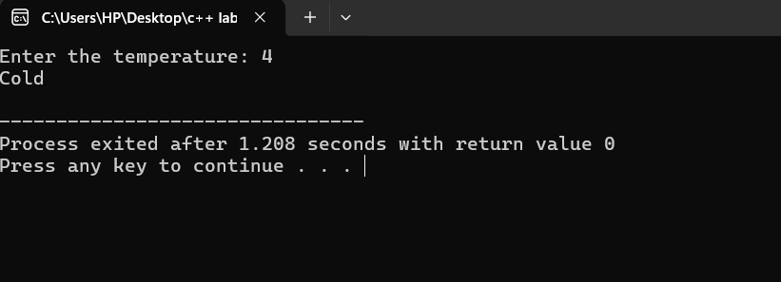

**TASK 4 PASS BY EFERENCE**

#include <iostream>

using namespace std;

void printTempOpinion(int &temp)

{

if (temp< 10)

{

cout<< "Cold" << endl;

}

else if (temp>= 20 && temp <= 30)

{

cout<< "OK" << endl;

}

else if (temp > 30)

{

cout << "Hot" << endl;

}

}

int main()

{

int temperature;

cout << "Enter the temperature: ";

cin >> temperature;

printTempOpinion(temperature);

return 0;

}

