#include <iostream>

using namespace std;

int main() {

int number;

cout << "Enter a number: ";

cin >> number;

for(int i = 1; i <= 10; i++) {

cout << number << " \* " << i << " = " << number \* i << endl;

}

return 0;

}

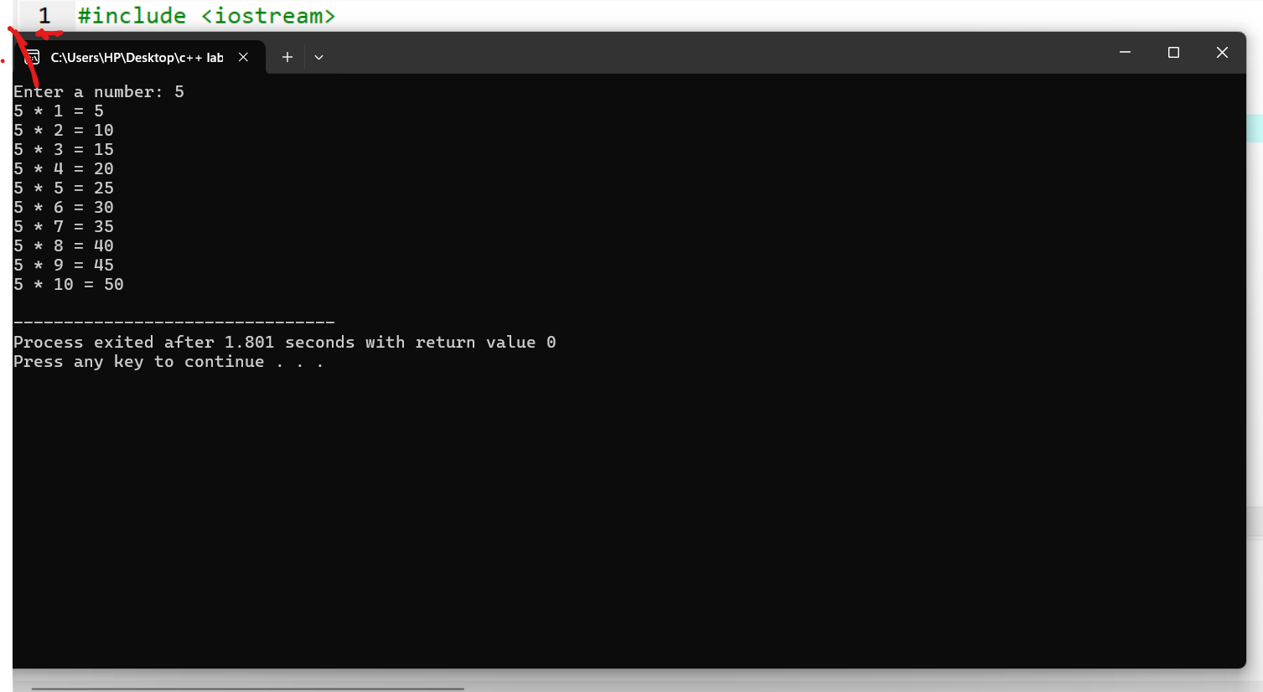h

#include <iostream>

using namespace std;

int main() {

int number;

cout << "Enter a number: ";

cin >> number;

for(int i = number; i >= 1; i--) {

cout << i << endl;

}

return 0;

}

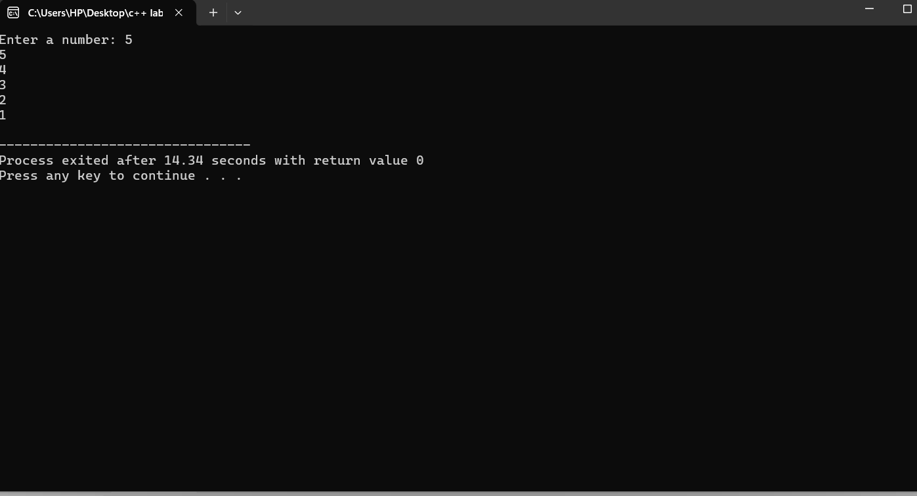hhhhh

#include <iostream>

using namespace std;

int main() {

int number, sum = 0;

cout << "Enter numbers (enter a negative number to stop): " << endl;

while (true) {

cin >> number;

if (number < 0)

break;

sum += number;

}

cout << "Total sum: " << sum << endl;

return 0;

}

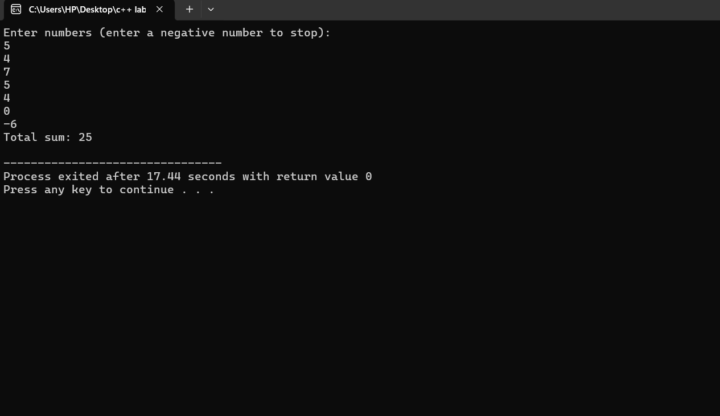k

#include <iostream>

using namespace std;

int main() {

int n, sum = 0, i = 1;

cout<< "Enter a number: ";

cin>> n;

while (i <= n) {

if (i % 2 != 0) {

sum += i;

}

i++;

}

cout << "Sum of odd numbers between 1 and " << n << " is: " << sum << endl;

return 0;

}

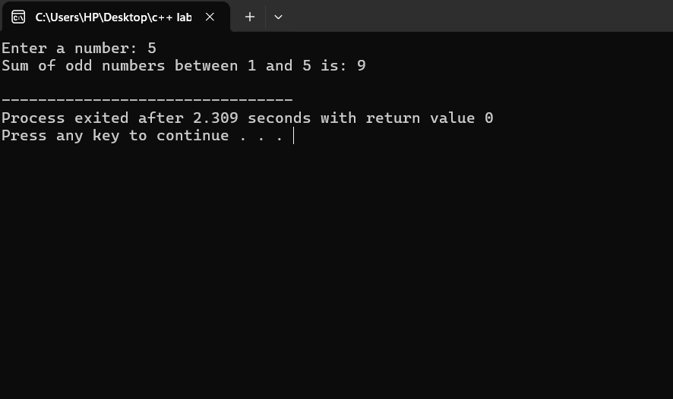h

#include <iostream>

using namespace std;

int main() {

const int days = 7;

float temp, sum = 0;

for(int i = 1; i <= days; i++) {

cout << "Enter temperature for day " << i << ": ";

cin >> temp;

sum += temp;

}

float average = sum / days;

cout << "Average temperature for the week: " << average << endl;

return 0;

}

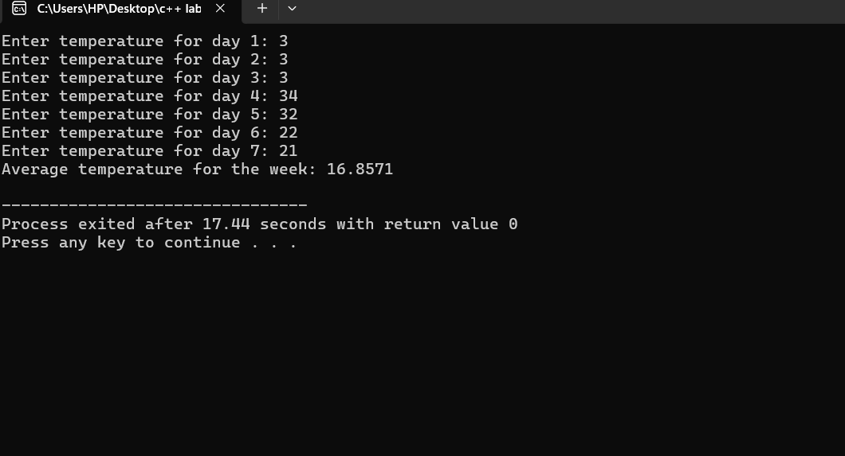S

#include <iostream>

using namespace std;

int main() {

float balance, withdrawal;

cout << "Enter initial balance: ";

cin>> balance;

while (true) {

cout<< "Enter withdrawal amount (0 to exit): ";

cin>> withdrawal;

if (withdrawal == 0) {

break;

}

if (withdrawal > balance) {

cout<< "Insufficient balance!" << endl;

} else {

balance -= withdrawal;

cout << "Withdrawal successful. Remaining balance: "<< balance<< endl;

}

}

cout << "Final balance: " << balance << endl;

return 0;

}

