REPORTE

CS2071

Project title: Clothing store.

Students:
- Rama Alkusair
- Sana Rahmani

Introduction
In this project, we wrote our case, and then we are creating a database for a R.S clothing store which will be used for managing the store's inventory and sales. The database is designed to include various properties such as a brand name, unique brand id, clothing type, price, size, and color, among others. The objective is to ensure that the database is organized, easy to navigate, and can easily manage the different aspects of the clothing store.
The case is what we wrote:
• Each brand has a name and unique brand id (integer). Nike is an example of a brand.
• A brand may produce multiple types of clothing such as shoes, t-shirts, and jackets.
• Every clothing item is produced by exactly one brand. We store the name, price, and unique item id (integer) for each item.
• For each item, we record its type (e.g. shoes, t-shirts, jackets), size, and color. For example, Nike produces shoes such as “Air Max 90” and t-shirts such as “Nike Sportswear Tee”.
• An item may be sold in one or more stores. A store may sell zero or more items produced by a brand.
• A store has a name, location, and unique store id (integer).
• For each customer, we store a name, email address, and unique customer id (integer).
• A customer can purchase one or more items in a single transaction.
• Every transaction has a unique transaction id (integer), date, and total cost.
• An employee can work in one or more stores. For each employee, we store a name, salary, and unique employee id (integer).
• A store has one or more employees.

ER Diagram
We begin by creating an ER diagram that outlines the relationships between the different properties in the database. Some of the key entities identified in the ER diagram include the brand, store, employee, customer, transaction, and item. The relationships between these entities are also defined, such as the fact that a store can sell one or more items produced by a specific brand, and that an employee can work in one or more stores.

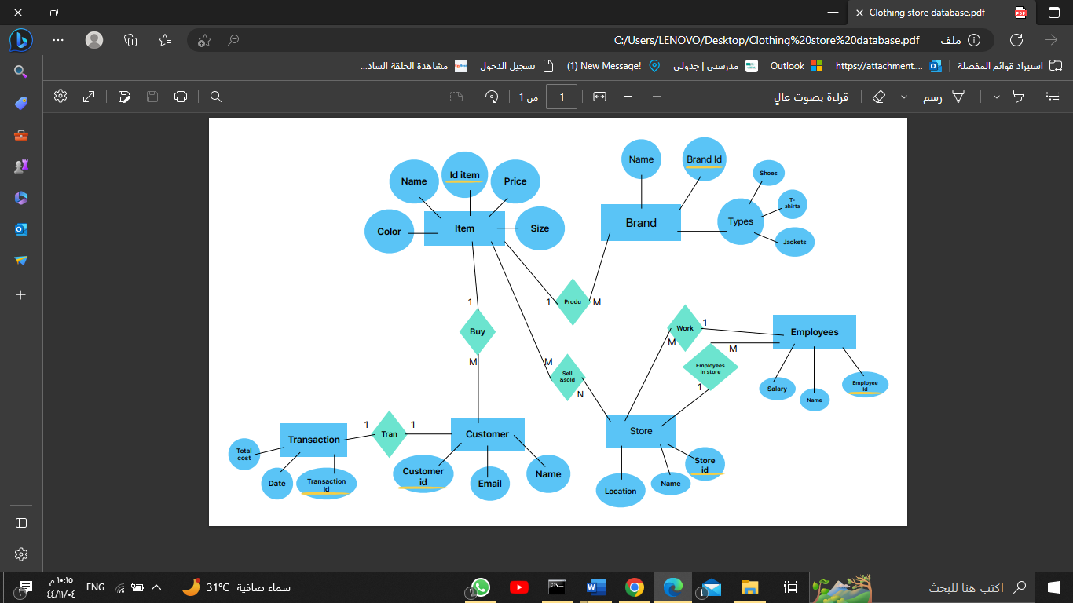
Our ER diagram:

In MySQL
Next, we create tables in MySQL based on the entities identified in the ER diagram. Each table includes various fields or columns that capture the different properties of the entities. For example, the Brand table includes fields such as brand_id and brand_name, while the Employee table includes fields like employee_id and employee_name.

We also define relationships between the tables through the use of foreign keys. For instance, the Item table has a foreign key that references the Brand table, since every item is produced by a specific brand and there, are more relationships between the tables.
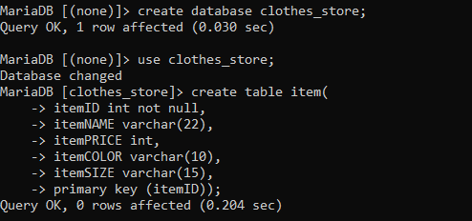

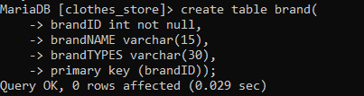

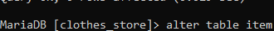
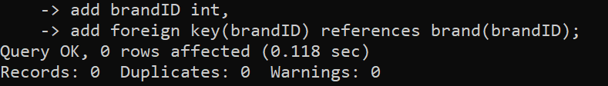

We also insert data into the tables.
Such as brand table:
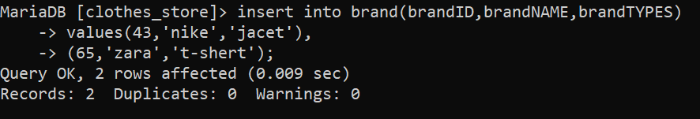
Item table:
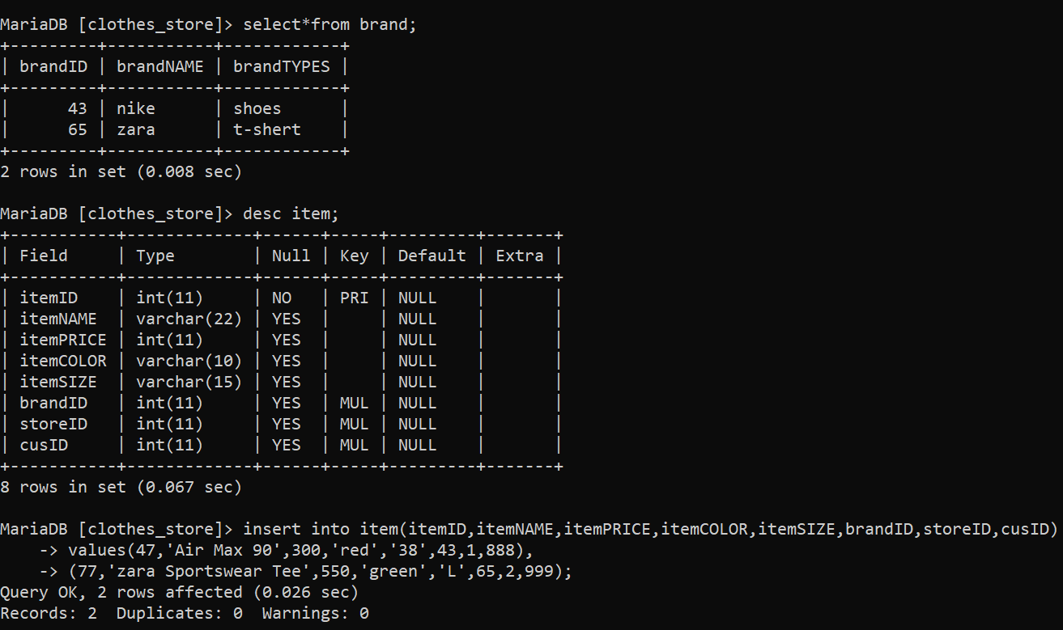
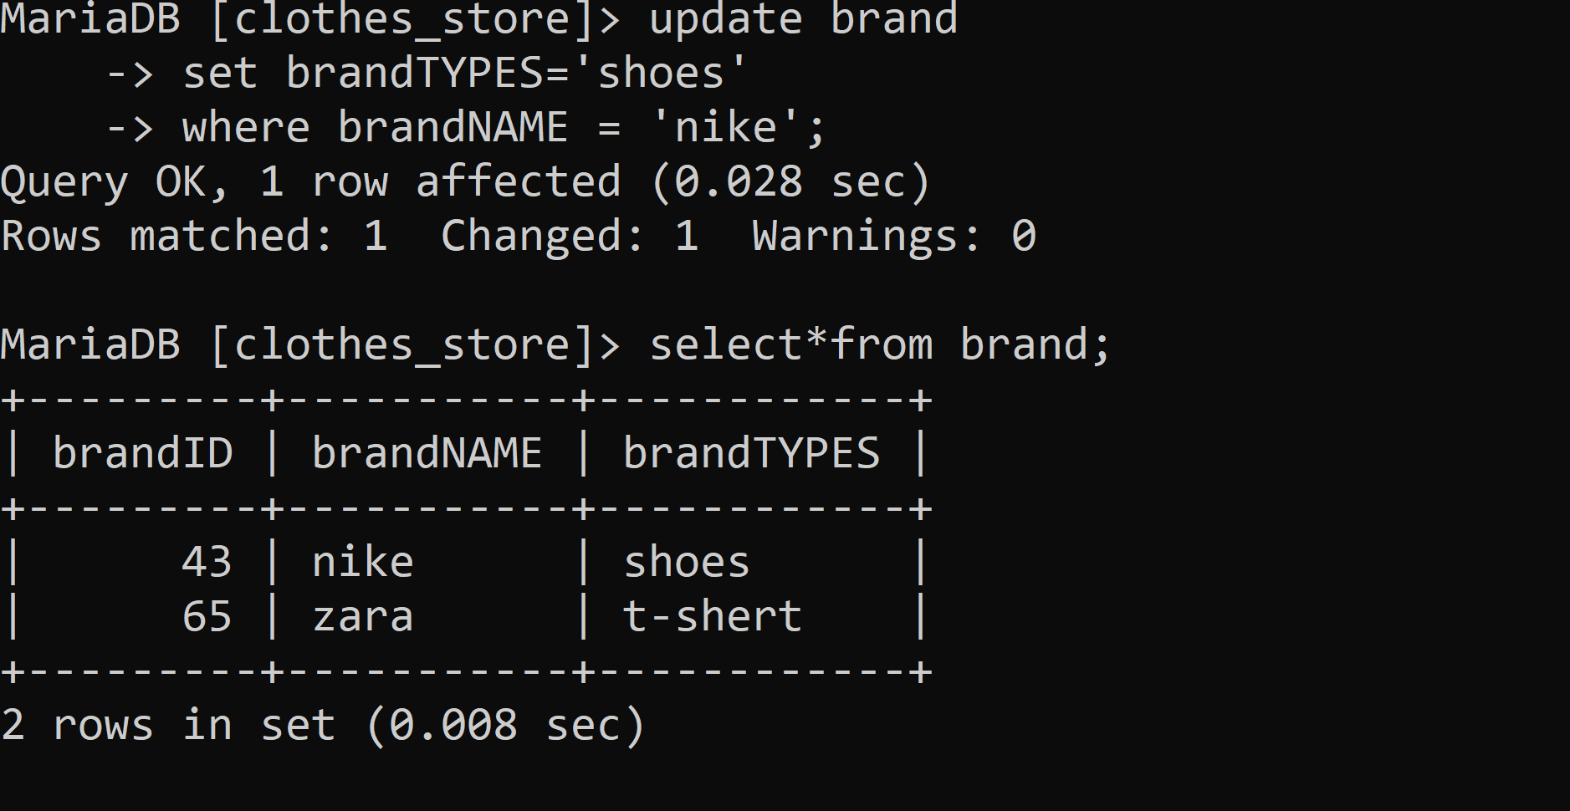
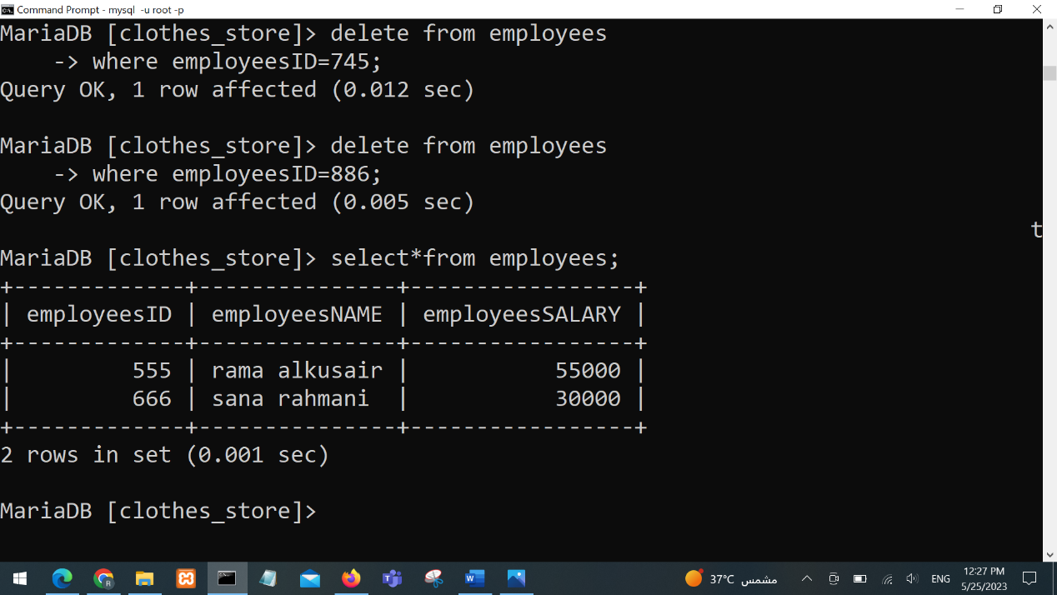

Conclusion
In conclusion, this project has been designed to create a database for a clothing store that incorporates various properties such as brand, item, store, employee, customer, and transaction. Through the use of an ER diagram and tables in MySQL, the properties are well defined, the relationships between entities are established, and the tables are populated with data. The resulting database is effective and can be used to manage various aspects of the store such as inventory and sales.

