Project Summary Report
Fill the document as per the requirements of the project. You must include the following sections in the document:
Students names:
Esraa Basalamh S21107013
Sana Rahmani S21107268
Rama Alkusair S21207487

- High level description of the organization for which the network plan is being created.
We build a network for a printer company that has 2 branches in Madinah and Makkah and a headquarter, its located in Jeddah. The headquarter has 4 departments with a server room. The departments and their respective devices are as follows:

• IT department: 4 PCs and 1 printer.
• HR department: 4 PCs and 1 printer.
• Accounting department: 4 PCs and 1 printer.
• Sales department: 5 PCs and 2 printers.
• Also, there is a DHCP server room.

To isolate the networks, each department has its own VLAN, and the devices in each department get their IP addresses automatically from DHCP server. Each VLAN is linked to a dictated switch and all the switches are interconnected using a multilayer switch. This multilayer switch is connected to a router, which allows communication with the other branches.

There are two branches, Makkah and Medina, each with one department of sales. Each branch has a router that helps them to communicate between the branches and the headquarters

- Description of end devices.

In our network setup, we used PCs and printers as the end devices and we assigned IP addresses to these end devices, using a DHCP server which handout IP addresses to each device as they connect to the network. This ensure that assigning IP addresses is automatic, and it eliminate the need for manual configuration on each device.

- Description of intermediate devices.

- Explanation of intermediate equipment.
We utilized routers, switches, and a multilayer switch as our intermediate devices. Within the headquarters, each department was configured into virtual LANs with distinct subnets. The multilayer switch interconnected these virtual LANs.
Configuration steps for the multilayer switch.

- Configuration steps for the multilayer switch.
The configuration steps for the multilayer switch involve several key processes. First, VLAN configuration is undertaken, where VLANs are established on the switch, each assigned a unique VLAN ID, and interfaces are allocated to these VLANs. Following this, IP routing is enabled on the switch to facilitate the forwarding of traffic between VLANs. Subsequently, VLAN trunking is configured on interfaces connecting the multilayer switch to other switches, allowing the transmission of traffic from multiple VLANs. Access port setup comes next, where the appropriate VLAN is assigned to each access port, enabling communication within respective VLANs. Finally, to establish connectivity with routers, specific interfaces on the multilayer switch are configured as Layer 3 interfaces, allowing for direct connection and communication between the switch and routers.

- Procedure for connecting routers.
The procedure for connecting routers entails several distinct steps. Initially, static IP addresses are assigned to each router, ensuring they belong to the same network as their respective LANs. Next, IP addresses are configured for the Serial DTE interfaces of each router, facilitating physical connections between them. Lastly, the Routing Information Protocol (RIP) is implemented, enabling the exchange of routing information among the routers and ensuring seamless interconnection within the network infrastructure.

- Screenshots of the completed network.

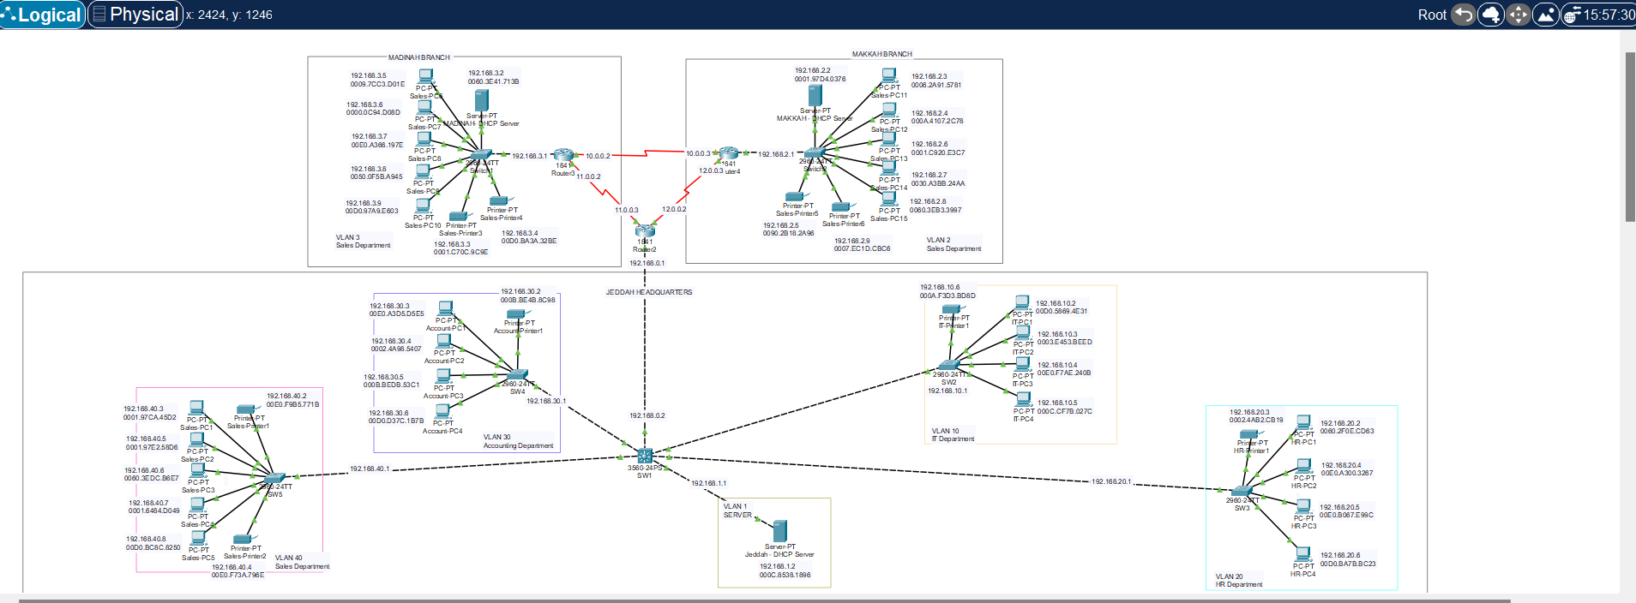

- Screenshots demonstrating working of the network in packet tracer.

Sending a ping message from a PC in the Madinah branch to another PC from the Jeddah headquarter in the accounting department.

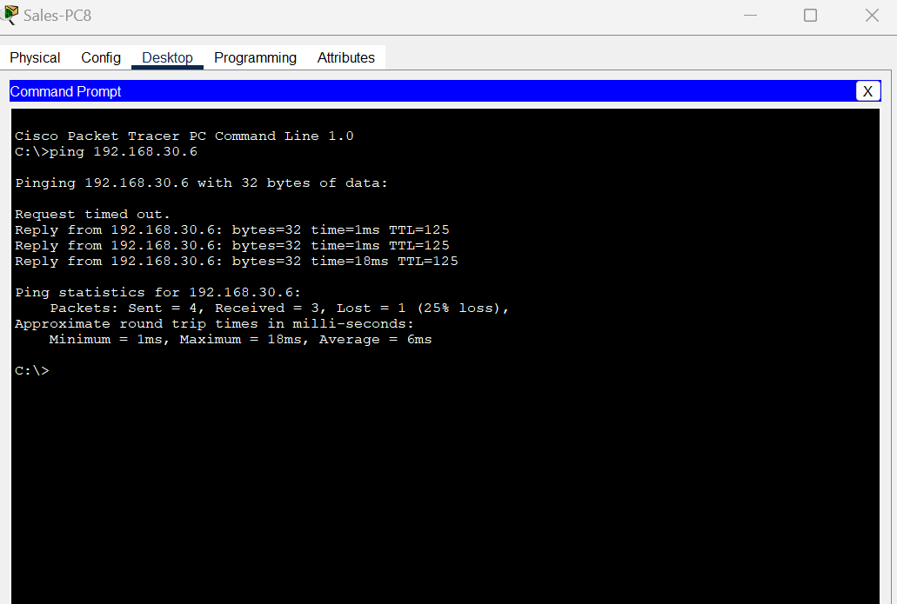

Sending a ping message from a PC in the Makkah branch to another PC from the Madinah branch

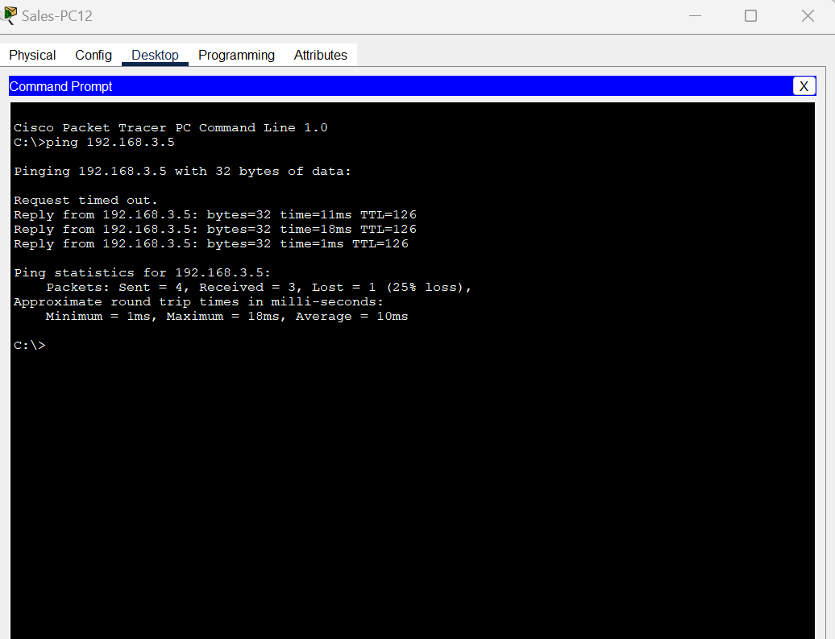

Sending a ping message from a PC in the Jeddah headquarters in the IT department to the Sales department

