**Assignment no 5**

Submitted by:

Sana Zeb

Submitted to:

Sir Azeem

Roll number:

15101598-110

Department:

Software engineering

Date:

07-Aug-17

**Q: 1**

package assignment522;

import javax.swing.*;

import java.awt.*;

import java.awt.event.ItemEvent;

import java.awt.event.ItemListener;

import java.awt.event.MouseEvent;

import java.awt.event.MouseListener;

public class Assignment522 implements ItemListener{

JFrame f;

JPanel mainp;

JRadioButtonMenuItem b1,b2,b3;

String s;

public void initGUI()

{

f = new JFrame("Using JPopup Menus");

mainp = new JPanel();

mainp.setLayout(null);

b1 = new JRadioButtonMenuItem("Red");

b2 = new JRadioButtonMenuItem("Yellow");

b3 = new JRadioButtonMenuItem("Green");

b1.setBounds(50,50,100,20);

b2.setBounds(50,70,100,20);

b3.setBounds(50,90,100,20);

b1.addItemListener(this);

b2.addItemListener(this);

b3.addItemListener(this);

mainp.add(b1);

mainp.add(b2);

mainp.add(b3);

f.add(mainp);

f.setVisible(true);

f.setSize(300,300);

f.setDefaultCloseOperation(JFrame.EXIT_ON_CLOSE);

}

public void itemStateChanged(ItemEvent e)

{

if(e.getItem() == b1)

{

JFrame f1 = new JFrame("Using JPopup Menus");

JPanel p1 = new JPanel();

p1.setBackground(Color.RED);

f1.add(p1);

f1.setVisible(true);

f1.setSize(300,300);

f1.setDefaultCloseOperation(JFrame.EXIT_ON_CLOSE);

}

else if(e.getItem() == b2)

{

JFrame f2 = new JFrame("Using JPopup Menus");

JPanel p2 = new JPanel();

p2.setBackground(Color.YELLOW);

f2.add(p2);

f2.setVisible(true);

f2.setSize(300,300);

f2.setDefaultCloseOperation(JFrame.EXIT_ON_CLOSE);

}

else if(e.getItem() == b3)

{

JFrame f3 = new JFrame("Using JPopup Menus");

JPanel p3 = new JPanel();

p3.setBackground(Color.GREEN);

f3.add(p3);

f3.setVisible(true);

f3.setSize(300,300);

f3.setDefaultCloseOperation(JFrame.EXIT_ON_CLOSE);

}

}

public Assignment522()

{

initGUI();

}

public static void main(String[] args) {

Assignment522 a = new Assignment522();

}

}

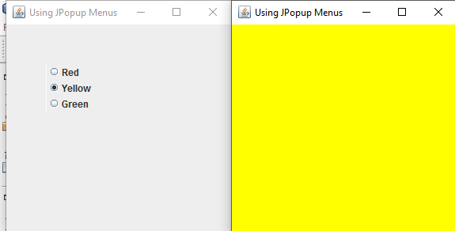

**Q: 2**

package assign53;

import java.awt.*;

import java.awt.Image;

import javax.swing.*;

import java.awt.event.*;

import javax.swing.ImageIcon;

public class Assign53 implements ActionListener{

JFrame f;

JPanel p;

JComboBox x;

String flowers[]={"Rose","Tulip","Daisy","Lily"};

ImageIcon lily,rose,tulip,daisy;

JLabel l;

public void initGUI()

{

f = new JFrame("Testing JCombo Box");

p = new JPanel();

x = new JComboBox(flowers);

x.setBounds(20,20,80,25);

x.addActionListener(this);

//String url1 = "lily.jpg";

//String url2 = "daisy.jpg";

//String url3 = "rose.jpg";

//String url4 = "tulip.jpg";

lily = new ImageIcon("lily.jpg");

rose = new ImageIcon("rose.jpg");

daisy = new ImageIcon("daisy.jpg");

tulip = new ImageIcon("tulip.jpg");

l = new JLabel(" ");

p.add(x);

f.add(p);

f.setSize(700,700);

f.setVisible(true);

f.setDefaultCloseOperation(JFrame.EXIT_ON_CLOSE);

}

public void actionPerformed(ActionEvent e)

{

JComboBox x = (JComboBox) e.getSource();

Object selected = x.getSelectedItem();

if(selected.toString().equals("Lily"))

{

l.setIcon(lily);

p.add(l);

}

else if(selected.toString().equals("Rose"))

{

l.setIcon(rose);

p.add(l);

}

else if(selected.toString().equals("Daisy"))

{

l.setIcon(daisy);

p.add(l);

}

else if(selected.toString().equals("Tulip"))

{

l.setIcon(tulip);

p.add(l);

}

}

public Assign53()

{

initGUI();

}

public static void main(String[] args) {

Assign53 a = new Assign53();

}

}

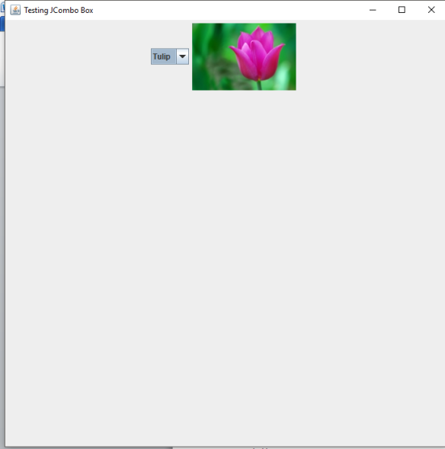

Q: 3

package assign54;

import com.sun.prism.paint.Color;

import java.awt.Dimension;

import javax.swing.*;

import javax.swing.event.ListSelectionEvent;

import javax.swing.event.ListSelectionListener;

import java.awt.*;

public class Assign54 implements ListSelectionListener {

JFrame f;

JPanel p;

JList l;

JScrollPane scroll;

String a[] = {"Red","Green","Yellow","Cyan","Gray","Light Gray"},s;

public void initGUI()

{

f = new JFrame("List Test");

p = new JPanel();

l = new JList(a);

l.setSelectionMode(ListSelectionModel.SINGLE_SELECTION); //for single selection of list items

l.setLayoutOrientation(JList.VERTICAL); //for layout of items

scroll = new JScrollPane(l);

scroll.setMinimumSize(new Dimension(50, 50));

l.setVisibleRowCount(4);

p.add(scroll);

l.addListSelectionListener(this);

f.add(p);

f.setVisible(true);

f.setSize(300,400);

f.setDefaultCloseOperation(JFrame.EXIT_ON_CLOSE);

}

public void valueChanged(ListSelectionEvent e)

{

JList l = (JList) e.getSource();

Object selected = l.getSelectedValue();

if(selected.toString().equals("Red"))

{

p.setBackground(java.awt.Color.red);

}

else if(selected.toString().equals("Green"))

{

p.setBackground(java.awt.Color.GREEN);

}

else if(selected.toString().equals("Yellow"))

{

p.setBackground(java.awt.Color.YELLOW);

}

else if(selected.toString().equals("Gray"))

{

p.setBackground(java.awt.Color.GRAY);

}

else if(selected.toString().equals("Cyan"))

{

p.setBackground(java.awt.Color.cyan);

}

else if(selected.toString().equals("Light Gray"))

{

p.setBackground(java.awt.Color.LIGHT_GRAY);

}

}

public Assign54()

{

initGUI();

}

public static void main(String[] args) {

Assign54 a =new Assign54();

}

}

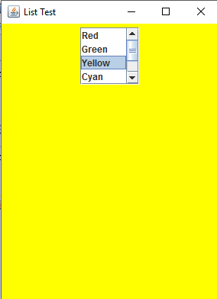

Q: 4

package assign55;

import java.awt.BorderLayout;

import java.awt.Color;

import javax.swing.*;

public class Assign55 {

JFrame f;

JPanel p,tp1,tp2,tp3;

JTabbedPane t;

String a[] = {"Tab One","Tab Two","Tab Three"};

JLabel l1,l2,l3;

JButton b1,b2,b3,b4;

public void initGUI()

{

f = new JFrame("JTabbed Pane");

p = new JPanel();

p.setLayout(null);

tp1 = new JPanel();

l1 = new JLabel("Panel One");

tp1.add(l1);

tp2 = new JPanel();

l2 = new JLabel("Panel Two");

tp2.add(l2);

tp2.setBackground(Color.CYAN);

tp3 = new JPanel();

tp3.setLayout(new BorderLayout());

l3 = new JLabel("Panel Three");

b1 = new JButton("North");

b2 = new JButton("East");

b3 = new JButton("South");

b4 = new JButton("West");

tp3.add(b1,BorderLayout.NORTH);

tp3.add(b2,BorderLayout.EAST);

tp3.add(b3,BorderLayout.SOUTH);

tp3.add(b4,BorderLayout.WEST);

tp3.add(l3,BorderLayout.CENTER);

t = new JTabbedPane();

t.setBounds(0,0,300,300);

t.addTab("Tab One",tp1);

t.addTab("Tab Two",tp2);

t.addTab("Tab Three",tp3);

p.add(t);

f.add(p);

f.setVisible(true);

f.setSize(320,340);

f.setDefaultCloseOperation(JFrame.EXIT_ON_CLOSE);

}

public Assign55()

{

initGUI();

}

public static void main(String[] args) {

Assign55 a = new Assign55();

}

}

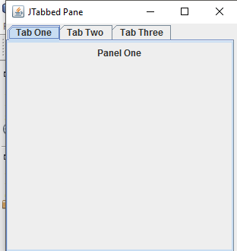 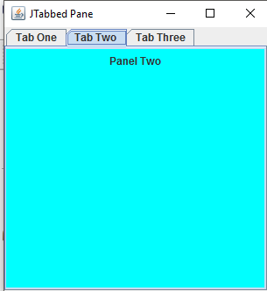 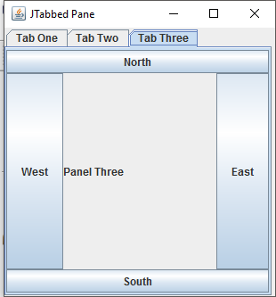

Q: 5

package assign56;

import javax.swing.*;

import java.awt.*;

public class Assign56 {

JFrame f;

JPanel p;

JTabbedPane tb;

JPanel p1,p2,p3,p4,p5;

JScrollPane s;

JButton b1,b2,b3,b4,b5,b6,b7,b8,b9,b10,b11,b12,b13,b14,b15;

public void initGUI()

{

f = new JFrame("Demonstrating Box Layout");

p = new JPanel();

p.setLayout(null);

p1 = new JPanel();

p1.setLayout(new BoxLayout(p1,BoxLayout.X_AXIS));

b1 = new JButton("Button 1");

b1.setAlignmentX(Component.CENTER_ALIGNMENT);

b2 = new JButton("Button 2");

b2.setAlignmentX(Component.CENTER_ALIGNMENT);

b3 = new JButton("Button 3");

b3.setAlignmentX(Component.CENTER_ALIGNMENT);

p1.add(b1);

p1.add(b2);

p1.add(b3);

p2 = new JPanel();

p2.setLayout(new BoxLayout(p2,BoxLayout.Y_AXIS));

b4 = new JButton("Button 1");

b4.setAlignmentX(Component.LEFT_ALIGNMENT);

b5 = new JButton("Button 2");

b5.setAlignmentX(Component.LEFT_ALIGNMENT);

b6 = new JButton("Button 3");

b6.setAlignmentX(Component.LEFT_ALIGNMENT);

p2.add(Box.createVerticalStrut(40));

p2.add(b4);

p2.add(Box.createVerticalStrut(40));

p2.add(b5);

p2.add(Box.createVerticalStrut(40));

p2.add(b6);

p2.add(Box.createVerticalStrut(40));

p3 = new JPanel();

p3.setLayout(new BoxLayout(p3,BoxLayout.X_AXIS));

b7 = new JButton("Button 1");

b7.setAlignmentX(Component.CENTER_ALIGNMENT);

b8 = new JButton("Button 2");

b9 = new JButton("Button 3");

p3.add(Box.createHorizontalGlue());

p3.add(b7);

p3.add(Box.createHorizontalGlue());

p3.add(b8);

p3.add(Box.createHorizontalGlue());

p3.add(b9);

p4 = new JPanel();

p4.setLayout(new BoxLayout(p4,BoxLayout.Y_AXIS));

b10 = new JButton("Button 1");

b11 = new JButton("Button 2");

b12 = new JButton("Button 3");

b10.setAlignmentX(Component.LEFT_ALIGNMENT);

b11.setAlignmentX(Component.LEFT_ALIGNMENT);

b12.setAlignmentX(Component.LEFT_ALIGNMENT);

p4.add(Box.createRigidArea(new Dimension(5,10)));

p4.add(b10);

p4.add(Box.createRigidArea(new Dimension(5,10)));

p4.add(b11);

p4.add(Box.createRigidArea(new Dimension(5,10)));

p4.add(b12);

p4.add(Box.createRigidArea(new Dimension(5,10)));

p5 = new JPanel();

p5.setLayout(new BoxLayout(p5,BoxLayout.Y_AXIS));

b13 = new JButton("Button 1");

b14 = new JButton("Button 2");

b15 = new JButton("Button 3");

b13.setAlignmentX(Component.LEFT_ALIGNMENT);

b14.setAlignmentX(Component.LEFT_ALIGNMENT);

b15.setAlignmentX(Component.LEFT_ALIGNMENT);

p5.add(Box.createVerticalGlue());

p5.add(b13);

p5.add(Box.createVerticalGlue());

p5.add(b14);

p5.add(Box.createVerticalGlue());

p5.add(b15);

p5.add(Box.createVerticalGlue());

tb = new JTabbedPane();

tb.setBounds(0,0,500,300);

tb.addTab("Horizontal Box",p1);

tb.addTab("Vertical Box with Struts",p2);

tb.addTab("Horizontal Box with Glue",p3);

tb.addTab("Vertical Box with Rigid Areas",p4);

tb.addTab("Vertical Box with Glue",p5);

tb.setTabLayoutPolicy(JTabbedPane.SCROLL_TAB_LAYOUT);

p.add(tb);

f.add(p);

//f.add(tb,BorderLayout.CENTER);

f.setVisible(true);

f.setSize(510,300);

f.setDefaultCloseOperation(JFrame.EXIT_ON_CLOSE);

}

public Assign56()

{

initGUI();

}

public static void main(String[] args) {

Assign56 a = new Assign56();

}

}

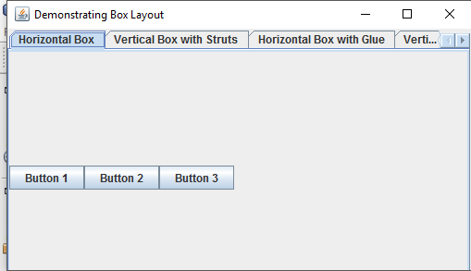 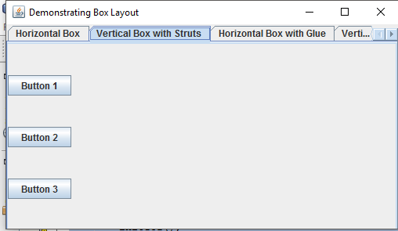

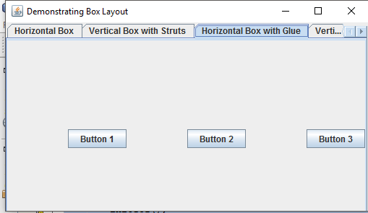 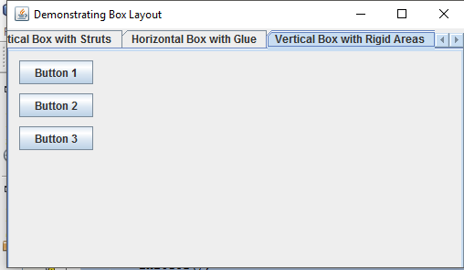 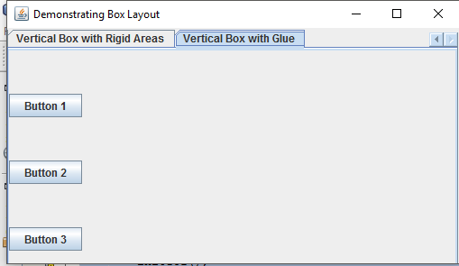

Q: 6

package assign57;

import javax.swing.*;

import java.awt.*;

import java.awt.event.ActionEvent;

import java.awt.event.ActionListener;

import java.awt.event.ItemEvent;

import java.awt.event.ItemListener;

import java.awt.event.KeyEvent;

import java.awt.font.*;

public class Assign57 implements ItemListener,ActionListener{

JFrame f;

JMenuBar mb;

JMenu file,format,color,font;

JMenuItem red,green,cyan,light_gray;

JRadioButtonMenuItem serif,monospaced,sansserif;

JSeparator s;

JCheckBoxMenuItem bold,italic;

JLabel text;

JPanel p;

public void initGUI()

{

f = new JFrame("Using JMenus");

p = new JPanel();

text = new JLabel("Sample Text");

text.setBounds(200,100,1000,100);

mb = new JMenuBar();

mb.setBounds(0,0,100,20);

file = new JMenu("File");

file.setMnemonic(KeyEvent.VK_F);

format = new JMenu("Format");

format.setMnemonic(KeyEvent.VK_H);

color = new JMenu("Color");

font = new JMenu("Font");

red = new JMenuItem("Red");

green = new JMenuItem("Green");

cyan = new JMenuItem("Cyan");

light_gray = new JMenuItem("Light Gray");

serif = new JRadioButtonMenuItem("Serif");

monospaced = new JRadioButtonMenuItem("Monospaced");

sansserif = new JRadioButtonMenuItem("SansSerif");

s = new JSeparator();

bold = new JCheckBoxMenuItem("Bold");

italic = new JCheckBoxMenuItem("Italic");

color.add(red);

color.add(green);

color.add(cyan);

color.add(light_gray);

font.add(serif);

font.add(monospaced);

font.add(sansserif);

font.add(s);

font.add(bold);

font.add(italic);

format.add(color);

format.add(font);

red.addActionListener(this);

green.addActionListener(this);

cyan.addActionListener(this);

light_gray.addActionListener(this);

serif.addItemListener(this);

monospaced.addItemListener(this);

sansserif.addItemListener(this);

bold.addItemListener(this);

italic.addItemListener(this);

mb.add(file);

mb.add(format);

p.add(text);

p.setLayout(new BorderLayout());

p.add(mb,BorderLayout.SOUTH);

f.add(p);

f.setJMenuBar(mb);

f.setSize(900,500);

f.setVisible(true);

f.setDefaultCloseOperation(JFrame.EXIT_ON_CLOSE);

}

public void itemStateChanged(ItemEvent e)

{

if(e.getItem() == serif)

{

text.setFont(new Font("Serif",Font.PLAIN,100));

}

else if(e.getItem() == monospaced)

{

text.setFont(new Font("Monospaced",Font.PLAIN,100));

}

else if(e.getItem() == sansserif)

{

text.setFont(new Font("Sansserif",Font.PLAIN,100));

}

else if(e.getItem() == bold)

{

text.setFont(new Font(null,Font.BOLD,100));

}

else if(e.getItem() == italic)

{

text.setFont(new Font(null,Font.ITALIC,100));

}

else if(e.getItem() == serif && e.getItem() == bold)

{

text.setFont(new Font("Serif",Font.BOLD,100));

}

else if(e.getItem() == monospaced && e.getItem() == bold)

{

text.setFont(new Font("Monospaced",Font.BOLD,100));

}

else if(e.getItem() == sansserif && e.getItem() == bold)

{

text.setFont(new Font("Sansserif",Font.BOLD,100));

}

else if(e.getItem() == serif && e.getItem() == italic)

{

text.setFont(new Font("Serif",Font.ITALIC,50));

}

else if(e.getItem() == monospaced && e.getItem() == italic)

{

text.setFont(new Font("Monospaced",Font.ITALIC,50));

}

else if(e.getItem() == sansserif && e.getItem() == italic)

{

text.setFont(new Font("Sansserif",Font.ITALIC,50));

}

}

public void actionPerformed(ActionEvent e)

{

if(e.getSource() == red)

{

p.setBackground(Color.red);

}

else if(e.getSource() == green)

{

p.setBackground(Color.GREEN);

}

else if(e.getSource() == cyan)

{

p.setBackground(Color.CYAN);

}

else if(e.getSource() == light_gray)

{

p.setBackground(Color.LIGHT_GRAY);

}

}

public Assign57()

{

initGUI();

}

public static void main(String[] args) {

Assign57 a = new Assign57();

}

}

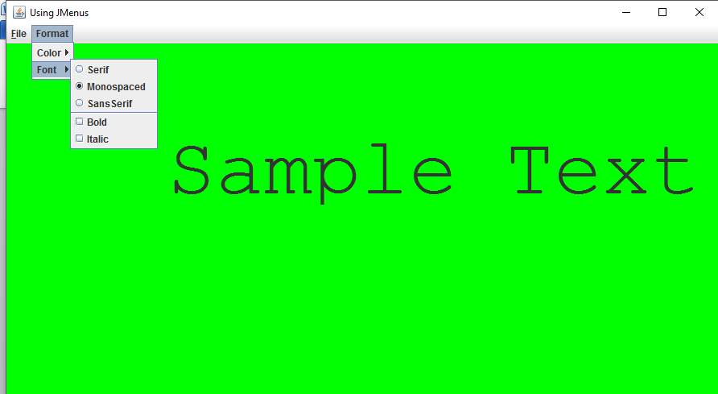

Q: 7

package assign51;

import java.awt.*;

import java.awt.Font;

import javax.swing.*;

import java.awt.event.*;

import javax.swing.border.TitledBorder;

import java.util.Vector;

public class Assign51 {

JLabel l1,l2,l3;

Container c;

JButton b1,b2;

JPanel p;

public void initGUI()

{

JFrame f=new JFrame("assignment");

f.setSize(600, 700);

f.setDefaultCloseOperation(JFrame.EXIT_ON_CLOSE);

c=f.getContentPane();

c.setLayout(null);

Font fo=new Font("calibri",Font.ITALIC,30);

l1=new JLabel("DynaList");

l1.setBounds(200,10,150,70);

l1.setFont(fo);

l1.setForeground(Color.magenta);

l2=new JLabel("left list");

l2.setBounds(10,80,100,50);

l2.setFont(new Font("calibri",Font.PLAIN,16));

l2.setForeground(Color.CYAN);

l3=new JLabel("right list");

l3.setBounds(400,80,100,50);

l3.setFont(new Font("calibri",Font.PLAIN,16));

l3.setForeground(Color.BLUE);

p=new JPanel();

p.setBounds(20, 290, 500, 50);

p.setBackground(Color.red);

final DefaultListModel<String> lm = new DefaultListModel<String>();

JList l_1 = new JList(lm);

l_1.setBounds(10, 130, 100, 150);

final DefaultListModel<String> lm1 = new DefaultListModel<String>();

JList l_2 = new JList(lm1);

l_2.setBounds(400, 130, 100, 150);

b1=new JButton("move>>");

b1.setBounds(180, 150, 150, 50);

b1.addActionListener(new ActionListener()

{

public void actionPerformed(ActionEvent e)

{

// for (int i = 0; i < lm.getSize(); i++)

// {

Object prev = lm.firstElement();

lm1.addElement((String)prev);

prev=lm.remove(0);

// }

}

});

b2=new JButton("<<move");

b2.setBounds(180, 200, 150, 50);

b2.addActionListener(new ActionListener(){

public void actionPerformed(ActionEvent e){

//for (int i = 0; i < lm1.getSize(); i++) {

Object prev = lm1.firstElement();

lm.addElement((String)prev);

prev=lm1.remove(0);

//}

}

});

TitledBorder tb=new TitledBorder("select list to operate upon");

p=new JPanel();

p.setBounds(20, 290, 500, 100);

p.setBackground(Color.CYAN);

p.setBorder(tb);

p.setLayout(null);

JRadioButton r1=new JRadioButton("left list");

JRadioButton r2=new JRadioButton("right list");

r1.setBounds(10,25,100,20);

r2.setBounds(375,20,100,30);

JButton panel_but=new JButton("Exeunt");

panel_but.setBounds(200, 20, 80, 30);

ButtonGroup bg=new ButtonGroup();

bg.add(r1);bg.add(r2);

p.add(r1);

p.add(r2);

p.add(panel_but);

JPanel p1=new JPanel();

p1.setBounds(20, 390, 500, 200);

p1.setLayout(null);

p1.setBackground(Color.blue);

JLabel p1_1=new JLabel("Enter item to be added");

JLabel p1_2=new JLabel("enter position");

p1_1.setBounds(10, 10, 130, 10);

p1_2.setBounds(10, 25, 100, 10);

JTextField jtf1=new JTextField();

JTextField jtf2=new JTextField();

jtf1.setBounds(150,10,130,15);

jtf2.setBounds(150,30,130,15);

JButton p1_jb1=new JButton("add in the begining");

JButton p1_jb2=new JButton("remove selected item");

JButton p1_jb3=new JButton("add in the end");

JButton p1_jb4=new JButton("remove element from position");

JButton p1_jb5=new JButton("add at position");

JButton p1_jb6=new JButton("remove all");

p1_jb1.setBounds(10, 50, 200, 20);

p1_jb1.addActionListener(new ActionListener(){

public void actionPerformed(ActionEvent e){

if(r1.isSelected()==true){

lm.add(0, jtf1.getText());

}

else if(r2.isSelected()) {

lm1.add(0, jtf1.getText());

}

}

});

p1_jb2.setBounds(10, 70, 200, 20);

p1_jb2.addActionListener(new ActionListener(){

public void actionPerformed(ActionEvent e){

if(r1.isSelected()==true){

lm.remove(l_1.getSelectedIndex());

}

else if(r2.isSelected()) {

lm1.remove(l_2.getSelectedIndex());

}

}

});

p1_jb3.setBounds(10, 90, 200, 20);

p1_jb3.addActionListener(new ActionListener(){

public void actionPerformed(ActionEvent e){

if(r1.isSelected()==true){

lm.addElement(jtf1.getText());

}

else if(r2.isSelected()) {

lm1.addElement(jtf1.getText());

}

}

});

p1_jb4.setBounds(210, 50, 200, 20);

p1_jb4.addActionListener(new ActionListener(){

public void actionPerformed(ActionEvent e){

if(r1.isSelected()==true){

lm.remove(Integer.parseInt(jtf2.getText())-1);

}

else if(r2.isSelected()) {

lm1.remove(Integer.parseInt(jtf2.getText())-1);

}

}

});

p1_jb5.setBounds(210, 70, 200, 20);

p1_jb5.addActionListener(new ActionListener(){

public void actionPerformed(ActionEvent e){

if(r1.isSelected()==true){

lm.add(Integer.parseInt(jtf2.getText())-1, jtf1.getText());

}

else if(r2.isSelected()) {

lm1.add(Integer.parseInt(jtf2.getText())-1, jtf1.getText());

}

}

});

p1_jb6.setBounds(210, 90, 200, 20);

p1_jb6.addActionListener(new ActionListener(){

public void actionPerformed(ActionEvent e){

if(r1.isSelected()==true){

lm.clear();

}

else if(r2.isSelected()) {

lm1.clear();

}

}

});

p1.add(p1_1);

p1.add(p1_2);

p1.add(jtf1);

p1.add(jtf2);

p1.add(p1_jb1);

p1.add(p1_jb2);

p1.add(p1_jb3);

p1.add(p1_jb4);

p1.add(p1_jb5);

p1.add(p1_jb6);

c.add(l1);

c.add(l2);

c.add(l3);

c.add(l_1);

c.add(l_2);

c.add(b1);

c.add(b2);

c.add(p);

c.add(p1);

f.setVisible(true);

}

public Assign51()

{

initGUI();

}

public static void main(String[] args) {

Assign51 a = new Assign51 }

}

