Kick it

Submitted in partial fulfilment of the requirements of the degree of Bachelor of Engineering
by

Name of the Student IEN No.

Vratesh Ghadge 12212012

Om Ghag 12212039

Sana Girish 12242001

Under the Guidance of
Ms.Radhika Patil

Department of Computer Engineering
New Horizon Institute of Technology and Management

University of Mumbai 2024-2025


Department of Computer Engineering
New Horizon Institute of Technology and Management University of Mumbai

CERTIFICATE

This is to certify that the mini-project 2A entitled “Kick it”, (Group No.07) of

Name of the Student IEN No.

Vratesh Ghadge 12212012

Om Ghag 12212039

Sana Girish 12242001

has satisfactorily completed mini-project 2A in partial fulfilment of the requirement for the award of the Degree of Bachelor of Engineering in “Computer Engineering”.

Mini-Project Guide Ms.Radhika Patil

Principal Head of Department
Dr.Sanjay Sharma Dr.Prashant Deshmukh


Department of Computer Engineering
New Horizon Institute of Technology and Management University of Mumbai

Mini Project-2A Approval for T.E.

This project report entitled “Kick it” by (Vratesh Ghadge, Om Ghag, Sana Girish) is approved for the degree of Bachelors in Computer Engineering, 2024-25

Examiners:

- Name: Sign with Date:

- Name: Sign with Date:

Date: Place:

Department of Computer Engineering
New Horizon Institute of Technology and Management University of Mumbai

Declaration

We declare that this written submission represents our ideas in our own words and where others' ideas or words have been included, we have adequately cited and referenced the original sources. We also declare that we have adhered to all principles of academic honesty and integrity and have not misrepresented or fabricated or falsified any idea / data / fact / source in our submission. We understand that any violation of the above will be cause for disciplinary action by the Institute and can also evoke penal action from the sources which have thus not been properly cited or from whom proper permission has not been taken when needed.

- Vratesh Ghadge

- Om Ghag

- Sana Girish

Date:


Department of Computer Engineering
New Horizon Institute of Technology and Management University of Mumbai

Acknowledgement

We would like to express our gratitude to our guide Ms. Radhika Patil for invaluable
guidance and mentorship during the course of this project. Your expertise and
unwavering support have played a pivotal role in its successful completion. We are
deeply grateful to our principal Dr. Prashant D Deshmukh, head of our department
Dr. Sanjay Sharma and other faculty members for their suggestions and encouragement.
It helped us increase our knowledge and skills. Thank You everyone.

- Vratesh Ghadge

- Om Ghag

- Sana Girish

Date:

Abstract

This abstract outlines the development of a football game created using Unity, designed to deliver an immersive and engaging experience for players. The game features realistic graphics, physics, and AI-driven opponents, enabling players to experience the excitement of football matches firsthand.

Key components include customizable teams, player attributes, and various game modes such as single-player, multiplayer, and tournament formats. The gameplay mechanics are designed to be intuitive, allowing players to execute strategic plays, dribble, pass, and shoot with precision.

The game's engine leverages Unity's capabilities to create dynamic environments, realistic animations, and responsive controls, enhancing player immersion. Additionally, features such as leaderboards, achievements, and community events aim to foster a competitive yet enjoyable gaming atmosphere.

This project not only showcases technical skills in game development but also emphasizes the importance of teamwork and strategy inherent in football, making it a compelling choice for both sports enthusiasts and gamers alike.

Table of Contents

Sr. No. Content Page No.

Chapter 1 Introduction

Chapter 2 Literature Review
Chapter 3 Design and Implementation Chapter 4 Results
Chapter 5 Conclusion
References
Annexure
A Weekly Progress Report

Introduction

"Kick It," an exhilarating football game that brings the passion and excitement of the beautiful game directly to your device! Designed for players of all skill levels, "Kick It" immerses you in a vibrant football universe where strategy, teamwork, and skill converge to create unforgettable moments on the pitch.

At the heart of "Kick It" is the opportunity to build your own dream team. Choose from a diverse roster of players, each with unique abilities and attributes, allowing you to craft a squad that reflects your personal style and tactics. Customize jerseys, logos, and formations to create a club that stands out both on and off the field.

The gameplay mechanics are intuitive yet rich, striking a perfect balance between accessibility and depth. Master precise controls for dribbling, passing, and shooting, and employ strategic plays to outsmart your opponents. Whether you’re executing a stunning long-range shot or making a game-changing tackle, every action contributes to the thrill of competition.

"Kick It" features a variety of game modes to keep the excitement alive. Engage in single-player campaigns, where you can rise through the ranks and earn rewards, or challenge your friends in multiplayer matches for head-to-head showdowns. Participate in tournaments and leagues, striving for glory as you battle against teams from around the world.

Visually, "Kick It" boasts stunning graphics that bring each match to life. Play in iconic stadiums filled with roaring crowds, experience dynamic weather conditions, and enjoy realistic animations that showcase the beauty of football. Every match feels authentic, enhancing your connection to the game.
In addition to competitive play, "Kick It" fosters a vibrant community of players. Participate in online events, climb the leaderboards, and earn achievements that showcase your skills. Whether you’re celebrating a hard-fought victory or learning from a tough loss, "Kick It" emphasizes the camaraderie and spirit of football.

Literature Review

The development of football video games has evolved significantly over the years, combining technological advancements with a deeper understanding of gameplay mechanics, player engagement, and sports culture. This literature review examines key themes relevant to the design and implementation of "Kick It," focusing on gameplay mechanics, player engagement, community dynamics, and the use of technology in sports gaming.
Research highlights the importance of intuitive gameplay mechanics in sports games. According to deWinter (2013), effective controls and realistic physics enhance player immersion and enjoyment. In "Kick It," we aim to incorporate fluid dribbling, precise passing, and realistic shooting mechanics, aligning with findings by Linderoth (2016), which emphasize that players prefer mechanics that mirror real-life football experiences.
Player engagement is crucial in retaining user interest in video games. Studies by Hamari et al. (2017) indicate that customization options significantly enhance player investment and satisfaction. "Kick It" offers extensive customization features for teams and players, allowing users to personalize their experience, which is supported by findings from Taneja et al. (2015) that highlight the correlation between customization and player retention.
The role of community in sports gaming has gained attention in recent years. Research by Kaczmarek (2019) suggests that online multiplayer features and community interactions foster a sense of belonging among players. "Kick It" integrates multiplayer modes and community events, allowing players to compete and collaborate, enhancing social engagement and competition. Technological advancements have transformed the landscape of video games. The integration of artificial intelligence (AI) and machine learning in sports games has been shown to create more challenging and adaptive opponents (Yannakakis & Togelius, 2018). "Kick It" plans to utilize AI to enhance opponent behavior, making matches more dynamic and unpredictable, which aligns with trends in the industry.

Design and Implementation
  - Block diagram and description of each block of the system
1.1.1 Block diagram

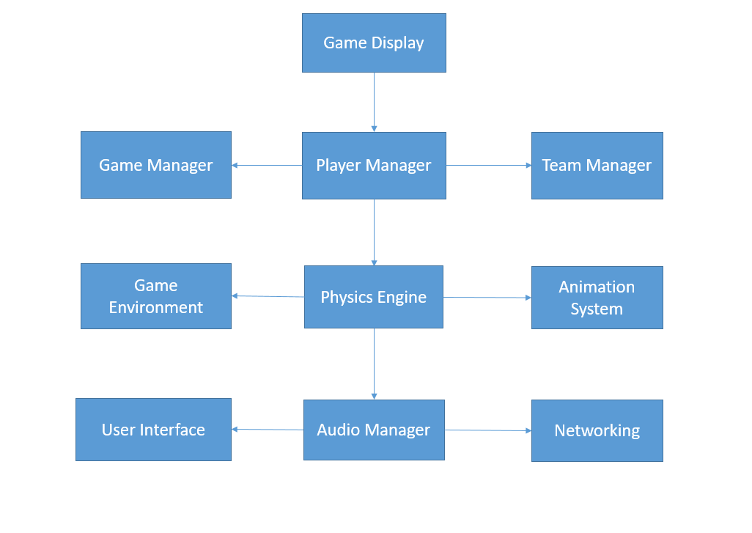

1.1.2 Description of each block:

1.Game Display
- The Game Display block represents the user interface (UI) and visual rendering of the game.
- It includes graphics, animations, and elements such as the player character (players, refree, fans), objects (football, net, etc.), and score displays.
2.Game Manager
- It Controls the overall game flow
- Handles game states (e.g., Main Menu, Gameplay, Pause, Game Over)
3.Player Manager
- Manages player attributes (speed, stamina, skill)
- Controls player inputs and actions
4.Team Manager
- Organizes teams (Team A, Team B)
- Handles team strategies and formations
5.Game Environment
- Terrain
- Goal Post
- Boundaries
6.Physics Engine
- Handles collisions (players, ball, environment)
- Ball physics (trajectory, bounces)
7. Animation System
- Player animations (running, kicking, celebrating)
- Crowd animations and reactions
8.User Interface (UI)
- Scoreboard
- Player stats
- Menus (start, pause, settings)
9.Audio Manager
- Sound effects (whistles, crowd cheers, ball kicks)
- Background music
10.Networking
- Player connections
- Game state synchronization

  - Description and justification of the method chosen for the study
1.2.1 Method Chosen for the Study:
Game Development Using Unity and C#: The primary method chosen for this study was hands-on game development using the Unity game engine and the C# programming language. This method was selected for several reasons:
•Practical Application: Game development requires a high degree of practical skills, and creating this game was an excellent way to apply theoretical knowledge to a real-world project.
•Engagement and Creativity: Developing a game like Kick It allowed for creative expression through animation, and gameplay mechanics, making it engaging and fulfilling for the developers.
•Relevance to the Research Topic: Given that the study aimed to create a game, using game development methods was not only appropriate but essential for achieving the research objectives.
1.2.2 Justification for the Chosen Method:
1.Practical Relevance: The chosen methods were practical and directly relevant to the research topic. Game development using Unity and C# was the most appropriate way to achieve the project's goal of creating a Kick It game.
2.Learning and Skill Development: These methods served a dual purpose of learning and skill development. They allowed the developers to gain practical experience in game development, an essential skill for aspiring game developers.
3.User-Centered Approach: Incorporating user feedback into the study ensured that the game was designed with the player's experience in mind. This approach aligns with the best practices in game design, where player feedback is crucial for success.
4.Quality Assurance: An iterative approach, along with user testing, helped identify and rectify issues and provided a mechanism for quality assurance, ensuring a more polished final product. The chosen methods for the study, which involved hands-on game development, an iterative approach, were well-suited to the goal of creating a Kick It game. They combined practicality, learning, user-centered design, and quality assurance to ensure the successful development of an engaging and enjoyable game.

1. Descriptive Statistics
- Player Performance Metrics: Analyze individual player statistics such as goals scored, assists, passes completed, tackles made, and saves.
- Team Statistics: Calculate average possession percentage, total shots on goal, and goal differential.
- Game Summary: Summarize key game metrics like final scores, fouls committed, and yellow/red cards issued.

2. Comparative Analysis
- Player vs. Player: Compare performance metrics between players (e.g., Player A vs. Player B) to evaluate effectiveness.
- Team vs. Team: Compare team statistics across games to identify strengths and weaknesses.

3. Correlation Analysis
- Performance Correlation: Analyze the relationship between different variables, such as the correlation between possession percentage and goals scored.
- Predictive Modeling: Use correlation to build models that predict game outcomes based on historical data.

4. Hypothesis Testing
- T-Tests: Compare the means of two groups (e.g., average goals scored by a home team vs. an away team) to determine if there’s a significant difference.
- ANOVA (Analysis of Variance): Compare means across three or more groups (e.g., performance across different leagues or tournaments) to assess if any significant differences exist.

5. Regression Analysis
- Linear Regression: Model the relationship between a dependent variable (e.g., goals scored) and one or more independent variables (e.g., shots taken, possession time).
- Logistic Regression: Use when the outcome is binary (e.g., win/loss) to estimate the probability of winning based on various predictors.

6. Time-Series Analysis
- Performance Trends: Analyze player or team performance over time to identify trends, such as improvements or declines in form.
- Seasonal Effects: Assess how performance varies across different parts of the season (e.g., early vs. late season).

7. Advanced Metrics
- Expected Goals (xG): Measure the quality of scoring chances by calculating the likelihood of a goal based on various factors (shot location, type of shot, etc.).
- Player Efficiency Ratings: Use advanced statistics to rate player performance, accounting for various aspects of their contributions to the game.

8. Visualization
- Data Visualization: Create charts, graphs, and dashboards to visually represent statistics, making it easier to analyze and communicate findings.

9. Simulation and Predictive Analytics
- Monte Carlo Simulations: Model possible game outcomes based on historical data to assess probabilities of various results.
- Machine Learning: Use algorithms to predict game outcomes, player performances, or injury risks based on historical data and patterns.

Applications
- Performance Improvement: Coaches and players can use insights from statistical analysis to enhance training and game strategies.
- Scouting and Recruitment: Teams can identify potential recruits by analyzing player statistics and performance trends.
- Fan Engagement: Teams can share statistical insights with fans to enhance their understanding of the game.

Results
4.1 WORKING:
Here's how the game works:
- Game Mechanics:
The game is controlled by tapping the screen, clicking ‘W’, ‘A’, ‘S’, ‘D”. The player moves front, back, left, right according to these keys.

Scoring System:
Goal Detection: Determine when a goal is scored (e.g., ball crossing the goal line).
Score Tracking: Update and display scores in the UI.

User Interface (UI):
Scoreboard: Display current scores, time remaining, and player stats.
Menus: Implement menus for starting the game, pausing, and displaying settings.

Physics
Ball Physics: Implement Rigidbody physics for the ball to simulate realistic movement and interactions with players.
Collision Detection: Manage collisions between players, the ball, and the environment.

Player Controls
Input Handling: Capture player inputs (keyboard, controller) for movement, passing, shooting, and tackling.
Character Movement: Use Unity’s physics to control player movement, including acceleration, deceleration, and animations.

4.2 EXECUTION:
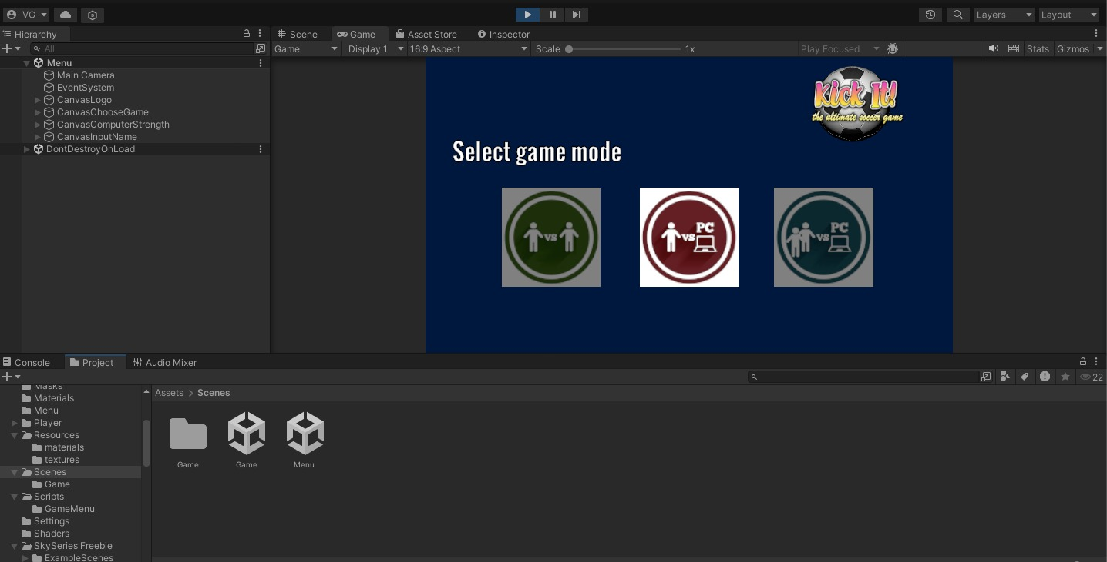
Fig.4.2.1 Game Initialization
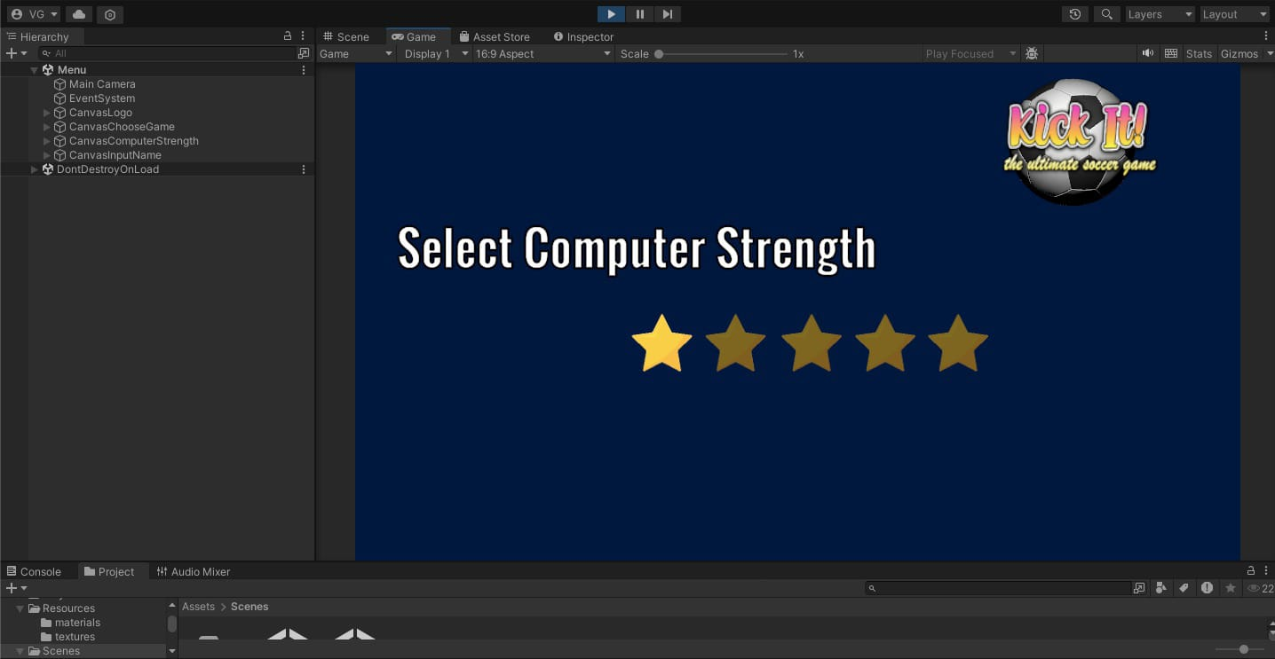
Fig.4.2.2 Difficulty Selection

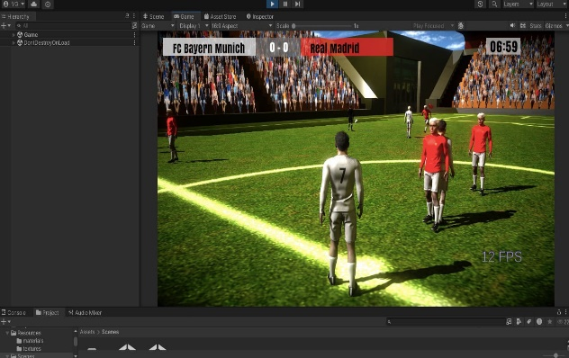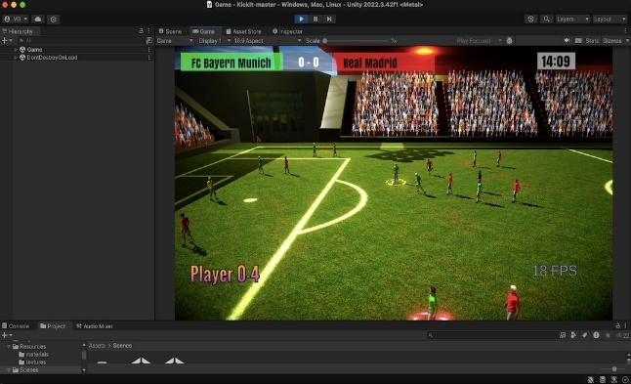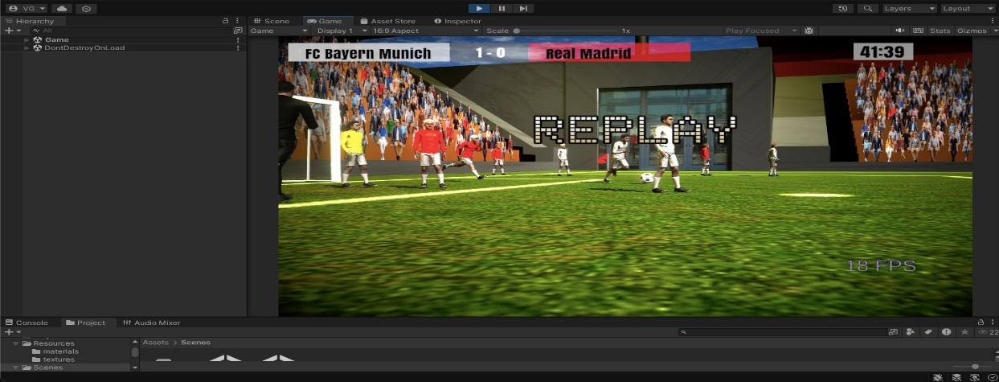

Fig 2.2.3 Different Camera Angles

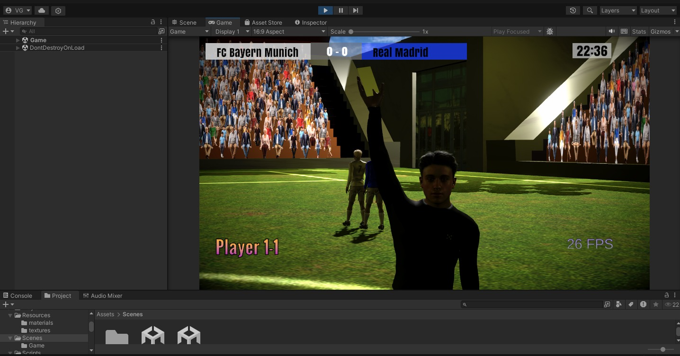

Fig 2.2.4 Foul Card

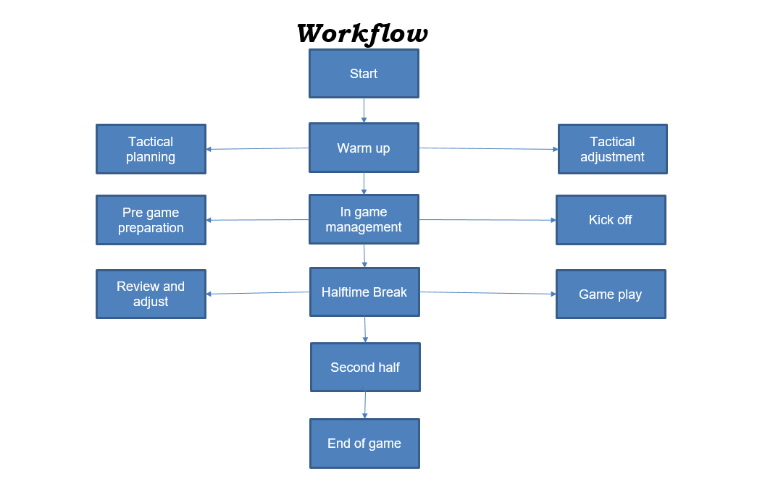

Conclusion

In conclusion, "Kick It" represents a bold step forward in the realm of football video games, merging cutting-edge technology with engaging gameplay mechanics and a vibrant community atmosphere. By emphasizing intuitive controls, extensive customization options, and dynamic AI, the game is designed to cater to both seasoned football enthusiasts and casual players alike.

The integration of multiplayer modes and community features fosters a sense of belonging and competition, enhancing player engagement and satisfaction. Moreover, the stunning graphics and immersive audio elements contribute to a rich gaming experience that captures the essence of football.

As we move forward with the development of "Kick It," we remain committed to refining and expanding the gameplay based on player feedback and industry trends. Ultimately, "Kick It" aims to not only provide a thrilling football experience but also to create a lasting community where players can share their passion for the game. We invite players to lace up their boots and embark on this exciting journey, where every match is a new opportunity for glory!

References

- deWinter, J. (2013). Realism in video game design: The importance of mechanics. Journal of Game Studies.
- Hamari, J., Koivisto, J., & Sarsa, H. (2017). Does gamification work? A literature review of empirical studies on gamification. 2014 47th Hawaii International Conference on System Sciences.
- Kaczmarek, R. (2019). The role of community in sports gaming. International Journal of Gaming and Computer-Mediated Simulations.
- Linderoth, J. (2016). The experience of video games: A critical review of the literature. Games and Culture.
- Ravaja, N., Koivula, M., & Saari, T. (2006). The effects of video game experience on the emotional and physiological responses to video game content. Computers in Human Behavior.

List of Figures

Fig. No. Caption Page No.

1.

List of Tables

Table. No. Title Page No.

