Hyper-V Day 1 – Template VM Preparation

Objective
Prepare standardized Hyper-V virtual machine templates to enable rapid, repeatable deployment of Windows systems for Ontario Skills IT competition scenarios.

Environment
- Host OS: Windows 10/11 Pro with Hyper-V enabled
- Virtualization Platform: Hyper-V
- VM Generation: Generation 2
- Network Type: Private virtual switch

Template Inventory
Windows 11 (Pro / Enterprise) – 2 vCPU, 4 GB RAM, 64 GB disk
Windows Server 2019 (Standard / Datacenter) – 2 vCPU, 4 GB RAM, 100 GB disk
Windows Server 2022 (Standard / Datacenter) – 2 vCPU, 8 GB RAM, 127 GB disk

Evidence Screenshots
Insert the following screenshots in order:
- Screenshot 1: Hyper-V Manager showing template virtual machines
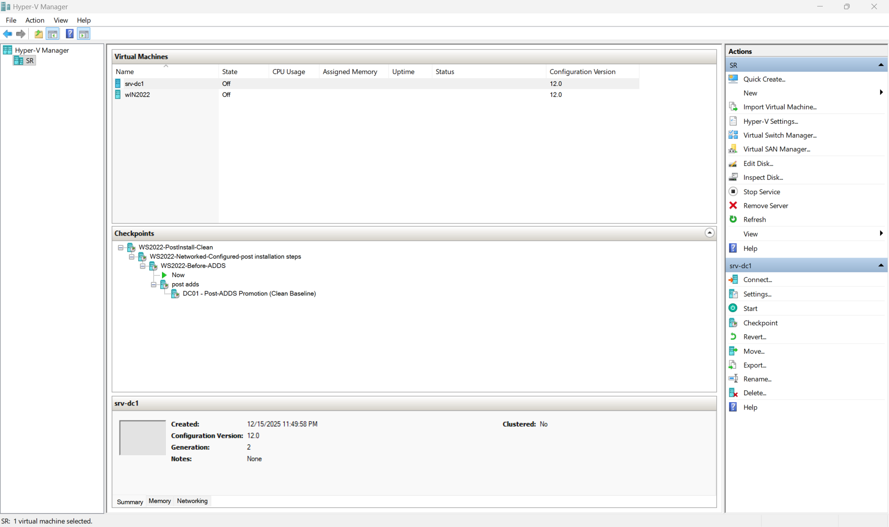
- Screenshot 2: Virtual Switch Manager showing private virtual switch configuration
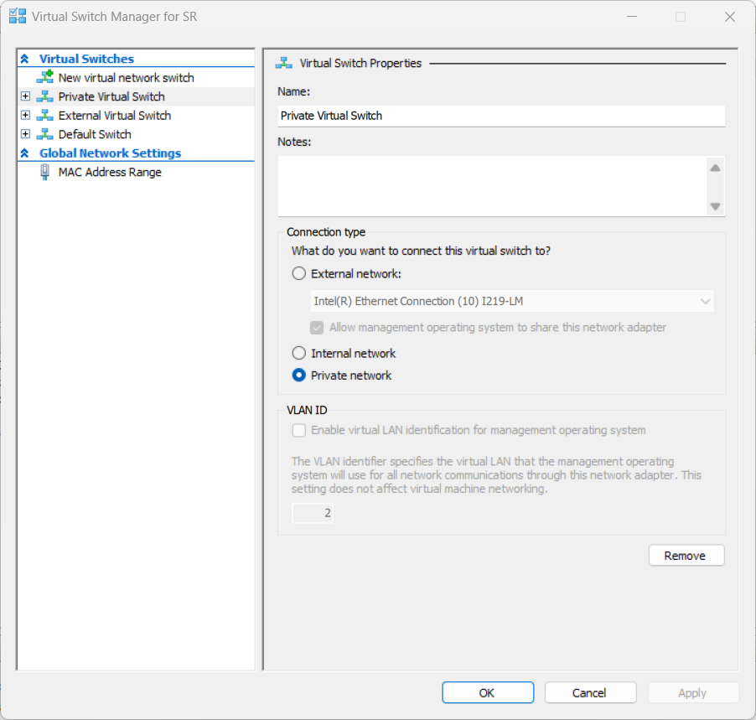

- Screenshot 3 (Optional): VM settings showing CPU, RAM, and Generation
- 