**OUTPUTS**

**JUnit_Testing_Exercise_1**

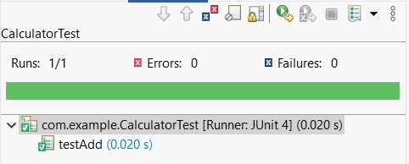

**JUnit_Testing_Exercise_3**

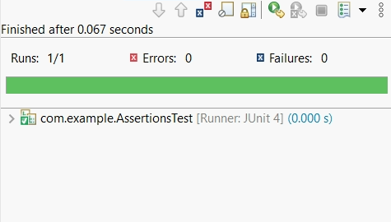

**JUnit_Testing_Exercise_4**

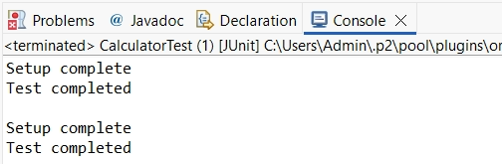

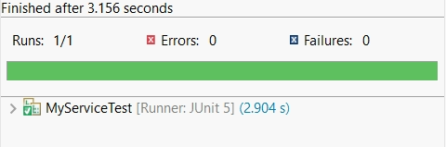

**Mockito_Exercise_1**

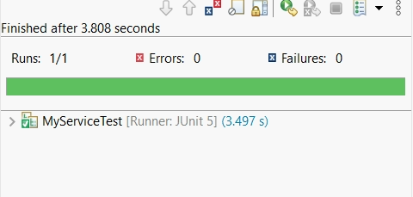

**Mockito_Exercise_2**



**SL4J_Logging_Exercise_1**

