Projects:

Phase1  
1.Jarvis (Jktech another rather very Intelligent system)

2. Sales prediction (in jarvis platform)

3. White Space Detection for Market Research Data

============

Phase2  
1.JKassist  
2.JKdiifbot  
3.EKE( Enterprise Knowledge EXplorer)  
4..Gen AI platform (7 bucket)  
5.Textto sql (Datajive)  
6..GraphEKE(Jiva)  
7.recomendation system (Decore genai)  
  
  
1.Jarvis

* Played a central role in the development of the Jarvis project, an MLOps platform similar to ClearML, with the goal of streamlining the end-to-end machine learning lifecycle.
* Proactively explored ClearML documentation to facilitate the replication of essential functionalities within the Jarvis platform, ensuring alignment with industry best practices
* Spearheaded the enhancement of the entire MLOps ecosystem, covering data creation, data versioning, model artifact management, pipeline orchestration, deployment, inference, monitoring, and more.
* Led efforts in experiment management and tracking, contributing to robust insights into model performance and iteration.
* Facilitated effective data management and versioning procedures, optimizing data availability for model training.
* Implemented refined model management and monitoring techniques, ensuring models operate effectively in real-world scenarios.
* Orchestrated pipeline processes, contributing to the seamless flow of data and models from development to deployment.
* Directed hyperparameter tuning and optimization strategies, enhancing model accuracy and efficiency.
* Conducted model comparison exercises, enabling the selection of the best-suited model for specific tasks.
* Ensured efficient model serving and inference capabilities, enabling rapid and accurate predictions.
* Monitored model behavior post-deployment, promptly addressing any anomalies for sustained performance.
* Integrated continuous integration/continuous deployment (CI/CD) practices, facilitating efficient code deployment and updates.

2.Sales prediction (in jarvis platform)

* Played a key role in the Sales Prediction Project, developing forecasting assets tailored for seamless integration with the Jarvis platform.
* Utilized SARIMAX modeling to create accurate sales prediction models, contributing to robust insights.
* done end-to-end asset development, from data preprocessing and model training to validation.
* Created an interactive front-end interface using Streamlit to demonstrate project outcomes effectively.

3.White Space Detection for Market Research Data

* Functioned as a prompt engineering specialist, utilizing the OpenAI API to generate meaningful cluster names by analyzing variance values of features within each cluster. The resulting contextually relevant and descriptive names accurately encapsulated the characteristics of the data within the respective groups.
* Developed a systematic approach to analyze data clusters and extract meaningful insights from feature variances.

1.JKAssist - Generative AI Application

* Description:
* Developed a generative AI application called jkassist, designed to assist users in extracting insights and information from diverse data sources. The application seamlessly integrates with various data formats including PDF, TXT, Slack, Web, and Gmail etc using Langchain.
* Key Accomplishments:
* Engineered a robust data ingestion and integration pipeline, enabling jkassist to aggregate data from disparate sources and formats.
* Transformed collected data into a text format, optimizing it for further analysis and processing.
* Utilized Doctran and Discus libraries to generate question-answer pairs, enhancing contextual learning.
* Implemented a user-friendly interface allowing users to upload data directly or use existing integrated sources.
* Developed a sophisticated generative AI application capable of answering user's questions based on the provided data.
* Technologies Used:
* Framework: langchain
* Database: vectordb:chromadb
* Library: doctran, disscus,openai etc
* Front End: streamlit Openai

2.JKDocDiff-Generative AI Application

* Designed and developed JKDocDiff, an advanced AI-powered document difference analyzer, crafted to facilitate effortless comparison between two uploaded files. By harnessing the capabilities of the OpenAI API, this tool offers users a comprehensive understanding of textual variations, enhancing data interpretation and decision-making processes.
* Orchestrated a seamless user experience, allowing users to easily upload documents for analysis within the JKDocDiffAI interface.
* Seamlessly integrated the OpenAI API, employing sophisticated natural language processing techniques for precise and insightful document comparison.

3.EKE-Enterprise Knowledge Explorer(In collaboration with google)  
  
**Objective** : Objective: To address the challenge of users being unaware of the potential actions they can take with their data, we developed the application to enable efficient exploration and utilization of data through features such as multi-PDF upload, file summary display, and structured segregation based on domains, personas, tasks, and subtasks.

**Steps**

1. **Upload Multiple PDFs**: Users can upload multiple PDF files simultaneously.
2. **File Summary Display**: Upon uploading, a summary of all the uploaded files is displayed in a single tab in the frontend.
3. **Domain,Persona, Tasks, Subtasks Segregation** : The system segregates the uploaded files based on domains such as healthcare, retail, insurance, HR, etc., along with the number of files in each domain. For example, if a user uploads 10 files (2 insurance, 2 retail, 3 HR, 3 healthcare), Persona, Tasks, Subtasks the system displays this, segregation.
4. **Domain Specific View**: When a user clicks on a specific domain (e.g., healthcare), the system displays specific personas, tasks, and subtasks associated with that domain.
5. **Task Navigation**: Users can click on a task to display its associated subtasks.
6. **Chat Functionality**: Users can engage in real-time chat discussions related to specific files, tasks, or subtasks. This allows for collaboration and discussion directly within the platform.

* For example, if a user uploads 10 files (2 insurance, 2 retail, 3 HR, 3 healthcare), the system displays this segregation along with related information:
  + Domain: [Insurance]
    - Persona: [Financial Advisor, Data Analyst, etc.]
    - Task: [Analyze the data]
    - Subtask: [Questions related to task]

Tools and technologies

* Frame work: langchain  
  db : chroma(vector db)  
  method : in context learning (RAG) and prompmt techniques  
  llm : openai

4.Text2sql

* Developed a Text-to-SQL application with the objective of providing answers along with SQL queries based on user-entered text.
* Implemented functionalities to connect to MySQL or Google BigQuery databases.(using sqlalchemy)
* Provided a frontend interface displaying database metadata/summary for user reference.(using open ai)
* Enabled users to ask questions in natural language against the database, specifying query optimization parameters such as the number of times the query needs to be executed.
* Displayed query answers along with SQL queries on the frontend interface.(using nlqltable query engine from llamaindex)
* Offered follow-up questions based on the initial query and generated plots for query results.(tried pandas ai but did not use some thing else used)

Tools and technologies  
framework : llamaindex -(explored other from langchain)

Data base: mysql and bigquery

LLm : open ai

Tool :NLSQLTableQueryengine  
  
Note: we can do using Rag also bu utilizing this tool

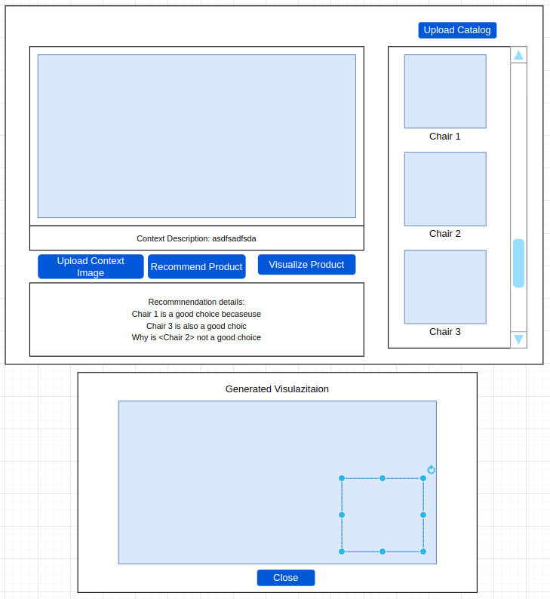

5.DecoreGenAI :   
  
Objective : Your main objective is to learn how to create a recommendation system that can provide both recommendations and explanations using a multimodal model: Gemini Pro Vision.(  
Generating recommendations based on provided images.)

Steps:

1.Users upload a room image, utilizing Gemini to describe the image.

2.Users upload four chair images, and the application provides recommendations on which chair suits the room, along with descriptions, and identifies which chairs do not suit the room.  
3.once the we will select the chair background get removed,and we will place thisin room image using front end technologies)

3.use can as any question on room (base image)  
  
Tools and technologies  
multimodel : Gemini Pro Vision

Python sdk :vertexai  
different promt techniques  
libarry : rembg(to remove background)  
  
link : <https://github.com/GoogleCloudPlatform/generative-ai/blob/main/gemini/use-cases/retail/multimodal_retail_recommendations.ipynb>

6.Jiva(Graph EKE)