Department of Computing
CS-344/ CS-313: Web Engineering
Class: BESE-14 A

Lab 01: Introduction to WSIWIG and Environment Setup

Date: 11.09.25
Name | Fatima Batool
Class | BESE 14 A
Qalam | 463405

Instructor: Engr. Naema Asif

Lab 01: Introduction to WSIWIG and Environment Setup

Introduction:

Students will get introduced to the concept of WYSIWYG in web development and will practically learn how to set up their development environment by installing VS Code, Git, and Node.js. They will also create and deploy a simple HTML page as their first hands-on activity.

Lab Objectives:

Understand WYSIWYG in web development.

Install and configure VS Code, Git, Node.js.

Create a simple Hello World HTML page.

Deploy the page locally and on GitHub Pages.

Helping Material:
- WYSIWYG in Web Development
  - https://www.techopedia.com/definition/5302/what-you-see-is-what-you-get-wysiwyg
- VS Code
  - https://code.visualstudio.com/
  - https://code.visualstudio.com/docs/introvideos/basics
- Git
  - https://git-scm.com/
  - https://guides.github.com/introduction/git-handbook/
- Node.js
  - https://nodejs.org/
  - https://nodejs.org/en/learn
- Live Server Extension for VS Code
  - https://marketplace.visualstudio.com/items?itemName=ritwickdey.LiveServer
- GitHub Pages Deployment
  - https://pages.github.com/

Part A – WYSIWYG Introduction
- WYSIWYG = "What You See Is What You Get."
- Allows developers to see results instantly while writing/editing code.
- Examples: WordPress, Wix, VS Code with Live Server.
- Advantages: Faster testing, easy debugging, visual feedback.

Part B – Installing Tools
- VS Code
  - Download: https://code.visualstudio.com
  - Install and open.
- Git
  - Download: https://git-scm.com
  - Install with default settings.
  - Verify:
git --version
- Node.js
  - Download: https://nodejs.org (LTS version).
  - Verify:
node -v
npm -v

Part C – Create "Hello World" Page
- Open VS Code.
- Create a folder named lab1-hello-world.
- Inside, create a file index.html.
- Add this code:
<!DOCTYPE html>
<html lang="en">
<head>
<meta charset="UTF-8">
<meta name="viewport" content="width=device-width, initial-scale=1.0">
<title>Hello World</title>
</head>
<body>
<h1>Hello World!</h1>
<p>Welcome to Web Engineering Lab 1</p>
</body>
</html>
- Install Live Server extension in VS Code.
- Right-click index.html → Open with Live Server.
- Page opens in browser showing "Hello World!".

Part D – Deploy with GitHub Pages
- Initialize Git:
git init
git add .
git commit -m "Hello World page"
- Create a new GitHub repository lab1-hello-world.
- Connect and push code:
git remote add origin https://github.com/your-username/lab1-hello-world.git
git branch -M main
git push -u origin main
- On GitHub → Settings → Pages.
  - Branch: main, Folder: /root.
- Access your live page at:
https://your-username.github.io/lab1-hello-world/

Answer:
Solution
Screenshot of task

Part A – WYSIWYG Introduction

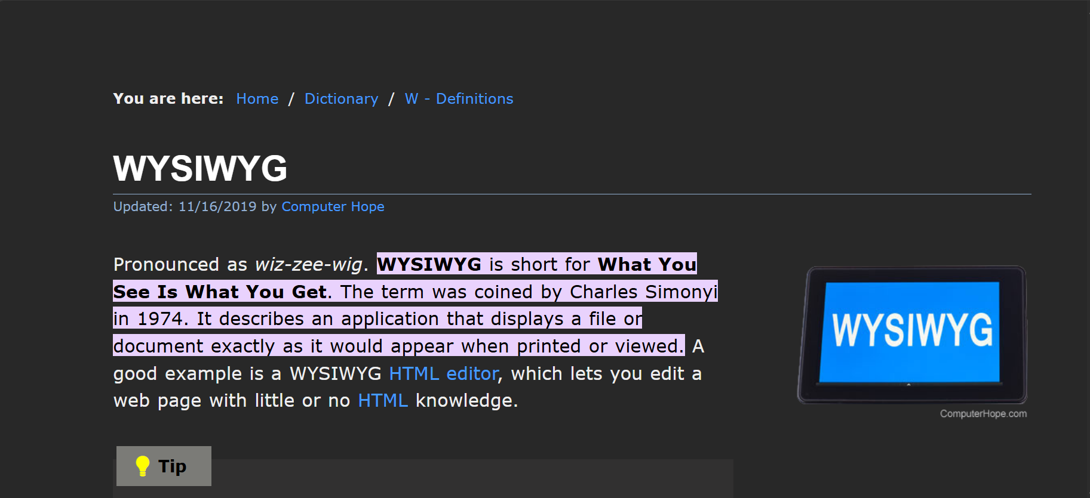

Part B – Installing Tools

VS Code:
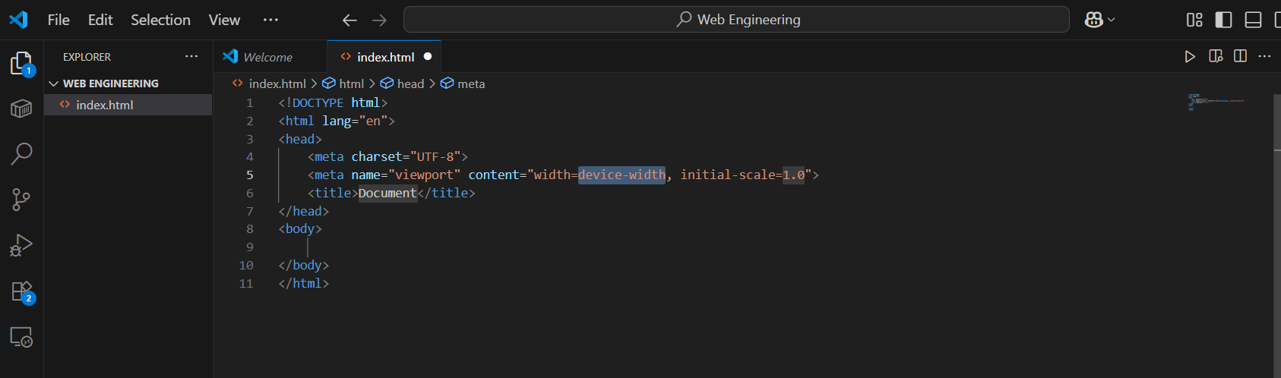
Node.js:
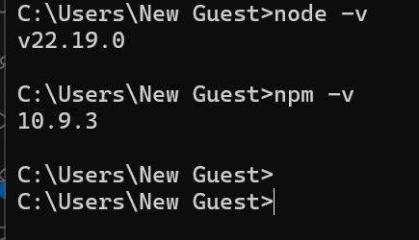
Git:
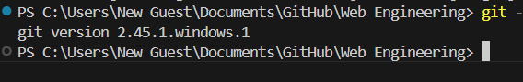

Part C – Create "Hello World" Page

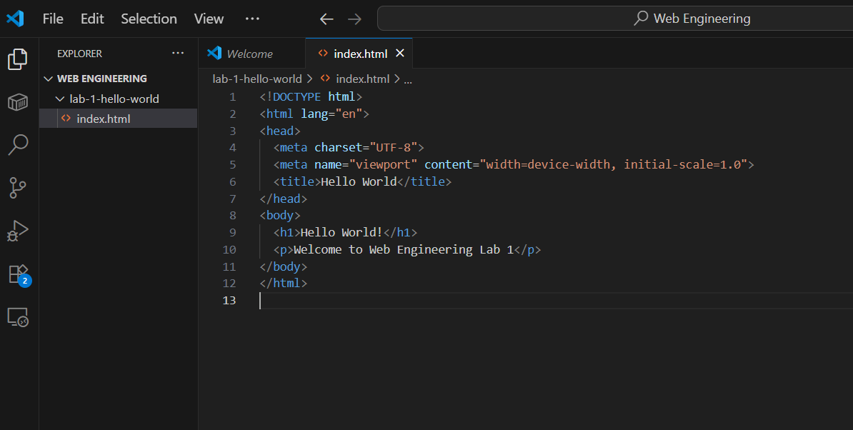

Live Server Download:
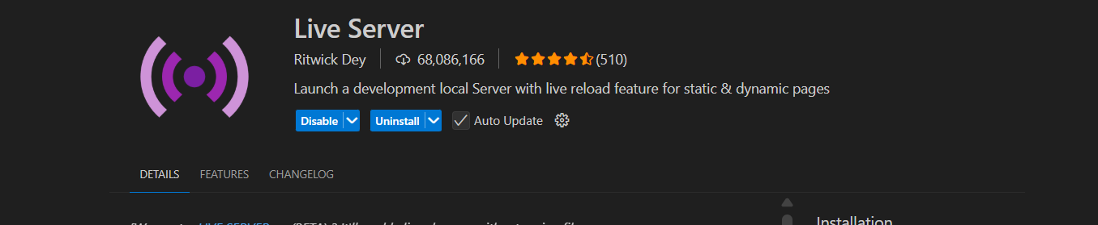
Previewing in live server:
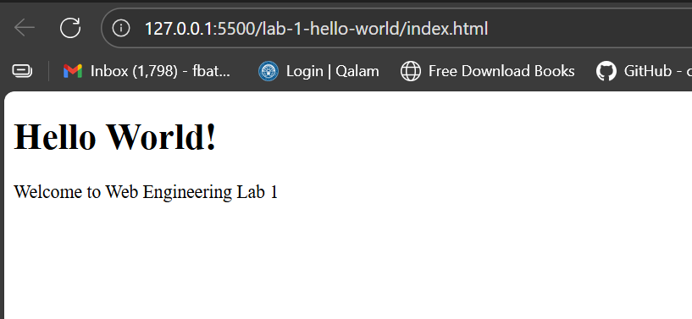

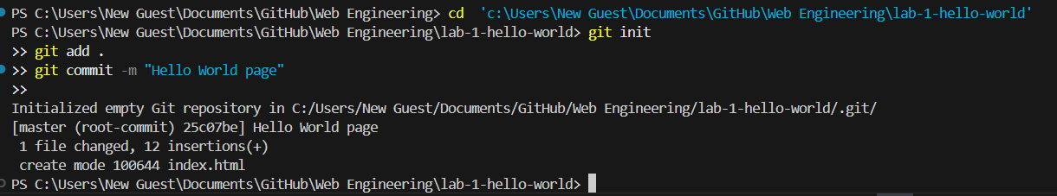

Part D – Deploy with GitHub Pages

https://github.com/fatofato24/lab-1-hello-world.git
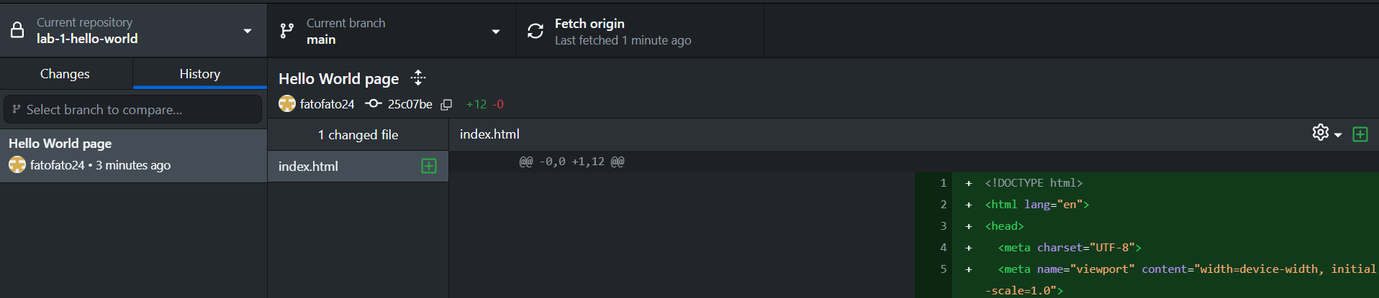
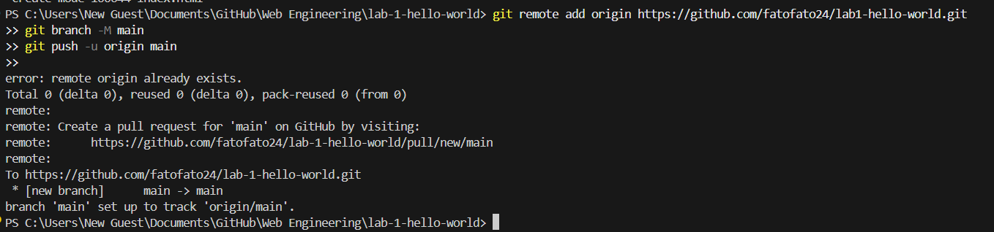

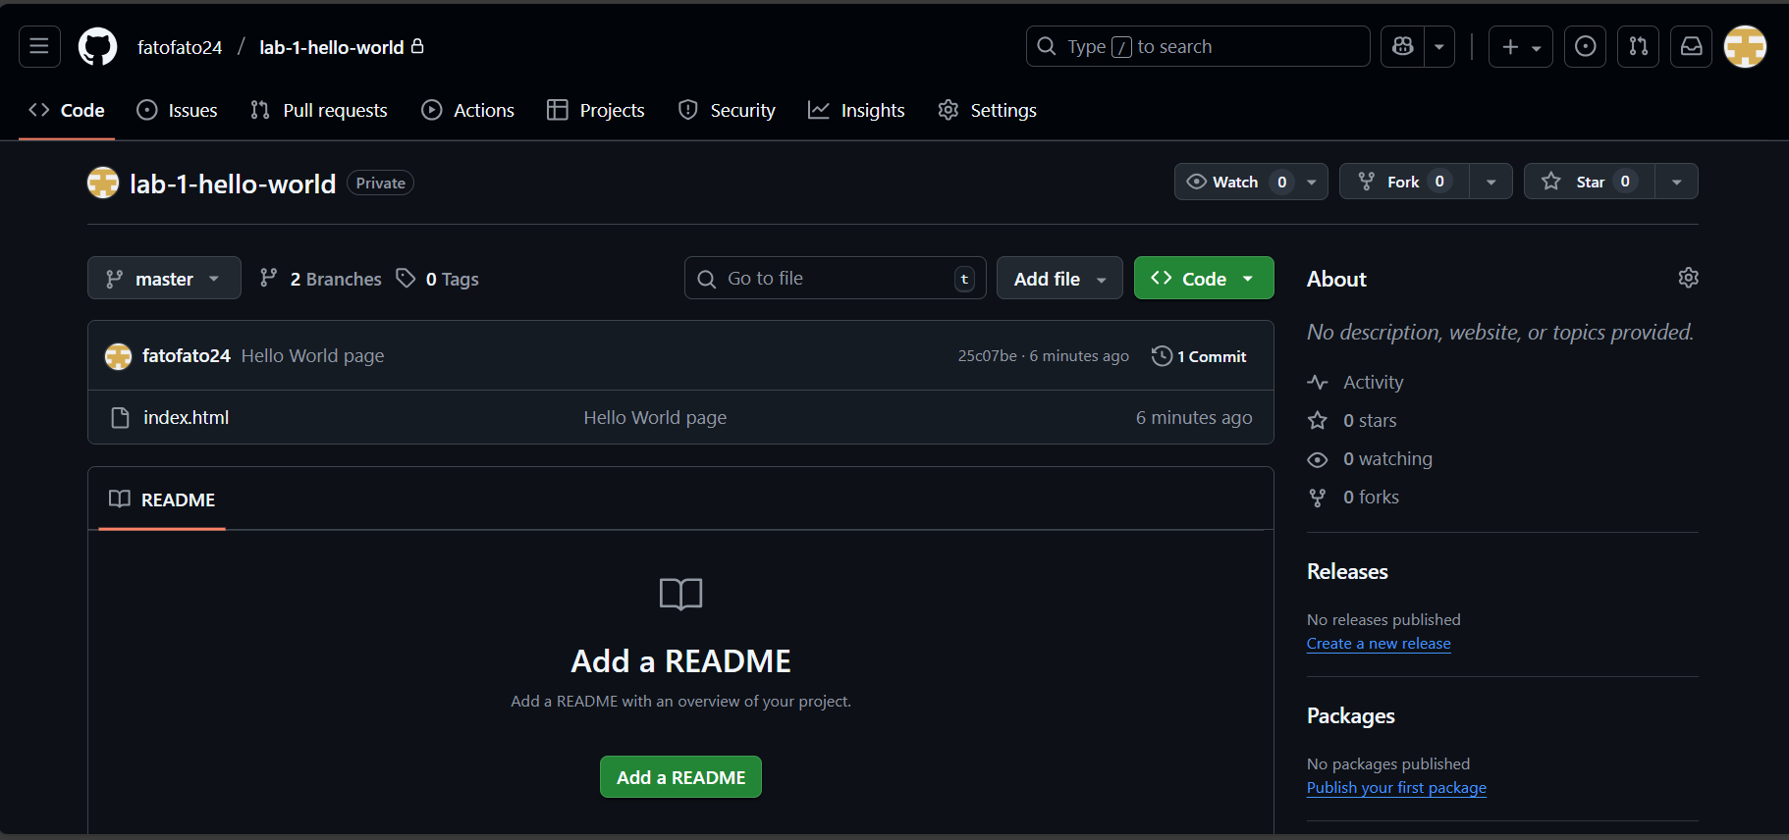
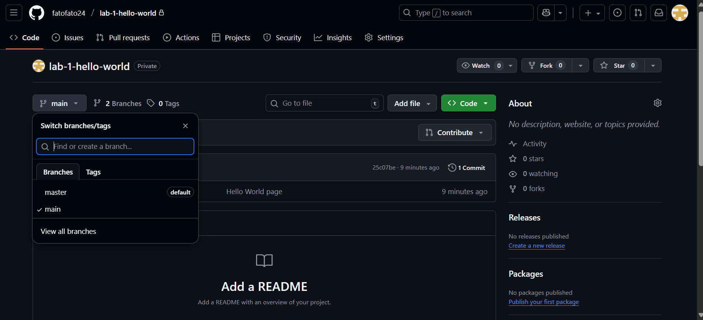

Deliverables
Students must submit the following by the end of the lab session:
- GitHub Repository Link – containing the index.html file.
- Live GitHub Pages URL – showing the deployed "Hello World" page.
- A short screenshot of the page running in the browser (optional if deployment link works).
Compile a single word document by filling in the solution part and submit this Word file on LMS. You must include your name, ID, and class on first page. For some of the labs, students have to present their solutions in a viva session. In case of any problems with submissions on LMS, you should contact your lab engineer Ms. Ayesha Asif by email at ayesha.asif@seecs.edu.pk

