AI-Driven Intelligent Test Automation Framework
for Software Quality Assurance
Professional Project Report
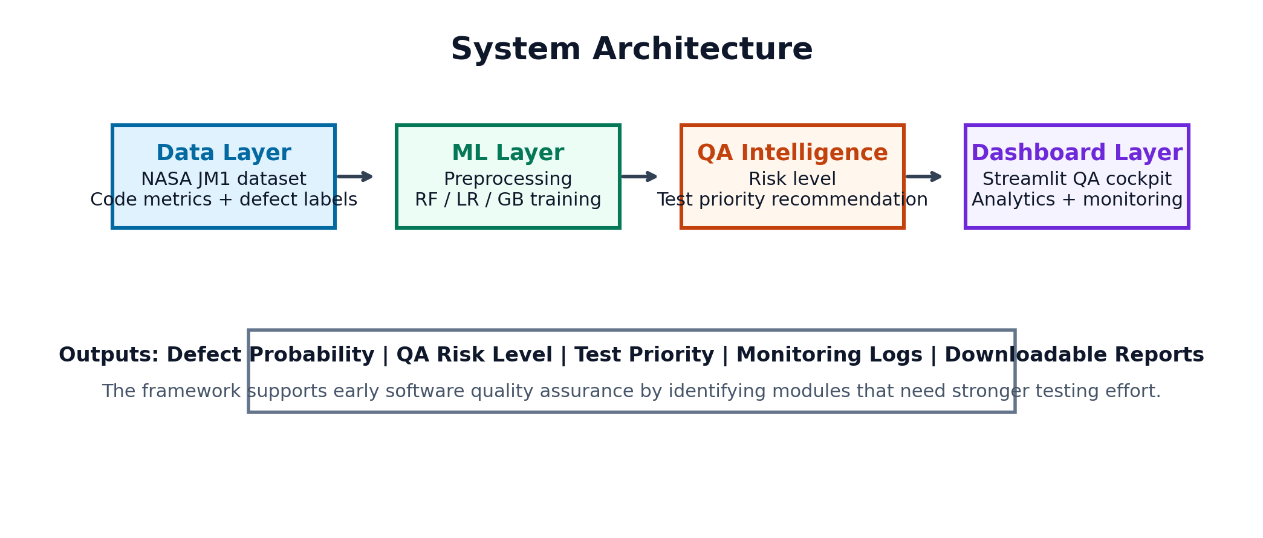
Item | Description
Project Type | Educational AI / Machine Learning Software Quality Assurance Project
Dataset | NASA JM1 Software Defect Dataset
Total Records | 10,885
Input Features | 21 static software metrics
Target Variable | defects (True = defective module, False = non-defective module)
Best Model | Random Forest
Primary Objective | Predict defect-prone software modules and guide intelligent test prioritization

1. Introduction
Software Quality Assurance (SQA) is a critical activity in modern software engineering because defects discovered late in the development lifecycle can increase cost, delay release schedules, and reduce customer trust. Traditional testing often depends on manual effort, static test plans, and equal test allocation across modules. However, not all software modules carry the same level of defect risk. Some modules are larger, more complex, or more difficult to maintain, and therefore require deeper testing attention.
This project develops an AI-driven intelligent test automation framework that predicts whether a software module is likely to be defective by learning from static code metrics. The system converts software measurements into defect risk, quality score, and test prioritization guidance. This helps QA teams focus their testing effort on the most risky modules instead of testing every component with the same priority.

2. Why We Do This Project
Purpose | How It Helps
Reduce manual QA effort | The system helps QA engineers identify high-risk modules before complete manual review.
Improve test prioritization | Modules predicted as defective can be tested first, reducing the chance of critical bugs reaching production.
Support early defect prediction | The model uses code metrics, so risk can be estimated before late-stage system testing.
Improve software reliability | Focusing on defect-prone modules supports better release quality and fewer production failures.
Create an educational AI testing pipeline | The project demonstrates a practical AI application in software engineering and quality assurance.

3. Dataset Description
The project uses the NASA JM1 Software Defect Dataset. JM1 is a well-known software defect prediction dataset containing static code metrics collected from software modules. Each row represents one software module and the target label indicates whether the module is defective or non-defective. The dataset is suitable for an educational AI testing framework because it is structured, compact, and directly related to software quality prediction.
The uploaded dataset contains 10,885 records and 21 input features. The target variable is defects. In this dataset, approximately 19.35% of modules are labelled defective. This class imbalance reflects a realistic software quality situation, where non-defective modules are usually more common than defective modules.
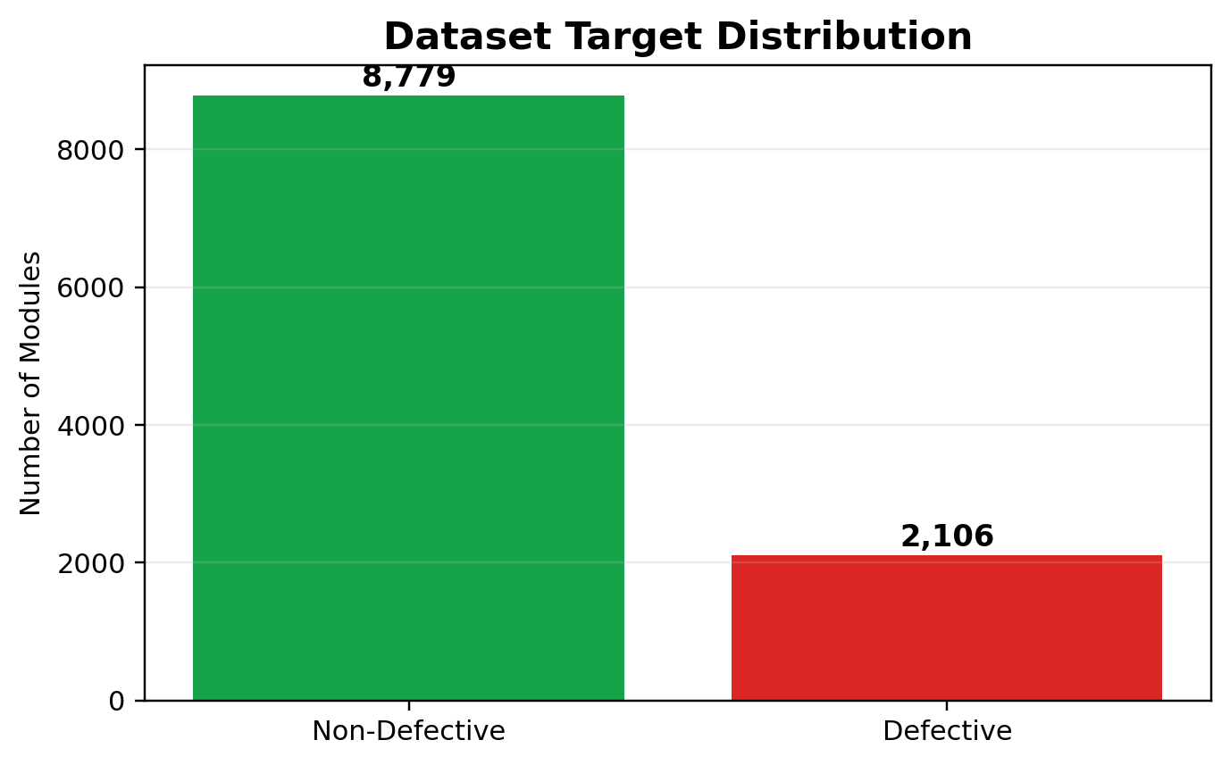
Dataset Attribute | Value
Dataset Name | NASA JM1 Software Defect Dataset
Records | 10,885
Features | 21 software code metrics
Target | defects
Defective Modules | 2,106
Non-Defective Modules | 8,779
Problem Type | Binary classification
Project Use | Defect prediction and intelligent test prioritization

4. Dataset Features and Meaning
The following table explains every feature used in the dataset. These metrics describe source code size, complexity, Halstead properties, operators, operands, and branching behavior. Such metrics are useful because they represent measurable software characteristics that can influence defect probability.
Feature | Detailed Description
loc | Total lines of code in a software module. Larger modules usually require more testing because they contain more logic and possible execution paths.
v(g) | McCabe cyclomatic complexity. It estimates the number of independent decision paths in code and is a strong indicator for testing difficulty.
ev(g) | Essential complexity. It measures unstructured logic complexity and helps identify modules that may be difficult to maintain or test.
iv(g) | Design complexity. It reflects the complexity of module interaction with design-level control flow.
n | Halstead length. It represents the total number of operators and operands and indicates code implementation size.
v | Halstead volume. It estimates program information volume and helps represent mental effort needed to understand code.
l | Halstead program level. It describes program simplicity; lower values can indicate more complex implementation.
d | Halstead difficulty. It estimates how difficult code is to understand and maintain.
i | Halstead intelligence. It reflects the amount of information expressed by the implementation.
e | Halstead effort. It estimates development and comprehension effort; high effort may increase defect risk.
b | Estimated number of delivered bugs based on Halstead measures. It is directly useful for defect-proneness analysis.
t | Estimated programming time. It approximates time required to implement or understand the module.
lOCode | Lines of executable code. It excludes comments and blank lines and shows actual operational code size.
lOComment | Number of comment lines. Comments can improve maintainability when accurate and meaningful.
lOBlank | Number of blank lines. It helps describe formatting and layout of code files.
locCodeAndComment | Lines containing both code and comments. It indicates inline documentation density.
uniq_Op | Unique operators used in the module. More unique operators can indicate more diverse operations and complexity.
uniq_Opnd | Unique operands used in the module. It reflects the variety of variables, constants, and data items.
total_Op | Total operators. It measures total operation usage in the module.
total_Opnd | Total operands. It measures total data element usage in the module.
branchCount | Number of branches or decision points. More branches usually require more test cases for adequate coverage.
defects | Target variable. True means the module contains defects; False means the module is non-defective.

5. Feature Categories
The model uses several groups of software engineering metrics. Grouping features makes the project easier to understand and shows how different software properties contribute to defect prediction.
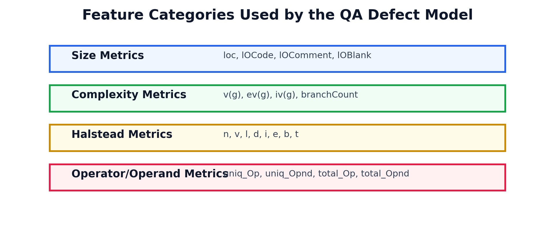
Category | Explanation
Size Metrics | Measure how large a module is, including total lines, executable lines, comments, and blank lines.
Complexity Metrics | Measure decision paths, branch behavior, and structured or unstructured complexity.
Halstead Metrics | Quantify operators, operands, volume, difficulty, effort, and estimated bugs.
Operator and Operand Metrics | Describe how many unique and total operations/data elements are used.
Target Label | Indicates whether each module is defective or non-defective.

6. Project Objective
The objective of this project is to create a complete AI-based test automation and quality assurance framework that predicts defective modules from code metrics and converts prediction results into practical QA decisions. The framework supports automated model training, model evaluation, live defect prediction, quality analytics, test prioritization, prediction logging, and dashboard monitoring.
Objective | Description
Data preprocessing | Clean the dataset, convert numeric columns, handle invalid values, and prepare input features.
Model training | Train multiple classification models on static software metrics.
Model evaluation | Compare models using Accuracy, Precision, Recall, F1 Score, and ROC-AUC.
Defect prediction | Predict whether a software module is defective or non-defective.
QA priority assignment | Convert model output into Low, Medium, or High testing priority.
Dashboard monitoring | Display dataset analytics, model performance, prediction logs, and testing recommendations.

7. Methodology and Workflow
The project follows a sequential machine learning and QA automation workflow. Each step has a specific role in transforming raw software metrics into test automation intelligence.
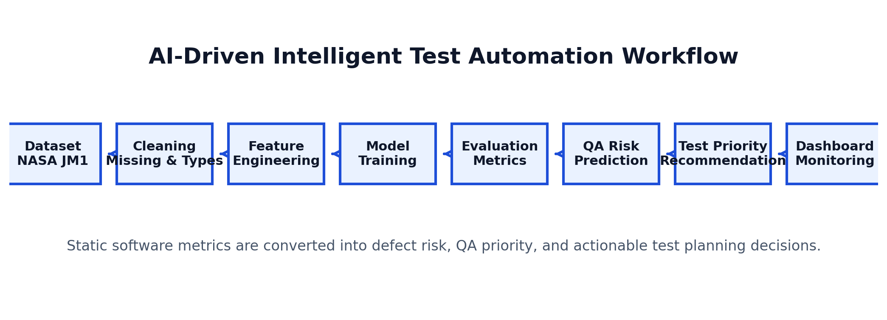
Sequence | Detailed Description
Step 1: Dataset Loading | The JM1 dataset is loaded from the raw data folder. Each row represents a software module and each column represents a static code metric or target label.
Step 2: Data Cleaning | Non-numeric values are converted where needed, invalid entries are handled, missing values are treated, and the target variable is prepared for binary classification.
Step 3: Feature Preparation | The 21 software metrics are separated from the target label. The model learns patterns between these metrics and defect occurrence.
Step 4: Train-Test Split | The dataset is divided into training and testing sets so the model can be evaluated on unseen examples.
Step 5: Model Training | Logistic Regression, Random Forest, and Gradient Boosting models are trained and compared.
Step 6: Model Evaluation | Accuracy, Precision, Recall, F1 Score, and ROC-AUC are calculated for each model.
Step 7: Best Model Selection | The best model is selected based on performance and saved as a reusable model artifact.
Step 8: Defect Prediction | The dashboard accepts module metrics and predicts defect risk in real time.
Step 9: Test Prioritization | The prediction probability is converted into QA priority such as Low, Medium, or High testing priority.
Step 10: Monitoring and Reporting | Prediction logs are stored and displayed in the dashboard for traceability and report generation.

8. Machine Learning Models Used
Model | Role in Project
Logistic Regression | A baseline classification model that learns a linear relationship between software metrics and defect probability.
Random Forest | An ensemble model that combines many decision trees. It is strong for structured data and handles nonlinear relationships well.
Gradient Boosting | An ensemble boosting method that sequentially improves weak learners and can produce strong classification performance.

9. Evaluation Metrics
Metric | Meaning
Accuracy | Measures total correct predictions out of all predictions. It is useful for overall performance but can be misleading on imbalanced datasets.
Precision | Measures how many modules predicted as defective were actually defective. High precision reduces false alarms.
Recall | Measures how many actual defective modules were correctly found. High recall is important when missing defects is costly.
F1 Score | Balances precision and recall. It is helpful when both false positives and false negatives matter.
ROC-AUC | Measures the model ability to separate defective and non-defective modules across thresholds.
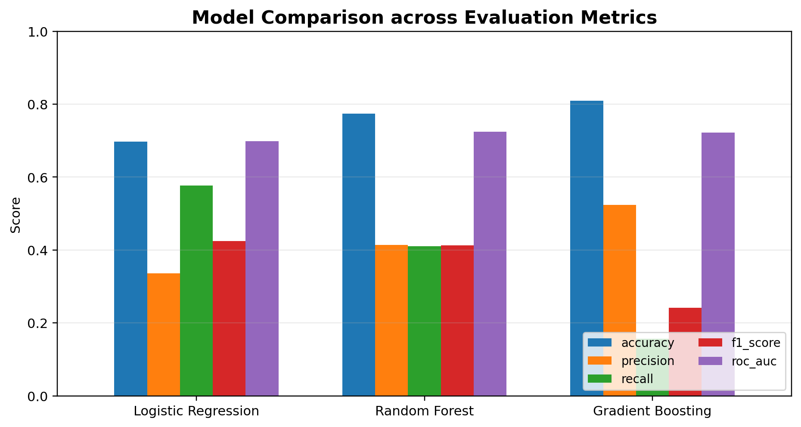

10. Model Results
Model | Accuracy | Precision | Recall | F1 Score | ROC-AUC
Logistic Regression | 0.6977 | 0.3361 | 0.5772 | 0.4248 | 0.6980
Random Forest | 0.7735 | 0.4139 | 0.4109 | 0.4124 | 0.7249
Gradient Boosting | 0.8094 | 0.5238 | 0.1568 | 0.2413 | 0.7216
The selected production model is Random Forest. It achieved an accuracy of 0.7735, precision of 0.4139, recall of 0.4109, F1 score of 0.4124, and ROC-AUC of 0.7249. These results show that the framework can identify defect-prone modules and support QA decision-making.

11. System Architecture
The system architecture is organized into four major layers: data layer, machine learning layer, QA intelligence layer, and dashboard layer. This structure keeps the project modular and easy to understand.

Layer | Description
Data Layer | Stores the NASA JM1 dataset and prepares raw software metrics.
Machine Learning Layer | Trains and evaluates multiple classification models.
QA Intelligence Layer | Converts prediction output into quality score, defect risk, and test priority.
Dashboard Layer | Presents results through a professional Streamlit interface.
Monitoring Layer | Logs predictions and displays test automation activity over time.

12. Dashboard and Functional Modules
Dashboard Section | Function
QA Overview | Displays dataset size, defect rate, model status, quality score, and general QA summary.
Defect Predictor | Allows the user to enter module metrics and receive a defect prediction with confidence score.
Quality Analytics | Shows defect distribution, model metrics, and software quality insights.
Test Prioritization | Classifies modules into testing priority levels to guide QA execution.
Monitoring | Tracks prediction logs and provides downloadable reports.
Project Guide | Explains workflow, dataset, technologies, and project purpose.

13. Technologies Used
Technology | Use in Project
Python | Main programming language used to build the project.
Pandas | Used for reading, cleaning, and analyzing the JM1 dataset.
NumPy | Used for numerical operations and array handling.
Scikit-Learn | Used for preprocessing, model training, evaluation, and prediction.
Random Forest | Used as the selected production model for defect prediction.
Gradient Boosting | Used as a comparative ensemble model.
Logistic Regression | Used as a baseline model for comparison.
Streamlit | Used to build the interactive dashboard interface.
Plotly | Used for professional charts and analytics visualizations.
Joblib | Used to save and load trained model artifacts.
CSV Logs | Used for storing prediction history and monitoring records.

14. How This Project Helps Software Quality Assurance
This project helps QA teams shift from reactive testing to proactive quality engineering. Instead of waiting for defects to appear during manual testing or after deployment, the model predicts risk based on measurable code characteristics. QA managers can use this information to allocate testers, design stronger test cases, and prioritize risky modules before release.
Stakeholder | Benefit
For QA Engineers | Highlights modules that need deeper test coverage.
For Developers | Identifies complex or risky modules that may need refactoring.
For Project Managers | Supports data-driven release planning and quality risk control.
For Organizations | Reduces defect leakage, improves product reliability, and saves testing cost.
For Students | Demonstrates a practical AI application in software engineering.

15. Conclusion
The AI-Driven Intelligent Test Automation Framework for Software Quality Assurance demonstrates how machine learning can improve defect prediction and testing decisions. Using the NASA JM1 Software Defect Dataset, the system learns from static code metrics and predicts whether a module is likely to contain defects. The project includes data preprocessing, model training, model comparison, prediction, QA prioritization, monitoring, and report generation. It provides a clear educational example of how AI can support modern software quality assurance and intelligent test automation.

