

CARDIVA: AN IOT WEARABLE FOR HEART HEALTH RISK ANALYSIS
by
Khansa Batool
Hafiza Sana
Ayesha Nadeem

Supervisor
Dr. Altaf Hussain

Department of Computer Science
Institute of Space Technology, KICSIT Kahuta Campus



CARDIVA: AN IOT WEARABLE FOR HEART HEALTH RISK ANALYSIS
by

Khansa Batool
Hafiza Sana
Ayesha Nadeem
Supervisor
Dr. Altaf Hussain
APPROVAL BY BOARD OF EXAMINERS
__________________

Dr Altaf Hussain
Supervisor
Committee Members
______________  Assistant Professor CS | ________________  Assistant Professor CS
_______________  Assistant Professor CS | ______________  Lecturer
______________________
Dr. Sehrish Khan Tayyaba
Project Coordinator
___________________ Dr. Altaf Hussain
HoD. Computer Science
AUTHORS DECLARATION

I take full responsibility for the research work conducted during the thesis titled “AI-Based Wearable Health Monitoring and Emergency Alert System.”
I solemnly declare that the research and development work presented in this thesis has been carried out solely by me with no significant help from any other person; however, any minor assistance received during the course of this work has been duly acknowledged. I further declare that I have written this thesis independently. Moreover, I confirm that this thesis, or any part of it, has not been submitted previously to any other degree-awarding institution within Pakistan or abroad.
I understand that the management of the institute has a zero-tolerance policy towards plagiarism. Therefore, I, as the author of the above-mentioned thesis, solemnly declare that no portion of my thesis has been plagiarized and that any material used in this thesis does not contain any literal citation (verbatim) of more than 70 words (in total), even with proper referencing, unless written permission has been obtained from the publisher. Furthermore, the work presented in this thesis is my own original contribution, and all related work by other researchers has been properly cited with clear differentiation between their work and mine.
I further understand that if I am found guilty of any form of plagiarism in my thesis work, even after graduation, the institute reserves the right to revoke my BS degree. Moreover, the institute shall have the right to publish my name on its official website, which maintains a record of students found guilty of plagiarism in their thesis work.

______________________
Khansa Batool

______________________
Hafiza Sana

______________________
Ayesha Nadeem

I hereby acknowledge that submitted thesis is final version and should be scrutinized for plagiarism as per IST policy

_____________________

Dr Altaf Hussain

Dated: _________________

_____________________________

Verified by Plagiarism Cell Officer

Dated: _________________

CERTIFICATE
This is to certify that the research work described in this thesis titled “AI-Based Wearable Health Monitoring and Emergency Alert System” is the original work of the author and has been carried out under my direct supervision. I have personally reviewed all the data, results, and materials reported in this thesis and certify their correctness and authenticity. I further certify that the material included in this thesis is not plagiarized and has not been used, either in part or in full, in any manuscript that has been submitted or is under submission for the partial or complete fulfillment of the award of any other degree from any institution.
I also certify that this thesis has been prepared under my supervision in accordance with the prescribed format and academic requirements of the Institute, and I endorse its evaluation for the award of the Bachelor of Science degree through the official procedures of the Institute.

____________________
Dr. Altaf Hussain

Copyright © 2026
This document is jointly copyrighted by the authors and the Institute of Space Technology (IST). Both authors and IST can use, publish or reproduce this document in any form. Under the copyright law no part of this document can be reproduced by anyone, except copyright holders, without the permission of authors.

DEDICATION
This research work is dedicated to our beloved Parents and Teachers and Friends who supported and motivated us in tough times and made us into what we are today.

Abstract
Cardiovascular diseases are one of the foremost causes of mortality in the world due to their late diagnosis and failure to maintain a continuous check on their health care. Traditional clinical evaluations tend to be uncommon and reactive thereby constraining early identification of any heart critical events. To overcome it, this project suggests an artificial intelligence (AI) based wearable health monitoring and emergency system, named Cardiva, that is aimed at cardiac surveillance in real-time and continuous mode.
In the proposed system, a smart wearable band and a series of physiological sensors that can track vital signs such as heart rate, oxygen saturation (SpO 2), and body temperature are to be used. Gathered biometric data are sent wirelessly to a specific mobile application, where an internal AI unit processes any received data and categorizes the user healthcare status as one of four conditions: normal, stable, warning or emergency. The application produces comprehensive health reports that are displayed in the application and all the records are safely stored in a cloud-based relational database that can be searched using unique user identifiers that allows tracking and analysis of trends over a long period.
In critical health classification, the system will automatically show the real-time Global Positioning System (GPS) position of the user and send text messages to both the user and the assigned attendant showing the health status and location information, which will make the emergency response faster. The platform also includes an AI-based chatbot to understand health reports and provide relevant guidance, and a feedback loop that constantly increases system accuracy and adapts to a specific user profile as time goes on.
Cardiva is to be used by individual customers and such healthcare providers as hospitals, clinics, and corporate wellness programs promoting the move toward proactive and preventive cardiac care. The solutions provided by Cardiva will help to address the gap between episodic clinical care and continuous personal health management by reducing unwarranted visits to hospital, reinforcing patient follow-ups, and providing a technologically efficient and economical solution.
Keywords:
Adaptable Health, C4.ai, Artificial Intelligence, Autonomous Emergency Response, Bluetooth Low Energy, Body Temperature, Bradycardia, Heart Rate, Cardiac Arrhythmia, Cardiovascular Disease, Cloud, Continuous Health, Rule-Based Expert System, Thermistor, Thresholds, Trend, User identifier, Vital Sign, Wearable Biosensor, Wearable Architecture, Wearable Device

Table of Contents
List of Figures x
List of Tables xi
Chapter 1 Introduction 1
1.1 Background and Context of Digital Health Monitoring 1
1.2 Limitations of Conventional Health Monitoring Approaches 3
1.3 Problem Statement 4
1.4 Motivation for Continuous and Remote Health Monitoring 5
1.5 Objectives of the Proposed System 7
1.6 Scope and Constraints of the Project 8
1.7 Constraints of the Project 9
Chapter 2 Foundations of Wearable and Mobile Health Systems 10
2.1 Wearable Technology in Healthcare Today 10
2.2 Physiological Vital Sign and clinical significance 11
2.3 Monitoring of Heart rate and Health Consequences 12
2.4 Oxygen Saturation and Respiratory Health 13
2.5 Abnormality and Body Temperature Detection 14
2.6 Mobile Applications and the role in acquiring health data 15
2.7 Cloud-Based Health Data storage and Access 17
2.8 Location-Aware Systems within the Emergency of Healthcare 19
Chapter 3 Review of Related Work 22
3.1 Current Wearable Health Monitoring Solutions 22
3.2 Mobile-Centric Health Monitoring Applications 25
3.3 Artificial Intelligence and Decision-Support methods in Health Monitoring 28
3.4 Healthcare Emergency Detection and Alert 31
3.5 Analysis of Existing Systems 34
3.6 Research Gaps and limitations determined 39
Chapter 4 System Design 43
4.1 General System Architecture 43
4.2 Use Case Diagram and Actor Identification 45
4.3 Detailed Use Case Specifications 48
4.3.1 Use Case 1: Monitor Vital Signs 48
4.3.2 Use Case 2: Analyze Health Trends 50
4.3.3 Use Case 3: Generate Health Report 51
4.3.4 Use Case 4: Detect Emergency Condition 53
4.3.5 Use Case 5: Retrieve GPS Location 54
4.3.6 Use Case 6: Send Emergency Alert 55
4.3.7 Use Case 7: Synchronize Cloud Data 57
4.4 Software Architecture Design 58
4.5 Entity Relationship Diagram (ERD) and Database Design 63
4.6 Activity Diagram: Anomaly Detection and Alert Flow 67
4.7 Sequence Diagram: Cardiva 71
4.8 Class Diagram: Object-Oriented Design Structure 75
Chapter 5 Implementation 81
5.1 Software Components/Modules 81
5.1.1 Presentation Layer 81
5.1.2 State-Management Layer 82
5.1.3 Domain Engine 82
5.1.4 Services Layer 83
5.1.5 Data and Core Layers 83
5.1.6 Classification and Decision Pipeline 84
5.1.7 Key External Integrations 85
5.2 Hardware Components and Firmware 86
5.2.1 System Architecture and Bill of Materials 86
5.2.2 I2C Wiring 87
5.2.3 Firmware Setup and Libraries 87
5.2.4 Vitals Computation 88
5.2.5 OLED Display 90
5.3 Hardware-Software Integration 90
5.4 Tools and Technologies 91
Chapter 6 Testing 92
6.1 Introduction 92
6.2 Verification and Validation 92
6.3 Test Cases, Suites, Scripts, and Scenarios 93
6.4 A Sample Testing Cycle 93
6.5 Test Cases 95
6.5.1 Sample Test Case 96
6.5.2 Detailed Test Cases 97
Chapter 7 Conclusion 103
7.1 Summary of the Work 103
7.2 Achievement of Objectives 103
7.3 Limitations 104
7.4 Future Work 104
References 105

List of Figures

Figure 1: Cardiva: The proposed solution 7
Figure 2: Usecase of Cardiva 46
Figure 3: Sequence Diagram of Usecase 1 50
Figure 4: Sequence Diagram of Usecase 2 51
Figure 5: Sequence Diagram of Usecase 3 52
Figure 6: Sequence Diagram of Usecase 4 54
Figure 7: Sequence Diagram of Usecase 5 55
Figure 8: Sequence Diagram of Usecase 6 57
Figure 9: Sequence Diagram of Usecase 7 58
Figure 10: Detailed system Architecture Diagram of Cardiva 59
Figure 11: Detailed ERD of Cardiva 63
Figure 12: Activity Diagram of Cardiva 67
Figure 13: Detailed Sequence Diagram of Cardiva 71
Figure 14: Class Diagram of AI-Based Wearable Health Monitoring & Emergency Response System 75

List of Tables

Table 1: Vitals recorded by wearable band 12
Table 2: Comparison of Cardiva with existing devices 38
Table 3: Use Case 1 - Monitor Vital Signs 49
Table 4: Use Case 2 - Analyze Health Trends 51
Table 5: Use Case 3 - Generate Health Report 52
Table 6: Use Case 4 - Detect Emergency Condition 53
Table 7: Use Case 5 - Retrieve GPS Location 55
Table 8: Use Case 6 - Send Emergency Alert 56
Table 9: Use Case 7 - Synchronize Cloud Data 58
Table 5.1: Principal application dependencies and stack 83
Table 5.2: Vital classification thresholds 85
Table 5.3: Bill of materials 86
Table 5.4: ESP32 I2C pin map 87
Table 5.5: Activity classification bands (rolling SD of acceleration magnitude) 89
Table 5.6: BLE GATT contract (device-side, authoritative) 90
Table 6.1: Troubleshooting matrix 94
Table 6.2: Representative test cases 95
Table 6.3: Sample test case - end-to-end fall detection and alert 96
Table 6.4: Resting heart-rate band edge 97
Table 6.5: SpO2 emergency threshold 98
Table 6.6: Bluetooth parsing of a valid payload 98
Table 6.7: No-finger sample dropped 99
Table 6.8: Malformed JSON rejected 99
Table 6.9: Emergency confidence gate 100
Table 6.10: Fall detection end-to-end 100
Table 6.11: Emergency SMS dispatch 101
Table 6.12: Background monitoring 101
Table 6.13: Respiration rate proxy 102

LIST OF ABBREVIATIONS AND SYMBOLS
Abbreviation | Full Form
AI | Artificial Intelligence
API | Application Programming Interface
BLE | Bluetooth Low Energy
bpm | Beats Per Minute
COPD | Chronic Obstructive Pulmonary Disease
CVD | Cardiovascular Disease
ECG | Electrocardiography
EMU | English Metric Unit
ERD | Entity Relationship Diagram
GDPR | General Protection of Data
GPS | Global Positioning System
HIPAA | Health Insurance Portability and Accountability Act.
HRV | Heart Rate Variability
I2C | Inter-Integrated Circuit
IMU | Inertial Measurement Unit
IoT | Internet of Things
IST | Institute of Space Technology.
JSON | JavaScript Object Notation
mHealth | Mobile Health
ML | Machine Learning
MVC | Model-View-Controller
NFC | Near-Field Communication
OLED | Organic Light-Emitting Diode
PDF | Portable Document Format
PERS | Personal Emergency Response System
PPG | Photoplethysmography
RF | Radio Frequency
SDK | Software Development Kit
SDNN | Standard Deviation of Normal-to-Normal Intervals
SMS | Short Message Service
SpO₂ | Peripheral Oxygen Saturation (measured through Pulse Oximetry)
SVM | Support Vector Machine
TLS | Transport Layer Security
UI | User Interface
UID | Unique Identifier
URL | Uniform resource locator
UUID | Universally Unique Identifier
WHO | World Health Organization
Wi-Fi | Wireless Fidelity
XML | Extensible Markup Language

Introduction

Background and Context of Digital Health Monitoring
Advancements in digital technology have significantly transformed the healthcare sector, particularly in the way health data is collected, monitored, and analyzed. Traditional healthcare systems primarily rely on periodic clinical visits, manual measurements, and delayed diagnosis, which often limit timely intervention, especially in cases where a patient’s health condition changes rapidly. With the growing global population, increasing prevalence of chronic diseases, and rising healthcare costs, there is a strong need for intelligent, continuous, and remote health monitoring solutions that can support both patients and healthcare providers.
In recent years, digital health monitoring has emerged as a critical area of research and development. Digital health monitoring refers to the use of electronic devices, sensors, mobile applications, and computational intelligence to continuously observe physiological parameters and assess an individual’s health status. These systems aim to shift healthcare from a reactive model to a proactive and preventive one, where early signs of health deterioration can be detected before they escalate into critical conditions.
One of the key enablers of digital health monitoring is the evolution of wearable technology. Wearable devices, such as smart bands and fitness trackers, are capable of continuously measuring vital physiological parameters including heart rate, oxygen saturation, and body temperature. Unlike conventional medical equipment, wearable devices are non-invasive, portable, and suitable for long-term use, making them ideal for continuous monitoring in everyday environments. The ability to collect real-time health data without disrupting daily activities has made wearables an important component of modern healthcare systems.
Alongside wearable devices, the widespread availability of smartphones has further strengthened digital health ecosystems. Mobile applications act as an interface between the user and the health monitoring system, enabling real-time visualization of health data, report generation, and user interaction. Smartphones also provide computational capabilities, connectivity options, and built-in sensors such as GPS, which can be leveraged to enhance health monitoring systems. As a result, mobile-based health monitoring applications, commonly referred to as mHealth solutions, have gained significant attention in both research and real-world deployments.
Another major development in digital health monitoring is the integration of artificial intelligence (AI) and data-driven analysis techniques. Raw physiological data alone is often insufficient to provide meaningful insights into a user’s health condition. AI-based analysis modules enable automated interpretation of health data by identifying patterns, trends, and deviations from normal behavior. Such analysis supports the classification of health states, for example, determining whether a user’s condition is normal, stable, or showing signs of deterioration. By reducing reliance on constant human supervision, AI-based systems improve efficiency and responsiveness in health monitoring.
In addition to real-time analysis, cloud computing plays a vital role in modern health monitoring systems by enabling long-term storage and management of health records. Cloud-based storage allows health data to be securely stored against a unique user identifier, making it accessible over extended periods. This supports longitudinal health tracking, progress monitoring, and historical analysis, which are essential for understanding long-term health trends and making informed decisions. Cloud platforms also enhance system scalability and reliability, allowing data to be accessed from multiple locations when required.
A critical aspect of health monitoring systems is the ability to respond effectively during emergency situations. In many cases, sudden changes in vital signs may indicate serious health risks that require immediate attention. Location-aware technologies, such as GPS, enable the identification of a user’s current position during such events. When combined with automated alert mechanisms, health monitoring systems can notify both the user and registered attendants or caregivers through communication channels such as SMS. This rapid dissemination of health status and location information can significantly reduce response time and potentially save lives.
Considering these technological advancements, there is a growing demand for integrated health monitoring systems that combine wearable sensing, mobile applications, intelligent analysis, cloud-based data management, and emergency alert mechanisms into a single cohesive solution. Such systems aim to provide continuous health supervision, timely detection of deterioration, and efficient emergency response, while also allowing users to monitor their health progress under normal conditions.
This project is developed within this context, focusing on the design and development of an AI-based wearable health monitoring and emergency alert system. The proposed system leverages wearable sensors to continuously monitor vital signs, utilizes a mobile application for data handling and visualization, applies intelligent analysis to assess health conditions, and incorporates cloud storage and location-based alerting to support both long-term monitoring

Limitations of Conventional Health Monitoring Approaches
Traditional health monitoring approaches, including periodic clinical checkups, manual measurement devices, and hospital-based observation systems, have several critical limitations that hinder timely detection and management of health deterioration. These limitations are particularly significant for individuals who require continuous monitoring due to chronic conditions, age-related vulnerabilities, or sudden-onset health risks.
One of the primary limitations is the episodic nature of monitoring. Conventional systems typically capture health data only during scheduled visits or when a patient actively seeks medical attention. Such intermittent monitoring fails to provide continuous insights into physiological trends, leaving subtle changes undetected until they escalate into more severe conditions. For example, gradual fluctuations in heart rate or oxygen saturation that may precede critical events often go unnoticed until they reach extreme thresholds, increasing the likelihood of delayed intervention.
Another limitation is the lack of real-time analysis and interpretation. Even when wearable or portable devices are used in conventional settings, they often only present raw data without context. Patients and caregivers may receive numeric values such as beats per minute or body temperature readings, but they are not equipped to interpret whether these values indicate a stable, deteriorating, or potentially dangerous condition. This absence of automated, meaningful health-state assessment reduces the utility of existing monitoring technologies.
Accessibility and portability also remain major challenges. Many conventional monitoring systems are confined to clinical environments and require professional operation. Patients at home or in remote locations may lack access to these tools, leading to inequalities in healthcare provision. Portable devices that exist are often fragmented, with sensor data, mobile applications, and alert mechanisms operating in isolation rather than in a unified system, making them less effective for proactive health management.
In addition, emergency responsiveness is limited or absent. Conventional systems generally rely on manual reporting of abnormal health events by the patient or caregiver. There is often no automated mechanism to detect emergencies or communicate critical information, such as location and vital status, to responsible parties in real time. This limitation is especially concerning for populations who may not be able to recognize early warning signs of health deterioration or act promptly during emergencies.
Finally, conventional approaches frequently fail to support long-term health tracking and trend analysis. Medical records are typically episodic and stored in centralized hospital systems, limiting the ability to maintain personalized, continuous health histories. The absence of longitudinal data hinders predictive analytics, early detection of health trends, and personalized intervention strategies that are central to preventive healthcare.
Collectively, these limitations highlight the urgent need for an integrated, intelligent, and context-aware health monitoring system. A system that continuously collects vital signs, interprets health states using AI-driven analysis, maintains long-term records in the cloud, and provides real-time emergency alerts can address these gaps. Such an approach not only improves the timeliness and accuracy of health assessments but also empowers users and caregivers to take proactive measures, reducing risks associated with delayed or reactive healthcare interventions.

Problem Statement
Despite the availability of modern wearable devices and mobile health applications, there remains a significant gap in integrated, real-time health monitoring systems that can continuously assess a user’s physiological state, provide meaningful interpretation, and respond autonomously during emergencies. Conventional approaches, as highlighted in Section 1.2, are limited by episodic observation, lack of automated analysis, and absence of real-time emergency response.
The core problem addressed by this research is the inability of existing solutions to transform raw vital sign data into actionable health insights in real time, while simultaneously maintaining longitudinal health records and ensuring immediate notification of critical events. Specifically, current systems do not provide:
Continuous health assessment that interprets trends in vital signs (heart rate, oxygen saturation, body temperature) to identify normal, stable, or deteriorating conditions.
Integrated emergency response, including automatic detection of abnormal conditions, retrieval of user location via GPS, and real-time notification of the user and their registered attendants.
Long-term health tracking, where individual user data is securely stored in the cloud under a unique identifier, enabling historical analysis and proactive health management.
Addressing these challenges requires the development of a wearable, AI-enabled health monitoring system capable of bridging the gap between raw sensor data and actionable healthcare decisions. Such a system would provide users with timely insights into their health status, generate automated health reports, and ensure rapid emergency alerts, thereby overcoming the limitations of existing solutions.

Motivation for Continuous and Remote Health Monitoring
The increasing prevalence of chronic diseases, age-related health vulnerabilities, and unpredictable acute medical conditions has created an urgent need for continuous and remote health monitoring solutions. Traditional healthcare practices, which rely heavily on episodic clinical assessments, fail to provide timely detection of subtle physiological changes that often precede serious health events. This gap motivates the development of systems capable of proactive monitoring and early intervention, rather than reactive responses to emergencies.
Research indicates that early detection of physiological deterioration can significantly improve patient outcomes, reduce hospitalization rates, and enhance overall quality of life. For instance, studies have demonstrated that continuous monitoring of vital signs such as heart rate, oxygen saturation, and body temperature can provide predictive insights into cardiovascular events, respiratory complications, and infections. However, these benefits are largely unrealized in current healthcare environments due to the lack of accessible, real-time monitoring technologies for everyday use.
The motivation for this research also stems from the limitations of existing wearable and mobile health devices. While many devices are capable of measuring physiological parameters, they generally do not provide intelligent interpretation, contextual insights, or automated responses during critical events. Users are often left to interpret raw data themselves, which can lead to misjudgment or delayed action. An integrated system that combines wearable sensing, AI-driven analysis, cloud-based record-keeping, and automated emergency alerts can address these shortcomings, providing meaningful health insights with minimal human intervention.
Another significant motivating factor is the potential for long-term health trend analysis. By maintaining historical health data associated with unique user identifiers, healthcare providers and users themselves can identify patterns, track progress, and implement preventive measures. This approach aligns with modern research in preventive and personalized healthcare, which emphasizes the importance of continuous monitoring and data-driven decision-making.
Moreover, in emergency scenarios, the ability to automatically detect critical health conditions and send location-aware alerts to caregivers or medical personnel can save lives. Research has shown that timely intervention in sudden-onset medical events, such as hypoxia or cardiac anomalies, drastically improves survival rates. Integrating emergency response capabilities within a wearable health monitoring system not only enhances safety but also promotes user confidence and independence, particularly for vulnerable populations.
Finally, the motivation extends beyond individual health. Continuous, AI-enabled health monitoring systems can contribute to larger-scale healthcare analytics, enabling epidemiological studies, population health management, and resource optimization. By collecting and analyzing aggregated anonymized data, such systems can support research initiatives and inform public health strategies, highlighting the broader significance of this project in the research community.

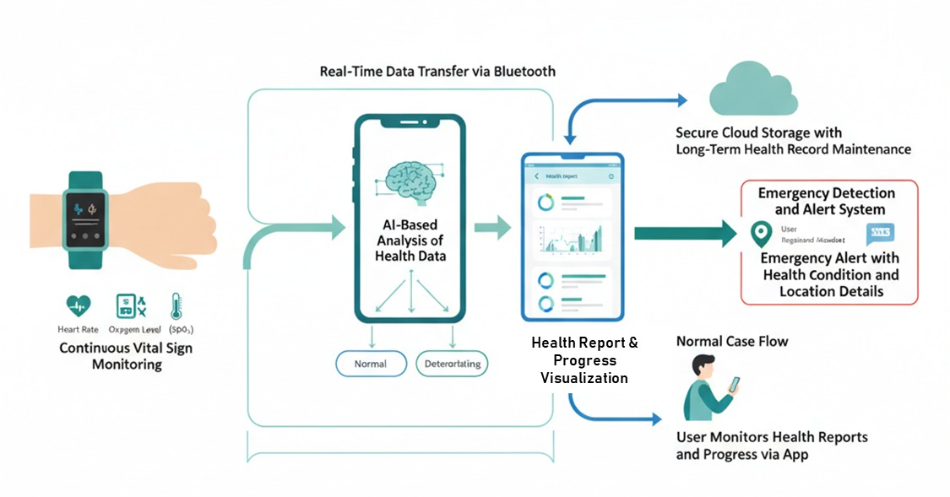
Figure 1: Cardiva: The proposed solution

Objectives of the Proposed System
The primary objective of this research is to design and develop an integrated wearable health monitoring system that continuously observes a user’s physiological parameters, interprets health conditions through AI-based analysis, maintains long-term records, and responds promptly during emergencies. The proposed system seeks to bridge the gap between raw sensor data and actionable healthcare insights, while ensuring usability, reliability, and scalability in real-world environments.
The specific objectives of the proposed system are as follows:
- Continuous Monitoring of Vital Signs:
To implement wearable sensors capable of continuously measuring critical physiological parameters, including heart rate, oxygen saturation (SpO₂), and body temperature, in order to provide uninterrupted health monitoring outside clinical settings.
- Intelligent Health State Assessment:
To develop a conceptual AI-based analysis module that classifies user health into distinct states normal, stable, or deteriorating based on trends in the measured vital signs, enabling proactive identification of potential health risks.
- Real-Time Health Report Generation:
To design a mobile application that receives sensor data, generates comprehensive health reports, and visually presents health trends, allowing users to track their condition effectively and make informed decisions about their health.
- Emergency Detection and Alert Mechanism:
To incorporate automated detection of critical health conditions, including abnormal or deteriorating trends, and implement location-aware alerts via SMS to the user and registered attendants, ensuring timely intervention during emergencies.
- Cloud-Based Long-Term Data Management:
To establish a secure cloud infrastructure that stores user-specific health data against unique identifiers, enabling long-term trend analysis, historical health tracking, and potential integration with larger-scale healthcare research or analytics initiatives.
- User-Centric Design and Accessibility:
To ensure that the system is easy to use, non-invasive, and suitable for daily wear, promoting high user adoption and continuous engagement without interfering with routine activities.
- Validation and Evaluation of System Effectiveness:
To evaluate the system’s performance under normal and emergency conditions, ensuring reliability, accuracy of health state classification, and efficiency of emergency response mechanisms.

Scope and Constraints of the Project
The proposed research focuses on the design and development of an AI-enabled wearable health monitoring system aimed at continuous, remote, and intelligent observation of user physiological parameters. The scope of this project is defined by its contributions to both practical healthcare applications and the broader research landscape:
- Continuous Physiological Monitoring:
The system continuously monitors critical vital signs, including heart rate, oxygen saturation (SpO₂), and body temperature, through non-invasive wearable sensors, enabling real-time tracking outside clinical environments.
- Intelligent Health Assessment:
An AI-based analysis module interprets incoming data to classify the user’s health status as normal, stable, or deteriorating. This supports research on lightweight, real-time decision-making algorithms for wearable devices.
- Mobile Application Integration:
The system transmits collected data to a mobile application that provides real-time visualization, health reports, and trend analysis, facilitating longitudinal monitoring and proactive health management.
- Emergency Detection and Location-Based Alerts:
In the event of critical health anomalies, the system automatically determines the user’s current location via GPS and sends SMS alerts to the user and registered caregivers, contributing to research on context-aware emergency healthcare systems.
- Cloud-Based Data Management:
Health data is securely stored in a cloud database associated with unique user identifiers, enabling historical trend analysis, research studies, and potential integration with broader healthcare analytics platforms.
- Research Contribution and Prototype Validation:
This project emphasizes conceptual validation of AI-driven health monitoring in a wearable context, providing a framework for future studies on continuous health monitoring, predictive healthcare, and user-centric emergency response systems.

Constraints of the Project
Despite its research relevance and practical utility, the system operates under specific constraints that define its scope and set realistic expectations for its performance:
- Limited Sensor Parameters:
The current system monitors only heart rate, SpO₂, and body temperature. Parameters such as ECG, blood pressure, or glucose levels are outside the scope, which may limit comprehensive clinical applicability.
- Dependence on Wearable Compliance:
Continuous monitoring assumes the user consistently wears the device correctly. Non-compliance, sensor misplacement, or removal may affect the quality and reliability of the collected data.
- Connectivity Requirements for Alerts:
GPS-based emergency notifications and SMS alerts depend on mobile network availability. In areas with poor network coverage, the system’s real-time responsiveness may be impacted.
- Prototype-Level AI Implementation:
The AI module is designed for conceptual proof-of-concept rather than clinical-grade predictive performance. The system focuses on demonstrating feasibility and research potential rather than providing certified medical diagnoses.
- Privacy and Data Security Considerations:
Although the system stores health data securely in the cloud, comprehensive compliance with healthcare privacy regulations (e.g., HIPAA, GDPR) is not fully implemented in this prototype and is recommended for future iterations.
- Controlled Testing Environment:
The system’s performance evaluation is conducted under controlled or simulated conditions. Real-world, large-scale deployment, and testing in diverse user populations remain areas for future research.

Foundations of Wearable and Mobile Health Systems

Wearable Technology in Healthcare Today
The advent of the wearable health technologies has radically changed the face of individual health monitoring and the control of chronic illnesses. Wearables, described by the possibility to wear them on the human body and the presence of built-in sensors, have become more complex than the step counters, reaching such a level of development as to be able to record several physiological parameters in real-time (Piwek et al., 2016). This has been made possible by the convergence of miniaturized sensor technology, low-power wireless communication protocols, and high-grade data processing capabilities which has created continuous non-invasive monitoring of vital signs outside the conventional clinical settings (Majumder et al., 2017).
The current wearable health devices are usually in the form of wrist-worn bands, smartwatches, or chest straps that have been structured in a way that ensures maximum sensor-skin contact and at the same time such devices should not cause inconvenience to the users when worn over extended periods (Pantelopoulos and Bourbakis, 2010). The basic design includes three key elements, namely sensing units that receive physiological signals, processing modules that condense the signals and initial analysis, and communication units that enable the transfer of data to other computing platforms (Ometov et al., 2021).
A number of convergent factors have led to the integration of wearable technologies in healthcare delivery. The rising number of chronic diseases, including cardiovascular disease and respiratory ailments, has posed significant need in that of an uninterrupted monitoring intervention that is not just restricted to periodic clinical evaluations (Steinhubl et al., 2018). At the same time, the development of photoplethysmography (PPG), electrochemical sensing, and thermistor technology has allowed measuring vital signs accurately using non-invasive and comfortable form factors that can be used on a daily basis (Castaneda et al., 2018). These sensing components have been miniaturized such that a number of physiological variables can be recorded at the same time by a single device that fits on the wrist (Seshadri et al., 2019).
Studies have shown that health monitoring systems in wearable form provide special benefits in the early detection of signs of physiological decline, tracking an individual treatment adherence, and the possibility of providing accurate response prior to the onset of an acute event (Dunn et al., 2018). Longitudinal health trends are among the benefits of continuous data collection that enable users to have access to more informed decision-making, and personalized care strategies (Perez and Zeadally, 2018).
The given system is based on the following existing principles: it introduces a wearable band which will constantly detect the heart rate, oxygen saturation, and body temperature, as three key vital signs that are considered to be basic indicators of physiological conditions. The system is based on a paradigm of wearable health monitoring by incorporating the paradigm of wrist-worn form factor with built-in sensors and wireless connectivity, and satisfies the particular requirement of multi-parameter vital signs monitoring in an environment that is not a clinical one.

Physiological Vital Sign and clinical significance
Vital signs are the simplest physiological tests which are employed in monitoring the most basic body functions and in identifying possible health disorders. The systematic observation of the vital signs is the basis of clinical assessment that presents measurable signs of cardiovascular, respiratory, and thermoregulatory system work (Churpek et al., 2016). Although traditional vital signs measurable activities have been limited to clinical interactions, the development of wearable sensing has introduced continuity in an ambulatory context that could present patterns and temporary pathologic conditions that might otherwise be missed by periodic clinical assessments (Bonafide et al., 2013). Heart rate, oxygen saturation, and body temperature are a clinically significant sub-set of vital signs that are measurably through the use of non-invasive wearable sensors, which collectively give information on cardiovascular functioning, respiratory sufficiency, and metabolic-inflammatory conditions (McGrath et al., 2016).

Table 1: Vitals recorded by wearable band
Vital Sign | Sensor Used
Temperature | DS18B20
Heart Rate | PPG
Blood Pressure | BP Sensor Module
Oxygen Saturation | MAX30102
Stress Level | GSR Sensor

Monitoring of Heart rate and Health Consequences
The heart rate which refers to the number of cardiac contractions each minute is one of the primary indicators of cardiovascular activity as well as activity of autonomic nervous system. The normal heart rate during rest in adults is 60-100 beats per minute, but there is also a significant variation between individuals depending on many factors such as age, fitness, and cardiovascular diseases (Palatini et al., 2016). Anomalies in the normal ranges of heart rate, whether tachycardia (higher heart rate) or bradycardia (lower heart rate), may indicate a number of pathological processes or physiological stress.
The continuous tachycardia can be an indication of cardiac arrhythmias, systemic infection, or a compensatory mechanism to decreased cardiac output (Palatini and Julius, 2004). On the other hand, bradycardia of unknown causes can be indicative of an abnormality in the conduction system or drug actions (Mangrum & DiMarco, 2000). Notably, the heart rate has a temporal variation that is affected by circadian rhythms, physical exercises, emotional changes, and sleep phases, and therefore, it cannot be analyzed using only a single measurement as required by a trend (Cooke et al., 1999).
Photoplethysmography has become the most popular technology in wearable devices to monitor the heart rate in non-invasive and continuous mode. PPG systems contain light-emitting diodes that light up peripheral tissue, which usually is the wrist, and photodetectors which measure changes in light absorption due to pulsatile fluctuations in blood volume during the cardiac cycle (Allen, 2007). The obtained PPG signal allows extracting the heart rate using peak detection algorithms, and modern models can reach the same accuracy as an electrocardiography in a clinical environment in controlled parameters (Gillinov et al., 2017). Nevertheless, motion artifacts, interference of ambient light, and physiological differences in individuals may influence PPG signal quality, and signal processing methods are needed to guarantee the reliability of measurements (Tamura et al., 2014).
The fact that the monitoring of the heart rate is going to be part of the suggested system allows recognizing the abnormal rate patterns, evaluating the temporal trends and making their own personal baseline values to compare the deviations. This feature is specifically applicable in detecting the initial signs of physiological degradation since the alteration in heart rate is typically preceded by other clinical symptoms (Churpek et al., 2012).

Oxygen Saturation and Respiratory Health
Oxygen saturation, which is referred to as SpO 2 when measured through pulse oximetry, is the proportion of hemoglobin molecules in arterial blood that are occupied by oxygen. This vital sign represents the crucial information on the performance of the respiratory system and the sufficiency of oxygen delivery to the peripheral tissues (Jubran, 2015). The normal levels of SpO2 of a healthy person in the sea are normally 95 to 100 with a level less than 90, usually being viewed as a manifestation of hypoxemia that needs clinical intervention (O'Driscoll et al., 2017).
The physiological significance of oxygen saturation measurements is based on its indication of lungs gas exchange, hemoglobin oxygen-carrying ability, and oxygen delivery to the heart (Peláez & Villar, 2015). Various pathological mechanisms such as pneumonia, chronic obstructive pulmonary disease, pulmonary embolism, and congestive heart failure can lead to reduced oxygen saturation and therefore it is a sensitive indicator of cardiopulmonary dysfunction (Luks and Swenson, 2011).
The technology of pulse oximmetry that allows measuring SpO 2 non-invasively is based on the principle of the light absorption difference between oxygenated and deoxygenated hemoglobin. Pulse oximeters determine the proportion of oxygenated to total hemoglobin by detecting transmitted or reflected light with peripheral tissues irradiated with light at two wavelengths (usually red, approximately 660 nm and infrared, approximately 940 nm) (Chan et al., 2013). This method has been effectively downscaled and incorporated into wearable designs so that it can be used to monitor continuously in non-clinical settings (Castaneda et al., 2018).
Pulse oximetry accuracy in wearable applications can be influenced by a number of factors. Motional artifacts of physical exercise can invalidate signal quality, whereas cold conditions cause peripheral vasoconstriction that can reduce perfusion to a level below which good measurements can be taken (Nitzan et al., 2014). Further, the skin pigmentation and surrounding light may affect the accuracy of the measurement, but modern algorithms tend to incorporate the compensatory mechanisms (Sjoding et al., 2020). In spite of these shortcomings, wearable pulse oximetry has proven to be useful in desaturation events checking and giving early alarms on the bad condition of the respiratory system (Morelli et al., 2018).
Within the suggested system, continuous SpO 2 monitoring allows one to recognize the instances of hypoxemia that could signify the respiratory impairment, assess the patterns of oxygen saturation and detect the patterns of desaturation that should be considered. This parameter in combination with measurements of heart rate and temperature can allow a more detailed evaluation of physiological condition compared to any of the vital signs applied separately.

Abnormality and Body Temperature Detection
Body temperature is one of the most basic physiological parameters which show how well the various heat generation and dissipation processes are balanced. Normal healthy adults usually have a minimal range of core body temperature at 37 o C (98.6 o F), with circadian changes of about 0.5 to 1.0 o C across the day (Sund-Levander et al., 2002). Temperature variations outside the normal temperature (fever, hyperthermia and hypothermia) may reflect an infection, inflammation, lack of normal metabolic functions or exposure to the environment (Laupland, 2009).
One of the most prevalent and clinically important effects of illness is fever which is simply defined as having an elevated core temperature over 38 degrees Celsius (100.4 degrees Fahrenheit). The effects of pyrogenic molecules such as inflammatory mediators and infectious agents on the hypothalamus thermoregulatory center raise the temperature set point in the body (Evans et al., 2015). Although the most typical connection of fever and autoimmune disorders, cancer, and drug responses, it can also be observed in the case of infections (Niven et al., 2013).
Non-thermal methods of body temperature measurement have been based on the oral, rectal, tympanic, and temporal artery measurements, each with unique accuracy profiles (Geneva et al., 2019). The introduction of temperature sensors into wearables has required the use of peripheral measurements, which normally access temperature at the skin surface at the wrist. Although the presence of peripheral skin temperature does not directly reflect a core body temperature because of environmental factors and changes in peripheral blood flow, studies have shown that sustained skin temperature monitoring can be used to diagnose fever development, circadian temperature fluctuations, and abnormal temperature patterns (Chamberlain et al., 2017).
There are two common types of wearable temperature sensors: thermistors or resistance temperature sensors, which have a predictable temperature-dependent change in electrical resistance (Dias & Paulo Silva Cunha, 2018). The sensors are capable of high accuracy in the measurement of the temperature of the skin surface, but any algorithms have to consider both the effects of ambient temperatures and the difference between peripheral and core measurements.
The suggested system integrates the provision of continuous body temperature measurements to identify the onset of fever, detect the changes in abnormal body temperature and support heart rate and oxygen saturation measurements in determining general physiological condition. The association of high temperature with tachycardia, e.g. may indicate an infectious disease, and the increase in temperature with desaturation may indicate respiratory infections. This multi-parameter model is more detailed in health assessment as compared to the use of single vital signs.

Mobile Applications and the role in acquiring health data
Mobile health (mHealth) has become an essential component of wearable health monitoring systems, which can perform several roles such as receiving data on wearable sensors, live visualization, initial analysis, user feedback, and connecting to the cloud (Istepanian & Al-Anzi, 2018). The ubiquity of smartphones, their computing power, uninterrupted access to the internet and embedded sensors have put mobile apps in a natural position to collectively aggregate and process the health data of external wearable devices (Kumar et al., 2013).
The wearable monitoring system architectural design of mHealth applications normally applies multiple fundamental functional layers. The communication layer handles wireless transfer of data provided by wearable devices based on a series of protocols, including Bluetooth Low Energy (BLE), which comes with the benefits of low power usage, sufficient data throughput in vital sign transmission, and universal device compatibility (Seneviratne et al., 2017). Data management layer deals with incoming vital sign measurements by receiving, parsing, validating, and storing the measurements and may use local databases to guarantee data persistence and to provide offline operation (Gope and Hwang, 2016). The presentation layer is the layer that offers user displays of the current measurements and past patterns and health status in a form that is easily understandable (Hamine et al., 2015).
In addition to the passive data display, the modern mHealth applications are functioning more and more to have analytics that can convert raw sensor data to a actionable health information. This involves statistical analysis to determine trends and anomalies, threshold-based alerting systems that indicate users of abnormal vital sign values, and visualization tools that can make the trends of time readable to non-clinical users (Patel et al., 2015). The combination of artificial intelligence and machine learning methods has broadened the analytical opportunities, allowing recognizing patterns and a personalized evaluation of health according to the baseline values and trends over time (Esteva et al., 2019).
There is a variety of approaches related to the use of AI methodologies in mobile health. Expert-specified decision criteria are applied in rule-based systems to categorize health states based on combinations of vital signs and thresholds and provide transparency and predictability (Alam et al., 2019). The identifying patterns of vital sign data can be complex and can be determined as a result of the application of machine learning algorithms, i.e. decision trees, support vehicle machines and neural networks capable of identifying the normal functionality, normal conditions or the present situation of declining health (Uddin et al., 2019). Such methods usually involve the use of labeled datasets with examples of various health conditions.
Within the framework of the suggested system, the mobile app will be the main interface of the system, through which the user can check vital signs and be evaluated regarding his/her health status. The AI-based theoretical module that is utilized in the application determines the health of the user as normal, stable, or deteriorating based on the trend in the heart rate, oxygen levels, and temperature data. This type of classification does not aim at making clinical diagnosis, but at finding the time patterns and changes in relation to the personal baselines. Parameters of interest in the trend-based analysis include progressive changes in vital signs over hours, days, abrupt changes in baseline parametric values, and combinations of parametric vital signs that imply changes of health status.
The tangible benefits of the health data acquisition using mobile devices are not limited to the analytical functions. The use of smartphones offers the user known interfaces and interaction paradigm, which ease technological hindrances to use (Peek et al., 2014). Mobile devices are portable, which facilitates health monitoring in everyday life, helping to measure the data in real-life conditions and not in a controlled clinical setting (Onnela & Rauch, 2016).
Security and privacy issues are very important issues in mobile health data acquisition systems. The data that is being sent between wearable gadgets and smartphone applications should be encrypted to avoid interception, whereas data stored on the smartphone devices should be secured against unauthorized access (Fernández-Alemán et al., 2013). Health data protection requirements posed by regulatory bodies require mobile health applications to respond to their technical and procedural protection (Yuksel et al., 2016).
In the deployment of the suggested system, the mobile application system should strike a balance between analytical enhancement and computational expediency, user interface intelligibility and completeness of information, and functionality and protection of privacy. The application can be used as a data receiver and display area but is also a smart filter that converts the unending streams of vital signs into actionable health information that can be accessed by the user regardless of his or her level of clinical knowledge.

Cloud-Based Health Data storage and Access
Cloud computing has essentially revolutionized health data management by offering remote storage infrastructure capable of scaling which breaks the barriers of the local device storage and supports maintenance of longitudinal health records (Kuo, 2011). The cloud-based storage can fulfill several essential purposes in the context of wearable health monitoring systems: preserving past vital signs data as it is not limited by the mobile gadgets, allowing access across various devices or locations, sharing data with medical professionals when permitted, and analyzing data (Abouelmehdi et al., 2018).
Such an architectural paradigm of cloud health data storage is a hierarchical system where wearable devices send data to mobile applications using local wireless protocols, and mobile applications are in turn synced to cloud servers through internet connectivity (Hossain and Muhammad, 2016). This level of implementation streamlines the use of power on wearable devices with resource constraints and guarantees the storage of data on the cloud with persistence.
Wearable monitoring systems based on clouds of health data storage need to consider a number of technical requirements. They need to be structured into schemas that support the various types of vital signs, temporal metadata such as the measurement timestamps, and user identification to support multi-user systems (Zhang et al., 2018). The suggested system uses individual identifiers to isolate separate health records, which data is isolated and individual information is easily retrieved with little effort. The given identifier-based architecture enables the system to store longitudinal health histories on every user, where the trends in vital signs can be traced across long durations to reveal the changes that could not be identified with short-term monitoring (Islam et al., 2015).
The amount of data produced continuously with continuous wearable monitoring offers natural benefits of cloud platforms. One wearable device with three vital signs every minute has about four thousand three hundred and twenty data points per day on the side of one user. This volume of data can be stored in cloud storage infrastructure and indexing techniques can be used to maintain query performance using distributed database designs (Raghupathi & Raghupathi, 2014). In addition, cloud services provide computing facilities that can be expanded to analyze data that has been collected over time, which helps identify trends over a wide time frame (Yang et al., 2017).
Availability aspect of cloud-based health data storage is reflected in a number of applications in practice. Patients who have wearable devices can share their patient-generated health data with healthcare providers via secure portals, and continuous trends of vital signs can be integrated into clinical evaluation and chronic disease management (Steinhubl et al., 2018). Authorized access can be given to the family members or caregivers to observe the vulnerable individuals, which could include the aged parents or patients with chronic illnesses, to allow them to monitor remotely and intervene at the earliest opportunity to detect abnormalities (Saranummi et al., 2009). The system presented takes advantage of the cloud storage to produce detailed health reports of vital signs trends, detected abnormalities, and health status categories across the given time frames and give users systematic summaries of monitoring data.
The most important issues in cloud-based health information systems are data security and privacy. The transfer of health data to cloud servers should use encryption protocols like Transport Layer Security (TLS) to ensure that they are not intercepted during transmission but data stored in the cloud storage should be encrypted using strong cryptographic algorithms (Chenthara et al., 2019). The access control mechanism should have authentication to validate the identity of the user and authorization to allow the user access to data according to the necessary permissions (Sun et al., 2012). The suggested system architecture presupposes the introduction of the following security measures in order to safeguard the confidential health information during its lifecycle.
The design of cloud-based health data storage is affected by regulatory compliance issues. Health information has to be stored on servers in local geographic regions, which are usually the jurisdiction of localization requirements, and in such cases, the selection of cloud providers with the right regional data centers is needed (Dhagarra et al., 2020). Regulations and assist in accountability in multi-user systems usually require audit logging capabilities of access to health data (Fernández-Alemán et al., 2013).
The proposed system of wearable health monitoring has the capacity to support the maintenance of health records continuously and bidirectionally due to cloud storage, which is not limited to the storage capacity of individual devices. The system can provide a complete health history helping to analyze trends and availing their users with permanent records of their physiological conditions, as vital sign data, health status classifications, generated reports are stored in the cloud under unique user identifiers.

Location-Aware Systems within the Emergency of Healthcare
Location-based technologies have also turned out to be part and parcel of the emergency response systems whereby they can quickly locate persons in need of assistance and efficiently mobilize emergency services (Rui and Wenyuan, 2010). Integration of positioning capabilities is relevant in the context of health monitoring systems, as the localization of an emergency is one of the critical challenges that physiological monitoring can detect the presence of a health crisis, but the manual reporting of the aforementioned location can be impaired due to the user being in a compromised medical condition (Torabi et al., 2014).
Global Positioning System (GPS) technology is the most commonly used outdoor positioning system which uses the signals of satellite to determine the geographic location with a range of between 5 and 10 meters in ideal circumstances (Zandbergen, 2009). With the introduction of GPS receivers into smartphones, the availability of location information to mobile health applications is easily accessed without using any specialized hardware (Rao & Minakakis, 2003). The GPS positioning works on the principle of trilateration, determining the position according to the measurements of signal time-of-flight of several satellites, and the accuracy depends on the factors such as the geometry of satellites, obstruction of signals, and the state of the atmosphere (Kaplan and Hegarty, 2017).
Several functional requirements are involved in the application of the location-aware systems in the healthcare emergency situation. To begin with, positioning should be automatic and passive that is, it should not need the user initiation in case of medical emergencies where the affected person may be incapacitated (Pattichis et al., 2002). Second, the data about the location should be sent to the relevant recipients, such as emergency contacts, as well as contextual health data that will guide the priorities in the response (Varshney, 2007). Third, the system should be able to cope with positioning failure and understand that when one is indoors or in a dense crowd of people, the visibility of the satellites is hindered (Dao et al., 2011).
In the context of health monitoring and emergency notification systems, alert systems are generally adopted as multi-channel strategies to increase the probability of getting to the assistance. SMS is a particularly strong notification system because it is universally available on mobile networks, has an asynchronous delivery model, which does not demand the presence of the recipient and has low data requirements are required which in turn allows it to be supported by a low quality network (Istepanian et al., 2004). The suggested system will utilize the SMS-based alert system to alert the user and a pre-registered attendant or emergency contact in case of an emergency condition being detected, sending the type of detected health emergency as well as the current GPS position of the user.
The identification of emergency conditions necessitating location-based alerting is based on the analysis of vital signs measurements in comparison with predefined clinical parameters and trends that could evidence the acute worsening of physiological conditions. In the case of extreme deviations in the personal vital signs (below 40 or above 140 beats per minute, oxygen saturation less than 85 or more, body temperature greater than 40 C), emergency measures may be implemented (Smith et al., 2013). Furthermore, the presence of combinations of vital sign abnormalities or rapid deterioration patterns detected with the help of the AI-based analysis module could help to identify emergencies that have to be addressed as soon as possible (Churpek et al., 2016). The suggested system applies a threshold-based detection and trend analysis to detect emergency conditions that require automated location sharing and notification.
The issue of privacy can be discussed in location-aware health monitoring systems because the permanent location monitoring and sharing the positioning data are the sensitive privacy concerns (Solanas et al., 2014). To be ethically implemented, it is necessary that, instead of constant sharing and storage, location information should be accessed and sent only in certain emergency cases, and under emergency conditions, users should be in charge of emergency contacts designation and preferences toward alerts (Avancha et al., 2012). The suggested system architecture restricts the retrieval of GPS location to emergency situations as detected during the analysis of vital signs and only the coordinates are transmitted in case emergency conditions are detected as opposed to having constant location tracking.
The issue of personal emergency response can also be highly relevant to wearable health monitoring systems, which involve incorporation of location-aware features, allowing individuals with a specific health condition to obtain timely help, even in the situations, when they are unable to inform the emergency response team of their position manually. Such systems will decrease the response time and potentially enhance the outcome of health emergencies based on the combination of physiological monitoring (to detect an emergency) and positioning technology (to locate victims) (Chan et al., 2004). This system where the emergency location is done using GPS that is notified through SMS provides a safety net to the user: especially the chronic patients or the elderly persons who live alone but are at a high risk of health-related emergencies.

Review of Related Work
Wearable health monitoring systems have received significant interest in research in the last 10 years due to the progress in sensor miniaturization, wireless communication and mobile computing [7]. The chapter provides an in-depth literature review and systems of the currently existing literature and systems applicable to health monitoring based on wearables, mobile health applications, artificial intelligence methods to assess health, and emergency response systems. The audit takes a critical examination of the merits and the drawbacks of the previous literature to establish the gaps in research that give an impetus to the suggested system.

Current Wearable Health Monitoring Solutions
Health monitoring wearables have been developed based on a single-parameter fitness trackers up through multi-parameter medical-grade, able to continuously measure vital signs. Initial prototypes of research were aimed at monitoring the heart rate by using the electrocardiography (ECG) sensors on the chest straps. As demonstrated by the work by Hao and Foster (2008), wireless ECG monitoring was done of cardiac patients to transmit the heart rate information to remote monitoring stations. Although this method gave precise cardiac rhythm estimation, the size of the chest straps was not very comfortable in prolonged usage, and therefore, compliance with the user was limited in the long-term monitoring conditions.
Wearing PPG on the wrist was an important step towards wearing comfort and accessibility. Poh et al. (2010) designed a wrist-worn device with PPG sensors to measure the heart rate and showed it to be the same in terms of accuracy when compared to the chest-strap ECG when resting. Their work however found that there was a significant loss in accuracy when it comes to physical activity because of motion artifacts and this has continued to be a constraint in the further applications of wearable computing. The authors also had to mention that signal processing methods that would allow separating motion artifacts and physiological signals that could be recognized as genuine were still a point of concern.
Various vital signs have increasingly been integrated into one wearable by research endeavors [8]. In one of the article sections, Dias and Paulo Silva Cunha (2018) suggested a wearable device to track heart rate, body temperature, and physical activity by using inbuilt sensors arranged in a bracelet shape. Their system sent information to a smartphone application that would be used to visualize and store the information. Although this multi-parameter design offered better health evaluation than single-vital-sign monitoring, the study indicated difficulties in ensuring consistency of measurements among different user groups especially the difference in skin coloring that impacts the quality of PPG signals and ambient temperature that affects the body temperature measurements.
Embedded pulse oximetry to derive oxygen saturation has been a topic of number of studies that have been conducted. Fernandez-Chimeno et al. (2013) invented a wrist-worn pulse oximeter that has the capability of monitoring SpO 2 continuously in patients with chronic obstructive lung diseases. Their analysis showed that they were clinically useful in terms of detecting nocturnal desaturation events that could not have been detected by routine clinical assessments. The authors however noted that the device was not effective in real time monitoring of health status because it had to be manually retrieved and had no automatic alert features.
Wearable health monitoring systems that are commercially available have been adopted at large scale, but with in many cases, the restriction of commercial systems in relation to their applicability to holistic health monitoring. The Apple Watch will have a heart rate sensor using PPG and in more recent models, blood oxygen saturation sensor and ECG (Spaccarotella et al., 2020). Although these devices offer vital sign monitoring that can be used by consumers, research reviews have reported that their main attention is more on fitness and wellness monitoring as opposed to on-going health monitoring. The machines do not have the option to measure the temperature of the body, and they also offer fewer historical trend analysis or predictive health assessment options.
The wide availability of Fitbit devices and the ability to track the heart rate at all times have been actively researched. Gillinov et al. (2017) tested the accuracy of a few commercial wearables, such as the Fitbit models, and the overall results indicated acceptable accuracy in the heart rate at rest but marked deviations at the time of the exercise. The paper noted that such devices are used as wellness tools, but not medical devices, and do not provide the extensive monitoring and analysis of vital signs to detect health deterioration.
Sophisticated sensing settings have been developed in research wearable platforms. Ghamari et al. (2016) introduced a multi-sensor wearable system with the heart rate, respiratory rate, body temperature, and physical activity monitoring. Their system showed the importance of multi-parameter monitoring as a comprehensive measure of health in detecting correlations between vital sign abnormalities that could be indicative of a particular health condition. Nonetheless, the platform was not automated to conduct automated data interpretation by medical personnel and did not offer automated decision-support systems that would supply users with real time health status classification.
BioHarness system is a physiological tracking system designed to track military and athletic users, and it incorporates an ECG, respiratory rate, body temperature, and posture sensors on a chest-strap format (Johnstone et al., 2012). Studies on evaluation showed a high accuracy on the parameters that were monitored although the bulky nature of the chest-strap form factor restricted applicability to the needs of civilian health monitor applications that had long-term continuous wear.
One limitation that is found to be similar throughout the existing wearable health monitoring solutions is the lack of sophisticated analytical services and the use of data gathering and presentations. Majority of the systems do not provide context, trend analysis or assessment of the health status to the users in the raw vital measurements. The interpretation of the observed values of vital signs to indicate normal functioning or presence of concerning abnormalities will require the user to interpret these values manually and this imposes unrealistic demands on non-medical users. Moreover, the current systems are not usually integrated with emergency response mechanisms that might automatically identify the important health events and start assistance procedures.
The proposed system would overcome these shortcomings with a system that incorporates heart rate, oxygen saturation, and body temperature monitors in the form of a comfortable wrist-worn device, automated trend-based health status classification, and emergency detection with location-based alerts. Such a combination of features is a step forward in contrast to the solutions that are currently available, which usually provide only a partial implementation of such capabilities.

Mobile-Centric Health Monitoring Applications
Mobile health applications are essential decoders between wearable sensors and users, offering a data visualization and analysis interface and health management interface. The sources of literature on the use of mobile health applications in wearable monitoring cover various methods of implementation, analysis functions, and interaction paradigms.
The early mobile health applications were mainly used to receive data passively and visualize them. Kulkarni and Ozturk (2011) created an app that can be installed in the smartphone to receive heart rate information transmitted by a wearable sensor using Bluetooth technology, showing the readings in real time and keeping a simple historical record. Although this strategy was effective in showing wireless sensor-smart phone integration, the application had no analytical components beyond a threshold-based notification of users when heart rate surpassed preset limits. The authors conceded that alerting by the use of thresholds without regard of time or personal baselines led to high false alarms that reduced trust among the users on the system.
Later studies discussed advanced mobile application architectures with local data processing and analysis. The mHealth system of chronic disease management suggested by Bourouis et al. (2014) was capable of collecting the vital signs in wearable sensors, conducting statistical analysis to determine the trends, and creating health reports that summarized the vital sign patterns over time. They assessed them with diabetic patients and showed that trend visualization allowed the user to comprehend their progress in health status. But the system demanded manual kickstarting of the data synchronization process and report generation, which was not as useful in full-time automated monitoring of health.
The incorporation of cloud connection into mobile health has been widely considered as a way of overcoming the problem of smartphone storage and allowing the cross-device access to data. The authors created a mobile application that gathers essential measurements of wearable devices, transmits the measured data to cloud servers, and provides authorized medical staff with access to patient surveillance information via web-based applications (Pandey et al., 2020). The architecture of their systems showed that it was possible to have a distributed health monitoring system such that ongoing wearable measurements can be used to make clinical decisions. The paper has found issues associated with network connectivity needs, where the reliance of the application on uninterrupted internet connectivity to maintain data synchronization left loopholes in the monitoring of the application when the network was offline.
The studies on the user interfaces of mobile health applications have focused on the significance of presenting complex health data in understandable formats that can be used by the non-clinical audience. Arsando et al. (2010) have realized user studies comparing various visualization techniques on how blood glucose trends should be displayed to the patients with diabetes. According to the findings of their study, graphical trend displays that were easily identified as normal or abnormal ranges were much more understandable by the user than the tabular numerical data. The paper suggested that medical monitoring software needs to focus on an intuitive display over a detailed visualization of the data to achieve the effect of maximum user interaction and insight.
Application platforms proposed by Apple such as HealthKit and analogs of other manufacturers have made it possible to standardize health data collection by multiple sources. The study by Hale et al. (2016) examined the possibilities of these frameworks to combine the data of wearable sensors with manual health-related data and data of other monitoring tools. Although these platforms have benefits of convenience and interoperability, the research has found that these platforms were limited in the ability to perform analysis, with most of the systems only providing data storage and retrieval services, but little or no automated health evaluation and recommendations.
The use of artificial intelligence in health data analysis in mobile applications is a novel area of study. Chung and Baek (2020) created an app on a smartphone that used machine learning classification on the data of the heart rate variability gathered by wearable sensors and broke down the stress level of the user as low, moderate, or high. Their analysis showed that automated classification gave actionable information to users that could not be obtained when using raw vital sign data. The application, however, did not cover the whole picture of health status examination through multiple vital signs (just one derived parameter, stress level).
Mobile application architectures in the case of emergency health situations have also been studied. The article by Rasid et al. (2015) used a mobile application, which used a wearable sensor to monitor the heart rate and automatically delivered SMS alerts with the GPS position of the user to emergency contacts in case potentially dangerous arrhythmias were observed. Although this method proved that it is possible to achieve automated emergency response, the detection system was only based on the examination of the heart rate pattern, without adding other vital signs which could provide supportive information about real emergencies and the false detection.
Research environments have been able to develop multi-parameter health monitoring applications, but with little deployment and evaluation. The study by Ahmed et al. (2019) is based on a mobile application that combines the heart rate and blood pressure with blood sugar measurement taken by another device. The app had rule-based logic to detect warning signs of vital signs combinations, including high heart rate and blood pressure. Nevertheless, the system used several separate monitors as opposed to built-in sensors and the rule based approach was not as versatile as machine learning methods that could be trained to recognize individual specific patterns.
One of the major gaps that can be observed in the current mobile health monitoring applications is that little longitudinal trend analysis with regards to individual baselines and time trends are implemented. In the vast majority of applications, the type of threshold comparisons used is based on pure static threshold comparisons, which lack the factor of gradual deterioration over days or weeks, as well as the creation of individualized normal ranges based on personal monitoring history. Also, not many applications provide a combination of the essential functions of emergency response that would combine vital sign analysis, automatic recognition of an emergency, and location-based alerts in one system.
The presented system can overcome these limitations by proposing a mobile application that captures multi-parameter vital signs in a wearable device and delivers trend-based health status classification basing on temporal patterns, longitudinal health histories synchronized with the cloud and integrated emergency detection with GPS-based location sharing, and SMS alert functionality. This is a holistic approach compared to the partial implementation in existing literature.

Artificial Intelligence and Decision-Support methods in Health Monitoring
Artificial intelligence and machine learning methods have found more and more applications to health monitoring data to identify significant patterns, categorize health conditions, and offer decision support [6]. A range of AI methodologies which vary in the level of complexity, accuracy, and applicability to clinical practice have been included in the literature.
The first style of automated health assessment in monitoring systems is the rule-based expert systems. Hsieh et al. (2013) created a rule-based elderly health monitoring system that used preset logic to the combination of vital signs. To illustrate, the system rated scenarios where the heart rate was high and the body temperature was high as possible infections whereas low oxygen saturation coupled with normal temperature indicated respiratory problem. The benefit of this method was that it was transparent and predictable since users and healthcare providers were able to know the rationale behind classifications. The authors however remarked that rule-based systems had difficulty accommodating the individual differences in normal ranges of vital signs and had no way of adapting to such pattern that had not been explicitly coded into the rule set.
The health state classification method using machine learning techniques has been extensively explored in the area of detecting the health states through the vital signs data [1], [2], [3], [4]. In their study Khalaf et al. (2019) used the support vectors machines (SVM) to identify heart rate, blood pressure and respiratory rate patterns to determine the state of patient health as stable or deteriorating. Their experiment trained the SVM classifier with labeled datasets of hospital surveillance systems with a classification accuracy of about 87 percent. The study established that machine learning strategies had the ability to detect the faint patterns in bundles of vital signs that would not be detected by the rule-based systems. Nevertheless, the need to find large labeled training data restricted the applications of this method in systems with individual users who do not have access to training data on the population level.
Health monitoring and decision tree algorithms have been studied because these algorithms have multiple parameter input capability and are interpretable. Daghistani and Alshammari (2020) have created a decision tree classifier to estimate deterioration in patients with chronic diseases based on wearable sensor data such as heart rate and physical activity levels. The decision tree format allowed visualising the decision-making process by indicating which patterns of vital signs resulted in certain classifications. According to the study classification accuracy was 82 percent in the case of historical patient data. One of these limitations was that decision trees have a tendency to overfit the training data and thus may lead to poor generalization when used with new users with different physiological baselines.
Deep learning architectures and neural network methods have shown interesting results in the use of neural networks in health monitoring. Rajkomar et al. (2018) used recurrent neural networks to time-varying vital sign data based on the electronic health record data and forecasted deterioration in patients hours in advance before clinical deterioration occurred. The deep learning model was more accurate than the traditional scoring systems that were employed in hospitals. Nevertheless, the study admitted that neural network models are black boxes with little interpretability and thus it is hard to interpret certain predictions to the users or clinicians. Moreover, deep neural networks demanded computational resources that made them questionable whether they could execute deep neural networks in real-time on resource-constrained mobile devices.
Anomaly detection methods are another method that aims at detecting anything that is not normal and not necessarily on the classification into the existing categories. The article by Fang et al. (2018) created an anomaly detection system of wearable health monitoring, which set baseline patterns of vital signs of an individual under a specified time of initial monitoring, after which abnormal measurements that did not match baseline values were considered an anomaly. This method was able to absorb personal differences in physiology without having to use population-wide training data. The researchers reported that in their test data with 78% detection of health deterioration events, their anomaly detection was successful. Nevertheless, the levels of false positives were also high, as about 15 percent of all tagged anomalies were natural physiological differences, but not issues related to health.
Combination of various classification algorithms has also been explored as ensemble learning techniques in order to enhance accuracy and resistance. Abideen et al. (2020) adopted an integrated method that used decision trees, the SVM, and naive Bayes classifiers to interpret the variability in heart rate and categorize cardiovascular health risk. The ensemble method was more accurate than the individual classifiers which exploited the strengths of these methods. There were concerns on whether real-time implementation in mobile health applications would be possible due to the computational burden of operating several classifiers.
Recent literature has discussed trend analysis methods that rely on temporal changes as opposed to immediate values of the vital signs. Clifton et al. (2013) created algorithms to identify the gradual deterioration in the vital signs of hospital patients through a series of trends over the 24-48 hour periods. Their scheme has discovered patients at risk of adverse events earlier than systems based on instantaneous threshold violations. The research highlighted the importance of gradual changes in the context of health deterioration as opposed to threshold crossings, which in turn facilitates the importance of trend-based assessment. Nevertheless, the trend analysis algorithms and requirement of continuous data over a long duration of time rendered wearable monitoring systems using a potential data gap difficult to implement.
Individualized health assessment strategies that can change with individual baselines have been explored as a way of enhancing classification accuracy. Veropoulos et al. (2018) created a customized monitoring system that provided the individual-specific normal ranges of vital signs during the first observation to apply machine learning classification with individual-specific bases instead of the population-average values. Their comparison showed that they had fewer false alarms than the numbers of the static threshold method. The need to have a preliminary period of personalization where the users need to be in familiar good health was a pragmatic constraint to be deployed in general populations.
There is a limited literature that has operated an integrated AI-based health monitoring system indicating multiple vital signs, trend arcs, individualized baselines, and functional classification into clear health status that can be utilized by non-clinical end users. Majority of the research is done on specific AI methods applied to particular monitoring situations instead of end to end systems. Moreover, a considerable number of studies test AI techniques on retrospective hospital data as opposed to continuous wearable data, which makes it questionable how well they apply to ambulatory monitoring settings with different data properties and noise distributions.
The suggested system will close these gaps by introducing a conceptual AI-based module to examine trends in heart rate, oxygen saturation, and body temperature to categorize health conditions as normal, stable, or worsening. This type of classification focuses on time pattern recognition and outliers to individual baselines and does not focus on trying to diagnose the case comprehensively using clinical methods. The trend-based approach corresponds to the research findings stating that the gradual changes may give advance warning of the health problems compared to the instantaneous breaches of the threshold.

Healthcare Emergency Detection and Alert
Emergency detection and response are key safety aspects of health monitoring systems, especially among the elderly people and patients with chronic illnesses who can be subjected to acute health events and which need urgent response. Literature on emergency detection covers a wide range of triggering mechanisms, notification and place based response systems.
The initial emergency detection systems used to be more manual whereby the user was supposed to press emergency activation buttons when faced by health crises. Doughty et al. (2000) traditional Personal Emergency Response System (PERS) study involved the evaluation of the device in the shape of a pendant that was worn by a user and could trigger the assistance. Although such systems offered convenience in offering a sense of security and quick response whenever triggered, the inherent height was that such a system had to be triggered by the user. Research reported that the users who developed cardiac events, strokes or falls had a tendency not to reach and press emergency buttons because of incapacitation, unconsciousness, or cognitive impairment caused by the health crisis itself.
As a development on the manual fall activation, automated fall detection systems developed, which utilised accelerator and gyroscopes to identify sudden impact and change of orientation of a fall. The article by Ntanasis et al. (2018) created fall detection algorithms that identify the acceleration pattern to differentiate between falls and other normal activities such as sitting and bending over. Their assessment reached fall detection sensitivity of 92 and specificity of 88 which proves their possible application in the real world. Nevertheless, it was observed in the study that motion-only fall detection was ineffective in detecting health crises that would not be accompanied by falls, such as heart attacks or extreme respiratory distress that a user was already seated or in the recumbent position.
Emergency detection based on vital signs has been explored as an auxiliary method, which did not emphasize physical events but physiological anomalies. Hu et al. (2018) designed a elderly monitoring system that facilitated detecting an emergency by notifying users of a decreased or increased heart rate below or above 40 or 130 beats per minute, respectively, which are possible signs of bradycardia and tachycardia conditions that could be fatal. Although this threshold-based method was successful in detecting much of the cardiac emergencies, the study had high false alarm rate and about 25 percent of the alerts were related to temporary physiological reactions to exercise, stress, or sleep and not an emergency. The authors concluded that threshold detection using single parameter needed optimization in order to minimize poor detections.
Combined multi-parameter emergency detection methods that combine several vital signs have been shown to be more specific than single-parameter based methods. Tarassenko et al. (2006) introduced a postsurgical monitoring system that examined patient heart rate, respiratory rate, blood pressure, and oxygen saturation in combinations to notify of the first signs in the patient that she was getting worse. Their multi-parameter methodology had better positive predictive value than in single vital signs thresholds because the true emergencies were usually characterized by abnormal values in several parameters at once. Nonetheless, the system has been applied to the hospital setting under constant supervision of nurses to confirm the alerts and cannot be directly applied to home-based wearable monitoring without clinical supervision.
GPS positioning has been considered in the development of location-sensitive emergency alerts to overcome the problem of localization of an emergency. The study conducted by Santos et al. (2014) created a cardiac monitoring device in form of a wearable that automatically sent the GPS position of the user to an emergency service in the event of potentially fatal arrhythmias. They observed that location-based notification allowed quick response to emergencies than the system that needed verbal location information by distressed users. One of the limitations was found to be the deterioration of GPS positioning in indoor areas where most health emergencies take place and where alternative methods of localization should be employed, like the last known outside position or manual entry of address.
SMS-based emergency notification is one of the delivery systems of alert mechanisms that have been embraced because it is reliable and universally available in all mobile networks [5]. The solution adopted by Chan et al. (2007) was an emergency alert system, which sent SMS messages with vital sign data and GPS coordinates to emergency pre-designated contacts in the event of abnormal conditions. The researchers concluded that SMS delivery was more than 98% even in the worst network conditions, which justifies its applicability in emergency health messages. Nevertheless, the study found that SMS-based notifications relied on subscribers to check their phones frequently and have their devices turned on, and in case emergency contacts did not receive the original messages, response time could be delayed.
Different tiers of alerting schemes where the notification intensifies according to the response time have been researched to enhance the reliability of emergency response. Al-Taee et al. (2015) created a monitoring system, which firstly issued warnings to the family members and then resorted to professional emergency services in case there was no reply within a certain time. Such a strategy harmonized the desire to use family-based initial response with the certainty of professional intervention should the family members be inaccessible. The multilevel nature of handling multiple tiers of alerts and the possible misunderstanding of who was responsible in responding was an issue in implementation.
There has been efforts at integrating emergency detection with other contextual information other than vital signs to minimize false alarms. Gia et al. (2016) designed a system that factored in the level of user activity, time of the day, and the overall trends of vital signs when weighing up the chances that abnormal measurements were signs of real emergencies or presupposed a transient physiological response. Indicatively, higher heart rate in the daytime following the physical activity was less prone to cause emergency alerts compared to a similar heart rate in night rest. This context-based method decreased the false alarm rates up to 40% as compared to threshold detection only. Nonetheless, demand of more sensor data and more complicated decision logic also added to the complexity of the system and mode of failure.
Cohesive implementations of emergency detection including multi-parameter vital sign analysis, trend-based evaluation, automated location sharing, and multi-recipient warning have not been reported in integrated implementations in wearable health monitoring. Majority of studies cover single set of elements of emergency identification and response instead of complete systems covering emergency detection, localization and notification.
To fill these gaps, the proposed system uses the emergency detection based on both the individual vital sign threshold and the multi-parameter trend analysis, the automatic retrieval of GPS location in case of emergency conditions recognition and SMS alerts with both health status and coordinates sent to the user and to an emergency contact that will be registered beforehand. This combined strategy offers holistic levels of emergency response that are not limited to partial implementation as was the case in existing literature.

Analysis of Existing Systems
An analytical analysis of the current wearable health monitoring systems has shown that they have different methods of implementation, where each has its own advantages and disadvantages to the overall goals of health monitoring during an emergency. This literature review compares the results of findings with the reviewed literature in order to determine similar trends, trade-offs, and gaps in the requirements.
In terms of sensor integration and coverage of vital signs, current systems can be seen to have a range of single-parameter to multi-parameter coverage. Other single-parameter systems that only monitor heart rate like simple fitness trackers may be easy and cheap to use, but they also lack health evaluation. As seen in a study by Gillinov et al. (2017), the heart rate is not able to differentiate between various health-related scenarios that cause similar tachycardia, including anxiety, dehydration, or cardiac arrhythmia. More detailed assessment such as heart rate, oxygen saturation, body temperature, and respiratory rate is given by multi-parameter research platforms, as demonstrated by Ghamari et al. (2016), but usually uses uncomfortable form factors, such as the chest straps that decrease adherence to long-term wear. The trade-off between the full coverage of vital signs and wearability still serves as a field of research in need of further elaboration, especially when it comes to solutions aimed at the general population and not only on patients admitted to the hospital.
Analytical capabilities are another aspect of major differences between currently in use systems. Simple wearable systems send raw data on vital signs, and it is up to non-medical users to interpret and determine if the readings are normal or abnormal. Intermediate systems introduce threshold-based alerting which can be studied by Kulkarni and Ozturk (2011) which alerts users about values that are abnormal, but has high false alarm rates because of the absence of temporal context and consideration of individual baselines. Systems based on advanced research with machine learning classification, including those by Khalaf et al. (2019), are more accurate in the health state assessment, yet usually require the training data at population level, which does not always reflect the specifics of individual user. The differences between easy approaches that produce too many false alarms and complex machine learning systems which demand large amounts of training data imply the necessity of hybrid solutions that would combine trend analysis with individual baselines.
Detection and response mechanisms of emergencies are quite different in terms of sophistication and reliability. The manual activation system employed by Doughty et al. (2000) requires the user to activate the help system and this involves the ability of the user which can be undermined during severe health emergencies. Automated fall detection considers one of the categories of emergencies but fails to consider health deterioration that is not based on falls but rather on vital signs, as observed by Ntanasis et al. (2018). Single-parameter vital sign threshold detection, a procedure that was analyzed by Hu et al. (2018), recognizes physiological abnormalities, but has high false positive. More specific Multi-parameter techniques analyzed by Tarassenko et al. (2006) have the benefit of being more specific, although they have mostly been tested in hospitals under clinical supervision and not independently operated at home. Location-sensitive emergency systems with GPS positioning, which are developed by Santos et al. (2014), allow fast localization of an emergency but do not tend to be integrated with automated emergency detection on the basis of physiological monitoring. The lack of connection between the logic of emergency detection and the location-specific notification systems points to the gap that needs to be addressed with the help of integrated implementations.
Existing systems in data management architecture have trade-offs between local processing and cloud integration. The systems that use a strictly local smartphone storage like the early mHealth applications that have been examined by Bourouis et al. (2014) do not have privacy concerns related to cloud transmission but are limited in storage capacity and cannot be utilized on more than one device. Longitudinal data preservation and cross-device access can be achieved with cloud-integrated architectures deployed by Pandey et al. (2020) but lead to dependencies on network connectivity and increases the privacy concerns that need to be addressed through the use of encryption and access control mechanisms. Not very many systems do hybrid solutions that will keep local data caching to operate offline, with real-time updates to cloud storage at any time possible, which is a chance to improve the architecture.
The methodology of user interface design between consumer oriented and research oriented systems varies greatly. Consumer wearables often focus on attractively presented interfaces that have simplified metrics and could reduce the status of health to levels of being over-simplified to the extent of having inadequate actionable data. The research systems can be very comprehensive such that the non-clinical user is bombarded with technical information. The results of user study by Arsando et al. (2010) indicated that information completeness and interpretability must strike a balance by offering clear indications of trends whether these patterns are normal functions or worrying trends. Most of the existing systems are either biased towards one side or the other instead of establishing this balance.
Form factor considerations reveal the existing conflict between the accuracy of the measurement process and the comfort of the user. Other aids such as the BioHarness (researched by Johnstone et al., 2012) have a high success rate with the various vital signs but are so obtrusive that such continuous monitoring cannot be sustained over time. Wrist-worn devices are more comfortable and more readily accepted by the users but possess issues on accuracy especially when it comes to oxygen saturation and motion artifact vulnerability in heart rate readings. The study of Poh et al. (2010) reported a considerable accuracy deterioration during physical activity in wrist-worn PPG devices and this weakness has remained in modern devices. Motion artifact reduction algorithms Advanced signal processing algorithms to reduce motion artifacts are an active research field, with partial solutions even though improvements have been made.
One of the challenges that have not been addressed in the current implementations is system integration and interoperability. Majority of wearable health monitoring systems are isolated platforms with no standardized interfaces with regard to sharing data with electronic health records or other systems involved in the management of health. The HealthKit framework examined by Hale et al. (2016) has partial data consolidation tools but does not have complete health analysis and emergency interventions. Practically, the most valuable step in wearable monitoring data is the true interoperability that would allow clinical decision-making, which is yet to be developed, despite the possible value of wearables in the context of chronic disease management and preventive care.
Such a comparison indicates that although single components of overall health monitoring have been covered by the existing systems, integrated implementations to merge multi-parameter vital sign monitoring with trend-based health status classification and longitudinal data management with automated emergency detection and location-aware alerts are a rarity. Most systems are good in certain dimensions and performing poorly in others. The proposed system will fill these gaps by integrating tested strategies found in the literature and execute multi-parameter wearable monitoring with trend-based AI analytics, cloud-based data storage, and GPS-facilitated emergency response into a unified architecture that would be applicable to the general population health monitoring.
Table 2: Comparison of Cardiva with existing devices
Characteristic /  Area of focus | HealthGuard | Integration of AI and Wearable Devices to Continuous Cardiac Health Monitoring | Smart Wearables to the Detection of Cardiovascular Diseases | AI-Based Smart Wristband | Proposed System
Continuous Vital Monitoring | Yes | Yes | Yes | Yes - Heart rate, SpO 2, and temperature monitoring. | Continuous Vital Monitoring
AI-Based Analysis | Machine learning anomaly detection | AI-based cardiac risk prediction | Multi-level ML classifiers (SVM, RF, ANN) to detect disease | Lightweight SVM to detect stress, Multi-level: Normal, Stable, Warning, Emergency. | AI-Based Analysis
Mobile Application Integration | Limited | Not fully integrated | Not included | Partial implementation | Fully integrated mobile application interface
Cloud-Based Long-Term Store | Unstructured to long-term record management | Not prioritized | Not covered | Not designed to structured cloud-based relational database with user specific long-term tracking. | Cloud-Based Long-Term Store
Real-Time Emergency Response | Limited | Not included | Not included | Not included | Automatic emergency detection and real-time processing.
GPS Based Alert System | Limited coordination | Not included | Not included | Not included | Live GPS location access and SMS notifications to user and registered attendant.
End-to-End Deployable Platform | Partial deployment | Research model of interest study | Prototype-based deployment | Fully integrated and deployable cardiovascular health platform. | End-to-End Deployable Platform
User Interaction Support | Nonexistent | Nonexistent | Nonexistent | Nonexistent | Nonexistent
Feedback-Based Learning | Not included | Not included | Not included | Not included | Combined feedback mechanism of model refinement and personalization
Individual Health Tracking on Personal Health Records | Limited | Prediction-only analysis on data only | Small scale experimental validation of a trend in personal health over long periods under unique user ID. | Individual Health Tracking on Personal Health Records | Limited

Research Gaps and limitations determined
The overall analysis of literature and systems available now shows that there are some major gaps and constraints which encourage the consideration of unified, automated, and trend-conscious health monitoring systems. The gaps include technical skills, analysis strategies, emergency response systems, and system integration aspects.
There is an inherent lack of integration between several vital signs in comfortable and continuously wearable form factors. Although research platforms have shown the ability to monitor multiple parameters simultaneously, they usually use intrusiveness that restricts their effectiveness in the long term as dress-up systems that utilize chest straps necessitate special clothing. On the other hand, wearables designed by consumers with high comfort and fashionability tend to be less thorough in terms of the vital sign coverage, giving much attention to heart rate and steps. Particular mixture of the heart rate, oxygen saturation and body temperature on a wrist-worn gadget that could be used throughout the day is an aspect that should be further developed. Commercial devices available currently either do not have all of these vital signs or have them in form factors that are not suitable to be carried out continuously by the general population.
The current systems exhibit analytical capabilities that show that there is a discontinuity between simplistic threshold-based methods that produce high numbers of false alarms and complex machine learning methods that demand large volumes of training data that are not available to individual users. It has been recorded in literature that the use of single-parameter threshold detection results in a false positive rate of more than 25% in certain applications, and population-trained machine learning classifiers might fail to generalize to individual physiological differences (Hu et al., 2018). The possibility has been to apply hybrid strategies which employ trend based analysis where individual baselines are set up on the first monitoring occasions and deviations to personal regular patterns are identified instead of using population based average thresholds. Not many current systems make use of such individualized, trend sensitive evaluation that is useable to identify gradual health decline during days or weeks as opposed to just on acute threshold breaches.
EDRS has weaknesses in its thoroughness and automation. The manual activation systems rely on the ability of the user during a health crisis at a time when the ability can be impaired. Automated fall detection is only relevant in the case of physical trauma but not vital signs-related emergencies. Individual parameter physiological threshold detection results in high false alarms, and multi-parameter techniques can only be tested in supervised scenarios within a hospital and not in autonomous home applications. Particular combination of multi-parameter vital sign analysis of emergency detection with automated GPS location recovery and SMS-based notification to multiple recipients is an aspect of functionality that has not been fully implemented in reviewed systems. Moreover, the trade-off between sensitivity in identifying the true emergencies and specificity in preventing false alarms is an issue that needs advanced detection logic with references to time patterns and combinations of vital signs.
The existing system data management architectures demonstrate flaws in longitudinal health record maintenance through accessibility and privacy protection. Several wearable systems store information on smartphones temporarily, and once the storage capacity is attained or replaced, they lose the historical data. Cloud-integrated systems can be used to store data in the long term but they usually do not allow the user to control data sharing and access control. The particular application of the cloud-based storage with unique user identifiers that allow the patient to have lifelong health records with data isolation and safety is not fully included in the implementations that can be readily accessed and used. Secondly, most systems do not produce comprehensive health reports that summarizes trends and patterns over a long period of time, but rather are concerned with current or recent measurements that are not synthesized longitudinally.
Location-aware emergency response and physiological monitoring integration show a lot of gaps. Although GPS-based localization of emergencies has been proved in a research setting, there is little interconnection of automated vital signs and emergency detection. Most systems apply either physiological monitoring or location sharing but not both in integrated implementations that only access location when there is an emergency and not constantly track the person and thereby raise privacy issues. The particular problem of separating true emergencies that justify sharing location and false alarms that do not deserves such action makes the decision logic very complex that is not visible in current implementations to a significant degree.
The user interface and interaction design weaknesses are reflected in the discontinuity between the expert-focused in-depth presentation of data and the consumer-focused simplification. Not many systems can present the information on health status in the forms that are both friendly to non-clinical users, yet detailed enough to help the users make informed decisions regarding the need to seek medical attention or not. The process of categorizing health status into discrete categories that can be understood, like normal, stable, or deteriorating, through the use of multi-parameter trend analysis is a process that has not been fully investigated in the literature. To make this kind of classification, there must always be the trade off between the simplicity and the accuracy, whereby the lesser complexity of categorical assessment does not obscure key physiological status nuances.
The gaps in the methodology of the current studies are system validation and real-world deployment. The majority of the studies have tested monitoring systems by retrospective hospitalized data or controlled laboratory settings that lack noises and motion artifacts, and changing environmental factors that occur during continuous ambulatory monitoring. The particular issues of measurement accuracy in normal everyday practice, the intermittent contacts and interpretation of information with sensors, and the ability to work without failure in the conditions of a wide range of user groups must be tested in the real-life implementation. Long term user acceptance and system reliability statistics have not been reported on much past pilot testing to look at the viability of the idea in practice over long term health monitoring.
The absence of standardization and interoperability between wearable health monitoring platforms is a systemic flaw to a crisis of clinical applicability of consumer-generated health data. The individual systems are independent platforms that lack data sharing mechanisms with healthcare providers and integration with the electronic health records. Although such data aggregation systems as HealthKit offer partial solutions, they are based on data collection, excluding the overall health evaluation and emergency response. There is also a chance to have systems that do not only gather and analyze health information but also allow proper sharing with the healthcare providers in case users want to include clinical supervision in the management of their health.
The combination of these gaps, as a whole, drives innovation towards the creation of integrated wearable health monitoring systems, which integrate the simultaneous measurement of multi-parameter vital signs in form factors that are comfortable, trend-based health status classification usable by non-clinical users, longitudinal cloud-based health records with privacy protection and automated emergency detection with location-based alerting. The proposed system would seek to fill these gaps by integrating the abilities that the existing implementations have but not wholly or individually. Being an integration of the established strategies presented in the literature and the elimination of limitations discovered, the offered system will help promote the state of automated, accessible, and comprehensive personal health monitoring.

System Design
This chapter will give the holistic design of the intended wearable health monitoring system that will detail the architectural structure, the interaction of components, data structure, and behavioral model that can be used to describe the structure and functionality of the system. It has a design with modularity, scalability, and wearable sensing, mobile computing, cloud storage and emergency response infrastructure. The design choices are based on the existing principles in the area of wearable health monitoring literature and modern software engineering standards so that the suggested system would cover the gaps in the research identified in Chapter 3 and at the same time would be realistically viable in terms of implementation and deployment.

General System Architecture
The system that is proposed utilizes a distributed and multi tier architecture which consists of four major layers which include the sensing layer, the mobile application layer, the cloud services layer and the notification layer. This architectural style is consistent with the past trends recorded in the literature of wearable health monitoring systems where a separation of concerns between different functional layers makes the system modular, maintainable and scalable, and solves the resource limitation of wearable devices.
Sensing layer is an integrated part of the wearable band that contains three sensors: a PPG sensor to measure the heart rate, a pulse oximetry sensor to detect the oxygen saturation (SpO 2) level in the blood, and a thermistor sensor to monitor the body temperature. The task of this layer involves the ongoing acquisition of physiological data, initial signal processing, to eliminate noise and motion artifacts, and wireless transmission of vital signs measurements to the mobile application, at a minimal power consumption. The clinical importance of such combination of the three vital signs as the basic indicators of cardiovascular, respiratory, and metabolic activity through the design choice to incorporate them into the design indicates that cardiovascular, respiratory, and metabolic systems are vital and essential indicators of health. The wearable makes use of the BLE communication protocol to transmit data packets with timestamped vital sign measurements in a regular interval usually after every 60 seconds of regular operation. This transmission frequency is a trade between constant monitoring and power limits of battery-powered wearable gadgets.
The mobile application layer of the system has been developed as the central intelligence of the system, which performs several key functions such as reception of data, local storage, trends analysis, classifying of health status, user interface presentation, cloud synchronization, and detection of emergencies. This layer is engineered to work on Android or iOS smart phones and uses their computing power, constant internet accessibility, and inbuilt GPS. The mobile application architecture is based on the Model-View-Controller (MVC) design pattern, which divides the data management, business logic, and user interface considerations into separate modules to promote modularity and allow each component to develop independently. The application has its local SQLite database and the instant data accessibility and offline capabilities, where users can see the latest vital indicators findings and past trends even when the network is not available. The AI-based analysis module conceptual layer is situated here, and it executes trend-based algorithms to process time-based trends in the vital signs data to determine the health status of the user as normal, stable, or deteriorating. This type of classification is based on recognizing patterns over time and not comparing thresholds immediately and it overcomes the disadvantage of high false alarm rates recorded in threshold-only systems analyzed in Chapter 3.
Cloud services layer The cloud services layer offers scalable, long-lasting data storage of longitudinal health information, which can store the vital signs measurements, health condition classifications, and report generation that are larger than the storage capacity of the mobile device. This layer is implemented by means of cloud database services that enable the organization of data storage with the indexing of unique user identifiers and allows retrieving user specific health records in an efficient way. The cloud architecture establishes the use of the RESTful API endpoints invoked by the mobile application during the data synchronization operations such as the uploading of the freshly-collected vital sign measurements, the historical data to visualize the trend, and the storage of the generated health reports. The design uses encryption of data transit on TLS protocols and encryption at rest in the cloud storage to secure sensitive health data, which responds to privacy and security concerns highlighted in the health informatics literature. The data isolation among the users and the access to the individual health records is achieved by using unique user identifier as a primary key in cloud data structures.
The notification layer includes the emergency alert systems that will be triggered in case of the critical health conditions being detected. This layer incorporates GPS location services on the smart phone and SMS gateway services on transmitting messages. In case the emergency detection logic in the mobile application detects a situation that requires urgent action, i.e. due to a severe change in vital signs or a rapid degradation of the situation, the system uses the current GPS position of the user and composes SMS messages with both the information on health status and the location. The messages are sent to two destinations, the user themselves, who allows them to know of the emergency that is being detected, and the automated alert being relayed to them, and a pre-registered attendant or emergency contact as established during the setup of the system. This design choice of using SMS as the notification method indicates its stability in a variety of network conditions and its applicability in all the mobile carriers as shown in the literature on emergency communication systems.
The general architecture shows the information moving in only one direction between sensing layer and mobile application layer to cloud services layer and the other way round between mobile application and cloud services layer through bidirectional communication. Emergency alerts are a parallel flow that splits off the mobile application layer going straight to the notification layer upon the occurrence of trigger conditions. This architecture design offers a range of benefits that have been reported in the literature of distributed systems: the conservation of sensor resources by offloading processing to more powerful mobile devices; the persistence of data by cloud storage; the availability to users through mobile interfaces; and the reliability of emergency responses over special notification channels. Independent scaling of each layer is made possible by the modular separation of concerns e.g. cloud storage capacity can be increased to support increased user populations without any changes to wearable components or mobile components.

Use Case Diagram and Actor Identification
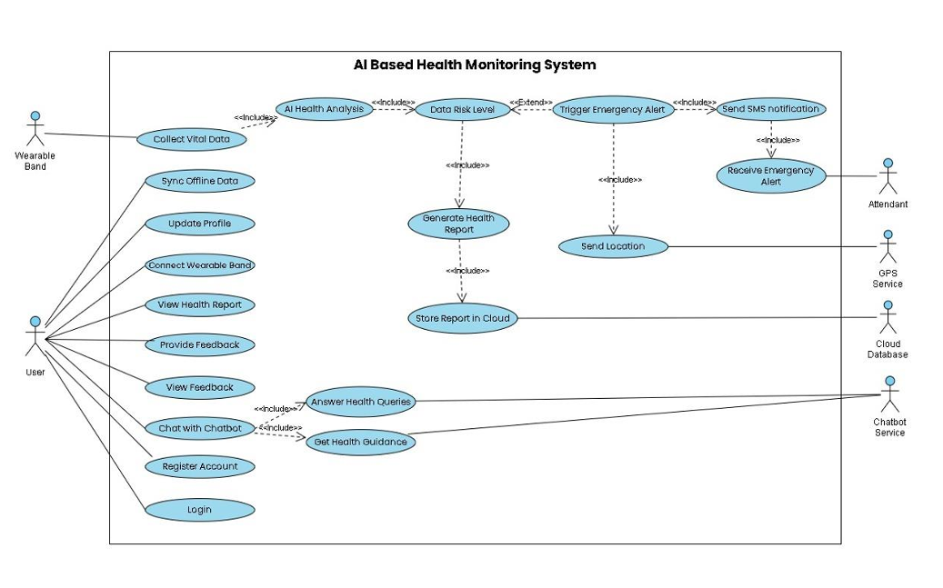
The use case analysis determines the key actors, the secondary actors, and their interaction with the proposed system giving an effective view of systems capabilities and stakeholder involvement. The analysis is based on the accepted use case modeling principles in software engineering to systematically articulate the system requirements in user-friendly perspectives.

Figure 2: Usecase of Cardiva
The User is the main participant and this is the person who wears the health monitoring device and uses the mobile application to monitor his or her health continuously. The system is used by the User in various use cases such as registering account and profile data, specifying emergency contacts information, putting on the monitoring device during the daily activities, checking recent vital signs data, analyzing past health trends, obtaining a summary of health information after monitoring the data in designated time frames, and emergency alerts when critical conditions are detected. User actor will be the main stakeholder whose health monitoring needs will be the functional requirements of the system.
Another secondary actor is the Attendant, who is the appointed emergency contact person sent SMS alerts in case of a health crisis. The Attendant is not directly connected to the system when it is operating normally but is involved when automatic notifications are sent because of emergency situations. The participation of the Attendant is passive in the system interaction perspective (they obtain information and do not give input), but paramount in the emergency response perspective (they are the human response channel after automated emergency detection).
Wearable Device acts as a non-human agent that triggers a number of systems processes. Although the wearable device is not a human stakeholder, it is an autonomous system element that will constantly monitor the vital signs measurements and relay the information to the mobile application at specific intervals. This actor is the sensing subsystem which supplies the underlying physiological information on which all the analysis and decision-making it follows.
Another non-human actor is the Cloud Service that offers data persistence and data retrieval services. The Cloud Service actor takes the request of the mobile application to save vital sign information, retrieve past measurements, and have health reports. This actor is a reflection of the back-office infrastructure that helps to maintain longitudinal data management that cannot be offered by individual mobile devices.
The SMS Gateway is the external communication service which will be used to provide emergency alert messages. The SMS Gateway actor is in use when the mobile application builds and transfers emergency SMS messages, the actual message transmission is done to specific recipients. This actor is the telecommunications infrastructure that allows the notification of emergencies.
The GPS Service is an actor that will give the mobile application the geographic location data in case of an emergency. Under emergency conditions, the mobile application uses the GPS Service to retrieve the present coordinates that are later added to emergency alert messages. This actor embodies the place-consciousness capabilities required in responding to an emergency.
The system is characterized by interactions between these actors, which determine the functional scope of the system. The User engages with the mobile application to set the settings, access data and get information. The Wearable Device sends the vital sign information to the mobile application continuously without the need of user intervention. The mobile application is the focal coordinator, which communicates with the Cloud Service to store the data, the GPS Service to provide the location information in case of an emergency and the SMS Gateway to send the alert. The SMS Gateway is the receiving side of the notification of the emergency and provides the Attendant with the information.
These interactions are captured by key use cases such as Monitor Vital Signs, where the Wearable Device continuously measures physiological parameters and sends the measurements to the mobile application to be displayed and analyzed; Analyze Health Trends, where the mobile application processes accumulated measurements of vital signs to detect trends in health status and classify the health status by condition, whereas; Generate Health Report, where the User requests the system and the system generates comprehensive summaries of measurements of vital signs over a given time period; Detect Emergency Condition, where the mobile application analysis functions identify patterns in health status and classify the health status
This use case model indicates the distributed character of the system, with other actors in charge of various functionality sectors. The design focuses on automation of data collection and emergency detection, which lowers the level of interaction that users have to with the application during its normal operation, and gives the users extensive access to information when they actively utilize the application. The fact that there are human actors (User, Attendant) as well as system actors (Wearable Device, Cloud Service, GPS Service, SMS Gateway) reflects the fact that health monitoring systems are socio-technical in nature because technological capabilities have to be embedded in human needs and behaviors.

Detailed Use Case Specifications
This section provides structured specifications for the primary use cases identified in the system design, detailing the goals, participating actors, preconditions, postconditions, and normal flow of interactions for each critical system function.

Use Case 1: Monitor Vital Signs
Goal: Continuously collect and display heart rate, oxygen saturation, and body temperature measurements to enable ongoing health assessment.
Actors: Patient
Supporting Actors: Wearable Band Sensors, Mobile Application, System AI
Purpose:
To continuously monitor the patient’s vital signs (heart rate, oxygen level, and body temperature) using wearable sensors and transmit the data to the mobile application.

Preconditions:
- Patient is wearing the wearable band properly.
- Sensors are functioning correctly.
- Wearable band is connected to the mobile application via Bluetooth/Internet.
Post-conditions:
- Real-time vital signs data is successfully transmitted to the mobile app.
- Data is stored temporarily for further AI analysis.
Overview:
- Wearable band sensors continuously measure heart rate, SpO₂, and body temperature.
- Data is transmitted to the connected mobile application.
- System validates and stores incoming vital data for further processing.
Table 3: Use Case 1 - Monitor Vital Signs
Typical Course of Actions
Flow | Response
- Patient wears the wearable band. | - System activates sensors and establishes connection with mobile app.
- Sensors measure heart rate, oxygen level, and temperature continuously. | - System collects and validates real-time vital data.
- Data is transmitted to the mobile application. | - System stores data temporarily for analysis.
Alternative Course of Actions
Flow | Response
- Wearable band battery is low. | - System sends low battery notification to the user.
- Bluetooth connection is unstable. | - System attempts automatic reconnection and notifies user if failed.
Exception Flow
Flow | Response
- Sensor malfunction occurs. | - System logs error and prompts user to check device.
- No data received for extended period. | - System flags monitoring interruption and alerts user.

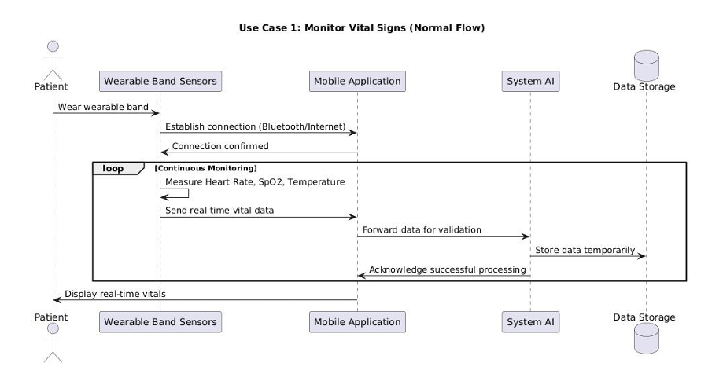
Figure 3: Sequence Diagram of Usecase 1

Use Case 2: Analyze Health Trends
Goal: Evaluate temporal patterns in vital sign data to classify the user's health status as normal, stable, or deteriorating, providing actionable health assessment to non-clinical users.
Actors: Patient
Supporting Actors: System AI, Mobile Application
Purpose:
To analyze collected vital signs data using AI algorithms and determine whether the user’s health status is normal, stable, or deteriorating.
Preconditions:
- Vital signs data is available from wearable sensors.
- AI analysis module is active and configured.
Post-conditions:
- Health status classification (Normal / Stable / Deteriorating) is generated.
- Trend patterns are identified and stored for reporting.
Overview:
- System AI receives real-time and historical vital data.
- AI algorithms analyze patterns and fluctuations in vitals.
- System classifies health condition into predefined categories.
- Analysis results are prepared for report generation.

Table 4: Use Case 2 - Analyze Health Trends
Typical Course of Actions
Flow | Response
1. Vital data becomes available. | 1. AI module retrieves real-time and historical data.
2. AI analyzes patterns and variations. | - System evaluates trends and compares with thresholds.
3. Health status is determined. | - System classifies condition as Normal, Stable, or Deteriorating.
Alternative Course of Actions
Flow | Response
- Insufficient historical data available. | - System performs analysis using available real-time data only.
Exception Flow
Flow | Response
- AI module processing failure. | - System logs error and restarts analysis service.
- Corrupted data detected. | - System discards invalid data and requests fresh input.
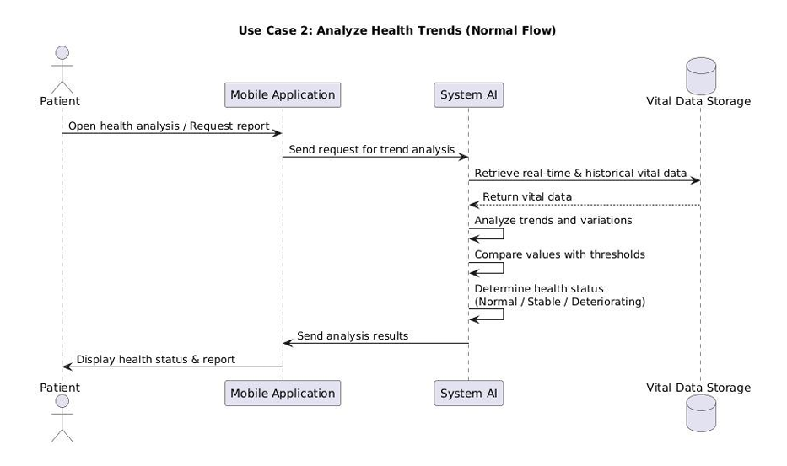
Figure 4: Sequence Diagram of Usecase 2

Use Case 3: Generate Health Report
Goal: Produce comprehensive summaries of vital sign data, health status classifications, and identified patterns over user-specified time periods to support longitudinal health tracking and communication with healthcare providers.
Actors: Patient
Supporting Actors: System AI, Mobile Application, Cloud Database
Purpose:
To generate a comprehensive health report based on AI analysis and store it for long-term record maintenance.
Preconditions:
- Health trend analysis has been completed.
- User has a registered unique ID in the system.
Post-conditions:
- Health report is displayed on the mobile application.
- Report is stored in the cloud database under the user’s unique ID.
Overview:
- System compiles analyzed data into a structured health report.
- Report includes vital summaries, trends, and health status.
- Report is shown in the mobile app dashboard.
- Report is synchronized and saved in cloud storage.
Table 5: Use Case 3 - Generate Health Report
Typical Course of Actions
Flow | Response
- Health analysis is completed. | - System compiles analysis results into structured report.
- User opens app dashboard. | - System displays health report with trends and status.
3. Report is finalized. | - System stores report in cloud under user’s unique ID.
Alternative Course of Actions
Flow | Response
- User is offline. | - System stores report locally and syncs later when internet is available.
Exception Flow
Flow | Response
- Cloud storage failure. | - System retries synchronization and logs failure if persistent.
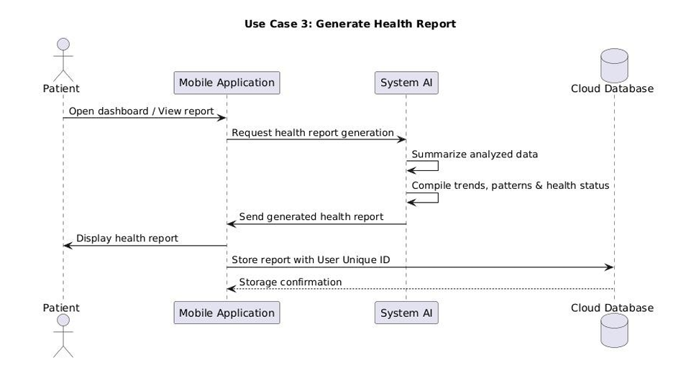
Figure 5: Sequence Diagram of Usecase 3

Use Case 4: Detect Emergency Condition
Goal: Automatically identify critical health situations based on vital sign abnormalities and deterioration patterns, enabling rapid response without requiring user recognition of the emergency.
Actors: Patient
Supporting Actors: System AI, Mobile Application
Purpose:
To identify serious or emergency health conditions based on abnormal vital readings.
Preconditions:
- Continuous vital monitoring is active.
- Emergency threshold values are predefined in the system.
Post-conditions:
- Emergency status is triggered if abnormal condition is detected.
- Alert process is initiated automatically.
Overview:
- AI compares incoming vitals with critical threshold values.
- Sudden drops or spikes in heart rate, oxygen, or temperature are detected.
- System flags emergency condition.
- Emergency response workflow is activated.
Typical Course of Actions
Flow | Response
- Abnormal vital reading occurs. | - System compares reading with emergency thresholds.
- Critical pattern is detected. | - System flags emergency status.
3. Emergency workflow is triggered. | - System initiates alert and GPS retrieval process.
Alternative Course of Actions
Flow | Response
- Slight abnormality detected. | - System generates warning notification instead of emergency alert.
Exception Flow
Flow | Response
- False positive detection. | - System revalidates data before triggering full emergency protocol.
Table 6: Use Case 4 - Detect Emergency Condition
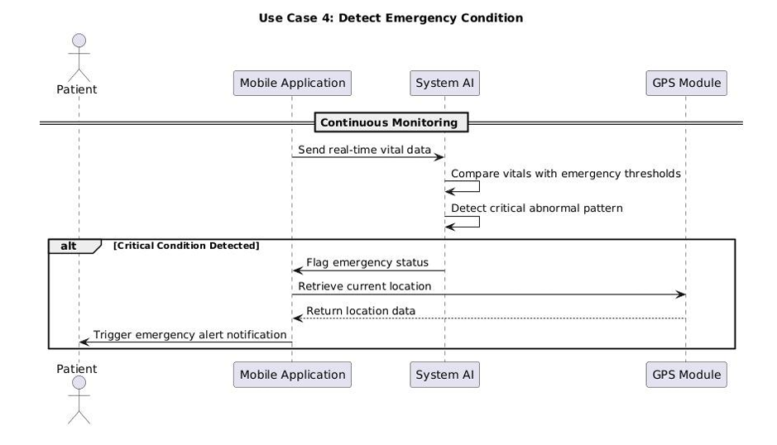
Figure 6: Sequence Diagram of Usecase 4

Use Case 5: Retrieve GPS Location
Goal: Obtain the user's current geographic coordinates during emergency scenarios to enable rapid localization for assistance.
Actors: Patient
Supporting Actors: Mobile Application, GPS Module, System AI
Purpose:
To retrieve the patient’s real-time geographic location during an emergency situation.
Preconditions:
- Emergency condition has been detected.
- GPS services are enabled on the mobile device.
Post-conditions:
- Accurate current location coordinates are retrieved.
- Location data is attached to emergency alert message.
Overview:
- System requests real-time GPS access from the mobile device.
- Current latitude and longitude coordinates are obtained.
- Location data is validated.
- Coordinates are prepared for SMS alert transmission.

Table 7: Use Case 5 - Retrieve GPS Location
Typical Course of Actions
Flow | Response
- Emergency is confirmed. | - System requests GPS access from device.
- GPS module activates. | - System retrieves latitude and longitude coordinates.
3. Location data is obtained. | - System attaches location to alert message.
Alternative Course of Actions
Flow | Response
- Weak GPS signal. | - System attempts multiple location requests to improve accuracy.
Exception Flow
Flow | Response
- GPS disabled by user. | - System sends alert without location and notifies user to enable GPS.
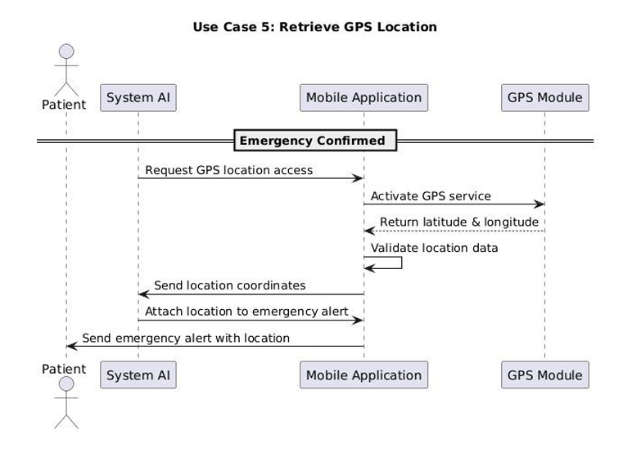
Figure 7: Sequence Diagram of Usecase 5

Use Case 6: Send Emergency Alert
Goal: Transmit SMS messages containing health status and location information to the user and designated emergency contact, enabling rapid awareness and response to critical health situations.
Actors: Patient
Supporting Actors: System AI, SMS Gateway, Registered Attendant
Purpose:
To send immediate SMS alerts to the patient and their registered attendant in case of an emergency.
Preconditions:
- Emergency condition has been confirmed.
- GPS location has been retrieved successfully.
- Registered contact details are available in the system.
Post-conditions:
- SMS alert containing health status and location details is sent to both patient and attendant.
- Alert log is recorded in the system.
Overview:
- System composes emergency message with condition details.
- GPS location link is embedded in the SMS.
- SMS gateway sends alert to registered contacts.
- System logs alert notification for record keeping.
Typical Course of Actions
Flow | Response
- Emergency and location confirmed. | - System composes emergency SMS with health and location details.
- System accesses registered contacts. | - SMS is sent to patient and registered attendant.
3. Alert delivery completes. | - System logs alert history.
Alternative Course of Actions
Flow | Response
- SMS delivery delay. | - System retries sending message.
Exception Flow
Flow | Response
- Invalid contact number. | - System logs error and notifies user to update contact details.
Table 8: Use Case 6 - Send Emergency Alert

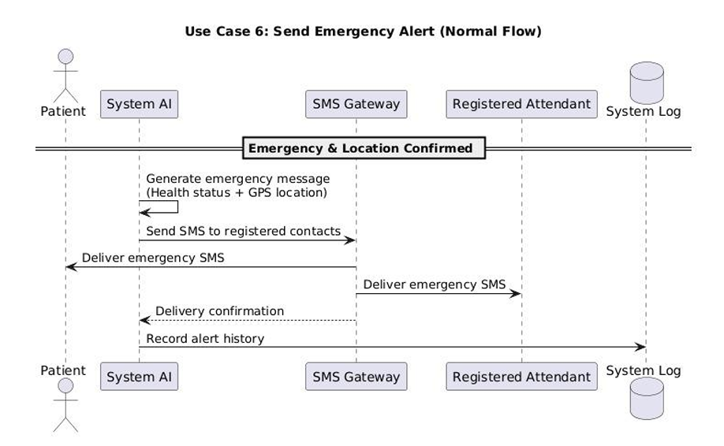
Figure 8: Sequence Diagram of Usecase 6

Use Case 7: Synchronize Cloud Data
Goal: Maintain consistency between local mobile database and cloud storage, ensuring data durability and enabling access from multiple devices.
Actors: Patient
Supporting Actors: Mobile Application, Cloud Database
Purpose:
To synchronize user health data and reports with the cloud database for long-term storage and accessibility.
Preconditions:
- Internet connection is available.
- User is authenticated with a unique ID.
Post-conditions:
- All health records are updated in cloud storage.
- Long-term health history is maintained securely.
Overview:
- Mobile application prepares health data for synchronization.
- Data is encrypted and transmitted to cloud server.
- Cloud database updates records under user’s unique ID.
- Confirmation of successful synchronization is sent to the app.

Table 9: Use Case 7 - Synchronize Cloud Data
Typical Course of Actions
Flow | Response
1. Internet connection is available. | 1. System prepares encrypted health data package.
2. Sync process starts. | 1. Data is transmitted to cloud server.
3. Upload completes successfully. | 1. Cloud database updates user’s records and confirms synchronization.
Alternative Course of Actions
Flow | Response
1. Slow internet connection. | 1. System performs partial synchronization and resumes automatically.
Exception Flow
Flow | Response
1. Authentication failure. | 1. System denies sync request and prompts user to re-login.
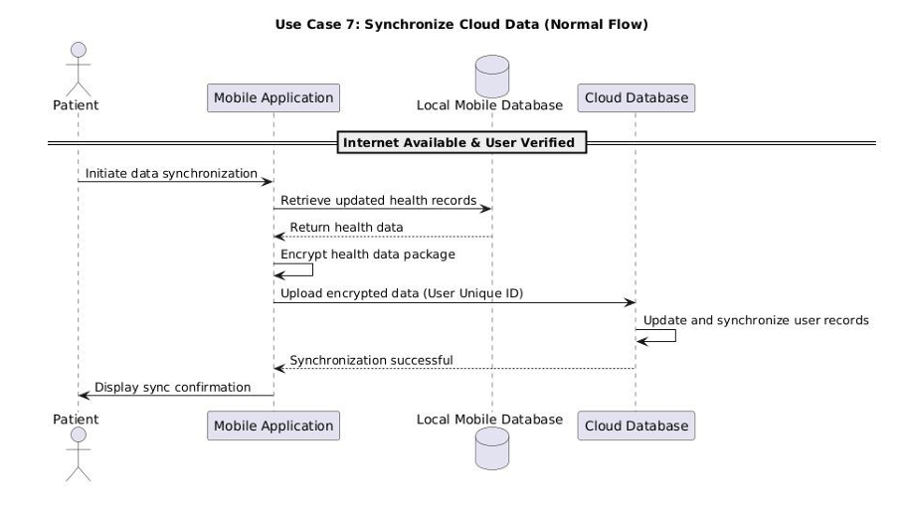
Figure 9: Sequence Diagram of Usecase 7

Software Architecture Design
The software architecture of the mobile application component represents the most complex element of the system design, implementing the intelligence layer that transforms raw vital sign data into actionable health insights while coordinating interactions with wearable sensors, cloud services, and emergency notification mechanisms. This section details the architectural patterns, module organization, and design principles governing the mobile application's structure.
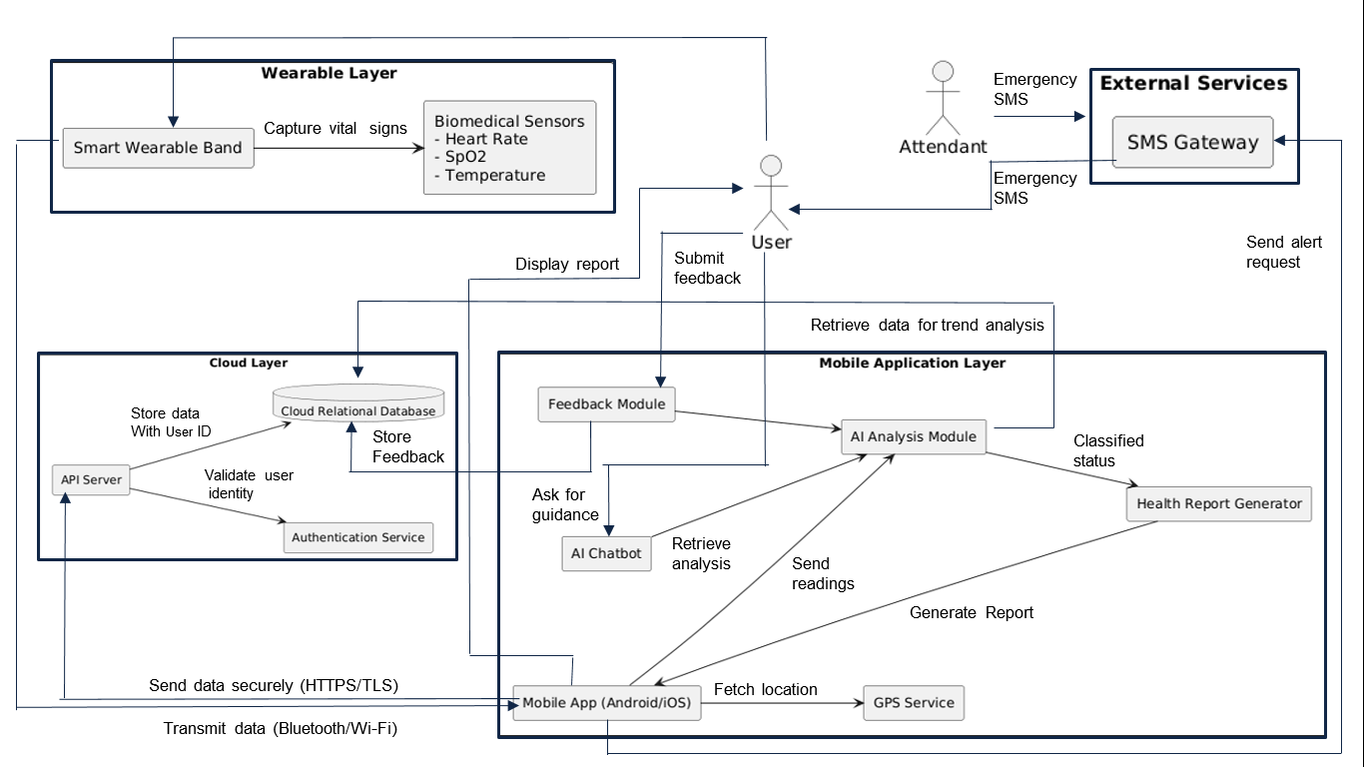
Figure 10: Detailed system Architecture Diagram of Cardiva
The mobile application architecture employs a layered design pattern consisting of five primary layers: the Presentation Layer, the Business Logic Layer, the Data Access Layer, the Communication Layer, and the Integration Layer. This layered approach follows established software architecture principles documented in software engineering literature, promoting separation of concerns, modularity, maintainability, and testability while enabling independent evolution of each layer.
The Presentation Layer encompasses all user interface components responsible for displaying information to users and capturing user input. This layer implements the "View" component of the Model-View-Controller pattern, rendering screens for vital sign display, health trend visualization, report viewing, settings configuration, and alert notifications. The design emphasizes clarity and accessibility, presenting health status information in formats comprehensible to non-clinical users while providing access to detailed vital sign data for users desiring deeper engagement. The Presentation Layer communicates exclusively with the Business Logic Layer, never directly accessing data storage or external services, ensuring that user interface modifications can be implemented without impacting core system functionality. The layer implements responsive design principles to accommodate diverse screen sizes across smartphones and tablets, with layout adaptation based on available display real estate.
The Business Logic Layer contains the core intelligence of the mobile application, implementing the algorithmic processing that analyzes vital sign data, classifies health status, detects emergencies, and generates reports. This layer is organized into several specialized modules, each responsible for distinct functional domains. The Vital Sign Analysis Module implements statistical processing to calculate baseline values, identify trends, and evaluate deviations from normal patterns for each monitored vital sign. This module maintains individual user baselines that evolve over time as additional monitoring data accumulates, enabling personalized assessment rather than reliance on population-average thresholds. The Health Status Classification Module implements the conceptual AI-based logic that examines multi-parameter vital sign patterns and temporal trends to categorize health status as normal, stable, or deteriorating. This module considers both individual vital sign trends and correlations between parameters, recognizing that combinations of abnormalities may indicate different health concerns than isolated deviations. The Emergency Detection Module evaluates incoming vital signs against critical threshold ranges and examines rapid deterioration patterns to identify conditions warranting immediate intervention. This module implements multi-criteria decision logic combining threshold violations, trend analysis, and pattern recognition to balance sensitivity in detecting genuine emergencies with specificity in avoiding false alarms. The Report Generation Module processes accumulated vital sign data to produce structured health summaries over user-specified time periods, calculating summary statistics and identifying notable events for inclusion in reports. The Business Logic Layer maintains no persistent state itself, instead relying on the Data Access Layer for data persistence and retrieval, enabling the logic to focus purely on processing and decision-making.
The Data Access Layer provides an abstraction interface between the Business Logic Layer and the underlying local database, implementing all database operations including data insertion, retrieval, updates, and deletions. This layer employs the Repository design pattern, exposing methods that the Business Logic Layer invokes to persist and access data without requiring knowledge of database implementation details. The Data Access Layer manages the local SQLite database containing tables for user profiles, vital sign measurements, health status classifications, generated reports, and emergency events. The layer implements transaction management to ensure data consistency, particularly during complex operations that modify multiple related records. The design includes caching mechanisms to optimize performance for frequently accessed data, such as recent vital sign measurements displayed on the main interface. By centralizing all database interactions within this layer, the architecture enables database schema evolution or even database technology replacement without requiring modifications to business logic or presentation components.
The Communication Layer manages all network interactions with external services, including the Cloud Service for data synchronization and the SMS Gateway for emergency alerting. This layer implements HTTP client functionality for invoking RESTful API endpoints exposed by the Cloud Service, handling request construction, response parsing, and error recovery for network operations. The layer incorporates retry logic with exponential backoff to handle transient network failures, ensuring that temporary connectivity issues do not result in data loss. For SMS transmission, the layer interfaces with the smartphone's native messaging capabilities or third-party SMS gateway APIs, constructing properly formatted messages and handling transmission confirmation. The Communication Layer also manages the Bluetooth Low Energy connection with the wearable device, implementing pairing, connection maintenance, and data reception from the sensor platform. The layer operates asynchronously to prevent network operations from blocking the user interface or other application functionality, employing background threads or asynchronous programming constructs appropriate to the mobile platform.
The Integration Layer provides interfaces to smartphone platform services including GPS location services for emergency localization, local notification services for alerting users to detected health concerns, and background task management for continued data collection and analysis when the application is not actively in use. This layer abstracts platform-specific APIs behind generic interfaces, facilitating potential cross-platform implementation where the core Business Logic Layer could be shared between Android and iOS versions while the Integration Layer provides platform-appropriate service access.
The architectural design implements several cross-cutting concerns that span multiple layers. Security mechanisms including data encryption for cloud transmission and local database encryption protect sensitive health information throughout its lifecycle within the application. The architecture incorporates encryption of vital sign data before transmission to the Cloud Service using TLS protocols, and optionally encrypts the local SQLite database using platform-provided encryption capabilities. Logging and diagnostics mechanisms distributed across all layers capture information about application behavior, errors, and performance metrics to support troubleshooting and optimization. Error handling strategies implement graceful degradation, where failures in non-critical components such as cloud synchronization do not prevent core vital sign monitoring functionality from continuing to operate.
The conceptual AI-based analysis module, residing primarily within the Business Logic Layer's Health Status Classification Module, implements a hybrid approach combining rule-based logic with statistical trend analysis. The module maintains a knowledge base of clinically-informed rules that define concerning vital sign patterns, such as simultaneous elevation of heart rate and body temperature suggesting fever with systemic response. The statistical trend analysis component examines temporal patterns in each vital sign, calculating metrics such as rate of change, variability, and deviation from individual baselines. These statistical metrics feed into the classification logic, which weights multiple factors to arrive at an overall health status categorization. The design deliberately avoids claiming clinical diagnosis capability, instead focusing on pattern recognition and trend identification that inform users about whether their vital signs appear normal or warrant medical consultation.
The software architecture emphasizes scalability and extensibility to accommodate future system evolution. The modular organization enables addition of new vital signs by extending the Vital Sign Analysis Module and modifying the Health Status Classification Module's logic without restructuring the entire application. The layered design facilitates technology upgrades, such as migration to different cloud services or database systems, by confining changes to specific layers. The separation of user interface from business logic enables interface redesigns based on user feedback without modifying analytical algorithms.
This architectural design synthesizes established software engineering patterns with domain-specific requirements of health monitoring applications, creating a structure that balances analytical sophistication with practical implementation feasibility, user experience quality with system robustness, and current functional requirements with future extensibility.

Entity Relationship Diagram (ERD) and Database Design
The database design defines the persistent data structures that capture user information, vital sign measurements, health assessments, and system events, supporting both local mobile storage and cloud-based long-term archival. This section describes the entity-relationship model and associated database schema that implements the system's data management requirements.
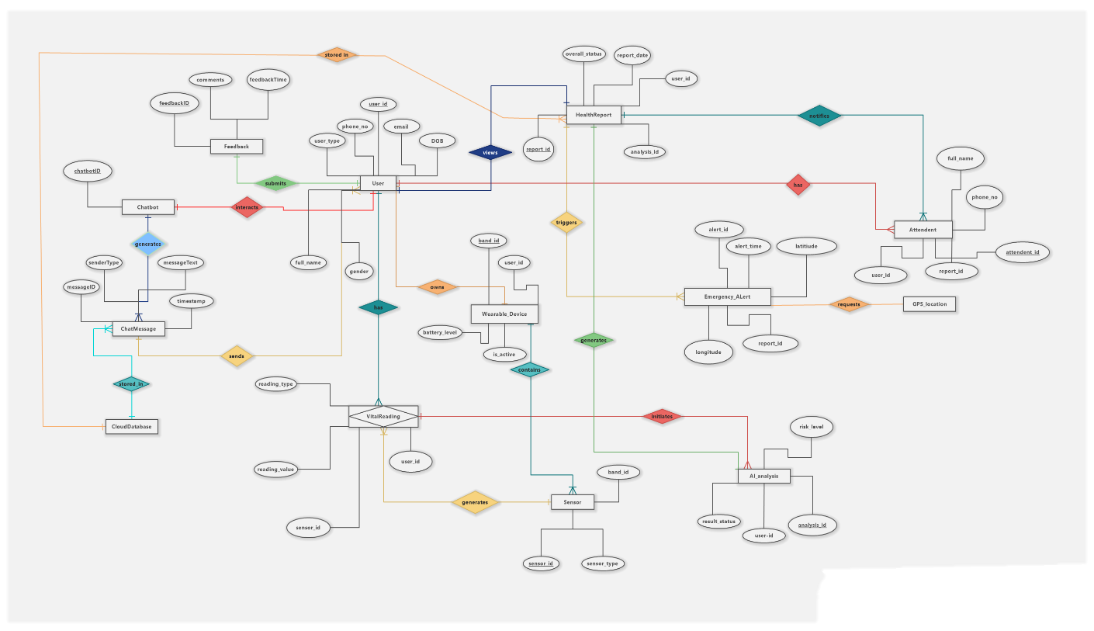
Figure 11: Detailed ERD of Cardiva
The database schema comprises six primary entities: User, VitalSignMeasurement, HealthStatusRecord, HealthReport, EmergencyEvent, and SystemConfiguration. These entities and their relationships implement the data model necessary to support all use cases identified in Section 4.1.3 while maintaining data integrity and enabling efficient querying.
The User entity represents individuals using the health monitoring system, storing profile information and serving as the primary key for all user-specific data. The User entity contains attributes including UserID (a unique identifier assigned during registration, serving as the primary key), Name (the user's full name), DateOfBirth (used to calculate age, which may inform health status interpretation), Gender (which can influence normal vital sign ranges), ContactNumber (the user's phone number), EmergencyContactName (the designated Attendant's name), EmergencyContactNumber (the Attendant's phone number for SMS alerts), RegistrationDate (timestamp of account creation), and LastLoginDate (tracking most recent application access). The UserID attribute employs a universally unique identifier (UUID) format to ensure global uniqueness across distributed system instances, enabling potential future federation of multiple monitoring system deployments. The User entity establishes one-to-many relationships with VitalSignMeasurement, HealthStatusRecord, HealthReport, and EmergencyEvent entities, reflecting that each user accumulates many measurements, assessments, reports, and potential emergency events over time.
The VitalSignMeasurement entity captures individual vital sign readings collected from the wearable device, representing the fundamental data upon which all analysis depends. This entity contains attributes including MeasurementID (unique identifier for each measurement record), UserID (foreign key referencing the User entity, establishing which user the measurement belongs to), Timestamp (date and time when the measurement was collected), HeartRate (measured beats per minute), OxygenSaturation (SpO₂ percentage), BodyTemperature (measured in Celsius), and SyncStatus (a flag indicating whether the measurement has been synchronized to cloud storage). The Timestamp attribute is critical for temporal analysis, enabling trend calculation and historical querying. The SyncStatus flag supports the data synchronization mechanism described in Use Case 7, allowing the application to identify which measurements require upload to the cloud. The entity implements indexes on UserID and Timestamp attributes to optimize queries retrieving measurements for specific users within specified time ranges, a common access pattern for trend analysis and report generation.
The HealthStatusRecord entity stores the results of health status classification performed by the AI-based analysis module, documenting the system's assessment of user health over time. This entity contains attributes including RecordID (unique identifier), UserID (foreign key to User), Timestamp (when the classification was performed), HealthStatus (an enumerated value of Normal, Stable, or Deteriorating), AnalysisWindow (the time period analyzed, such as "24 hours"), and Notes (optional textual explanation of factors contributing to the classification, such as "elevated heart rate trend with stable SpO2 and temperature"). The HealthStatus attribute implements a controlled vocabulary ensuring consistency in classification categories. The relationship between HealthStatusRecord and User is one-to-many, as each user receives multiple health status assessments over the monitoring period. The temporal sequence of HealthStatusRecord entries for a given user documents the progression of their health status, enabling identification of concerning patterns such as transition from Normal to Stable to Deteriorating classifications.
The HealthReport entity represents generated summary documents that synthesize vital sign data over specified time periods, as described in Use Case 3. This entity contains attributes including ReportID (unique identifier), UserID (foreign key to User), GenerationDate (when the report was created), ReportStartDate (beginning of the reporting period), ReportEndDate (end of the reporting period), SummaryStatistics (structured data containing calculated averages, minimums, maximums, and standard deviations for each vital sign), NotableEvents (textual description of significant occurrences during the reporting period), and CloudStorageURL (reference to the report's location in cloud storage). The SummaryStatistics attribute stores JavaScript Object Notation (JSON) or similar structured data encoding multiple statistical measures, enabling flexible report content without rigid schema constraints. The relationship between HealthReport and User is one-to-many, as users can generate multiple reports covering different time periods or overlapping periods for comparison.
The EmergencyEvent entity documents detected health emergencies and associated alert transmissions, creating an audit trail of critical situations and system responses. This entity contains attributes including EventID (unique identifier), UserID (foreign key to User), DetectionTimestamp (when the emergency was detected), TriggerCondition (description of the vital sign abnormality or pattern that triggered emergency classification, such as "Heart rate 148 bpm exceeds critical threshold"), GPSLatitude (geographic latitude at time of detection), GPSLongitude (geographic longitude at time of detection), AlertSentToUser (boolean indicating whether SMS alert was successfully transmitted to user), AlertSentToAttendant (boolean indicating whether SMS alert was successfully transmitted to emergency contact), ResolutionTimestamp (when the emergency condition resolved, if applicable), and ResolutionNotes (optional documentation of how the emergency was resolved). The EmergencyEvent entity implements a complete record of emergency detection and response, supporting post-event review and system performance evaluation. The relationship between EmergencyEvent and User is one-to-many, as users may experience multiple emergency events over extended monitoring periods.
The SystemConfiguration entity stores application settings and parameters that control system behavior, including vital sign threshold values, analysis algorithm parameters, and user preferences. This entity contains attributes including ConfigID (unique identifier), UserID (foreign key to User, as configurations are user-specific), HeartRateMinThreshold (minimum heart rate value before emergency detection), HeartRateMaxThreshold (maximum heart rate value before emergency detection), SpO2MinThreshold (minimum oxygen saturation before emergency detection), TemperatureMinThreshold (minimum body temperature before emergency detection), TemperatureMaxThreshold (maximum body temperature before emergency detection), AnalysisFrequency (how often health status classification is performed), and SyncFrequency (how often cloud synchronization occurs). The ability to customize threshold values accommodates individual physiological variations, enabling users with known baseline abnormalities (such as athletes with low resting heart rates) to adjust thresholds appropriately. The relationship between SystemConfiguration and User is one-to-one, as each user has a single active configuration at any time, though the design could be extended to support configuration history tracking.
The entity relationships implement referential integrity through foreign key constraints, ensuring that child entities (VitalSignMeasurement, HealthStatusRecord, HealthReport, EmergencyEvent, SystemConfiguration) always reference valid User entities. Cascade delete behaviors are defined such that deletion of a User entity (should a user choose to remove their account) automatically deletes all associated child records, maintaining database consistency. Index structures on frequently queried attributes, particularly UserID in all child entities and Timestamp in VitalSignMeasurement and HealthStatusRecord entities, optimize query performance for common operations such as retrieving a specific user's recent vital signs or health status history.
The database schema is implemented identically in both the local SQLite database on the mobile device and the cloud-based database, ensuring structural consistency that simplifies synchronization logic. The local database provides immediate access to recent data and offline functionality, while the cloud database provides durability and capacity for long-term storage. The unique UserID attribute serves as the primary key for data segregation in the cloud, with access control policies ensuring that users can only access their own data while system administrators can perform aggregate analysis across de-identified datasets for system monitoring and improvement.
This entity-relationship design captures all data elements necessary to support the system's functional requirements while maintaining normalization principles that minimize data redundancy and ensure update consistency. The schema balances storage efficiency with query performance, providing a robust foundation for the system's data management requirements.

Activity Diagram: Anomaly Detection and Alert Flow
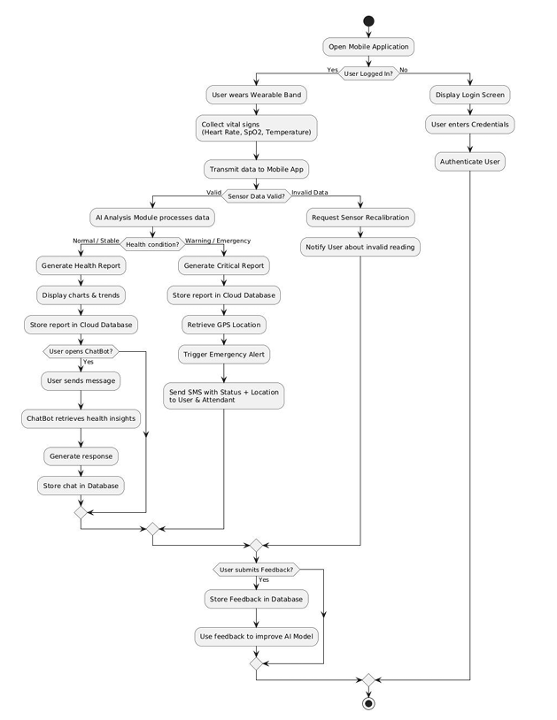
Figure 12: Activity Diagram of Cardiva
The activity flow begins with the initial state where the wearable device is active and paired with the mobile application. From this initial state, continuous parallel activities execute: vital sign acquisition and health status analysis.
The vital sign acquisition activity initiates when the wearable device's internal timer triggers a measurement cycle, typically every 60 seconds. The wearable's sensors simultaneously capture heart rate through PPG signal analysis, oxygen saturation through dual-wavelength pulse oximetry, and body temperature through thermistor resistance measurement. These three sensing processes execute in parallel, completing within a brief time window of approximately 10-15 seconds. Upon completion of all three measurements, the wearable packages the vital sign values with a timestamp into a structured data packet. The wearable then transmits this packet to the mobile application via the established Bluetooth Low Energy connection. The mobile application receives the data packet, validates data integrity by checking packet structure and value ranges for basic plausibility, and stores the validated measurements in the local database with the UserID and timestamp. The user interface is updated to display the most recent vital sign values. This vital sign acquisition activity then waits for the next timer trigger, creating a continuous loop of measurement, transmission, storage, and display.
In parallel with vital sign acquisition, the health status analysis activity executes periodically, typically every 6 hours or when a configurable number of new measurements have accumulated. This activity retrieves recent vital sign measurements from the local database, typically covering the past 24-48 hours, to establish the analysis window. The analysis module calculates individual baselines for each vital sign by computing mean values and standard deviations from historical data, establishing personalized normal ranges. The module then examines the most recent measurements against these baselines, calculating deviation magnitudes and identifying temporal trends such as progressive increases or decreases in vital sign values.
A critical decision point occurs where the analysis module evaluates whether detected patterns indicate normal function, stable condition, or deteriorating health. If all vital signs remain within individual baseline ranges with no concerning trends, the health status is classified as Normal. If minor deviations are present but stable without progressive worsening, the status is classified as Stable. If significant adverse trends are detected, such as progressive elevation in multiple vital signs or rapid deterioration in any parameter, the status is classified as Deteriorating. The classification result is stored in the database as a HealthStatusRecord and displayed to the user through the application interface. The analysis activity then waits for the next scheduled execution interval.
The anomaly detection activity executes each time new vital sign measurements are received, evaluating whether emergency conditions are present. This activity implements multiple parallel evaluation paths that assess different emergency criteria.
The first evaluation path examines individual vital sign thresholds, checking whether heart rate is below 40 bpm or above 140 bpm, whether oxygen saturation is below 85%, or whether body temperature is below 35°C or above 40°C. These threshold values represent severe abnormalities that may indicate life-threatening conditions based on clinical literature. If any threshold is violated, this path flags a potential emergency condition.
The second evaluation path analyzes temporal trends, examining whether heart rate has increased by more than 30 bpm over the past 4 hours, whether oxygen saturation has decreased by more than 5% over the past 2 hours, or whether body temperature has increased by more than 1.5°C over the past 6 hours. These trend criteria identify rapid deterioration that may precede critical threshold violations, enabling earlier intervention. If any concerning trend is detected, this path flags a potential emergency condition.
The third evaluation path examines multi-parameter patterns, identifying combinations of vital sign abnormalities that collectively suggest specific emergency scenarios. For example, simultaneously elevated body temperature and heart rate with normal or slightly reduced oxygen saturation may indicate fever with systemic stress, while reduced oxygen saturation with elevated heart rate may suggest respiratory compromise with compensatory cardiac response. This pattern-based evaluation implements domain knowledge about physiological relationships between vital signs. If concerning multi-parameter patterns are present, this path flags a potential emergency condition.
A consolidation decision point evaluates the flags from all three evaluation paths using Boolean OR logic, if any path has flagged a potential emergency, the overall decision is that an emergency condition exists. This design prioritizes sensitivity in emergency detection, ensuring that diverse manifestations of health crises trigger the alert pathway.
If no emergency condition is detected, the activity flow returns to the monitoring state, awaiting the next vital sign measurement. If an emergency condition is detected, the activity flow proceeds to the emergency response sequence.
The emergency response sequence begins with retrieving the user's current GPS location by invoking the smartphone's location services. This GPS acquisition may take 10-30 seconds depending on satellite visibility and prior location fix recency. Concurrently, the application constructs the emergency alert message text, describing the detected emergency condition with vital sign values and including relevant context. Once both GPS coordinates and message text are ready, the application composes two SMS messages: one addressed to the user's own phone number and one addressed to the configured emergency contact. The SMS Gateway is invoked to transmit both messages. The application creates an EmergencyEvent record in the database documenting the detection timestamp, trigger condition, GPS coordinates, and alert transmission status.
A decision point evaluates whether alert transmission succeeded. If both SMS messages were successfully sent, the application displays an emergency alert notification to the user confirming that help has been notified and providing the emergency contact's number. If SMS transmission failed for any reason, the application displays an alert to the user indicating the emergency detection and advising them to manually contact emergency services, also providing fallback contact methods.
Following alert transmission, the activity flow enters an emergency monitoring state where vital signs continue to be acquired and analyzed but with increased frequency, measurements may accelerate to every 30 seconds rather than 60 seconds. The system monitors for resolution of the emergency condition, which may occur if vital signs return to normal ranges and concerning trends dissipate. When resolution is detected, the application updates the EmergencyEvent record with a resolution timestamp and optionally sends follow-up SMS messages indicating that the emergency appears to have resolved. The activity flow then returns to normal monitoring mode.
This activity diagram illustrates the autonomous, continuous operation of the health monitoring system, demonstrating how vital sign acquisition, analysis, emergency detection, and alert transmission processes coordinate to provide comprehensive health surveillance with automated crisis response. The design emphasizes parallel execution of independent activities, multiple evaluation criteria for emergency detection, and graceful handling of both successful and failed alert transmission scenarios.

Sequence Diagram: Cardiva
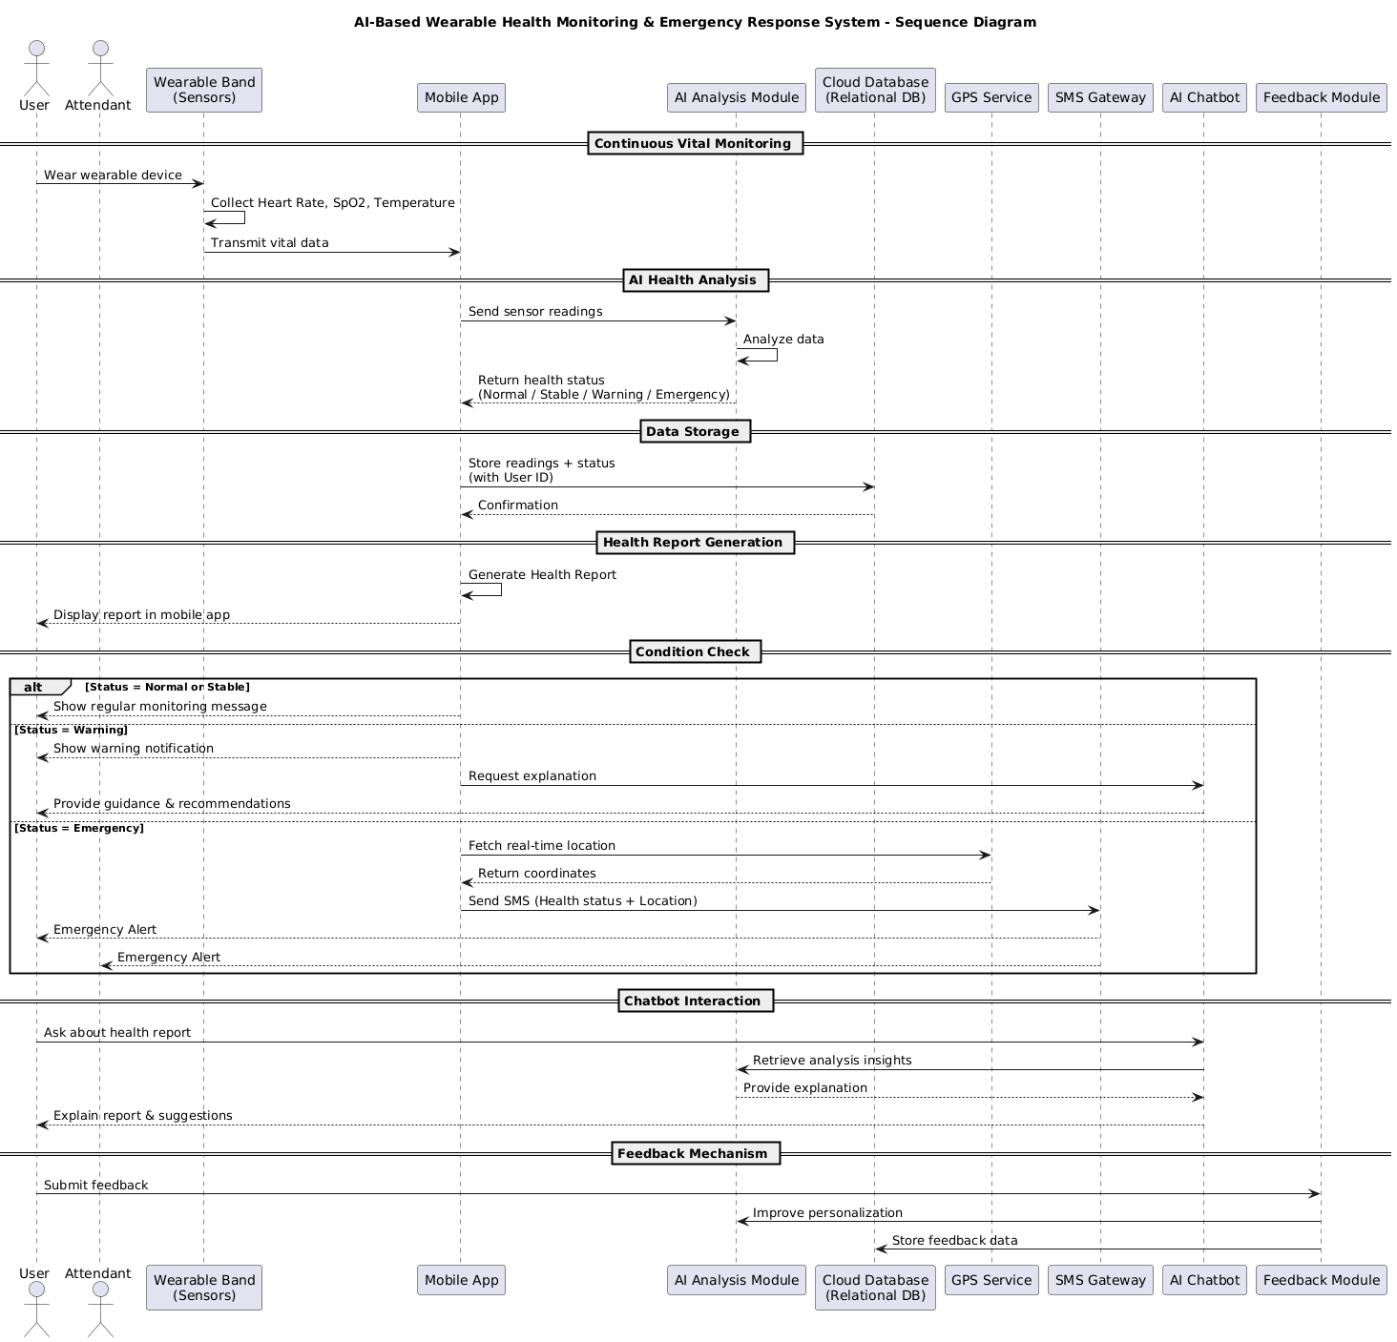
Figure 13: Detailed Sequence Diagram of Cardiva
The sequence diagram for health emergency detection illustrates the temporal ordering and message exchanges among system components during a representative emergency scenario, detailing the interactions between the wearable device, mobile application, cloud service, GPS service, and SMS gateway that collectively implement automated emergency response.
The scenario begins with the wearable device in its normal operating state, having established a Bluetooth Low Energy connection with the mobile application. Time progresses from top to bottom in the sequence, with each component represented as a vertical lifeline showing its active periods.
At time T0, the wearable device's measurement timer expires, triggering a new vital sign acquisition cycle. The wearable's sensor subsystem executes measurement routines, capturing heart rate, oxygen saturation, and body temperature values. For this emergency scenario, the measurements indicate severe abnormalities: heart rate of 148 bpm, oxygen saturation of 83%, and body temperature of 38.9°C. These values collectively suggest significant physiological distress, potentially indicating severe respiratory compromise with systemic stress response.
At time T1, the wearable device packages these abnormal measurements with a timestamp into a data packet and transmits it to the mobile application via the established BLE connection. The transmission is represented as a message arrow from the wearable device lifeline to the mobile application lifeline, labeled "transmitVitalSigns(HR: 148, SpO2: 83%, Temp: 38.9°C, Timestamp)".
At time T2, the mobile application receives the data packet and invokes its data validation routine, confirming that packet structure is correct and values are within physically plausible ranges (though abnormal). The validated measurements are immediately stored in the local database through an interaction with the Data Access Layer, represented as a self-message on the mobile application lifeline labeled "storeVitalSigns()".
At time T3, the mobile application's emergency detection module is automatically invoked following vital sign storage. This module evaluates the received measurements against emergency criteria. The oxygen saturation value of 83% violates the critical threshold of 85%, the heart rate of 148 bpm exceeds the emergency threshold of 140 bpm, and the elevated body temperature combined with these cardiovascular and respiratory abnormalities constitutes a concerning multi-parameter pattern. The emergency detection logic determines that an emergency condition exists.
At time T4, having detected an emergency, the mobile application initiates parallel interactions with the GPS Service and begins composing the emergency alert message. The GPS Service invocation is represented as a message arrow from the mobile application to the GPS Service lifeline, labeled "requestCurrentLocation()". Simultaneously, the mobile application's message composition module constructs alert text describing the emergency: "EMERGENCY ALERT: Critical vital signs detected. Heart rate: 148 bpm, Oxygen saturation: 83%, Temperature: 38.9°C. User may require immediate assistance."
At time T5, the GPS Service processes the location request, acquiring signals from available satellites and calculating position coordinates. After several seconds of processing, the GPS Service returns the user's location to the mobile application as a response message labeled "returnLocation(latitude: 31.4504, longitude: 73.1350)", representing example coordinates in Faisalabad, Pakistan.
At time T6, the mobile application receives the GPS coordinates and integrates them into the emergency alert message, producing the complete message text: "EMERGENCY ALERT: Critical vital signs detected. Heart rate: 148 bpm, Oxygen saturation: 83%, Temperature: 38.9°C. User may require immediate assistance. Location: 31.4504, 73.1350. Timestamp: 2024-02-06 14:32:18."
At time T7, the mobile application invokes the SMS Gateway twice in rapid succession, sending identical messages to two recipients. The first invocation is represented as a message arrow labeled "sendSMS(userPhoneNumber, alertMessage)", transmitting the emergency alert to the user's own phone number. The second invocation is labeled "sendSMS(attendantPhoneNumber, alertMessage)", transmitting the same alert to the pre-configured emergency contact.
At time T8, the SMS Gateway processes both message transmission requests, interfacing with the cellular network infrastructure to deliver the messages. The SMS Gateway returns delivery confirmation messages to the mobile application, represented as response arrows labeled "confirmDelivery(status: sent)" for both transmissions.
At time T9, the mobile application creates a comprehensive EmergencyEvent record in the local database, documented through a self-message labeled "createEmergencyEvent()". This record captures the detection timestamp, vital sign values that triggered the emergency, GPS coordinates, alert message content, and transmission confirmation status. The event record serves both for user review and system audit purposes.
At time T10, the mobile application synchronizes the EmergencyEvent record to the Cloud Service to ensure persistent storage beyond the mobile device. This interaction is represented as a message arrow to the Cloud Service lifeline labeled "uploadEmergencyEvent(eventData)". The Cloud Service stores the event record in the cloud database indexed by the user's unique identifier and returns a confirmation message labeled "confirmStorage(status: success)".
At time T11, the mobile application displays an emergency notification on the smartphone screen informing the user of the detected emergency and confirmed alert transmission. This notification is represented as a message to an implicit User Interface component: "displayEmergencyNotification('Emergency detected. Alert sent to emergency contact: [attendant name] at [attendant number]')".
Concurrently, at approximately time T11, the user and the designated attendant receive the SMS messages on their respective devices. This is represented by message arrows from the SMS Gateway to implicit User and Attendant actor lifelines. The attendant, upon receiving the alert with vital sign details and GPS coordinates, can immediately assess the severity of the situation and take appropriate action, whether contacting the user directly, dispatching emergency medical services, or traveling to the provided location.
At time T12, the mobile application transitions into an enhanced monitoring mode, represented by a state change annotation on its lifeline. In this mode, vital sign acquisition frequency may increase, and continued monitoring evaluates whether the emergency condition persists or resolves. If subsequent measurements show vital signs returning to normal ranges, the application will update the EmergencyEvent record with a resolution timestamp and may send follow-up messages indicating apparent resolution.
This sequence diagram illustrates the coordinated interactions among distributed system components during emergency detection and response, demonstrating the temporal flow from vital sign abnormality detection through location acquisition, alert composition, multi-recipient notification, and data persistence. The design emphasizes rapid automated response without requiring user intervention, addressing the critical challenge of emergency localization and notification when the affected individual may be incapacitated.
The sequence reveals several important design characteristics: the use of parallel activities (GPS acquisition concurrent with message composition) to minimize total response time, redundant alert transmission to both user and emergency contact to maximize the likelihood of reaching assistance, persistent documentation of emergency events in both local and cloud storage for accountability and post-event analysis, and graceful handling of asynchronous operations through confirmed message delivery patterns.

Class Diagram: Object-Oriented Design Structure
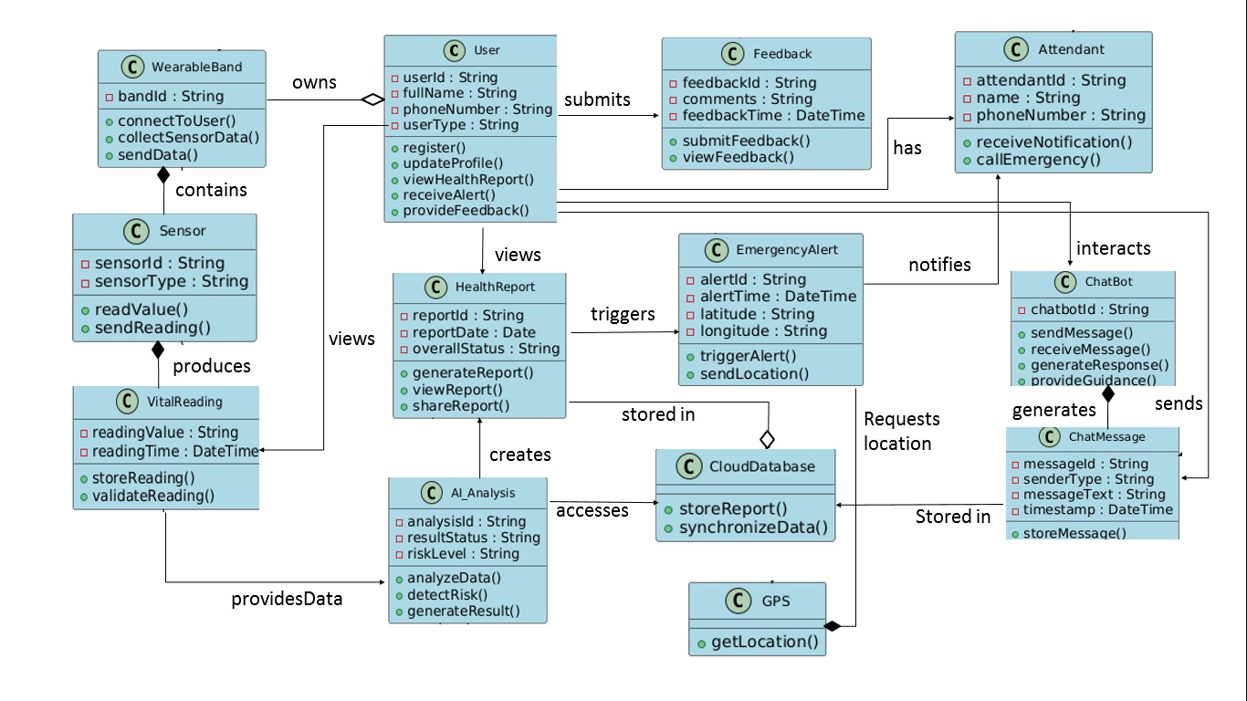
Figure 14: Class Diagram of AI-Based Wearable Health Monitoring & Emergency Response System

The class diagram describes the object-oriented design structure of the mobile application, defining the classes that encapsulate data and behavior, their attributes and methods, and the relationships among classes that implement the system's functionality. This structural model provides the blueprint for object-oriented implementation of the software architecture detailed in Section 4.1.4.
The User class represents registered system users and encapsulates user profile information and authentication. This class contains attributes including userId (String, unique identifier), name (String), dateOfBirth (Date), gender (String), contactNumber (String), emergencyContactName (String), emergencyContactNumber (String), registrationDate (Date), and passwordHash (String, for authentication). The class defines methods including registerUser() for creating new user accounts, authenticateUser(password) for verifying login credentials, updateProfile() for modifying user information, and getEmergencyContact() for retrieving configured emergency contact details. The User class implements validation logic ensuring that required fields are populated and that contact numbers conform to valid formats. This class serves as the root of the data model, with many other classes referencing User instances through the userId attribute.
The VitalSignMeasurement class encapsulates individual vital sign readings collected from the wearable device. Attributes include measurementId (String, unique identifier), userId (String, foreign key to User), timestamp (Date), heartRate (Integer, beats per minute), oxygenSaturation (Integer, percentage), bodyTemperature (Double, Celsius), and syncStatus (Boolean, indicating cloud synchronization status). Methods include constructor methods for creating new measurement instances from wearable data packets, getters for accessing individual vital sign values, isAbnormal() which evaluates whether any vital sign exceeds normal ranges, and markSynced() which updates the synchronization status after cloud upload. The class implements comparison logic enabling sorting of measurements by timestamp, supporting chronological trend analysis. VitalSignMeasurement maintains an association relationship with User, where each User has many VitalSignMeasurement instances but each measurement belongs to exactly one user (many-to-one cardinality).
The HealthStatusRecord class represents health status classifications produced by the AI-based analysis module. Attributes include recordId (String), userId (String), timestamp (Date), healthStatus (HealthStatusEnum with values NORMAL, STABLE, DETERIORATING), analysisWindow (String, describing the time period analyzed), and notes (String, optional explanation of classification rationale). Methods include constructor for creating new records, getHealthStatus() accessor, generateExplanation() which produces human-readable text describing why the particular status was assigned, and hasStatusChanged(previousRecord) which compares with the previous classification to detect transitions. The class implements the Comparable interface to enable chronological sorting. HealthStatusRecord has a many-to-one association with User and a dependency relationship with VitalSignMeasurement, as classification is derived from analyzing vital sign data though the association is not explicitly modeled to avoid circular dependencies.
The HealthReport class encapsulates generated summary documents synthesizing vital sign data over specified periods. Attributes include reportId (String), userId (String), generationDate (Date), reportStartDate (Date), reportEndDate (Date), summaryStatistics (Map<String, VitalSignStatistics>), notableEvents (List<String>), and cloudStorageUrl (String). The VitalSignStatistics nested class contains mean, minimum, maximum, and standardDeviation attributes for each vital sign type. Methods include generateReport(startDate, endDate) which performs the statistical analysis and creates the report, exportToText() which produces a textual representation suitable for sharing, exportToPDF() which generates a formatted document, and uploadToCloud() which stores the report in cloud storage and returns the storage URL. The class implements composition with VitalSignStatistics, as statistics are integral parts of reports with no independent existence. HealthReport has a many-to-one association with User and a dependency on VitalSignMeasurement as the data source for statistical analysis.
The EmergencyEvent class documents detected health emergencies and system responses. Attributes include eventId (String), userId (String), detectionTimestamp (Date), triggerCondition (String, describing the vital sign abnormality), gpsLatitude (Double), gpsLongitude (Double), alertSentToUser (Boolean), alertSentToAttendant (Boolean), resolutionTimestamp (Date, nullable), and resolutionNotes (String, nullable). Methods include recordEmergencyEvent() constructor, markResolved(notes) for updating when the emergency condition resolves, getLocation() which returns GPS coordinates as a formatted string, and generateAlertMessage() which produces the SMS message text incorporating vital sign details and location. The class has a many-to-one association with User and a dependency on VitalSignMeasurement representing the measurements that triggered the emergency.
The VitalSignAnalyzer class implements analytical logic for processing vital sign data and identifying patterns. This class does not represent persistent entities but rather encapsulates processing algorithms. Attributes include userId (String, identifying the user being analyzed) and baselineStatistics (Map<String, VitalSignBaseline>) storing calculated normal ranges for each vital sign. The VitalSignBaseline nested class contains mean, standardDeviation, and confidenceInterval attributes. Methods include calculateBaseline(measurements) which computes personalized normal ranges from historical data, analyzeTrend(measurements) which identifies temporal patterns such as increasing or decreasing trends, detectAnomalies(measurement) which evaluates whether a new measurement deviates significantly from baseline, and evaluateMultiParameterPatterns(measurements) which examines correlations between vital signs. The class implements a dependency relationship with VitalSignMeasurement as it operates on measurement data without storing persistent references.
The HealthStatusClassifier class implements the conceptual AI-based logic for categorizing health status. This processing class contains attributes including userId (String) and classificationRules (List<ClassificationRule>) encoding the decision logic. Methods include classifyHealthStatus(measurements, baseline) which is the primary classification method returning a HealthStatusEnum value, applyRules(measurements) which evaluates rule-based criteria, analyzeTemporalPatterns(measurements) which examines trends over time, and generateClassificationExplanation() which produces textual rationale for the classification decision. The class has dependencies on both VitalSignMeasurement and VitalSignAnalyzer, utilizing analyzed data to make classification decisions.
The EmergencyDetector class implements logic for identifying critical health conditions warranting immediate intervention. Attributes include userId (String), thresholdConfiguration (EmergencyThresholds), and detectionHistory (List<EmergencyEvent>) tracking past emergency events. The EmergencyThresholds nested class encapsulates configurable threshold values for each vital sign. Methods include evaluateEmergency(measurement) which is the primary detection method returning a Boolean indication of emergency status, checkThresholdViolations(measurement) which evaluates individual vital signs against critical thresholds, checkRapidDeterioration(recentMeasurements) which analyzes trends for concerning patterns, checkMultiParameterPatterns(measurement) which examines vital sign combinations, and getTriggerConditionDescription() which produces textual description of why the emergency was detected. The class depends on VitalSignMeasurement for data and associates with EmergencyEvent by creating event records when emergencies are detected.
The CloudSyncManager class handles synchronization of data between local storage and cloud services. Attributes include userId (String), cloudServiceEndpoint (String, URL of the cloud API), authenticationToken (String), and syncQueue (List<Syncable>) containing items awaiting upload. Methods include syncVitalSigns() which uploads unsynchronized measurements, syncHealthReports() which uploads generated reports, syncEmergencyEvents() which uploads emergency records, downloadHistoricalData(startDate, endDate) which retrieves past data from cloud storage, and handleSyncFailure() which implements retry logic for failed operations. The class has dependencies on VitalSignMeasurement, HealthReport, and EmergencyEvent as the data types being synchronized.
The AlertService class manages emergency notification transmission. Attributes include smsGatewayEndpoint (String), retryAttempts (Integer), and messageQueue (List<AlertMessage>). The AlertMessage nested class encapsulates recipient, message text, and delivery status. Methods include sendEmergencyAlert(userId, message, recipients) which transmits SMS messages to specified recipients, formatAlertMessage(emergencyEvent) which constructs message text from emergency details, confirmDelivery(messageId) which processes delivery confirmations, and retryFailedMessages() which implements retry logic. The class depends on EmergencyEvent as the source of alert content and interacts with external SMS gateway services.
The LocationService class interfaces with GPS functionality. Attributes include lastKnownLocation (GPSCoordinates) and locationAccuracy (Double, in meters). The GPSCoordinates nested class contains latitude and longitude attributes. Methods include getCurrentLocation() which invokes platform GPS services and returns current coordinates, formatCoordinates() which produces human-readable location strings, and calculateAccuracy() which assesses location precision. This class has a dependency relationship with EmergencyEvent as location data is incorporated into emergency records.
Relationships among these classes implement the collaborations necessary for system functionality. The User class serves as the central entity with associations to VitalSignMeasurement, HealthStatusRecord, HealthReport, and EmergencyEvent representing the one-to-many relationships where each user accumulates many instances of each data type. Processing classes including VitalSignAnalyzer, HealthStatusClassifier, and EmergencyDetector depend on data classes, using them as inputs without storing persistent references. Service classes including CloudSyncManager, AlertService, and LocationService encapsulate interactions with external systems, abstracting implementation details from core business logic.
The class structure implements several object-oriented design principles. Encapsulation is achieved by defining private attributes with public accessor methods, preventing uncontrolled data modification. Single Responsibility Principle is followed by assigning distinct concerns to separate classes, data representation, analysis, classification, emergency detection, synchronization, and alerting each have dedicated classes. Dependency management through interfaces (though not explicitly shown in this textual description) would enable testing by allowing mock implementations of external services.
This object-oriented design provides a comprehensive blueprint for implementing the mobile application's functionality, defining clear responsibilities for each class, establishing relationships that model domain concepts, and organizing code in a maintainable, testable structure that supports the system's functional requirements.

Implementation
This chapter documents how the Cardiva system is realised in working software and hardware, translating the architecture defined in Chapter 4 into concrete modules, firmware, sensor wiring, and a communication contract. The system is implemented as three cooperating parts that together deliver the cardiac-monitoring objectives set out in Chapter 1: an ESP32 firmware layer that reads physiological and motion data and computes six vitals on-board, a companion Flutter application that classifies health status and dispatches emergency alerts, and a BLE communication layer that binds the two. The sections that follow begin with the software components of the mobile application, proceed to the hardware build and on-board vitals computation, and conclude with the hardware-software integration and the development environment used throughout.

Software Components/Modules
The Cardiva mobile application is implemented in Flutter (Dart) and follows a layered architecture that separates presentation, application state, domain logic, and platform services. This separation keeps the rule-based decision logic and the device-communication code independent of the user interface, so that the same vitals pipeline runs whether readings originate from real hardware or from a development data source. The layers, described in the subsections below, are: a presentation layer of screens and reusable widgets; a Riverpod state-management layer of providers; a domain engine of classifiers and decision logic; a services layer that wraps platform and external integrations; a data and model layer; and a core layer of constants, utilities, and routing.

Presentation Layer
The presentation layer comprises over thirty-five screens grouped by feature, together with reusable widget atoms and theming. The authentication and entry flow includes the splash screen, a three-page onboarding sequence, and the auth screens (login, register, and forgot-password). The first-run setup flow guides the user through profile setup, device pairing, and emergency-contact setup. Once configured, the application presents a bottom-tab container, the main navigation screen, that hosts the four principal tabs: a dashboard of live vital cards augmented with a confidence indicator and status badge; a history view with vitals charts and analysis records; an artificial-intelligence analysis area (the vitals AI screen and prediction-result screen); and a settings area that exposes profile, attendant management, emergency contacts, notification preferences, and help and support. Additional screens cover device connection and live monitoring, the emergency screen and alert-sent confirmation, the chatbot, notifications, and the health-report and report-detail views. Reusable atoms such as the bottom navigation bar, floating action button, pill, ring and spark widgets, skeleton loaders, status badge, step indicator, vital animations, and the vital-card atom promote visual consistency across screens.

State-Management Layer
Application state is managed with the flutter_riverpod package. A small set of providers expose reactive state to the presentation layer while hiding the underlying services. The principal providers are the vital provider, which surfaces the stream of incoming readings; the health-status provider, which exposes the current four-class classification; the analysis provider for the AI analysis pipeline; the history provider; the report provider; the notifications provider; the settings provider, which also governs the dark and light theme; and the user provider. Because the providers sit between the services and the widgets, screens rebuild automatically as new vitals arrive without any explicit subscription management in the UI.

Domain Engine
The domain engine contains the project's original decision logic. The vital classifier applies the medical thresholds to each reading, the activity classifier interprets the reported activity context, and the confidence engine produces a confidence score for the classification. The health-status engine fuses these results into a single four-class output, while the emergency trigger orchestrates the alert flow when danger is detected. The chatbot engine drives the conversational assistant. The engine also embeds two on-device machine-learning models, derived from TensorFlow Lite and stored under the generated sub-package, for fall detection and emergency classification; these are surfaced to the user through the AI analysis screens. The detailed classification rules implemented by this layer are described in Section 5.1.6.

Services Layer
The services layer wraps every platform capability and external integration behind a narrow interface so that the engine and providers remain testable. The BLE service connects to the wearable and decodes its vitals stream, while a mock data service supplies synthetic readings so that the full pipeline can run without hardware during development. The ML service hosts the on-device models, and the Groq service integrates the large-language-model chatbot. Firebase concerns are split across an authentication service, a Firestore service, and a cloud service, with a storage service for media such as profile pictures. The location service obtains the device's GPS coordinates, the SMS service composes native short-message alerts, the notification service raises local notifications, and the background service runs continuous monitoring. A Portable Document Format (PDF) report service generates health reports, and session and storage services persist local state.

Data and Core Layers
The data layer centres on a vitals repository together with a family of immutable models, including the vital reading, vital, vital status, alert class, alert event, analysis record, attendant, emergency contact, health event, health report, machine-learning prediction, notification, and user profile. The core layer holds cross-cutting concerns: constants for API endpoints, application colours, and the medical thresholds; an application-exceptions error type; date-formatting and validation utilities; and an application navigator. Routing is centralised in the application router, which declares all named routes; the application's entry point initialises Flutter and Firebase, and the root widget manages application lifecycle. Table 5.1 lists the principal third-party dependencies that underpin these layers.
Table 5.1: Principal application dependencies and stack
Concern | Package / technology | Notes
Framework | Flutter (Dart) | Cross-platform UI; Android target
State management | flutter_riverpod ^2.5.1 | Reactive providers
Backend / Auth | firebase_core ^3.6, firebase_auth ^5.3 | Project cardiva-30297
Database | cloud_firestore ^5.4 | Per-user vitals, events, contacts, reports
Storage | firebase_storage ^12.3 | Profile pictures
App integrity | firebase_app_check ^0.3 | App attestation
Federated sign-in | google_sign_in ^6.2, sign_in_with_apple ^6.1 | Google and Apple auth
BLE | flutter_blue_plus ^1.35.5 | Wearable connection
Charts | fl_chart ^0.68 | History and vitals charts
PDF / sharing | pdf ^3.11, share_plus ^10 | Health reports and sharing
Notifications | flutter_local_notifications ^17 | Local notifications
Background | flutter_background_service ^5.0.9 | Continuous monitoring loop
Location | geolocator ^13 | GPS coordinates for alerts
SMS | url_launcher ^6.3 | Native SMS alerts (no Twilio)
HTTP | http ^1.2 | REST calls to the LLM API
Chatbot rendering | flutter_markdown ^0.6 | Markdown chat output
Environment | flutter_dotenv ^5.2 | Loads GROQ_API_KEY from .env

Classification and Decision Pipeline
The rule-based vital classifier evaluates each reading against the thresholds centralised in the thresholds constants, with the heart-rate bands adjusted for the reported activity context. The heart-rate thresholds are keyed by activity (resting, walking, running, and lying down), each band defining emergency-low, warning-low, normal-low, normal-high, warning-high, and emergency-high boundaries, with stable bands for the resting profile. For a resting user, for example, sixty to one hundred beats per minute is treated as normal, fifty and one hundred and twenty as warning boundaries, and forty and one hundred and fifty as emergency boundaries. Blood-oxygen saturation is not activity-adjusted: a value of ninety-five percent or above is normal, ninety-three percent is a stable-low boundary, ninety percent is a warning-low boundary, and any value below ninety percent is treated as an emergency. Heart-rate variability, expressed as the standard deviation of normal-to-normal intervals (SDNN), is normal at fifty milliseconds or above, with stable-low and warning-low boundaries at thirty-five and twenty milliseconds and an emergency below twenty milliseconds. Respiration is normal between twelve and twenty breaths per minute, with warning boundaries at eight and twenty-five and emergency boundaries at five and thirty. Table 5.2 summarises these thresholds.
Table 5.2: Vital classification thresholds
Vital | Normal | Warning boundary | Emergency boundary
Heart rate (resting) | 60-100 BPM | 50 / 120 BPM | 40 / 150 BPM
SpO2 | >= 95 % | 90 % (warning-low) | < 90 %
HRV (SDNN) | >= 50 ms | 20 ms (warning-low) | < 20 ms
Respiration | 12-20 br/min | 8 / 25 br/min | 5 / 30 br/min
The confidence engine produces a confidence score for each classification, and an emergency-confidence gate of seventy is applied before an emergency decision is allowed to propagate, suppressing low-confidence false alarms. The health-status engine combines the rule-based classification, the confidence gate, and the fall flag into a single four-class output, namely Normal, Vitals Alert, Fall Alert, or Emergency, mirroring the four-class model introduced in Chapter 4. When the output reaches the Emergency class, the emergency trigger initiates the alert flow described in the services layer, dispatching a native short message with the user's location to the registered contacts. The two on-device TensorFlow Lite models complement the rule engine by providing learned fall-detection and emergency-classification outputs through the AI analysis screens.

Key External Integrations
The application depends on a small number of well-defined external integrations. The conversational assistant is powered by the Groq large-language-model service, called over HTTPS at the OpenAI-compatible completions endpoint https://api.groq.com/openai/v1/chat/completions using the llama-3.3-70b-versatile model. Requests carry Bearer authentication using the GROQ_API_KEY loaded from the environment file, a temperature of 0.5, a configurable maximum token count, and a thirty-second timeout; the chatbot engine maintains session history and renders responses as markdown. Firebase provides the backend: authentication supports email and password, Google, and Apple sign-in; Cloud Firestore synchronises per-user vitals, events, contacts, reports, and feedback; and Firebase Storage holds profile pictures, all under project cardiva-30297. Emergency short messages are sent natively through url_launcher using sms URIs, removing any dependency on a paid messaging gateway, and real GPS coordinates obtained through geolocator are embedded in each alert. A background service runs an approximately five-minute monitoring loop so that classification continues while the application is backgrounded, and the PDF report service generates shareable health reports with a persistent report history. It should be noted that, although the API-endpoints constants still contain vestigial Supabase and Twilio definitions, these are not part of the live system; the active backend is Firebase and the active messaging path is native SMS.

Hardware Components and Firmware
The wearable node is built around an ESP32 development board that hosts three sensors on a shared I2C bus and runs the on-board vitals engine. This section presents the bill of materials, the wiring of the I2C bus, and the firmware setup.

System Architecture and Bill of Materials
The hardware comprises an ESP32 development board, a MAX30100 pulse-oximeter breakout for photoplethysmography, an MPU9250 or MPU9265 inertial measurement unit (IMU) for motion sensing, and an SSD1306 128x64 organic light-emitting diode (OLED) for the local display. All three sensors are I2C devices and share a single bus, which simplifies wiring to two signal lines. Table 5.3 lists the components and their I2C addresses.
Table 5.3: Bill of materials
Component | Notes / I2C address
ESP32 DevKit (any variant) | Two free GPIOs for I2C: GPIO21 SDA, GPIO22 SCL
MAX30100 pulse-oximeter breakout | Heart rate and SpO2; address 0x57
MPU9250 / MPU9265 IMU breakout | Accelerometer; address 0x68 (0x69 if AD0 high)
SSD1306 OLED 128x64 (I2C) | Local display; address 0x3C (0x3D on some boards)
Jumper wires + breadboard / PCB | All three sensors share one I2C bus

I2C Wiring
Because all three peripherals are I2C devices, they are connected in parallel on a single two-wire bus together with shared power and ground. Each module's power input is tied to the ESP32's 3.3-volt rail and its ground to the common ground; the data and clock lines of every module connect to GPIO21 and GPIO22 respectively. Table 5.4 records the pin map. Where the breakout boards do not provide on-board pull-ups, a 4.7 kohm resistor is added from each of the SDA and SCL lines to the 3.3-volt rail to guarantee reliable bus operation. The bus is verified before integration by running an I2C-scanner sketch, which must report devices at 0x3C for the OLED, 0x57 for the MAX30100, and 0x68 for the MPU9250 or MPU9265; a missing address indicates a wiring or power fault on the corresponding module.
Table 5.4: ESP32 I2C pin map
ESP32 pin | Connects to | Purpose
3V3 | VCC on all three modules | Power (3.3 V)
GND | GND on all three modules | Common ground
GPIO 21 | SDA on all three modules | I2C data
GPIO 22 | SCL on all three modules | I2C clock

Firmware Setup and Libraries
The firmware is written for the ESP32 using the Arduino framework and the ESP32 BLE Arduino stack. It includes the Wire library for I2C, the Adafruit GFX and Adafruit SSD1306 libraries for the display, the MAX30100 pulse-oximeter library, the MPU9250_asukiaaa library for the inertial measurement unit, and the BLEDevice, BLEServer, BLEUtils, and BLE2902 components for the BLE GATT server. Key compile-time constants define the bus and display geometry, with the SDA pin set to 21, the SCL pin to 22, the OLED reset to minus one, and the screen dimensions to 128 by 64. The reporting interval is fixed at one thousand milliseconds, giving a one-hertz update rate; the inter-beat-interval buffer holds twenty samples and the acceleration buffer fifty samples; and a no-finger timeout of eight thousand milliseconds detects an absent finger. The respiration estimator uses smoothing constants of 0.25 and 0.08 and a minimum breath interval of one thousand five hundred milliseconds. At start-up the firmware opens the serial port at 115200 baud, initialises the OLED with the switch-capacitor configuration at address 0x3C, and begins BLE advertising with a minimum preferred connection parameter of 0x06 under the device name Cardiva-ESP32.

Vitals Computation
All six vitals are computed on the ESP32 itself, so the mobile application receives ready-to-classify values rather than raw sensor data. This section describes how each vital is derived.

Heart Rate and Blood-Oxygen Saturation
Heart rate and blood-oxygen saturation are obtained directly from the MAX30100 library once per reporting cycle through its heart-rate and SpO2 accessors. The sensor performs the photoplethysmographic pulse detection internally, so the firmware simply samples the computed values at the one-hertz reporting cadence and forwards them to the display and BLE layers.

Heart-Rate Variability
Heart-rate variability is reported as the standard deviation of normal-to-normal intervals, SDNN. On each detected beat a callback records the inter-beat interval in milliseconds, and once per second the firmware computes the standard deviation of the last twenty intervals. Intervals falling outside the range of three hundred to two thousand milliseconds, corresponding to thirty to two hundred beats per minute, are discarded as physiologically implausible noise before the statistic is computed, which keeps the SDNN estimate robust against missed or spurious beats.

Respiration Rate
Respiration rate is the one vital that cannot be measured rigorously with the available sensor interface, and the implementation is therefore an honest best-effort proxy. A clinical-grade respiration estimate would require a 0.1 to 0.5 hertz bandpass filter applied to the raw infrared photoplethysmography signal; however, the MAX30100 library's public interface exposes only the computed heart rate, not the raw infrared buffer. The firmware consequently samples the instantaneous heart rate at five hertz, counts the directional reversals (peaks and troughs) of this signal over a rolling window, and converts the reversal rate into breaths per minute. This proxy is documented as demo-grade rather than clinical-grade; the upgrade path is to access the raw infrared buffer and apply a digital bandpass filter, which would yield a clinically meaningful respiration signal.

Activity Classification
Activity is inferred from the inertial measurement unit by computing the rolling standard deviation of the acceleration magnitude over the last fifty samples and mapping it to one of four states. A low variance indicates rest, while progressively higher variance indicates sedentary movement, walking, and active motion. The state thresholds are given in Table 5.5. The resulting activity label is significant beyond the display, because the mobile application uses it to select the activity-adjusted heart-rate bands described in Section 5.1.6.
Table 5.5: Activity classification bands (rolling SD of acceleration magnitude)
State | SD range (g)
Resting | < 0.02
Sedentary | 0.02 - 0.15
Walking | 0.15 - 0.5
Active | > 0.5

Fall Detection
Fall detection is implemented as a two-phase state machine operating on the acceleration magnitude, designed to reject the false alarms that a single-threshold detector would produce. The first phase detects a candidate free-fall when the acceleration magnitude drops below 0.4 g. If, within one second of this event, an impact spike exceeding 2.5 g follows, the firmware flags a fall; if no impact occurs within the window, the state machine resets and no fall is reported, filtering out ordinary low-acceleration motion. When a fall is confirmed it is transmitted once as a one-shot fall flag in the BLE payload and is then cleared firmware-side, so a single event produces a single alert rather than a continuous stream.

OLED Display
The OLED provides immediate local feedback independent of the mobile application. On power-up the firmware draws a boot screen and then transitions to a live dashboard. The dashboard shows an animated pulsing heart icon synchronised to the reporting interval, large readouts of heart rate and SpO2, a secondary row carrying heart-rate variability and respiration rate, and the current activity state. A connection icon indicates BLE status and an uptime clock is displayed. When a fall is confirmed, the firmware overrides the dashboard with a full-screen inverted FALL! overlay, ensuring the event is unmistakable to anyone observing the device.

Hardware-Software Integration
The wearable and the mobile application communicate over a single custom BLE GATT service that defines the entire contract between hardware and software. The firmware acts as the GATT server and exposes one vitals characteristic that supports both read and notify operations. Once per second the firmware packs the six computed vitals into a compact UTF-8 JSON string and notifies it on this characteristic. Table 5.6 records the authoritative contract.
Table 5.6: BLE GATT contract (device-side, authoritative)
Item | Value
Device name | Cardiva-ESP32
Service UUID | 12345678-1234-5678-1234-56789abcdef0
Vitals characteristic UUID | 12345678-1234-5678-1234-56789abcdef1
Properties | READ, NOTIFY
Payload | UTF-8 JSON string, notified once per second
Example payload | {"hr":78.0,"spo2":97.5,"hrv":42.3,"rr":16.0,"act":"Walking","fall":false}
On the application side, the BLE service uses the flutter_blue_plus package to scan for and connect to the advertised Cardiva-ESP32 device, discover its services, locate the vitals characteristic, and subscribe to its notifications. Each notification's bytes are decoded from UTF-8 and parsed from JSON into a typed vital reading carrying heart rate, SpO2, heart-rate variability, respiration rate, an activity enumeration, and a fall flag. A reading in which both heart rate and SpO2 are zero is interpreted as a no-finger or invalid sample and is dropped, and malformed JSON is rejected without crashing the connection. Valid readings are broadcast on a stream that the vital provider consumes, after which the classification pipeline described in Section 5.1.6 derives the four-class health status and, where warranted, the emergency trigger fires. The mock data service mirrors this same stream interface, allowing the entire pipeline from provider through status engine to alerting to run without hardware during development.

Tools and Technologies
The two halves of the system are developed with distinct but complementary toolchains. The firmware is developed in the Arduino IDE with the ESP32 board package installed, together with the Adafruit GFX and SSD1306 libraries, the MAX30100 pulse-oximeter library, the MPU9250_asukiaaa library, and the ESP32 BLE Arduino libraries; the serial monitor at 115200 baud is used to observe start-up and runtime diagnostics. The mobile application is developed with the Flutter software development kit (SDK): dependencies are resolved with flutter pub get, the application is launched with flutter run, which uses the mock data service by default so that development requires no wearable, and static analysis is performed with flutter analyze. The environment file must be present in the project root and must contain the GROQ_API_KEY for the chatbot to function. This dual environment, together with the mock data path, allows the application and firmware to be developed and tested in parallel, which sets the stage for the verification and validation activities discussed in Chapter 6.

Testing

Introduction
This chapter describes the strategy and activities used to test the Cardiva system and to establish confidence that it satisfies the objectives defined in Chapter 1. Because Cardiva is a combined hardware and software system, testing spans three surfaces: the ESP32 firmware that acquires sensor data and computes the six vitals, the Bluetooth Low Energy contract that carries those vitals to the mobile application, and the Flutter application that classifies health status and dispatches emergency alerts. The chapter first frames testing in terms of verification and validation, then defines the vocabulary of test cases, suites, scripts, and scenarios, presents a representative testing cycle for the system, and finally documents the concrete test cases, concluding with a detailed sample test case for the safety-critical fall-detection path.

Verification and Validation
Testing of Cardiva is organised around the two complementary notions of verification and validation. Verification asks whether the system has been built correctly, that is, whether each component conforms to its specification. For Cardiva, verification activities include static analysis of the Flutter codebase using flutter analyze, unit testing of the deterministic decision logic in the classification engine and of the Bluetooth payload parser, inspection of the firmware serial-log output at 115200 baud during start-up and operation, and confirmation that the Bluetooth service exposes exactly the service and characteristic identifiers and the JSON payload defined by the device contract in Chapter 5.
Validation asks the broader question of whether the right system has been built, that is, whether Cardiva meets the real needs of its users. Validation is concerned with end-to-end behaviour: whether the wearable produces plausible vitals when worn on a real finger, whether a fall or a dangerous vital is detected promptly, whether an emergency alert actually reaches a registered contact together with the user location, and whether the application can be operated by a cardiac patient and a caregiver without specialist knowledge. These activities trace directly back to the objectives set out in Chapter 1.
In short, verification confirms that the system has been built right, while validation confirms that the right system has been built. Both are necessary, because a system can conform perfectly to a flawed specification or can pursue the right goal with a defective implementation, and only the combination of the two activities guards against both kinds of failure.

Test Cases, Suites, Scripts, and Scenarios
To describe the testing activity precisely, the following terms are used throughout this chapter. A test case is the smallest unit of testing; it specifies an input or event, the conditions under which it is applied, and the expected result, so that the actual result can be compared against it. A test script adds the procedure and the data needed to execute one or more test cases, whether manually or through automation. A test suite is a named collection of related test cases that share a configuration and a common goal. A test scenario describes a realistic sequence of actions through the system, typically spanning several components, and is used to derive system-level test cases.
Cardiva is exercised through four test suites that together cover the system from individual functions to complete user journeys. The unit suite targets the deterministic logic of the application: the boundaries of the rule-based vital classifier, the activity-adjusted heart-rate bands, the seventy-point confidence gate, and the Bluetooth payload parser that converts an incoming JSON string into a typed reading. The integration suite verifies that data flows correctly along the pipeline from the Bluetooth notification, through the vital provider and the health-status engine, to the four-class output and, where warranted, the emergency trigger; the mock data service allows this pipeline to be exercised without hardware. The system suite covers complete end-to-end behaviour on real hardware, including the emergency flow with GPS and SMS, the five-minute background-monitoring loop, and report generation. The acceptance suite confirms the user-facing journeys, namely authentication, profile and contact setup, live dashboard updates, history charts, the chatbot, notifications, and the theme switch.

A Sample Testing Cycle
Although the precise activities vary with the component under test, testing in Cardiva follows a recognisable cycle. It begins with requirements analysis, in which the testable aspects of each feature are identified from the objectives and the system design. Test planning then defines the strategy, the test environment, and the data required. During test development the individual test cases, scripts, and scenarios are written. Test execution runs the system against these tests and records the outcomes, after which test reporting summarises the results and judges readiness, and any defects found are corrected before the affected tests are repeated.
A representative execution of this cycle for Cardiva exercises the system from firmware start-up to a mobile alert. The firmware is flashed and the serial monitor is opened at 115200 baud to confirm that the start-up banner is printed and that the sensors initialise. The OLED is observed to move from its boot screen to the live dashboard with its pulsing heart icon. A finger is held firmly and still on the MAX30100 sensor until, after ten to fifteen seconds, the heart-rate and SpO2 readings stabilise on both the display and the serial log. The mobile application is then installed and granted Bluetooth and location permissions, and its scan screen is expected to list the device as Cardiva-ESP32. Selecting the device connects it, after which the dashboard begins to update and its animation tracks the live heart rate. Finally, a sharp simulated drop is used to trigger the fall path, and a brisk walking motion is used to confirm that the reported activity changes from resting to walking or active.
When a step of this cycle does not behave as expected, a small set of recurring faults accounts for most failures. Table 6.1 records the symptoms observed during testing together with their most likely causes and remedies, and serves as the first reference during diagnosis.
Table 6.1: Troubleshooting matrix
Symptom | Likely cause / fix
Sensor missing from I2C scan | Wiring or power; confirm the same SDA/SCL bus
pox.begin() FAILED | MAX30100 wiring, or library not installed
HR stays 0 with finger on | Press firmer, hold still, wait 10-15 s
App cannot find ESP32 | Bluetooth on, permissions granted, device powered and in range
Connects but no vitals | Check BLE TX serial logs; verify UUIDs match firmware and app
Gradle sync fails (MPAndroidChart) | JitPack repository missing in settings.gradle

Test Cases
Building on the suites and the testing cycle described above, this section presents the concrete test cases used to evaluate Cardiva. Table 6.2 lists a representative selection drawn from across the four suites, each expressed as a precondition, the steps applied, and the expected result, together with the status observed during testing. Where a result is qualitative rather than a strict pass, such as the demo-grade respiration proxy, this is stated explicitly rather than reported as a measured pass.
Table 6.2: Representative test cases
ID | Description | Precondition | Steps | Expected result | Status
TC-01 | Resting HR band edge | Reading with activity resting | Classify HR = 100, then HR = 101 | 100 = Normal; 101 = Stable/Warning | Pass
TC-02 | SpO2 emergency threshold | Valid reading | Classify SpO2 = 89 | Classified as Emergency | Pass
TC-03 | BLE parse of valid payload | Connected device | Notify valid vitals JSON | Populated VitalReading produced | Pass
TC-04 | No-finger sample dropped | Connected device | Notify JSON with hr=0 and spo2=0 | Reading dropped (null) | Pass
TC-05 | Malformed JSON rejected | Connected device | Notify non-JSON bytes | No crash; reading dropped | Pass
TC-06 | Confidence gate | Low-confidence emergency input | Classify with confidence < 70 | Emergency suppressed by gate | Pass
TC-07 | Fall end-to-end | Device worn and connected | Simulate free-fall then impact | Fall Alert in app + FALL! on OLED | Pass
TC-08 | Emergency SMS dispatch | Contact registered, GPS available | Trigger Emergency class | SMS intent with location to contact | Pass
TC-09 | Background monitoring | App backgrounded | Wait one 5-minute loop | Classification continues in background | Pass
TC-10 | Respiration proxy | Finger held steady | Observe RR readout | Plausible RR (demo-grade) | Qualitative

Sample Test Case
To illustrate the level of detail at which individual cases are specified, Table 6.3 documents a single end-to-end test case in full, namely the detection of a fall and the propagation of the resulting emergency alert. This case is chosen because it exercises the safety-critical path of the system, crossing every boundary from the firmware fall-detection state machine, through the Bluetooth contract, to the mobile application and the outbound SMS alert.
Table 6.3: Sample test case - end-to-end fall detection and alert
Test Case id : TC-CARD-001 | Test Item : Fall Detection and Emergency Alert
Author : Project Team | Documentation Date : 24-06-2026
Test Type : Manual - System (Black Box, end-to-end) | Test Case Name : End-to-End Fall Detection and Alert
Component : Safety-Critical Alert Path (firmware to BLE to app to SMS) | Release / Version # : 1.0
Test case Description: This test case verifies that a physical fall is detected by the wearable two-phase free-fall and impact state machine, transmitted over Bluetooth Low Energy, surfaced as a Fall Alert in the application, and, when the resulting status is Emergency, dispatched as an SMS containing the user GPS location to a registered emergency contact.
Operation Procedure:
1. Confirm that the OLED dashboard shows live vitals and a resting activity state.
2. Apply a sharp downward free-fall to the device, immediately followed by an impact.
3. Observe the OLED overlay, the application status, and the registered contact phone.
The test case ends.
Pre-conditions : | Post-conditions :
The firmware is flashed and running with the OLED on its live dashboard; the application is installed and connected with Bluetooth and location permissions granted; at least one emergency contact is registered; and GPS is available. | The fall event is recorded; a Fall Alert is shown in the application; and an SMS intent carrying the user location is dispatched to the registered contact.
Input Data/Events : | Expected output Data/Events :
A free-fall in which the acceleration magnitude falls below 0.4 g, followed within one second by an impact spike exceeding 2.5 g. | The firmware emits a single fall=true flag; the OLED shows the full-screen FALL! overlay; the application raises a Fall Alert; and, on the Emergency class, an SMS with the location is sent to the contact.
The successful execution of this sample case demonstrates that the safety-critical path of the system, namely the timely detection of a fall and the dispatch of an alert to a registered contact, functions correctly across every hardware and software boundary it crosses.

Detailed Test Cases
While the sample above documents a single case in full, the remaining cases are recorded here in a consistent, compact form. Each table states the objective of the case, its precondition, the steps performed, the input data, and the expected and actual results, together with the resulting status. The cases are drawn from all four test suites and correspond to the rows summarised in Table 6.2, ranging from unit-level checks of the classification engine to end-to-end system behaviour.
Table 6.4: Resting heart-rate band edge
Test Case ID | TC-01
Test Case Name | Resting heart-rate band edge
Objective | Verify the rule-based classifier resolves the resting heart-rate normal boundary correctly.
Precondition | A vital reading with the activity context set to resting.
Test Steps | 1. Submit a reading with HR = 100 BPM. 2. Submit a reading with HR = 101 BPM. 3. Observe the classification for each.
Test Data / Input | HR = 100 BPM and HR = 101 BPM (resting).
Expected Result | HR = 100 is classified Normal; HR = 101 is classified Stable/Warning, lying just outside the resting normal band of 60-100 BPM.
Actual Result | 100 returned Normal and 101 returned Stable, matching the threshold table.
Status | Pass

Table 6.5: SpO2 emergency threshold
Test Case ID | TC-02
Test Case Name | SpO2 emergency threshold
Objective | Verify that a blood-oxygen value below 90 percent is classified as an Emergency.
Precondition | A valid vital reading is available.
Test Steps | 1. Submit a reading with SpO2 = 89 percent. 2. Observe the classification.
Test Data / Input | SpO2 = 89 percent.
Expected Result | The reading is classified as Emergency, since a value below 90 percent is the emergency boundary.
Actual Result | The reading was classified Emergency.
Status | Pass

Table 6.6: Bluetooth parsing of a valid payload
Test Case ID | TC-03
Test Case Name | Bluetooth parsing of a valid payload
Objective | Verify the BLE service decodes a valid vitals JSON notification into a typed reading.
Precondition | The application is connected to the Cardiva-ESP32 device.
Test Steps | 1. The device notifies a valid vitals JSON string on the vitals characteristic. 2. Inspect the decoded reading.
Test Data / Input | {"hr":78.0,"spo2":97.5,"hrv":42.3,"rr":16.0,"act":"Walking","fall":false}
Expected Result | A populated VitalReading carrying the corresponding heart rate, SpO2, heart-rate variability (HRV), respiration, activity and fall fields is produced.
Actual Result | A correctly populated VitalReading was produced and broadcast to the vital provider.
Status | Pass

Table 6.7: No-finger sample dropped
Test Case ID | TC-04
Test Case Name | No-finger sample dropped
Objective | Verify that an invalid no-finger reading is discarded rather than classified.
Precondition | The application is connected to the device.
Test Steps | 1. The device notifies a JSON payload with hr = 0 and spo2 = 0. 2. Observe whether a reading is produced.
Test Data / Input | A vitals JSON payload with hr = 0 and spo2 = 0.
Expected Result | The reading is interpreted as a no-finger or invalid sample and dropped (null); no classification occurs.
Actual Result | The reading was dropped and the pipeline produced no status update.
Status | Pass

Table 6.8: Malformed JSON rejected
Test Case ID | TC-05
Test Case Name | Malformed JSON rejected
Objective | Verify the parser rejects malformed data without crashing the connection.
Precondition | The application is connected to the device.
Test Steps | 1. The device notifies non-JSON or malformed bytes. 2. Observe the application behaviour.
Test Data / Input | A malformed, non-JSON byte sequence.
Expected Result | No crash occurs; the malformed notification is rejected, the reading is dropped, and the connection remains alive.
Actual Result | The notification was safely ignored and the application continued running.
Status | Pass

Table 6.9: Emergency confidence gate
Test Case ID | TC-06
Test Case Name | Emergency confidence gate
Objective | Verify the confidence gate suppresses low-confidence emergency decisions.
Precondition | An input that would classify as Emergency but with a confidence score below the gate.
Test Steps | 1. Submit an input whose confidence score is below 70. 2. Observe whether the Emergency decision propagates.
Test Data / Input | An Emergency-class input with a confidence score below 70.
Expected Result | The Emergency decision is suppressed by the seventy-point confidence gate and no alert fires.
Actual Result | The emergency was gated and no alert was dispatched.
Status | Pass

Table 6.10: Fall detection end-to-end
Test Case ID | TC-07
Test Case Name | Fall detection end-to-end
Objective | Verify a physical fall is detected and surfaced across firmware, application and OLED (detailed in Section 6.5.1).
Precondition | The device is worn and connected to the application.
Test Steps | 1. Simulate a free-fall followed by an impact. 2. Observe the OLED and the application.
Test Data / Input | A free-fall below 0.4 g followed within one second by an impact spike above 2.5 g.
Expected Result | A Fall Alert is raised in the application and the inverted FALL! overlay is shown on the OLED.
Actual Result | The fall was flagged once; the application raised a Fall Alert and the OLED displayed FALL!.
Status | Pass

Table 6.11: Emergency SMS dispatch
Test Case ID | TC-08
Test Case Name | Emergency SMS dispatch
Objective | Verify an Emergency classification dispatches an SMS with location to a registered contact.
Precondition | At least one emergency contact is registered and GPS is available.
Test Steps | 1. Drive the system to the Emergency class. 2. Observe the outbound SMS intent.
Test Data / Input | An Emergency-class status with a registered contact and a GPS fix.
Expected Result | A native SMS intent containing the user location is created for the registered contact.
Actual Result | The SMS intent with GPS coordinates was launched to the contact through url_launcher.
Status | Pass

Table 6.12: Background monitoring
Test Case ID | TC-09
Test Case Name | Background monitoring
Objective | Verify classification continues while the application is backgrounded.
Precondition | The application is running and then moved to the background.
Test Steps | 1. Background the application. 2. Wait one five-minute monitoring loop. 3. Confirm classification still occurs.
Test Data / Input | The application in the background for one five-minute cycle.
Expected Result | The background service continues to classify vitals during the loop.
Actual Result | Classification continued in the background across the loop.
Status | Pass

Table 6.13: Respiration rate proxy
Test Case ID | TC-10
Test Case Name | Respiration rate proxy
Objective | Assess the demo-grade respiration estimate for plausibility.
Precondition | A finger is held steadily on the sensor.
Test Steps | 1. Hold a finger steady on the MAX30100. 2. Observe the respiration-rate readout.
Test Data / Input | Steady finger contact on the MAX30100 sensor.
Expected Result | A plausible respiration rate is displayed; the estimate is demo-grade rather than clinically validated.
Actual Result | A plausible breaths-per-minute value was shown, consistent with the documented proxy.
Status | Qualitative (demo-grade)

Taken together, the cases in this section exercise the deterministic decision logic, the device-communication layer, the safety-critical alert path, and the background and reporting features of the system. Their successful execution, alongside the verification and validation activities described earlier in this chapter, provides the evidence that Cardiva behaves as designed and meets the objectives established at the outset of this work.

Conclusion
This thesis has presented the design, implementation, and testing of Cardiva, a wearable cardiac-vitals monitoring system intended for cardiac patients and their caregivers. This concluding chapter summarises the work that was undertaken, evaluates it against the objectives established in Chapter 1, acknowledges the limitations of the current system, and identifies directions for future development.

Summary of the Work
Cardiva couples a compact wearable node, built around an ESP32 microcontroller, with a companion mobile application developed in Flutter. The wearable reads photoplethysmographic and motion data from a MAX30100 pulse oximeter and an MPU9250 inertial measurement unit over a shared I2C bus, and computes six vitals on board: heart rate, blood-oxygen saturation, heart-rate variability, respiration rate, an activity state, and fall events. These values are shown on a local OLED display and are streamed once per second over Bluetooth Low Energy as a compact JSON payload. The mobile application decodes this stream into typed readings, classifies the user health status with an activity-aware rule-based engine complemented by on-device TensorFlow Lite models, and, when an emergency is detected, dispatches a native short message containing the user GPS location to the registered emergency contacts. Around this core, the application provides Firebase-backed authentication and cloud synchronisation, background monitoring, generation and sharing of PDF health reports, a large-language-model chatbot, and caregiver management. The system was realised against the layered architecture defined in Chapter 4 and was exercised through the verification, validation, and test cases presented in Chapter 6.

Achievement of Objectives
The objectives established in Chapter 1 have, in large part, been met. The system acquires the targeted cardiac vitals from a self-contained wearable and presents them to the user in real time. It classifies the user health status into the four-class model of Normal, Vitals Alert, Fall Alert, and Emergency that was introduced in the system design, adjusting its heart-rate expectations for the user current activity. It detects falls through a two-phase free-fall and impact state machine that is designed to reject the false alarms of a single-threshold detector, and it delivers timely emergency alerts, complete with the user location, to caregivers without any dependence on a paid messaging gateway. The supporting profile, history, reporting, and assistance features required for day-to-day use by a patient and a caregiver have also been implemented. In this sense, the project demonstrates an end-to-end path from raw sensor signals on the wearable to an actionable alert on a caregiver phone.

Limitations
Several limitations of the current system should be acknowledged. The respiration rate is the one vital that cannot be measured rigorously through the available sensor interface, and it is therefore reported as an honest demo-grade proxy rather than a clinically validated measurement. The system as a whole has been developed and exercised with a prototype wearable and a development mock-data path; it has not yet been validated at scale against medical-grade reference instruments, so the clinical accuracy of the computed vitals and of the resulting classification has not been quantified. The classification thresholds are rule-based and reflect general physiological ranges rather than being personalised to an individual patient baseline. The dedicated caregiver portal, as a separate application, is not yet complete, and end-to-end testing, while covering the safety-critical paths, has not extended to prolonged field deployment.

Future Work
These limitations highlight key areas for future development. Accessing the raw infrared PPG signal and applying digital filtering would improve respiration-rate accuracy. Future work should validate vitals and classifications against medical-grade devices using larger, more diverse datasets, while personalizing thresholds to individual patient baselines. The caregiver portal should be completed, production-ready app releases prepared, and machine-learning models enhanced with larger datasets and advanced arrhythmia detection capabilities. Improvements to Bluetooth reliability and power efficiency will further support continuous monitoring. Overall, Cardiva demonstrates the feasibility of an affordable wearable and intelligent mobile platform for continuous cardiac monitoring and emergency response, providing a strong foundation for future enhancements.

References
[1] Fedesoriano, "Stroke Prediction Dataset," Kaggle, 2020. [Online]. Available: https://www.kaggle.com/datasets/fedesoriano/stroke-prediction-dataset
[2] Priyanksrikanth, "Heart Disease Dataset," Kaggle, 2021. [Online]. Available: https://www.kaggle.com/code/priyanksrikanth/heartdiesease-ds/input
[3] Jacob Health, "Health Status Dataset," Kaggle, 2021. [Online]. Available: https://www.kaggle.com/datasets/jacobhealth/health-status-dataset
[4] Sulianova, "Cardiovascular Disease Dataset," Kaggle, 2021. [Online]. Available: https://www.kaggle.com/datasets/sulianova/cardiovascular-disease-dataset
[5] A. Bheemala et al., "HealthGuard: Real-Time Health Monitoring and Emergency Alert System," Int. J. Res. Appl. Sci. Eng. Technol., 2024. [Online]. Available: https://www.ijraset.com/research-paper/real-time-health-monitoring-and-emergency-alert-system
[6] H. Zainab, A. H. Khan, R. Khan, and H. K. Hussain, "Integration of AI and Wearable Devices for Continuous Cardiac Health Monitoring," Int. J. Multidiscip. Sci. Arts, vol. 3, no. 4, 2024. [Online]. Available: https://jurnal.itscience.org/index.php/ijmdsa/article/view/4956
[7] M. Moshawrab, M. Adda, A. Bouzouane, H. Ibrahim, and A. Raad, "Smart Wearables for the Detection of Cardiovascular Diseases: A Systematic Literature Review," Sensors, vol. 23, no. 2, p. 828, 2023. [Online]. Available: https://www.mdpi.com/1424-8220/23/2/828
[8] N. Mitro et al., "AI-Enabled Smart Wristband Providing Real-Time Vital Signs and Stress Monitoring," Sensors, vol. 23, no. 5, p. 2821, 2023. [Online]. Available: https://www.mdpi.com/1424-8220/23/5/2821

