Working with VPNs

Objective:

Understand the role of VPNs in protecting privacy and secure communication.

1. Why VPN?

VPNs (Virtual Private Networks) encrypt your internet traffic and mask your IP address, giving you:

Privacy: Hide your real location/IP

Security: Encrypts data, especially on public Wi-Fi

Freedom: Access blocked or restricted content

2. Setup Steps Recap (ProtonVPN)

Required Steps You Likely Did:

1. Created a free ProtonVPN account: https://account.protonvpn.com

2. Downloaded OpenVPN configuration files from: https://account.protonvpn.com/downloads

3. Placed .ovpn files into:

C:\Program Files\OpenVPN\config

4. Ran OpenVPN as Admin, right-clicked tray icon → Connected to server.

3. Screenshots

Take the following screenshots:

1. protonVPN showing “Connected” (bottom-right taskbar icon green)

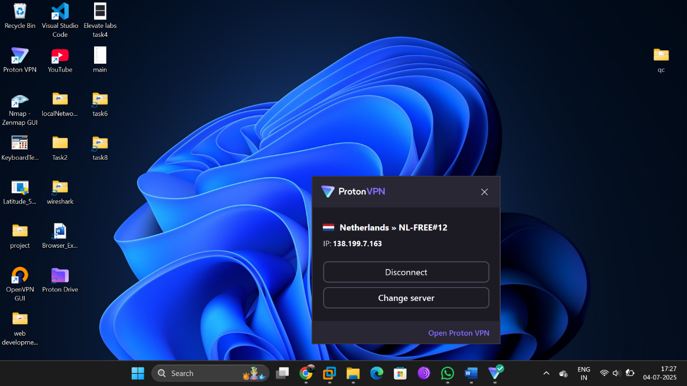

1. https://whatismyipaddress.com with new ProtonVPN-assigned IP

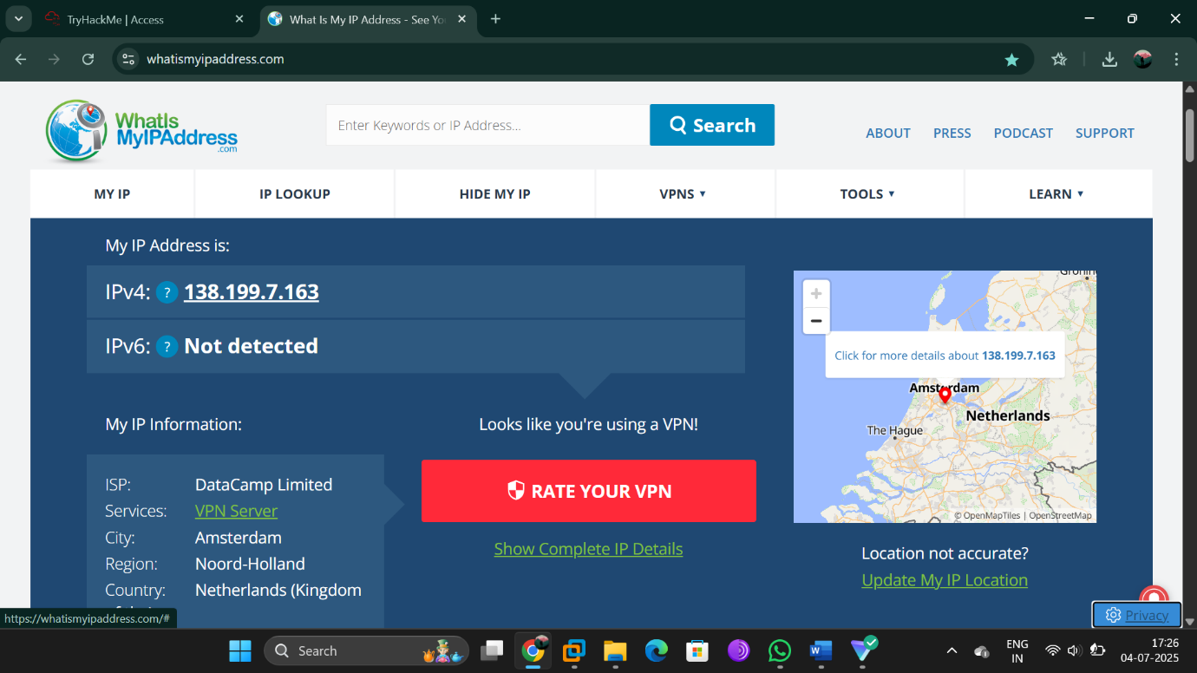

3. Wireshark with TLS filter applied: tls

Confirms encrypted HTTPS traffic



4. Disconnected state – show original IP and/or speed comparison (optional: speedtest.net)

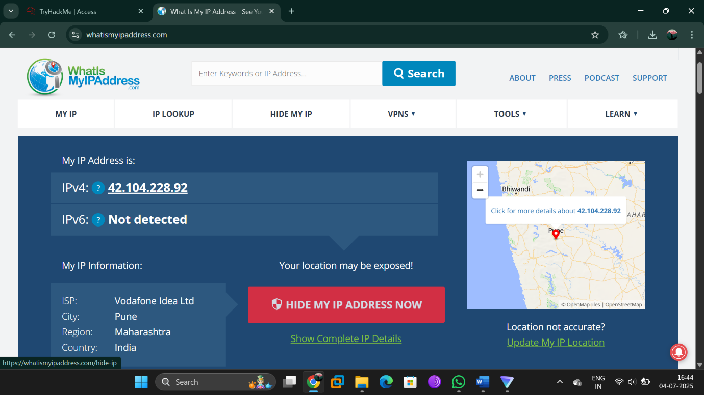

4. Verify VPN Effectiveness

Visit: https://whatismyipaddress.com

Before VPN: Take note of your IP & location.

After VPN: Confirm IP has changed to ProtonVPN server location.

Run Wireshark:

Filter: tls

You should see encrypted traffic when browsing HTTPS websites.

5. VPN Encryption & Privacy Features (ProtonVPN)

Protocols: OpenVPN (UDP/TCP), IKEv2, and WireGuard

Encryption: AES-256, perfect forward secrecy (PFS)

DNS Leak Protection: Enabled

Kill Switch: Prevents traffic leaks if VPN disconnects

No Logs Policy: No personal data stored or sold

Secure Core: (Paid only) routes traffic through multiple servers

6. Summary: VPN Benefits & Limitations

Benefits:

Strong traffic encryption

Masks IP and protects against ISP/government surveillance

Secures public Wi-Fi use

Access geo-blocked content (limited in free plan)

Limitations:

Free plan only has a few servers (can affect speed)

No P2P or Secure Core on free accounts

Slight latency increase due to encryption

Trust still required in VPN provider