Real-World Internship Offer Analysis

Real-World Internship Offer Analysis: Email (.eml), PDF, and URL Investigation

Objective:
To conduct a comprehensive cybersecurity analysis of a suspicious internship, offer by examining the email (including raw .eml file), attached PDF document, and embedded URL to identify indicators of social engineering, phishing behaviour, and potential financial exploitation.

Tools Used:
- VirusTotal (file and URL reputation analysis)
- WHOIS Lookup (basic domain investigation)
- Manual Static Analysis (email headers, PDF content, URL inspection)

Analysis:

1.Email Analysis (.eml based):
The email was analysed using its raw .eml format to inspect headers, sender infrastructure, and embedded elements.

Header Observations:
- SPF, DKIM, and DMARC authentication checks passed
- However, authentication does not guarantee legitimacy

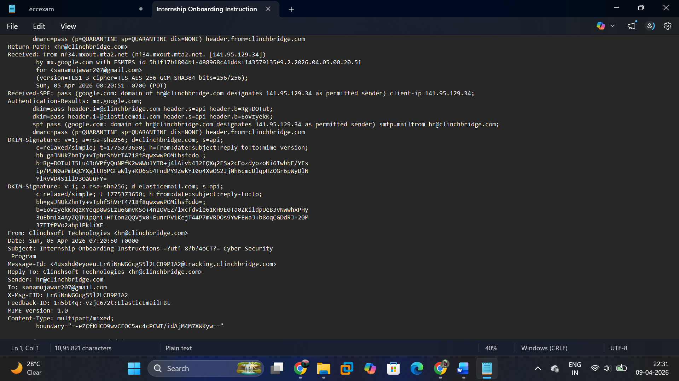
Figure 1: Email Header Analysis Showing Domain Mismatch and Sender Infrastructure

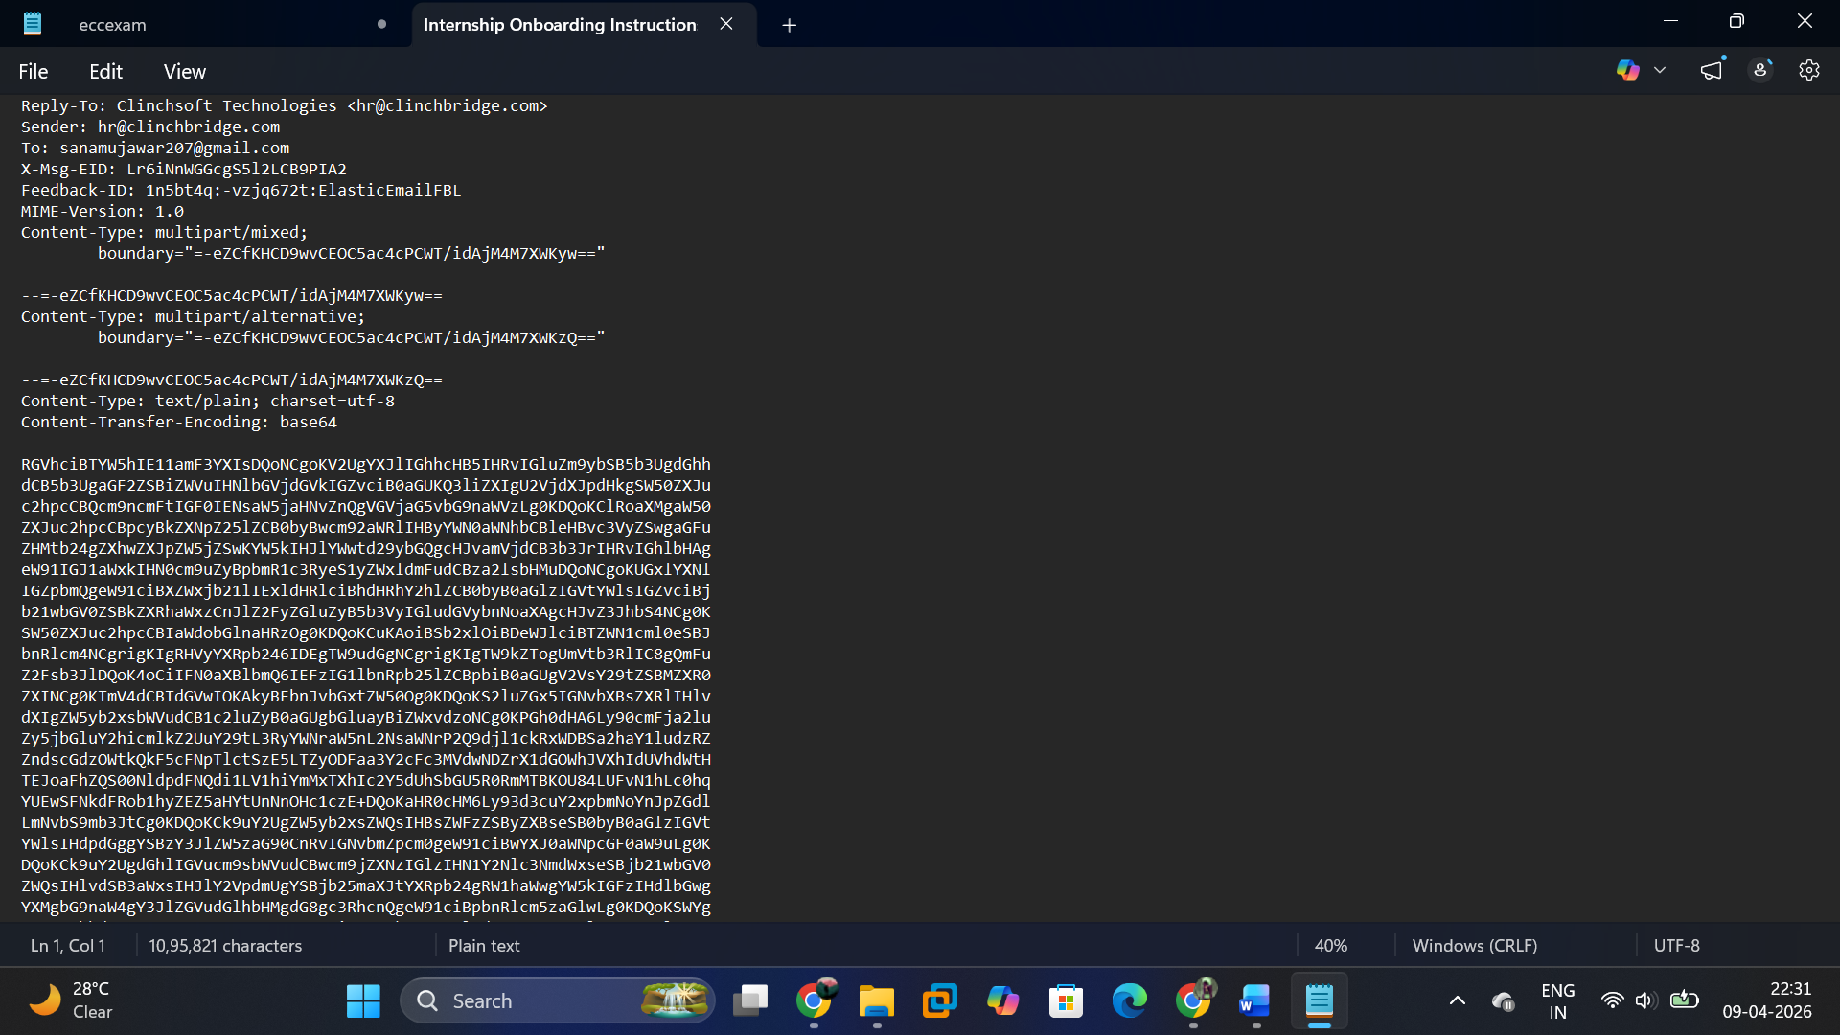
Figure 2: Presence of Tracking Links and Message-ID Indicating Automated Email System

Key Observations:
- Domain Mismatch:
Email claims to be from "Clinchsoft Technologies"
Sender domain: hr@clinchbridge.com
→ Indicates inconsistency and potential impersonation
- Bulk Email Infrastructure:
Email routed via elasticemail.com
→ Common in mass campaigns
- Tracking Mechanisms:
Multiple tracking links detected:
tracking.clinchbridge.com
Hidden tracking pixel (1x1 image) present
- Encoded Content:
Email body encoded in base64 format
- Suspicious Call-to-Action:
Direct enrolment request without interview or evaluation

Analysis:
These characteristics align with mass-targeted campaigns using automation and tracking.

Conclusion:
The email shows multiple behavioural red flags despite passing authentication checks.
--------------------------------------------------------------------------------------------------------------

2. PDF Analysis:
The PDF was analysed using screenshots and extracted content without executing the file, following safe analysis practices.

Key Observations:
- Upfront Payment Requirement:
₹1563 required to confirm enrolment
- Conditional Stipend:
Provided only after project completion
- Misleading Salary Representation:
₹23,000/month prominently displayed
- Flexible Joining:
No structured onboarding
- Unrealistic Job Promise:
Up to ₹5 LPA without defined criteria
- Embedded Link:
Contains enrolment/payment link

Figure 3: Mandatory Upfront Payment Requirement (₹1563) in Offer Letter
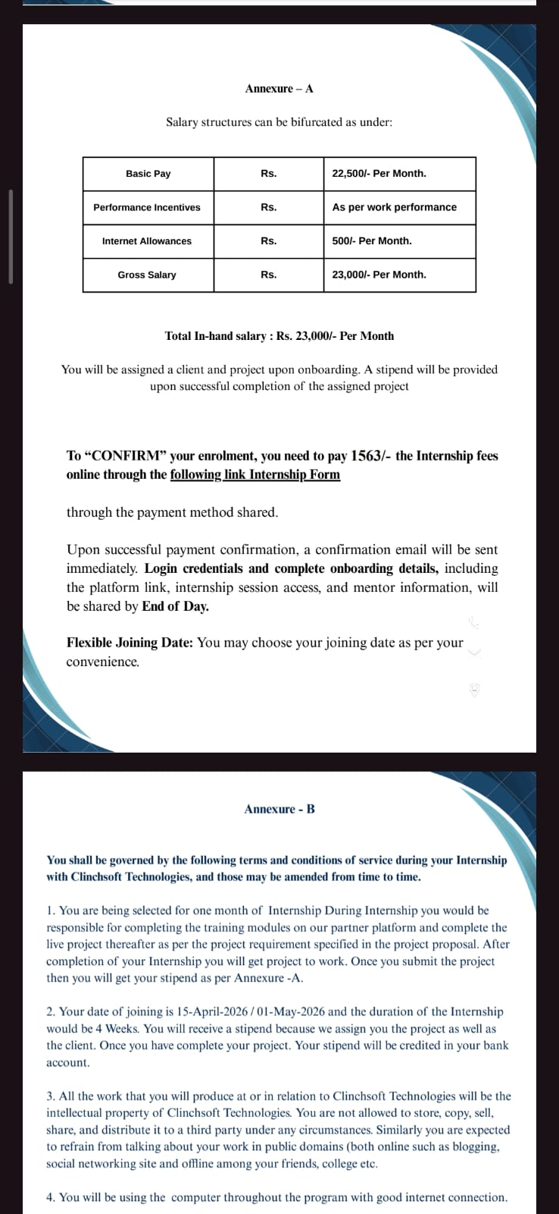
Figure 4: Offer Letter Showing Conditional Stipend, Misleading Salary Structure (₹23,000/month), and Embedded Enrolment/Payment Link

Analysis:

Social Engineering Techniques Identified:
- Baiting (high salary claims)
- Low entry barrier (₹1563 fee)
- Delayed reward (stipend after work)
- Action trigger (embedded link)

Conclusion:
The document indicates a pay-to-join model rather than legitimate employment.

Note:
The PDF was not executed locally due to security considerations. Analysis was performed using screenshots.
--------------------------------------------------------------------------------------------------------------

3. URL Analysis (Updated Version)

Analysed URL:
http://tracking.clinchbridge.com/tracking/click?d=...

Observations:
- Use of HTTP:
No encryption → communication is not secure and can be intercepted
- Tracking Subdomain:
tracking.clinchbridge.com
→ Indicates use of a tracking/redirect infrastructure
- Tracking Path:
/tracking/click
→ Suggests click-tracking mechanism typically used in campaigns
- Encoded Parameter:
d= contains encoded data
→ Obfuscates the actual destination URL
- Redirection Behaviour:
The URL likely redirects to another page (final destination not visible)
- Brand Mismatch (Critical Finding):
The email referenced LinkedIn, but the actual link points to a different domain
→ Indicates link spoofing / brand impersonation

Analysis:
This URL follows a structure commonly used in:
- Tracking and marketing systems
- Redirect-based link management
- Phishing campaigns (to hide final malicious destination)
Although the link is not flagged as malicious by security vendors, it demonstrates deceptive characteristics, including:
- Link masking
- Brand impersonation
- Hidden redirection
Such techniques are frequently used in social engineering attacks to gain user trust and bypass security detection.
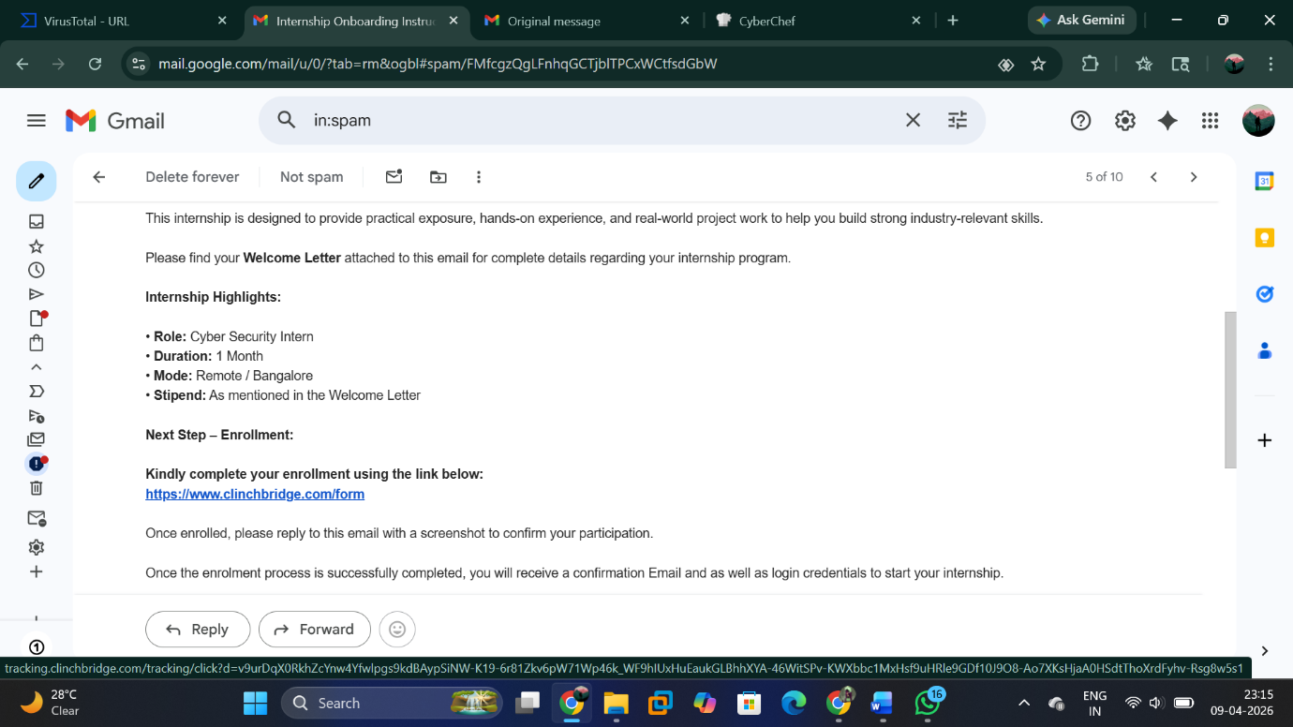
Figure 5: URL Analysis Showing Enrolment Link
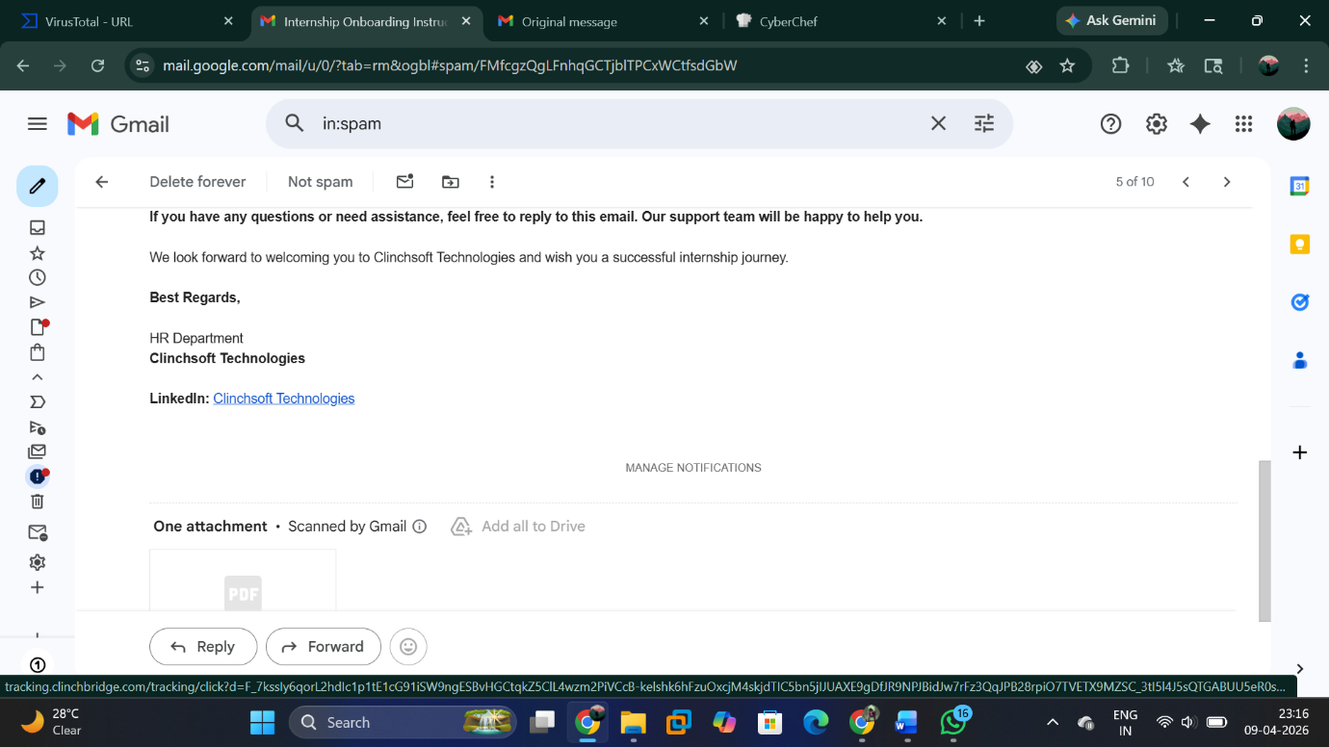
Figure 6: LinkedIn Brand Mismatch via Tracking URL

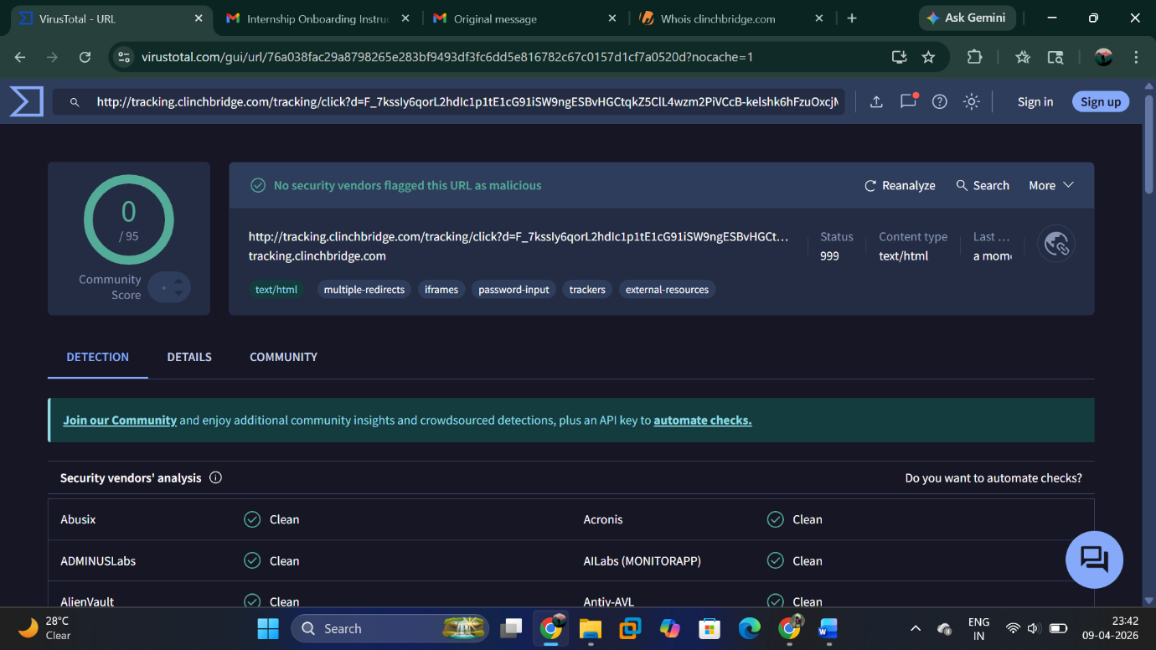
Figure 7: VirusTotal Scan Results

Conclusion:
The URL is a tracking-enabled redirection link designed to obscure the destination.
While not explicitly flagged as malicious, the presence of link spoofing, redirection, and brand misuse makes it suspicious and potentially unsafe.

Findings:
- Upfront payment required before joining
- Domain mismatch (Clinchsoft vs clinchbridge)
- Brand impersonation using LinkedIn
- Use of bulk email infrastructure
- Tracking links and tracking pixel present
- Unencrypted tracking URL (HTTP)
- Encoded parameters hiding destination
- Hidden redirection chain
- No structured hiring process
- Misleading salary and stipend claims
--------------------------------------------------------------------------------------------------------------

4. Domain Analysis

Domain Details:
- Domain: clinchbridge.com
- Registrar: HOSTINGER (IANA ID: 1636)
- Registration Date: 13 November 2025
- Last Updated: 14 November 2025
- Expiry Date: 13 November 2026
- Domain Status: clientTransferProhibited

Infrastructure Details:
- Name Servers:
  - ns8.wixdns.net
  - ns9.wixdns.net
Indicates usage of Wix hosting infrastructure

Registrant Information:
- Country: Lithuania (LT)
- Contact: Protected via registrar privacy service

Analysis:
- Newly Registered Domain:
The domain was registered recently (2025), which increases suspicion, as many phishing domains are newly created for short-term campaigns.
- Short Registration Period:
Valid for only 1 year → commonly seen in temporary or disposable domains used in scams.
- Privacy-Protected Ownership:
Registrant details are hidden → reduces transparency and accountability.
- Hosting Infrastructure:
Use of shared platforms like Wix and HOSTINGER is common for both legitimate and malicious websites, but also frequently abused due to low setup cost.
- Geographical Mismatch:
Domain registered in Lithuania, while the job opportunity context appears unrelated geographically → potential indicator of suspicious activity.
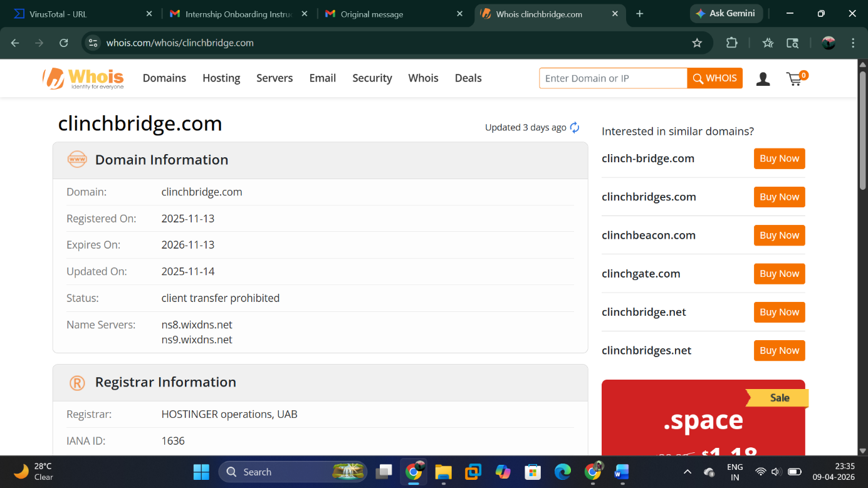
Figure 8: WHOIS Data Showing Recent Domain Registration (2025)

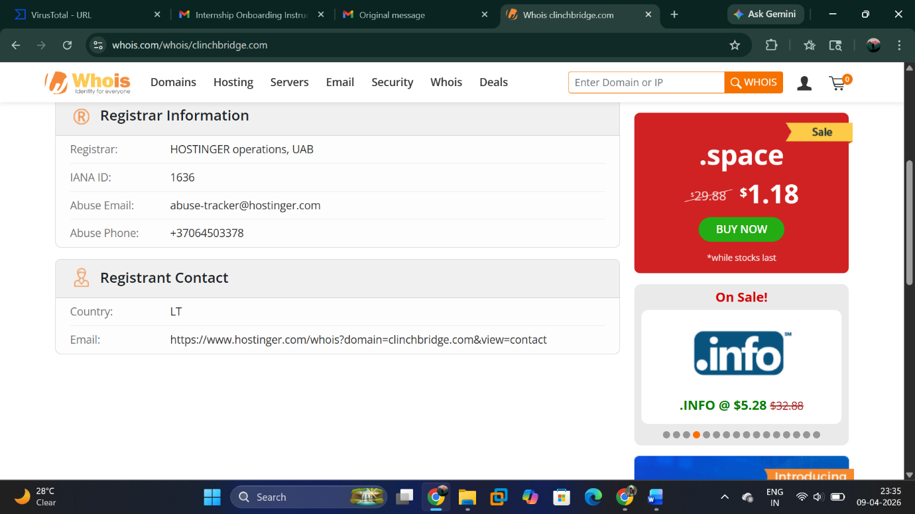
Figure 9: Domain Ownership Privacy and Hosting Infrastructure Details

Conclusion:
The domain clinchbridge.com shows multiple risk indicators, including recent registration, short lifespan, privacy-protected ownership, and infrastructure commonly used in low-cost deployments.
Although not inherently malicious, these characteristics are consistent with domains used in phishing and scam campaigns.

Note:
Newly registered and low-reputation domains are a common indicator in phishing investigations and should always be treated with caution.”

--------------------------------------------------------------------------------------------------------------

Final Conclusion:
This investigation indicates that the internship offer follows a pay-to-join model using social engineering techniques.
Multiple indicators such as domain mismatch, tracking-based URLs, payment requirement, and misleading job claims raise significant concerns about its legitimacy.
Overall, the offer appears suspicious and highlights the importance of verifying opportunities before making any financial commitment.
This approach reflects real-world SOC practices for identifying suspicious activities and protecting users.

--------------------------------------------------------------------------------------------------------------

