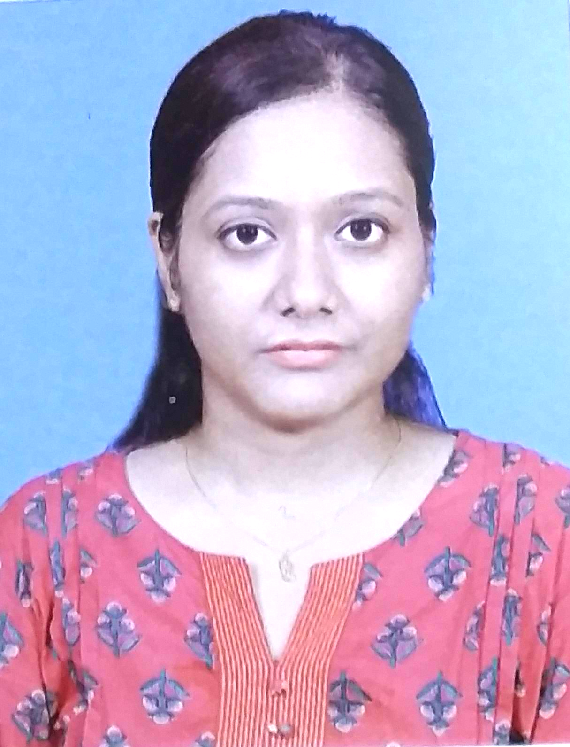
Web Designer
-------------------------------------------------------------------------------------------------------

SWASTIKA SANA
Contact No. +91-9163730848
E-mail - sanaswastika21@gmail.com

PROFILE SUMMARY
Knowledgeable Web Designer with expert knowledge of HTML and CSS with basic knowledge of Wordpress. Total Job experience - 8 years. About 5 years of work experience in the field of web designing. At present working as a web designer in Magicnines Infotech Pvt. Ltd. Along with my job I am pursuing a executive Pg programme on Full Stack Web Development.

KEY SKILLS
- HTML5,  - CSS3,  - JavaScript, JQuery  - FTP | - Bootstrap3, Bootstrap4, Bootstrap5  - WordPress.  - Photoshop  - Photo Editing, Colour Correction

JOB EXPERIENCE
MAGICNINES INFOTECH PVT. LTD.
Tenure: 2017 March – Present
Location: Kolkata (Remote)
Role: Web Designer: To design and coding Web Pages for clients, Updating regular updates and changes on website using HTML, CSS, Bootstrap, Javascript & JQuery .

PROJECTS HANDLED:

- Desun Hospital (Kolkata & Siliguri Website):
  - Converting the non-responsive home page (Kolkata) into responsive; Updating new content, Banner; Recreating pages; Creating new inner pages; Website re-designing (in 2020 & 2021). Landing pages.
- Desun Tests & Calibration Lab:
  - Designing and Coding the Responsive Home page and inner pages.
- Ruby Hospital:
  - Coding Home pages, inner pages & landing pages. Updating new contents & banner.
- Contents update for J. D. Birla Institute.
- Coding Home Page & inner pages for Jeesa Gupta, Excel Fashions, Dr. Manas Saha’s Website, Bleubury, PJ Foods, Arrange Marriages, PropertyInc.
- Designing & Coding landing page for Dr. Sunil Kumar Das.
- Converting Tour De Sundarban static website to responsive.
- Poster Design for Tour De Sundarban ad.
------------------------------------------------------------------------------------------------------------------------------------------------------------
MANAGEMENT & COMPUTER CONSULTANTS PVT. LTD.
Tenure: 2014 February – 2017 February (3 years, 1 month.)
Location: Kolkata.
Role: Operator

OPERATIONS HANDLED:
- Editing Photo for “Digitization and Archival of Documents”, a project of Management and Computer Consultants Company. I have edited approximately 300 images every day and deliver usable high-quality captured images.
- Verification of data for name enrolment of Calcutta University, Madhyamik marks enrolment and name enrolment of Tripura Board of Secondary Education for Management and Computer Consultants Company.

RELEVANT LINKS
- Github Profile - https://github.com/SanaProjects/
- Chat Bot Replica - https://sanaprojects.github.io/chatbot.github.io/
- Tic Tac Toe Game in React - http://fascinated-vegetable.surge.sh/

QUALIFICATIONS & IT SKILLS
- Pursuing PG programme on Full Stack Web Development (executive programme under N.S.D.C)
- Completed Certificate Course on Web Designing from E-Job India (2017)
- Completed Post Graduate Diploma in Image Editing & Animation from Brainware & Jadavpur University joint Programme (2011)
- B.SC (Honours) from Calcutta University in Economics in 2010

IT SKILLS
- HTML5
- CSS3
- Bootstrap 3
- Bootstrap 4
- Bootstrap 5
- Photoshop (CS3)
- MS Word, MS Excel, MS PowerPoint

PERSONAL INFORMATION
- Date of Birth: 21-06-1987.
- Permenant Address: Balaka, Suripara, N. S. Road Chinsurah-Hooghly, West Bengal-712101
- Nationality: Indian.
- Marital Status: Married
- Hobbies:
  - Using online tutorials to develop my skills
  - Capturing and Editing Photos.
  - Internet Surfing.
  - Designing E-Cards, WhatsApp Invitation cards for friends.

Declaration: I hereby declare that all the information, furnished above is true to the best of my knowledge.

(Swastika Sana)

