**WEEK_1**

**TASK_3**

**BASIC HTML MULTIPAGE WEBSITE WITH CSS STYLING**

**SWAT VALLEY**

**HTML CODE:-**

<!DOCTYPE html>

<html lang="en">

<head>

  <meta charset="UTF-8">

  <title>Swat Valley</title>

  <link rel="stylesheet" href="style.css">

</head>

<body>

  <nav>

    <a href="index.html">Home</a>

    <a href="attractions.html">Attractions</a>

    <a href="contact.html">Contact</a>

  </nav>

  <header class="hero">

    <h1>Welcome to Swat Valley</h1>

    <p class="tagline">The Switzerland of Pakistan</p>

  </header>

  <section class="intro">

    <p>

      Swat is a majestic valley in the Khyber Pakhtunkhwa province of Pakistan. Known for its breathtaking mountains, clear rivers, and friendly people, Swat is the perfect getaway for nature lovers and adventure seekers alike.

    </p>

  </section>

</body>

</html>

<!DOCTYPE html>

<html lang="en">

<head>

  <meta charset="UTF-8">

  <title>Attractions in Swat</title>

  <link rel="stylesheet" href="style.css">

</head>

<body>

  <nav>

    <a href="index.html">Home</a> |

    <a href="attractions.html">Attractions</a> |

    <a href="contact.html">Contact</a>

  </nav>

  <h1>Top Attractions</h1>

  <ul>

    <li>Malam Jabba</li>

    <li>Mahodand Lake</li>

    <li>Fizagat Park</li>

    <li>Kalam Valley</li>

  </ul>

  <div class="grid">

        <div class="item">

            <div class="image"> <img src="pic.png" alt="Malam jabba" float="left" width="188px"></div>

            <div class="content">

                <h3>Malam jabba</h3>

                <p>Malam Jabba is one of Pakistan’s most popular hill stations and ski resorts, located in the Hindu

                    Kush range.It is famous for winter sports like skiing, snowboarding, and chairlift rides. The snow-covered

                    slopes and cool climate make it a perfect spot for adventure lovers, especially during the winter season.</p>

            </div>

        </div>

         <div class="item">

            <div class="image"> <img src="pic2.png" alt="Malam jabba" float="left" width="188px"></div>

            <div class="content">

                <h3>Kalam valley</h3>

                <p>Kalam Valley is a peaceful and scenic valley in the upper Swat region. Surrounded by pine forests and

            snow-capped mountains, Kalam is known for its fresh air, calm rivers, and relaxing atmosphere. It is an

            ideal place for camping, sightseeing, and enjoying the serenity of nature.</p>

            </div>

        </div>

         <div class="item">

            <div class="image"> <img src="pic3.png" alt="Malam jabba" float="left" width="188px"></div>

            <div class="content">

                <h3>Mahodand lake</h3>

                <p>Mahodand Lake is a beautiful alpine lake located near Kalam. Surrounded by tall mountains and pine forests, it is a popular spot for boating, fishing, and horse riding. The crystal-clear water and breathtaking scenery make it a must-visit destination in Swat.</p>

            </div>

        </div>

         <div class="item">

            <div class="image"> <img src="pic4.png" alt="Malam jabba" float="left" width="188px"></div>

            <div class="content">

                <h3>Fizagat park</h3>

                <p>Fizagat Park is a riverside recreational park near Mingora, perfect for families and kids. It has playgrounds, walking tracks, and picnic spots with views of the Swat River. The cool breeze and scenic surroundings make it a relaxing place to spend quality time with loved ones</p>

            </div>

        </div>

    </div>

</body>

</html>

<!DOCTYPE html>

<html lang="en">

<head>

  <meta charset="UTF-8">

  <title>Contact Us</title>

  <link rel="stylesheet" href="style.css">

</head>

<body>

  <nav>

    <a href="index.html">Home</a>

    <a href="attractions.html">Attractions</a>

    <a href="contact.html">Contact</a>

  </nav>

  <section class="contact-section">

    <h1>Get in Touch</h1>

    <p>We'd love to hear from you. Fill out the form below and we'll respond as soon as possible.</p>

    <form class="contact-form">

      <input type="text" placeholder="Your Name" required>

      <input type="email" placeholder="Your Email" required>

      <textarea rows="5" placeholder="Your Message"></textarea>

      <button type="submit">Send Message</button>

    </form>

  </section>

</body>

</html>

**CSS CODE:-**

body {

  font-family: 'Segoe UI', Tahoma, Geneva, Verdana, sans-serif;

  background-color: #f0f8ff;

  margin: 0;

  padding: 0;

}

nav {

  background-color: #2c3e50;

  padding: 15px;

  text-align: center;

}

nav a {

  color: white;

  text-decoration: none;

  margin: 0 20px;

  font-weight: bold;

  font-size: 18px;

}

nav a:hover {

  color: #ffd700;

}

header, section, footer {

  padding: 30px;

  text-align: center;

}

h1, h2 {

  color: #2c3e50;

}

ul {

  list-style-type: square;

  text-align: left;

  max-width: 600px;

  margin: 20px auto;

  padding-left: 20px;

}

p {

  max-width: 600px;

  margin: auto;

  line-height: 1.6;

  color: #333;

}

.grid{

    display: grid;

    width: 70vw;

    align-items: center;

    grid-template-columns: 1fr 1fr 1fr 1fr;

    row-gap: 30px;

    column-gap: 15px;

    justify-content: center;

    margin: 9px 0px;

    margin-left: 155px;

}

item{

    width: 220px;

    background-color: rgb(211, 206, 206);

    height: 365px;

    border-radius: 7px;

    border: none;

}

.image{

    padding: 15px;

}

.image img{

        height: 124px;

        border-radius: 7px;

       }

       .content{

        padding: 1px 10px;

       }

     .content p{

        font-size: 10px;

        color:gray;

      }

        .content h1{

        padding: 13px;

        font-size: 20px;

      }

      .hero {

  background: url('https://upload.wikimedia.org/wikipedia/commons/8/89/Mahodand_Lake_in_Swat.jpg') no-repeat center center/cover;

  color: white;

  text-align: center;

  padding: 80px 20px;

}

.hero h1 {

  font-size: 48px;

  margin-bottom: 10px;

}

.tagline {

  font-size: 20px;

  font-style: italic;

  opacity: 0.9;

}

.intro {

  max-width: 700px;

  margin: 30px auto;

  padding: 20px;

  background-color: white;

  border-radius: 12px;

  box-shadow: 0 2px 8px rgba(0,0,0,0.1);

  text-align: center;

  color: #333;

  line-height: 1.6;

}

.contact-section {

  max-width: 600px;

  margin: 40px auto;

  padding: 30px;

  background-color: white;

  border-radius: 12px;

  box-shadow: 0 2px 8px rgba(0,0,0,0.1);

  text-align: center;

}

.contact-form {

  display: flex;

  flex-direction: column;

  gap: 15px;

  margin-top: 20px;

}

.contact-form input,

.contact-form textarea {

  padding: 12px;

  font-size: 16px;

  border: 1px solid #ccc;

  border-radius: 8px;

}

.contact-form button {

  background-color: #2c3e50;

  color: white;

  padding: 12px;

  border: none;

  font-size: 16px;

  border-radius: 8px;

  cursor: pointer;

  transition: background-color 0.3s ease;

}

.contact-form button:hover {

  background-color: #1a252f;

}

**OUTPUT:-**

**HOME PAGE:-**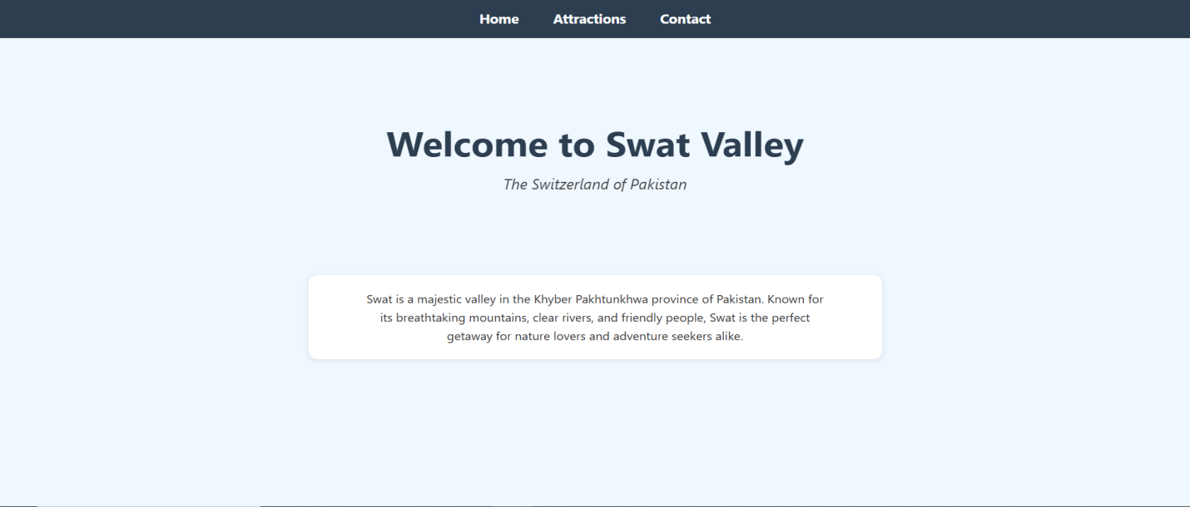

**ATTRACTION PAGE:-**

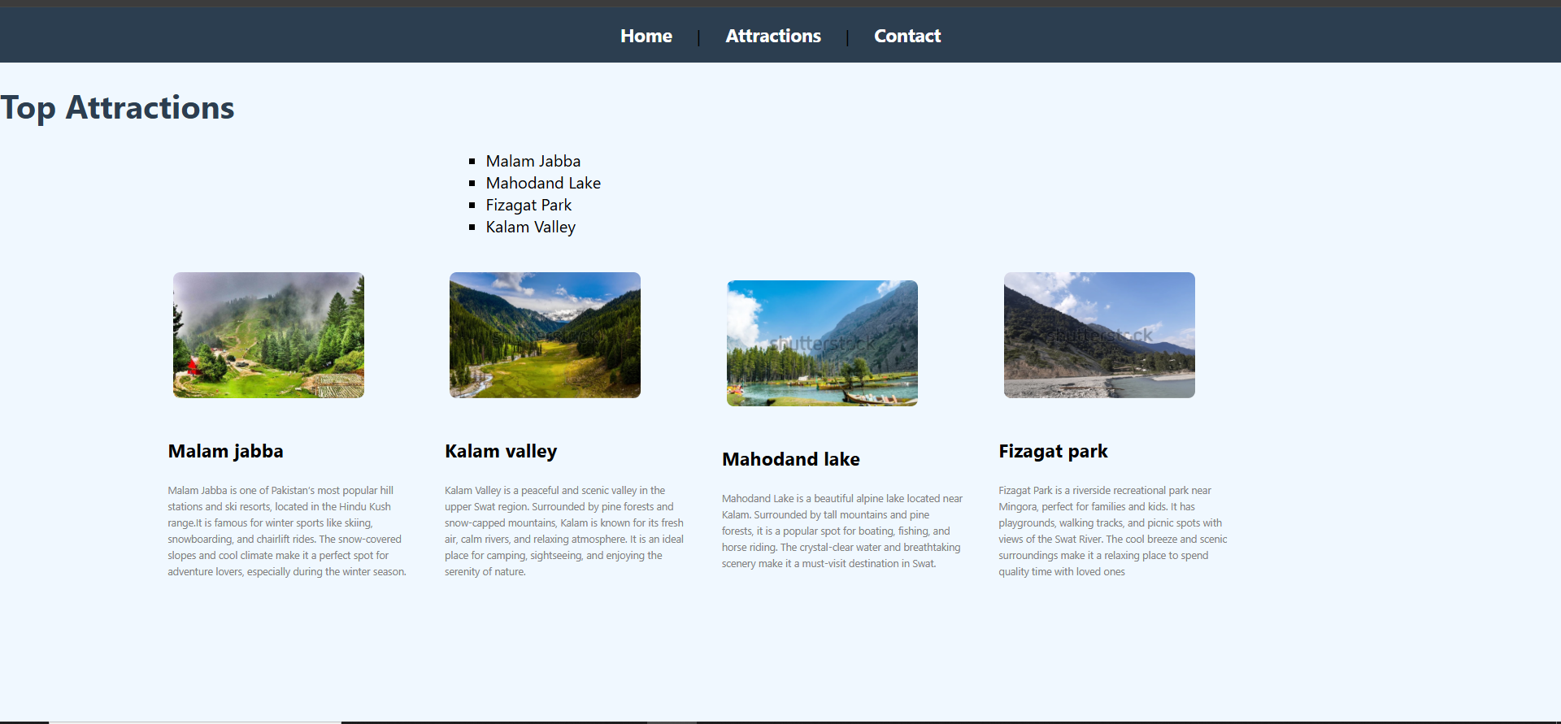

**CONTACT PAGE:-**

