**NAME: SANA TARIQ**

**CLASS: BSE 5B**

**REG.NO: 058**

**SUBJECT: CLOUD COMPUTING**

**ASSIGNMENT #1:**

**TASK#01:**

Task 1: Run Gitea in Codespace and Create an Initial Repo  
  
1. Set up Gitea:  
   - Run a Gitea server inside your Codespace.  
   - Use HTTPS for communication (SSH is not supported in Codespace).  
  
2. Create a Repository:  
   - Create a new repository on your Gitea server.  
   - Add a README.md file listing each student's name and roll number.  
  
3. Add Remote Repo:  
   - Use the following command to add your Gitea repository as a remote:  
     git remote add gitea <your_gitea_repo_https_url>  
   - Push your initial commit containing the README.md to Gitea.

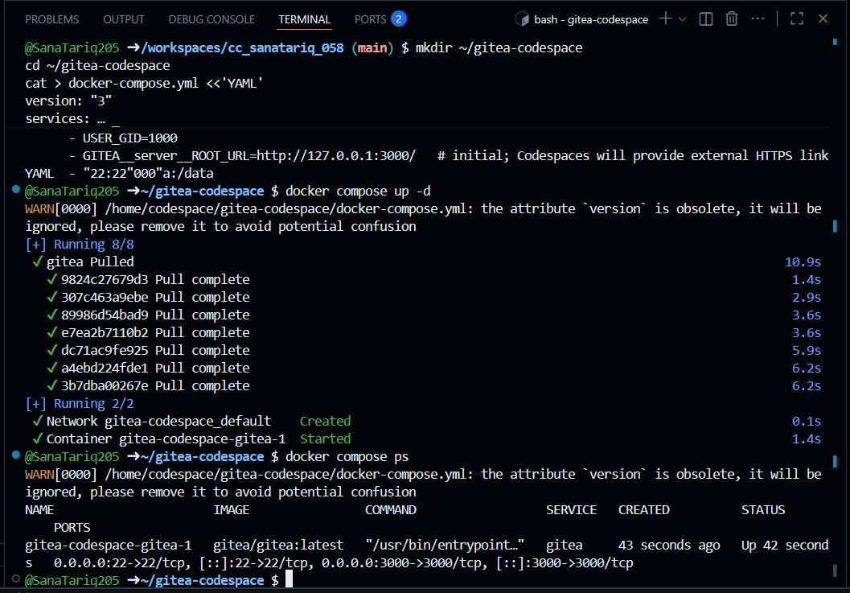

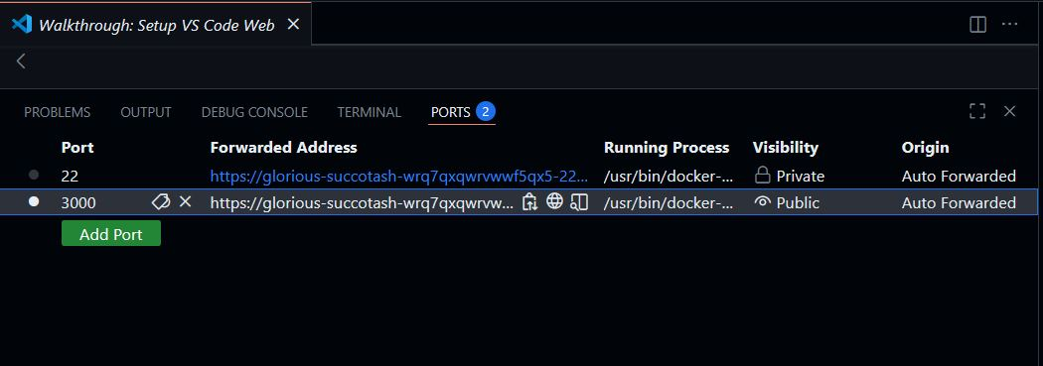

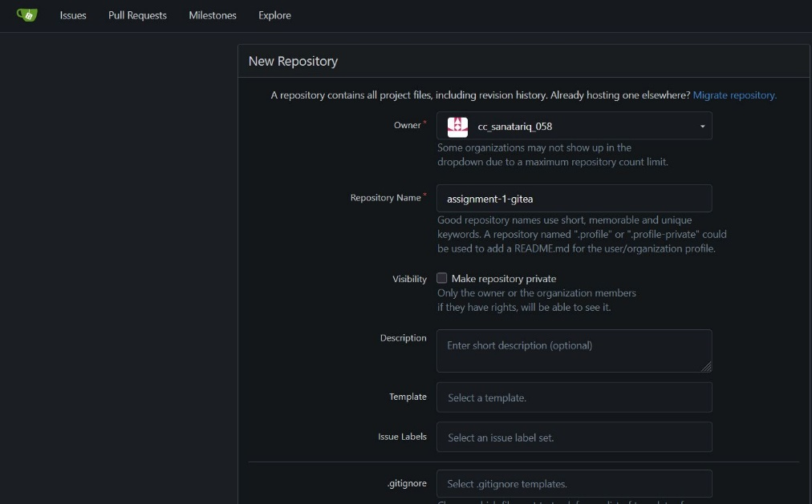

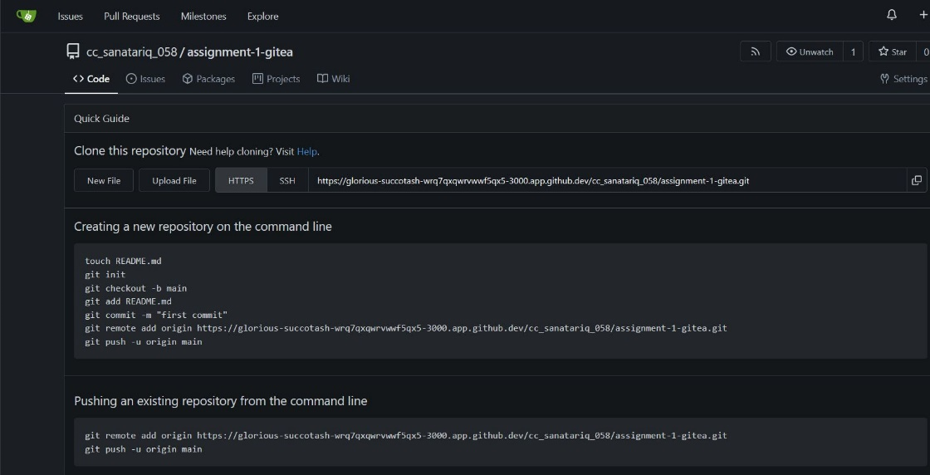

**TASK#02:**

Task 2: Mirror README.md from Gitea to GitHub  
  
1. Continue Working with Your Existing Repository:  
   - You will use the same repository that you created and pushed to your Gitea server in Task 1.  
  
2. Create GitHub Repository:  
   - Create a new GitHub repository named assignment 1.  
  
3. Add GitHub as a Second Remote:  
   - Add your GitHub repository as a remote to your local repository:  
     git remote add github <your_github_repo_https_url>  
  
4. Push the README.md File to GitHub:  
   - Push the contents (including the README.md) from your local repository to GitHub.  
  
5. Verify Remotes:  
   - Run git remote -v and ensure both remotes (gitea and github) are listed.

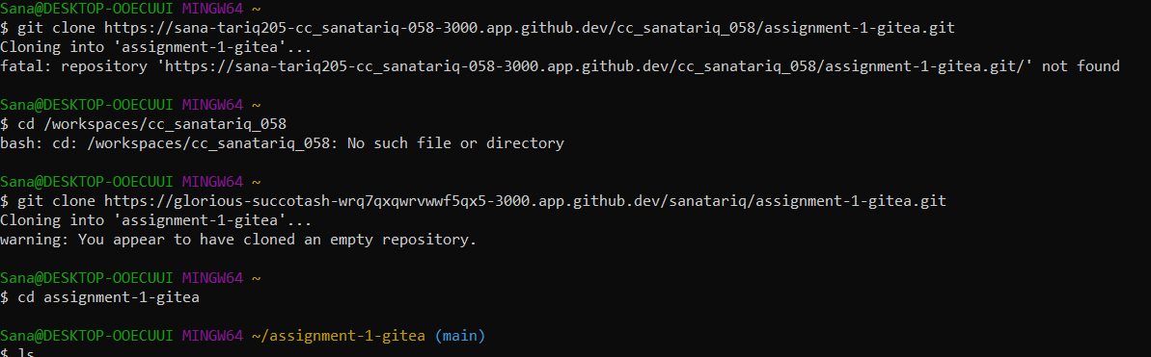

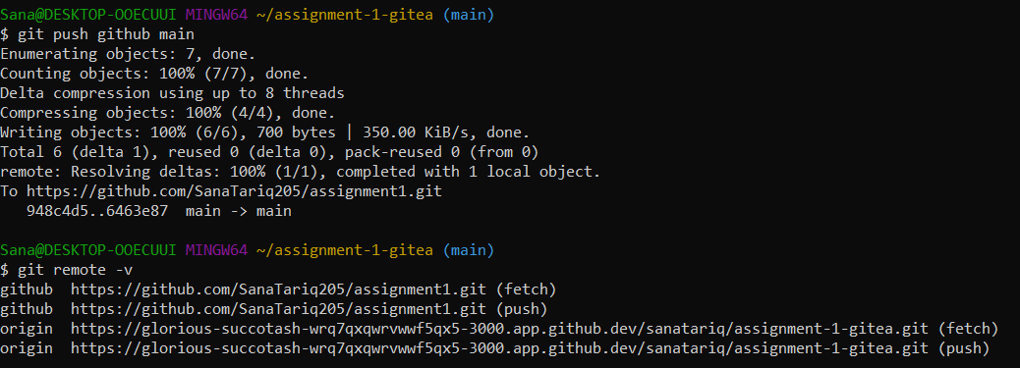

**TASK#03:**  
Task 3: Use Git LFS for Large Files  
  
1. Install Git LFS:  
   - Set up Git LFS in your local repository.  
  
2. Add Large Files:  
   - Add three files larger than 100 MB each to your repository.  
   - Track them using Git LFS:  
     git lfs track "*.ext"  
   - Replace .ext with the appropriate file extension.  
  
3. Reference in Assignment Repo:  
   - Commit and push these large files to your GitHub assignment 1 repo.  
   - Ensure the files are referenced correctly in your repository history.

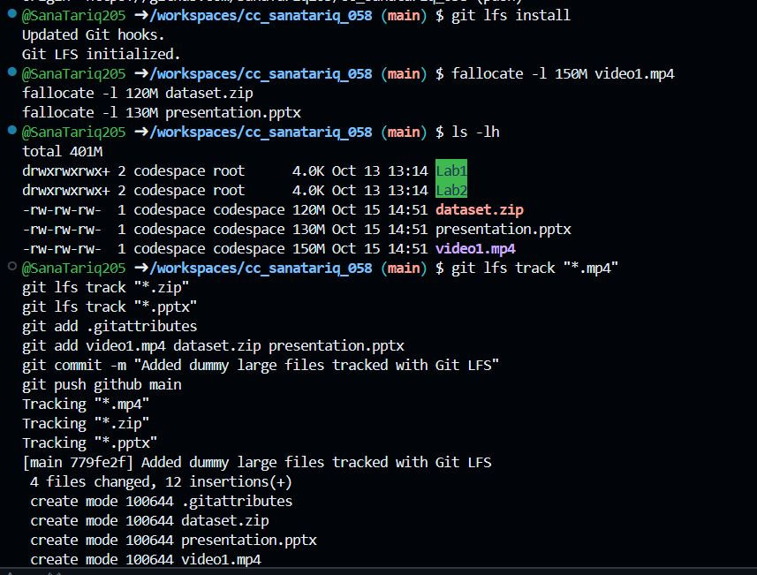

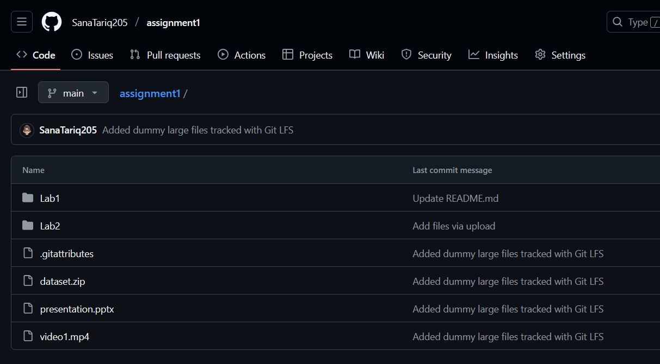

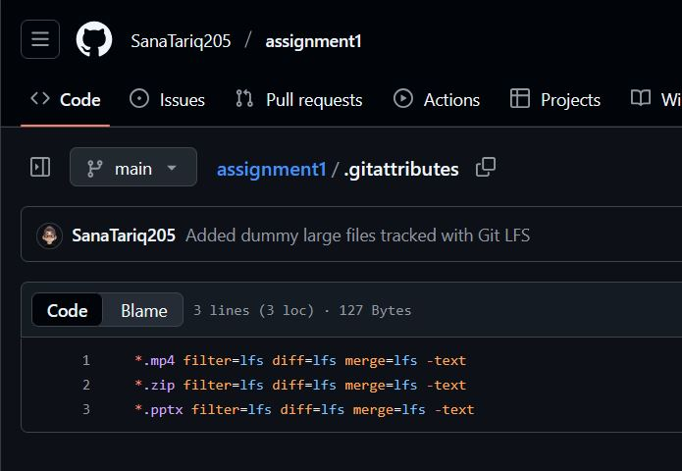

**TASK#04:**

Task 4: Create a Portfolio/CV with GitHub Pages  
  
1. Create a new repository for GitHub Pages:  
   - Create a new repository named <your-username>.github.io.  
   - Replace <your-username> with your actual GitHub username (e.g., johnsmith.github.io).  
  
2. Design Your Portfolio/CV:  
   - Create your portfolio or CV in HTML/CSS (or use a static site generator).  
  
3. Publish with GitHub Pages:  
   - Push your portfolio/CV files to the <your-username>.github.io repository.  
   - Enable GitHub Pages in your repository settings if not automatically enabled.  
   - Publish your site and share the link.

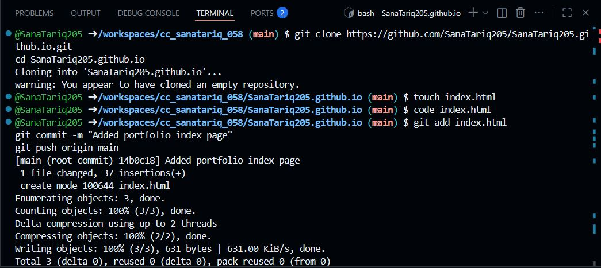

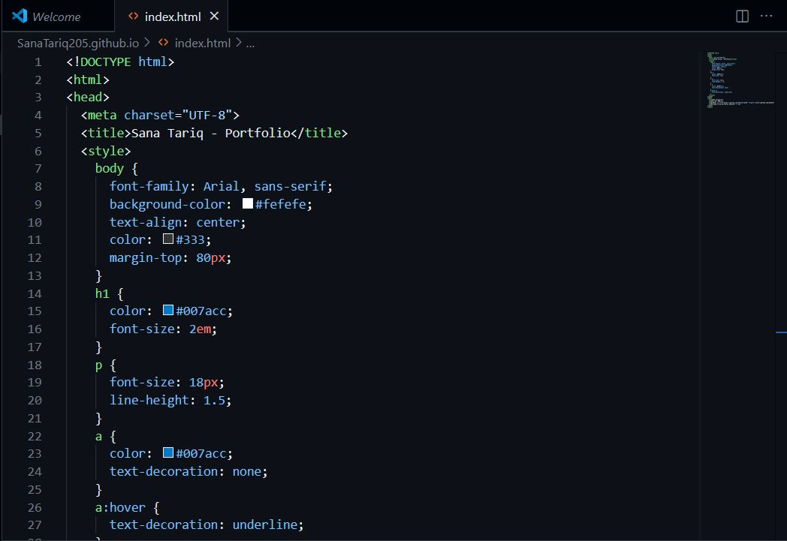

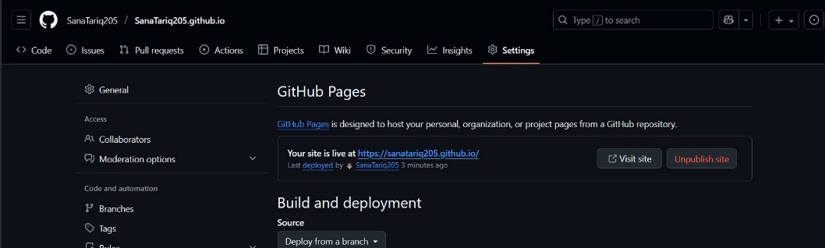

**LINK:**

<https://github.com/SanaTariq205/assignment1>

<https://sanatariq205.github.io/>

