Skill Link


By:

Sana Ullah
13328
Hammad Javed
26693

Supervised by: Nadeem Khan

Faculty of Computing
Riphah International University, Islamabad
Spring/Fall 2025
A Dissertation Submitted To

Faculty of Computing,
Riphah International University, Islamabad
As a Partial Fulfillment of the Requirement for the Award of the Degree of
Bachelors of Science in Software Engineering

Faculty of Computing
Riphah International University, Islamabad

Date: [date of final presentation]
Final Approval

This is to certify that we have read the report submitted by Sana Ullah (13328) and Hammad Javed (26693) for the partial fulfillment of the requirements for the degree of the Bachelors of Science in Software Engineering (BSSE). It is our judgment that this report is of sufficient standard to warrant its acceptance by Riphah International University, Islamabad for the degree of Bachelors of Science in Software Engineering (BSSE).

Committee:

1 | Nadeem Khan  (Supervisor)
2 | Dr. Musharaf Ahmad  (Head of Department/chairman)

Declaration

We hereby declare that this document “Skill Link” neither as a whole nor as a part has been copied out from any source. It is further declared that we have done this project with the accompanied report entirely on the basis of our personal efforts, under the proficient guidance of our teachers especially our supervisor Mr Muhammad Nadeem Khan. If any part of the system is proved to be copied out from any source or found to be reproduction of any project from anywhere else, we shall stand by the consequences.

___________________________
Sana Ullah
13328

___________________________
Hammad Javed
26693

Dedication
We dedicate this project to Allah Almighty our creator, our strong pillar, our source of inspiration, wisdom, knowledge and understanding. He has been the source of our strength throughout this program. Also, we dedicate our work to our family, friends and teachers. The unrivalled encouragement from our parents and outstanding support from teachers is what lead to success of this project. We also dedicate our work to our supervisor Nadeem Khan and the faculty members.

Acknowledgement

First of all, we are obliged to Allah Almighty the Merciful, the Beneficent and the source of all Knowledge, for granting us the courage and knowledge to complete this Project.
We are thankful to our friends, Sana Ullah (13328) and Hammad Javed (26693)

___________________________
Sana Ullah
13328

___________________________
Hammad Javed
26693
Abstract

In many areas of Pakistan, people like electricians, plumbers, cleaners, and other skilled workers are ready to help with daily problems. But these workers often find it hard to get regular work because they don’t have a proper platform. At the same time, people who need these services struggle to find trusted and nearby workers. Many times, they face problems like fraud, delays, or unskilled service.
SkillLink is a mobile app that connects people with local skilled workers in their area. With this app, users can easily find and book workers for services like cleaning, plumbing, repairing, and more. The app shows the worker’s profile, ratings, and location so users can choose the right person. SkillLink also helps workers get more jobs without paying any extra fees. Our goal is to make daily life easier for people and give more job chances to skilled workers across Pakistan.

Table of Contents

List of Figures | 10
List of Tables | 11
Chapter 1: Introduction | 12
- Opportunity & Stakeholders | 13
- Motivations and Challenges | 14
- Goals and Objectives | 14
- Solution Overview | 14
- Report Outline | 15
Chapter 2: Literature / Market Survey | 17
2.1 Introduction | 18
2.2 Literature Review/Technologies Overview | 18
2.3 Summary | 19
Chapter 3: Requirement Engineering | 20
3.1 Introduction | 21
3.2 Problem Scenarios | 21
3.3 Functional Requirements | 23
3.4 Non-Functional Requirements  3.5 SQA activities: Defect Detection  - Test Case Design  3.6 Summary | 25  25  25  25  31
Chapter 4: System Design | 32
4.1 Introduction | 33
4.2 Architectural Design | 34
4.3 Class Diagram  4.4 Use Case Diagram  4.5 Fully Address Use Case  4,6 Activity Diagram | 35  36  38  67
Chapter 5: Implementation | 84
5.1 Endeavour (Team + Work + Way of Working) | 85
5.2 Flow Control/Pseudo codes | 88
5.3 Components, Libraries, Web Services and stubs  5.4 IDE, Tools and Technologies | 89  89
5.5 Best Practices / Coding Standards  5.5.1 Software Engineering Practices  5.5.2 Development Practices & Standards | 89  89  89
Chapter 6: Testing and Evaluation | 90  91
6.1 Introduction | 92
6.2 List of Test Scenarios | 92
Chapter 7: Conclusion and Outlook | 116
7.1 Introduction | 117
7.2 Achievements and Improvements | 117
7.3 Critical Review | 118
7.4 Future Recommendations/Outlook | 118
7.5 Summary | 118
Appendices
Appendix-A: Software Requirements Specifications (SRS)
Appendix-B: Design Documents
Appendix-C: Coding Standards/Conventions
Appendix-D: Test Scenarios
Appendix-E: Work Breakdown Structure
Appendix-F: Roles & Responsibility Matrix

List of Figures

Architecture Diagram 1.0 34
Class Diagram 1.0 35
Customer Use Case Diagram 36
Admin Use Case Diagram 36
Worker Use Case Diagram 37
Activity Diagram 01 67
Activity Diagram 02 68
Activity Diagram 03 69
Activity Diagram 04 70
Activity Diagram 05 71
Activity Diagram 06 72
Activity Diagram 07 73
Activity Diagram 08 74
Activity Diagram 09 75
Activity Diagram 10 76
Activity Diagram 11 77
Activity Diagram 12 78
Activity Diagram 13 79
Activity Diagram 14 80
Activity Diagram 13 81
Activity Diagram 14 82
Activity Diagram 14 83

List of Tables

1.1 label of first table of first chapter | 6
1.2 label of second table of first chapter | 7
2.1 label of first table of second chapter | 14
2.2 label of second table of second chapter | 22
2.3 label of third table of second chapter | 26
5.1 label of first table of fifth chapter | 49
5.2 label of second table of fifth chapter | 49

Chapter 1:
Introduction
Chapter 1:
Introduction:
In this chapter, we will talk about why we started this project and what problems we are trying to solve. We will also explain who will use our app and how it will help them. Along with that, we will tell you about the solution we are giving and the problems we faced while making the system. SkillLink is a mobile app that helps people find workers like electricians, plumbers, cleaners, and others near their homes. People can use the app to book these workers easily. The app also helps workers get jobs without paying any extra charges. Users can see the worker’s name, work details, location, and rating before booking. SkillLink helps people get good service at home and gives more work chances to local skilled workers.

  - Opportunity & Stakeholders
Workers like plumbers, electricians, and cleaners face many problems in finding regular work. There is no proper system where they can show their skills or tell others that they are available for work. Most of the time, they wait at home or in shops, hoping someone will call them. This wastes their time and talent. People also face problems when they need help with fixing wires, water leaks, or cleaning. They don’t know who to call. Even if they find someone, that person may come late, charge too much, or not do the job properly. There is no easy and trusted way to find a nearby skilled worker.

1.1.1 Stakeholders
Customers
Workers
Admin

  - Motivation & Challenges:
The biggest problem for workers is how to find work. Most workers sit at home or wait at their shops, hoping someone will call them. This is hard and wastes their time. In Pakistan, there is no easy system to help such workers. Even when they get work it is not always good. Sometimes people don’t pay on time, or treat the worker badly. Many workers want to learn more and become better, but they don’t know how or where to go.
People who need help at home like fixing wires, broken pipes, or cleaning also face problems. They don’t know who to call or trust. Even if someone comes, they may take too much money or not do the work properly. So, SkillLink is made to solve these problems. It will help workers find work, and also help people find good and nearby workers easily.

  - Goals and Objectives:
The main goal of this project is to help and support workers in Pakistan, like plumbers, electricians, and cleaners. This system will give them a chance to find work easily without going here and there. SkillLink will bring everything in one place, so workers don’t have to worry about finding jobs, showing their skills, or learning new things. It will make their life easy and help them grow. This system will also help people who need such workers in their homes or shops. They can easily find a nearby and trusted person for the work they need.

  - Solution Overview:
We will make a mobile app that will give workers a proper place where they can show their skills and find work. Workers like plumbers, electricians, cleaners, and others will be able to join this system. They will not have to go around looking for work. People who need help in their homes or shops can also use this app. They can see the list of nearby workers and choose the one they want. Workers will also be able to see the jobs and accept them if they are free. This app will help both workers and the people who need them. It will save time for both sides and make the work easy and simple. Our solution will intended to solve the following problems:
- Finding skilled workers easily and securely
- Instant availability checking for workers
- Secure payments without any hassle
- Verified profiles and reviews for trust and reliability
- Real-time tracking of workers' location during service delivery
- In-app communication between customers and workers

1.4.1 Project Scope
The project is divided into five main modules
- Booking
- Real Time Location
- Ratings & Reviews
- Emergency Services
- In-App Chat

  - Report outline
This report covers the detail of all aspects of the system, for understanding and clarity. This report has been divided into seven chapters.

1.5.1 Chapter 1:
This chapter introduces our system by the needs and technological issues addressed by the system. Goals, objectives and methodologies used for the development of the proposed solution.
1.5.2 Chapter 2:
This chapter focuses on the current situation of the market, how the system is unique and useful for the users.
1.5.3 Chapter 3:
This chapter is all about need analysis as it examines the real requirements and problem scenarios addressed by the developed system. It also identifies the real user of the system and those affected by the system.
1.5.4 Chapter 4:
This chapter provides all the information related to design factor of the developed system by describing the system architecture design consideration and different diagrams that model the working behavior of the system.
1.5.5 Chapter 5:
This chapter keeps track about the information related to the actual development of the system by describing the system flow and the environment in which the proposed system was developed.
1.5.6 Chapter 6:
This chapter provides information about the environment in which the developed system was used and evaluated for the performance, usability and other related consideration.
1.5.7 Chapter 7:
This chapter concludes the project report into the improvement and achievement made during the development. It also briefs improvements not only about the product but the developer as well. It also reviews the final product.

Chapter 2:
Literature / Market Survey
Chapter 2:
Literature / Market Survey
2.1 Introduction
In this chapter, we will explain the market research we did for our project. We will also tell how the current system works and how it links with our app, SkillLink. During our research, we saw that people face many problems when they need skilled workers like electricians, plumbers, or cleaners. Most people ask friends or look around nearby. There is no proper way to check if the worker is good, available, or honest. On the other side, many workers also have no proper way to find work. They wait for someone to call or depend on small ads or word of mouth. This makes it hard for both sides to connect. Right now, in Pakistan, only a few apps are helping with this, but they also miss many important things like location, reviews, prices, and real profiles. That’s why we are making SkillLink an app where people can easily find nearby skilled workers, book them, see ratings, and feel sure about who they are hiring.

2.2 Literature Review
Our team found 4 existing system that are developed in Pakistan like Hazir App, Karsaaz App, The Handy Man and Mahir Company. These platforms help people book workers for jobs like plumbing, electrical work, and cleaning but these apps have limited services. Some only work in big cities, and many don’t have features like live location, proper reviews, clear prices, or checked profiles. People also face slow replies, no trust, and weak support. Right now, there is no single app that gives a full and easy way to find and book trusted workers. That’s why we think SkillLink can help. It will let people find nearby workers easily and trust who they are calling.

App Name | Plumber/ Electrion | Fixed rate | Biding | Fixed location | Real time location | Real time message | reviews
Hazir  App | √ | √ | × | √ | × | × | ×
Karsaaz App | √ | √ | × | √ | × | × | ×
Mahir  Company | √ | √ | × | √ | × | × | ×
The handy Man | √ | √ | × | √ | × | × | ×

2.3 Summary
So, to conclude:
- In Pakistan, there is currently no complete and proper app that connects people with skilled workers in a smart and easy way.
- The current system of finding plumbers, electricians, and cleaner is mostly manual and slow.
- Existing apps only focus on limited services and lack important features like real-time location, biding, chat, or reviews.
- SkillLink is designed to solve all these problems

Chapter 3:
Requirement Analysis

Chapter 3:
Requirement Analysis
3.1Introduction
In this chapter we will discuss all the functional and non-functional requirements of " Skill Link". Prior to that we will discuss all the problem statement that we have found while researching on the project idea. These requirements are gathered through various requirement gathering techniques involving brainstorming, interviewing and analyzing. The non-functional requirements will collect by observing the gathered requirements.

3.2 Problem Scenarios
There are many problems in the current scenario many people face problems when they need skilled workers like plumbers or electricians. It’s hard to find trusted workers quickly and people waste time calling around. In emergencies, it becomes even harder. There is no easy way to check worker details or book services. People also worry about safety because they don’t know who they are letting into their home. These problems show the need for a better, simple platform like SkillLink.

3.2.1 Problem Statement

Problem Statement – Challenges For Customers
Problems | Description
The Problem of | Finding workers quickly is a challenge.
Affect | Workers  Customers
The Result of Which | Time-consuming  Unclear pricing
Benefits of | Easy matching of workers and customers through location.  Find Rated & Reviewed Workers for  Services.

3.2.2 Problem Statement

Problem Statement – Challenges For Workers
Problems | Description
Problems | Many workers struggle to find consistent  jobs.
The Problem of | Workers  Customers
Affect | Workers remain unemployed.  Customers have fewer worker options.
The Result of Which | More job opportunities for skilled workers. Customers get a wider range of service  providers.

3.2.3 Problem Statement

Problem Statement – Challenges For Customers
Problems | Description
Problems | Customers have no single trusted  platform. to find skilled workers easily.
The Problem of | Workers  Customers
Affect | Customers rely on word-of-mouth referrals.  Workers struggle to get consistent work.
The Result of Which | A dedicated app for easy worker-customer matching.  Increased visibility for skilled laborers.

3.3 Functional Requirements

3.3.1 Customer
ID | Requirement
FR-01 | Customer shall be able to register using email and password.
FR-02 | Customer shall be able to log in securely using credentials.
FR-03 | Customer shall be able to update their profile information.
FR-04 | Customer shall be able to view a dashboard with three service options: Plumber, Cleaner, and Electrician.
FR-05 | Customer shall be able to book a plumber from there nearby location.
FR-06 | Customer shall be able to book an electrician from there nearby location.
FR-07 | Customer shall be able to book a cleaner from there nearby location.
FR-08 | Customer shall be able to booked emergency service (plumber, Electrician, Cleaner) from nearby location

3.3.2 Worker
ID | Requirement
FR-09 | Worker shall be able to register using email and password.
FR-10 | Worker shall be able to log in securely using valid credentials.
FR-11 | Worker shall be able to create and update their service profile (e.g., name, photo, skills, experience, availability, service category).
FR-12 | Worker shall be able to view job requests sent by customers
FR-13 | Worker shall be able to accept a booking request.
FR-14 | Worker shall be able to reject a booking request.
FR-15 | Worker shall be able to mark a job as completed after finishing the work.

3.3.3 Admin
ID | Requirement
FR-16 | Admin shall be able to log in securely to the system.
FR-17 | Admin shall be able to view a list of all registered customers.
FR-18 | Admin shall be able to view a list of all registered workers (Plumbers, Electricians, Cleaners).
FR-19 | Admin shall be able to add, edit, or delete any customer and worker account.
FR-20 | Admin shall be able to verify and approve new worker profiles before they are visible to customers.
FR-21 | Admin shall be able to view all booking details made by customers.
FR-22 | Admin shall be able to monitor and manage emergency booking requests.
FR-23 | Admin shall be able to view and manage customer reviews and ratings.

3.4 Nonfunctional requirements
There is no specific NFR in our system.
3.5 SQA Activities Defect Detection:
We applied black box testing techniques for defect detection and designed our test cases.

3.5.1 Test Case Design:
Functional Requirement Test Case

3.5.1.1 User Registration –valid Cases

Test Case ID | Username | Email | Password | Role
Input | Usman | Usman7@gmail.com | Usman123 | User/Plumber/Electrician
Partition Tested | {aA,bB...zZ } | {aA,bB...zZ}  { 0,1,2……..9 }  {@} | Length>=6  {aA,bB...zZ }  { 0,1,2……..9 }  {@} | User/Plumber/Electrician
Expected Outcomes | Valid Input | Valid Input | Valid Input | Valid Input

3.5.1.2 User Registration – Invalid Cases

Test Case ID | Username | Email | Password | Role
Input | 123Ali!! | ali@com | ai123 | User/Plumber/Electrician
Partition Tested | {aA,bB...zZ } | {aA,bB...zZ }  { 0,1,2……..9 }  {@} | Length>=6  {aA,bB...zZ }  { 0,1,2……..9 }  {@} | User/Plumber/Electrician
Expected Outcomes | InValid Input | InValid Input | InValid Input | InValid Input

Test Case ID | Username | Email | Password | Role
Input | @123ju | ali@@gmail.com | 1abcd | User/Plumber/Electrician
Partition Tested | {aA,bB...zZ } | {aA,bB...zZ }  { 0,1,2……..9 }  {@} | Length>=6  {aA,bB...zZ }  { 0,1,2……..9 }  {@} | User/Plumber/Electrician
Expected Outcomes | InValid Input | InValid Input | InValid Input | InValid Input

3.5.1.3 Login valid Cases

Test Case ID | Email | Password
Input | Usman78@gmail.com | Usman123
Partition Tested | {aA,bB...zZ }  { 0,1,2……..9 }  {@} | Length>=6  {aA,bB...zZ }  { 0,1,2……..9 }  {@}
Expected Outcomes | Valid Input | Valid Input

3.5.1.4 Login – Invalid Cases

Test Case ID | Email | Password
Input | sana@@gmail.com | 56bcd
Partition Tested | {aA,bB...zZ }  { 0,1,2……..9 }  {@} | Length>=6  {aA,bB...zZ }  { 0,1,2……..9 }  {@#$!}
Expected Outcomes | InValid Input | InValid Input

Test Case ID | Email | Password
Input | aus@.com | 54yte
Partition Tested | {aA,bB...zZ }  { 0,1,2……..9 }  {@} | Length>=6  {aA,bB...zZ }  { 0,1,2……..9 }  {@#$!}
Expected Outcomes | InValid Input | InValid Input

3.5.1.5 OTP Verification –valid Cases

Test Case ID | Otp
Input | 445471
Partition Tested | Length=6  { 0,1,2……..9 }
Expected Outcomes | Valid Input

3.5.1.6 OTP Verification – Invalid Cases

Test Case ID | Otp
Input | 44547
Partition Tested | Length=6  { 0,1,2……..9 }
Expected Outcomes | InValid Input

Test Case ID | Otp
Input | 4435
Partition Tested | Length=6  { 0,1,2……..9 }
Expected Outcomes | InValid Input

3.5.1.7 User Profile – Valid Cases

Test Case ID | Image | Full name | Contact Number
Input | Png | Sanaullah | 3482101901
Partition Tested | Png, Jpg | {aA,bB...zZ } | { 0,1,2……..9 }
Expected Outcomes | Valid Input | Valid Input | Valid Input

3.5.1.8 User Profile – Invalid Cases

Test Case ID | Image | Full name | Contact Number
Input | Jpeg | Jk145@ | @qwae12
Partition Tested | Png, Jpg | {aA,bB...zZ } | { 0,1,2……..9 }
Expected Outcomes | InValid Input | InValid Input | InValid Input

Test Case ID | Image | Full name | Contact Number
Input | Word | Jktr5# | #4hyfuui8
Partition Tested | Png,Jpg | {aA,bB...zZ } | { 0,1,2……..9 }
Expected Outcomes | InValid Input | InValid Input | InValid Input

3.5.1.9 Worker Profile – Valid Cases

Test Case ID | Image | Full name | Contact Number | Per Hour
Input | Png | Hammad | 3481099100 | 200
Partition Tested | Png,Jpg | {aA,bB...zZ } | { 0,1,2……..9 } | { 0,1,2……..9 }
Expected Outcomes | Valid Input | Valid Input | Valid Input | Valid Input

3.5.1.10 Worker Profile – Invalid Cases

Test Case ID | Image | Full name | Contact Number | Per Hour
Input | jpeg | Karee@% | 1234f#@ | asdfg
Partition Tested | Png,Jpg | {aA,bB...zZ } | { 0,1,2……..9 } | { 0,1,2……..9 }
Expected Outcomes | InValid Input | InValid Input | InValid Input | InValid Input

Test Case ID | Image | Full name | Contact Number | Per Hour
Input | Word | Jqwe#$ | asde@3 | As3@
Partition Tested | Png,Jpg | {aA,bB...zZ } | { 0,1,2……..9 } | { 0,1,2……..9 }
Expected Outcomes | InValid Input | InValid Input | InValid Input | InValid Input

3.5.1.11 Service Booking – Valid Cases

Test Case ID | Image | Description
Input | Png | Add description about problem
Partition Tested | Png,Jpg | {aA,bB...zZ }
Expected Outcomes | Valid Input | Valid Input

3.5.1.12 Service Booking – Invalid Cases

Test Case ID | Image | Description
Input | Jpeg | Dghjkl#$@
Partition Tested | Png,Jpg | {aA,bB...zZ }
Expected Outcomes | InValid Input | InValid Input

Test Case ID | Image | Description
Input | Pdf | 123456@3456
Partition Tested | Png,Jpg | {aA,bB...zZ }
Expected Outcomes | InValid Input | InValid Input

3.5.1.13 Feedback & Rating – Valid Cases

Test Case ID | Rating
Input | 2
Partition Tested | 12345
Expected Outcomes | Valid Input

3.5.1.14 Feedback & Rating – Invalid Cases

Test Case ID | Rating
Input | !!!!
Partition Tested | 12345
Expected Outcomes | InValid Input

Test Case ID | Rating
Input | @
Partition Tested | 12345
Expected Outcomes | InValid Input

3.5.1.15 Chat – Valid Cases

Test Case ID | Messages
Input | Description about problem
Partition Tested | {aA,bB...zZ }
Expected Outcomes | Valid Input

3.5.1.16 Chat – Invalid Cases

Test Case ID | Messages
Input | !@Z#4x5c6v7
Partition Tested | {aA,bB...zZ }
Expected Outcomes | InValid Input

Test Case ID | Messages
Input | Zxe34f5768
Partition Tested | {aA,bB...zZ }
Expected Outcomes | InValid Input

3.6. Summary
As shown above, we have written all the functional requirements of our system after using simple methods like discussions, brainstorming, and asking questions. These requirements were gathered by understanding how users will interact with the system and what actions they need to perform. However, we do not have any written non-functional requirements for our system. Some things like speed, security, and easy-to-use design were discussed during the planning, but we did not write them separately. These points were kept in mind while thinking about the system but not mentioned as a separate list.

Chapter 4:
System Design

Chapter 4:
System Design

4.1 Introduction
Design is an important part of building any software system. It helps us plan how the system will work before we actually make it. A good design comes from understanding the needs of the user. If we don’t design the system properly, there is a chance that the system may not work well, especially when we need to make small changes later. A system without a clear design can also be very hard to test, and its problems may only appear in the later stages — when fixing them becomes more difficult and expensive. In this part, we will explain why design is important, what method we used to design our system, and which structure (architecture) we selected for creating our SkillLink application.

4.2 Model View Controller Diagram (MVC)

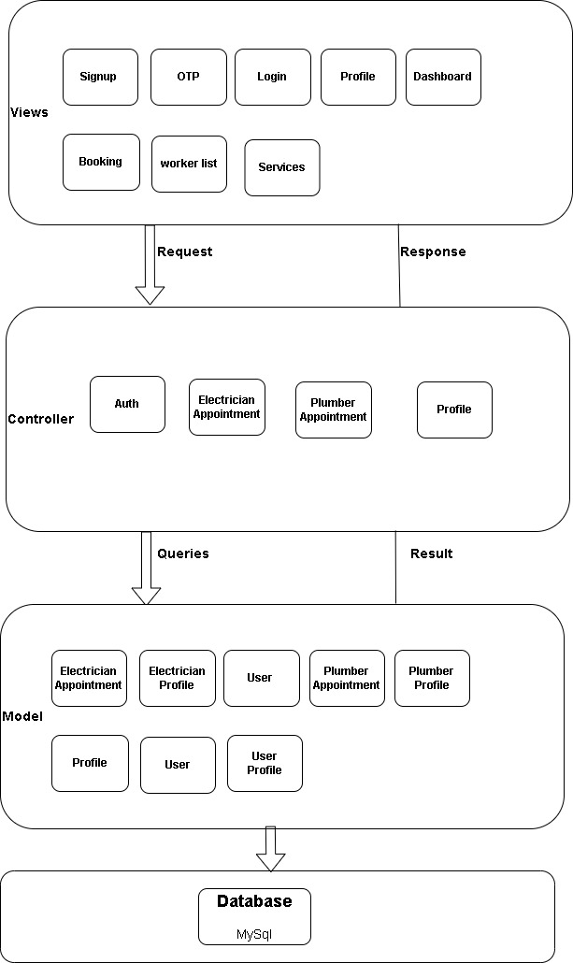

4.3 Class Diagram

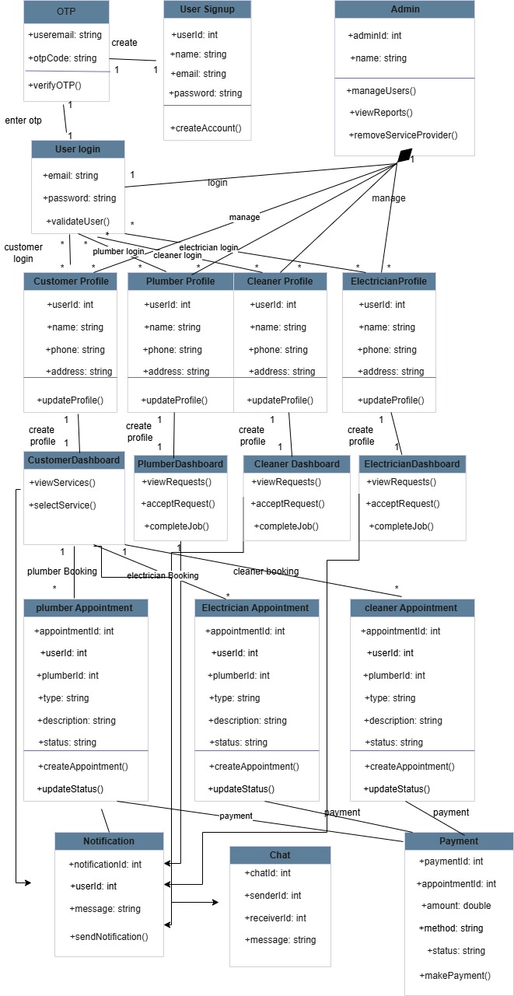

4.4 Use Case Diagram

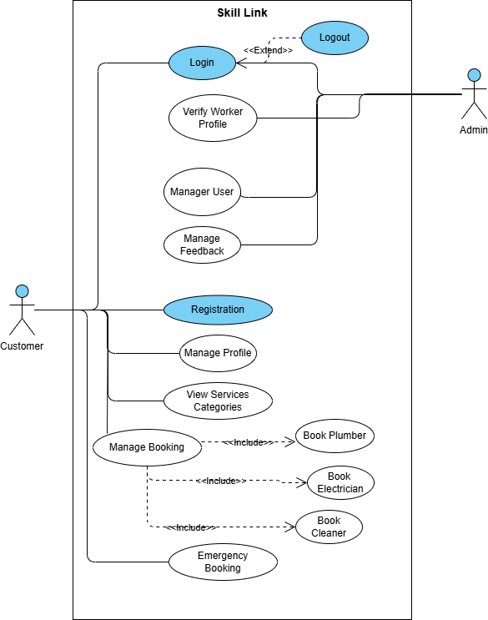

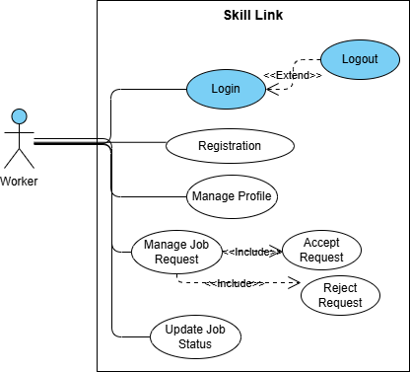

4.5 Fully Address Use Case:

4.5.1 Customer

Use Case-1 Customer SignUp
Use case Name | Customer SignUp
Use case ID | UC-01
Level | User Level
Primary Actor | Customer
Stakeholders And  Interests | Customer will register himself/herself to book a service
Precondition | Customer will provide all the required information on the registration  form.
Post condition | Customer successfully registered him/herself to the system
Main Success Scenario |  | Action | Response
Main Success Scenario |  | 1. Customer will click on “register” button from menu bar.  3.Customer will enter minatory Information (User name, Email, Phone Number, Password, Role).  5.Customer presses the “Register” button. | 2. System will display registration form.  4. System checks the format of credentials entered by Customer.  6. System display a message that you are register Successfully
Alternative Scenario | 1a. Invalid Credentials (Email or Phone Number).  - The system displays an error message  - Customer will re-enter the email or Phone Number  - The customer submits the registration form  - Customer successfully registers  1b. Empty Fields:  - The system displays an error message  - Customer will fill the empty field  - The customer submits the registration form  - Customer successfully registers into the system.
Technical  Requirements | Customer must have a device capable to run Mobile Application and internet connection.

Use Case-2 Customer Login
Use case Name | Customer Login
Use case ID | UC-02
Level | User Level
Primary Actor | Customer
Stakeholders And  Interests | Customer will Login to the system to manage all the account activities.
Precondition | Customer will enter his\her email or phone number to Login.
Post condition | Customer is successfully login
Main Success Scenario |  | Action | Response
Main Success Scenario |  | 1. Customer will click on “login” button from menu bar.  3.Customer will enter minatory Information (Email, Password).  5.Customer presses the “login” button. | 2. System will display login form.  4. System checks the format of credentials entered by Customer.  6. System display a message that you are login Successfully
Alternative Scenario | 1a. Invalid Credentials (Email or Phone Number).  - The system displays an error message  - Customer will re-enter the email or password  - The customer submits the login form  - Customer successfully login  1b. Empty Fields:  - The system displays an error message  - Customer will fill the empty field  - The customer submits the login form  - Customer successfully login into the system.
Technical  Requirements | Customer must have a device capable to run Mobile Application and internet connection.

Use Case-3 Update Customer Profile
Use case Name | Update Customer Profile
Use case ID | UC-03
Level | User Level
Primary Actor | Customer
Stakeholders And  Interests | Customer will Login to the system to manage all the account activities
Precondition | Customer logged in from his/her account and then he/she goes to edit  profile option.
Post condition | Customer profile updated successfully.
Main Success  Scenario |  | Action | Response
Main Success  Scenario |  | 1. Customer will click on “login” button from menu bar.  3.Customer will enter minatory Information (profile photo, Full name, Bio, Contact Number).  5.Customer click on the “Save profile” button. | 2. System will display profile page.  4. System checks the format of credentials entered by Customer.  6. System display a message that your profile is created Successfully
Alternative Scenario | 1a. Invalid Credentials (Email or Phone Number).  - The system displays an error message  - Customer will re-enter the detail  - The customer submits the save profile button  - Customer successfully create profile
Technical  Requirements | Customer must have a device capable to run Mobile Application and internet connection.

Use Case-4 View Dashboard with Service Categories
Use case Name | View Dashboard with Service Categories
Use case ID | UC-04
Level | User Level
Primary Actor | Customer
Stakeholders And  Interests | Customer will Login to the system to view service categories
Precondition | Customer logged in from his/her account and then he /she goes to dashboard to view service categories
Post condition | Customer successfully view service categories
Main Success  Scenario |  | Action | Response
Main Success  Scenario |  | 1. Customer will login.  - Customer will view service category options. | - System will display dashboard.  4. System will show Plumber, Cleaner, and Electrician options with icons.
Alternative Scenario | No
Technical  Requirements | Customer must have a device capable to run Mobile Application and internet connection.

Use Case-5 Book Plumber
Use case Name | Book Plumber
Use case ID | UC-05
Level | User Level
Primary Actor | Customer
Stakeholders And  Interests | Customer will Login to the system to book plumber
Precondition | Customer logged in from his/her account and then he/she goes to plumber option to book plumber
Post condition | Customer successfully book plumber
Main Success Scenario |  | Action | Response
Main Success Scenario |  | - Customer will select Plumber option from dashboard.  - Customer will select the plumber.  6. Customer will enter minatory Information (Image, Description).  - Customer will click on submit problem button. | - System will search the plumber new by location.  - System will show plumber list  5. System will show problem form.  - System will send booking request to selected Plumber.
Alternative Scenario | 1a. No Photo Uploaded:  - The system displays: “Please upload a photo of the plumbing issue.”  - Customer selects a photo from gallery or camera.  - Customer resubmits the form.  - Booking request is successfully sent.
Technical  Requirements | Customer must have a device capable to run Mobile Application and internet connection.

Use Case-6 Book electrician
Use case Name | Book Electrician
Use case ID | UC-06
Level | User Level
Primary Actor | Customer
Stakeholders And  Interests | Customer will Login to the system to book electrician
Precondition | Customer logged in from his/her account and then he/she goes to electrician option to book electrician
Post condition | Customer successfully book electrician
Main Success Scenario |  | Action | Response
Main Success Scenario |  | - Customer will select Electrician option from dashboard.  - Customer will select the electrician.  6. Customer will enter minatory Information (Image, Description).  - Customer will click on submit problem button. | - System will search the electrician new by location.  - System will show plumber list  5. System will show problem form.  - System will send booking request to selected Electrician.
Alternative Scenario | 1a. No Photo Uploaded:  - The system displays: “Please upload a photo.”  - Customer selects a photo from gallery or camera.  - Customer resubmits the form.  - Booking request is successfully sent.
Technical  Requirements | Customer must have a device capable to run Mobile Application and internet connection.

Use Case-7 Book Cleaner
Use case Name | Book Cleaner
Use case ID | UC-07
Level | User Level
Primary Actor | Customer
Stakeholders And  Interests | Customer will Login to the system to book cleaner
Precondition | Customer logged in from his/her account and then he/she goes to cleaner option to book cleaner
Post condition | Customer successfully book cleaner
Main Success Scenario |  | Action | Response
Main Success Scenario |  | - Customer will select cleaner option from dashboard.  - Customer will select the cleaner  6. Customer will enter minatory Information (Image, Description).  - Customer will click on submit problem button. | - System will search the cleaner new by location.  - System will show plumber list  5. System will show problem form.  - System will send booking request to selected Cleaner.
Alternative Scenario | 1a. No Photo Uploaded:  - The system displays: “Please upload a photo.”  - Customer selects a photo from gallery or camera.  - Customer resubmits the form.  - Booking request is successfully sent.
Technical  Requirements | Customer must have a device capable to run Mobile Application and internet connection.

Use Case-8 Emergency Service Booking
Use case Name | Emergency Service Booking
Use case ID | UC-08
Level | User Level
Primary Actor | Customer
Stakeholders And  Interests | Customer will Login to the system to Booking Emergency Service
Precondition | Customer logged in from his/her account and then he/she goes to emergency option to booking emergency service
Post condition | Customer successfully booking emergency service
Main Success Scenario |  | Action | Response
Main Success Scenario |  | 1. Customer will login to the system  - Customer will click on “Emergency” from bottom navigation bar.  5. Customer will select one category (e.g., Plumber Electrician, Cleaner).  7. Customer will upload image.  9. Customer will set or confirms location.  - Customer will enter bid amount and quick job note.  - Customer will click “Send Emergency Request” option.  14. Customer will receive confirmation that emergency request was sent. | 2. System will the dashboard with navigation bar.  - System will open emergency module with 3 options: Plumber, Electrician, Cleaner.  6. System will prompt user to upload a picture of the issue.  - System prompts for location access or manual entry.  - System will shows bid form for emergency request.  - System will sent request as urgent, sends to nearby available provider.
Alternative Scenario | 1a. No Category Selected:  - The system displays: “Please select a service category.”  - Customer selects Plumber, Electrician, or Cleaner and proceeds  - Customer successfully confirmation the emergency request  1b. No Photo Uploaded:  - The system prompts: “Please upload a picture of the problem.”  - Customer uploads photo and continues.  - Customer successfully confirmation the emergency request  1c. Location Not Set:  - The system displays: “Location is required for emergency help.”  - Customer allows GPS or enters location manually.  - Customer successfully confirmation the emergency request  1d. Bid Form Left Empty:  - The system displays: “Please enter an estimated amount and message.”  - Customer fills the form and resubmits.  - Customer successfully confirmation the emergency request
Technical  Requirements | Customer must have a device capable to run Mobile Application and internet connection.

4.5.2 Worker

Use Case-9 Worker SignUp
Use case Name | Worker SignUp
Use case ID | UC-09
Level | User Level
Primary Actor | Worker
Stakeholders And  Interests | Worker will register himself/herself to book a service
Precondition | Worker will provide all the required information on the registration  form.
Post condition | Worker successfully registered him/herself to the system
Main Success Scenario |  | Action | Response
Main Success Scenario |  | 1. Worker will click on “register” button from menu bar.  3.Worker will enter minatory Information (User name, Email, Phone Number Password).  5.Worker presses the “Register” button. | 2. System will display registration form.  4. System checks the format of credentials entered by Worker.  6. System display a message that you are register Successfully
Alternative Scenario | 1a. Invalid Credentials (Email or Phone Number).  - The system displays an error message  - Worker will re-enter the email or Phone Number  - The Worker submits the registration form  - Worker successfully registers  1b. Empty Fields:  - The system displays an error message  - Worker will fill the empty field  - The Worker submits the registration form  - Worker successfully registers into the system.
Technical  Requirements | Worker must have a device capable to run Mobile Application and internet connection.

Use Case-10 Worker Login
Use case Name | Worker Login
Use case ID | UC-10
Level | User Level
Primary Actor | Worker
Stakeholders And  Interests | Worker will Login to the system to get job opportunities.
Precondition | Worker will enter his\her email and password to Login.
Post condition | Worker is successfully login
Main Success Scenario |  | Action | Response
Main Success Scenario |  | 1. Worker will click on “login” button from menu bar.  3.Worker will enter minatory Information (Email, Password).  5.Worker presses the “login” button. | 2. System will display login form.  4. System checks the format of credentials entered by Worker.  6. System display a message that you are login Successfully
Alternative Scenario | 1a. Invalid Credentials (Email or Phone Number).  - The system displays an error message  - Worker will re-enter the email or password  - The Worker submits the login form  - Worker successfully login  1b. Empty Fields:  - The system displays an error message  - Worker will fill the empty field  - The Worker submits the login form  - Worker successfully login into the system.
Technical  Requirements | Worker must have a device capable to run Mobile Application and internet connection.

Use Case-11 Update Worker Profile
Use case Name | Update Worker Profile
Use case ID | UC-11
Level | User Level
Primary Actor | Worker
Stakeholders And  Interests | Worker will Login to the system to manage all the account activities
Precondition | Worker logged in from his/her account and then he/she goes to edit  profile option.
Post condition | Worker profile updated successfully.
Main Success  Scenario |  | Action | Response
Main Success  Scenario |  | 1. Worker will click on “login” button from menu bar.  3.Worker will enter minatory Information (profile photo, Full name, Bio, Contact Number).  5.Worker click on the “Save profile” button. | 2. System will display profile page.  4. System checks the format of credentials entered by Worker.  6. System display a message that your profile is created Successfully
Alternative Scenario | 1a. Invalid Credentials (Email or Phone Number).  - The system displays an error message  - Worker will re-enter the detail  - The Worker submits the save profile button  - Worker successfully create profile
Technical  Requirements | Worker must have a device capable to run Mobile Application and internet connection.

Use Case-12 View Job Requests
Use case Name | View Job Requests
Use case ID | UC-12
Level | User Level
Primary Actor | Worker
Stakeholders And  Interests | Worker will Login to the system to views the list of all received requests.
Precondition | Worker logged in from his/her account and then he/she goes to view job requests in queue.
Post condition | Worker successfully views job requests.
Main Success  Scenario |  | Action | Response
Main Success  Scenario |  | 1. Worker will click on “Job Request” option.  - Worker clicks on the “Request” option. | 2. System will display the list of pending job request  4. System will display detail information about job
Alternative Scenario | No
Technical  Requirements | Worker must have a device capable to run Mobile Application and internet connection.

Use Case-13 Accept Booking
Use case Name | Accept Booking
Use case ID | UC-13
Level | User Level
Primary Actor | Worker
Stakeholders And  Interests | Worker will Login to the system to accept the job booking
Precondition | Worker logged in from his/her account and then he/she goes to accept booking option.
Post condition | Worker profile updated successfully.
Main Success  Scenario |  | Action | Response
Main Success  Scenario |  | - Worker will click on “New Request” option.  3.Worker will click on accept option. | 2. System will display request detail (Image, Description).  4. System will accept booking and update customer
Alternative Scenario | No
Technical  Requirements | Worker must have a device capable to run Mobile Application and internet connection.

Use Case-14 Reject Booking
Use case Name | Reject Booking
Use case ID | UC-14
Level | User Level
Primary Actor | Worker
Stakeholders And  Interests | Worker will Login to the system to Reject the job booking
Precondition | Worker logged in from his/her account and then he/she goes to reject booking option.
Post condition | Worker profile updated successfully.
Main Success  Scenario |  | Action | Response
Main Success  Scenario |  | - Worker will click on “New Request” option from dashboard.  3.Worker will click on Reject option. | 2. System will display request detail (Image, Description).  4. System will reject booking and update customer
Alternative Scenario | No
Technical  Requirements | Worker must have a device capable to run Mobile Application and internet connection.

Use Case-15 Mark Job as Completed
Use case Name | Mark Job as Completed
Use case ID | UC-15
Level | User Level
Primary Actor | Worker
Stakeholders And  Interests | Worker will Login to the system to mark job as completed.
Precondition | Worker logged in from his/her account and then he/she goes to the completed job option then he/she marks job as completed
Post condition | Worker successfully mark job as completed  .
Main Success  Scenario |  | Action | Response
Main Success  Scenario |  | - Worker will select “Completed Job” option from the dashboard.  3. Worker will click on completed button. | - System will display mark job as completed.  4. System will successfully update mark job as completed.
Alternative Scenario | - No
Technical  Requirements | Worker must have a device capable to run Mobile Application and internet connection.

4.5.3 Admin
Use Case-16 Admin Login
Use case Name | Admin Login
Use case ID | UC-16
Level | User Level
Primary Actor | Admin
Stakeholders And  Interests | Admin will login to system to monitor all activities
Precondition | Admin will enter his\her email or phone number to Login.
Post condition | Admin successfully login to the system
Main Success Scenario |  | Action | Response
Main Success Scenario |  | 1. Admin will click on "Login" button.  - Admin enters username and password  5.Admin will clicks "Submit" button | 2. System displays the admin login form  - System will verify credentials  6. System logs in the Admin and redirects to dashboard
Alternative Scenario | 1a. Invalid credentials:  - The system shows error: "Incorrect username or password"  - Admin re-enters correct login details and resubmit
Technical  Requirements | Admin must have a device capable to run Mobile Application and internet connection.

Use Case-17 View Customer List
Use case Name | View Customer List
Use case ID | UC-17
Level | User Level
Primary Actor | Admin
Stakeholders And  Interests | Admin will login to system to view all customer accounts to monitor or manage them.
Precondition | Admin will login his/her account the he/she goes to customer option to view customer list.
Post condition | Admin successfully view customer list
Main Success Scenario |  | Action | Response
Main Success Scenario |  | 1. Admin will click on “Customer List” in the dashboard  3. Admin will scroll or searches for a specific customer | 2. System will load and displays a list of all registered customers  4. System will filter and displays matching records
Alternative Scenario | No
Technical  Requirements | Admin must have a device capable to run Mobile Application and internet connection.

Use Case-18 View Worker List
Use case Name | View Worker List
Use case ID | UC-18
Level | User Level
Primary Actor | Admin
Stakeholders And  Interests | Admin will login to system to view all registered workers including Plumbers, Electricians, and Cleaners.
Precondition | Admin will login his/her account the he/she goes to worker option to view worker list.
Post condition | Admin successfully view worker list
Main Success Scenario |  | Action | Response
Main Success Scenario |  | 1. Admin will click on “worker List” in the dashboard  3. Admin will view names, categories, and status  4. Admin can scroll, search, or filter by category (Plumber, Electrician, Cleaner) | 2. System will load and displays a list of all registered workers
Alternative Scenario | No
Technical  Requirements | Admin must have a device capable to run Mobile Application and internet connection.

Use Case-19 Add/Edit/Delete Customer or Worker
Use case Name | Add/Edit/Delete Customer or Worker
Use case ID | UC-19
Level | User Level
Primary Actor | Admin
Stakeholders And  Interests | Admin will login to system to manage customer and worker accounts (add new, edit details, or delete).
Precondition | Admin will login his/her account the he/she goes to worker and customer account then manage customer and worker accounts (add new, edit details, or delete).
Post condition | Admin successfully Add/Edit/Delete/ Updated Customer or Worker record.
Main Success Scenario |  | Action | Response
Main Success Scenario |  | 1. Admin will open the “Customer” or “Worker” section  3. Admin will select a user and clicks “Edit” or “Delete”  5. Admin will make changes and clicks “Save” or confirms delete | 2. System will display the list of users  - System will load the user details or confirms delete request  6.System will update or removes the user and shows success message
Alternative Scenario | 1a. Empty or invalid data while editing:  - The system will show: “Please fill in all required fields correctly.”  - Admin will correct and resubmits.  - Admin will successfully Add/Edit/Delete/ Updated Customer or Worker record.
Technical  Requirements | Admin must have a device capable to run Mobile Application and internet connection.

Use Case-20 Approve Worker Profile
Use case Name | Approve Worker Profile
Use case ID | UC-20
Level | User Level
Primary Actor | Admin
Stakeholders And  Interests | Admin will login to system to verify the worker’s profile before making it visible to customers.
Precondition | Admin will login his/her account the he/she goes to pending worker profiles awaiting approval.
Post condition | Admin successfully Approve Worker Profile
Main Success Scenario |  | Action | Response
Main Success Scenario |  | 1. Admin will click on “Pending Worker Profiles”  3. Admin will click on a worker profile to review details  5. Admin will clicks “Approve” | 2. System will display list of unverified worker accounts  4. System will display profile information (name, skills, location, documents)  6.System will update status and moves the worker to the active list
Alternative Scenario | 1a. Admin finds missing or incorrect information:  - Admin will click “Reject” or “Request Edit”  - System will send notification to the worker to update their profile  - Worker will update their profile  - System send notification to admin.  - Admin successfully Approve Worker Profile
Technical  Requirements | Admin must have a device capable to run Mobile Application and internet connection.

Use Case-21 View Booking Details
Use case Name | View Booking Details
Use case ID | UC-21
Level | User Level
Primary Actor | Admin
Stakeholders And  Interests | Admin will login to system to monitor all bookings made between customers and workers.
Precondition | Admin will login his/her account the he/she goes to booking option and monitor all bookings made between customers and workers.
Post condition | Admin successfully View Booking Details
Main Success Scenario |  | Action | Response
Main Success Scenario |  | 1. Admin will click on “Bookings” in the dashboard  3. Admin will use filters to search by date, status, or category | 2. System will display all bookings including date, time, customer, worker, and status  - System will update the displayed list accordingly
Alternative Scenario | 1a. No bookings found for selected filter:  - System will show: “No bookings found for this selection.
Technical  Requirements | Admin must have a device capable to run Mobile Application and internet connection.

Use Case-22 Manage Emergency Requests
Use case Name | Manage Emergency Requests
Use case ID | UC-22
Level | User Level
Primary Actor | Admin
Stakeholders And  Interests | Admin will login to system to monitor emergency service requests made by customers.
Precondition | Admin will login his/her account the he/she goes to emergency option to monitor emergency service requests made by customers.
Post condition | Admin successfully Manage Emergency Requests
Main Success Scenario |  | Action | Response
Main Success Scenario |  | 1. Admin will click on “Emergency Requests” tab  3. Admin will view request details (location, user, type of issue)  4. Admin will monitor response status or manually assigns a worker if needed | 2. System displays list of all emergency bookings marked with high priority
Alternative Scenario | 1a. No emergency bookings available:  - System shows: “There are no emergency requests at this time.”
Technical  Requirements | Admin must have a device capable to run Mobile Application and internet connection.

Use Case-23 Manage Reviews
Use case Name | Manage Reviews
Use case ID | UC-23
Level | User Level
Primary Actor | Admin
Stakeholders And  Interests | Admin will login to system to monitor reviews left by customers about workers.
Precondition | Admin will login his/her account the he/she goes to manage reviews option to monitor reviews left by customers about workers.
Post condition | Admin successfully manage reviews
Main Success Scenario |  | Action | Response
Main Success Scenario |  | 1. Admin will click on “Manage Reviews”  3. Admin will click on a review to view more details  4. Admin chooses to delete, keep, or flag the review  5. Admin clicks action button | 2. System shows a list of all reviews with worker and customer names  6. System performs the selected action and updates the review status
Alternative Scenario | 1a. No reviews in the system:  - System displays: “No reviews available to show.”
Technical  Requirements | Admin must have a device capable to run Mobile Application and internet connection.

4.6 Activity Diagram

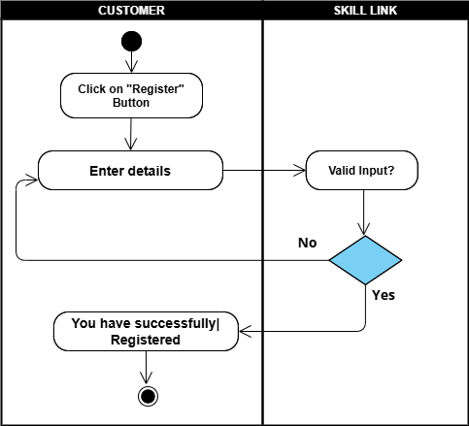

4.6.1 Registration

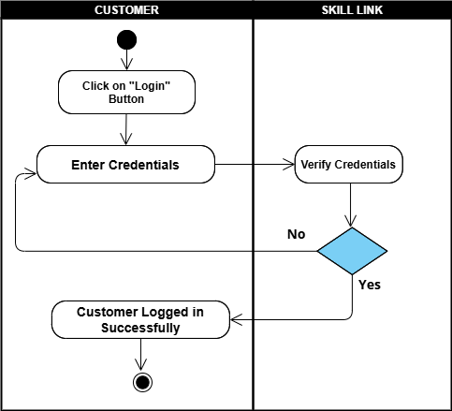

4.6.2 Login

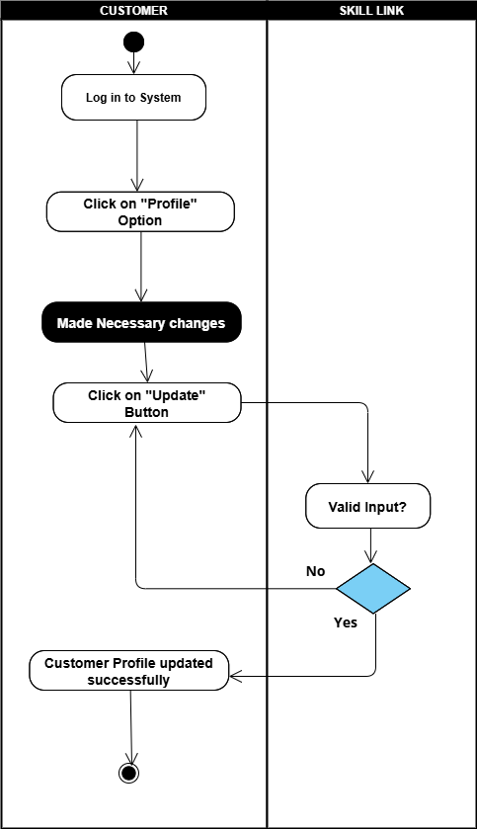

4.6.3 Update Customer Profile

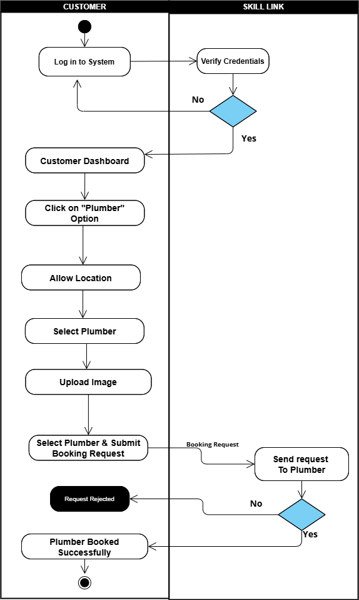

4.6.4 Booked Plumber

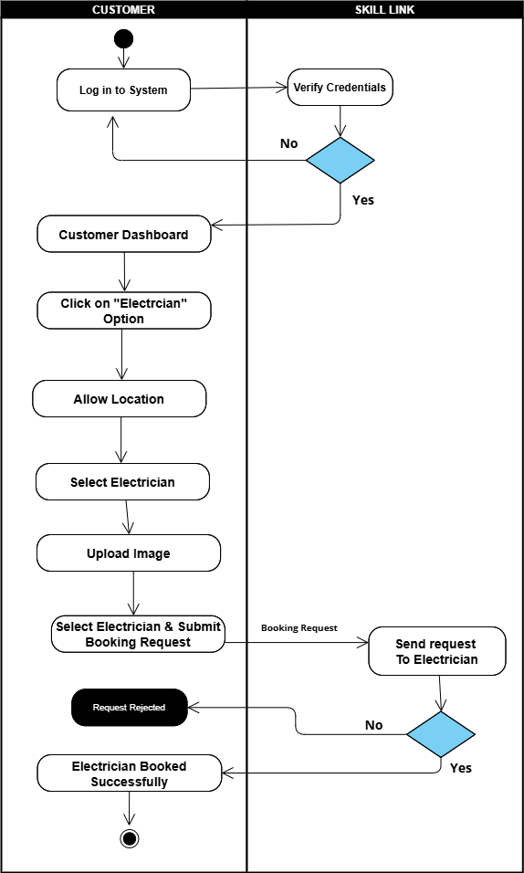

4.6.5 Booked Electrician
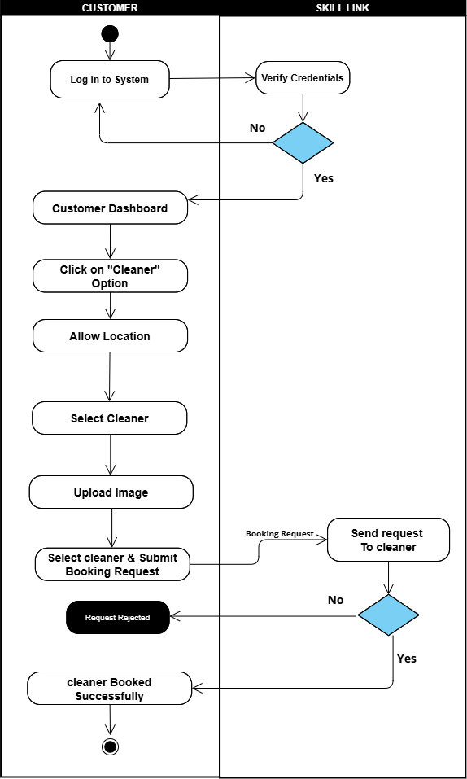

4.6.6 Booked Cleaner
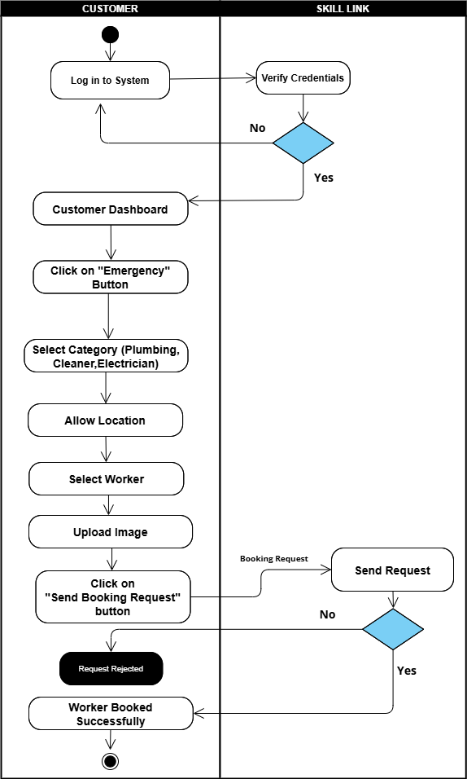

4.6.7 Emergency Services Booking

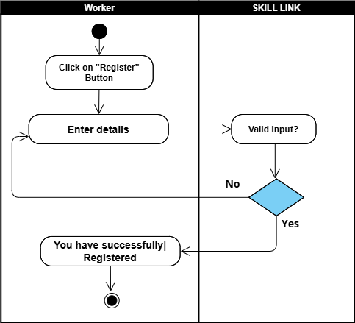

4.6.8 Worker Register

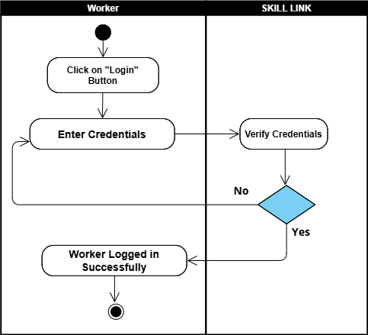

4.6.9 Worker Login

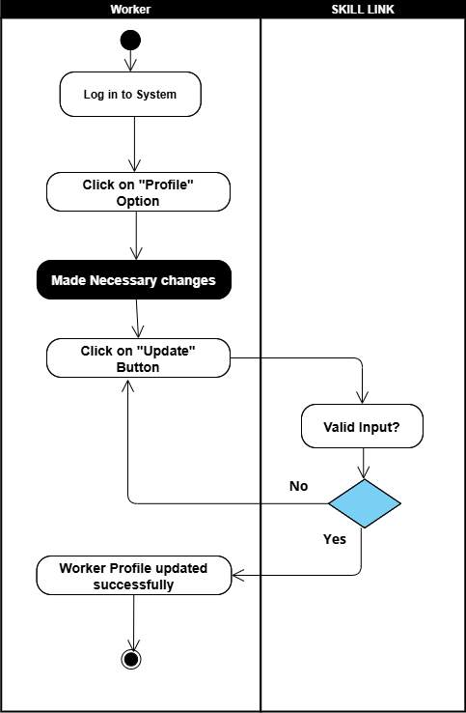

4.6.9 Update Worker Profile

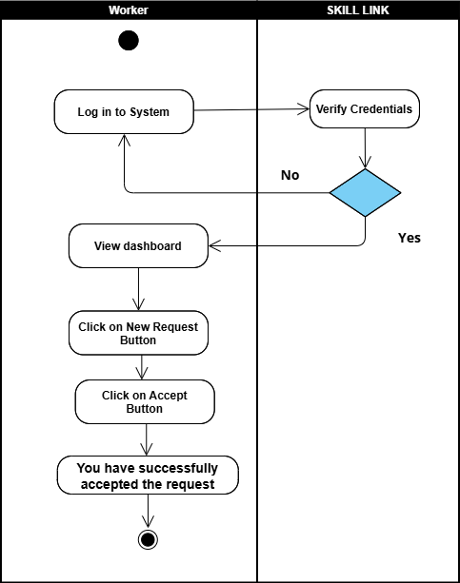

4.6.10 Accept Request

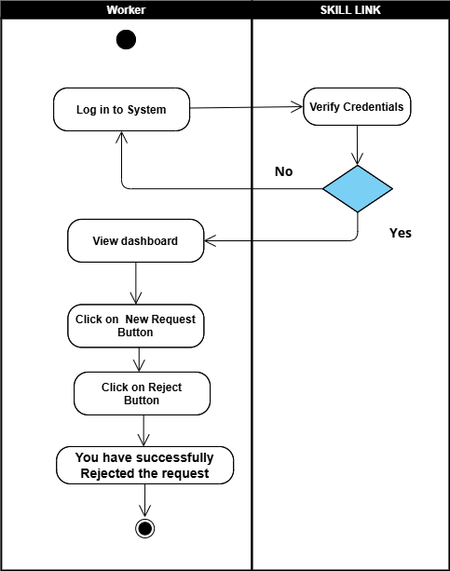

4.6.11 Reject Request

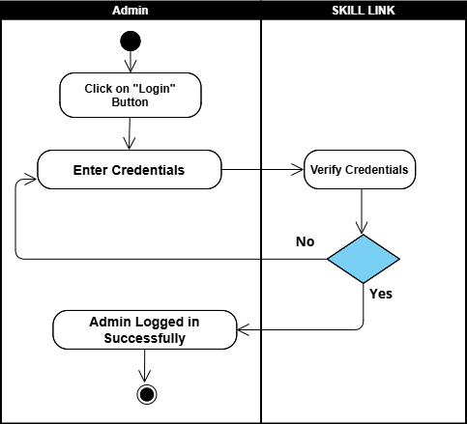

4.6.12 Login

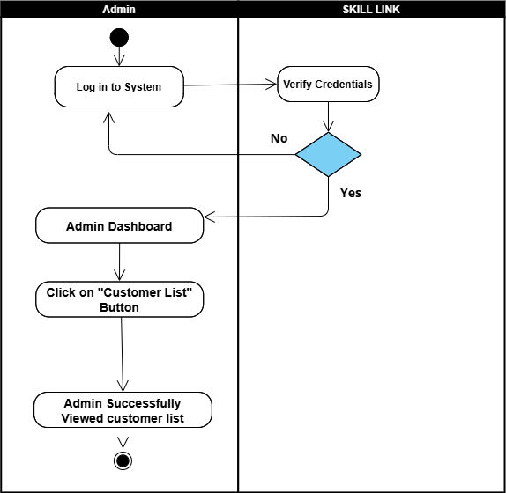

4.6.13 View Customer List

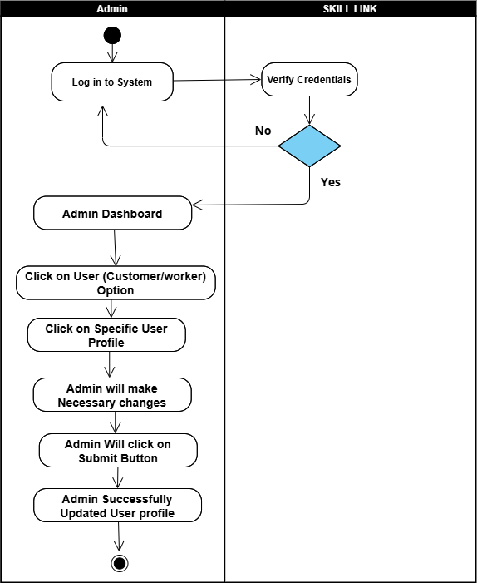

4.6.14 Manage User Profile

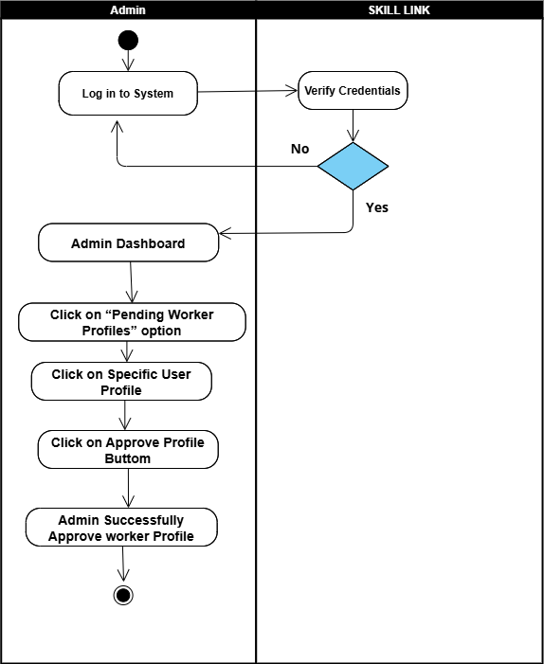

4.6.15 Approve Worker Profile

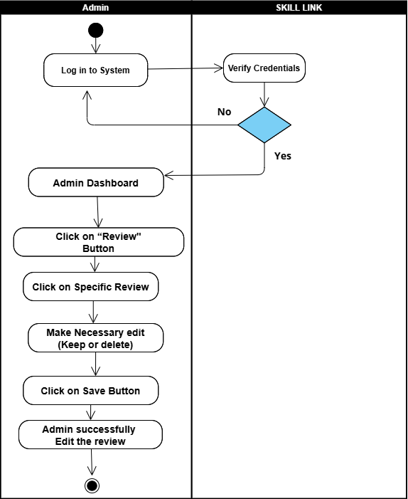

4.6.16 Manage Reviews

Chapter 5:
Implementation

Chapter 5:
Implementation
5.1. Endeavour (Team + Work + Way of Working)
5.1.1: Team
- Sana Ullah
- Hammad Javed
5.1.2: Work Breakdown Structure

WBS # | WBS  Deliverable | Activity # | Activity to complete the deliverable | Duration (# of Days) | Responsible Team Member(s) & Role(s)
2 | Documentation | 2.1 | Team Members and Project Proposal | 2 | Sana ullah  Hammad Javed
2.2 | Documentation | 2.2 | Project Proposal Document | 3 | Sana ullah  Hammad Javed
2.2 | Project Proposal Document | 2.2.1 | Opportunity & Stakeholders | 1 | Sana ullah  Hammad Javed
2.2 | Project Proposal Document | 2.2.2 | Existing Systems | 2 | Sana ullah  Hammad Javed
2.2 | Project Proposal Document | 2.2.3 | Problem Statement | 1 | Sana ullah  Hammad Javed
2.2 | Project Proposal Document | 2.2.4 | Proposed Solution | 1 | Sana ullah  Hammad Javed
2.2 | Project Proposal Document | 2.2.5 | Project Scope | 4 | Sana ullah  Hammad Javed
2.2 | Project Proposal Document | 2.2.5.1 | Booking Module | 20 | Sana ullah
2.2 | Project Proposal Document | 2.2.5.2 | Real-Time Notification | 15 | Sana ullah
2.2 | Project Proposal Document | 2.2.5.3 | Worker Profile Management | 15 | Sana ullah
2.2 | Project Proposal Document | 2.2.5.4 | Customer Feedback & Ratings | 20 | Sana ullah  Hammad Javed
2.2 | Project Proposal Document | 2.2.5.5 | Emergency Booking Module | 15 | Sana ullah  Hammad Javed
2.4 | Planning Document | 2.4 | Each Team Member’s Responsibilities | 1 | Sana ullah  Hammad Javed
2.5 | Documentation | 2.5 | Final Documentation Introduction | 1 | Sana ullah  Hammad Javed
2.6 | Documentation | 2.6 | Market Survey | 10 | Sana ullah  Hammad Javed
2.6 | Market Survey | 2.6.1 | Survey | 1 | Sana ullah  Hammad Javed
2.6 | Market Survey | 2.6.2 | Brainstorming | 6 | Sana ullah  Hammad Javed
2.7 | Documentation | 2.7 | Requirement Analysis | 5 | Sana ullah  Hammad Javed
2.7 | Requirement Analysis | 2.7.1 | Functional Requirements | 4 | Sana ullah  Hammad Javed
2.7 | Requirement Analysis | 2.7.2 | Non-Functional Requirements | 3 | Sana ullah  Hammad Javed
2.7 | Requirement Analysis | 2.7.3 | Stakeholder Requirements | 1 | Sana ullah  Hammad Javed
2.7 | Documentation | 2.8 | System Design | 8 | Sana ullah
2.8 | System Design | 2.8.1 | Class Diagram | 8 | Hammad Javed
2.8 | System Design | 2.8.2 | Architectural Design | 3 | Hammad Javed
2.8 | System Design | 2.8.3 | Use Cases | 3 | Hammad Javed
2.8 | System Design | 2.8.4 | Activity Diagrams | 5 | Sana ullah  Hammad Javed
2.9 | Implementation on | 2.9 | Development | 30 | Sana ullah  Hammad Javed
 | Evaluation
3 | System | 3.1 | Development Environment | 10 | Sana ullah  Hammad Javed
3.1 | System | 3.2 | Mobile Application | 40 | Sana ullah
3.2 | Mobile Application | 3.2.1 | Front End | 20 | Sana ullah  Hammad Javed
3.3 | Mobile Application | 3.3.1 | Back End | 20 | Sana ullah  Hammad Javed

5.2 Flow Control/Pseudo codes
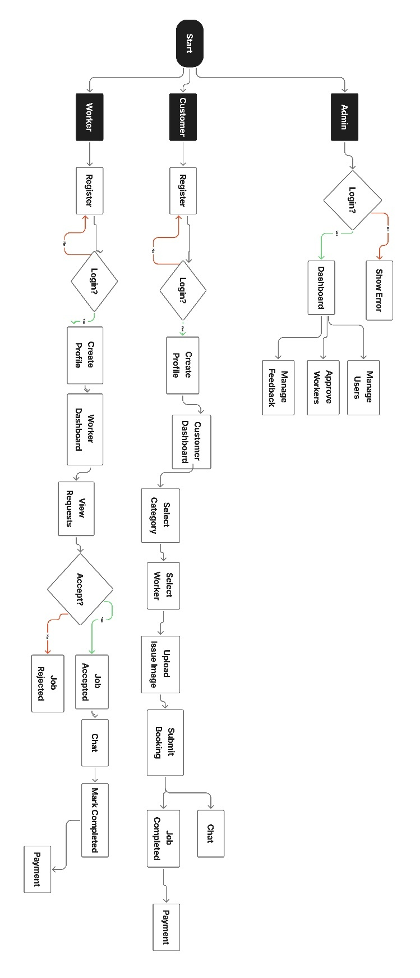

5.3 Components, Libraries, Web Services and Stubs
To build the SkillLink mobile application, we used the following technologies and tools.
5.3.1 Front-End:
- Flutter
- Dart
5.3.2 Back-End:
- Laravel
5.3.3 Database:
- MySQL
5.4 IDE, Tools and Technologies
To develop the SkillLink system, we worked with the following tools:
- Visual Studio Code
- Git & GitHub
- Visual Paradigm
- XAMPP
- Canva
- Android Studio
5.5 Best Practices / Coding Standards
5.5.1 Software Engineering Methodologies
- Agile Methodology:
We divided the work into small parts and took feedback after each part. We made changes according to suggestions during the development.
5.5.2 Coding Standards
- Naming Conventions:
We used clear and simple names for all files, functions, and variables.
- Code Documentation:
We wrote comments in the code so that others could easily understand what each part does.
- Error Handling:
We added checks and messages for mistakes or wrong data to help the system work smoothly.
- Code Reviews:
After writing code, the other team member checked it to make sure everything was correct and clear.

5.6 Development Diagram

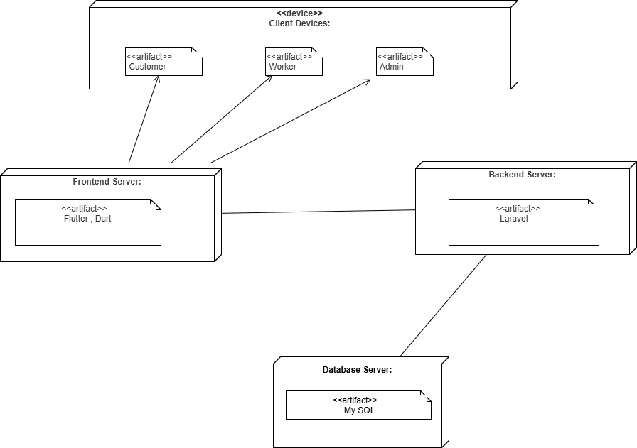

Chapter 6:
Testing & Evaluation

Chapter 6:
Testing & Evaluation
6.1 Introduction
For assuring the quality of the system, testing is the most essential step for assuring the quality of the system. The purpose of testing is to find out the system errors and bugs in the system. So, in this chapter we will discuss testing of our mobile application Skill Link. We will use two approaches of testing. First is the black box testing and second is white box testing. In black box testing we will examine the functionality of the application from requirements without looking at the code structure. And in the next sections we will do white box testing.
6.2 List of Test Scenarios
In this section we will cover all the test data and test cases of all the stakeholders involved in our system. Following are the list of all test cases for SkillLink.

6.2.1 Test Cases For Sign-Up validation
6.2.1.1 Test Case 1 — Name Field Validation
Field | Description
ID | TC-01
Requirement | FR-01, FR-09
Form | Customer /Worker Signup
Stakeholder | Customer, Plumber, Electrician, Cleaner
Field | Name
Technique | ECP + BVA
Valid Inputs | Hammad, Ali Raza (alphabets + space)- Length ≥ 2
Invalid Inputs | - Only numbers (“1234”)- Special characters only (“@@@”)  - Single character (“A”)

6.2.1.2 Test Case 2 — Email Validation
Field | Description
ID | TC-02
Requirement | FR-01, FR-09
Form | Customer /Worker Signup
Stakeholder | Customer, Plumber, Electrician, Cleaner
Field | Email
Technique | ECP
Valid Inputs | - hammad@gmail.com, gondal123@gmail.com
Invalid Inputs | - Missing '@’ testgmail.com, Missing '.' → hammad@gmailcom, Empty email, Wrong format → abc@com, @gmail.com

6.2.1.3 Test Case 3 — Password Validation
Field | Description
ID | TC-03
Requirement | FR-01, FR-09
Form | Customer /Worker Signup
Stakeholder | Customer, Plumber, Electrician, Cleaner
Field | Password
Technique | BVA (Boundary Value Analysis)
Valid Inputs | - 6 characters minimum → “abc123”, “Hammad99”
Invalid Inputs | - Less than 6 chars → “abc12”, “12345”, Empty password, only spaces

6.2.1.4 Test Case 4 — Confirm Password
Field | Description
ID | TC-04
Requirement | FR-01, FR-09
Form | Customer /Worker Signup
Stakeholder | Customer, Plumber, Electrician, Cleaner
Field | Confirm Password
Technique | ECP
Valid Inputs | - password = “abc123” AND confirm Password = “abc123”
Invalid Inputs | - password = “abc123”, confirm Password = “abc124”, Empty confirm Password, Case mismatch → (“Pass123” vs “pass123”)

6.2.1.5 Test Case 5 — Role Selection
Field | Description
ID | TC-05
Requirement | FR-01, FR-09
Form | Customer /Worker Signup
Stakeholder | Customer, Plumber, Electrician, Cleaner
Field | Role Dropdown
Technique | ECP
Valid Inputs | - plumber- electrician- cleaner- user/customer
Invalid Inputs | - No role selected

6.2.2 Test Cases For Login validation
6.2.2.1 Test Case 6 — Login
ID | TC-06
Requirement | FR-02, FR-10, FR-16
Form | Login
Stakeholder | Customer, Plumber, Electrician, Cleaner, Admin
Field | Email and Password
Technique | Equivalence Class Partitioning (ECP)
Valid | - Email = hammad@gmail.com  - Password = Hammad@123
Invalid | Outside Valid

6.2.3 Test Cases For Customer Profile
6.2.3.1 Test Case 7 — Customer Profile Validation
Field | Description
ID | TC-07
Requirement | FR-03
Form | Customer Profile
Stakeholder | Customer
Field | Profile Image
Technique | ECP
Valid Inputs | - Any uploaded image file - profileExists = true
Invalid Inputs | - Null image - profileExists = false
Expected Output | - “Profile image is required”

6.2.3.2 Test Case 8 — Name Validation
Field | Value
ID | TC-08
Requirement | FR-03
Form | Customer Profile
Stakeholder | Customer
Field | Name
Technique | ECP + BVA
Valid Inputs | - “Ali”, “Hammad Javed”, length 1-15
Invalid Inputs | - "" (empty) >15 characters
Expected Output | - “Name is required”  - “Name must be less than 15 characters”

6.2.3.3 Test Case 9 — Bio Validation
Field | Value
ID | TC-09
Requirement | FR-03
Form | Customer Profile
Stakeholder | Customer
Field | Bio
Technique | BVA
Valid Inputs | - Empty string allowed (“”), text ≤ 255 chars
Invalid Inputs | - >255 characters
Expected Output | - “Bio must be less than 255 characters”

6.2.3.4 Test Case 10 — Location Validation
Field | Value
ID | TC-10
Requirement | FR-03
Form | Customer Profile
Stakeholder | Customer
Field | Location
Technique | ECP + BVA
Valid Inputs | - “Lahore”, “Karachi Gulshan”, length 1–30
Invalid Inputs | - "" (empty) >100 characters
Expected Output | - “Location is required”  - “Location must be less than 100 characters”

6.2.3.5 Test Case 11 — Contact Number Validation
Field | Value
ID | TC-11
Requirement | FR-03
Form | Customer Profile
Stakeholder | Customer
Field | Contact Number
Technique | ECP + BVA
Valid Inputs | - “03001234567”, “3212345678” (10–11 digits only)
Invalid Inputs | - "" - Letters included (“03A2345”)  - Symbols included (“03-2345”)  - Less than 10 digits - More than 11 digits
Expected Output | - - “Contact number is required”  - “Please enter a valid 10–11-digit contact number”

6.2.4 Test Case For Plumber Profile Validation
6.2.4.1 Test Case 12 — Profile Image Validation
Field | Description
ID | TC-12
Requirement | FR-11
Form | Plumber Profile
Stakeholder | Plumber
Field | Profile Image
Technique | ECP
Valid Inputs | - profileImage! = null OR profileExists = true
Invalid Inputs | - profileImage == null AND profileExists = false
Expected Output | - “Profile image is required”

6.2.4.2 Test Case 13 — Name Validation
Field | Description
ID | TC-13
Requirement | FR-11
Form | Plumber Profile
Stakeholder | Plumber
Field | Name
Technique | ECP + BVA
Valid Inputs | - “Ali”, “Muhammad Usman”, length 1–100
Invalid Inputs | - (empty) - More than 100 chars
Expected Output | - “Name is required”  - “Name must be less than 100 characters”

6.2.4.3 Test Case 14 — Email Validation
Field | Description
ID | TC-14
Requirement | FR-11
Form | Plumber Profile
Stakeholder | Plumber
Field | Email
Technique | ECP
Valid Inputs | - ““hammad@gmail.com”  - “gondal@gmail.com”
Invalid Inputs | - "abc.com", "abc@", "abc@gmail"
Expected Output | - “Email is required” OR “Please enter a valid email”

6.2.4.4 Test Case 15 — Experience Validation
Field | Description
ID | TC-15
Requirement | FR-11
Form | Plumber Profile
Stakeholder | Plumber
Field | Experience
Technique | ECP + BVA
Valid Input | - “3 years”, “1 year experience” (≤ 50 chars)
Invalid Input | - >50 chars
Expected Output | - “Experience is required” OR “Experience must be less than 50 characters”

6.2.4.5 Test Case 16 — Skills Validation
Field | Description
ID | TC-16
Requirement | FR-11
Form | Plumber Profile
Stakeholder | Plumber
Field | Skills
Technique | ECP + BVA
Valid Inputs | - “Pipe fitting, Leakage repair” (≤ 100 chars)
Invalid Inputs | - >100 chars
Expected Output | - “Skills are required” OR “Skills must be less than 100 characters”

6.2.4.6 Test Case 17 — Service Area Validation
Field | Description
ID | TC-17
Requirement | FR-11
Form | Plumber Profile
Stakeholder | Plumber
Field | Service Area
Technique | ECP + BVA
Valid Inputs | - “Lahore Township”, “Karachi Gulshan”
Invalid Inputs | - >255 chars
Expected Output | - “Service Area is required” OR “Service Area must be less than 255 characters”

6.2.4.7 Test Case 18 — Hourly Rate Validation
Field | Description
ID | TC-18
Requirement | FR-11
Form | Plumber Profile
Stakeholder | Plumber
Field | Hourly Rate
Technique | ECP + BVA
Valid Inputs | - “200”, “500.50” (0–999999.99)
Invalid Inputs | - "abc" "-10" "1000000"
Expected Output | - “Hourly rate is required”  - “Please enter a valid number”  - “Hourly rate must be between 0 and 999,999.99” |

6.2.4.8 Test Case 19 — Contact Number Validation
Field | Description
ID | TC-19
Requirement | FR-11
Form | Plumber Profile
Stakeholder | Plumber
Field | Contact Number
Technique | ECP + BVA
Valid Inputs | - “03001234567”, “3212345678”
Invalid Inputs | - “1234”, “111111111111”, “03A1234567”, “03-1234567”
Expected Output | - “Please enter a valid 10–11-digit contact number”

6.2.5 Test Case For Electrician Profile Validation
6.2.5.1 Test Case 20 — Profile Image Validation
Field | Description
ID | TC-20
Requirement | FR-11
Form | Electrician Profile
Stakeholder | Electrician
Field | Profile Image
Technique | ECP
Valid Inputs | - Any uploaded image file - profileExists = true
Invalid Inputs | - Null image - profileExists = false
Expected Output | - “Profile image is required”

6.2.5.2 Test Case 21 — Name Validation
Field | Description
ID | TC-21
Requirement | FR-11
Form | Electrician Profile
Stakeholder | Electrician
Field | Name
Technique | ECP + BVA
Valid Values | - “Ali Raza” - Length 1–15 characters
Invalid Values | - "" (empty) - More than 15 characters  - Only digits “12345” (not a name)
Expected Output | - “Name is required”  - “Name must be less than 15 characters”

6.2.5.3 Test Case 22 — Email Validation
Field | Description
ID | TC-22
Requirement | FR-11
Form | Electrician Profile
Stakeholder | Electrician
Field | Email
Technique | ECP
Valid Inputs | - “hammad@gmail.com”  - “gondal@gmail.com”
Invalid Inputs | - “abc.com” - “abc@”  - “ham@gmail.”
Expected Output | - “Email is required”  - “Please enter a valid email”

6.2.5.4 Test Case 23 — Experience Validation
Field | Description
ID | TC-23
Requirement | FR-11
Form | Electrician Profile
Stakeholder | Electrician
Field | Experience
Technique | ECP + BVA
Valid Inputs | - “2 years”  - “5 years electrician”  - ≤ 50 characters
Invalid Inputs | - More than 50 characters
Expected Output | - “Experience is required”  - “Experience must be less than 50 characters”

6.2.5.5 Test Case 24 — Skills Validation
Field | Description
ID | TC-24
Requirement | FR-11
Form | Electrician Profile
Stakeholder | Electrician
Field | Skills
Technique | ECP + BVA
Valid Inputs | - “Wiring, Fan Repair”  - Up to 100 characters
Invalid Inputs | - More than 100 characters
Expected Output | - “Skills are required”  - “Skills must be less than 100 characters”

6.2.5.6 Test Case 25 — Service Area Validation
Field | Description
ID | TC-25
Requirement | FR-11
Form | Electrician Profile
Stakeholder | Electrician
Field | Service Area
Technique | ECP + BVA
Valid Inputs | - “Lahore Township”  - “Karachi Saddar”- ≤ 255 characters
Invalid Inputs | - More than 255 characters
Expected Output | - “Service Area is required”  - “Service Area must be less than 255 characters”

6.2.5.7 Test Case 26 — Hourly Rate Validation
Field | Description
ID | TC-26
Requirement | FR-11
Form | Electrician Profile
Stakeholder | Electrician
Field | Hourly Rate
Technique | ECP + BVA + Numeric Validation
Valid Inputs | - “200” - “500.50” - Value between 0–999999.99
Invalid Inputs | - Non-numeric “abc” - Negative “-10” - Above Range “1000000”
Expected Output | - ‘Hourly rate is required’  - ‘Please enter a valid number’  - ‘Hourly rate must be between 0 and 999,999.99’

6.2.5.8 Test Case 27 — Contact Number Validation
Field | Description
ID | TC-27
Requirement | FR-11
Form | Electrician Profile
Stakeholder | Electrician
Field | Contact Number
Technique | ECP + BVA + Regex
Valid Inputs | - 10- or 11-digit number: “03001234567”, “3212345678”
Invalid Inputs | - “1234567” (less digits)- “0300123456789” (more digits)  - Letters “03A45B778”  - Special characters “03-000-12345”
Expected Output | - “Please enter a valid 10–11-digit contact number”

6.2.6 Test Cases For Cleaner Profile Validation
6.2.6.1 Test Case 28 — Profile Image Validation
Field | Description
ID | TC-28
Requirement | FR-11
Form | Cleaner Profile
Stakeholder | Cleaner
Field | Profile Image
Technique | ECP
Valid Inputs | - Any uploaded image file - profileExists = true
Invalid Inputs | - Null image - profileExists = false
Expected Output | - “Profile image is required”

6.2.6.2 Test Case 29 — Name Validation
Field | Description
ID | TC-29
Requirement | FR-11
Form | Cleaner Profile
Stakeholder | Cleaner
Field | Name
Technique | ECP + BVA
Valid Values | - “Ali Raza” - Length 1–15 characters
Invalid Values | - "" (empty) - More than 15 characters  - Only digits “12345” (not a name)
Expected Output | - “Name is required”  - “Name must be less than 15 characters”

6.2.6.3 Test Case 30 — Email Validation
Field | Description
ID | TC-30
Requirement | FR-11
Form | Cleaner Profile
Stakeholder | Cleaner
Field | Email
Technique | ECP
Valid Inputs | - “hammad@gmail.com”  - “gondal@gmail.com”
Invalid Inputs | - “abc.com” - “abc@”  - “ham@gmail.”
Expected Output | - “Email is required”  - “Please enter a valid email”

6.2.6.4 Test Case 31 — Experience Validation
Field | Description
ID | TC-31
Requirement | FR-11
Form | Cleaner Profile
Stakeholder | Cleaner
Field | Experience
Technique | ECP + BVA
Valid Inputs | - “2 years”  - “5 years electrician”  - ≤ 50 characters
Invalid Inputs | - More than 50 characters
Expected Output | - “Experience is required”  - “Experience must be less than 50 characters”

6.2.6.5 Test Case 32 — Skills Validation
Field | Description
ID | TC-32
Requirement | FR-11
Form | Cleaner Profile
Stakeholder | Cleaner
Field | Skills
Technique | ECP + BVA
Valid Inputs | - “Wiring, Fan Repair”  - Up to 100 characters
Invalid Inputs | - More than 100 characters
Expected Output | - “Skills are required”  - “Skills must be less than 100 characters”

6.2.6.6 Test Case 33 — Service Area Validation
Field | Description
ID | TC-33
Requirement | FR-11
Form | Cleaner Profile
Stakeholder | Cleaner
Field | Service Area
Technique | ECP + BVA
Valid Inputs | - “Lahore Township”  - “Karachi Saddar”- ≤ 255 characters
Invalid Inputs | - More than 255 characters
Expected Output | - “Service Area is required”  - “Service Area must be less than 255 characters”

6.2.6.7 Test Case 34 — Hourly Rate Validation
Field | Description
ID | TC-34
Requirement | FR-11
Form | Cleaner Profile
Stakeholder | Cleaner
Field | Hourly Rate
Technique | ECP + BVA + Numeric Validation
Valid Inputs | - “200” - “500.50” - Value between 0–999999.99
Invalid Inputs | - Non-numeric “abc” - Negative “-10” - Above Range “1000000”
Expected Output | - ‘Hourly rate is required’  - ‘Please enter a valid number’  - ‘Hourly rate must be between 0 and 999,999.99’

6.2.6.8 Test Case 35 — Contact Number Validation
Field | Description
ID | TC-35
Requirement | FR-11
Form | Cleaner Profile
Stakeholder | Cleaner
Field | Contact Number
Technique | ECP + BVA + Regex
Valid Inputs | - 10- or 11-digit number: “03001234567”, “3212345678”
Invalid Inputs | - “1234567” (less digits)- “0300123456789” (more digits)  - Letters “03A45B778”  - Special characters “03-000-12345”
Expected Output | - “Please enter a valid 10–11-digit contact number”

6.2.7 Test Case For Appointment Booking
6.2.7.1 Test Case 36 — Selected Date Validation
Field | Description
ID | TC-36
Requirement | FR-05, FR-06, FR-07, FR-08
Form | Appointment Form
Stakeholder | Customer
Field | Selected Date
Technique | Equivalence Class Partitioning (ECP), Boundary Value Analysis (BVA)
Valid | - Any date ≥ current date (e.g., 15-11-2025, 20-11-2025)
Invalid | - Null or empty field  - Past dates (e.g., 10-11-2025 if today is 13-11-2025)  - Non-date input (e.g., “abcd”, “123xyz”)

6.2.7.2 Test Case 37 — Selected Time Validation
Field | Description
ID | TC-37
Requirement | FR-05, FR-06, FR-07, FR-08
Form | Appointment Form
Stakeholder | Customer
Field | Selected Time
Technique | ECP, BVA
Valid | - Time between service hours (e.g., 09:00 AM 08:00 PM)  - Correct format (HH:MM AM/PM)
Invalid | - Empty value- Time outside service hours (e.g., 02:00 AM)  - Wrong format (“9AM”, “25:00”, “abcd”)

6.2.7.3 Test Case 38 — Service Type Validation
Field | Description
ID | TC-38
Requirement | FR-05, FR-06, FR-07, FR-08
Form | Appointment Form
Stakeholder | Customer
Field | Service Type
Technique | ECP
Valid | - Any available service type (e.g., “Plumber”, “Cleaner”, “Electrician”)
Invalid | - Not selecting any service type (null/empty)  - Selecting a service not listed (e.g., “Doctor”, “Driver”)

6.2.7.4 Test Case 39 — Description Validation
Field | Description
ID | TC-39
Requirement | FR-05, FR-06, FR-07, FR-08
Form | Appointment Form
Stakeholder | Customer
Field | description
Technique | ECP, BVA
Valid | - Text between 10–250 characters- Alphanumeric and special characters (., !?) allowed
Invalid | - Empty field- Text less than 10 characters- Text exceeding 250 characters  - Only special characters (e.g., “!!!@@@”)

Chapter 7:
Conclusion And Outlook

Chapter 7:
Conclusion & Outlook

7.1 Introduction:
SkillLink is a service booking application that connects customers, workers, and the admin on one platform. The system solves common problems in service booking such as late responses, communication issues, and lack of proper record-keeping. Through this application, users can register easily, verify their accounts with OTP, book services, chat in real-time, and give feedback. These features make the service process simple, clear, and well-managed for everyone.

7.2 Achievements and Improvements:
7.2.1 Achievements:
- A role-based registration system has been developed, where Customer, Worker (Plumber, Electrician, Cleaner), and Admin have their own roles.
- Customers can easily book services (Normal and Emergency) by writing problem details and uploading images.
- Workers can accept or reject requests and update the service status.
- Admin has full control of the system, including managing users, monitoring services, and handling complaints.
- OTP verification and secure login system are added for better security of user accounts.
- Real-time chat (Firebase) is available, which helps customers and workers communicate directly.
    - Improvements:
- Service history and reports should be shown in more detail.
- A progress tracking feature for workers can be added in the future.
- The feedback and rating system should be improved so that customer and worker experiences are more clear.

7.3 Critical Review:
SkillLink has solved many problems in the service booking process. The system provides registration, booking, worker management, chat, and feedback all in one platform, which makes the whole process easy and organized. The role-based registration keeps the application simple to use for everyone. Real-life issues such as OTP verification, booking delays, and complaints have been considered while designing features. However, the system still needs more testing, especially for response time and service tracking, to make sure everything works properly.

7.4 Future Recommendations/Outlook:
- A live tracking feature can be added so that customers can see the worker’s location in real-time.
- Notifications and alerts should be added so that users are updated on booking status immediately.
- The system can be expanded to include more services like painters and carpenters.
- A payment integration system can be added in the future to make the booking process complete.

7.5 Summary:
SkillLink is a platform that connects customers, workers, and the admin to make service booking easy. Customers can book services, workers can provide services, and the admin can monitor the whole process. The role-based registration and real-time chat make the application useful and practical. In the future, more features like notifications, payments, and live tracking can make the system even better and more reliable.

Reference and Bibliography

- https://www.wrike.com/blog/what-is-a-use-case/ (Use Case Reference)
- https://www.figma.com/ (UI tools)
- www.visualparadiagm.com (For Diagram

