08-02-2019
last day 1st week

HTML & CSS

Q1..How are inline and block elements different from each other?
Ans.
Inline : for example <span>, when used dosen’t cause a line to break and dosen’t covers the width of the web page only for the cotent bounded inside the openig & closing of this tag.
Block : for example <div> , when used always starts on a new line and takes up the full width of a page, from left to right. These element can take up one line or multiple lines and has a line break before and after the element.

Q2. .Explain the difference between visibility:hidden and display:none
Ans.
Visibility:hidden -this leaves the element in the normal flow of the page such that it still occupies space.
Visibility: none – this removes the element from the normal flow of the page, allowing other elements to fill in

Q3.Explain the clear and float properties.
Ans.
Clear: specifies what elements can float beside the cleared element and on which side.
Clear can have values :-
left, right, none , inherit ,both.

Float: specifies how an element should float, used for positioning and formatting content
float can have values :-

left, right, none , inherit .

Q4. explain difference between absolute, relative,fixed and static.
Ans.
Absolute :top, right, bottom, and left properties of a relatively-positioned element will cause it to be adjusted away from its normal position.
Relative : top, right, bottom, and left properties of a relatively-positioned element will cause it to be adjusted away from its normal position.
Fixed : an element with position: fixed , it always stays in the same place even if the page is scrolled. The top, right, bottom, and left properties are used to position the element.
static : it is default for html tags, element with position: static; is not positioned in any special way; it is always positioned according to the normal flow of the pageand are not affected by left , right ,bottom , topproperties.

Q5.Write the HTML code to create a table in which there are 4 columns( ID , Employee Name, Designation, Department) and at least 6 rows. Also do some styling to it.
Ans. input-
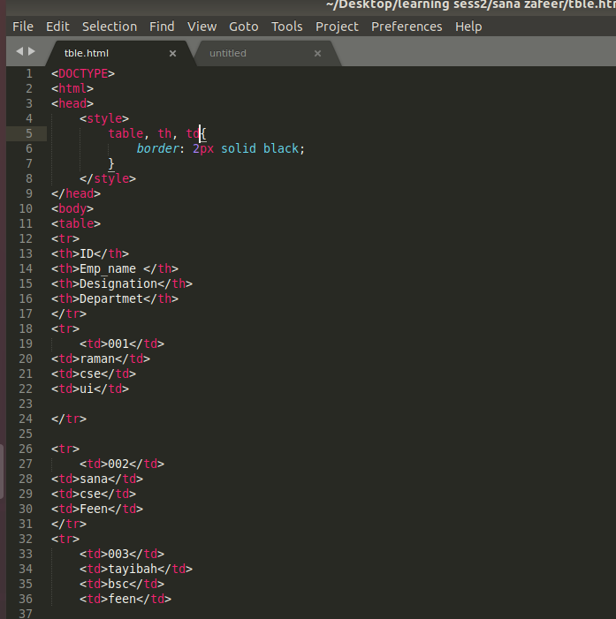
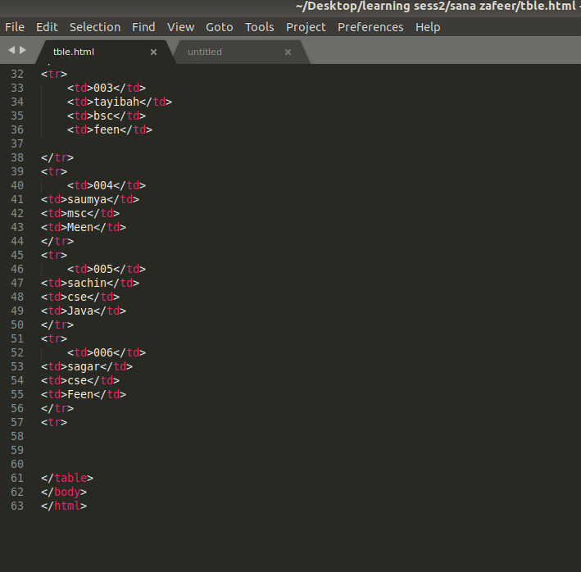
..

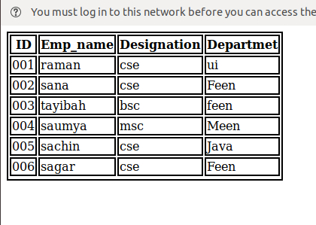
.....
Output-

Q6.Why do we use meta tags?
Ans.
used to specify page description, keywords, author of the document, last modified, and other such things. The metadata can be used by browsers , search engines , or other web services.

Q7. Explain box model.
Ans. It consists of: margins, borders, padding, and the actual content.

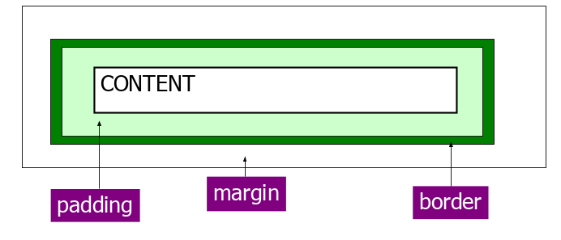
(i took this image from the slides shared with us, just to refrence my answer of box model)
Content - The content of the box, where text and images appear
Padding - Clears an area around the content. The padding is transparent
Border - A border that goes around the padding and content
Margin - Clears an area outside the border. The margin is transparent

Q8.What are the different types of CSS Selectors?
Ans.
Id & Class , where id’s are unique and classes are not unique.
Syntax – selector{property:value}
with class selector we use ‘ . ‘ and ‘#’ with id selector.

Q9.Define Doctype.
Ans. it is an instruction to the web browser about what version of HTML the page is written in.

Q10.Explain 5 HTML5 semantic tags.
Ans.
<article> :Defines an article in the document
<aside> : Defines content aside from the page content like sidebar.
<footer>: Defines a footer for the document or a section.
<header>: Defines a section in the document
<section> :defines a section in a document
Q11. 2. Please create the following form using required html5 form tags.
Ans. Input:
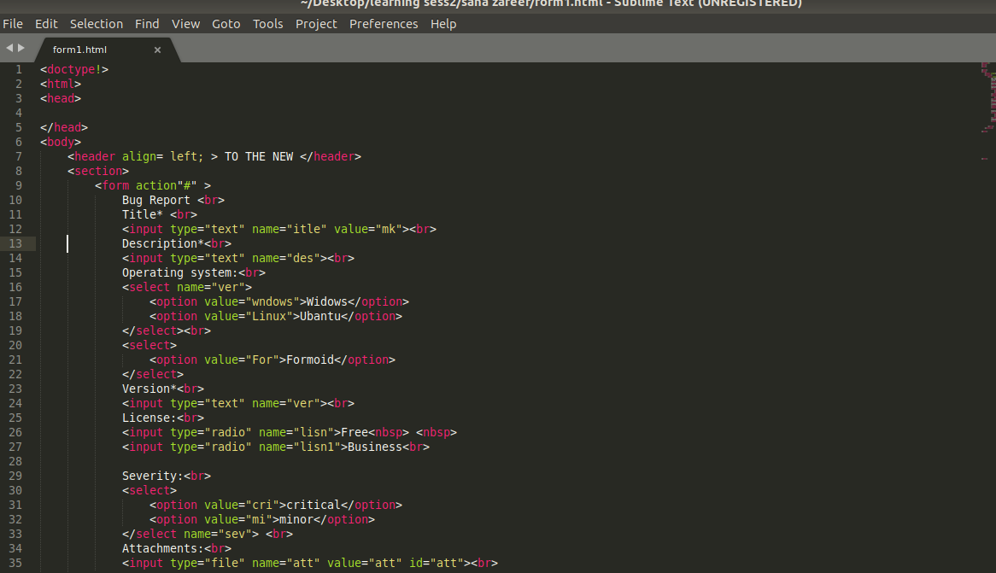
..
Output:
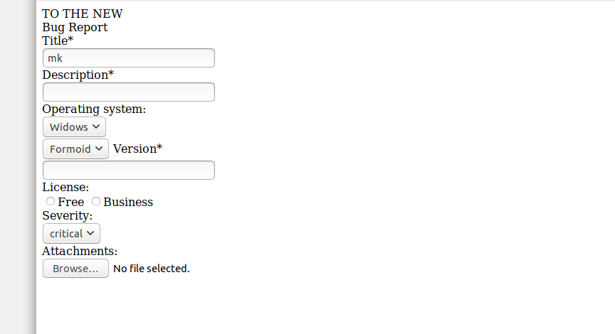

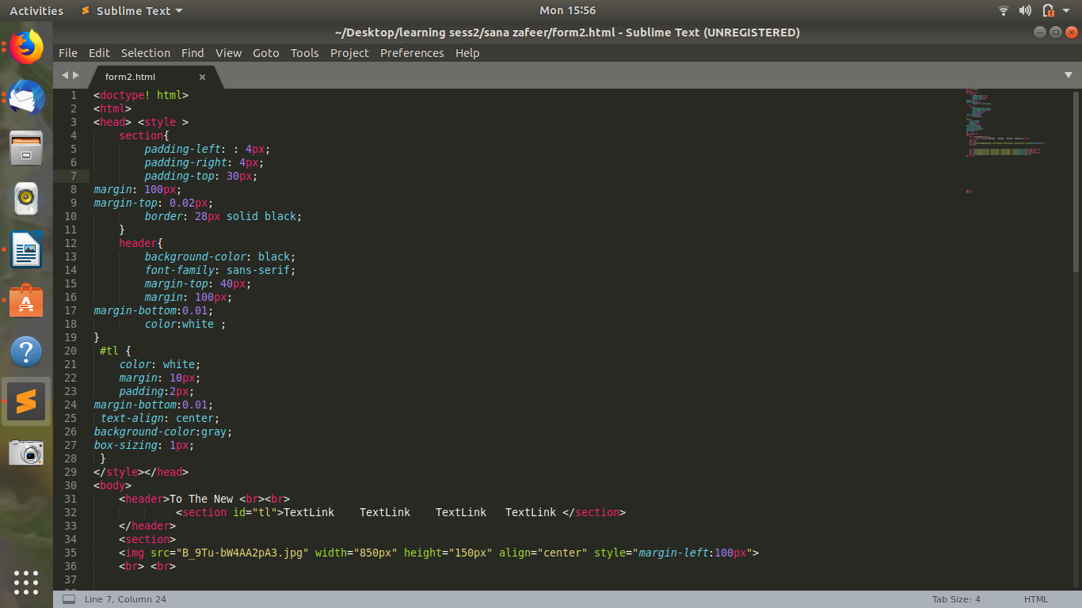
Q12.Create the following web page using html5 tags and required css.
Ans:
input-
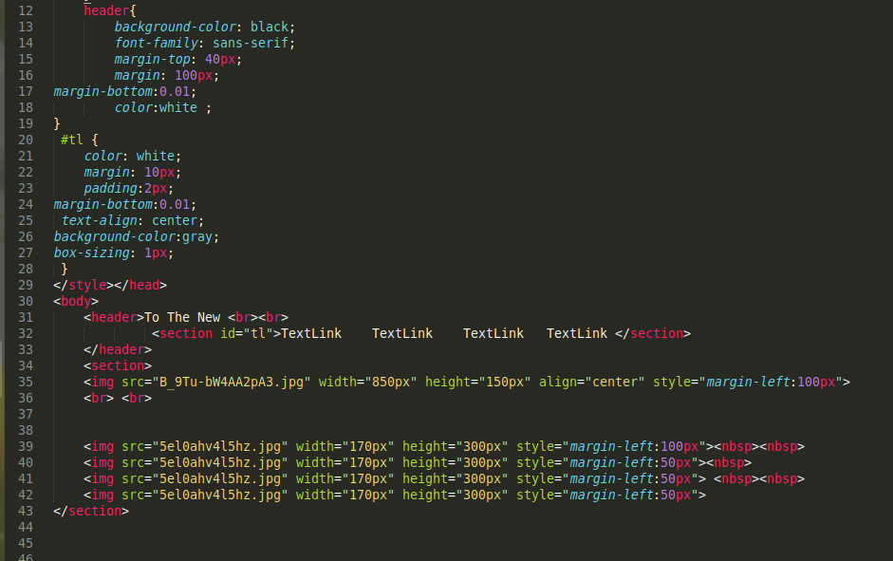
..
Output:


