06-02-2019
3rd day 1st week
Introduction to database

Problem Statement: There can be multiple customers, who can place multiple orders on the site. Now a sales person can handle these orders will distribute into multiple sales persons (One order will be assign to one salesperson only). So a sales person can have multiple orders of multiple customers

1.Create Database.

Ans. Created a database having name ‘excercise3’
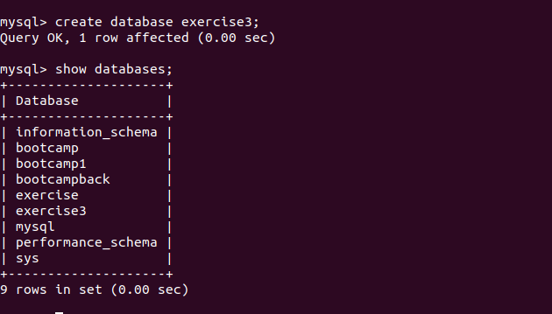

Q3.Create tables .
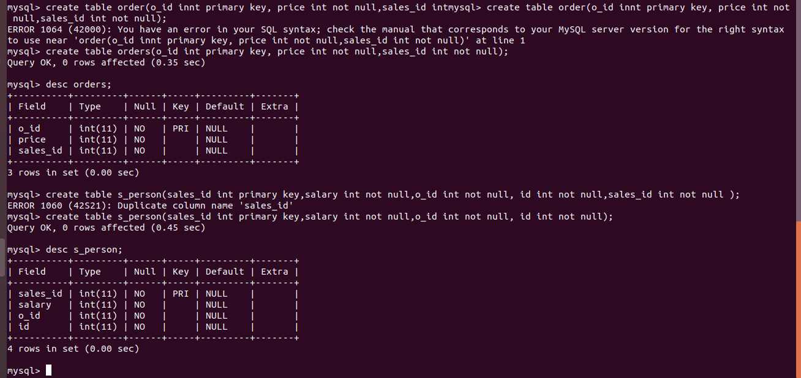
Ans
Q4.Insert sample data
ans.
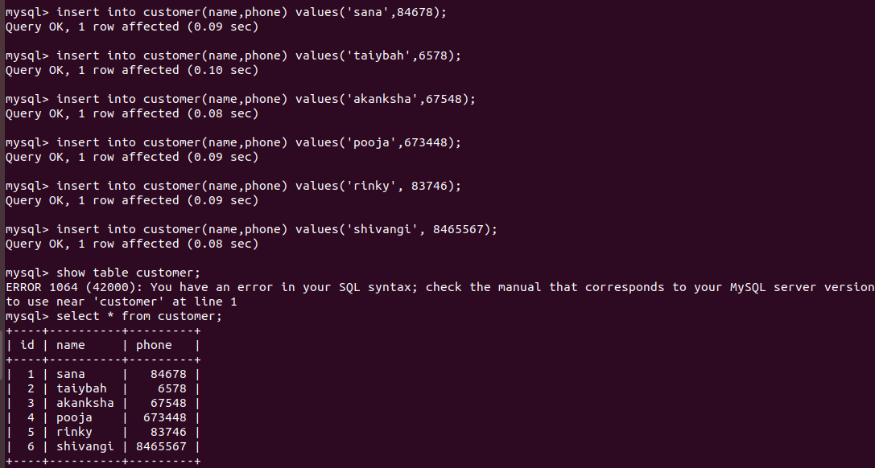
Q7.Create index

Q8.How to show index on a table
ans. Using ‘show index’

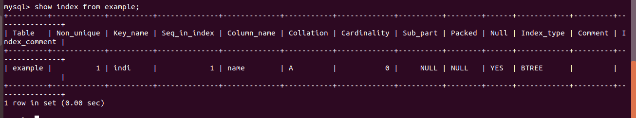

Q2.
ans.

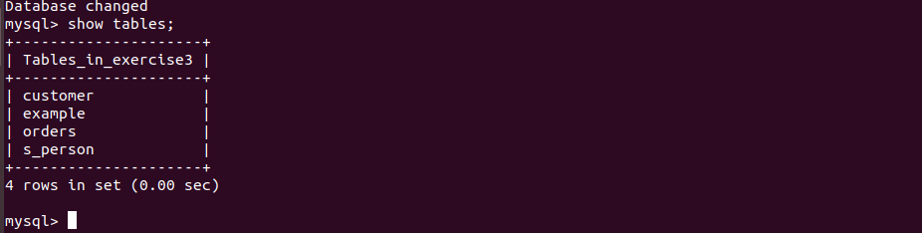
Q5. Find the sales person have multiple orders.
Ans.
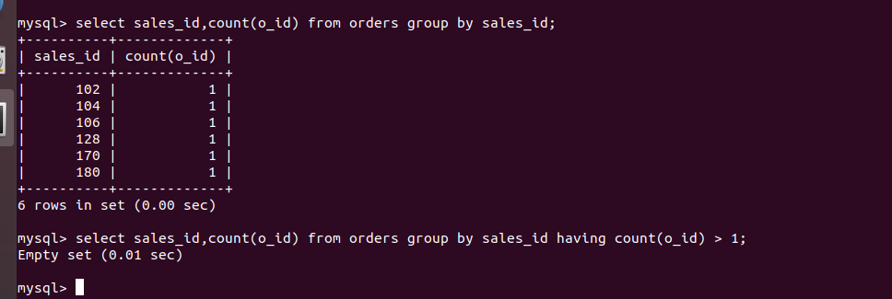

Q6. Find the all sales person details along with order details
ans.
