13-02-2019
3rd day 2nd week
Introduction to JQuery

Q1.Console "Hello Word" in document.ready function
ans.

<!DOCTYPE html>
<html>
<head>

</head>
<body>

<script src="https://ajax.googleapis.com/ajax/libs/jquery/3.3.1/jquery.min.js"></script>
<script >

$(document).ready(function( ) {

console.log("ello World");
});
</script>
</body>
</html>

Otput:
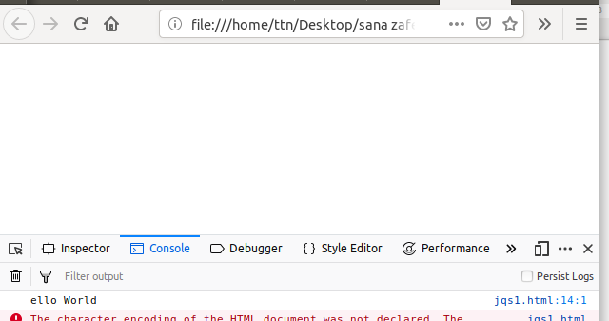

Q2.Select a ID name "#test" and add class "load" when DOM is loaded.
Ans
<!DOCTYPE html>

<html>
<head>
<style>

.load{
color:red;
background-color :black;
}
</style>

</head>
<body>
<div>
hey
<div id="test"> Thisis a div</div>
</div>

<script src="https://ajax.googleapis.com/ajax/libs/jquery/3.3.1/jquery.min.js"></script>
<script >

$(window).on('load',function(){
$('#test').addClass('load');
});
</script>

</body>
</html>

Output:
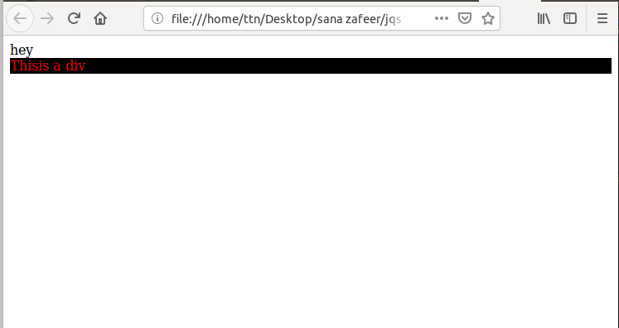
Q3.Change the color of element which class name end with "-new"
ans.
<!DOCTYPE html>
<html>
<head>
<meta charset="utf-8">
<script src="https://ajax.googleapis.com/ajax/libs/jquery/3.1.1/jquery.min.js"></script>
<script>
$(document).ready(function(){
$("[class$=new]").css("color", "blue")
})
</script>
</head>
<body>

<div class="fid">
<h3 class="my-new">first is here</h3>
<h3 class="second">second </h3>

</div>
</body>
</html>

Output:



Q4.Disable submit button using jquery attr method

ans.
<html>
<head>
<title>The jQuery Example</title>
<script type = "text/javascript"
src = "https://ajax.googleapis.com/ajax/libs/jquery/2.1.3/jquery.min.js">
</script>

<script type = "text/javascript">

$(document).ready(function() {
$("#myb").attr("disabled", true);
});
</script>
</head>

<body>
<h1 id="my-new">Third 3</h1>

<form>
First name:<br>
<input type="text" name="firstname" value="0">
<br>
Last name:<br>
<input type="text" name="lastname" value="0">
<br><br>
<input type="submit" value="Submit" id="myb">
</form>
</body>

Output:
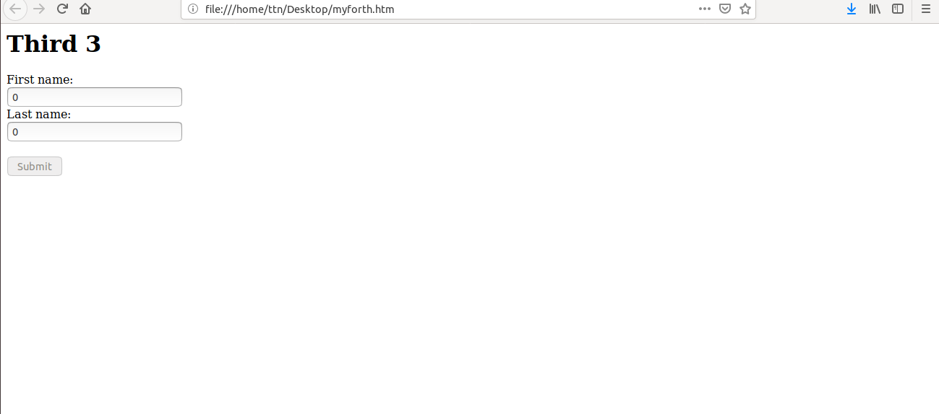

Q5.Change the font size of ".target" which has parent element with id name "#main"

<!DOCTYPE html>
<html>
<head>
<title> change the font size of ".target" which has parent element with id name "#main"</title>
<style >
.hey{
border: solid red 4px;
margin: 20px;
padding: 8px;
}
#main {
border: dashed black 2px;

}
</style>
</head>
<body>
<div class="hey"> parent of ll div.<br>
<div id="main"> we are starting here a ne div which is child of a another div and parent for some div . <br>
<div class="target"> hello this div has target class
<div id="i1"></div>
</div>
</div>
<footer>closing all div</footer>
</body>
<script src="https://ajax.googleapis.com/ajax/libs/jquery/3.3.1/jquery.min.js"> </script>
<script>
$("#main").css({'color':'red','font-size':'20px'});
</script>
</html>

Output:
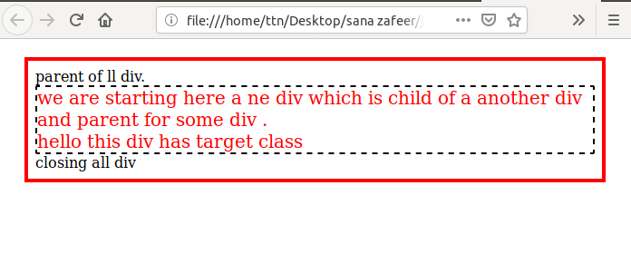
Q6.After page load change the HTML of div element with "p" element
Ans-
<html>
<head>
<script src="https://code.jquery.com/jquery-1.9.1.min.js"></script>
<script>

$( window ).on( "load", function() {
$("div").replaceWith("<p>New para</p>");
});
</script>
</head>
<body>
<div>Here is the division</div>
<p>Here is the para of my answer</p>

</body>
</html>
Output:

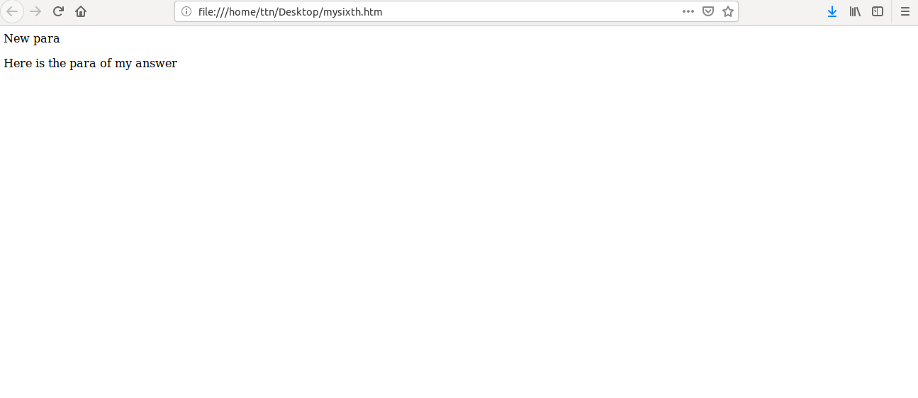

Q7.Bind a click function to an "click" element and append next "click" next to it.
ans.
<!DOCTYPE html>
<html>
<head>
<title></title>
<h3><b>Q. Bind a click function to an "click" element and append next "click" next to it.</b></h3>
</head>
<body>

<button id="bt">click to generate more buttons</button>
<br> <p> buttons will be generayed here</p>

</body>

<script src="https://ajax.googleapis.com/ajax/libs/jquery/3.3.1/jquery.min.js"></script>

<script >

$(document).ready(function(){
$("button").click(function(){
$("<span><button>iAmAppended</button></span>").appendTo("body") ;
});
});

</script>

</html>

Output:
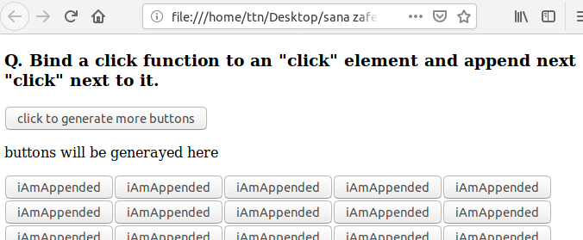

Q8.Click event not working on element which added dynamicly or via script, make it work using .on method
ans.
<!DOCTYPE html>
<html>
<head>
<meta charset="utf-8">
<script src="https://ajax.googleapis.com/ajax/libs/jquery/3.3.1/jquery.min.js"></script>
<script>

$(document).ready(function() {
$("#myb").click(function(){
$("#fid").append("<br><button id= 'newb'> new button</button><br>");

});""
$(document).on("latest","latbtn",function(){
$("#fid").append("<br><button id= 'latestb'> latest button</button><br>");
});
});
</script>
</head>
<body>
<div id="fid">
<p>7th question</p>
<p>This is another paragraph.</p>
<button id="myb">Try</button><br>
</div>

</body>
</html

Output:
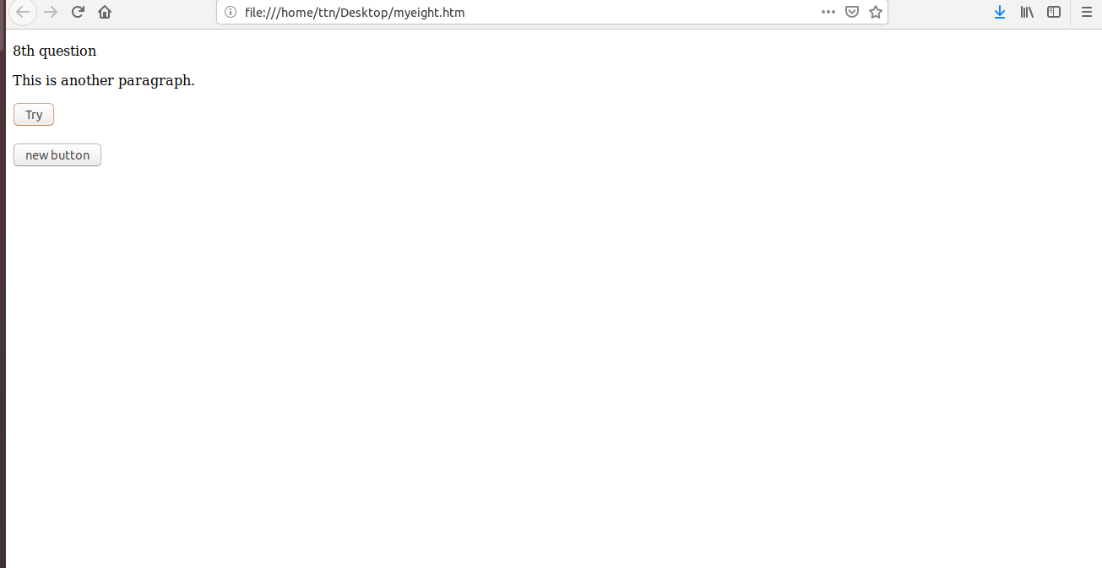

9.Get dropdown selected value on onchanage event and append in div container
Ans-
<!DOCTYPE html>
<html>
<head>
<meta charset="utf-8">
<script src="https://ajax.googleapis.com/ajax/libs/jquery/3.3.1/jquery.min.js"></script>
<script>

$(document).ready(function() {
$("#myse").change(function(){
$("#container").append("<h5>"+$("#myse").val()+"</h2>")

});
});
</script>
</head>
<body>
<div id="fid">Choose from the option
<select id="myse">
<option value="tiger">Tiger</option>
<option value="fox">fox</option>
<option value="cat">cat</option>
<option value="dog">dog</option>
</select>
</div>

<div id="container">

</div>

</body>
</html>

Output:
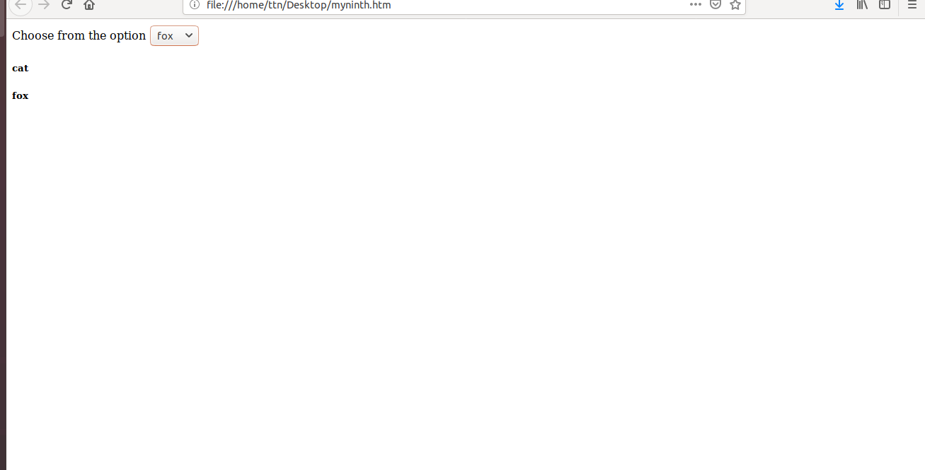

10.Create a dropdown menu using hover method in jquery
Ans-
<!DOCTYPE html>
<html>
<head>
<meta charset="utf-8">
<script src="https://ajax.googleapis.com/ajax/libs/jquery/3.3.1/jquery.min.js"></script>
<script>

$(document).ready(function() {
$("$myb").hover(function(){
$('#mydd').slideDown('fast');},
function(){
$('#mydd').slideUp('fast');});
});

});
});
</script>
</head>
<body>
<div id="fid">Choose from the option
<button id="myb">click to create dropdown</button>
<div id="mydd" style="display:none">
<button>tiger</button>
<button>lion</button>
<button>dog</button>
</div>
</div>

<div id="container">

</div>

</body>
</html>
Output:


11.On clicking on "google" tag. It is taking us to google home page. Stop it from happening.
Ans-
<!DOCTYPE html>
<html>
<head>
<meta charset="utf-8">
<script src="https://ajax.googleapis.com/ajax/libs/jquery/3.3.1/jquery.min.js"></script>
<script>

$(document).ready(function() {
$("#togoogle").attr("href","");
});
</script>
</head>
<body>
<div id="fid">
<a id="togoogle" href="https://www.google.com/">Google</a>

</div>

</body>
</html>

Output:
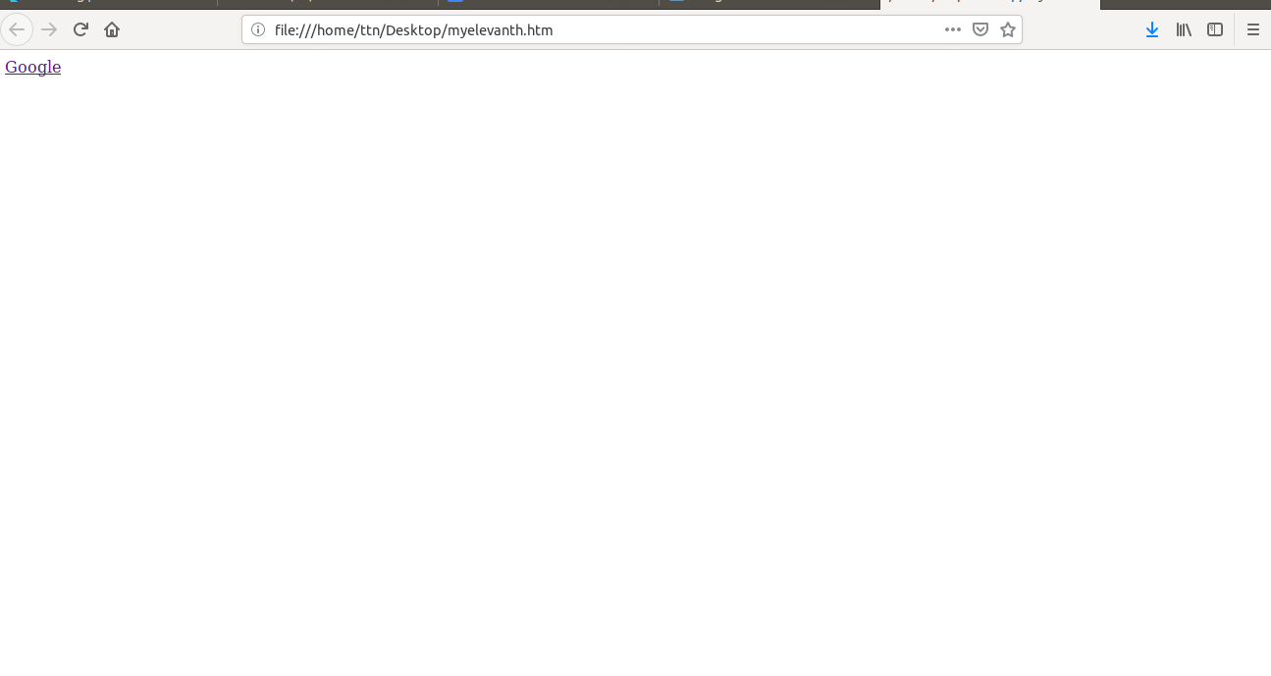

12.We have bind a click funtion to parent div but we want stop it from performing when user clicks on its child li
Ans-
<!DOCTYPE html>
<html>
<head>
<meta charset="utf-8">
<script src="https://ajax.googleapis.com/ajax/libs/jquery/3.3.1/jquery.min.js"></script>
<script>

$(document).ready(function() {
$("#childid").click(function(){
$("$fid").off("click");
$("$tid").append("<br><h3>child click</h3>");
});

});
</script>
</head>
<body>
<div id="fid" style="width:360px;height:260px;background-color:red">
<div id="childid" style="width:150px;height:150px;background-color:green"></div>
</div>

<div id="tid">here:
</div>

</body>
</html>

Output:
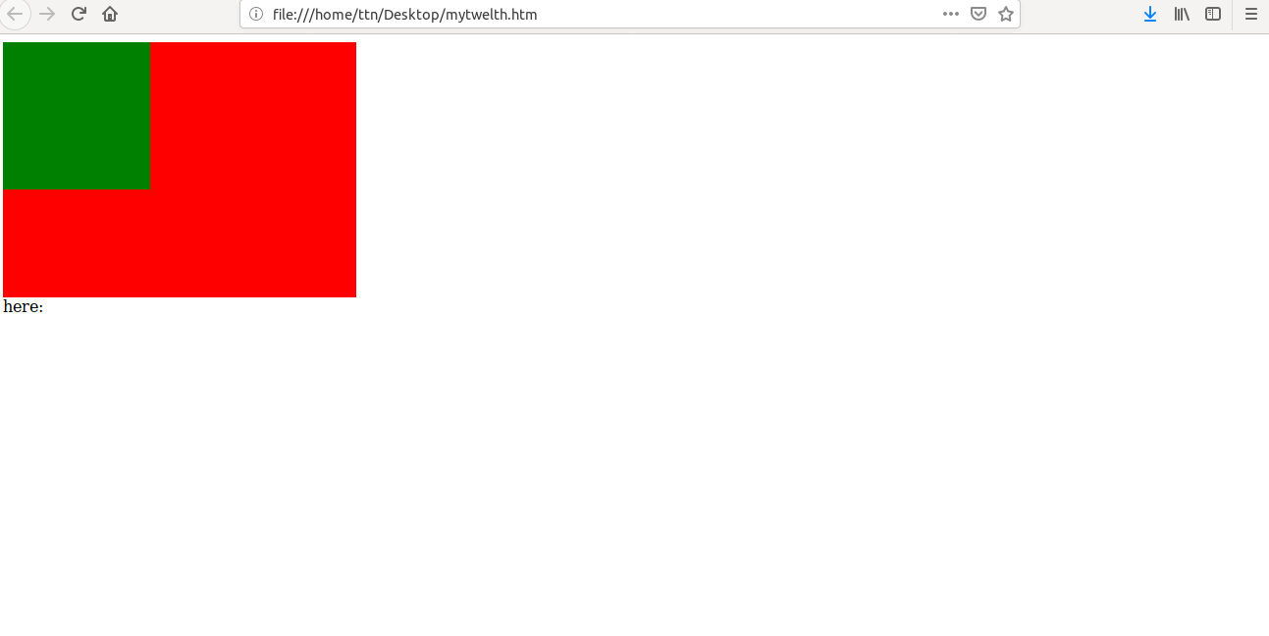

13.Get the max height of elements using jquery each method
Ans-

<!DOCTYPE html>
<html>
<head>
<meta charset="utf-8">

<script src="https://ajax.googleapis.com/ajax/libs/jquery/3.1.1/jquery.min.js"></script>
<script>
$(document).ready(function(){
var max = -1;
$(".main > div").each(function() {
var h = $(this).height();
max = h > max ? h : max;
});
$("#container").append("<h2> Maximum height of elements is" + max + "</h2>")
})
</script>
</head>
<body>
<div class="main">
<div id="myf1" style="background-color: red; width:50px;height:30px"></div><br>
<div id="myf2" style="background-color: blue; width:30px;height:20px"></div><br>
<div id="myf3" style="background-color: yellow; width:30px;height:50px"></div><br>

</div>
<div id="container">

</div>
</body>
</html>
Output:

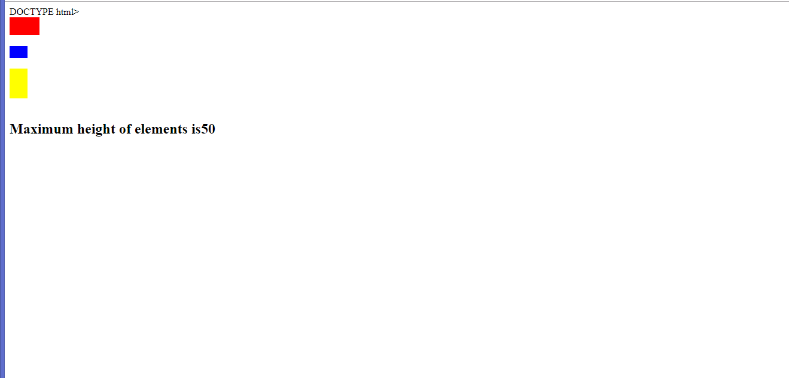

14.Change color of every cell which has numberl larger than 10.
Ans-
<!DOCTYPE html>
<html>
<head>
<meta charset="utf-8">
<script src="https://ajax.googleapis.com/ajax/libs/jquery/3.3.1/jquery.min.js"></script>
<script>

$(document).ready(function() {
$("td").each(function(){
if($(this).html()>10){
$(this).css({"background-color": "red"});
} });
});
</script>
</head>
<body>
<div id="fid">
<table id="myt" border="1px" style="width:100%">
<tr>
<td>12</td>
<td>23</td>
<td>4</td>
</tr>
<tr>
<td>4</td>
<td>11</td>
<td>43</td>
</tr>
<tr>
<td>1</td>
<td>3</td>
<td>9</td>
</tr>
</table>
</div>

</body>
</html>

Output:
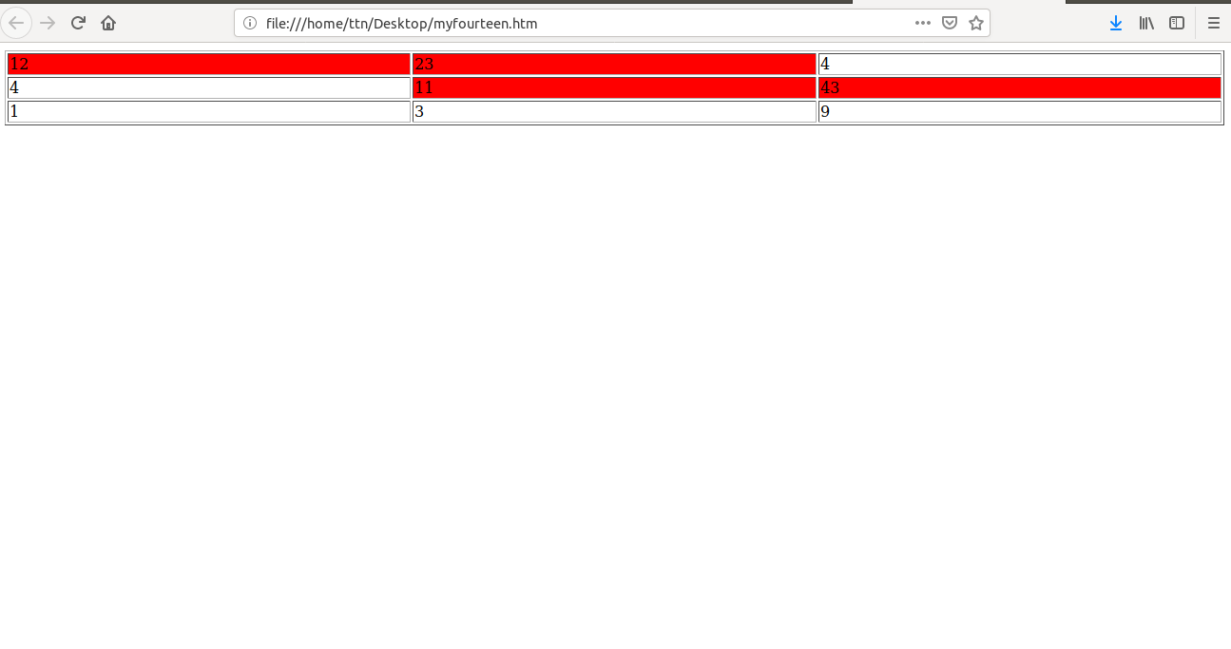

15.Retrive the data from server using ajax get call
Ans-
<!DOCTYPE html>
<html>
<head>
<meta charset="utf-8">
<script src="https://ajax.googleapis.com/ajax/libs/jquery/2.1.3/jquery.min.js"></script>
<script>

$(document).ready(function() {
$("#childid").click(function(){
$("$fid").off("click");
$("$tid").append("<br><h3>child click</h3>");
});

});
</script>
</head>
<body>
<div id="fid" style="width:360px;height:260px;background-color:red">
<div id="childid" style="width:150px;height:150px;background-color:green"></div>
</div>

<div id="tid">here:
</div>

</body>
</html>
Output:
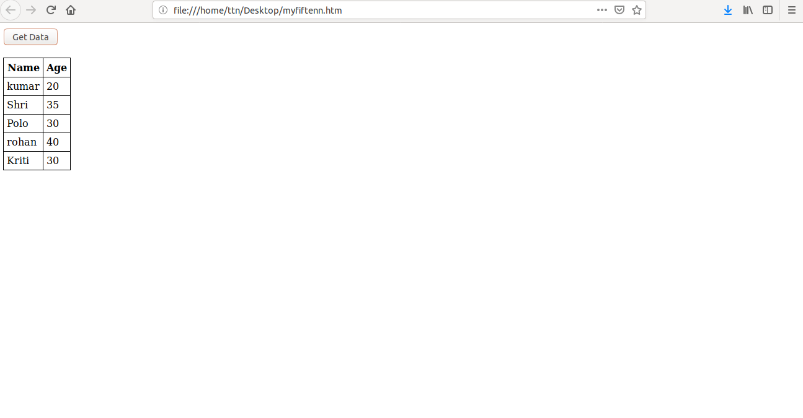
16.Add cross button on row and bind click function which make a delete request to server, after success event remove the row from dom
Ans-
<!DOCTYPE html>
<html>
<head>
<meta charset="utf-8">
<script src="https://ajax.googleapis.com/ajax/libs/jquery/2.3.1/jquery.min.js"></script>
<script>
var json;
$(document).ready(function(){
$("#get_data").click(function(){
$("#table_head").children().replaceWith("")
$("#table_body").children().replaceWith("")
$.ajax({url: "https://api.myjson.com/bins/mhh92", success: function(result){
$("#table_head").append("<th> Name </th> <th> Age </th>")
$("#data").attr({"border":"1", "cellpadding":"5px"})
putJsonInTable(result);
json = result;
}});
})

})
var putJsonInTable = function(data){
var i = 0
data.forEach(function (item) {
$("#table_body").append("<tr> <td>" + item.name + "</td> <td> <button class='b" + i +"' id='del_btn'>x</button> </tr>")
i++
});
}
$(document).on("click","#del_btn",function(){
var clicked_id = $(this).attr("class")
json.splice(clicked_id[1],1)
$("#table_body").children().replaceWith("")
putJsonInTable(json)
})
// my json file
//[{"name":"kumar","age":20},{"name":"Shri","age":35},{"name":"Polo","age":30},{"name":"rohan","age":40},{"name":"Kriti","age":30}]
</script>
</head>
<body>
<h2>Solution 16</h2>
<div id="main">
<button id="get_data">Get Data!</button><br><br>
<div id="container">
</div>
<div>
<table id="data" style="border-collapse: collapse;">
<thead id="table_head">

</thead>
<tbody id="table_body">

</tbody>
</table>
</div>
<div>
<table id="data1" style="border:1; border-collapse: collapse;">
<thead id="table_head1">

</thead>
<tbody id="table_body1">

</tbody>
</table>
</div>
</div>
</body>
</html>
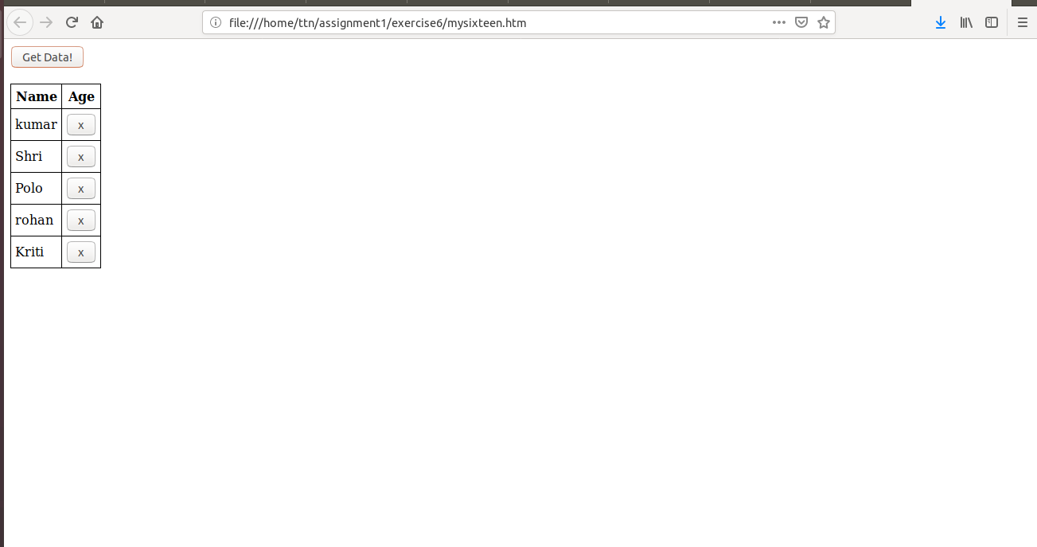

17.Create a image array and in div create a slide show to animate images of delay of 500ms.
Ans-
<!DOCTYPE html>
<html>
<head>
<meta charset="utf-8”>
<script src="https://ajax.googleapis.com/ajax/libs/jquery/2.3.1/jquery.min.js"></script>
<style>
#slider{
width:200px;
height:200px;
overflow:hidden;
}
#slider .slides{
display: block;
width: 200px;
height: 200px;
margin: 0;
padding: 0;
}
#slider .slide{
float:left;
list-style-type: none;
width:200px;
height:200px;
}
</style>
<script>
$(document).ready(function () {
$("img").css("display", "none");
$('#0').css("display", "block");
var len = $("img").length
console.log(len);
slideshow();
var count = 1;
function slideshow() {
if (count == len - 1) {
$("img").css("display", "none");
$('#' + count).css("display", "block");
count = 0;
} else {
$("img").css("display", "none");
$('#' + count).css("display", "block");
count++;
}
setTimeout(slideshow, 500)
}
})
</script>
</head>
<body>
<div id="slider">
<img id="0" src="exercise6/joshua-earle-63441-unsplash.jpg">
<img id="1" src="exercise6/joshua-earle-63441-unsplash.jpg">
<img id="2" src="exercise6/joshua-earle-63441-unsplash.jpg">
<img id="3" src="exercise6.joshua-earle-63441-unsplash.jpg">
</div>
</body>
</html>

