12-02-2019
2nd day 2nd week
Introduction to java script

Q1.Prompt for amount, interest rate and no. of years and calculate simple interest.
Ans.
<!DOCTYPE html>
<html>
<head>

</head>
<body>
<h3>hello, this page shows simple interest value</h3><br>
to know simple interest, enter number of years and interest rate<br>
<br><button onclick="hey()"> click to enter values</button>
<script>
function hey(){

var p = prompt("enter amount");
var x = prompt("Enter rate of interest");
var y = prompt(" Enter years ");
alert( (p*x*y)/10000 );
}
</script>

</body>
</html>
..
Output:
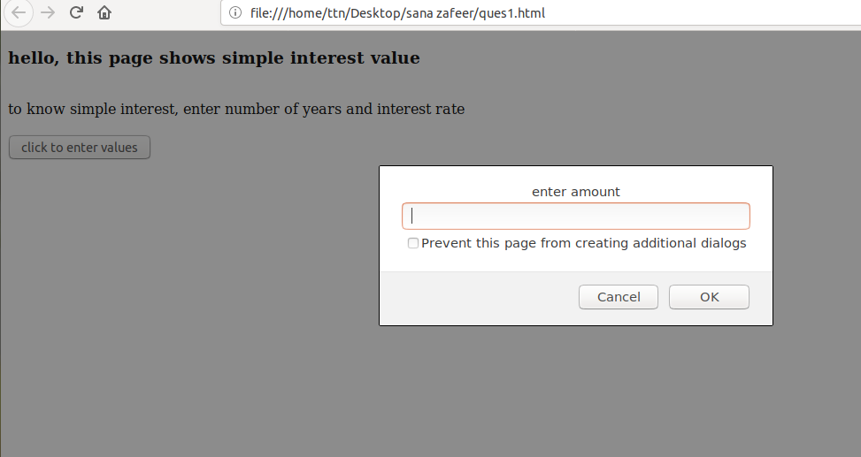

Qcheck for Palidrome string.
Ans.
<!DOCTYPE HTML>
<html>
<head>
<script>
function checkpel(){
var a = document.getElementById('mystring').value;
var s='';
var i='';
var j=a.length;
for(i=j-1;i>=0;i--){
s+=a.charAt(i);
}
if(s==a){
document.getElementById('results').value="it is a palindrome";
}else{
document.getElementById('results').value="it is not palindrome";
}
}
</script>
</head>
<body>
<div>
<h2>Palindrome question </h2><br>
Enter the String: <input type="text" value="." id="mystring"><br><br>
<button onClick ="checkpel()">Check</button><br><br><br>
</div>

output:
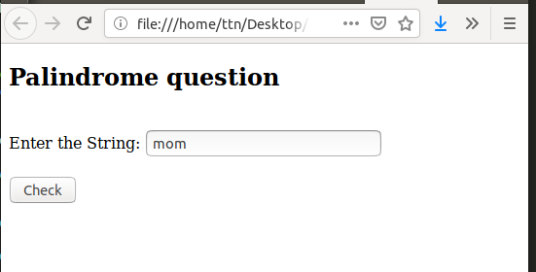
...
Q3. Area of circle.
Ans.
<!DOCTYPE html>
<html>
<head>
<title>area of circle</title>
<STYLE>
SECTION{
border-radius: 6PX;
border: gray solid 2.5px;
padding: 10px;
}
</STYLE>
</head>
<body>
<section>this page calculates area of cirle , enter radius of circle<br>
and get the calculation done.
....

</section>
<button onclick="hey()">click & find area</button>
<script >
function hey(){

var r = prompt ("enter radius");
alert( r*r*3.14);
</script>

</body>
</html>
Output:
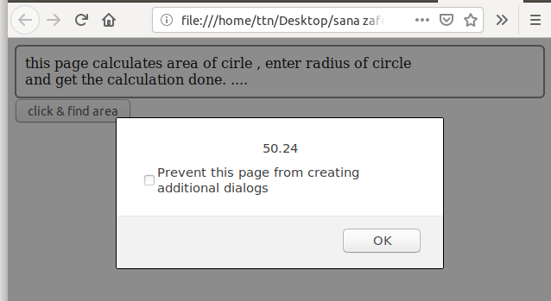

Q4.Copy information of one object to another and log it to console.
Ans
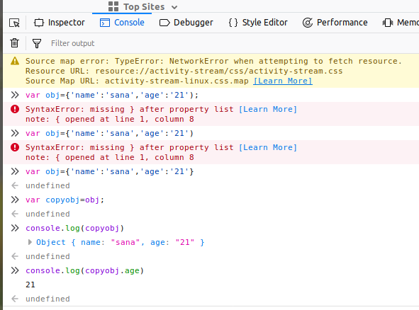

Q5. create a list of objects of Employee with info as follow :
- Name, age, salary ,DOB
- filter all employees with salary greater than 5000
- group employee on the basis of their age
- fetch employees with salary less than 1000 and age greater than 20. Then give them an increment 5 times their salary.
Ans.

<!DOCTYPE HTML>
<html>
<head>
<title>employee list</title>
</head>
<body>
<pre id="test"></pre>
<script>
var employees=[
{ name:'kumar',age:19,salary:3000,DOB:'12-12-1999'},
{ name:'Shri',age:21,salary:4000,DOB:'24-10-1997'},
{ name:'Lily',age:21,salary:900,DOB:'15-03-1997'},
{ name:'somesh',age:24,salary:15000,DOB:'22-04-1996'}
];
employees.forEach(
function(e){
document.write(JSON.stringify(e)+"<br>");
});

document.write("<br> Employees whose salary is bigger than 5000");
i=0;
employees.forEach(
function(e){
if(e.salary>=5000){
i++;
document.write("<br>"+e.name+"-"+e.salary+"<br>");
}

});

document.write("<br> fetch employees with salary less than 1000 and age greater than 20. Then give them an increment 5 times their salary");
i=0;
employees.forEach(
function(e){
if(e.salary<1000 && e.age>20){
i++;
document.write("<br>"+e.name+"-"+e.salary+"<br>");
}

});

document.write("<br> Increment it by 5 times");
i=0;
employees.forEach(
function(e){
if(e.salary<1000 && e.age>20){
i++;
e.salary*=5;
document.write("<br>"+e.name+"-"+e.salary+"<br>");
}

});

document.write("<br> Group employee by age:");

Array.prototype.groupBy = function(prop) {
return this.reduce(function(groups, item) {
const val = item[prop]
groups[val] = groups[val] || []
groups[val].push(item)
return groups
}, {})
};

const groupByMake = employees.groupBy('age');
document.write("<br> Group employee by age:"+groupByMake);

</script>

</body>
</html>
Output:





