**Tables and forms**

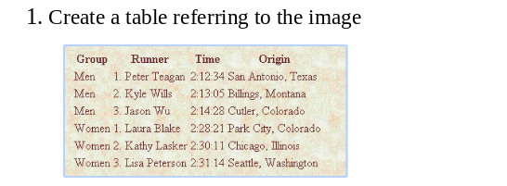

Ans.

Code

.. <!DOCTYPE html>

<html>

<head>

<title>

table

</title>

<style >

table{

text-transform: capitalize;

padding: 25px;

background-image: url(tablebackground.png);

}

td{

padding: 8px;

}

</style>

</head>

<body>

<table>

<tr> <th>Group</th>

<th>Runner</th>

<th>Time</th>

<th>Origin</th>

</tr>

<tr>

<td>Men</td>

<td>1.peter Teagan</td>

<td>2:12:34</td>

<td>San antonio, Texas</td>

</tr>

<tr>

<td>Men</td>

<td>2. Kyle wills</td>

<td>2:13:05</td>

<td>billings , montana</td>

</tr>

<tr>

<td>Men</td>

<td>3. jason wu</td>

<td>2:14:28</td>

<td>cutler , colorado</td>

</tr>

<tr>

<td>women</td>

<td>1. laura blake</td>

<td>2:28:21</td>

<td>park city, colorado</td>

</tr>

<tr>

<td>women</td>

<td>2.kathy lasker</td>

<td>2:30:11</td>

<td>Chikago , washington</td>

</tr>

<tr>

<td>women</td>

<td>3.lisa peterson</td>

<td>2:38:12</td>

<td>seattle, washington</td>

</tr>

</table>

</body>

</html>

Output:

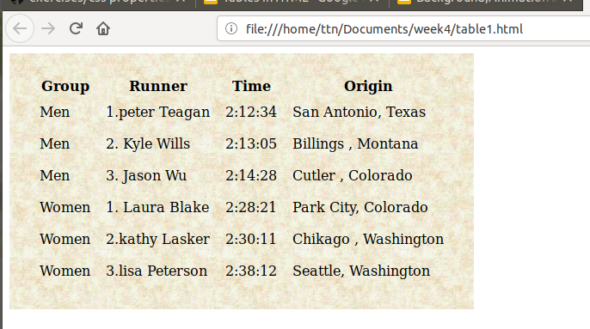

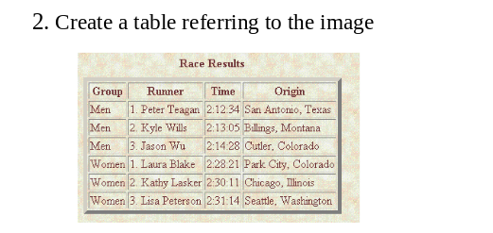

Code:

<!DOCTYPE html>

<html>

<head>

<title>

table

</title>

<style >

body{

background-image: url(tablebackground.png);

background-height: 250px;

}

table{

text-transform: capitalize;

}

td{

padding: 4px;

}

h4{

margin-left: 165px;

}

</style>

</head>

<body>

<table border="5px">

<h4>Race Result</h4>

<tr>

<th>Group</th>

<th>Runner</th>

<th>Time</th>

<th>Origin</th>

</tr>

<tr>

<td>Men</td>

<td>1.peter Teagan</td>

<td>2:12:34</td>

<td>San antonio, Texas</td>

</tr>

<tr>

<td>Men</td>

<td>2. Kyle wills</td>

<td>2:13:05</td>

<td>billings , montana</td>

</tr>

<tr>

<td>Men</td>

<td>3. jason wu</td>

<td>2:14:28</td>

<td>cutler , colorado</td>

</tr>

<tr>

<td>women</td>

<td>1. laura blake</td>

<td>2:28:21</td>

<td>park city, colorado</td>

</tr>

<tr>

<td>women</td>

<td>2.kathy lasker</td>

<td>2:30:11</td>

<td>Chikago , washington</td>

</tr>

<tr>

<td>women</td>

<td>3.lisa peterson</td>

<td>2:38:12</td>

<td>seattle, washington</td>

</tr>

</table>

</body>

</html>

Output:

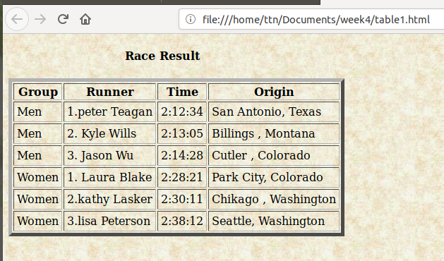

Ques3.

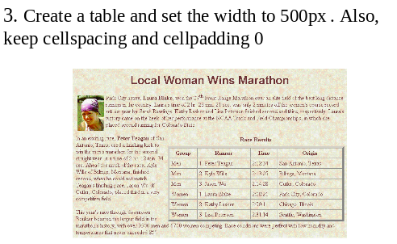

Code:

<!DOCTYPE html>

<html>

<head>

<title>

table

</title>

<style >

body{

background-image: url(tablebackground.png);

background-height: 250px;

}

.table-wrapper{

float: right;

}

table{

text-transform: capitalize;

width: 500px;

}

td{

padding: 4px;

}

h4{

margin-left: 165px;

}

h3{

text-align: center;

text-transform: capitalize;

}

.logo-image{

float: left;

}

</style>

</head>

<body>

<section class="content-wrapper">

<h3>local woman wins marathon </h3>

<img src="logo.png" class="logo-image">

<p> ipsum dolor sit amet, consectetur adipisicing elit, sed do eiusmod

tempor incididunt ut labore et dolore magna aliqua. Ut enim ad minim veniam,

quis nostrud exercitation ullamco laboris nisi ut aliquip ex ea commodo

consequat. Duis aute irure dolor in reprehenderit in voluptate velit esse

cillum dolore eu fugiat nulla pariatur. Excepteur sint occaecat cupidatat non

proident, sunt in culpa qui officia deserunt mollit anim id est laborum.

ipsum dolor sit amet, consectetur adipisicing elit, sed do eiusmod

tempor incididunt ut labore et dolore magna aliqua. Ut enim ad minim veniam,

quis nostrud exercitation ullamco laboris nisi ut aliquip ex ea commodo

consequat. Duis aute irure dolor in reprehenderit in voluptate velit esse

cillum dolore eu fugiat nulla pariatur. Excepteur sint occaecat cupidatat non

proident, sunt in culpa qui officia deserunt mollit anim id est laborum.

<section class="table-wrapper">

<table border="5px" cellpadding="0" cellspacing="0">

<h4>Race Result</h4>

<tr>

<th>Group</th>

<th>Runner</th>

<th>Time</th>

<th>Origin</th>

</tr>

<tr>

<td>Men</td>

<td>1.peter Teagan</td>

<td>2:12:34</td>

<td>San antonio, Texas</td>

</tr>

<tr>

<td>Men</td>

<td>2. Kyle wills</td>

<td>2:13:05</td>

<td>billings , montana</td>

</tr>

<tr>

<td>Men</td>

<td>3. jason wu</td>

<td>2:14:28</td>

<td>cutler , colorado</td>

</tr>

<tr>

<td>women</td>

<td>1. laura blake</td>

<td>2:28:21</td>

<td>park city, colorado</td>

</tr>

<tr>

<td>women</td>

<td>2.kathy lasker</td>

<td>2:30:11</td>

<td>Chikago , washington</td>

</tr>

<tr>

<td>women</td>

<td>3.lisa peterson</td>

<td>2:38:12</td>

<td>seattle, washington</td>

</tr>

</table>

</section>

ipsum dolor sit amet, consectetur adipisicing elit, sed do eiusmod

tempor incididunt ut labore et dolore magna aliqua. Ut enim ad minim veniam,

quis nostrud exercitation ullamco laboris nisi ut aliquip ex ea commodo

consequat. Duis aute irure dolor in reprehenderit in voluptate velit esse

cillum dolore eu fugiat nulla pariatur. Excepteur sint occaecat cupidatat non

proident, sunt in culpa qui officia deserunt mollit anim id est laborum.

ipsum dolor sit amet, consectetur adipisicing elit, sed do eiusmod

tempor incididunt ut labore et dolore magna aliqua. Ut enim ad minim veniam,

quis nostrud exercitation ullamco laboris nisi ut aliquip ex ea commodo

consequat. Duis aute irure dolor in reprehenderit in voluptate velit esse

cillum dolore eu fugiat nulla pariatur. Excepteur sint occaecat cupidatat non

proident, sunt in culpa qui officia deserunt mollit anim id est laborum

</p>

</body>

</html>

OUTPUT:

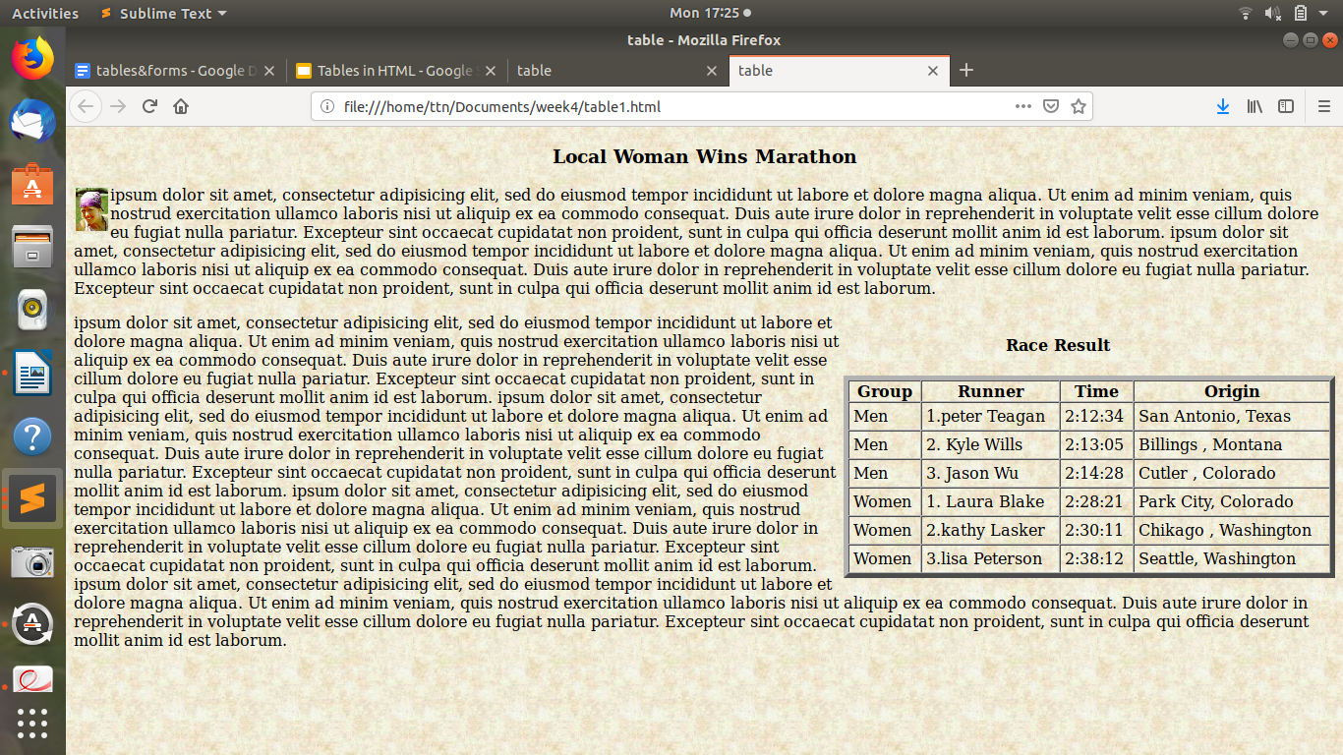

Ques4.

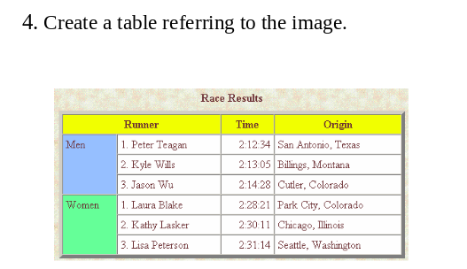

Ans:

Code :

<!DOCTYPE html>

<html>

<head>

<title>

table

</title>

<style >

body{

background-image: url(tablebackground.png);

background-height: 250px;

}

table{

text-transform: capitalize;

}

td{

padding: 4px;

}

.men{

background-color: aqua;

}

.women{

background-color: lightgreen;

}

.headings{

background-color: yellow;

}

h4{

margin-left: 165px;

}

</style>

</head>

<body>

<table border="3px">

<h4>Race Result</h4>

<tr class="headings">

<th>Group</th>

<th>Runner</th>

<th>Time</th>

<th>Origin</th>

</tr>

<tr>

<td rowspan="3" class="men">Men</td>

<td>1.peter Teagan</td>

<td>2:12:34</td>

<td>San antonio, Texas</td>

</tr>

<tr>

<td>2. Kyle wills</td>

<td>2:13:05</td>

<td>billings , montana</td>

</tr>

<tr>

<td>3. jason wu</td>

<td>2:14:28</td>

<td>cutler , colorado</td>

</tr>

<tr>

<td rowspan="3" class="women">women</td>

<td>1. laura blake</td>

<td>2:28:21</td>

<td>park city, colorado</td>

</tr>

<tr>

<td>2.kathy lasker</td>

<td>2:30:11</td>

<td>Chikago , washington</td>

</tr>

<tr>

<td>3.lisa peterson</td>

<td>2:38:12</td>

<td>seattle, washington</td>

</tr>

</table>

</body>

</html>

Output :

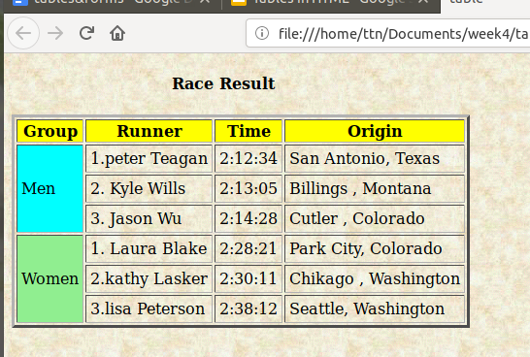

Ques.5

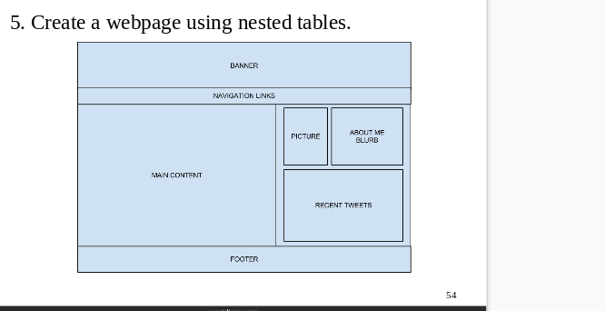

Ans.

Code:

<!DOCTYPE html>

<html>

<head>

<title></title>

<style >

.wrapper{

background-color: aqua;

}

.mid-div{

width: 300px;

border: none; c

}

table{

border: 1px solid black;

width: 600px;

}

td{

border: .4px solid black;

padding: 0px;

}

.banner-row{

text-transform:uppercase;

text-align:center;

height: 80px;

}

.nav-row{

text-transform: uppercase;

text-align: center;

height: 26.7px;

}

.footer-row{

text-transform: uppercase;

text-align: center;

height: 40px;

}

.first-division{

height: 350px;

width: 300px;

text-align: center;

text-transform: uppercase;

}

.second-division{

text-align: center;

text-transform: uppercase;

}

</style>

</head>

<body>

<section class="wrapper">

<table cellspacing="0" cellpadding="0">

<tr> <td class="banner-row"> banner</td></tr>

<tr> <td class="nav-row"> navigation links</td>

<table class="nested-table1" cellpadding="0" cellspacing="0">

<tr> <td class="first-division"> main</td>

<td class="second-division">

<table class="mid-div" cellspacing="8px" cellpadding="0">

<tr height="175px">

<td > picture </td>

<td width="170px">abut me</td>

</tr>

<tr height="175px">

<td colspan="2">recent tweets </td>

</tr>

</table>

</td>

</tr>

</table>

<table cellpadding="0" cellspacing="0px">

<tr>

<td class="footer-row">footer</td>

</tr>

</table>

</table>

</section>

</body>

</html>

**Output:**

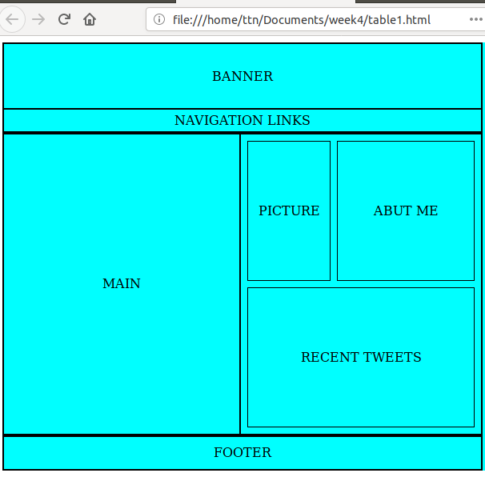

Ques.6.

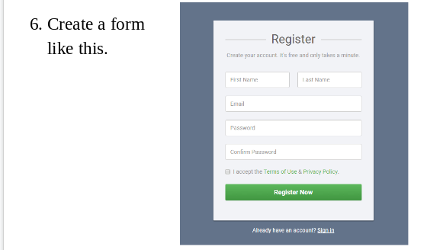

Ans.

Code:

<!DOCTYPE html>

<html>

<head>

<title>form</title>

<style>

.wrapper{

width: 450px;

height: 800px;

background-color: orange;

}

.form-wrapper{

background-color: lightblue;

width: 380px;

height: 400px;

margin-left: 35px;

padding-top: 20px;

border: 1px solid lightblue;

}

h2{

text-align: center;

}

p{

margin-left: 3.6px;

margin-bottom: 10px;

color:gray;

text-align: center;

font-size: small;

}

.fname , .lname{

width: 160px;

height: 29px;

margin-left: 11px;

border-radius: 3px;

}

.password1 , .e-mail{

width: 339px;

height: 29px;

margin-left: 12px;

margin-top: 16px;

border-radius:3px;

}

.checkbox1{

margin-top: 20px;

margin-left: 12px;

font-size: x-small;

}

button{

width: 340px;

background-color: lightgreen;

text-align: center;

text-transform: capitalize;

height: 42px;

color: white;

border-radius: 6px;

margin: 16px 0px 0px 16px ;

}

footer{

text-align: center;

color: white;

}

</style>

</head>

<body>

<section class="wrapper">

<section class="form-wrapper">

<form>

<header class="form-header">

<h2> Register</h2>

<p>create your account its free and only takes a minute</p>

</header>

<section class="input-elements">

<input type="text" class="fname"placeholder="First Name">

<input type="text" class="lname" placeholder="Last Name">

<input type="email" class="e-mail" placeholder="Email">

<input type="password" class="password1"placeholder="Password">

<input type="password" class="password1" placeholder="Confirm Password">

<input type="checkbox" class="checkbox1"> I accept the terms of use and privacy.

<button>Register Now</button>

</section>

</form>

</section>

<footer>

already have an account? <a href="hello.html"> sign in </a>

</footer>

</section>

</body>

</html>

Output:

