Student Name: Sana Student ID: SP17-BSSE-0071

# Mohammad Ali Jinnah University

**Software Architecture (AM) (Lab)**

**Final Examination**

**(Morning)**

**Instructor Name: Mahnoor Iftikhar Total Marks: 50**

**Date: July 3, 2020 Time: 3 hours**

**Maximum Time: 24 hours**

**Instructions:**

1. **Submit this document with labelling instructions provided below, sign the honor statement provided below by HIGHLIGHTING the desired option.**

**“**I pledge on my honor that I have not given or received any unauthorized assistance on this examination.”

* 1. Agree
  2. Disagree

1. **Submit SEPARATE files with question number, your id, and section (for example Q1-SP19-BSXXXXXX-AM).**
2. **If screenshots are required, then copy and paste all the images in a word file and label it according to the instructions provided above.**
3. **NO .zip/ .rar will be accepted.**
4. **Plagiarism/Copied content will result in ZERO marks.**
5. **UNDERSTANDING IS PART OF EXAMINATION.**
6. **You can make assumptions but your assumptions should not contradict the understanding of question.**

## Question 1: 15 marks

Consider you are a Software Architect, and you are currently running your own software house. A client has asked you to develop a purchasing system, which can be used by About the Fit, which is an online fashion site. Your boss has asked you to attend a meeting with him along with a developer so that you can visualize the requirements proposed by the client. During the meeting, client asks to propose the architecture diagram of their system. He describes as follows, the purchasing system will be used by a customer which will be provided with different services such as Make purchase, Subscribe, and Payment etc. These services runs other several processes like Select Category, Register, and Pay which can be combined in Processing process. Register process requires Customer Information. Processing process is handled by an employee of About the Fit Company. Payment process is processed by Payment Processing Service and Register is processed with Customer Management Service which are working on application side. There are two components i.e. CRM system and Financial Application. CRM system requires Customer Data which is extracted from Customer Information. Then, Financial Application is catered by Hosting Service which runs on a Server. Dressed System which runs on the device using the server. It has a Database Management System Software which provides Database Management service using CRM system. Database Management service can access Customer

Database Tables which is an artifact.

**SOLUTION:**

Here I am considering one of my assumptions, as there was a little bit ambiguity.

* Customer will save its information (Customer Information) in a business object, registration process fetches from that object.

Here is the screenshot attached. Archi file is also provided with submissions:

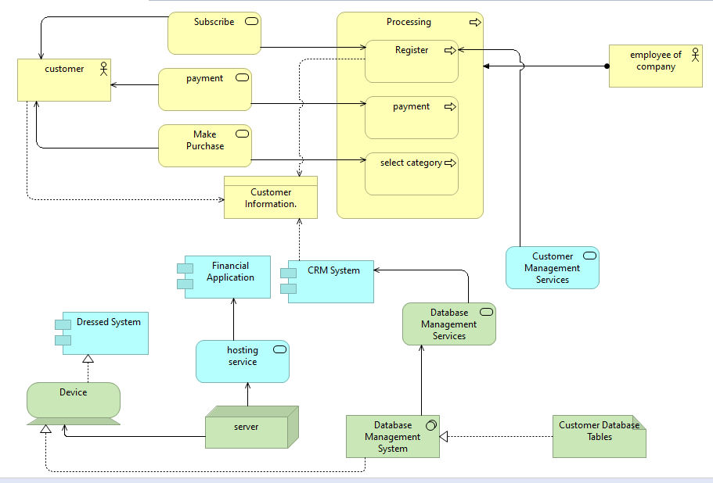

## Question 2: 20 marks

Design architecture diagram for following scenarios using Physical Viewpoint.

Physical Viewpoint is the one which contains equipment (one or more physical machines, tools, materials, or instruments) that can create, use, store move, or transform materials, how the equipment is connected via the distribution network, and what other active elements are assigned to the equipment.

1. The first stage of a typical 2-step Reheat and Blow Machine bottle manufacturing process is injection molding. Plastic pellets are plasticized in the barrel of an injection molding machine where the plastic is melted by heat and the shearing action of a feed screw. The plastic is then injected into multiple-cavity molds where it assumes the shape of long, thin tubes. These tubes, called parisons, usually include the formed necks and threads that will be used to cap the bottles that are yet to come. PET parisons, or [pre-forms,](https://www.thomasnet.com/products/pet-preforms-97008925-1.html) are easily shipped to bottling facilities as they are much more compact than fully formed bottles. During the re-heat process, the parisons are loaded into a feeder and run through an unscrambler, which orients the parisons for feeding into the blow molding machine. The parisons are heated by passing by quartz heaters and then enter the mold. Here, a thin steel rod, called a mandrel, slides into the neck of the parison where it fills the parison with highly pressurized air, and [stretch blow molding](https://www.thomasnet.com/products/stretch-blow-molds-97001198-1.html) begins: as a result of the pressurized air, heat, and pressure, the parison is blown and stretched into the mold axially and radially, where it assumes a bottle shape. This process produces what is called a biaxially oriented bottle which provides a CO2 barrier ideal for containing carbonated beverages.

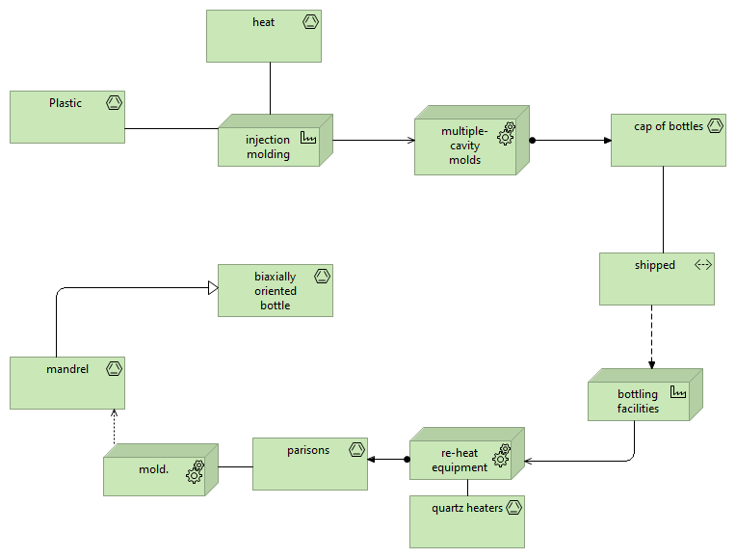

1. Consider a company which requires different raw materials to manufacture plastic, glass or steel. You are hired by Pakistan Steel Mills Corporation Limited, also known as Pak Steels, is a producer of long rolled steel and heavy metal products and entities in the country, to design the production system using the physical elements provided by ArchiMate. Raw materials like coal and iron ore are transported using conveyer belts using Material elements. These raw materials are transported to different factories which can be denoted using Facility element. Different factories include Coke, Pellet, and Sinter factory. These factories processes raw materials into its intermediate product such as cokes and pellets, which is then passed to blast furnace. Blast Furnace turns the mixture into liquid iron which then combines with scrap and oxygen and passed to steel plant where it is converted into steel slabs. These steel slabs are then passed to Hot strip mill where it passes through a roll line using the equipment roll by Process control software system. The finished product steel then comes out from the mill and stored in the warehouse where storage process takes place. Different process is part of the production i.e. processing of raw materials, steel making, casting, rolling and storage.

**SOLUTION:**

While designing the physical viewpoint, I’ve kept few points as my assumptions:

If I talk about the problem statement, it simply taking in some raw products and giving out complete material after some processing.

* I have used “Material” for all materials.
* “Facility” for all processing and storing.
* “Path” for transportation.
* Facility is assign to give out processed materials
* Facility is accessing raw or intermediate products.

So, I’ve applied arrows based on these assumptions of mine. Below is the screenshot attached. Also archi file is submitted.

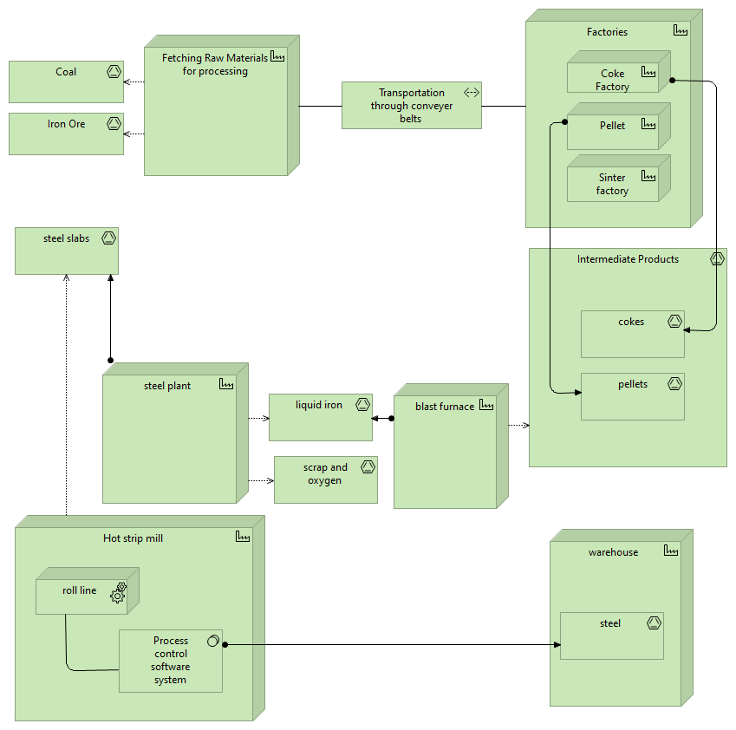

## Question 3: 15 marks

Implement the model of reactive programming. You need to design a database for the company mentioned in Question 1. Given the scenario in Question 1, as it is an online site, it has the responsibility to maintain the information of the articles placed on their site. There should be a class named Article having an id, label, description, vendor and all the getter and setter methods for the database fields. Implement methods, that is, findById, deleteById, create, update in resource class. There will be a class repository which holds extends mongo repository. There will be services like saving the article data, finding article by id, find all and delete. You code should interact with the database and provide output when asked to view all the articles information stored in database. Snippet of output should be submitted as mentioned in the instructions above (each student output should vary from one another).

**Rubrics for Question 3:**

Database ---------- 5 marks

Classes ---------- 10 marks (each class 2.5 marks)

**SOLUTION:**

Code is attached with submission

