

Computer Science Department

**COMP338 Artificial Intelligence**

**Assignment II**

**Problem: Round Table Seating Arrangement**

**Report: Comparison and Analysis of Seating Arrangement Optimization Algorithms**

Prepared By: Sanaa Obied-1211079

Instructor: Dr. Mohammed Helal

Section: 1

Date: 11/6/2024

**Report: Comparison and Analysis of Seating Arrangement Optimization Algorithms**

**Introduction :**

In this report, we will explain and analyze the results of three algorithms used to optimize seating arrangements: Genetic Algorithm (GA), Simulated Annealing (SA), and Hill Climbing (HC). We will explain the results for each algorithm, justify these results, outline the parameters used in each algorithm, and discuss the challenges encountered during the process.

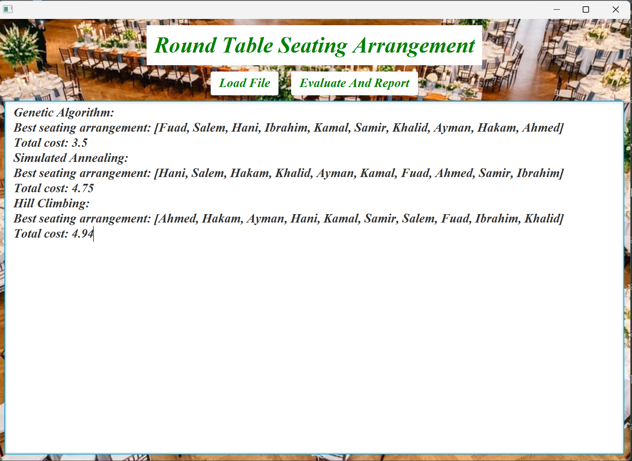

1. **Explanation and Comparison of Results for Each Algorithm:**

**Genetic Algorithm (GA)**

* **Best Seating Arrangement**: [Fuad, Salem, Hani, Ibrahim, Kamal, Samir, Khalid, Ayman, Hakam, Ahmed]
* **Total Cost**: 3.5

**Simulated Annealing (SA)**

* **Best Seating Arrangement**: [Hani, Salem, Hakam, Khalid, Ayman, Kamal, Fuad, Ahmed, Samir, Ibrahim]
* **Total Cost**: 4.75

**Hill Climbing (HC)**

* **Best Seating Arrangement**: [Ahmed, Hakam, Ayman, Hani, Kamal, Samir, Salem, Fuad, Ibrahim, Khalid]
* **Total Cost**: 4.9

**--------------------------------------------------------------------------------------------------------**

**2. Justification of Results**

**Genetic Algorithm**

The Genetic Algorithm produced the best seating arrangement with the lowest total cost (3.5) due to its ability to explore a wide solution space through genetic operations like crossover and mutations. The selection of the top 60% of the population (elitism) helped maintain the quality of solutions and their evolution over generations.

**Simulated Annealing**

Simulated Annealing provided a good arrangement but with a slightly higher total cost (4.75). This algorithm gradually decreases the temperature to temporarily accept worse solutions, aiding in escaping local minima. The higher cost might be due to insufficient exploration of the solution space compared to the Genetic Algorithm.

**Hill Climbing**

Hill Climbing resulted in the least optimal arrangement with the highest total cost (4.9). This algorithm improves solutions sequentially without multiple restarts, making it prone to getting stuck in local optima without mechanisms like mutations or temporary acceptance of worse solutions.

**3.Parameters Used in Each Algorithm:**

**Genetic Algorithm**

* Population Size: 100
* Number of Generations: 1000
* Mutation Rate: 0.1
* Elitism: Top 60% of the population selected

**Simulated Annealing**

* Initial Temperature: 1000
* Cooling Rate: 0.99
* Number of Iterations: 10000

**Hill Climbing**

* Number of Restarts: 100

**--------------------------------------------------------------------------------------------------------**

**4. Challenges Encountered**

**Cost Calculation**

Adjusting the cost calculation method was necessary to consider both directions between adjacent pairs and avoid asymmetry, ensuring accurate cost evaluation.

**Genetic Algorithm**

Managing the population and maintaining genetic diversity across generations was challenging to prevent premature convergence to local optima.

**Simulated Annealing**

Determining the optimal cooling rate was crucial to ensure sufficient exploration of solutions without rapid cooling, which could lead to losing good solutions.

**Hill Climbing**

Hill Climbing faced challenges with getting stuck in local optima due to the lack of mechanisms like mutations or temporary acceptance of worse solutions to explore different solution spaces.

**Conclusion:**

The Genetic Algorithm proved most effective in finding the optimal seating arrangement with the lowest total cost. However, each algorithm has strengths and weaknesses, and the choice of the most suitable algorithm depends on the problem's nature and constraints.

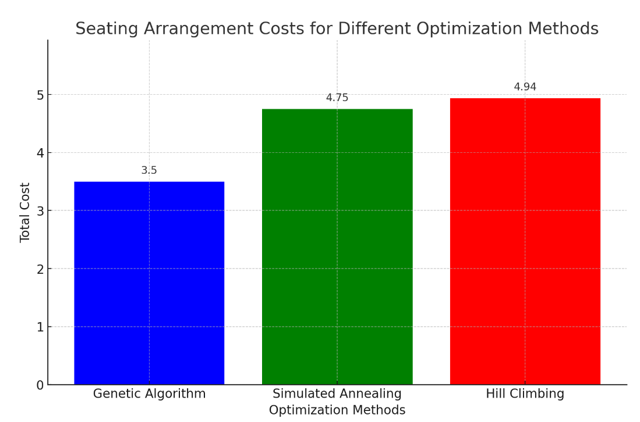

**DONE**