

Computer Science Department

***COMP438 Assignment #1***

Prepared By: Sanaa Obied-1211079

Instructor: Dr. Abdallah Karakra

Date: 30/11/2023

***Part A:***

***In an increasingly interconnected digital world, online security and privacy have become paramount concerns for users. When browsing the web, you may have encountered SSL (Secure Sockets Layer) warnings—those messages that pop up in your web browser, often making you pause and wonder about their meaning and implications. This assignment delves into the realm of usable security and privacy, challenging you to analyze and understand these SSL warnings . As a starting point, please examine the provided SSL warning figure below. Then, answer the following series of questions and scenarios. We aim to assess your ability to interpret these messages.***

***1-What do you think that message means?***

***Answer: It suggests that the connection may not be secure, potentially exposing your data to unauthorized access.***

***2-What do you think the risks are if you see an error like this?***

***Answer: This could lead to unauthorized access to sensitive information such as login credentials, personal details.***

***3-What would you do if you got this error?***

***Answer: If I encounter this error, I would refrain from entering any sensitive information on the website and avoid proceeding further.***

***4-Do you know what that means when it says someone is tampering with the connection?***

***Answer: When the message mentions someone tampering with the connection, it occurs when a third party intercepts and potentially alters the communication between two parties without their knowledge.***

***5-*** ***If the site is your bank account, what you do?***

***Answer: If the site in question is related to my bank account, I would absolutely not proceed and refrain from entering any sensitive information. I would contact my bank's support immediately to report the issue.***

***6-*** ***Design a usable user interface for this warning***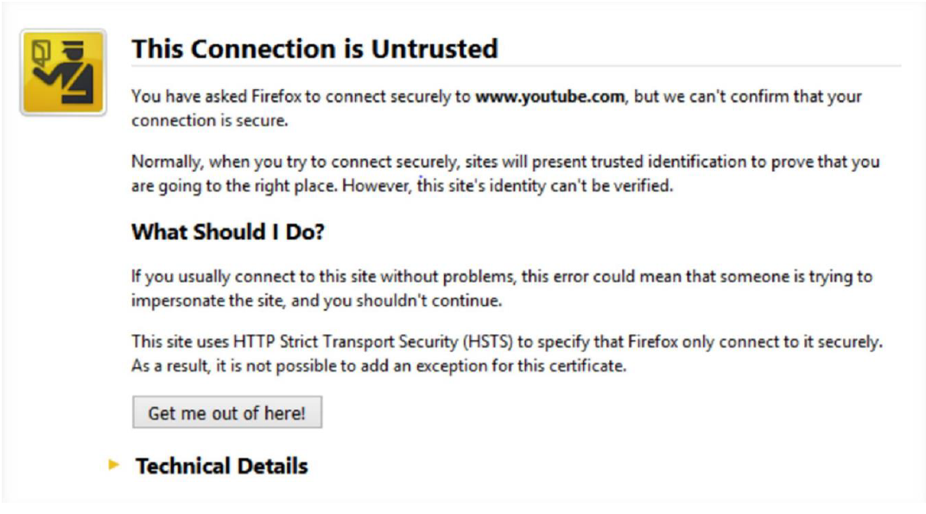

***Part B:***

1. ***Find one more warning message other than the one provided in this question and, in two lines, explain why you think that this warning message is not usable (difficult for users to understand or deal with). Your answer must be related to the material you have learned in this course.***

***Answer :***

***Due to the excessive amount of information, the warning should be crafted to be understandable by anyone, featuring a visually appealing and clear design for enhanced comprehension and user engagement.***

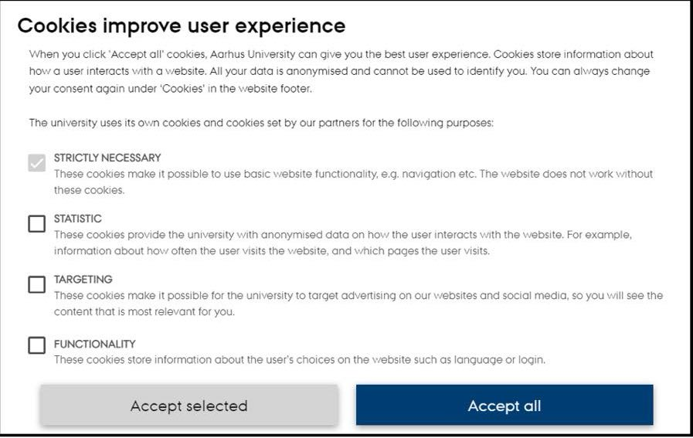

***References:***<https://cookie-script.com/documentation/cookie-banner?fbclid=IwAR3mW1Opbu1pOaZpbpDXRWK4DnETdzh4Ly7xt7Y3FyLnMK80q78nI31WGDo>

1. ***Design a usable user interface for this warning?***

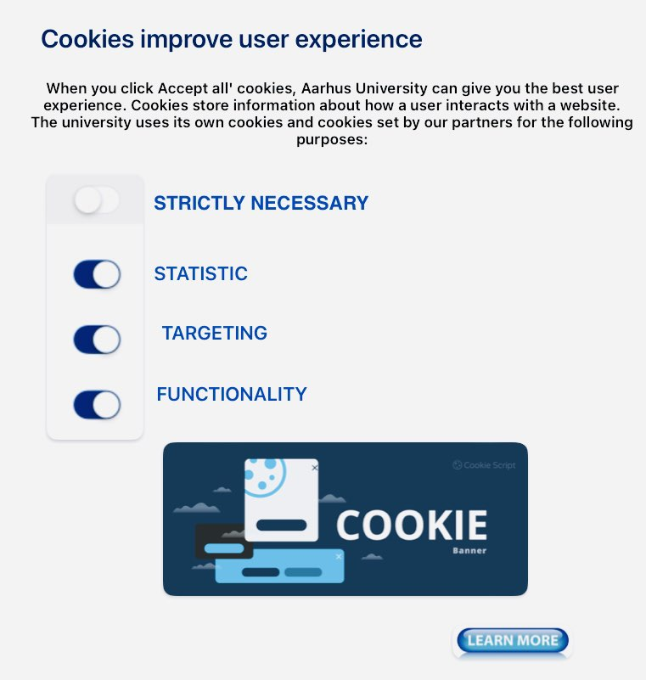

-------------------------------------------------------------------------------------------------

***DONE***