Jail Management System

by

Member 1 [Sanaan Azfar 22I-2594 ]
Member 2 [Muhammad Hassan ]
Member 3 [Saif Ur Rehman]

Data-Base Project
Iteration 1

Submitted to [Ma’am Laiba Imran]
Date: 15/November/2024

Table of Contents
Entity Relationship Diagram: 3
Explanation: 3
Relational Models: 6
User(User_id,User_type,User_name,Email,Password) 6
Event(Event_id, Description, Location, Email, Title, Start_Date, End_Date, Category) 6
Report(Report_id,Report_type, Details, Generated_Date) 6
BookingTable(Booking_id, Ticket_id, Event_id, User_id) 6
Provided_ServicesTable( Services_id, Event_id, User_id) 6
AttendsTable(FeedBack_id, Event_id, User_id) 6
OrganizerTable(Profile_id, Event_id, User_id) 6
Event_ReportTable(Event_ReportTable_id,Report_id, Event_id) 6
Ticket_ReportTable(Ticket_ReportTable_id,Report_id, Ticket_id) 6
User_ReportTable(User_ReportTable_id,Report_id, Ticket_id) 6
Atendee_ReportTable(Atendee_ReportTable_id,Report_id, User_id) 6
Ticket(Ticket_id, Price, Ticket_type, Event_id, User_id ) 6
Services(Services_id, Equipment, Service_type, Staff, Event_id, User_id) 6
Profile(Profile_id, Services, Business_type, Profile_type, Event_id, User_id) 6
Feed_Back(FeedBack_id, comments ,rating ,Event_id, User_id) 6
Github: 6

Entity Relationship Diagram:
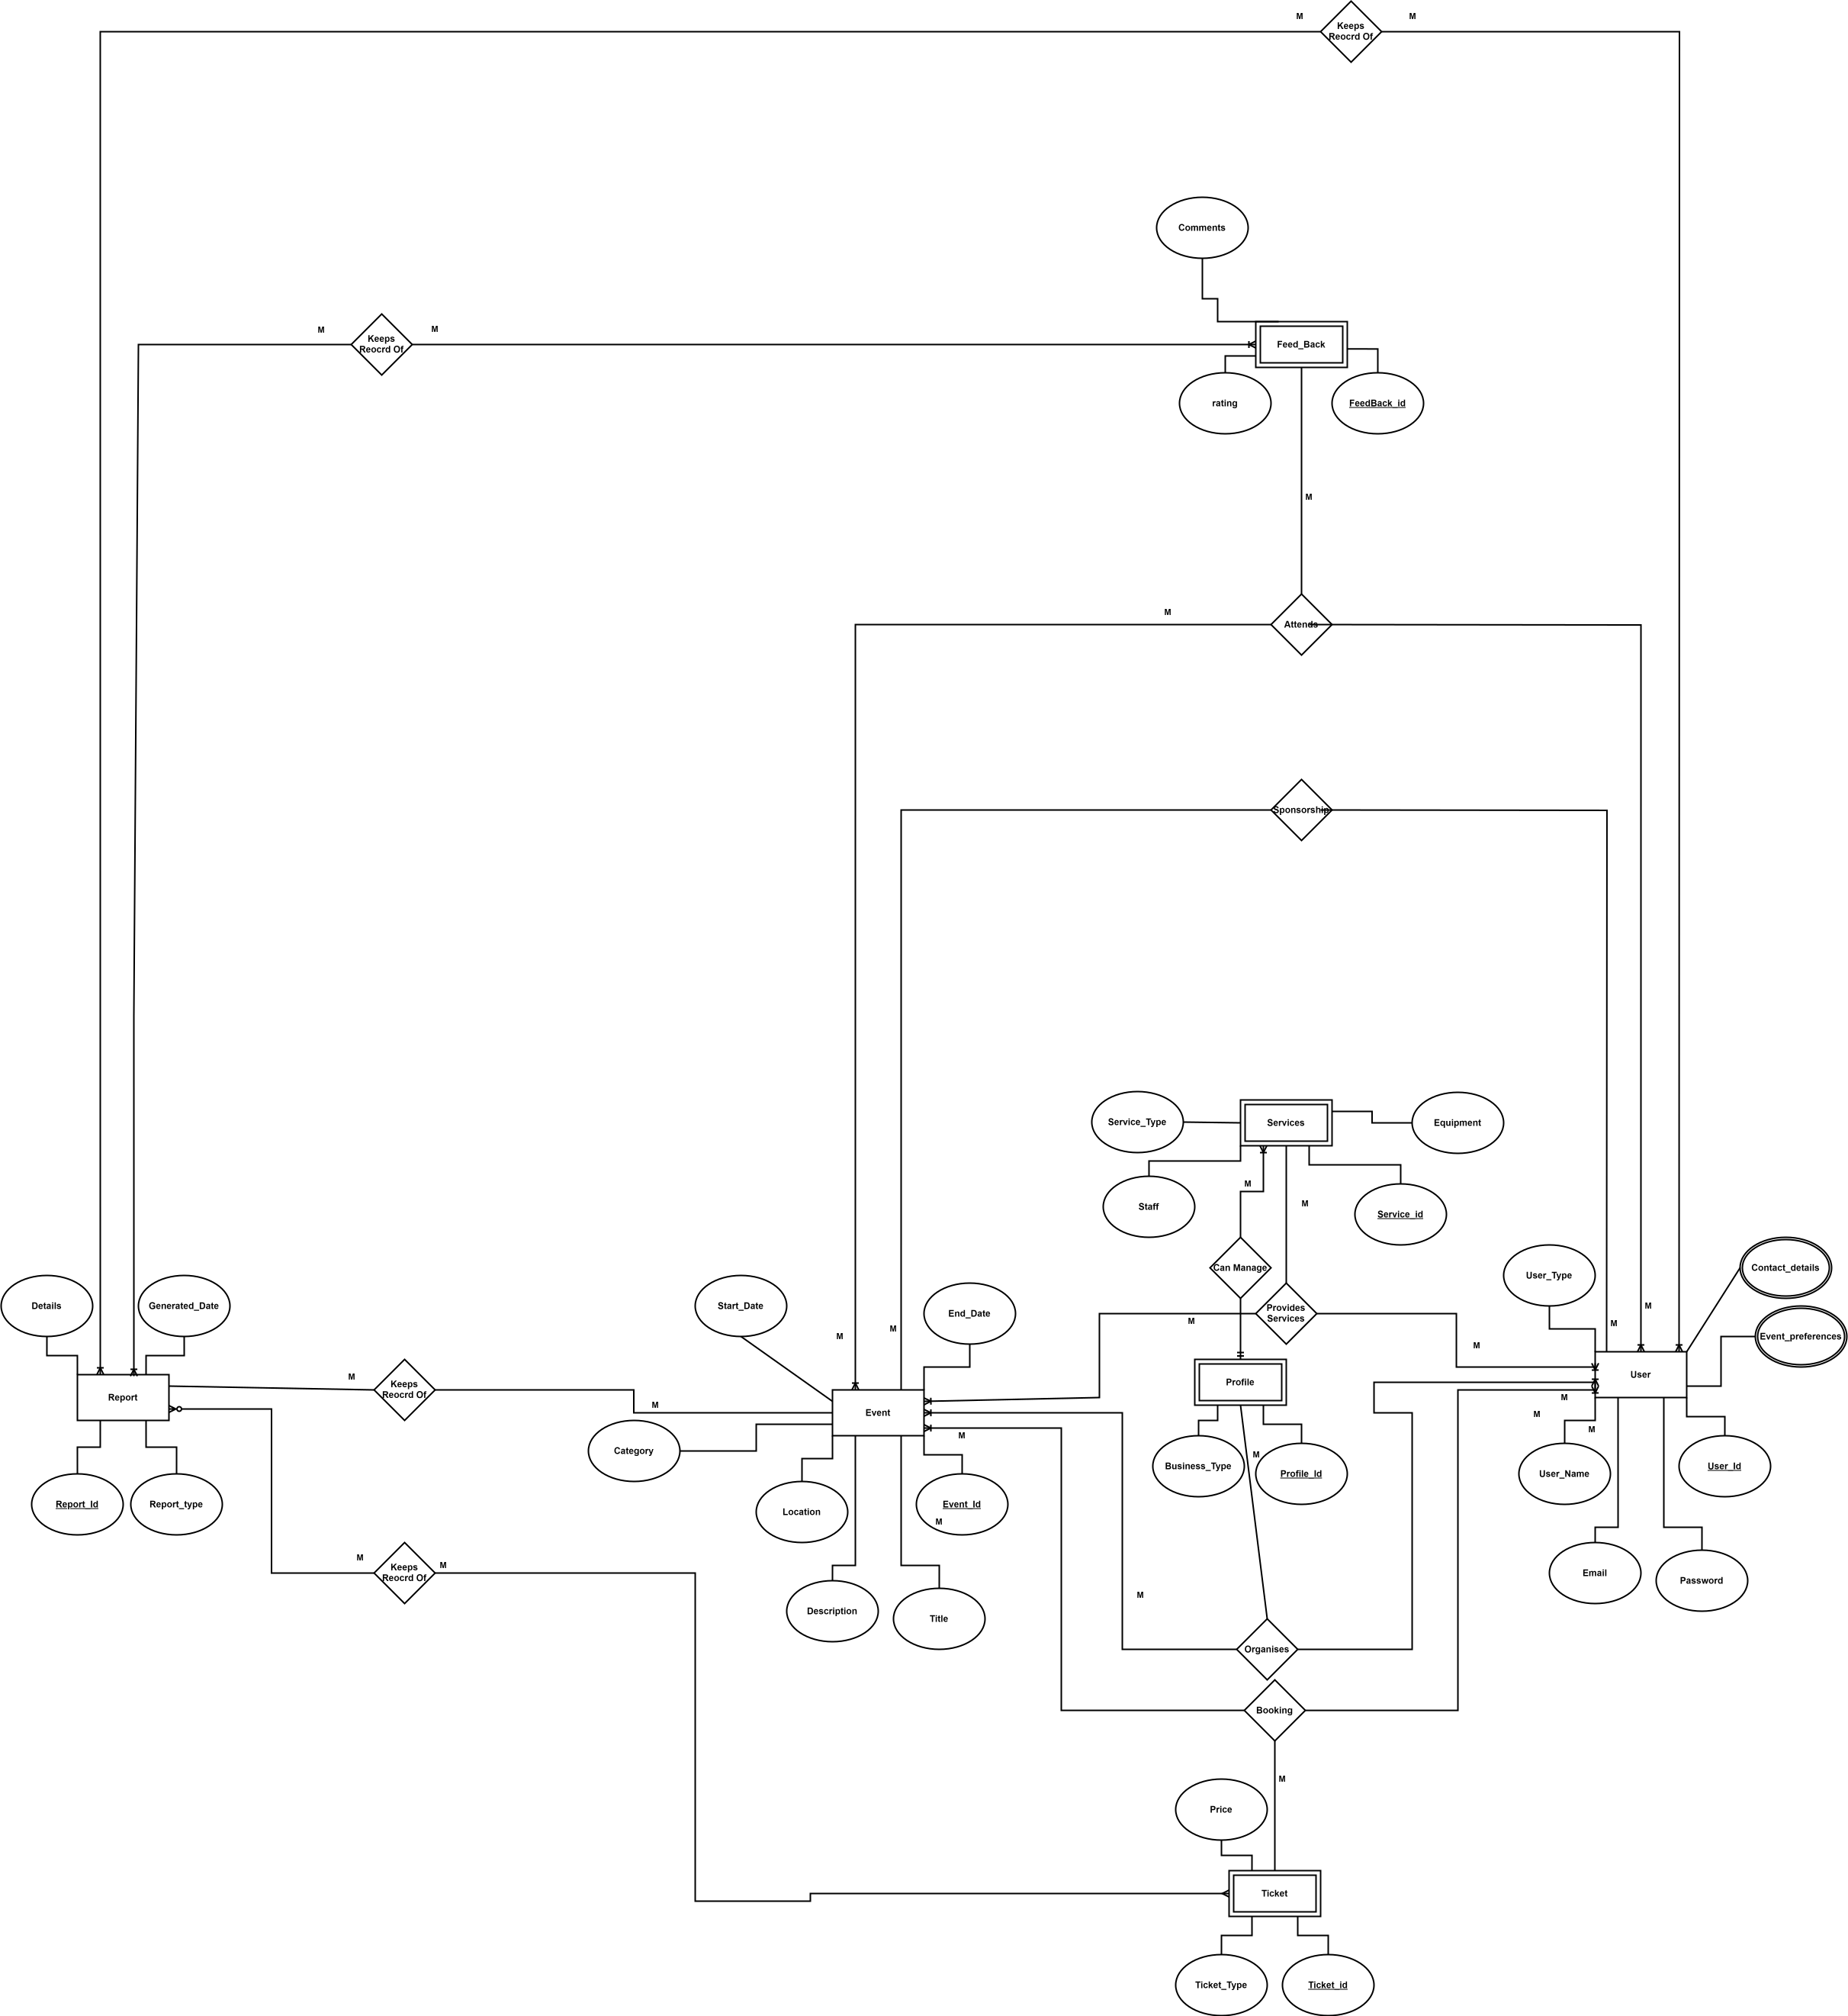

Explanation:
User:
  - Main attributes: User_id, Name, Email, Password, and User_Type.
  - Multi-Variable attributes: Contact_Details and User_Preferences.
  - Relationships:
    - One User can have Many Event Tickets, and Can Attend Many Events .
    - Multiple Reports can Be Generated on one attendee.
    - Many User having type organizers, may Organize Many Events.
    - Many User having type vendors, may give services to Many Events.
    - Many User having type sponsor, may Sponsor Many Events
    - Many User having type attendee, may attend Many Events
    - Many User having type attendee, may Book many tickets for Many Events
- Event:
  - Main attributes: Event_id, Title, Description, Start_Date, End_Date, Location, and Category.
  - Relationships:
    - Many , at minimum one, Event(s) may have one or many organizers.
    - Many , at minimum one, Event(s) may have be provided services by one or many Users as vendors.
    - Many , at minimum one, Event(s) may have be sponsored by one or many Users as Sponsors.
    - Many , at minimum one, Event(s) may have be attended by one or many Users as attendees.
    - Many , at minimum one, Event(s) may have be attended by one or many Users as attendees.
    - Many , at minimum one, Event(s) may have one or many reports Written on it.

- Ticket:
  - Main attributes: Ticket_id, Ticket_Type, and Price.
  - Relationships:
    - A User may Book Many Tickets for Many Events.
    - Many Reports may be made on ticket sales

- Report:
  - Main attributes: Report_id, Date, and Content_Links.
  - Relationships:
    - Many Reports may be made on many attendee user.
    - Many Reports may be made on many ticket sales.
    - Many Reports may be made on multiple User Feedback.
    - Many Reports may be made on multiple Events

- Feedback:
  - Main attributes: Feedback_id, Comments, and Rating.
  - Relationships:
    - many users will submit feedback.
    - ​Multiple feedback is submitted for may events

- Service:
  - Main attributes: Service_id, Service_Type, and Equipment.
  - Relationships:
    - ​Many Events may hire a vendor for services
    - A User of type vendor may provide many services .

- Profile:
◦ Main attributes: Profile_id, Business_Type, and Email.
◦ Relationships:
  - A Profile can be can manage multiple Services.
  - An Organizer can use one profile to manage multiple Events.

Relational Models:

User(User_id,User_type,User_name,Email,Password)

Event(Event_id, Description, Location, Email, Title, Start_Date, End_Date, Category)

Report(Report_id,Report_type, Details, Generated_Date)

BookingTable(Booking_id, Ticket_id, Event_id, User_id)

Provided_ServicesTable( Services_id, Event_id, User_id)

AttendsTable(FeedBack_id, Event_id, User_id)

OrganizerTable(Profile_id, Event_id, User_id)

Event_ReportTable(Event_ReportTable_id,Report_id, Event_id)

Ticket_ReportTable(Ticket_ReportTable_id,Report_id, Ticket_id)

User_ReportTable(User_ReportTable_id,Report_id, Ticket_id)

Atendee_ReportTable(Atendee_ReportTable_id,Report_id, User_id)

Ticket(Ticket_id, Price, Ticket_type, Event_id, User_id )

Services(Services_id, Equipment, Service_type, Staff, Event_id, User_id)

Profile(Profile_id, Services, Business_type, Profile_type, Event_id, User_id)

Feed_Back(FeedBack_id, comments ,rating ,Event_id, User_id)

Github:
https://github.com/SanaanAzfar/I222594_B_Project.git

