

Experiment NO#6

**STEP RESPONSE ANALYSIS**

**Name: Sanabel Maali.**

**ID: 202010484.**

***Objective:***

* 1. Examine the behavior of first-order and second-order circuits in response to a step input.
  2. Examine the step-response in RLC circuit.
  3. Solving 1st and 2nd order differential equations to derive responses in various cases.

***Experiment Procedure:***

***Part One: Pulse response of first-order circuit***

**1.Connect the circuit shown below.**

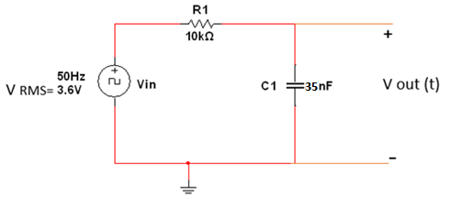

2.Set the function generator to produce a square wave with a frequency of 50 Hz, no DC offset and RMS voltage of 3.6 V.

3.Set the oscilloscope to display the waveform VOUT (t) produced by this circuit.

4.Measure the circuit time constant τ charging and τ discharging.

5.Change R1 to 15 KΩ and 27 KΩ, then measure time constant τ charging and τ discharging in each case.

7.Tabulate your result in the Table (1):

**Table 1:**

|  |  |  |  |  |
| --- | --- | --- | --- | --- |
| **R1** | **τ charging**  **(By MULTISIM)** | **τ charging**  **(Measured in lab)** | **τ discharging**  **(By MULTISIM)** | **τ discharging**  **(Measured in lab)** |
| **10kΩ** | 500us | 479.564us | -490.323us | -479.564us |
| **15 kΩ** | 532.71us | 540.21us | -538.71us | -540.21us |
| **27 kΩ** |  | 946.657us | 959.677us | -946.657us |

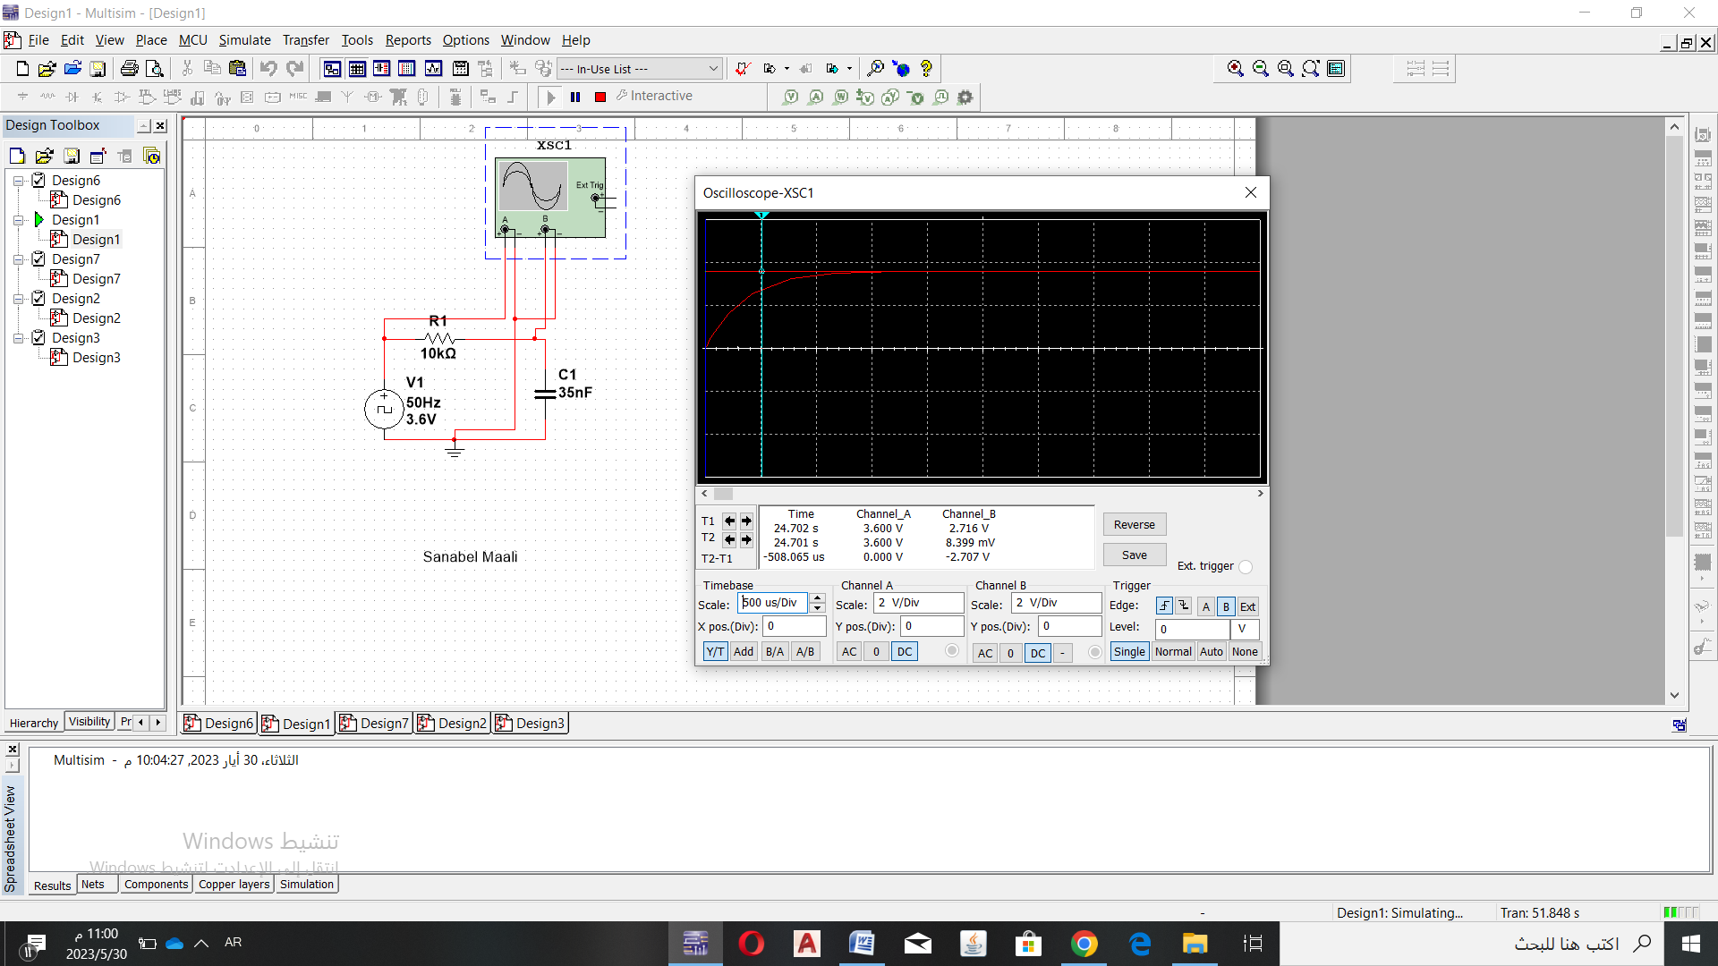

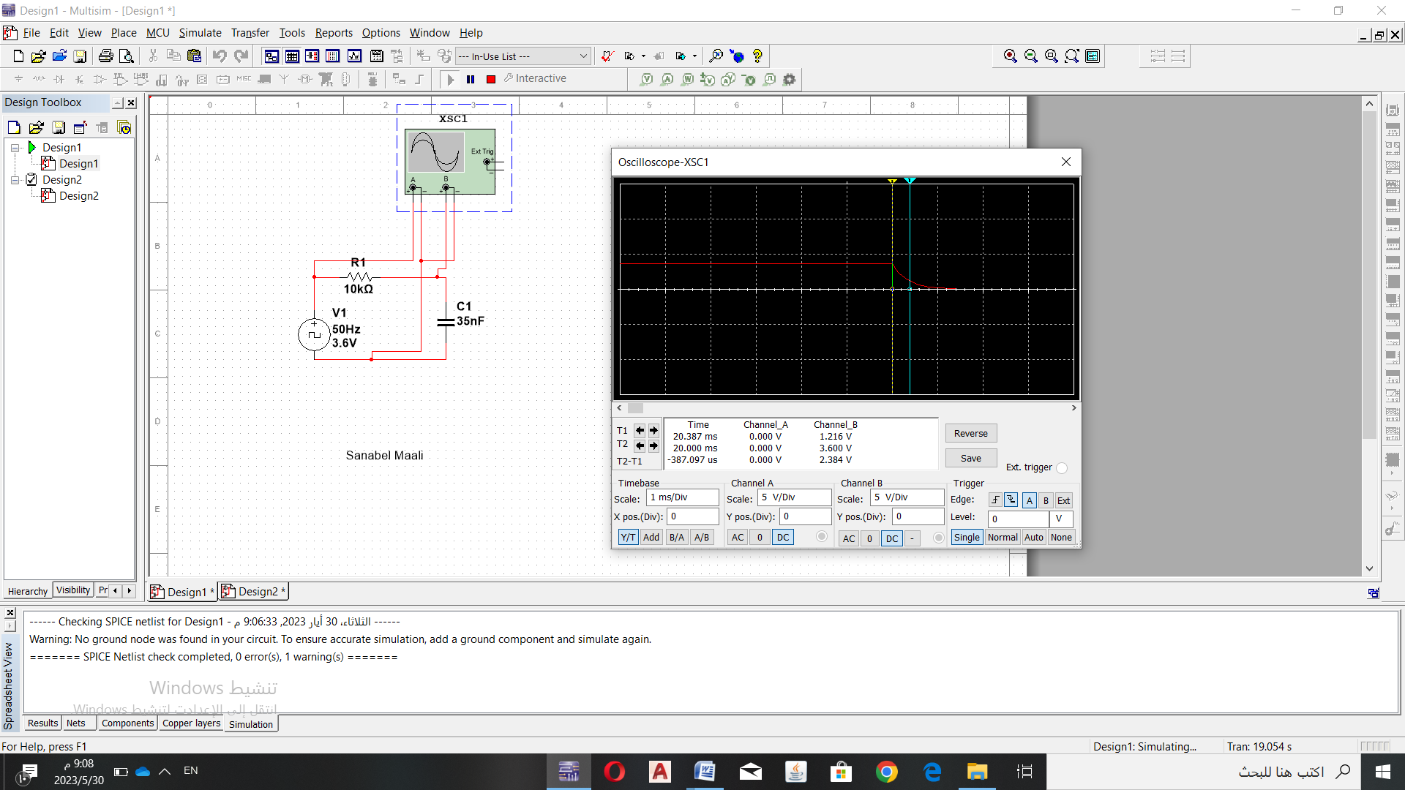

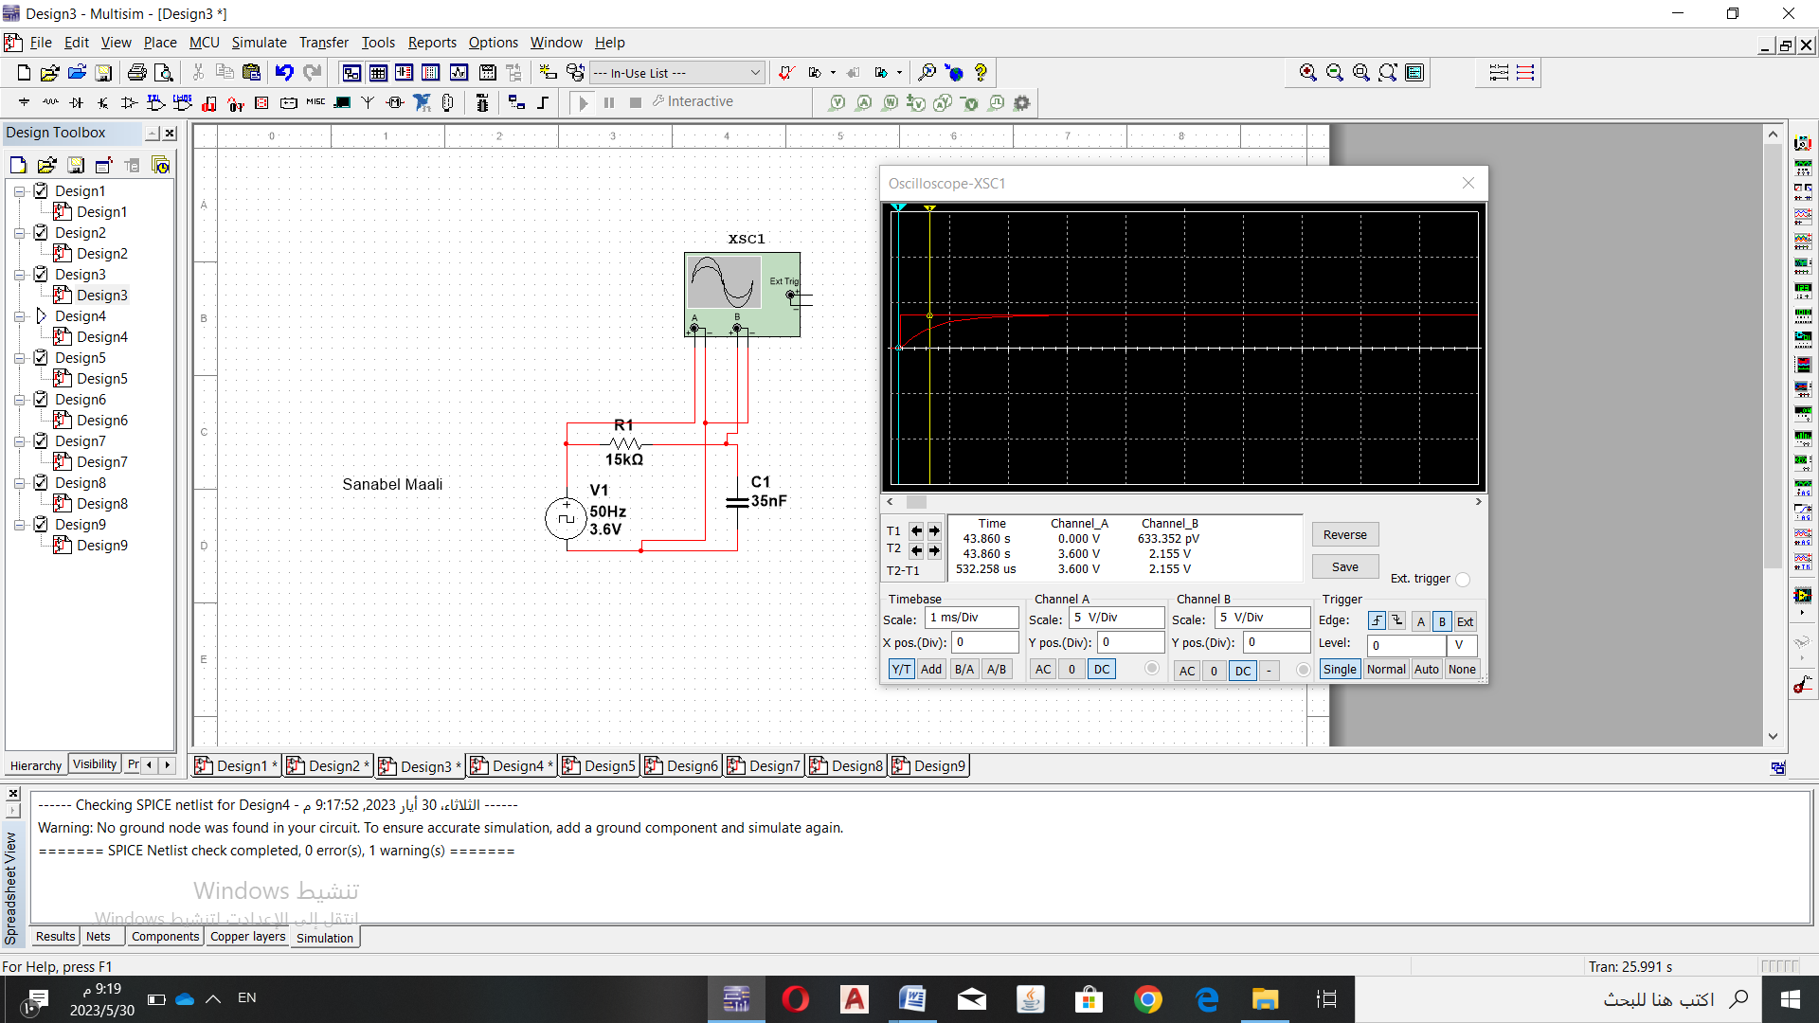

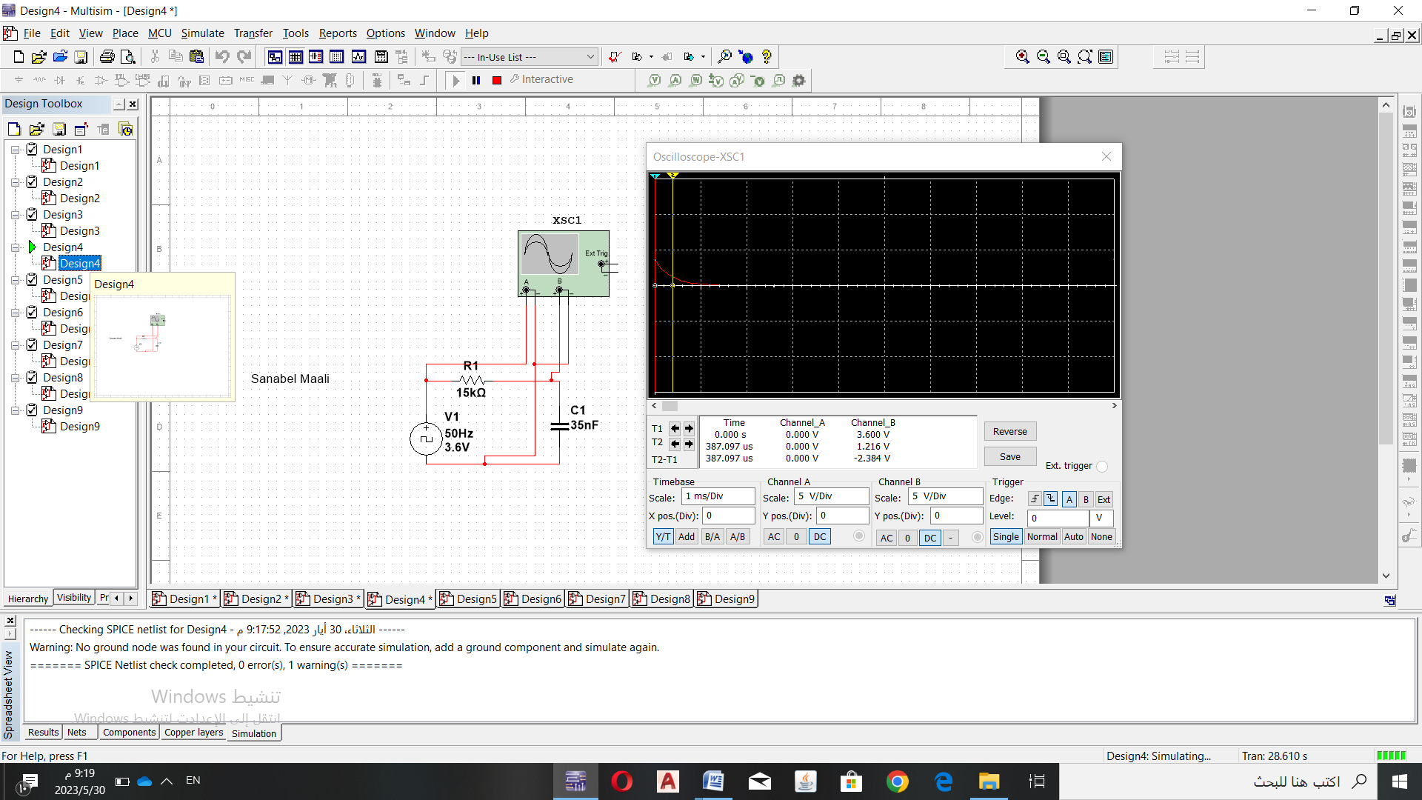

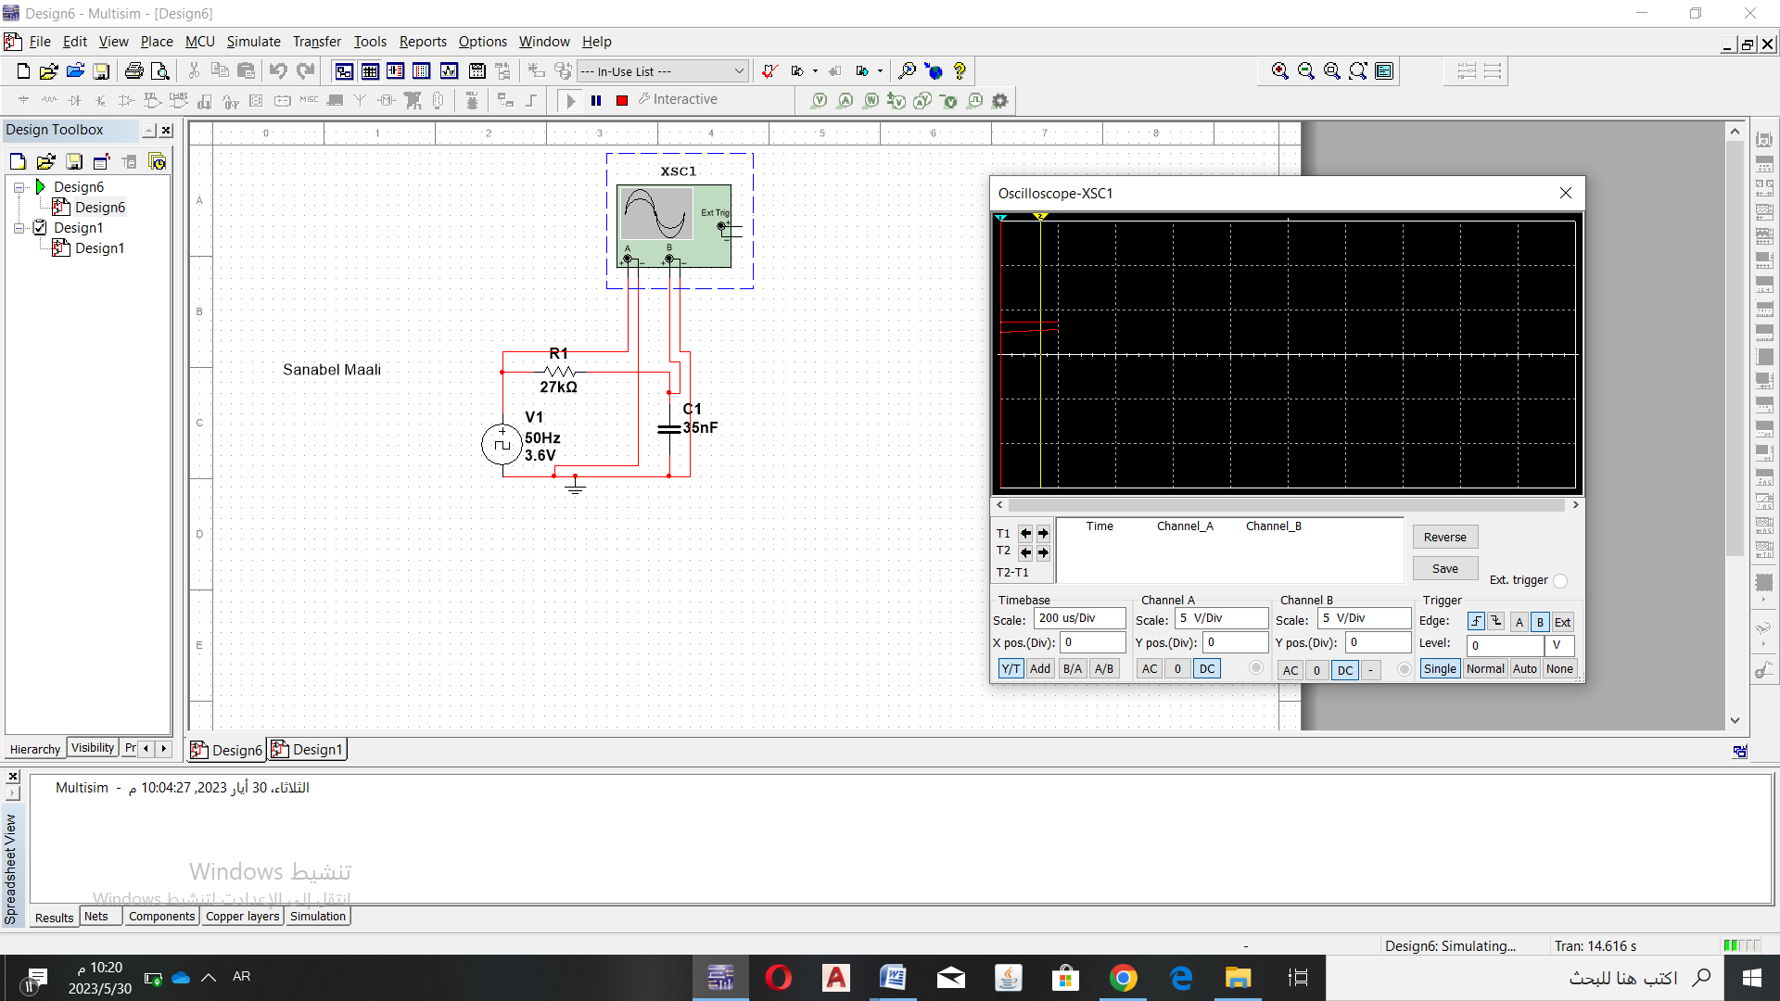

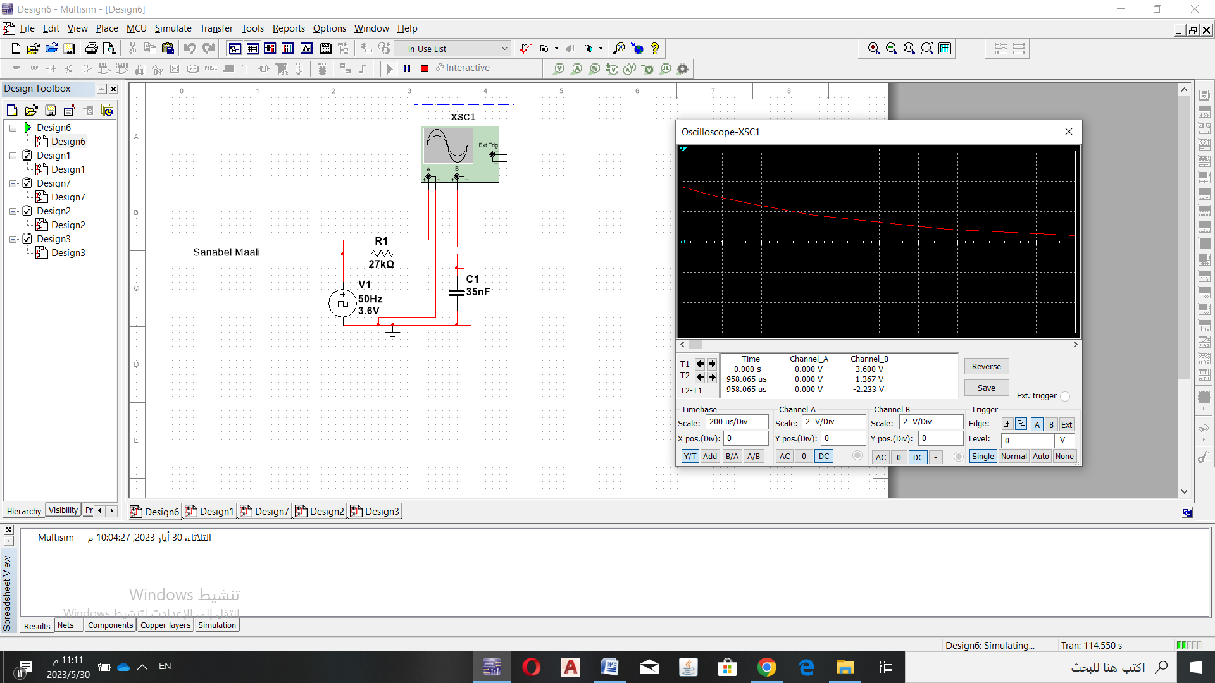

**7. Discuss the result in table 1 and support your answer by drawing VOUT (t).**

***Part Two: Pulse response of second-order circuit***

1. **Connect the circuit shown below.**

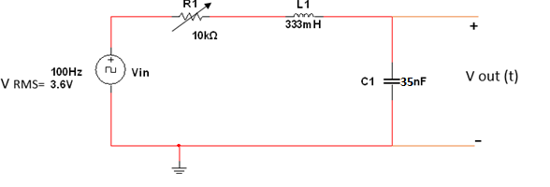

1. **Set the function generator to 100Hz square wave output, 3.6 V RMS.**
2. **Connect the oscilloscope across the capacitor and turn on the function generator. Vary the variable resistor over its entire range and note how the output waveform Vout(t) varies.**
3. **For each of the following cases, draw an accurate sketch of the resulting output waveform:**

* **Case A: Set the variable resistor to its maximum (10kΩ) and measure its value. Sketch Vout(t) as displayed by the oscilloscope. Measure the decay time constant (τ charging):**

**1.Vout(t) as displayed by the oscilloscope:**

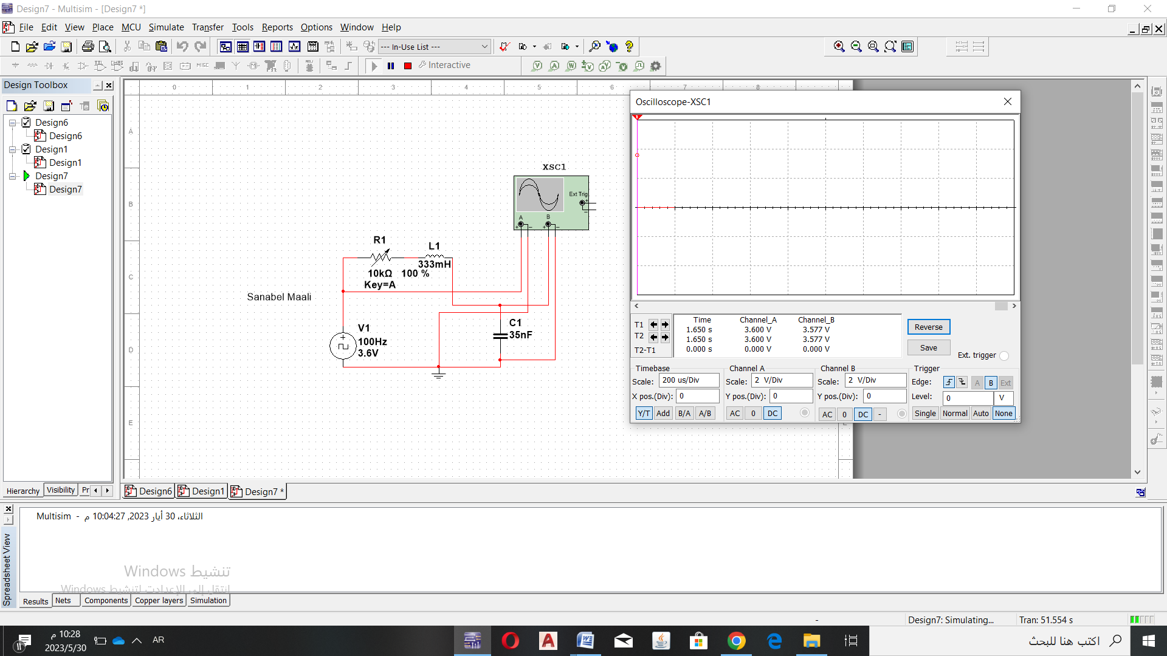

**2.τ (charging) using Multisim :351.413us**

**1.Sketch Vout(t) as displayed by the oscilloscope**:

**2.Measure the decay time constant (τ charging):**

**Case B: Set the variable resistor so that the output waveform is in the critically damped case. Measure the value of R1 and then Sketch Vout(t) as displayed by the oscilloscope.**

***R*critical = = = 6.0090kΩ**

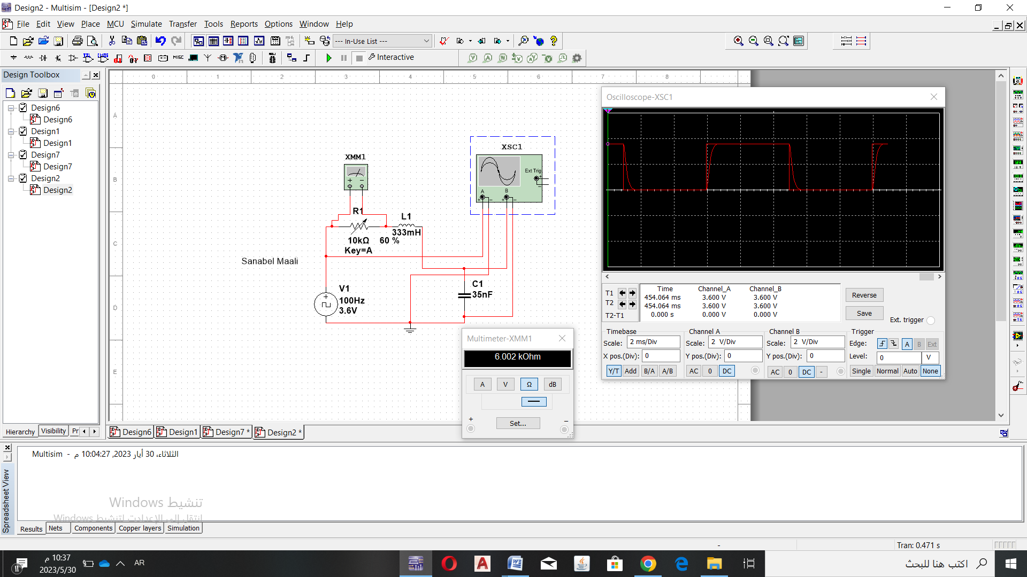

**Case C: Remove the variable resistor from the circuit and replace it by a wire. Sketch Vout(t) as displayed by the oscilloscope. Measure the damped frequency (*fd*).**

**f = = = 1427.460049Hz.**

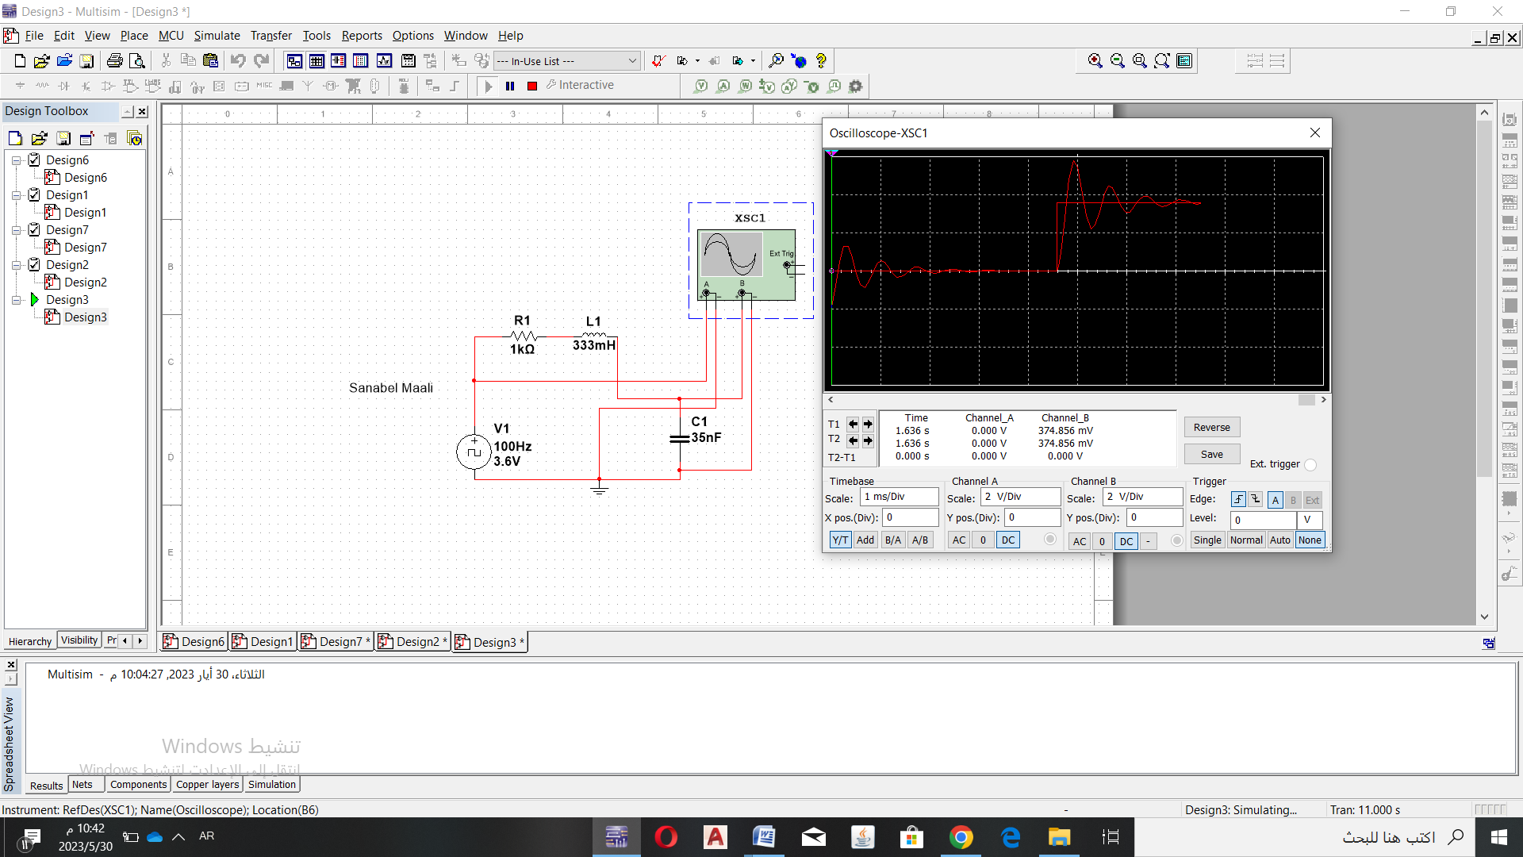

***Conclusion and Analysis:***

1. Compare measured values to analytical values obtained by MULTISIM program
2. Write down a comprehensive conclusion to sum up what you have learnt today