Pymaceuticals Report

# Review

This document is a report of a basic analysis on the effects of a series of drugs on tumors. Included in this "Review section are the main statistics on the study.

## Basic Summary Table

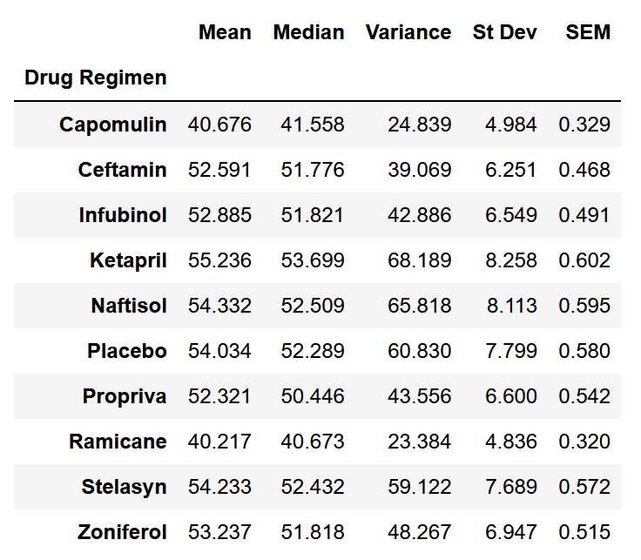

*Figure set 1.a

## No. of Measurements for Each Drug Regimen

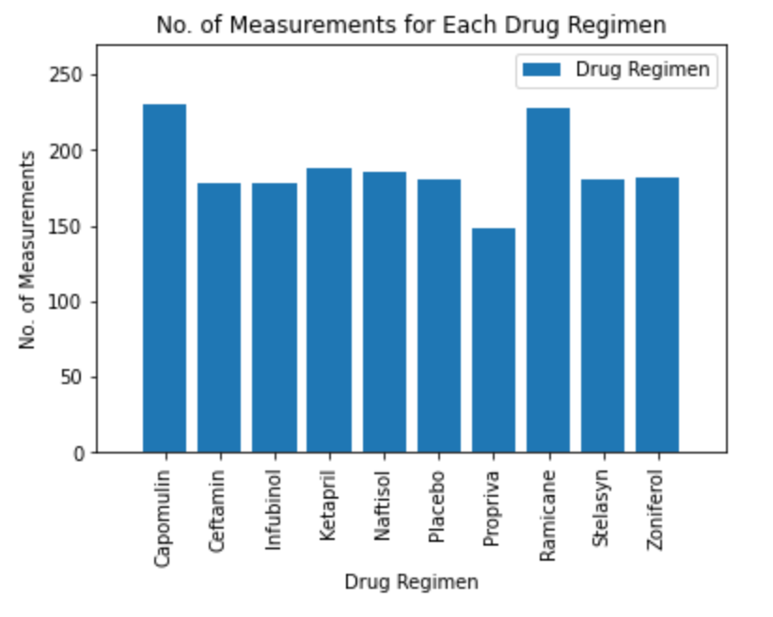

*Figure 2.a

## Gender Distribution of Mice

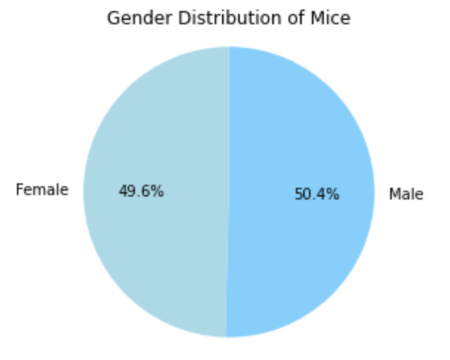

*Figure 3.a

## Quartile/Outlier Review for Final Tumor Volumes for Top 4 Promising Drugs

Capomulin

--------------------------------

Lower Quartile: 32.377

Upper Quartile: 40.159

IQR: 7.782

Lower Bound: 20.705

Upper Bound: 51.832

No outliers for Capomulin

Ramicane

--------------------------------

Lower Quartile: 31.560

Upper Quartile: 40.659

IQR: 9.099

Lower Bound: 20.705

Upper Bound: 54.307

No outliers for Ramicane

Infubinol

--------------------------------

Lower Quartile: 54.049

Upper Quartile: 65.526

IQR: 11.477

Lower Bound: 20.705

Upper Bound: 82.741

Outliers present for Infubinol

Mouse ID Final Tumor Volume

15 c326 36.321346

Ceftamin

--------------------------------

Lower Quartile: 48.722

Upper Quartile: 64.300

IQR: 15.578

Lower Bound: 25.355

Upper Bound: 87.666

No outliers for Ceftamin

*Dataset 5.a

## Visual Outlier and Distribution Study of Drug Effect on Final Tumor Size by Boxplot

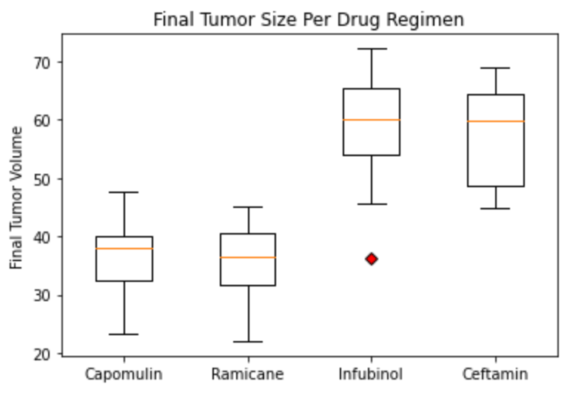

*Figure 6.a

## Studies of Tumor Volume over Time for Capomulin

|  |  |
| --- | --- |
| *Figure 7.a | *Figure 7.b |
| *Figure 7.c | *Figure 7.d |

## Mouse Weight and Average Tumor Volume Study

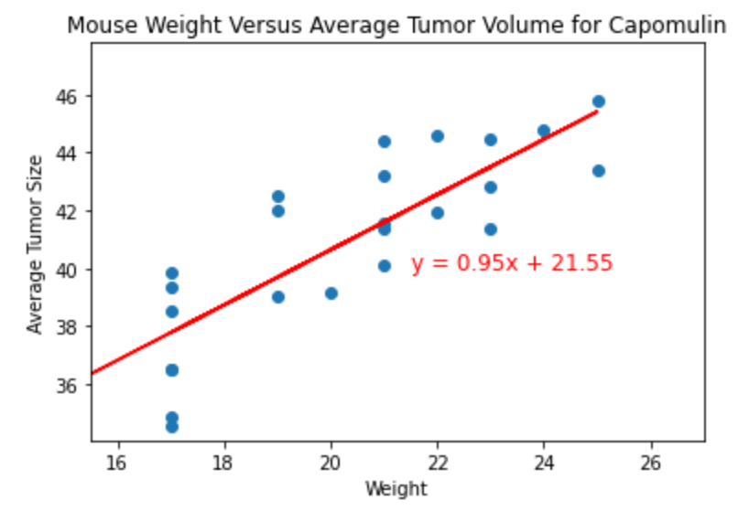

*Figure 8.a

The correlation between Mouse Weight and Average Tumor Volume for Capomulin is: 0.84.

# Conclusions

## Conclusion 1

Reviewing the final tumor volumes of mice under the top four promising drugs(*Figure 6.a), mice under Infubinol had the highest measures of final tumor volumes, while Capomulin and Ramicane had results similar between each other at the lowest tumor volumes, with Ramicane's median measure at the lowest out of all four drugs. This implies that Capomulin and Ramicane may be effective at treating tumorous cells and are possibly the treatments to proceed to production.

#### Recommended Follow Up

* Proceed with testing on larger sample sizes to further validate the current results

## Conclusion 2

Mice under Capomulin treatment show an overall decrease in tumor volume over time, consistently across almost all samples (*Figure 7.a-d). On top of Conclusion 1, this further implies that Capomulin may have an effect of reduced tumor size and may be an effective treatment for tumorous growths.

#### Recommended Follow Up

* Continue study of the same mice over longer periods of time
* Compare tumor growth between the specimen under Capomulin and a control specimen set

## Conclusion 3

Mice under Capomulin showed a strong correlation between a mouse's weight and the size of its tumor at a correlation coefficient of 0.84 (*Figure 8.a). This further supports other studies that obesity can lead to higher growth rates within tumors.

#### Recommended Follow Up

* Study the correlation of weight and tumor size of mice under the other drug regimens, to better determine if this correlation is not an effect of Capomulin