Heroes of Pymoli Report

# Review

This is a report on a basic analysis on the player base on *Heroes of Pymoli*. Included are comprehensive statistics within various demographic slices (gender, age) as well as information on the players that have spent the most and items that have the most transactions and see the most revenue.

## Results

### Total Players

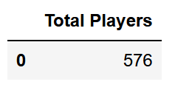

Purchasing Analysis (Total)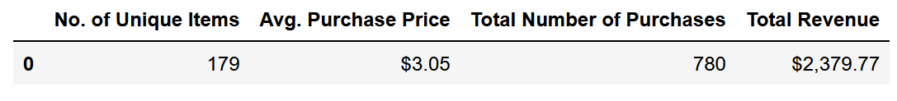

### Gender Demographics

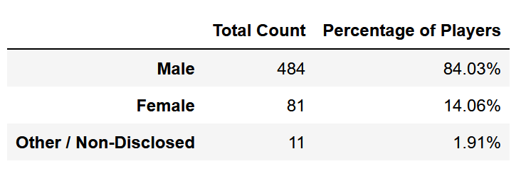

### Purchasing Analysis (Gender)

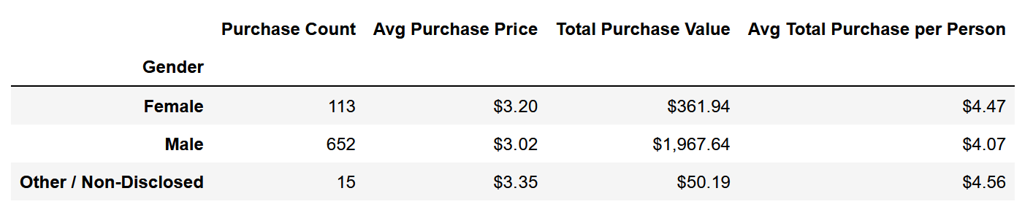

### Age Demographics

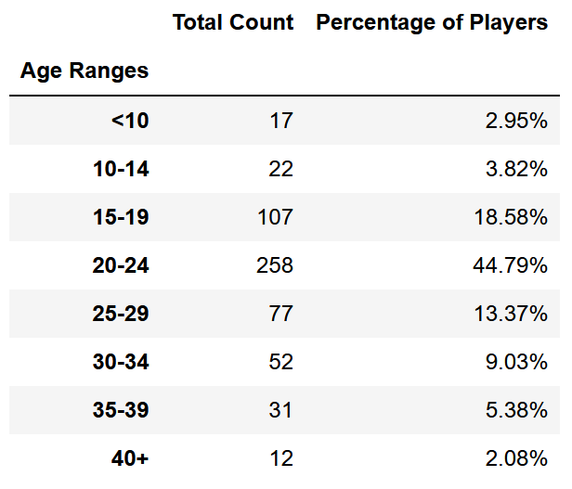

### Purchasing Analysis (Age)

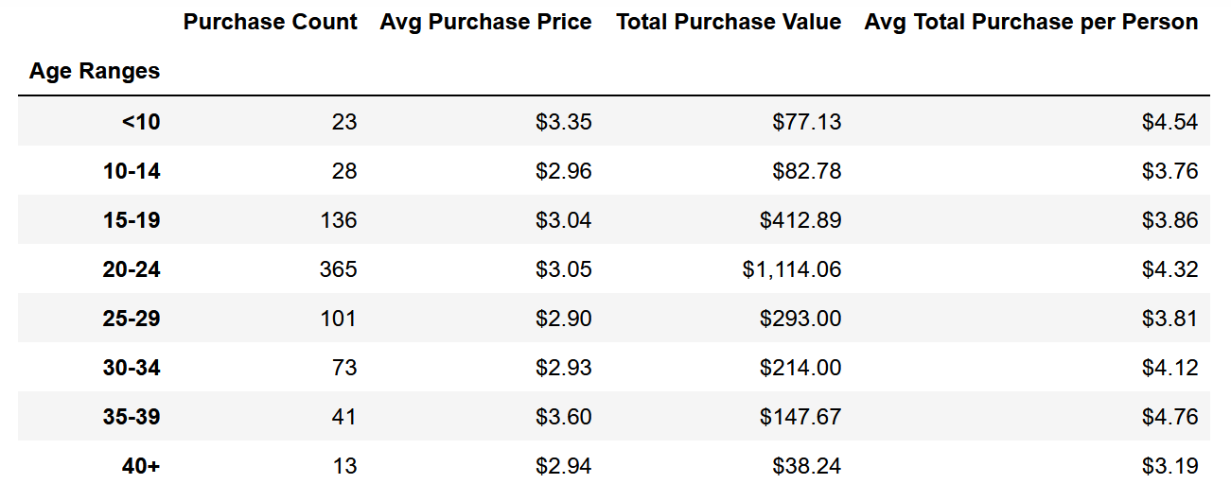

### Top Spenders

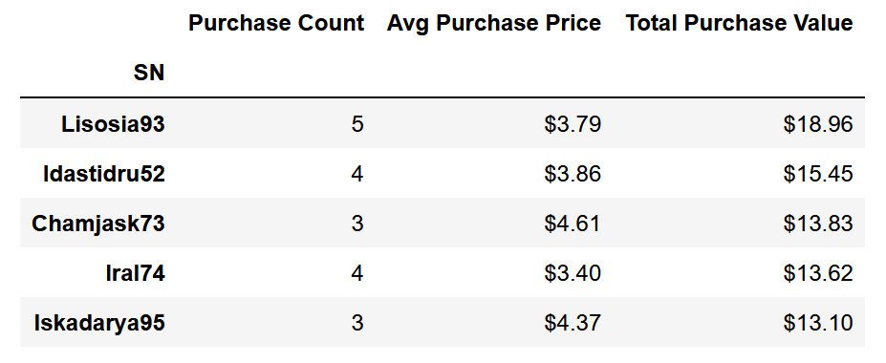

### Most Popular Items

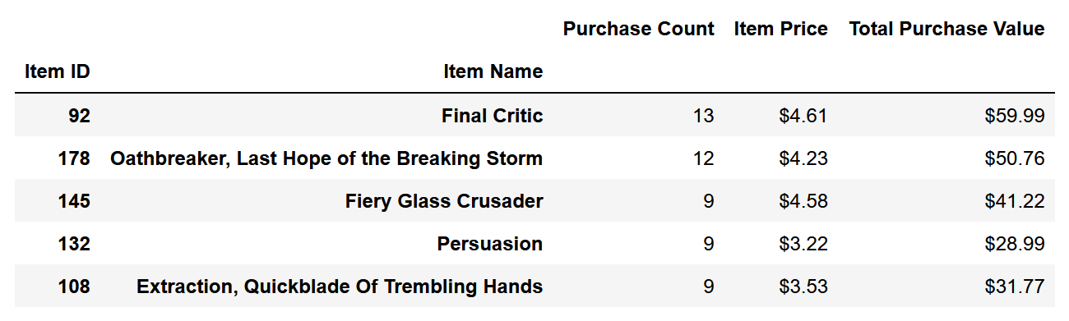

### Most Profitable Items

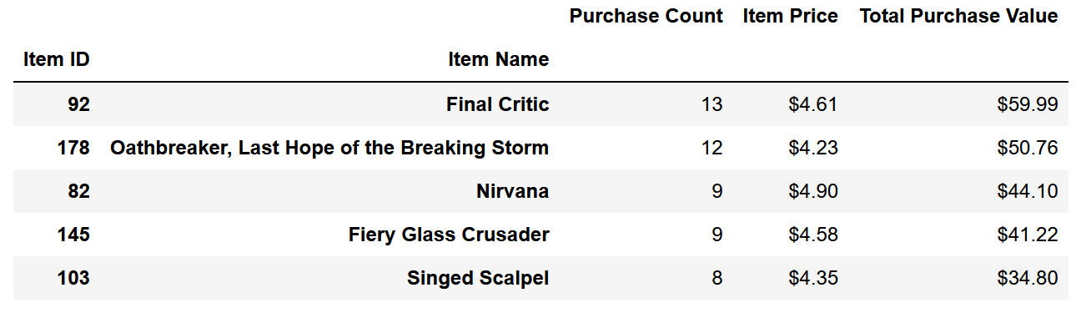

# Conclusions

## Conclusion 1

In the "Purchasing Analysis (Gender)" chart, the Females and Other demographics show a higher average purchase than the male demographic. This implies that these demographics will generate more revenue over time than the male demographic if these populations are increased.

#### Recommended Action Items

* Analyze if female/other demographic in general shows higher compensation as normal behavior across most of the demographic or if the average is skewed by whales. If the behavior is normal across the demographic, recommend a focus in character design and marketing toward female audiences to grow the player base of this demographic.
* Determine what items these demographics are purchasing and focus design and in-game events around these items.

## Conclusion 2

While there is no significant difference between the age group's average total spending, there is a significant dropoff in the player baase from Age Range "20-24" to "25-29". This implies the possibility of either:

1. An absolute age that all players decide to stop playing (approximate guess of age 23 ~ 26)
2. A retention duration across players, where players stop playing after the same amount of time from when they began

#### Recommended Action Items

* To determine whether of the above possibilities is plausible:  
  1: Analyze from account creation and KPIs whether there is a consistent retention duration among players  
  2: Analyze player age on account creation against that player's age when KPI entries become infrequent/stop  
    
  Shift design/marketing strategies depending on the results of this analysis

## Conclusion 3

In "Most Profitable Items", the most popular item is Final Critic, followed closely by Oathbreaker. On the same chart, it can be observed that all 5 item prices are not significantly different from each other. This implies the possibilities that:

1. A meta has developed amongst players where these items are required for the highest-level play
2. An unknown social media buzz/chatter about these items

#### Recommended Action Items

To determine whether of the above possibilities is plausible:

1. Ensure the number of Purchases had not been affected by flash sales by reviewing historical flash sale contents
2. Review social media hash tags on the game for either of the top 2 popular items to see if any factors other than gameplay are affecting item purchase decisions.

Upon determining these two effects are not taking place, recommend rebalancing the mechanics of other items to make those items a more plausible purchase options for players.