*An Electric Craving*

UCSD Data Science and Programming Bootcamp

Project One

Jacob Zacarias

Sanabu Washizuka

Tanlin Hung

Walaa Alani

Theme of the Study

*"Should I get an electric vehicle over a gas-powered car?"*

A series of studies on various perspectives on EVs (electric vehicles), focusing on the popularity and cost efficiency of EVs and the availability of supporting infrastructure in the form of charge stations.

# Questions

* Q1. Will I be able to find charging stations wherever I am?
* Q2. Out of both categories (EVs and gas-powered cars) which make and model is the most cost-effective for their fuel?
* Q3. Will EVs really pay themselves off?
* Q4. What factors might hint that a city has a lot of charging stations?
* Q5. How much will I save on a trip?

# Q1. Will I be able to find charging stations wherever I am?

For actual searches, several methods are available to EV owners, including:

* + Websearch
  + Google maps
  + Applications: PlugShare, Open Charge Map
  + Charging at home

Charge stations are found largely in metropolitan areas, and has a wide spread on the eastern half of the United States. The Midwest sees few hotspots, while several cities in California exist as hotspots.

# Q2. Out of both categories (EVs and gas-powered cars) which make and model is the most cost-effective for their fuel?

Review most popular cars to choose comparison candidates:

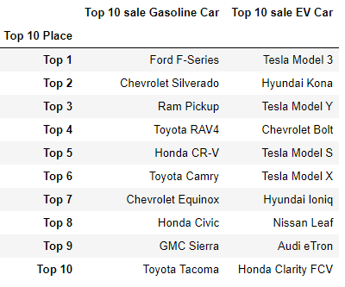

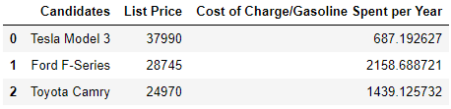

Tesla model 3 and Ford F series are the most popular EV and gas cars, however to make the comparison fair as the F-Series is a truck we take Toyota Camry as consideration as well. Between these three, if we are only talking about cost- effective for fuel/power with list price, the most fuel efficient cars for their price considering the fuel they use would be the following order:

# Q3. Will EVs really pay themselves off?

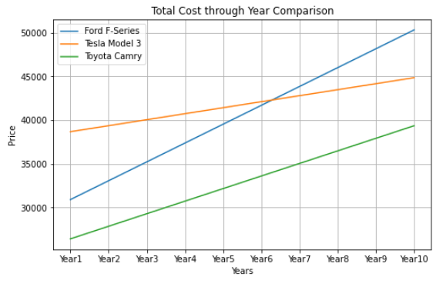

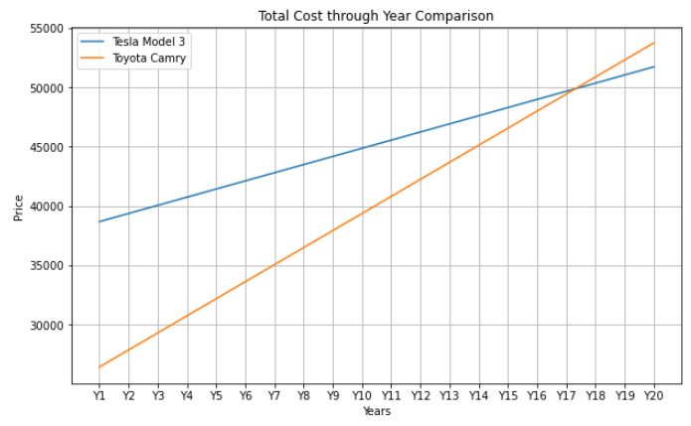

(observing a comparable vehicle type, a sedan, with the Tesla Model 3)

## Overall Observations

The break point of when the EV pays itself off in fuel against the Toyota Camry is after 17 years of purchase with normal use. The break point of when the EV pays itself off in fuel against the Ford F-Series is just after 6 years of purchase with normal use.

## Study of pay-off pace between states

Tesla 3 vs Ford F Series - Years it takes for Tesla to payout the Price Difference

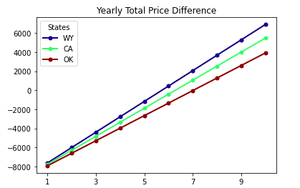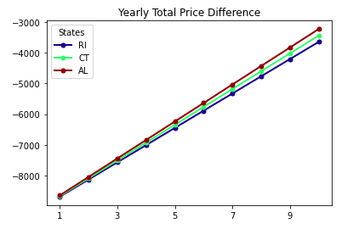

Tesla 3 vs Toyota Camry - Years it takes for Tesla to payout the Price Difference

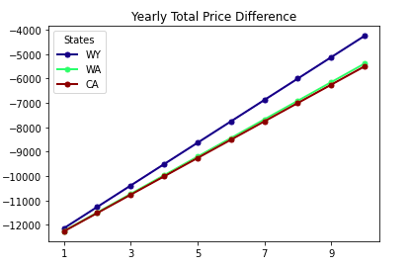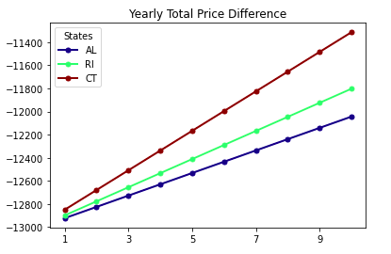

Top Cars in each State EV vs Gasoline

Years it takes for top EV to payout in each state Price Difference

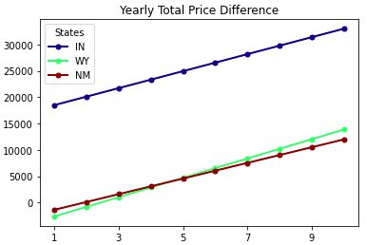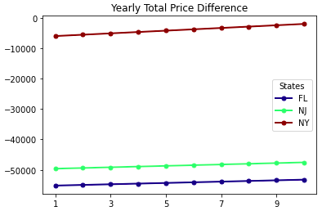

### Overall Observations

For the top three states like Wyoming, California and Oklahoma the EV owner will actually make a net positive

over 3k from the differential pricing.

For the bottom three states that is Rhode Island, Connecticut , and Alabama the Ev owners would be

a few thousand dollars behind the breaking point to even out the price differences.

When it comes down to the Toyota Camry, EV owners would be 4 to 6 thousand dollars away from reaching the breaking point.

The price difference between the Tesla 3 and the Toyota Camry in the top three states were 4 k to 6k away from reaching the breakpoint in a ten year span.

For the worst three states you would barely make 2k back.

The reasons for this big disparity is do to the affordable fuel efficient costs of the Toyota Camry that minimize the cheap fuel alternative the EV’s provide

# Q4. What factors might hint that a city has a lot of charging stations?

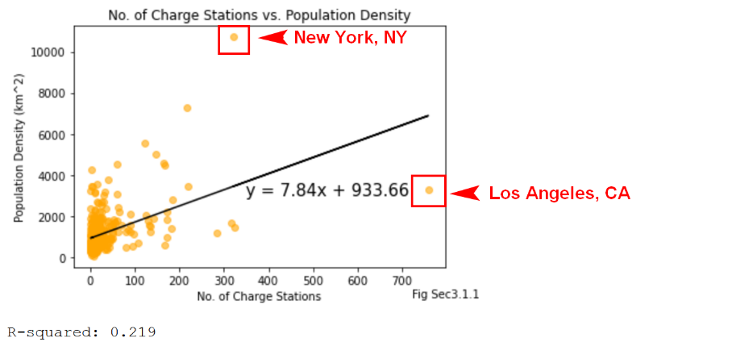

Weak R-squared – likely no correlation between no. of charge stations and population density

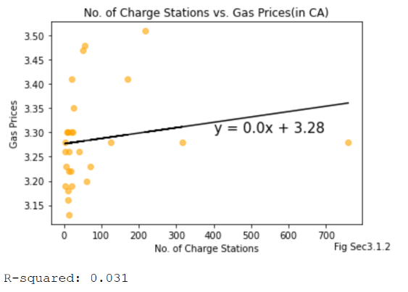

Very weak R-squared – likely no correlation between no. of charge stations and gas station prices. Much lower R-squared than population density.

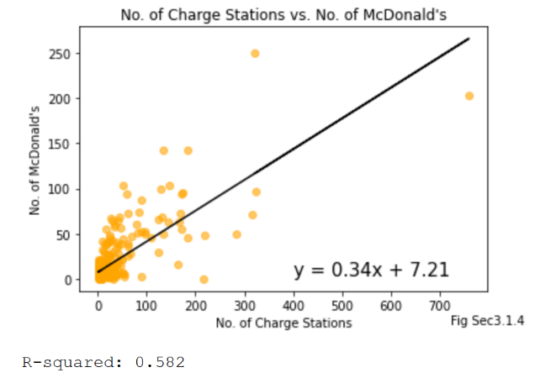

Moderate R-squared – possible correlation between no. of charge stations and McDonald’s (though not likely)

## Overall Observations

* Few properties of a city (if any) reflect charge station availability
* Los Angeles, CA potentially skews the study with a large amount of charge stations  
  (reflect on what constitutes an “outlier” for correlational studies)

# Q5. How much will I save on a trip?

Observe the savings in fuel made from using an EV compared to a gas-powered vehicle.

Gas powered Vehicle trip:

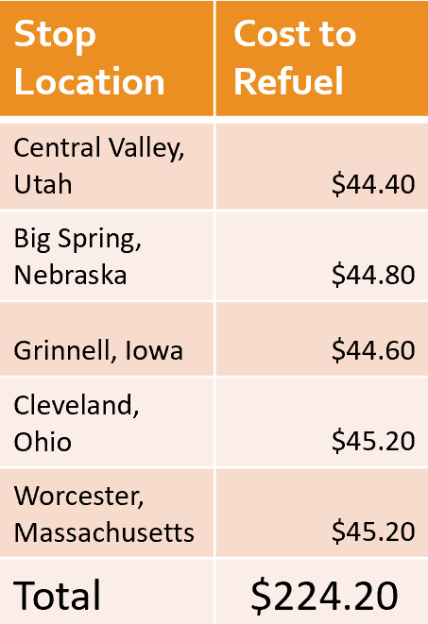

Electric Vehicle trip:

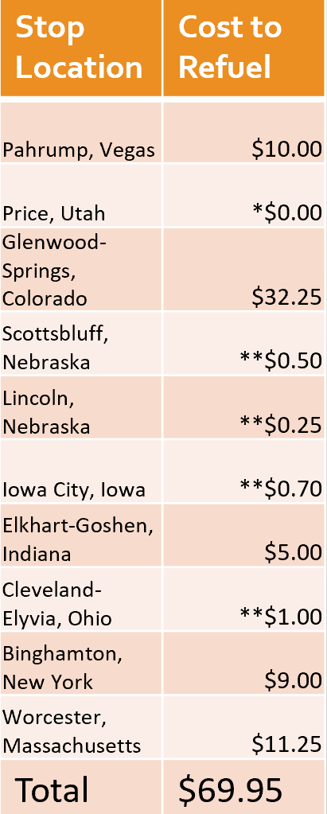

*Free use station

**Flat rates with use of paid utilities

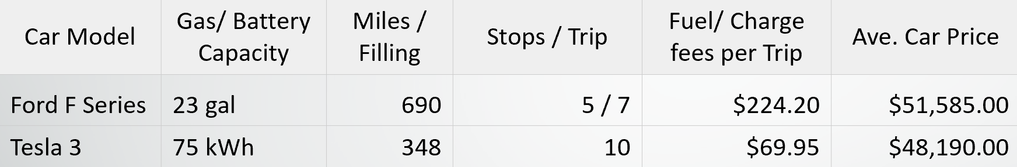

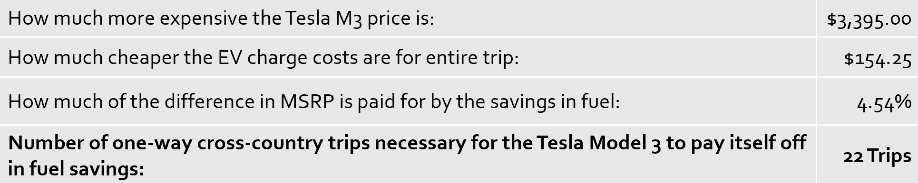

## Overall Observations

The savings made in a cross-country trip (from San Diego, CA to Portland, Maine) between the Tesla Model 3 and the Ford F-150 is approximately $155 dollars.

# Overall Conclusion

The decision will depend heavily on personal preferences and requirements, however, it is possible for fuel savings from using an EV can cover the price difference against more expensive gas cars, and there is enough support for EVs in the form of charge stations in almost all metropolitan area. Although no major correlations between cities and charge station availabilities exist, through searching and planning, you can find enough to travel across the U.S.