*What's the Weather Like?* Report

# Summary

This document is a report of a basic analysis of a location's latitude on the globe across various properties of weather. The weather properties observed are the following:

* Maximum Temperature
* Humidity (%)
* Cloud Coverage (%)
* Wind Speed (mph)

# Global Scatterplots

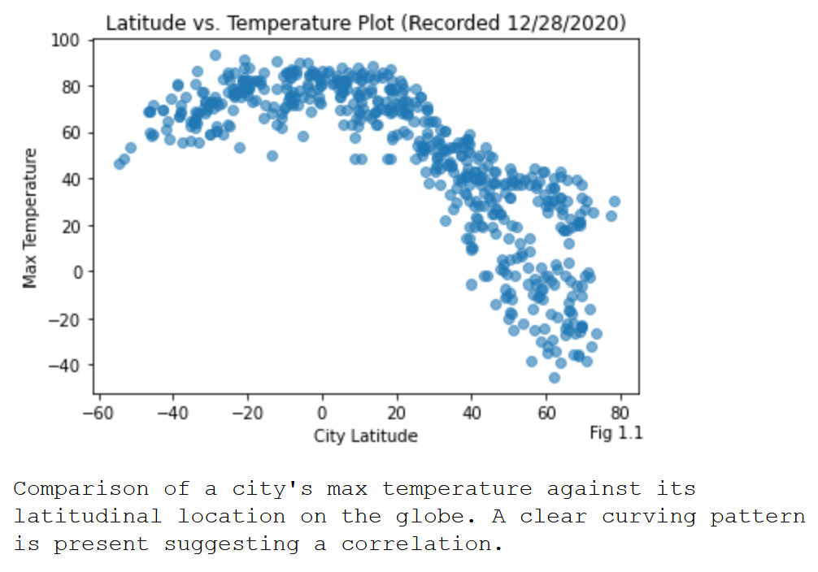

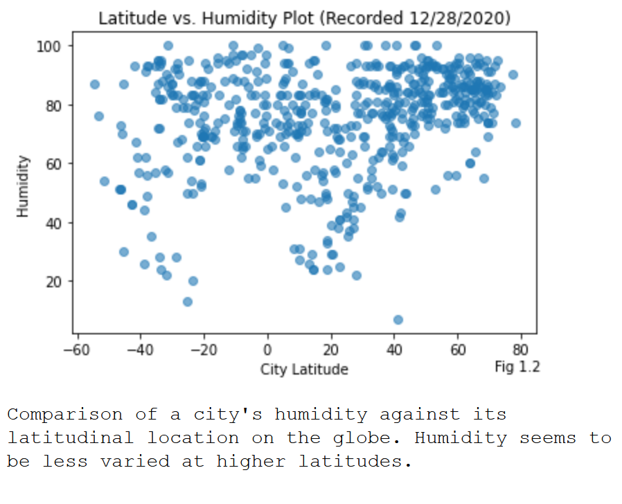

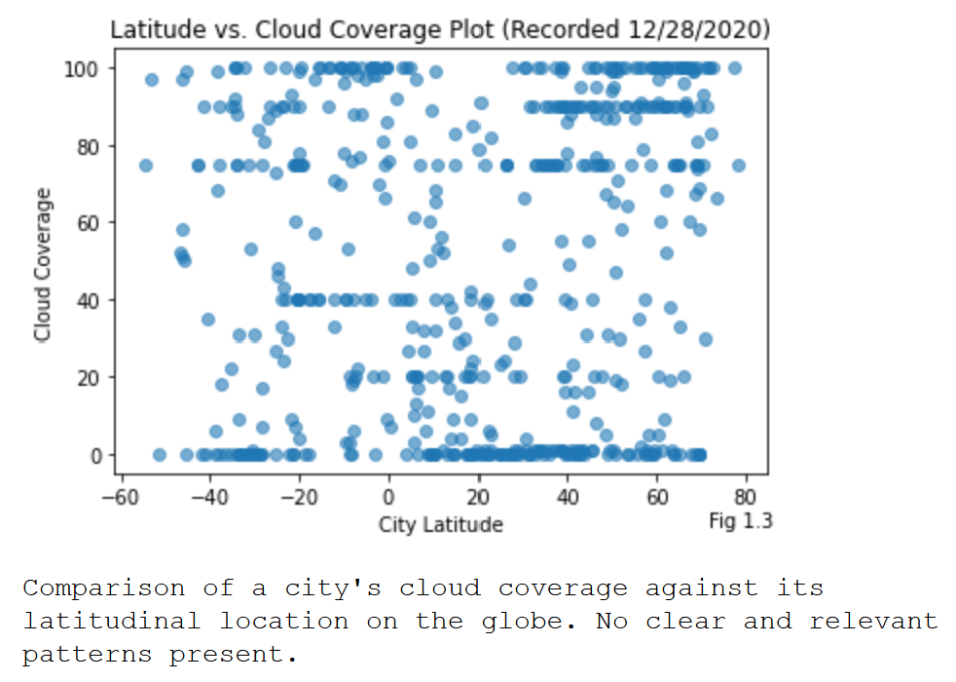

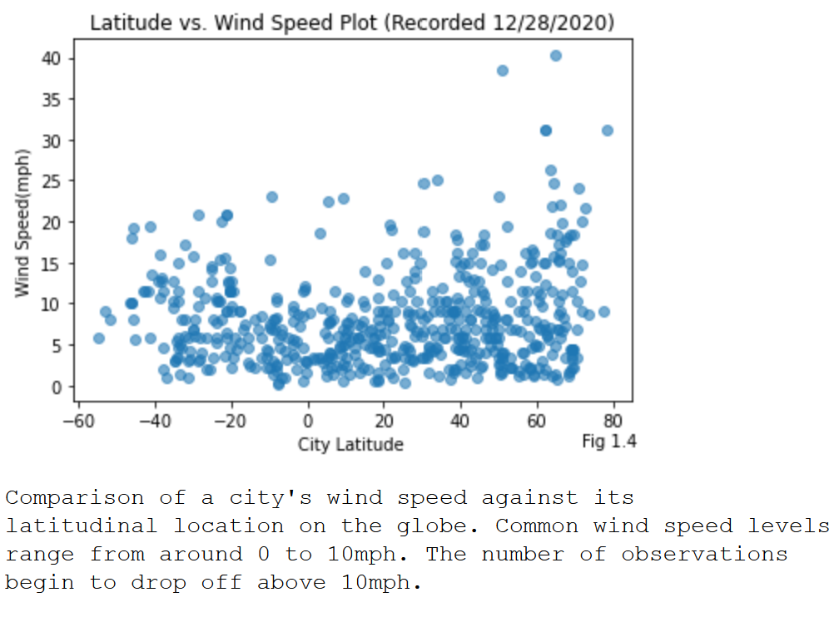

# Regression Analysis Scatterplots

## Max Temperature

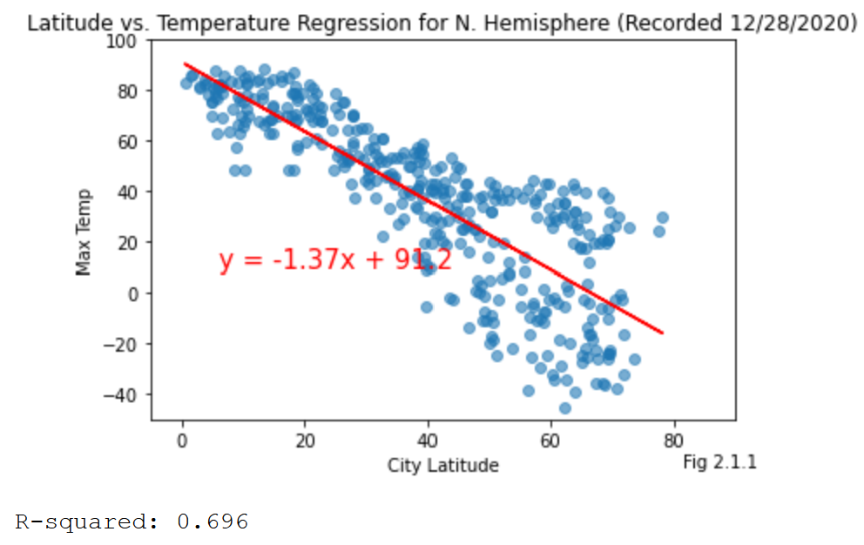

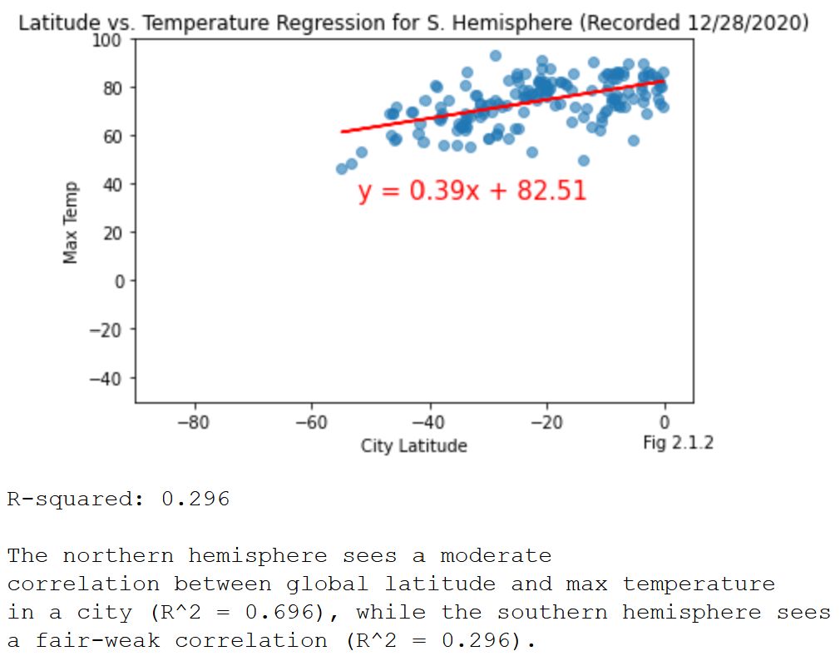

## Humidity

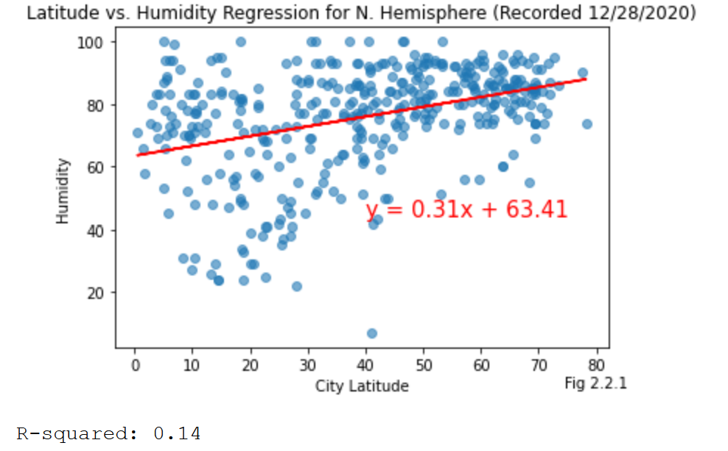

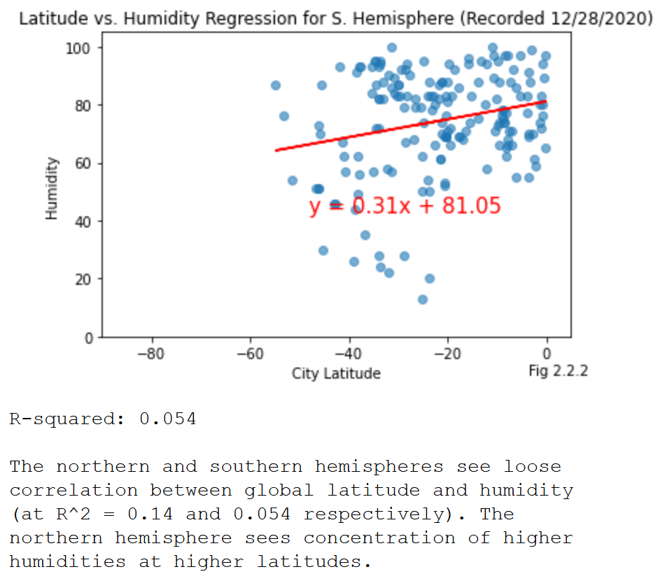

## Cloud Coverage

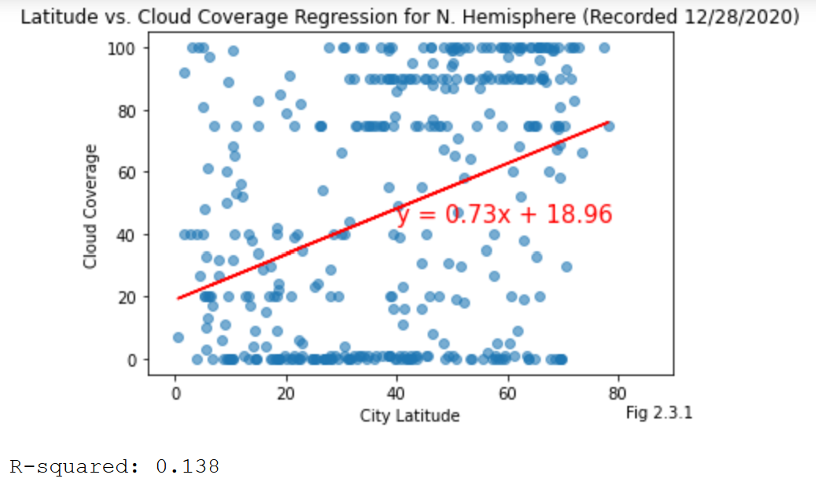

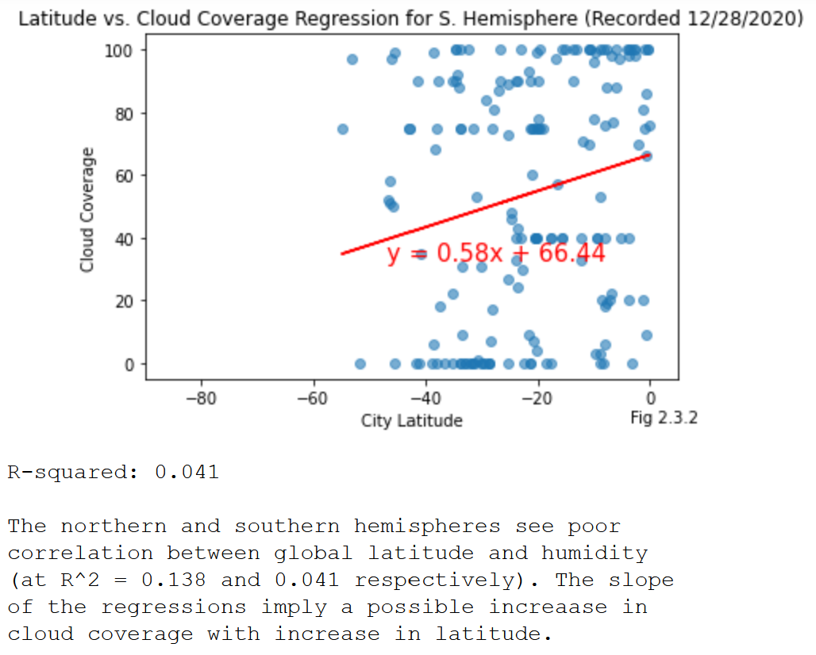

## Wind Speed

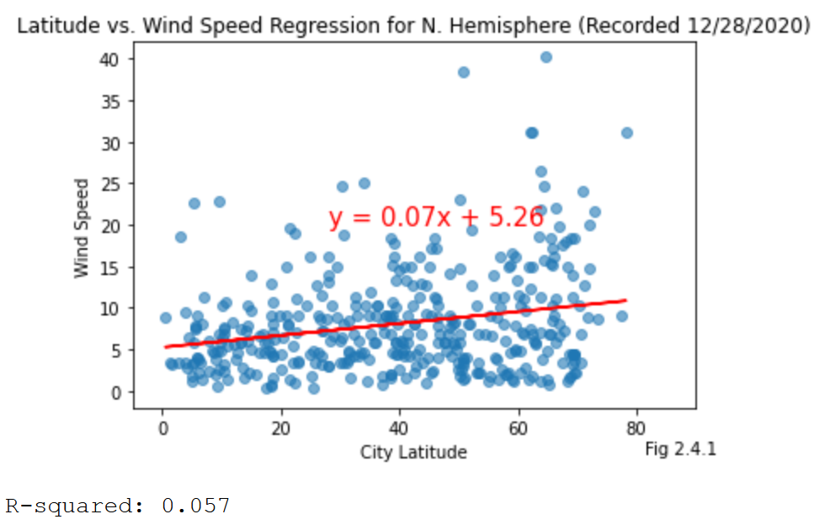

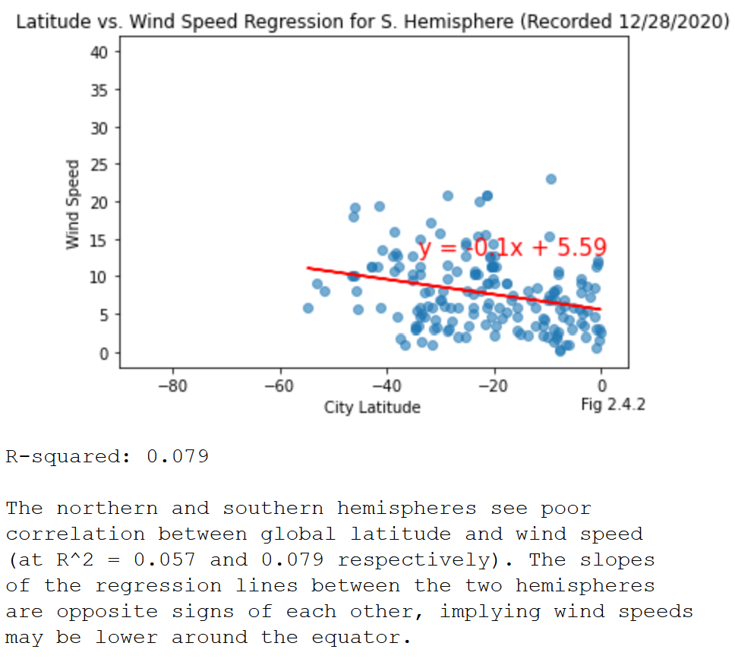

# Observations

## Observation 1: Latitude vs Max Temperature

Correlation between latitude and temperature seems to be strong in the northern hemisphere (R^2: 0.696) and relatively fair in the southern hemisphere (R^2: 0.296). The slopes of their regressions are also opposite of each other, climbing in the southern hemisphere as latitude rises northward to 0 and falling as latitude continues to rise past 0. This reinforces findings that the highest temperatures are around the equator, likely due to the relative distance from the sun compared to positions further north and south on the globe.

## Observation 2: Latitude vs Humidity

Correlation between latitude and humidity seems to be poor in the northern hemisphere (R^2: 0.14) and considerably poor in the southern hemisphere (R^2: 0.054). However, the trend between the two regressions is that the slope of the regression continues to remain positive as latitude increases, implying humidity may increase at higher latitudes overall. This may be due to maximum temperature being lower overall in the extremes of the northern hemisphere. The southern hemisphere shares the same trend, which may be caused by local topography more than global location. More analysis is necessary to discern any possible correlating factors.

## Observation 3: Latitude vs Wind Speed

Correlation between latitude and wind speed seems to be considerably poor in both the northern hemisphere (R^2: 0.057) and southern hemisphere (R^2: 0.079). However, the regression lines between both regions are opposite of each other, falling in the southern hemisphere as latitudes approach 0, and climbing again as latitudes increase away from 0. Following the observation with max temperature, it may also be implied that higher temperatures correlate negatively with an increase in windspeed, with temperature itself affecting air movement patterns.

## Practical Applications

For the purposes of vacationing or relocation, the observations above imply that those who wish for calm, warm weather may want to travel to spots near the equator. Those who are willing to endure, or enjoy humid and varied weather patterns may want to open themselves to travelling further north on the globe. However, there are multiple instances of poor regression fits within this study and further analysis is recommended.