Simon Fraser University

Course Project: Interactive Newspaper

Benedict Wong

301265786

IAT359 D101

Helmine Serban

April 1, 2019

Abstract:

The Interactive Newspaper is a light-weight news-retrieving and reading application with the feature to retrieve Local News according to the user’s current location. Unlike apps where the full news article is fully displayed at all times, the Interactive Newspaper shows only a preview description, cutting down data usage and allowing users to quickly scroll through all of the latest news. If the user is interested in a particular news article, they only need to tap once on the article space and the app will instantly open the news article up in the browser of their choice.

Completion Report:

Basic Functionality (Revisited):

In Milestone 1, I briefly touched on the fact that the Interactive Newspaper is to replicate a similar look and feel to a physical newspaper. However, after iterating the design, the “newspaper-esque” look felt very gaudy. Instead, I went for a simpler and minimal approach to the design, showing only what is necessary for the user and omitting what is unnecessary. Despite the change in appearance, the Interactive Newspaper ultimately contains the main functionality of its goal: Separating news into respective areas and allowing the user to freely go to any of these sections to view the relevant news for that area.



Figure 1: The Interactive Newspaper’s main screen, detailing its 4 categories, separating local news, world news, sports news and the bookmarks activities.

Standard Functionality (Complete):

As mentioned in Milestone 2, the sensor used in the Interactive Newspaper has been changed from an accelerometer that detects when the device has been placed down to a light sensor that dynamically changes the theme of the app to prevent eye strain in low-light conditions. Next, GPS checks have been successfully implemented, as the Interactive Newspaper shows the user’s current location on the main page as well as changing the local news depending on the user’s current province. While the code for the GPS checker also contains a hash map for all of the 52 States of America, the local news only grabs news for the Canadian Provinces and Territories.

The SharedPreferences have been implemented successfully as well, as the SharedPreferences are used to store longitude and latitude coordinates, as well as province and territory abbreviations as a way to output local news for the user. The SQLite Database on the other hand allows the user to store his/her favorite or ‘to be read later’ news into the bookmarks area.

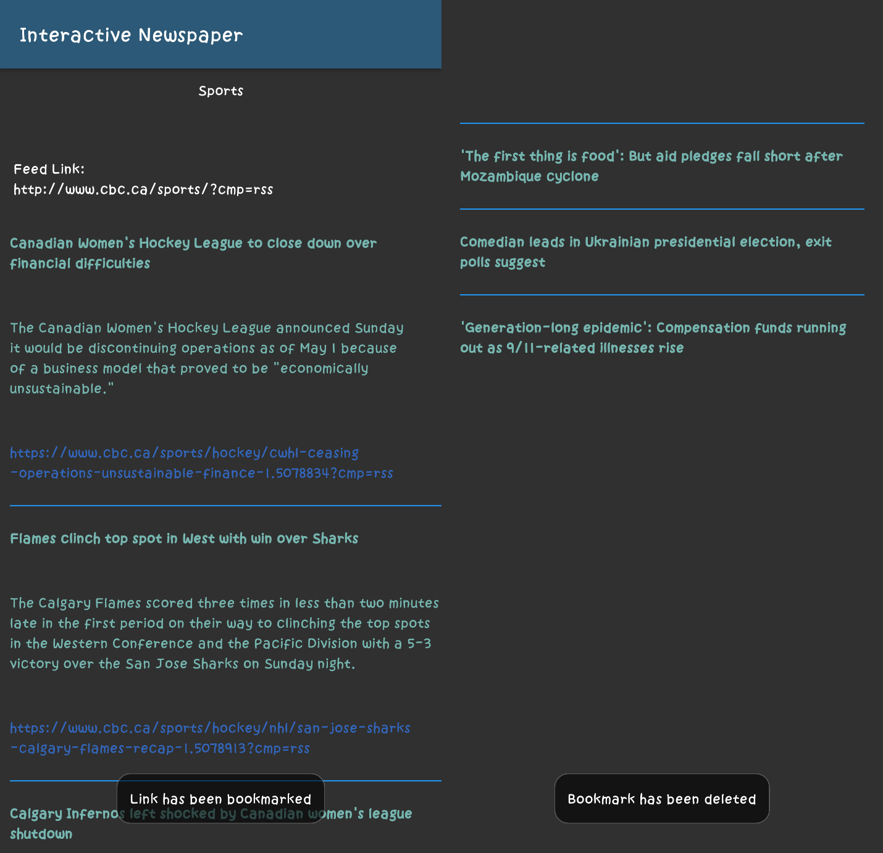

Figure 2: Long Clicking to bookmark a news article (Left), Long Clicking to remove a bookmark (Right).

Bonus Functionality (Not completed):

Ultimately, I was unable to develop the sidebar menu into the application as I was unable to figure out how to make the sidebar work across all activities automatically.

Challenges:

While implementing the GPS location service, I was faced with the fact that Surrey is not detected in the Geocoder database. While I initially believed that my application was broken and did not detect the user’s location correctly, I later found out that Surrey does not exist in the database itself. Despite knowing that Surrey does not exist in the database, I was unable to find a solution to the issue. One of the strategies I thought up to remedy the fact was to set a range of longitude and latitude coordinates that, if it was close enough to Surrey, then these coordinates would point to Surrey itself. Although this may solve the issue on hand, it is infeasible to do so as other regions may also be undetected and it is not possible to catch every single undetected location and fix it manually.