**FULL STACK WITH MERN (JAVA) ASSIGNMENT-4**

Sanagala Sai Sreeja

Vignan’s Nirula Institute of

Technology and Science

For Women (VNITSW)

4th B-Tceh (CSE)

20NN1A05A2

**ASSIGNMENT-4: Creating a Database Using MongoDB and Mongosh**

**OBJECTIVE:**

The objective of this assignment is to familiarize yourself with MongoDB and its command-line interface, Mongosh, and to understand how to create, manage,and query databases and collections in MongoDB.

**PROCESS**

1. **DATABASE SETUP**: Create a new MongoDB database called myDatabase.

* use myDatabase
* **Output:**

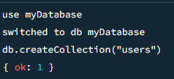

1. **COLLECTION CREATION:** Create a collection named users within the myDatabase database.

* db.createCollection("users")
* **Output:**



1. **DOCUMENT INSERTION:** Insert at least three documents into the users collection, each representing a user with fields such as name, email, and age.

* db.users.insertMany([

{ name: "John Doe", email: "john@example.com", age: 25 },

{ name: "Sai", email: "sai@example.com", age: 35 },

{ name: "Alice Johnson", email: "alice@example.com", age: 30 },

{ name: "pavan", email: "pavan@example.com", age: 19 },

{ name: "lohi", email: "lohi@example.com", age: 20 },

{ name: "shubman gill", email: "shubman@example.com", age: 24 },

])

* **Output:**

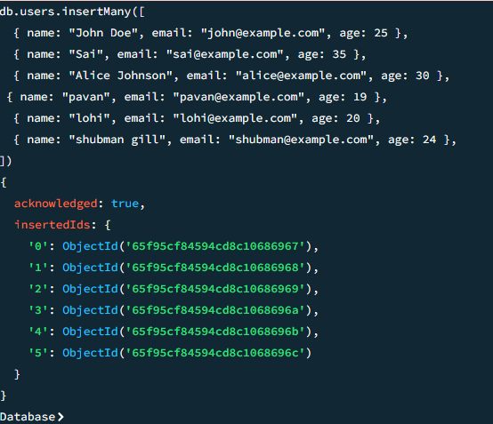

1. **QUERYING:** Write queries to retrieve: All users from the users collection.

* db.users.find()

* **Output:**

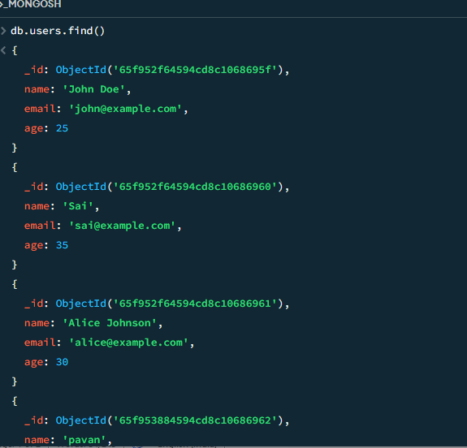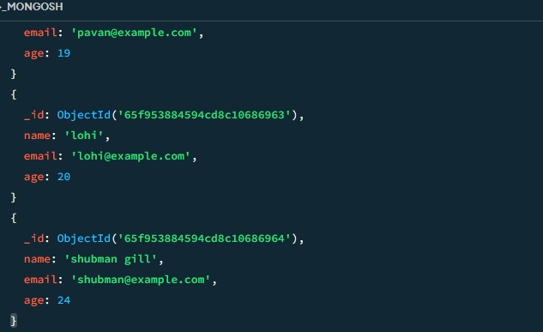

1. **RETRIVING USERS WHOSE AGE IS GREATER THAN 30**: Users with an age greater than or equal to 30.

* db.users.find({ age: { $gte: 30 } })

* **Output:**

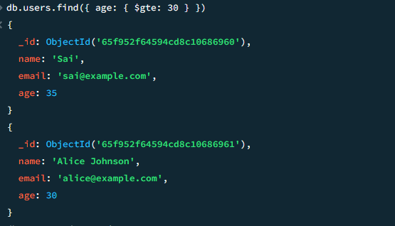

1. **UPDATE OPERATION:** Update the age of a user with a specific email address.

* db.users.updateOne(

{ email: "john@example.com" },

{ $set: { age: 28 } }

)

* **Output:**

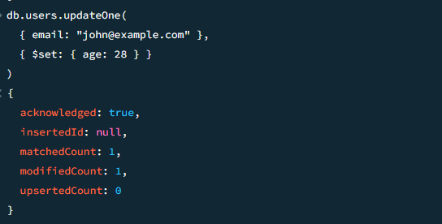

**7. DELETION OPERATION:** Delete a user document based on a specific email address.

* db.users.deleteOne({ email: "alice@example.com" })
* **Output:**

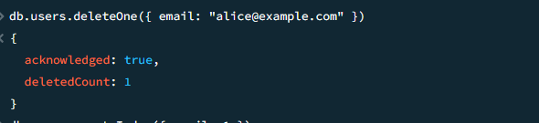

1. **INDEX CREATION:** Create an index on the email field of the users collection.

* db.users.createIndex({ email: 1 }, { unique: true })
* **Output:**

