**Create a movie review website using SvelteKit, TypeScript, and Tailwind CSS.**

**Requirements:**

* [Visual Studio Code (aka VS Code)](https://code.visualstudio.com/download) with the Svelte extension
* Node.js (version 18+)

**Creating a project on SvelteKit using VS Code with the Svelte extension:**

Run the following commands on VS Code terminal.

npm create svelte@latest my-app

cd my-app

npm install npm run dev

The first command will scaffold a new project in the my-app directory. The subsequent will then install its dependencies and start a server on [**localhost:5173**](http://localhost:5173/).

**Wireframes:**

**Home Page:**

Title

Footer

Search

Movie Poster

Movie Poster

Movie Poster

Movie Poster

**Movie Review Page:**

Title

Movie Poster

Footer

Movie details and review

Rating

I named the movie review website as ‘Shott’. Once the layout for each screen is ready, the project can be built on SvelteKit. I used a static Json file to store the list of movies and data related to it to be shown on the screen. The navigations available were as follows:

* Home page that would show the banners for all the movies.
* Search bar is available on the home page to search movies by name or genre.
* From the home page, or searched results, the user can click on the movie banner to view the review, detail, and rating of the movie as a ‘Shott Score’ along with a single word description.
* All screens have the functionality to navigate back to home page.

I created components for Home Page, Movie poster (to navigate), Rating and Search bar and routes for Review screen and search results.

**Application screenshots:**

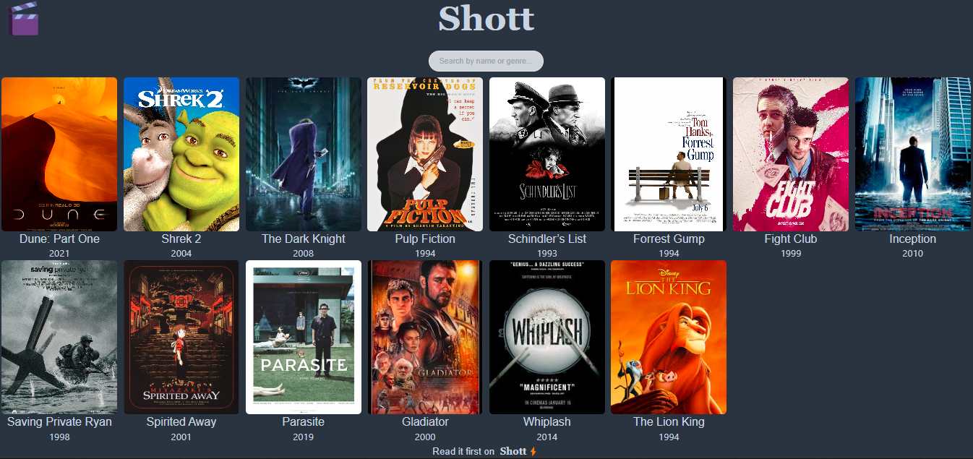

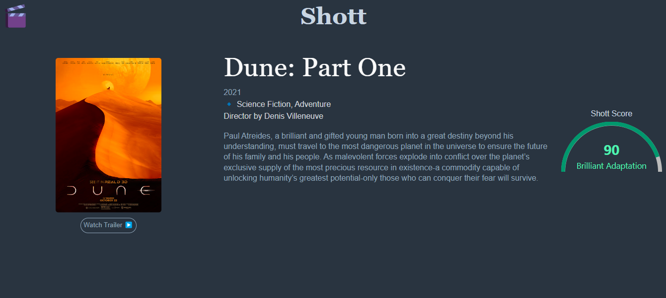

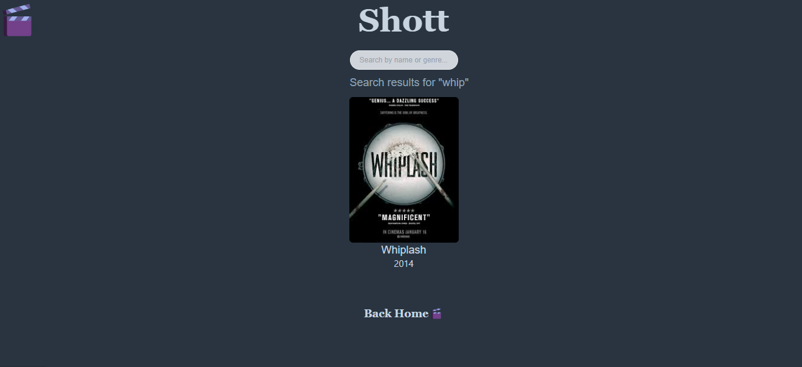

**GitHub Repository URL:**

<https://github.com/SanahHassan/svelt_movie_review>

**Vercel hosted app:**

<https://svelt-movie-review-3iqs.vercel.app/>