
Tribhuvan University
Faculty of Humanities and Social Sciences

A PROJECT REPORT
On
STUDENT FEEDBACK SYSTEM

In partial fulfillment of the requirements for the degree of Bachelor of Computer
Applications

Submitted to:
Department of Computer Application
Swastik College
Chardobato, Bhaktapur

Submitted by:
Sanam Marikhu (113102123)
Bibek Ghorasaine (113102103)
December, 2025

Under the Supervision of
Sujan Poudel
Tribhuvan University
Faculty of Humanities and social science
Swastik College

Student Declaration

This is to certify that this project prepared by Sanam Marikhu and Bibek Ghorsaine titled “STUDENT FEEDBACK SYSTEM” submitted is based on my original research work done in partial fulfillment of the requirements for the Bachelors of Computer Application under the supervision and guidance of Sujan Poudel. Related works on the topic, by other researchers, have been duly acknowledged. We owe all the liabilities relating to accuracy and authenticity of the data or any other information included here under.

Sanam Marikhu Bibek Ghorasaine
Symbol no: 113102123 Symbol no: 113102103

Tribhuvan University
Faculty of Humanities and social science
Swastik College

Supervisor’s Recommendation

I hereby recommend that this project prepared under our supervision by Sanam Marikhu and Bibek Ghorasaine entitled “STUDENT FEEDBACK SYSTEM” in partial fulfillment of the requirements of the degree of Bachelor of Computer Application in Faculty of Humanities and Social Science awarded by Tribhuvan University, is recommended for the final evaluation. we recommend the same for acceptance by Tribhuvan University.

Sujan Poudel
Lecturer
Swastik College

Tribhuvan University
Faculty of Humanities and social science
Swastik College

Letter of Approval

This is to certify that this project prepared by Sanam Marikhu & Bibek Ghorasaine entitled “STUDENT FEEDBACK SYSTEM” in partial fulfillment of the requirements for the degree of Bachelor in Computer Application has been evaluated. In our opinion it is satisfactory in the scope and quality as a project for the required degree.

…………………….. …………………………
Sujan Poudel Ms. Sristi Khatiwada
Supervisor Coordinator
Lecturer, Swastik College BCA Department, Swastik College

…………………………… ……………………………
Internal Examiner External Examiner

ACKNOWLEDGEMENT

We would like to express our heartfelt gratitude to our supervisor, Mr. Sujan Poudel, for his invaluable support and guidance throughout the development of the Student Feedback System. His expertise and encouragement have been pivotal in shaping this project and ensuring its success.
We extend our sincere thanks to Mrs. Sristi Khatiwoda for her constant encouragement and constructive feedback, which has played a significant role in the successful completion of the Student Feedback System.
We also want to take this opportunity to thank our parents and friends for their unwavering support and understanding during the entire development process. Their encouragement and belief in us have been a driving force that helped us meet the project's deadlines and challenges.
This project would not have been possible without the combined effort and support from all these individuals. We are genuinely grateful for their contributions, which have made this project a reality.

With Regards:
Sanam Marikhu
Bibek Ghorasaine

ABSTRACT
The Student Feedback System (SFS) is a web-based application designed to automate and streamline the process of collecting, managing, and analyzing feedback from students regarding their courses and teachers. The system facilitates key functions such as student registration, secure login, feedback submission, and feedback viewing for both teachers and administrators. By integrating MySQL as the database, the system ensures structured and secure storage of all data related to students, teachers, courses, and feedback.
The SFS incorporates an intuitive dashboard designed using HTML and CSS, providing a simple and user-friendly interface for students, teachers, and administrators. Students can easily submit feedback for their enrolled courses, while teachers can view feedback related to their courses to improve teaching quality. Administrators can manage students, teachers, and courses efficiently, ensuring smooth operation of the system.
This project addresses common challenges in manual feedback collection, such as misplaced forms, delayed analysis, and lack of centralized data. By providing a centralized, automated, and secure platform, the Student Feedback System improves feedback management, enhances transparency, and supports data-driven decision-making in educational institutions.
Keywords: Student Feedback System (SFS), Feedback Management, Student Registration, Teacher Evaluation, MySQL Database, User-Friendly Interface, Course Management, Data Analysis

Contents
ACKNOWLEDGEMENT i
ABSTRACT ii
CHAPTER1: INTRODUCTION 1
1.1Introduction 1
1.2 Problem Statement 1
1.3 Objectives 1
1.4 Scope and Limitations 2
1.5 Report Organization 2
CHAPTER 2: BACKGROUND STUDY AND LITERATURE REVIEW 3
2.1 Background Study 3
2.2 Literature Review 3
CHAPTER 3: SYSTEM ANALYSIS AND DESIGN 4
3.1. System Analysis 4
3.1.1 Requirement Analysis 4
3.1.2 Feasibility Analysis 6
3.1.3 Data Modeling 7
3.1.4 Process Modeling (DFD) 9
3.2 System Design 12
3.2.1 Architectural Design 12
3.2.2Database Schema Design 13
3.2.3 Interface Design 15
3.2.4 Physical DFD 16
CHAPTER 4: IMPLEMENTATION AND TESTING 17
4.1 Implementation 17
4.1.1 Tools Used 17
4.1.2 Implementation Details of Modules 18
4.2 Testing 19
4.2.1 Test Cases for Unit Testing 19
CHAPTER5: CONCLUSION AND FUTURE RECOMMENDATIONS 20
5.1 Lesson Learnt/Outcome 20
5.2 Conclusion 21
5.3 Future Recommendations 21
REFERENCES 22
APPENDIXES 23
User Interface 23

List of Figures
Figure 1:Use Case Diagram 6
Figure 2:Gantt chart of Student Feedback System 7
Figure 3:E-R Diagram of Student Feedback System 8
Figure 4:DFD(Level 0) 10
Figure 5:DFD (Level 1) 11
Figure 6:Architecture Design 13
Figure 7:Database Schema Design 13
Figure 8:Login Interface Design 15
Figure 9:Dashboard Interface Design 16
Figure 10:Physical level DFD for Student Feedback System 16

List of Tables
Table 1:Test cases for unit testing 19
Table 2:Test cases for system testing 19

CHAPTER1: INTRODUCTION

1.1Introduction
In the modern educational environment, maintaining and improving the quality of teaching and learning is a major concern for academic institutions. One of the most effective ways to evaluate teaching effectiveness and course quality is through regular student feedback. However, in many institutions, the feedback collection process is still carried out manually using paper-based forms, which is inefficient, time-consuming, and prone to errors.
The Student Feedback System (SFS) is a web-based application designed to automate the process of collecting, managing, and reviewing feedback provided by students. The system allows students to submit feedback for their respective courses in a structured and secure manner. Teachers can view feedback related to their courses, and administrators can manage students, teachers, and courses through a centralized system.
This project is developed using PHP as the server-side scripting language and MySQL as the database management system. The user interface is designed using HTML and CSS, ensuring simplicity, consistency, and ease of use. By digitizing the feedback process, the Student Feedback System minimizes manual work, improves data accuracy, and enables timely evaluation of academic performance.

1.2 Problem Statement
In many educational institutions, feedback collection is done manually using paper forms. This approach is time-consuming, difficult to manage, and lacks data accuracy and confidentiality.
Manual feedback systems often lead to:
- Misplacement or loss of feedback forms.
- Difficulty in compiling and analyzing results.
- Delayed reporting and decision-making.
- Lack of anonymity, which can discourage honest feedback.
To overcome these issues, there is a need for an automated web-based Student Feedback System that ensures efficiency, data security, easy management, and quick access to reports.

1.3 Objectives
The main objectives of the Student Feedback System are:
- To automate the process of student feedback collection.
- To provide a secure login-based system for students, teachers, and administrators.
- To allow students to submit feedback easily for courses.
- To enable teachers to view feedback related to their assigned courses.
- To allow administrators to manage students, teachers, and courses efficiently.
- To reduce paperwork and improve data accuracy and accessibility.

1.4 Scope and Limitations
Scope of the Project:
- Student registration and authentication.
- Feedback submission with ratings and comments.
- Teacher dashboard to view course-wise feedback.
- Admin panel to manage students, teachers, and courses.
- Centralized database for secure data storage.
Limitations of the Project:
- The system is intended for use within a single institution.
- Advanced analytics and graphical reports are not included.
- Internet connectivity is required as the system is web-based.
- Feedback evaluation is limited to basic ratings and textual comments.

1.5 Report Organization
The report is organized as follows:
Chapter 1 provides an introduction to the Student Feedback System (SFS) project. It outlines the core problem that the system aims to address and presents the objectives, scope, and limitations of the project. This chapter serves as the foundation for understanding the purpose and significance of the Student Feedback System.
Chapter 2 discusses the background study and literature review related to student feedback systems. This chapter includes a description of fundamental concepts, terminologies, and existing practices used in academic feedback systems. It also presents a critical review of similar projects and studies conducted by other researchers, providing insight into existing systems and approaches.
Chapter 3 focuses on the system analysis and design of the Student Feedback System. It includes requirement analysis, feasibility studies, data modeling, and system design. This chapter explains how the system is structured and how different components interact with each other.
Chapter 4 covers the implementation and testing phase of the Student Feedback System. It describes the tools and technologies used during development and explains the implementation details of various system modules. This chapter also presents testing procedures carried out to ensure the functionality, reliability, and correctness of the system.
Chapter 5 summarizes the overall findings and outcomes of the Student Feedback System project. It presents the conclusion, lessons learned during the development process, and possible future enhancements. This chapter also provides recommendations for improving the system and extending its functionality in the future.

CHAPTER 2: BACKGROUND STUDY AND LITERATURE REVIEW

2.1 Background Study
Student feedback plays a vital role in improving the quality of education in academic institutions. It provides insights into teaching effectiveness, course content, and overall learning experience from the student’s perspective. A Student Feedback System is designed to systematically collect, store, and analyze this feedback to support academic evaluation and improvement.
In a typical feedback system, students evaluate teachers and courses based on predefined criteria such as teaching methodology, clarity of explanation, course content, and interaction. Traditionally, feedback was collected manually using paper forms, which required significant effort to distribute, collect, and analyze. These manual systems often faced challenges such as delayed processing, data inconsistency, lack of anonymity, and difficulty in long-term data storage.
With the advancement of web technologies and database management systems, automated student feedback systems have become more popular. Web-based feedback systems allow students to submit feedback online, ensuring anonymity and ease of access. These systems store data in a centralized database, enabling quick retrieval and analysis of feedback information. Administrators can manage users, courses, and feedback records efficiently, while teachers can view feedback related to their assigned courses.
The Student Feedback System developed in this project uses a web-based approach with server-side processing and a relational database. It focuses on simplicity, security, and ease of use, making it suitable for academic institutions seeking a reliable feedback management solution.

2.2 Literature Review
Student feedback systems have been widely studied and implemented as an effective mechanism for evaluating teaching performance and improving academic quality in higher education institutions. Various researchers have highlighted the importance of collecting structured feedback from students to assess course delivery, teaching methods, and overall learning experience [1], [4].
Several studies emphasize that traditional paper-based feedback systems are inefficient due to manual data handling, lack of confidentiality, and difficulty in long-term data storage. These limitations often result in delayed analysis and reduced accuracy, making decision-making ineffective [4]. To overcome these challenges, web-based student feedback systems have been proposed and implemented in many academic environments.
Research on online feedback systems shows that automation significantly improves data accuracy, accessibility, and processing speed [1], [2]. According to existing studies, students are more willing to provide honest feedback when anonymity is maintained. Web-based systems ensure this by managing user authentication and restricting access to feedback data, which encourages unbiased responses and enhances the reliability of collected feedback [7].
Many existing systems use structured questionnaires with rating scales and open-ended comments to capture both quantitative and qualitative feedback [4]. Some advanced systems incorporate graphical visualization and statistical analysis to support academic decision-making. However, such systems often require complex technologies and higher maintenance costs, which may not be suitable for small or medium-sized educational institutions.
Literature also highlights the importance of usability and simplicity in academic information systems. A user-friendly interface increases student participation and reduces errors during feedback submission [2]. Similarly, role-based access control is considered essential to protect sensitive information and ensure that only authorized users can view feedback data [7].
Based on the review of existing systems and studies, the Student Feedback System developed in this project focuses on essential functionalities such as user management, course management, and structured feedback collection. The system avoids unnecessary complexity while ensuring data security, ease of use, and reliability. The findings from the literature have guided the design and implementation of the proposed system.

CHAPTER 3: SYSTEM ANALYSIS AND DESIGN

3.1. System Analysis
System analysis is a crucial phase of the Student Feedback System (SFS) project. It focuses on understanding the existing problems, identifying system requirements, and evaluating the feasibility of developing the proposed system. This phase ensures that the system meets user expectations and institutional needs before moving into the design and implementation stages.

3.1.1 Requirement Analysis
Requirement analysis defines what the system should do and how it should perform. The requirements of the Student Feedback System were gathered through observation of existing manual feedback processes and analysis of institutional evaluation needs.
i. Functional Requirements
The functional requirements describe the core functionalities of the Student Feedback System:
- Students must be able to register and log in securely.
- Students can submit feedback for assigned courses and teachers.
- The system allows students to provide ratings and written comments.
- Admin users can manage students, teachers, courses, and departments.
- Admin can view, analyze, and manage submitted feedback.
- The system should prevent unauthorized access.
- Feedback data should be stored securely in the database.
ii. Non-Functional Requirements
The non-functional requirements define the quality and performance aspects of the system:
- Usability: The system should allow a new user to submit feedback or view reports within 3 clicks on average. User interface actions should require less than 5 minutes to learn for first-time users.
- Performance: Feedback submission and retrieval should complete within 2 seconds under normal load. Dashboard loading time for teachers and admins should be under 3 seconds.
- Security: All passwords should be hashed using secure algorithms. Unauthorized access attempts should be logged and prevented, with less than 0.1% system downtime due to security breaches.
- Reliability: System uptime should be 99% or higher. Database transactions must maintain 100% data integrity, with no loss of feedback records.
- Scalability: The system should support an increasing number of users and feedback records.
iii.Use Case Diagram
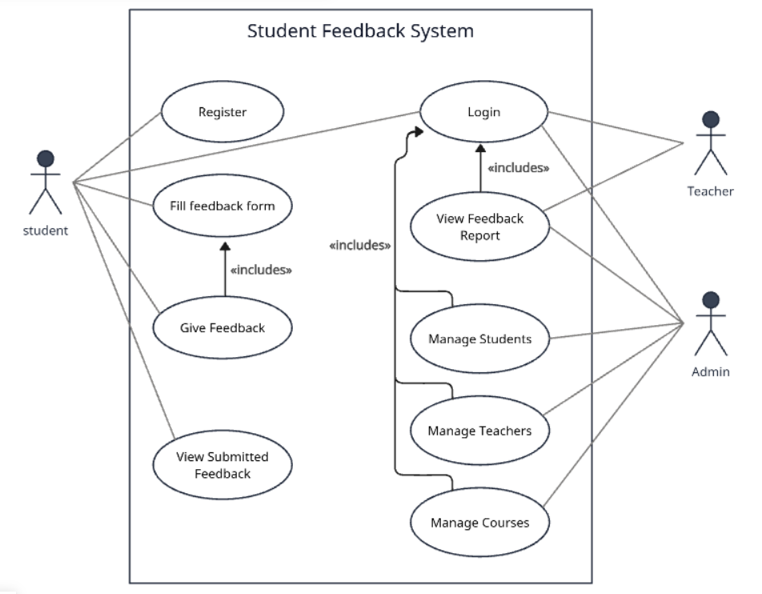
Figure 1:Use Case Diagram

3.1.2 Feasibility Analysis
Feasibility analysis is conducted to evaluate whether the proposed Student Feedback System (SFS) is practical and achievable within the given constraints of time, cost, and resources. The feasibility of the system is analyzed under the following aspects:

a) Technical Feasibility
The Student Feedback System is technically feasible as it is developed using technologies that are well-known, stable, and already covered in the BCA curriculum. The system uses PHP for server-side scripting, MySQL for database management, and HTML/CSS for user interface design. These technologies are compatible with commonly available web servers such as Apache (XAMPP) and can run efficiently on standard computer systems.
No specialized hardware or licensed software is required, making the system easy to implement and maintain. The development team possesses sufficient technical knowledge to design, implement, and troubleshoot the system.
b) Operational Feasibility
The system is operationally feasible as it is designed to be simple and user-friendly for all stakeholders, including students, teachers, and administrators. Students can easily submit feedback through a structured form, teachers can view feedback related to their courses, and administrators can manage users and courses efficiently.
The system minimizes manual work and reduces errors associated with traditional paper-based feedback systems. Since the workflow aligns with existing academic processes, users can adopt the system with minimal training.

c) Economic Feasibility
The Student Feedback System is economically feasible because it requires no additional financial investment. The development is carried out using open-source tools and technologies such as PHP, MySQL, and Apache, which are freely available.
There are no licensing costs, and the system can be deployed on existing institutional infrastructure. Therefore, the overall development and operational cost of the system is very low, making it suitable for educational institutions with limited budgets.
d) Schedule Feasibility
The project is schedule-feasible as it can be completed within the academic timeframe specified by Tribhuvan University. The system development is divided into phases such as requirement analysis, design, implementation, testing, and documentation.
Given the moderate complexity of the system and the availability of required resources, the project can be completed within the allocated semester without compromising quality.

Time  Phases | Sept 5th -Sept 18th | Sept 18th -Sept 25th | Sept 25th -Oct 25th | Oct 25th -Nov 10th | Nov 10th -Dec 5th | Dec 5th -Dec 20th
Planning
Analysis
Design
Implementation
Testing
Documentation
Figure 2:Gantt chart of Student Feedback System

3.1.3 Data Modeling
The Entity Relationship (ER) Diagram represents the logical structure of the Student Feedback System by identifying key entities, their attributes, and the relationships among them. The ER model helps in understanding how data is stored, related, and managed within the system.
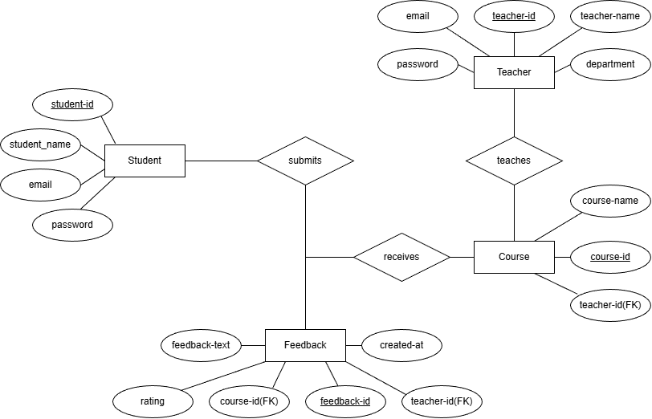
Figure 3:E-R Diagram of Student Feedback System

Entities and Attributes
- Student
- student_id (Primary Key)
- student_name
- email
- password
The student entity stores information related to students who provide feedback for courses.
- Teacher
- teacher_id (Primary Key)
- teacher_name
- email
- password
- department
The Teacher entity represents faculty members responsible for teaching courses.
- Course
- course_id (Primary Key)
- course_name
- teacher_id (Foreign Key)
Each course is associated with a specific teacher through the teacher_id foreign key.
- Feedback
- feedback_id (Primary Key)
- rating
- feedback_text
- created_at
- course_id (Foreign Key)
- teacher_id (Foreign Key)
The Feedback entity stores student feedback along with ratings and comments for courses.

Relationships
- Student submits Feedback
A student can submit multiple feedback entries, but each feedback is submitted by only one student.
- Course receives Feedback
A course can receive feedback from many students, while each feedback entry belongs to a single course.
- Teacher teaches Course
A teacher can teach multiple courses, but each course is taught by one teacher.

3.1.4 Process Modeling (DFD)
Process modelling illustrates how data flows within the Student Feedback System (SFS) and how different processes interact with users and data stores. Data Flow Diagrams (DFDs) are used to visually represent the movement of data from input to output through various system processes
a) DFD Level 0 (Context Diagram)
The Context Diagram presents the SFS as a single process and shows its interaction with external entities.

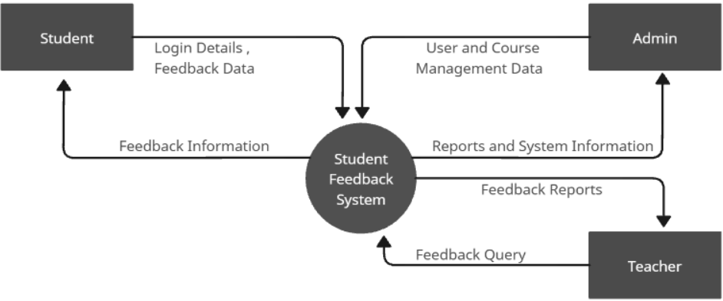
Figure 4:DFD(Level 0)
External Entities
- Student: Submits feedback, views courses
- Admin: Manages students, teachers, courses, and views reports
- Teacher: Views feedback related to assigned courses
Main Process
- Student Feedback System
Data Flows
Student → System: Login details, feedback data
System → Student: Feedback Information
Admin → System: Student/Teacher/Course management data
System → Admin: Reports, feedback summaries
System → Teacher: Course-wise feedback reports
Purpose: Gives a high-level overview of the entire system.

b) DFD Level 1
The Level-1 Data Flow Diagram (DFD) of the Student Feedback System (SFS) illustrates the internal processes of the system and how data flows between external entities, processes, and data stores. This diagram decomposes the main system into four major functional processes.
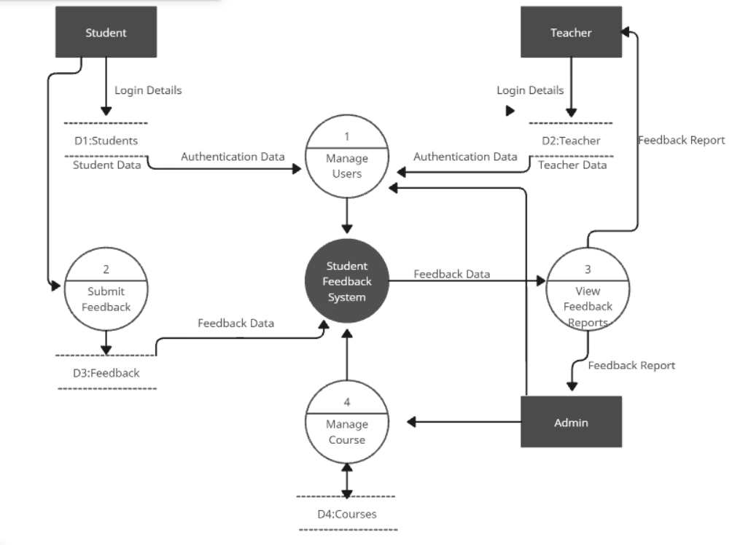
Figure 5:DFD (Level 1)
Processes Description
Process 1: Manage Users
- This process handles authentication of both students and teachers.
- Students and teachers provide login details.
- Authentication data is verified using Student Data (D1) and Teacher Data (D2).
- Upon successful authentication, users gain access to system functionalities.

Process 2: Submit Feedback
- This process allows students to submit feedback.
- Students provide feedback data such as rating and comments.
- The feedback is stored in the Feedback Data Store (D3).
- Submitted feedback is forwarded to the central Student Feedback System for processing

Process 3: View Feedback Reports
- This process enables teachers and administrators to view feedback reports.
- The system retrieves feedback data from the database.
- Teachers receive feedback reports related to their courses.
- Admin receives comprehensive feedback reports for monitoring and evaluation.
Process 4: Manage Course
- This process is controlled by the admin.
- Admin adds, updates, or deletes course information.
- Course details are stored and maintained in the Courses Data Store (D4).
- Updated course data is made available for feedback submission.

Data Stores
D1: Students: Stores student login and profile information.
D2: Teachers: Stores teacher login and profile information.
D3: Feedback: Stores submitted feedback details.
D4: Courses: Stores course-related information.

3.2 System Design
System design translates the requirements identified during system analysis into a structured blueprint that guides the implementation of the Student Feedback System. This phase focuses on defining the system architecture, database structure, interface layout, and process representation to ensure efficiency, usability, and maintainability.

3.2.1 Architectural Design
The Student Feedback System follows a web-based client–server architecture.
- Client Side:
Users (Students, Teachers, and Admin) interact with the system using a web browser. The interface is developed using HTML and CSS to ensure simplicity and consistency.
- Server Side:
The server processes requests, handles authentication, manages feedback submission, and retrieves data using PHP.
- Database Layer:
MySQL is used as the backend database to store user information, courses, and feedback records securely.
This architecture ensures centralized data management, easy access, and scalability for future enhancements.
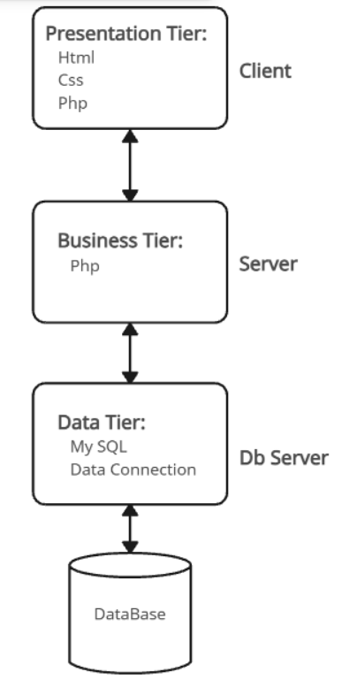
Figure 6:Architecture Design

3.2.2Database Schema Design
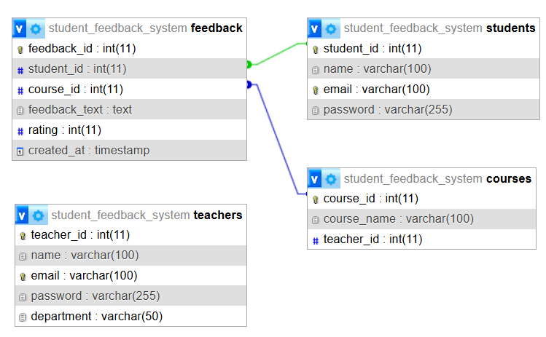
Figure 7:Database Schema Design
The database schema of the Student Feedback System (SFS) is designed using a relational database model to ensure data integrity, consistency, and efficient data retrieval. The system uses MySQL as the backend database. The schema consists of four major tables: Students, Teachers, Courses, and Feedback. Proper primary key and foreign key constraints are used to establish relationships among these tables.
- Students Table
The Students table stores information related to students who provide feedback. Each student is uniquely identified by a student ID.
- student_id (Primary Key)
- name
- email
- password
This table is used for student authentication and identification during feedback submission.
- Teachers Table
The Teachers table maintains information about teachers who receive feedback from students.
- teacher_id (Primary Key)
- name
- email
- password
- department
Each teacher belongs to a specific department such as BCA or CSIT.
- Courses Table
The Courses table stores details of courses offered in the system and their assigned teachers.
- course_id (Primary Key)
- course_name
- teacher_id (Foreign Key)
The teacher_id acts as a foreign key referencing the Teachers table, establishing a one-to-many relationship between teachers and courses.
- Feedback Table
The Feedback table records feedback submitted by students for specific courses.
- feedback_id (Primary Key)
- student_id (Foreign Key)
- course_id (Foreign Key)
- rating
- feedback_text
- created_at
This table links students, courses, and teachers together, allowing the system to track feedback details accurately.

3.2.3 Interface Design
The interface design focuses on simplicity, usability, and consistency.
- Student Interface:
Allows students to log in, select courses, submit feedback, and view submission confirmation.
- Teacher Interface:
Enables teachers to log in and view feedback reports related to their courses.
- Admin Interface:
Provides functionality to manage students, teachers, courses, and view overall feedback reports.
An orange-themed color scheme is used throughout the system to maintain a consistent look and feel.
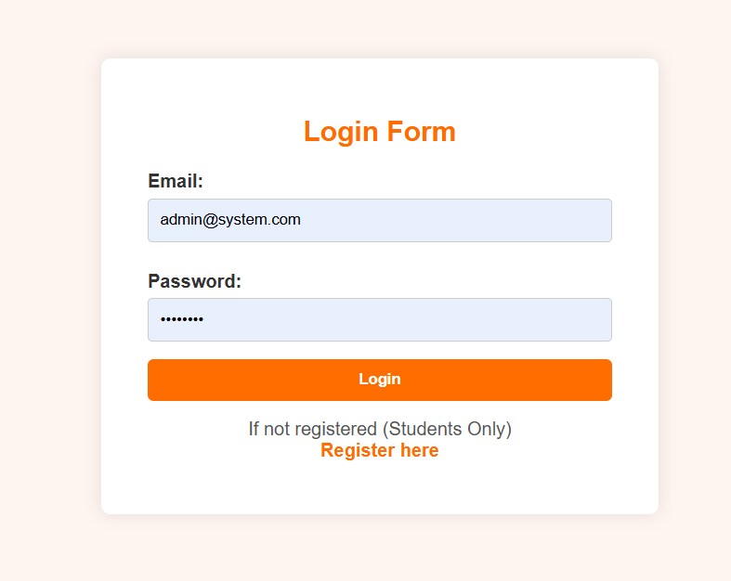
Figure 8:Login Interface Design

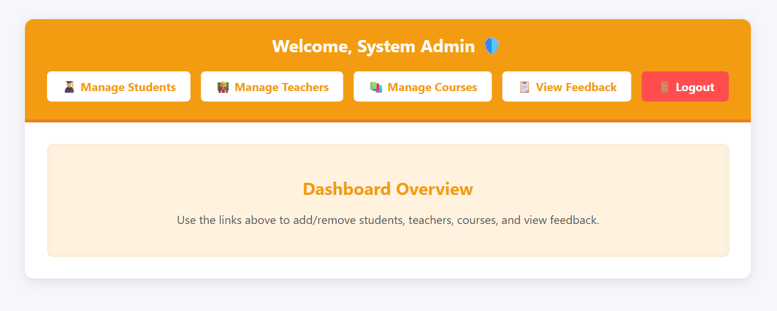
Figure 9:Dashboard Interface Design

3.2.4 Physical DFD
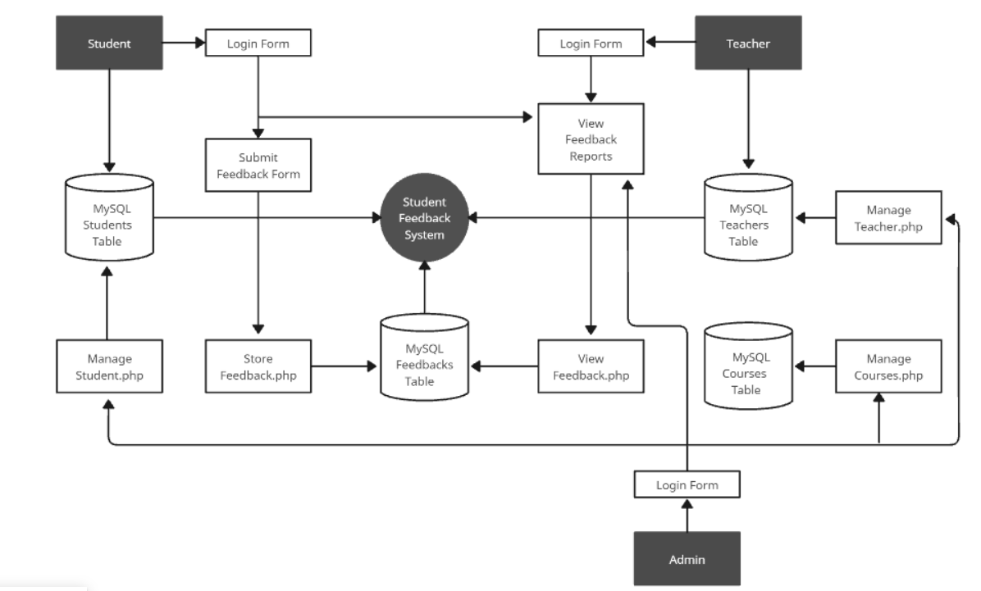
Figure 10:Physical level DFD for Student Feedback System
The Physical Data Flow Diagram (DFD) illustrates the actual implementation of the Student Feedback System. It represents real system components such as PHP scripts, MySQL database tables, and user interfaces used during system operation. Students, teachers, and administrators interact with the system through login forms. Student feedback is submitted using feedback forms and stored in the MySQL feedback table through server-side PHP scripts. Teachers and administrators retrieve feedback reports via view modules. Administrative functions such as managing students, teachers, and courses are handled through dedicated PHP programs connected to corresponding database tables. This diagram clearly demonstrates how data flows through physical components of the system during real-time execution.

CHAPTER 4: IMPLEMENTATION AND TESTING

4.1 Implementation
This chapter describes the actual development of the Student Feedback System (SFS). It explains the tools used, system architecture, and implementation of major modules. The system is implemented as a web-based application that allows students to submit feedback, teachers to view feedback reports, and administrators to manage users and courses.

4.1.1 Tools Used

- CASE Tools (Computer-Aided Software Engineering):
- phpMyAdmin: A web-based client for the administration of MySQL using the graphic shell. That means using without having to write the SQL commands themselves, creating, editing and deleting databases, tables and records. It provides import/export of data, SQL query execution, user permission management, and performance optimization for databases, which makes it a favorite with web developers and admins.
- Xampp: an open source and free software that offers a local web development environment. It refers to Apache (web server), MySQL/MariaDB (database management), PHP (server-side scripting), and Perl. XAMPP enables developers to install and keep their web applications on their own machines for testing and running them, even before going live server side. It is popular for PHP projects and comes with applications such as phpMyAdmin for convenient management of databases.
- Creately: This tool was used to create diagramming tool like DFD, ER diagram for system analysis and design.

- Back-end Tools:
- PHP: a server-side scripting language used for creating dynamic and interactive web applications. It handles data processing, database management, user authentication, and content generation, all of which it does before it sends HTML pages to the browser via the client. PHP is usually used with HTML and alongside databases such as MySQL to create actionable and data-driven sites.

- Programming Languages:
- PHP: Used for developing the dynamic and interactive backend logic of the Library Management System, enabling server-side operations, form processing, and data handling.
- HTML & CSS: Used for designing the frontend of the Library Management System, ensuring a structured layout and visually appealing interface. HTML defines the content structure, CSS enhancing HTML by ensuring a consistent and user-friendly design.
- SQL: Used for managing and manipulating MySQL database, handling CRUD operations, and ensuring efficient data storage and retrieval in phpMyAdmin.

4.1.2 Implementation Details of Modules
The Student Feedback System is divided into several functional modules. Each module performs a specific task within the system.
a) User Authentication Module
This module handles login functionality for students, teachers, and administrators.
- Validates user credentials using email and password.
- Uses PHP sessions to maintain login state.
- Prevents unauthorized access to restricted pages.
Outcome:
Only authenticated users can access their respective dashboards.

b) Student Module
The student module allows students to submit feedback for courses.
Functions include:
- Student login
- Viewing assigned courses
- Submitting feedback with ratings and comments
- Preventing duplicate or invalid submissions
Outcome:
Students can easily provide structured feedback through a simple interface.
c) Teacher Module
The teacher module enables teachers to view feedback related to their courses.
Functions include:
- Teacher login
- Viewing aggregated feedback reports
- Analyzing ratings and comments submitted by students
Outcome:
Teachers can evaluate teaching performance and improve course delivery.
d) Admin Module
The admin module provides complete control over the system.
Functions include:
- Managing students (Add, View, Delete)
- Managing teachers
- Managing courses
- Viewing overall feedback reports
Outcome:
Administrators can efficiently manage system data and monitor feedback activity.
e) Feedback Management Module
This module handles storage and retrieval of feedback data.
- Stores feedback securely in the database
- Maintains relationships between students, courses, and teachers
- Ensures data consistency using foreign keys
Outcome:
Feedback data is stored systematically and can be retrieved efficiently.

4.2 Testing
Testing was conducted to ensure that the Student Feedback System works correctly and meets the specified requirements. Both unit testing and system testing were performed.

4.2.1 Test Cases for Unit Testing
Unit testing ensures that each individual component of the Student Feedback System(SFS) functions correctly. Below are detailed test cases for the key modules, including the input, expected output, and purpose of each test.

Table 1:Test cases for unit testing
Test case ID | Module | Input Condition | Expected Output | Actual Output | Update Made | Final Result
UT-1 | Login | valid username and password | Successful login | Successful login | Not required | Pass
UT-2 | Login | Invalid password | Error message | Page reload without message | Added validation message in php | pass
UT-3 | feedback  submit | All fields not filled | Error message | Feedback saved | Added form validation logic | pass

4.2.2. Test cases for System Testing
System testing verifies the complete functionality of the system as a whole.
Table 2:Test cases for system testing
Test case ID | Scenario | Expected Output | Actual Output | Problem Identified | Update Made | Final result
ST-1 | Student submits feedback | Feedback stored and success message shown | Message not shown | Message not shown | Added success message after submission | Pass
ST-2 | Teacher views feedback | Correct feedback displayed | Incomplete feedback shown | SQL query missing join condition | Corrected SQL join query | Pass
ST-3 | Admin deletes courses | Course deleted | Course deleted | No problems | Not needed | Pass
ST-4 | Unauthorized user access | Redirect to login | Page accessible | Session not checked | Added session validation | pass

CHAPTER5: CONCLUSION AND FUTURE RECOMMENDATIONS

5.1 Lesson Learnt/Outcome
During the development of the Student Feedback System, several important lessons were learned. This project helped in understanding the complete software development life cycle, including requirement analysis, system design, implementation, testing, and documentation.
The project improved practical knowledge of web technologies such as HTML, CSS, PHP, and MySQL. It also enhanced skills in database design, user authentication, and data handling. Problem-solving skills were developed by identifying errors during testing and implementing appropriate solutions.
The outcome of this project is a functional and reliable Student Feedback System that allows students to submit feedback, teachers to view feedback reports, and administrators to manage users and courses effectively.

5.2 Conclusion
The Student Feedback System was successfully designed and implemented to automate the feedback collection process in educational institutions. The system reduces manual effort, improves data accuracy, and ensures secure handling of feedback information.
All the objectives of the project were achieved within the defined scope. The system provides an easy-to-use interface, reliable performance, and basic security features. Testing results confirmed that the system performs as expected after necessary corrections.
Overall, the project meets academic requirements and can be practically used in small to medium-sized institutions.

5.3 Future Recommendations
The Student Feedback System can be further enhanced in the future by implementing the following improvements:
- Integration of graphical reports and charts for better feedback analysis.
- Development of a mobile application version of the system.
- Addition of anonymous feedback functionality.
- Implementation of email or SMS notification services.
- Enhancement of security using encryption and advanced authentication methods.
- Optimization for handling a large number of users and feedback records.

REFERENCES
[1] I. Sommerville, Software Engineering, 10th ed. Boston, MA, USA: Pearson Education, 2016.
(Used for system development life cycle, requirements analysis, and feasibility study.)
[2] R. S. Pressman and B. R. Maxim, Software Engineering: A Practitioner’s Approach, 8th ed. New York, NY, USA: McGraw-Hill Education, 2014.
(Referenced for software design, testing, and quality attributes.)
[3] T. Connolly and C. Begg, Database Systems: A Practical Approach to Design, Implementation, and Management, 6th ed. Harlow, UK: Pearson Education, 2015.
(Used for database schema design, normalization, and ER-diagram concepts.)
[4] A. Al-Shayea, “A Web-Based Student Feedback System for Academic Performance Evaluation,” International Journal of Computer Applications, vol. 181, no. 25, pp. 1–6, 2018.
(Referenced in literature review to discuss similar student feedback systems.)
[5] W3Schools, “PHP Tutorial,” 2024. [Online]. Available: https://www.w3schools.com/php/.
(Used for PHP syntax, session handling, and form processing.)
[6] W3Schools, “MySQL Database Tutorial,” 2024. [Online]. Available: https://www.w3schools.com/mysql/.
(Used for SQL queries, relational database concepts, and CRUD operations.)
[7] IEEE Computer Society, “IEEE Recommended Practice for Software Requirements Specifications,” IEEE Std 830-1998, 1998.
(Referenced for SRS structure and documentation standard.)

APPENDIXES

User Interface
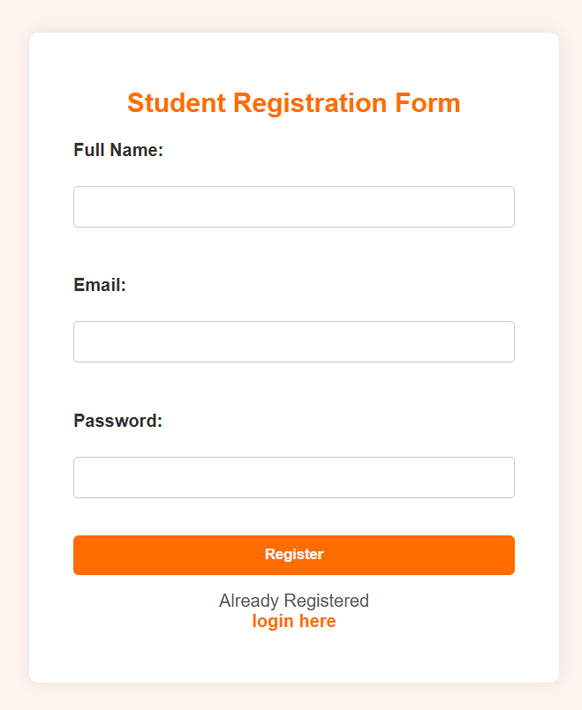
Figure 11:Student Registration Form UI

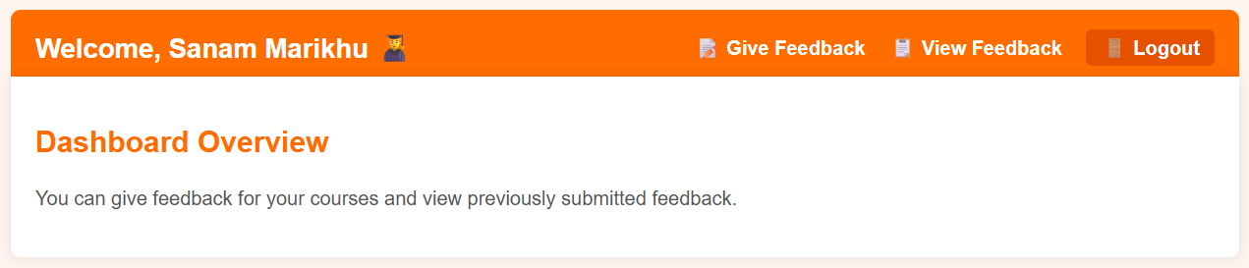
Figure 12: Student Dashboard UI

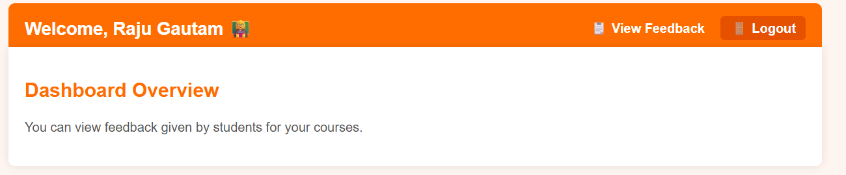
Figure 13:Teacher Dashboard UI
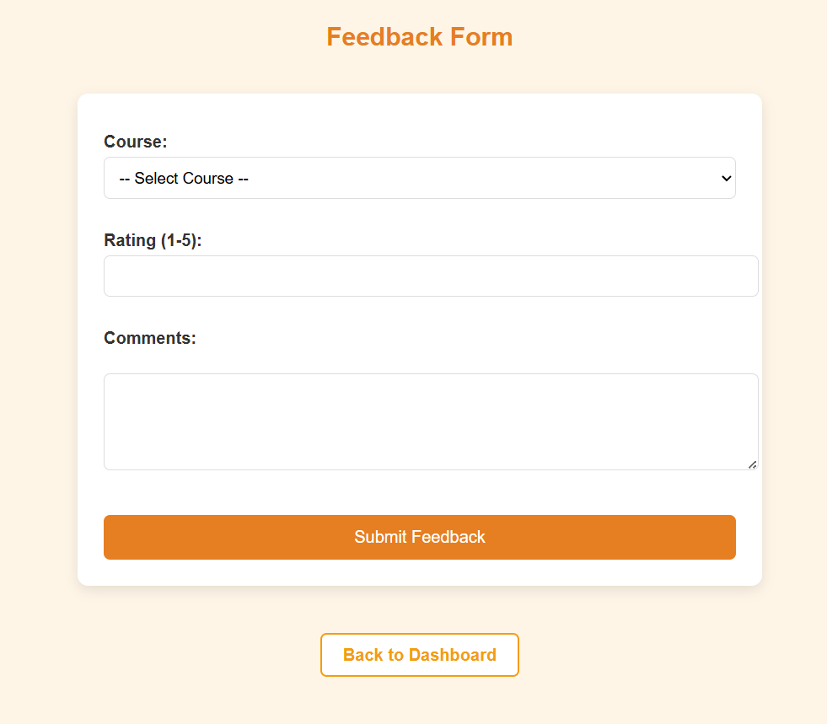
Figure 14:Feedback Form UI

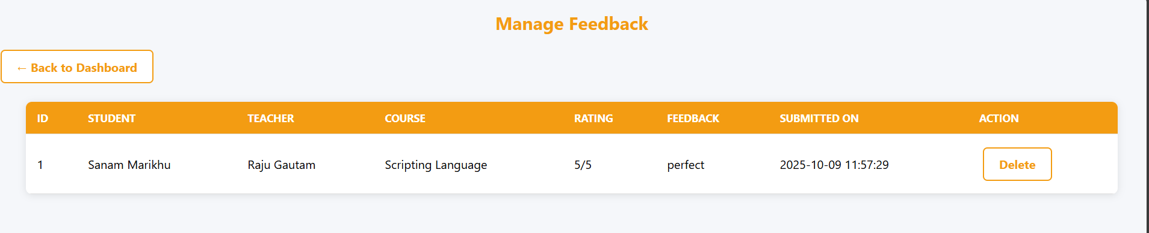
Figure 15:Feedback Report UI
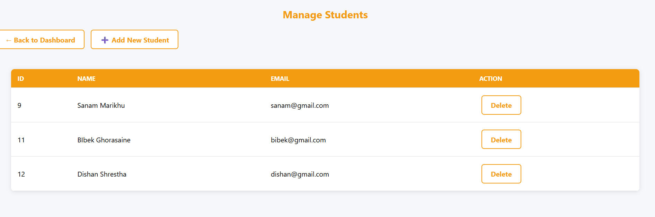
Figure 16:Manage Student UI

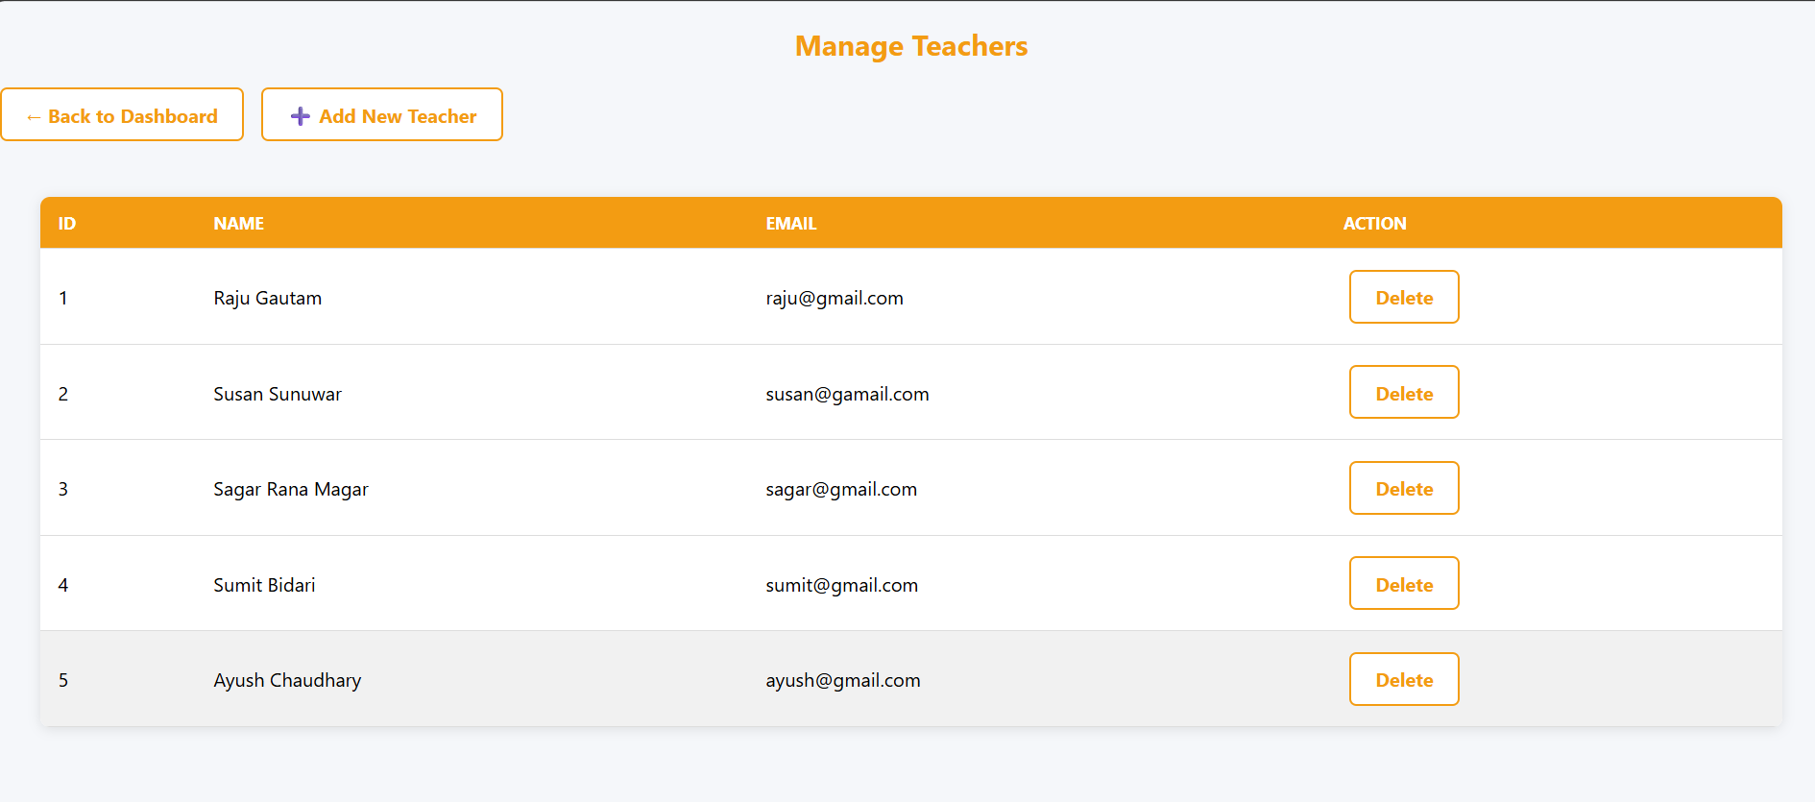
Figure 17:Manage Teacher UI

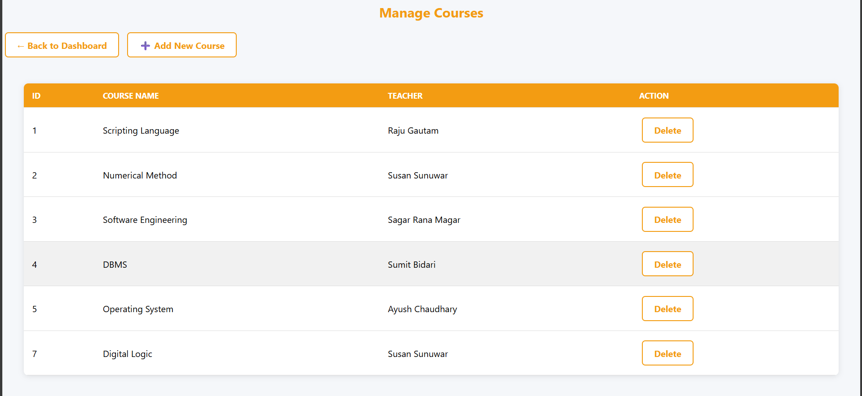
Figure 18:Manage Course UI

