2018

Sanam Duwal(c7181417)

British College

11/23/2018

Bug Traking



Login Form

-Login with validation

-type

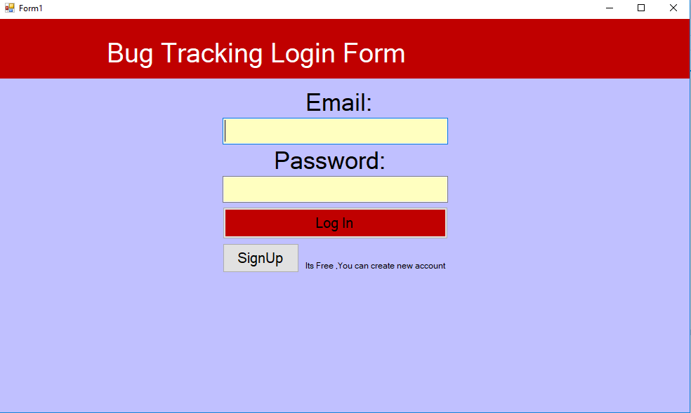

2. Registration

-Validation

-Requirement

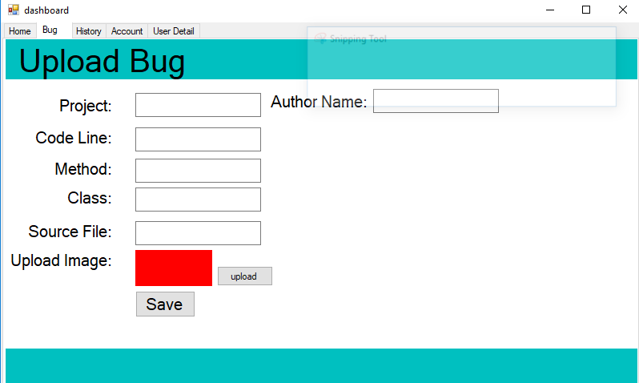

3. Dashboard

-Admin dashboard

-Programmer Dashboard

-Tester Dashboard

