

Graphical representation

[Document subtitle]



January 14, 2019

Submitted to :resham pun

Sanam Duwal(c7181417

**TRELLO**

https://trello.com/b/DJzILpPu/new

AGILE DEVELOPMENT

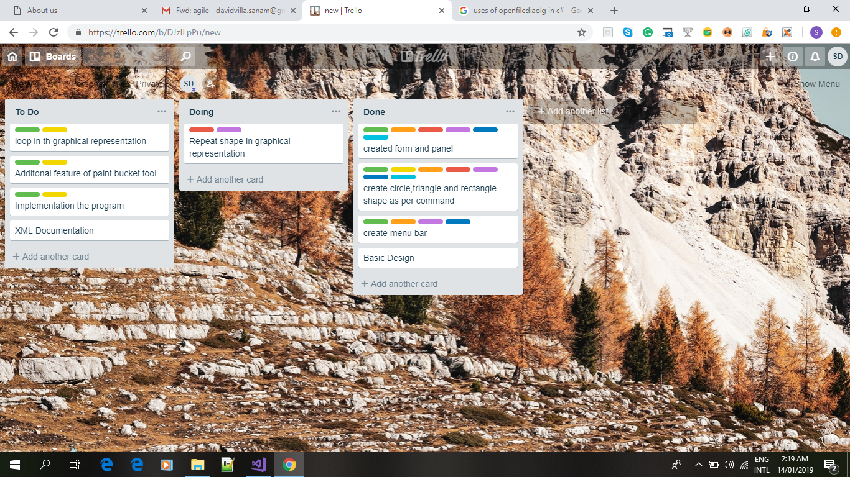

Agile software development is a set of principles for software development in which requirements and solutions evolve through collaboration between self-organizing, cross-functional teams. It promotes adaptive planning, evolutionary development, early delivery, and continuous improvement, and it encourages rapid and flexible response to change.

**VERSION CONTROL**

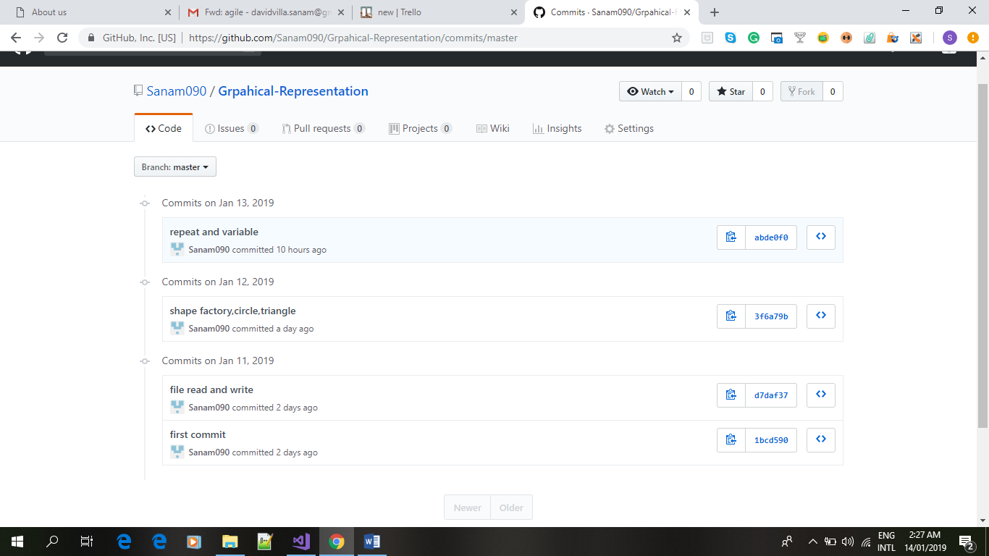

**Version control** is a system that records changes to a file or set of files over time so that you can recall specific versions later. For the examples in this book, you will use software source code as the files being **version** controlled, though in reality you can do this with nearly any type of file on a computer.

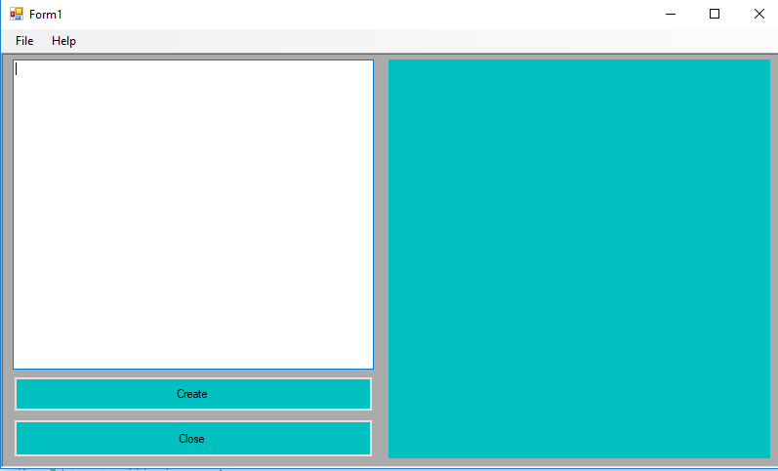

**This is the first frame which is seen when the program is started.**

**UNIT TESTING**

|  |  |  |  |  |  |  |
| --- | --- | --- | --- | --- | --- | --- |
| **Steps** | **Test Data** | **Expected result** | **Actual result** | **Pass/fail** | **Class** | **Method** |
|  | **Parameter length** | **2 parameter value passed** | **Valid parimeter must be passed** | **passed** | **shapeRectangle** | **setData** |
|  | **Height and width of parameter** | **2 parameter value passed** | **Valid parimeter must be passed** | **passed** | **shapeTriangle** | **SetaData** |

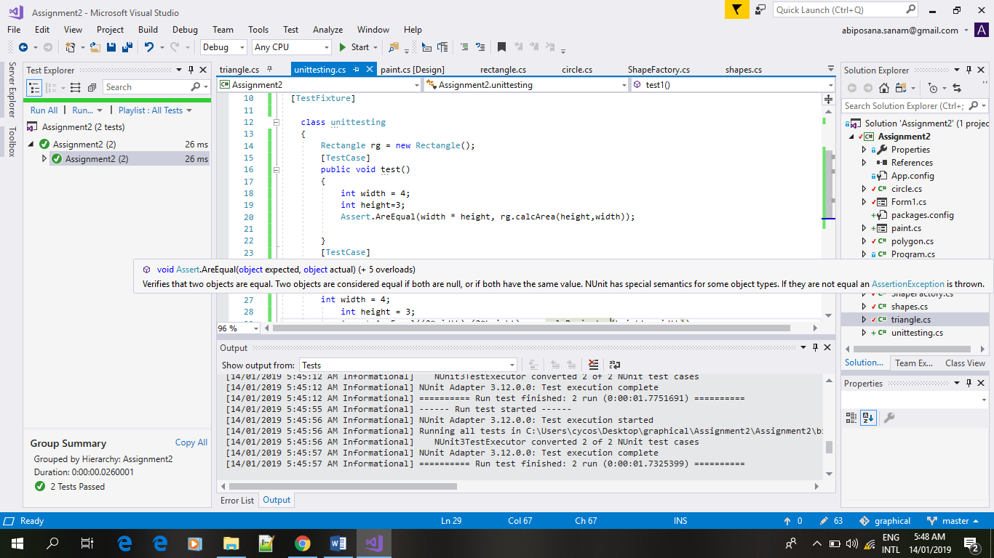

NUnit has a graphical user interface ([GUI](https://searchwindevelopment.techtarget.com/definition/GUI)) similar to that used in JUnit. Tests can be run continuously. Results are provided immediately. Multiple tests can be run concurrently. No subjective human judgments or interpretations of test results are required. This is a testing nunit process where I check different shapes of class whether the valid parameter is passed or not.