GOMENDRA MULTIPLE COLLEGE

**Birtamode-04, Jhapa**

**Affiliated to Purbanchal University**



**Program: BCA-IT**

**Semester: First**

**Faculty of Science and Technology**

**Project report on**

**PUBLIC CHOICE AWARD VOTING SYSTEM**

**Submitted by : Under the supervision of**

**Sanam Acharya Assistant lecturer:**

**Sanjok Tamang Mr. Nabin Prasain**

**Acknowledgement**

In the pursuit of our Bachelor in Computer Application degree, we embarked on an enriching journey during the first semester, tasked with the creation of a significant project - the "Voting Management System." This endeavor not only served as a pivotal component of our academic journey but also as a testament to our collaborative spirit and our introduction to the practical intricacies of software development.

This report serves as a comprehensive documentation of the system's requirements and design, meticulously articulated in natural language to provide a lucid understanding of each facet. We would like to extend our heartfelt gratitude to Gomendra Multiple College for providing us with the platform to undertake and complete this project successfully.

Our profound appreciation goes to our mentor and guide, Mr. Nabin Prasain, whose unwavering support and encouragement propelled us through the challenging phases of the project. His guidance, insightful suggestions, and willingness to navigate us through obstacles were instrumental in the project's triumph. We extend our thanks to the entire faculty of the Department of Computer Application for their continuous support and invaluable guidance, which nurtured our growth and learning throughout this endeavor.

Lastly, we want to express our gratitude to our friends, whose unwavering support, constant encouragement, and invaluable suggestions were a source of motivation and inspiration throughout the project's duration. This project has not only broadened our horizons but has also affirmed the importance of collaboration, dedication, and innovation in the field of computer science. We look forward to applying the knowledge and experiences gained here in our future endeavors.

**Table of Contents**

|  |  |  |
| --- | --- | --- |
| S.N | Contents | Page Number |
| 1 | Introduction to Project | 1 |
| 2 | Objectives | 2 |
| 3 | Importance of Voting Management System | 3 |
| 4 | System Requirements | 4 |
| 5 | Flow Chart | 5 |
| 6 | Source Code | 6 |
| 7 | Output | 17 |
| 8 | Future use and implementation | 20 |
| 9 | Group Information/ Feasibility Information | 21 |
| 10 | Conclusion | 22 |
| 11 | Bibliography | 23 |

**Introduction of Project**

Title: Public Choice Award Voting System

Introduction:

The "Public Choice Awards Voting System" is a versatile C program designed to facilitate the process of casting votes for the best actors in various roles in a movie awards event. This project aims to provide a user-friendly platform for movie enthusiasts to participate in the voting process for their favorite actors and actresses.

Key Features:

This program boasts several key features, including:

1. User Authentication: Before casting a vote, users are required to enter their phone number. This ensures that each user can only cast one vote, preventing duplicate votes and ensuring fairness in the voting process.

2. Casting Votes: Users can cast their votes for the best actors in different categories, including lead roles for both male and female actors, as well as supporting roles for male and female actors.

3. Real-time Vote Tally: The program keeps a real-time tally of the votes received by each actor in all categories, allowing users to see the current standings.

4. Menu-driven Interface: The user interface is menu-driven, making it easy for users to navigate and cast their votes or view the results.

Objectives of the project

Project overview:

The primary objective of the "Voting System for Best Actor Awards" program is to create a user-friendly application that facilitates the voting process for selecting the best actors in various categories, including lead roles (male and female) and supporting roles (male and female). This program serves several key objectives:

Objectives:

1. Enable User Voting: The program allows users to cast their votes for their favorite actors in different award categories. It ensures a simple and accessible voting process.

2.Ensure Fairness: To maintain the integrity of the voting process, the program checks whether a user has already cast their vote using their phone number. This prevents multiple votes from the same user and ensures a fair competition.

3. Collect and Tabulate Votes: The program records the votes received by each actor in the respective categories. It then calculates and displays the total votes garnered by each actor in real-time.

4. Display Results: Users can view the voting results at any time by selecting the "See Result" option from the menu. The program displays the current vote tally for all actors in all categories.

5. Save Results to File: To preserve the voting results for future reference or analysis, the program provides an option to save the results to a file named "voting_results.txt." This allows for easy record-keeping and sharing of the outcomes.

6. User-Friendly Interface: The program offers a user-friendly menu-driven interface that guides users through the voting process, ensuring a seamless experience.

# Importance of Voting Management System

**1. Engaging the Audience:** This voting system actively engages the film-loving audience in the decision-making process, making them feel like an integral part of the entertainment industry. This engagement can lead to increased enthusiasm and participation.

**2.Democratizing Awards:** By allowing anyone with a valid phone number to vote, the system democratizes the awards process. It ensures that everyone's voice, regardless of their background or affiliations, is heard and considered.

**3.Transparency and Fairness:** The system maintains transparency and fairness by preventing duplicate votes through phone number verification. This guarantees that the awards are given based on legitimate votes, enhancing the credibility of the results.

**4. Feedback to the Film Industry:** The collected voting data provides valuable feedback to the film industry about the preferences of the audience. This information can influence casting decisions, film marketing, and content creation, leading to the production of movies that better align with audience tastes.

**5. Data-Driven Insights:**The system generates data that can be analyzed to identify trends and patterns in voting behavior. These insights can be used to tailor future marketing campaigns and film productions to align with popular choices.

**6. Promoting Talent:** By recognizing and awarding actors in different categories, this system encourages and promotes emerging talents. Actors who excel in their roles can gain recognition and potentially further their careers.

**7. Adding Credibility to Awards:** Public choice awards add credibility to the overall awards landscape. They are seen as a reflection of the audience's preferences and can complement industry-specific awards, providing a more comprehensive view of an actor's success.

**8. Enhancing Public Interest in Films:** The voting system generates interest and excitement among the public about upcoming films and performances. It motivates people to watch and discuss movies, ultimately benefiting the film industry.

# System Requirements

**Minimum System Requirements:**

* Operating System: Windows, Linux, or macOS.
* Processor: Dual-core processor (e.g., Intel Core i3 or equivalent).
* Memory (RAM): 2GB of RAM or higher.
* Storage: 50MB of free disk space for program installation and data storage.
* Input Devices: Standard keyboard and mouse for user interactions.
* Display: Monitor with a minimum resolution of 1024x768 pixels.
* Software Dependencies: A C compiler (e.g., GCC for Linux or MinGW for Windows) and standard C libraries.

These minimum requirements should allow you to run the Voting Management System project smoothly without encountering any major issues. However, for optimal performance and to accommodate larger datasets, it's recommended to use a system that exceeds these minimum specifications, especially in terms of RAM and processor capabilities.

**Flowchart**

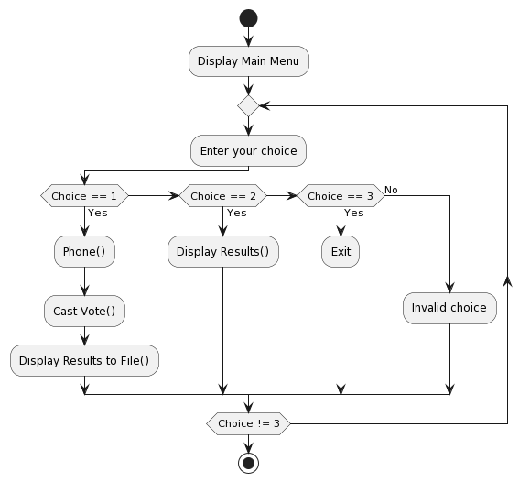

**Source Code**

#include <stdio.h>

#include <stdlib.h>

#define actor_lead_m1 "Chillian Murphy"

#define actor_lead_m2 "Leonardo DiCaprio"

#define actor_lead_m3 "Tom Cruise"

#define actor_lead_m4 "Johnny Depp"

#define actor_lead_f1 "Emma Watson"

#define actor_lead_f2 "Ana De Armas"

#define actor_lead_f3 "Emma Stone"

#define actor_lead_f4 "Jennifer Connelly"

#define actor_support_m1 "Jennifer Lawrence"

#define actor_support_m2 "Penelope Cruz"

#define actor_support_m3 "Alexandra Daddario"

#define actor_support_m4 "Emila Carkile"

#define actor_support_f1 "Rami Malik"

#define actor_support_f2 "Bruce Wayne"

#define actor_support_f3 "Robert John"

#define actor_support_f4 "Cris Brown"

int lead_role_male1_votes = 0, lead_role_male2_votes = 0, lead_role_male3_votes = 0, lead_role_male4_votes = 0;

int lead_role_female1_votes = 0, lead_role_female2_votes = 0, lead_role_female3_votes = 0, lead_role_female4_votes = 0;

int supporting_role_male1_votes = 0, supporting_role_male2_votes = 0, supporting_role_male3_votes = 0, supporting_role_male4_votes = 0;

int supporting_role_female1_votes = 0, supporting_role_female2_votes = 0, supporting_role_female3_votes = 0, supporting_role_female4_votes = 0;

int phone()

{

long long int number;

long long int another_number;

FILE *file = fopen("numbers.txt", "r");

if (file == NULL)

{

printf("Error opening the file.\n");

return 1;

}

printf("Enter your Phone Number: ");

scanf("%lld", &number);

int found = 0;

long long int num;

while (fscanf(file, "%lld", &num) == 1)

{

if (num == number)

{

found = 1;

break;

}

}

fclose(file);

if (found)

{

printf("Seems Like You Have Already Casted the Vote Try with another Phone Number!\n");

printf("Enter Different Number: ");

scanf("%lld", &another_number);

}

else

{

FILE *file = fopen("numbers.txt", "a+");

if (file == NULL)

{

printf("Please try again!\n");

return 1;

}

fprintf(file, "%lld\n", number);

fclose(file);

printf("YOU MAY PROCEED TO VOTE\n\n\n\n");

}

}

void castvote()

{

int vote;

do

{

printf("VOTE FOR BEST ACTOR IN THE LEAD ROLE MALE\n");

printf(" 1. %s\n", actor_lead_m1);

printf(" 2. %s\n", actor_lead_m2);

printf(" 3. %s\n", actor_lead_m3);

printf(" 4. %s\n", actor_lead_m4);

scanf("%d", &vote);

switch (vote)

{

case 1:

lead_role_male1_votes++;

break;

case 2:

lead_role_male2_votes++;

break;

case 3:

lead_role_male3_votes++;

break;

case 4:

lead_role_male4_votes++;

break;

default:

printf("Invalid choice. Please choose a valid option (1-4).\n");

}

} while (vote < 1 || vote > 4);

do

{

printf("VOTE FOR BEST ACTOR IN THE LEADING ROLE FEMALE\n");

printf(" 1. %s\n", actor_lead_f1);

printf(" 2. %s\n", actor_lead_f2);

printf(" 3. %s\n", actor_lead_f3);

printf(" 4. %s\n", actor_lead_f4);

scanf("%d", &vote);

switch (vote)

{

case 1:

lead_role_female1_votes++;

break;

case 2:

lead_role_female2_votes++;

break;

case 3:

lead_role_female3_votes++;

break;

case 4:

lead_role_female4_votes++;

break;

default:

printf("Invalid choice. Please choose a valid option (1-4).\n");

}

} while (vote < 1 || vote > 4);

do

{

printf("VOTE FOR BEST ACTOR IN THE SUPPORTING ROLE MALE\n");

printf(" 1. %s\n", actor_support_m1);

printf(" 2. %s\n", actor_support_m2);

printf(" 3. %s\n", actor_support_m3);

printf(" 4. %s\n", actor_support_m4);

scanf("%d", &vote);

switch (vote)

{

case 1:

supporting_role_male1_votes++;

break;

case 2:

supporting_role_male2_votes++;

break;

case 3:

supporting_role_male3_votes++;

break;

case 4:

supporting_role_male4_votes++;

break;

default:

printf("Invalid choice. Please choose a valid option (1-4).\n");

}

} while (vote < 1 || vote > 4);

do

{

printf("VOTE FOR BEST ACTOR IN THE SUPPORTING ROLE FEMALE\n");

printf(" 1. %s\n", actor_support_f1);

printf(" 2. %s\n", actor_support_f2);

printf(" 3. %s\n", actor_support_f3);

printf(" 4. %s\n", actor_support_f4);

scanf("%d", &vote);

switch (vote)

{

case 1:

supporting_role_female1_votes++;

break;

case 2:

supporting_role_female2_votes++;

break;

case 3:

supporting_role_female3_votes++;

break;

case 4:

supporting_role_female4_votes++;

break;

default:

printf("Invalid choice. Please choose a valid option (1-4).\n");

}

} while (vote < 1 || vote > 4);

}

void displayResults()

{

printf("VOTING RESULTS\n");

printf("---------------\n");

printf("BEST ACTOR IN THE LEAD ROLE MALE\n");

printf("%s: %d votes\n", actor_lead_m1, lead_role_male1_votes);

printf("%s: %d votes\n", actor_lead_m2, lead_role_male2_votes);

printf("%s: %d votes\n", actor_lead_m3, lead_role_male3_votes);

printf("%s: %d votes\n", actor_lead_m4, lead_role_male4_votes);

printf("\n");

printf("BEST ACTOR IN THE LEADING ROLE FEMALE\n");

printf("%s: %d votes\n", actor_lead_f1, lead_role_female1_votes);

printf("%s: %d votes\n", actor_lead_f2, lead_role_female2_votes);

printf("%s: %d votes\n", actor_lead_f3, lead_role_female3_votes);

printf("%s: %d votes\n", actor_lead_f4, lead_role_female4_votes);

printf("\n");

printf("BEST ACTOR IN THE SUPPORTING ROLE MALE\n");

printf("%s: %d votes\n", actor_support_m1, supporting_role_male1_votes);

printf("%s: %d votes\n", actor_support_m2, supporting_role_male2_votes);

printf("%s: %d votes\n", actor_support_m3, supporting_role_male3_votes);

printf("%s: %d votes\n", actor_support_m4, supporting_role_male4_votes);

printf("\n");

printf("BEST ACTOR IN THE SUPPORTING ROLE FEMALE\n");

printf("%s: %d votes\n", actor_support_f1, supporting_role_female1_votes);

printf("%s: %d votes\n", actor_support_f2, supporting_role_female2_votes);

printf("%s: %d votes\n", actor_support_f3, supporting_role_female3_votes);

printf("%s: %d votes\n", actor_support_f4, supporting_role_female4_votes);

printf("\n");

}

void displayMenu()

{

printf("1. Cast vote\n");

printf("2. See Result\n");

printf("3. Exit\n");

}

void displayResultsToFile()

{

FILE *outfile = fopen("voting_results.txt", "w"); // Open a file for writing

if (outfile == NULL)

{

printf("Error opening the file for writing.\n");

return;

}

fprintf(outfile, "VOTING RESULTS\n");

fprintf(outfile, "---------------\n");

fprintf(outfile, "BEST ACTOR IN THE LEAD ROLE MALE\n");

fprintf(outfile, "%s: %d votes\n", actor_lead_m1, lead_role_male1_votes);

fprintf(outfile, "%s: %d votes\n", actor_lead_m2, lead_role_male2_votes);

fprintf(outfile, "%s: %d votes\n", actor_lead_m3, lead_role_male3_votes);

fprintf(outfile, "%s: %d votes\n", actor_lead_m4, lead_role_male4_votes);

fprintf(outfile, "\n");

fprintf(outfile, "BEST ACTOR IN THE LEADING ROLE FEMALE\n");

fprintf(outfile, "%s: %d votes\n", actor_lead_f1, lead_role_female1_votes);

fprintf(outfile, "%s: %d votes\n", actor_lead_f2, lead_role_female2_votes);

fprintf(outfile, "%s: %d votes\n", actor_lead_f3, lead_role_female3_votes);

fprintf(outfile, "%s: %d votes\n", actor_lead_f4, lead_role_female4_votes);

fprintf(outfile, "\n");

fprintf(outfile, "BEST ACTOR IN THE SUPPORTING ROLE MALE\n");

fprintf(outfile, "%s: %d votes\n", actor_support_m1, supporting_role_male1_votes);

fprintf(outfile, "%s: %d votes\n", actor_support_m2, supporting_role_male2_votes);

fprintf(outfile, "%s: %d votes\n", actor_support_m3, supporting_role_male3_votes);

fprintf(outfile, "%s: %d votes\n", actor_support_m4, supporting_role_male4_votes);

fprintf(outfile, "\n");

fprintf(outfile, "BEST ACTOR IN THE SUPPORTING ROLE FEMALE\n");

fprintf(outfile, "%s: %d votes\n", actor_support_f1, supporting_role_female1_votes);

fprintf(outfile, "%s: %d votes\n", actor_support_f2, supporting_role_female2_votes);

fprintf(outfile, "%s: %d votes\n", actor_support_f3, supporting_role_female3_votes);

fprintf(outfile, "%s: %d votes\n", actor_support_f4, supporting_role_female4_votes);

fprintf(outfile, "\n");

fclose(outfile); // Close the file

}

int main()

{

while (1)

{

int userChoice;

displayMenu();

printf("Enter your choice: ");

scanf("%d", &userChoice);

switch (userChoice)

{

case 1:

phone();

castvote();

displayResultsToFile();

break;

case 2:

displayResults();

break;

case 3:

printf("Exiting...\n");

exit(0);

default:

printf("Invalid choice.\n");

break;

}

}

return 0;

}

**Output/ Application Overview Windows**

**Menu window**

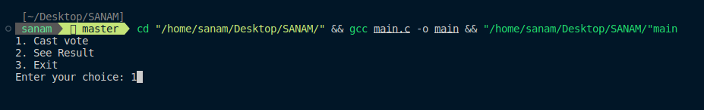

**Authentication window to prevent multiple votes**

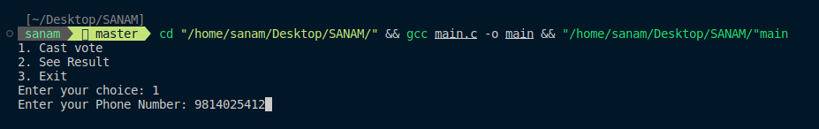

**Voting window after user authenticating:**

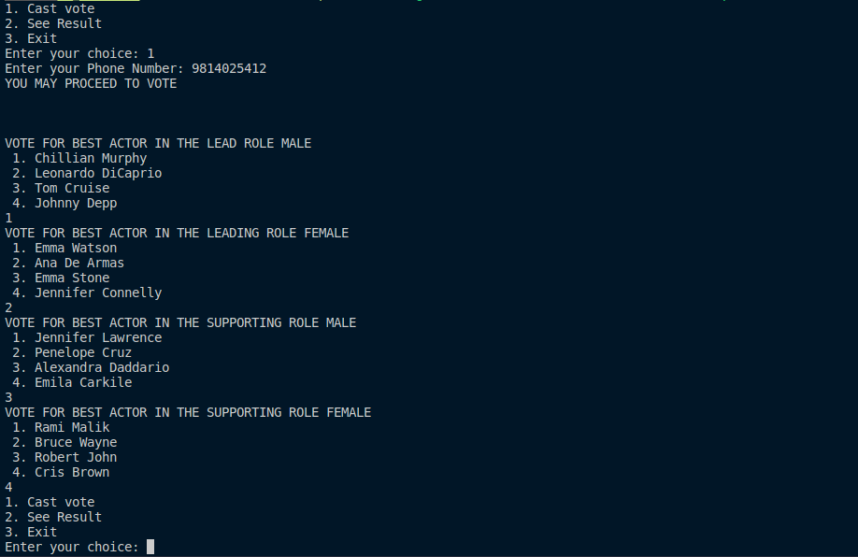

**Voting result:**

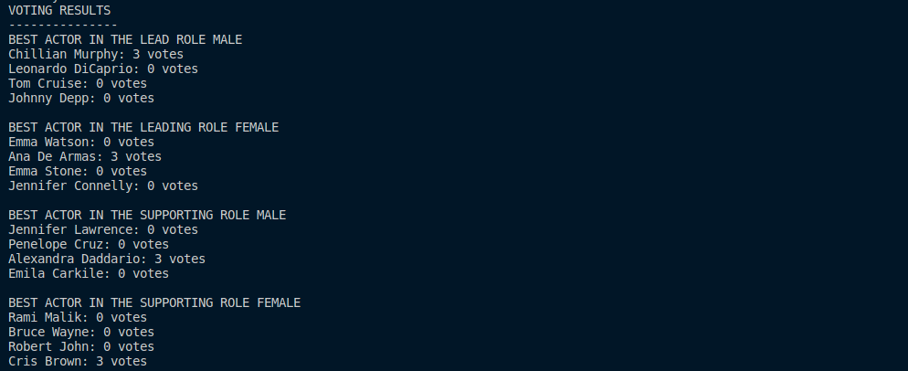

**Voting result save in ‘voting_results.txt’ file:**

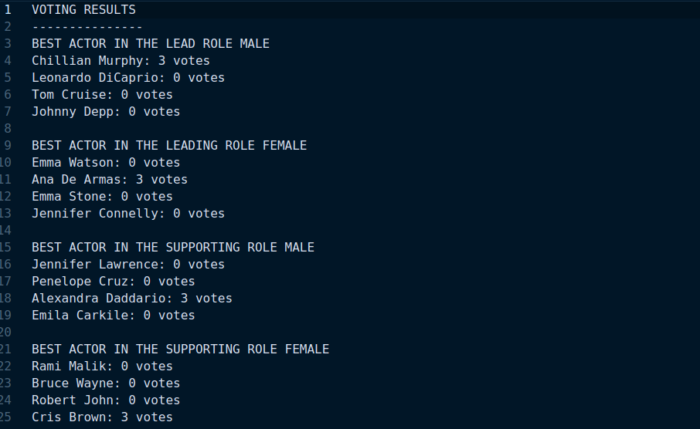

**Exiting the program:**

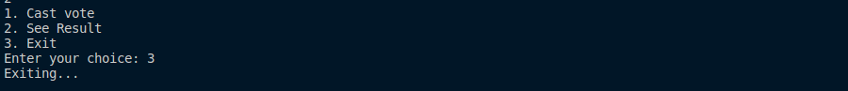

**Future uses and implementation**

The "Public Choice Award Voting System" is a versatile platform meticulously crafted to involve the public actively in the selection of the finest actors across diverse categories, encompassing lead and supporting roles for both male and female performers. This system kickstarts the voting process by soliciting user phone numbers as a fundamental authentication mechanism, assuring the integrity and accuracy of the voting endeavor.

In pursuit of future improvements and adaptations, numerous avenues beckon. To fortify the system's foundation, it is essential to fortify security measures with the introduction of more advanced user authentication techniques. By evolving the system into a web-based application, its reach can be magnified manifold, transcending geographical boundaries and ensuring inclusivity. Integrating a robust database solution emerges as a pivotal step towards optimizing data management, enhancing security, and facilitating comprehensive analysis of voting trends.

An exciting prospect for the system's evolution entails the implementation of real-time vote counting and result dissemination, infusing a sense of immediacy and engagement among users. Additionally, the introduction of user profiles provides an avenue for individuals to track their voting history, imbuing a personalized dimension to the experience. Crafting dedicated mobile applications further extends accessibility, enabling users to cast their votes conveniently from their smartphones.

Beyond its immediate utility, the "Public Choice Award Voting System" holds the potential to serve as an educational tool, facilitating the exploration of programming concepts and software development principles. Its adaptability extends beyond the realm of award voting, finding applications in diverse public voting scenarios, each time championing the tenets of security, transparency, and fairness in the decision-making process. This multifaceted system emerges as a dynamic platform poised to evolve and adapt to the ever-changing landscape of public choice award voting, consistently prioritizing user experience and the integrity of the democratic process.

**Feasibility Information / Group Information**

**Student Name: Sanam Acharya**

|  |  |  |  |  |
| --- | --- | --- | --- | --- |
| S.N | Job description | Date from | Date to | Reference |
| 1 | Requirement Gathering | 9th August | 15th August |  |
| 2 | Coding | 16th August | 22th August |  |
| 3 | Testing | 23th August | 26th August |  |
| 4 | Debugging | 27th August | 29th August | Gathered together and had discissions about project |

**Student Name: Sanjok Tamang**

|  |  |  |  |  |
| --- | --- | --- | --- | --- |
| S.N | Job description | Date from | Date to | Reference |
| 1 | Requirement Gathering | 9th August | 15th August |  |
| 2 | Testing | 16th August | 22th August |  |
| 3 | Documentation | 29th August | 31st August | We both equally divided the documentation |

**Conclusion**

In conclusion, the "Public Choice Award Voting System" represents an innovative and inclusive approach to involving the public in the selection of outstanding actors across various categories. By initiating the voting process with phone number authentication, it ensures the fairness and accuracy of the results. However, its potential for growth and enhancement is boundless.

As we look to the future, this system can evolve into a formidable tool for public engagement and decision-making. Strengthening security measures, transforming into a web-based application, and integrating databases are essential steps to ensure scalability, accessibility, and data management efficiency. Real-time updates, user profiles, and mobile applications offer a more personalized and engaging voting experience.

Moreover, beyond its immediate utility, this system has the potential to serve as an educational instrument, teaching programming concepts and software development principles. Its adaptability for various public voting scenarios underscores its versatility.

In a world where public opinion matters, the "Public Choice Award Voting System" stands as a beacon of transparency, inclusivity, and fairness, allowing the public's voice to resonate in the world of entertainment. Its journey of evolution and adaptation is a testament to its commitment to continually prioritize user experience and the integrity of the democratic process.

**Bibliography**

To complete this project we took help of following Sites , Books and Videos.

**Websites:**

* github.com/cognitive-ninja/Mini-Voting-System
* stackoverflow.com/questions/840501/how-do-function-pointers-in-c-work
* stackoverflow.com/questions/41857146/how-to-use-array-and-file-handling-in-c
* chat.openai.com
* [www.plantuml.com/plantuml/uml](http://www.plantuml.com/plantuml/uml)

**Books:**

* C Programming A Modern Approach(Author: K.N. King)
* The C Programming Language(Author: Brian W. Kernighan)

**Video Links**

* youtube.com/watch?v=4dX_hQ7A_8M
* youtube.com/watch?v=irqbmMNs2Bo
* youtube.com/watch?v=RhLSYjDXB4Q
* youtube.com/watch?v=fltaqGek-oA