**GOMENDRA MULTIPLE COLLEGE**

**Birtamod-4, Jhapa**

**Affilitated to Purbanchal University**

**Program: BCA-IT**

**Semester: First**

**Faculty: Science and Technology**

Project report on

**PUBLIC CHOICE AWARD VOTING SYSTEM**

**Submitted by :**

**1. Sanjog Tamang**

**2. Sanam Acharya**

**Under the supervision of**

**Assistant lecturer:**

**Mr. Nabin Prasain**

**ACKNOWLEDGEMENT**

I would like to express my sincere gratitude to all those who have contributed to the successful completion of this college project, titled "Public Choice Award Voting System”. First and foremost, I would like to thank **Gomendra Multiple College** for providing me with the opportunity to work on this project, which allowed me to apply my programming skills and gain valuable experience in software development.

I am deeply thankful to my project supervisor, **Mr. Nabin Prasain**, for guidance, support, and valuable insights throughout the project. Their expertise and feedback were instrumental in shaping the project's direction and ensuring its successful completion. I would also like to extend my appreciation to my fellow classmates and friends who provided valuable feedback and assistance during the development and testing phases of the project. Their contributions were invaluable in identifying and resolving issues in the system.

Additionally, this project has been a significant learning experience, and I am grateful for the opportunity to work on it. I hope that this "Public Choice Award Voting System" serves as a testament to the skills and knowledge I have gained during my time at **Gomendra Multiple College**.

Lastly, this project has not only broadened our horizons but has also affirmed the importance of

collaboration, dedication, and innovation in the field of computer science. We look forward to

applying the knowledge and experiences gained here in our future endeavors.

**Table of Contents**

|  |  |  |
| --- | --- | --- |
| **S.N** | **Contents** | **Page**  **Number** |
| 1 | Introduction to project |  |
| 2 | Objectives |  |
| 3 | Importance of Public Choice Award Voting System |  |
| 4 | System Requirements |  |
| 5 | Source Code |  |
| 6 | Output/ Application Overview Windows |  |
| 7 | Future use and implementation |  |
| 8 | Feasibility Information/ Group Information |  |
| 9 | Conclusion |  |
| 10 | Bibliography |  |

**Introduction to Project**

In today's digitally connected world, public choice awards play a pivotal role in recognizing excellence and fostering community engagement. The "Public Choice Award Voting System" is a pioneering project designed to streamline and enhance the process of collecting and tallying votes for such awards.

**Key Features:**

1. User-Friendly Interface: Our system offers an intuitive and user-friendly interface, ensuring that participants can easily cast their votes and engage with the awards process effortlessly.

2. Security and Integrity: Security is paramount. The system employs robust security measures to protect against fraud and ensure the integrity of the voting process.

3. Real-time Updates: Stay informed in real-time. Users can track voting progress and view live updates on vote counts and leading candidates, enhancing transparency.

4. Scalability: Our system is designed to scale, accommodating awards of varying sizes, from local community contests to international events, with ease.

5. Customization: Event organizers have the flexibility to customize the system to match the unique requirements and branding of their awards.

6. Audit Trail: A comprehensive audit trail is maintained, ensuring that every vote can be traced and verified, bolstering trust in the results.

7. Data Analytics: Leverage the power of data. Our system offers data analytics tools to gain insights into participant demographics, preferences, and trends.

8. Accessibility: Inclusivity matters. The system is designed to be accessible to a diverse user base, including individuals with disabilities.

This project represents a commitment to innovation, efficiency, and transparency in the realm of public choice awards. With a user-centric approach and robust security measures, we aim to elevate the awards experience for both participants and organizers alike.

In the following sections, we delve into the technical specifications, design considerations, and implementation details of the "Public Choice Award Voting System," providing a comprehensive overview of its capabilities and potential impact.

**Objectives**

**Project overview:**

The primary objective of the **PUBLIC CHOICE AWARD VOTING SYSTEM** is to create a user friendly application that facilitates the voting process for selecting the best actors in various categories, including lead roles (male and female) and supporting roles (male and female).

**Objective:**

**1. Enhance User Experience:** Create an intuitive and engaging voting process for participants.

**2. Improve Security:** Implement robust measures to ensure the integrity of the voting process.

**3. Enable Real-Time Updates**: Provide live vote counts and candidate standings for participants.

**4. Support Scalability:** Adapt the system for awards of various sizes and complexities.

**5. Customization for Organizers:** Allow event organizers to tailor the system to their specific needs.

**6. Establish an Audit Trail:** Enable vote tracking and verification to ensure transparency.

**7. Leverage Data Insights:** Provide data analytics tools for informed awards planning.

**8. Ensure Accessibility:** Design the system to be inclusive for all users.

**9. Streamline Awards Management:** Simplify administrative tasks for organizers.

**10. Enhance the Entertainment Industry:** Contribute to recognizing talent in film and television

**Importance of Public Choice Award Voting System**

**1. Engaging the Audience:** This voting system actively engages the film loving audience in the decision-making process, making them feel like an integral part of the entertainment industry. This engagement can lead to increased enthusiasm and participation.

**2.Democratizing Awards:** By allowing anyone with a valid phone number to vote, the system democratizes the awards process. It ensures that everyone&#39;s voice, regardless of their background or affiliations, is heard and considered.

**3.Transparency and Fairness:** The system maintains transparency and fairness by preventing duplicate votes through phone number verification. This guarantees that the awards are given based on legitimate votes, enhancing the credibility of the results.

**4. Feedback to the Film Industry:** The collected voting data provides valuable feedback to the film industry about the preferences of the audience. This information can influence casting decisions, film marketing, and content creation, leading to the production of movies that better align with audience tastes.

**5. Data-Driven Insights:** The system generates data that can be analyzed to identify trends and patterns in voting behavior. These insights can be used to tailor future marketing campaigns and film productions to align with popular choices.

**6. Promoting Talent:** By recognizing and awarding actors in different categories, this system encourages and promotes emerging talents. Actors who excel in their roles can gain recognition and potentially further their careers.

**7. Adding Credibility to Awards:** Public choice awards add credibility to the overall awards landscape. They are seen as a reflection of the audience&#39;s preferences and can complement industry-specific awards, providing a more comprehensive view of an actor’s success.

**8. Enhancing Public Interest in Films:** The voting system generates interest and excitement among the public about upcoming films and performances. It motivates people to watch and discuss movies, ult

**System Requirements**

**Minimum System Requirements:**

* Operating System: Windows, Linux, or macOS.
* Processor: Dual-core processor (e.g., Intel Core i3 or equivalent).
* Memory (RAM): 2GB of RAM or higher.
* Storage: 50MB of free disk space for program installation and data storage.
* Input Devices: Standard keyboard and mouse for user interactions.
* Display: Monitor with a minimum resolution of 1024x768 pixels.
* Software Dependencies: A C compiler (e.g., GCC for Linux or MinGW for Windows) and standard C libraries.

These minimum requirements should allow you to run the Voting Management System project smoothly without encountering any major issues. However, for optimal performance and to accommodate larger datasets, it’s recommended to use a system that exceeds these minimum specifications, especially in terms of RAM and processor capabilities.

**Flowchart**

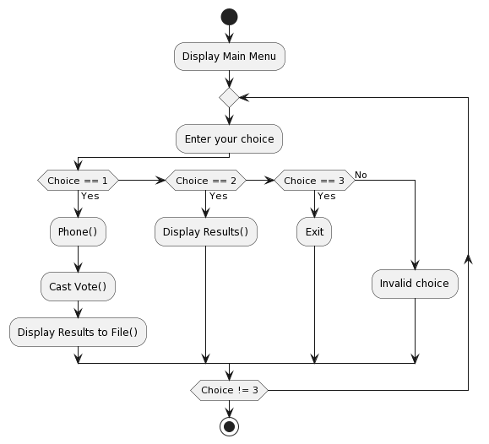

**Source Code**

#include <stdio.h>

#include <stdlib.h>

#define actor_lead_m1 "Chillian Murphy"

#define actor_lead_m2 "Leonardo DiCaprio"

#define actor_lead_m3 "Tom Cruise"

#define actor_lead_m4 "Johnny Depp"

#define actor_lead_f1 "Emma Watson"

#define actor_lead_f2 "Ana De Armas"

#define actor_lead_f3 "Emma Stone"

#define actor_lead_f4 "Jennifer Connelly"

#define actor_support_m1 "Jennifer Lawrence"

#define actor_support_m2 "Penelope Cruz"

#define actor_support_m3 "Alexandra Daddario"

#define actor_support_m4 "Emila Carkile"

#define actor_support_f1 "Rami Malik"

#define actor_support_f2 "Bruce Wayne"

#define actor_support_f3 "Robert John"

#define actor_support_f4 "Cris Brown"

int lead_role_male1_votes = 0, lead_role_male2_votes = 0, lead_role_male3_votes = 0, lead_role_male4_votes = 0;

int lead_role_female1_votes = 0, lead_role_female2_votes = 0, lead_role_female3_votes = 0, lead_role_female4_votes = 0;

int supporting_role_male1_votes = 0, supporting_role_male2_votes = 0, supporting_role_male3_votes = 0, supporting_role_male4_votes = 0;

int supporting_role_female1_votes = 0, supporting_role_female2_votes = 0, supporting_role_female3_votes = 0, supporting_role_female4_votes = 0;

int phone(){

long int number;

long int another_number;

FILE *file = fopen("numbers.txt", "r");

if (file == NULL)

{

printf("Error opening the file.\n");

return 1;

}

printf("Enter your Phone Number: ");

scanf("%lld", &number);

int found = 0;

long int num;

while (fscanf(file, "%lld", &num) == 1)

{

if (num == number)

{

found = 1;

break;

}

}

fclose(file);

if (found)

{

printf("Seems Like You Have Already Casted the Vote Try with another Phone Number!\n");

printf("Enter Different Number: ");

scanf("%lld", &another_number);

}

else

{

FILE *file = fopen("numbers.txt", "a+");

if (file == NULL)

{

printf("Please try again!\n");

return 1;

}

fprintf(file, "%lld\n", number);

fclose(file);

printf("YOU MAY PROCEED TO VOTE\n\n\n\n");

}

}

void castvote()

{

int vote;

do

{

printf("VOTE FOR BEST ACTOR IN THE LEAD ROLE MALE\n");

printf(" 1. %s\n", actor_lead_m1);

printf(" 2. %s\n", actor_lead_m2);

printf(" 3. %s\n", actor_lead_m3);

printf(" 4. %s\n", actor_lead_m4);

scanf("%d", &vote);

switch (vote)

{

case 1:

lead_role_male1_votes++;

break;

case 2:

lead_role_male2_votes++;

break;

case 3:

lead_role_male3_votes++;

break;

case 4:

lead_role_male4_votes++;

break;

default:

printf("Invalid choice. Please choose a valid option (1-4).\n");

}

} while (vote < 1 || vote > 4);

do

{

printf("VOTE FOR BEST ACTOR IN THE LEADING ROLE FEMALE\n");

printf(" 1. %s\n", actor_lead_f1);

printf(" 2. %s\n", actor_lead_f2);

printf(" 3. %s\n", actor_lead_f3);

printf(" 4. %s\n", actor_lead_f4);

scanf("%d", &vote);

switch (vote)

{

case 1:

lead_role_female1_votes++;

break;

case 2:

lead_role_female2_votes++;

break;

case 3:

lead_role_female3_votes++;

break;

case 4:

lead_role_female4_votes++;

break;

default:

printf("Invalid choice. Please choose a valid option (1-4).\n");

}

} while (vote < 1 || vote > 4);

do

{

printf("VOTE FOR BEST ACTOR IN THE SUPPORTING ROLE MALE\n");

printf(" 1. %s\n", actor_support_m1);

printf(" 2. %s\n", actor_support_m2);

printf(" 3. %s\n", actor_support_m3);

printf(" 4. %s\n", actor_support_m4);

scanf("%d", &vote);

switch (vote)

{

case 1:

supporting_role_male1_votes++;

break;

case 2:

supporting_role_male2_votes++;

break;

case 3:

supporting_role_male3_votes++;

break;

case 4:

supporting_role_male4_votes++;

break;

default:

printf("Invalid choice. Please choose a valid option (1-4).\n");

}

} while (vote < 1 || vote > 4);

do

{

printf("VOTE FOR BEST ACTOR IN THE SUPPORTING ROLE FEMALE\n");

printf(" 1. %s\n", actor_support_f1);

printf(" 2. %s\n", actor_support_f2);

printf(" 3. %s\n", actor_support_f3);

printf(" 4. %s\n", actor_support_f4);

scanf("%d", &vote);

switch (vote)

{

case 1:

supporting_role_female1_votes++;

break;

case 2:

supporting_role_female2_votes++;

break;

case 3:

supporting_role_female3_votes++;

break;

case 4:

supporting_role_female4_votes++;

break;

default:

printf("Invalid choice. Please choose a valid option (1-4).\n");

}

} while (vote < 1 || vote > 4);

}

void displayResults()

{

printf("VOTING RESULTS\n");

printf("---------------\n");

printf("BEST ACTOR IN THE LEAD ROLE MALE\n");

printf("%s: %d votes\n", actor_lead_m1, lead_role_male1_votes);

printf("%s: %d votes\n", actor_lead_m2, lead_role_male2_votes);

printf("%s: %d votes\n", actor_lead_m3, lead_role_male3_votes);

printf("%s: %d votes\n", actor_lead_m4, lead_role_male4_votes);

printf("\n");

printf("BEST ACTOR IN THE LEADING ROLE FEMALE\n");

printf("%s: %d votes\n", actor_lead_f1, lead_role_female1_votes);

printf("%s: %d votes\n", actor_lead_f2, lead_role_female2_votes);

printf("%s: %d votes\n", actor_lead_f3, lead_role_female3_votes);

printf("%s: %d votes\n", actor_lead_f4, lead_role_female4_votes);

printf("\n");

printf("BEST ACTOR IN THE SUPPORTING ROLE MALE\n");

printf("%s: %d votes\n", actor_support_m1, supporting_role_male1_votes);

printf("%s: %d votes\n", actor_support_m2, supporting_role_male2_votes);

printf("%s: %d votes\n", actor_support_m3, supporting_role_male3_votes);

printf("%s: %d votes\n", actor_support_m4, supporting_role_male4_votes);

printf("\n");

printf("BEST ACTOR IN THE SUPPORTING ROLE FEMALE\n");

printf("%s: %d votes\n", actor_support_f1, supporting_role_female1_votes);

printf("%s: %d votes\n", actor_support_f2, supporting_role_female2_votes);

printf("%s: %d votes\n", actor_support_f3, supporting_role_female3_votes);

printf("%s: %d votes\n", actor_support_f4, supporting_role_female4_votes);

printf("\n");

}

void displayMenu()

{

printf("1. Cast vote\n");

printf("2. See Result\n");

printf("3. Exit\n");

}

void displayResultsToFile()

{

FILE *outfile = fopen("voting_results.txt", "w"); // Open a file for writing

if (outfile == NULL)

{

printf("Error opening the file for writing.\n");

return;

}

fprintf(outfile, "VOTING RESULTS\n");

fprintf(outfile, "---------------\n");

fprintf(outfile, "BEST ACTOR IN THE LEAD ROLE MALE\n");

fprintf(outfile, "%s: %d votes\n", actor_lead_m1, lead_role_male1_votes);

fprintf(outfile, "%s: %d votes\n", actor_lead_m2, lead_role_male2_votes);

fprintf(outfile, "%s: %d votes\n", actor_lead_m3, lead_role_male3_votes);

fprintf(outfile, "%s: %d votes\n", actor_lead_m4, lead_role_male4_votes);

fprintf(outfile, "\n");

fprintf(outfile, "BEST ACTOR IN THE LEADING ROLE FEMALE\n");

fprintf(outfile, "%s: %d votes\n", actor_lead_f1, lead_role_female1_votes);

fprintf(outfile, "%s: %d votes\n", actor_lead_f2, lead_role_female2_votes);

fprintf(outfile, "%s: %d votes\n", actor_lead_f3, lead_role_female3_votes);

fprintf(outfile, "%s: %d votes\n", actor_lead_f4, lead_role_female4_votes);

fprintf(outfile, "\n");

fprintf(outfile, "BEST ACTOR IN THE SUPPORTING ROLE MALE\n");

fprintf(outfile, "%s: %d votes\n", actor_support_m1, supporting_role_male1_votes);

fprintf(outfile, "%s: %d votes\n", actor_support_m2, supporting_role_male2_votes);

fprintf(outfile, "%s: %d votes\n", actor_support_m3, supporting_role_male3_votes);

fprintf(outfile, "%s: %d votes\n", actor_support_m4, supporting_role_male4_votes);

fprintf(outfile, "\n");

fprintf(outfile, "BEST ACTOR IN THE SUPPORTING ROLE FEMALE\n");

fprintf(outfile, "%s: %d votes\n", actor_support_f1, supporting_role_female1_votes);

fprintf(outfile, "%s: %d votes\n", actor_support_f2, supporting_role_female2_votes);

fprintf(outfile, "%s: %d votes\n", actor_support_f3, supporting_role_female3_votes);

fprintf(outfile, "%s: %d votes\n", actor_support_f4, supporting_role_female4_votes);

fprintf(outfile, "\n");

fclose(outfile); // Close the file

}

int main()

{

while (1)

{

int userChoice;

displayMenu();

printf("Enter your choice: ");

scanf("%d", &userChoice);

switch (userChoice)

{

case 1:

phone();

castvote();

displayResultsToFile();

break;

case 2:

displayResults();

break;

case 3:

printf("Exiting...\n");

exit(0);

default:

printf("Invalid choice.\n");

break;

}

}

return 0;

}

**Output/ Application Overview Windows**

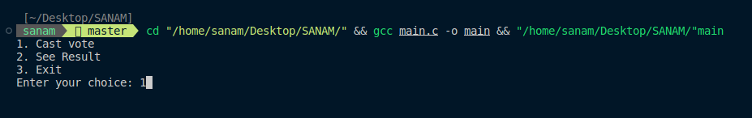**Menu window**

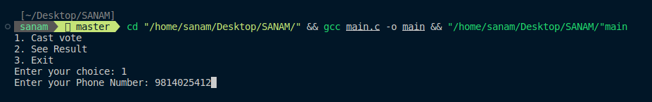**Authentication window to prevent multiple votes**

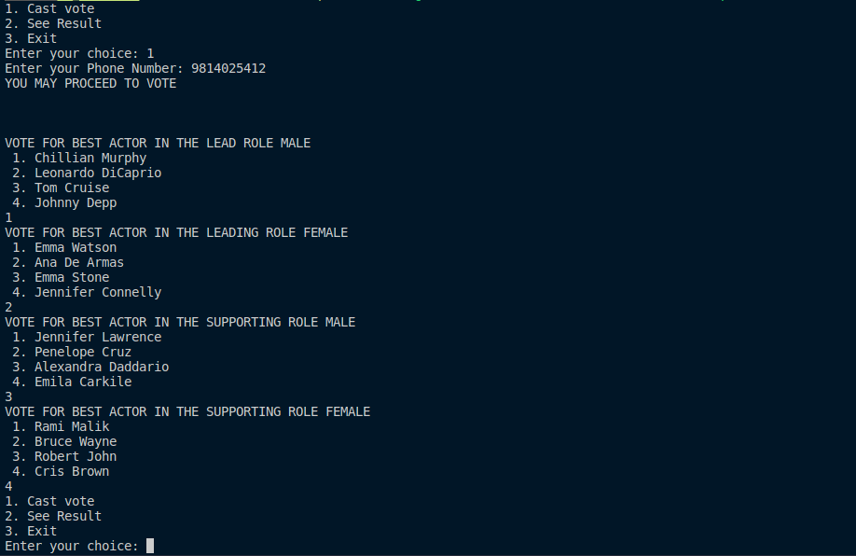**Voting window after user authenticating:**

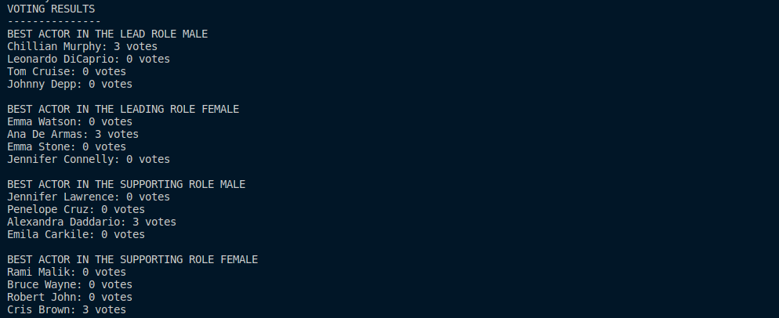**Voting result:**

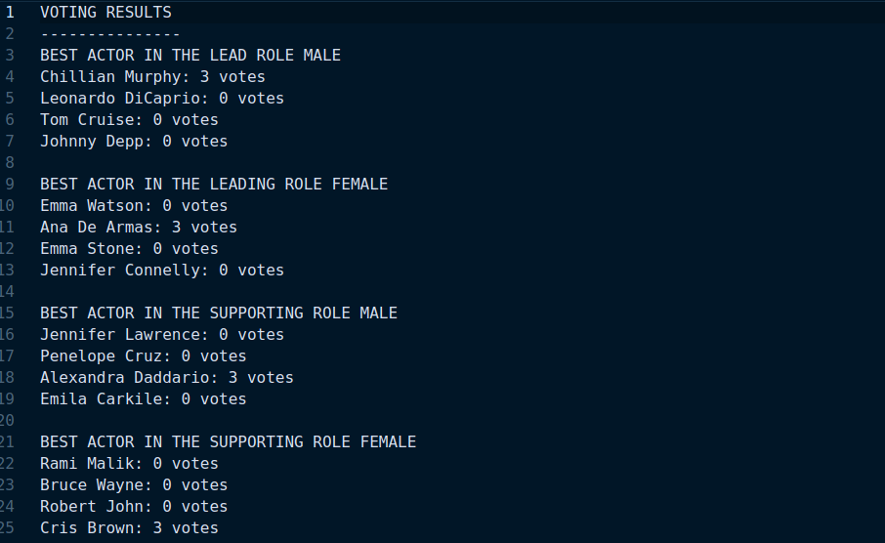**Voting result save in ‘voting_results.txt’ file:**

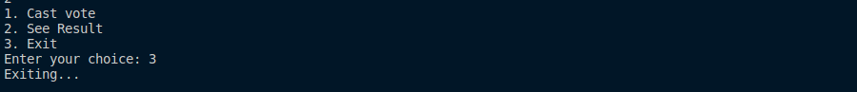**Exiting the program:**

**Future uses and implementation**

The "Public Choice Award Voting System" is a versatile platform meticulously crafted to involve the public actively in the selection of the finest actors across diverse categories, encompassing lead and supporting roles for both male and female performers. This system kickstarts the voting process by soliciting user phone numbers as a fundamental authentication mechanism, assuring the integrity and accuracy of the voting endeavor.

In pursuit of future improvements and adaptations, numerous avenues beckon. To fortify the system's foundation, it is essential to fortify security measures with the introduction of more advanced user authentication techniques. By evolving the system into a web-based application, its reach can be magnified manifold, transcending geographical boundaries and ensuring inclusivity. Integrating a robust database solution emerges as a pivotal step towards optimizing data management, enhancing security, and facilitating comprehensive analysis of voting trends.

An exciting prospect for the system's evolution entails the implementation of real-time vote counting and result dissemination, infusing a sense of immediacy and engagement among users. Additionally, the introduction of user profiles provides an avenue for individuals to track their voting history, imbuing a personalized dimension to the experience. Crafting dedicated mobile applications further extends accessibility, enabling users to cast their votes conveniently from their smartphones.

Beyond its immediate utility, the "Public Choice Award Voting System" holds the potential to serve as an educational tool, facilitating the exploration of programming concepts and software development principles. Its adaptability extends beyond the realm of award voting, finding applications in diverse public voting scenarios, each time championing the tenets of security, transparency, and fairness in the decision-making process. This multifaceted system emerges as a dynamic platform poised to evolve and adapt to the ever-changing landscape of public choice award voting, consistently prioritizing user experience and the integrity of the democratic process.

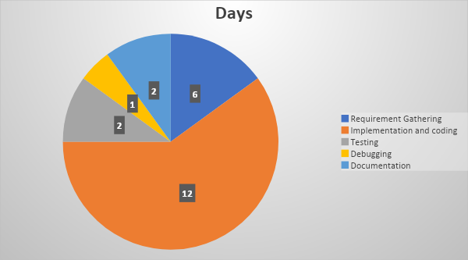**Feasibility Information / Group Information**

**Student Name: Sanam Acharya:**

|  |  |  |  |  |
| --- | --- | --- | --- | --- |
| S.N | Job Description | Date from | Date to | Reference |
| 1 | Requirement Gathering | 10th August | 13th August |  |
| 2 | Coding | 14th August | 24th August |  |
| 3 | Testing | 25th August | 26th August |  |
| 4 | Debugging | 27th August | 28th August | Gathered together and had discussion about project |

**Student Name: Sanjog Tamang:**

|  |  |  |  |  |
| --- | --- | --- | --- | --- |
| S.N | Job Description | Date from | Date to | Reference |
| 1 | Requirement Gathering | 10th August | 13th August |  |
| 2 | Testing | 25th August | 26th August |  |
| 3 | Documentation | 29th August | 31th August | We both equally divided the documentation |

**Conclusion**

In conclusion, the "Public Choice Award Voting System" represents an innovative and inclusive approach to involving the public in the selection of outstanding actors across various categories. By initiating the voting process with phone number authentication, it ensures the fairness and accuracy of the results. However, its potential for growth and enhancement is boundless.

As we look to the future, this system can evolve into a formidable tool for public engagement and decision-making. Strengthening security measures, transforming into a web-based application, and integrating databases are essential steps to ensure scalability, accessibility, and data management efficiency. Real-time updates, user profiles, and mobile applications offer a more personalized and engaging voting experience.

Moreover, beyond its immediate utility, this system has the potential to serve as an educational instrument, teaching programming concepts and software development principles. Its adaptability for various public voting scenarios underscores its versatility.

In a world where public opinion matters, the "Public Choice Award Voting System" stands as a beacon of transparency, inclusivity, and fairness, allowing the public's voice to resonate in the world of entertainment. Its journey of evolution and adaptation is a testament to its commitment to continually prioritize user experience and the integrity of the democratic process.

**Bibliography**

To complete this project we took help of following Sites , Books and Videos:

**Websites:**

* github.com/cognitive-ninja/Mini-Voting-System
* stackoverflow.com/questions/840501/how-do-function-pointers-in-c-work
* stackoverflow.com/questions/41857146/how-to-use-array-and-file-handling-in-c
* chat.openai.com
* www.plantuml.com/plantuml/uml

**Books:**

* C Programming A Modern Approach(Author: K.N. King)
* The C Programming Language(Author: Brian W. Kernighan)

**Video Links**

* youtube.com/watch?v=4dX_hQ7A_8M
* youtube.com/watch?v=irqbmMNs2Bo
* youtube.com/watch?v=RhLSYjDXB4Q
* youtube.com/watch?v=fltaqGek-oA