FindDefault- Prediction of Credit Card Fraud

Capstone Project

Sanam Bodake

## Problem Statement

A credit card is one of the most used financial products to make online purchases and payments. Though Credit cards can be a convenient way to manage your finances, they can also be risky. Credit card fraud is the unauthorized use of someone else's credit card or credit card information to make purchases or withdraw cash. It is important that credit card companies are able to recognize fraudulent credit card transactions so that customers are not charged for items that they did not purchase.

## About Credit Card Fraud Detection:

### What is credit card fraud detection?

Credit card fraud detection is the collective term for the policies, tools, methodologies, and practices that credit card companies and financial institutions take to combat identity fraud and stop fraudulent transactions.

In recent years, as the amount of data has exploded and the number of payment card transactions has skyrocketed, credit fraud detection has become largely digitized and automated. Most modern solutions leverage artificial intelligence (AI) and machine learning (ML) to manage data analysis, predictive modeling, decision-making, fraud alerts and remediation activity that occur when individual instances of credit card fraud are detected.

### Anomaly detection

Anomaly detection is the process of analyzing massive amounts of data points from both internal and external sources to produce a framework of “normal” activity for each individual user and establish regular patterns in their activity.

Data used to create the user profile includes:

* Purchase history and other historical data
* Location
* Device ID
* IP address
* Payment amount
* Transaction information

When a transaction falls outside the scope of normal activity, the anomaly detection tool will then alert the card issuer and, in some cases, the user. Depending on the transaction details and risk score assigned to the action, these fraud detection systems may flag the purchase for review or put a hold on the transaction until the user verifies their activity.

### What can be an anomaly?

* A sudden increase in spending
* Purchase of a large ticket item
* A series of rapid transactions
* Multiple transactions with the same merchant
* Transactions that originate in an unusual location or foreign country
* Transactions that occur at unusual times

If the anomaly detection tool leverages ML, the models can also be self-learning, meaning that they will constantly gather and analyze new data to update the existing model and provide a more precise scope of acceptable activity for the user.

## Project Introduction:

The dataset contains transactions made by credit cards in September 2013 by European cardholders. This dataset presents transactions that occurred in two days, where we have 492 frauds out of 284,807 transactions. The dataset is highly unbalanced, the positive class (frauds) account for 0.172% of all transactions.

In this Project, we have to build a classification model to predict whether a transaction is fraudulent or not. We will use various predictive models to see how accurate they are in detecting whether a transaction is a normal payment or a fraud. Let's start!

## Project Outline:

* **Exploratory Data Analysis:** Analysing and understanding the data to identify patterns, relationships, and trends in the data by using Descriptive Statistics and Visualizations.
* **Data Cleaning:** Checking for the data quality, handling the missing values and outliers in the data.
* **Dealing with Imbalanced data:** This data set is highly imbalanced. The data should be balanced using the appropriate Resampling Techniques (NearMiss Undersampling, SMOTETomek) before moving onto model building.
* **Feature Engineering:** Transforming the existing features for better performance of the ML Models.
* **Model Training:** Splitting the data into train & test sets and use the train set to estimate the best model parameters.
* **Model Validation:** Evaluating the performance of the models on data that was not used during the training process. The goal is to estimate the model's ability to generalize to new, unseen data and to identify any issues with the model, such as overfitting.
* **Model Selection:** Choosing the most appropriate model that can be used for this project.
* **Model Deployment:** Model deployment is the process of making a trained machine learning model available for use in a production environment.

## Project Work OverView:

For the detailed explanation along with Coding Part refer notebooks section

### Exploratory Data Analysis:

This dataset comprises 284,807 rows and 31 columns. Except for the 'Time' and 'Amount' columns, the nature of the remaining columns (V1 to V28) remains undisclosed due to privacy concerns. These undisclosed columns have undergone scaling and PCA transformation (dimensionality reduction technique).

Notably, there are no missing values present in the dataset.



On Examining the below distribution plot for the Transaction Class, we can conclude-

Our dataset exhibits significant class imbalance, with the majority of transactions being non-fraudulent (99.82%). Using this dataset as the foundation for our predictive models and analysis may lead to substantial errors and overfitting. This is because the algorithms may incorrectly assume that most transactions are not fraudulent, compromising their ability to detect genuine fraud patterns. Instead, we aim for our model to discern distinctive patterns indicative of fraudulent activity rather than making assumptions based on class distribution.

Percentage share of non-fraud records: 99.827

Percentage share of Fraud records: 0.173

Distribution Plot for Each Column-

The columns labeled 'V1' to 'V28' have undergone transformation using PCA techniques, while the 'Class' column serves as the target variable. As a result, our primary focus will be on analysing the 'Time' and 'Amount' columns.

Based on the distplots illustrating the distribution of Transaction Amount and Time, notable skewness is observed in both columns. The Transaction Amount feature exhibits a right-skewed distribution, indicating a higher frequency of smaller transactions with a tail extending towards larger values. As for the Time distribution, it illustrates transaction timings over a two-day period. Notably, transactions appear to be least frequent during nighttime and peak during daytime hours.

Fraudulent Transactions- Non-fraudulent Transactions-

Upon examining the distribution of fraudulent and non-fraudulent amounts, it becomes evident that the range of fraudulent amounts (0 to 2125) is narrower compared to non-fraudulent amounts (0 to 25691). Additionally, fraudulent amounts exhibit higher mean and standard deviation values.

### Data Preprocessing:

As the columns labeled V1 to V28 contain sensitive information and have already undergone both scaling and PCA transformation, there is limited opportunity for further feature transformation or analysis with respect to these features. As a result, our primary focus is on transforming the 'Time' and 'Amount' columns.

Time and Amount, like other columns, require scaling for consistency in data preprocessing. We have opted to scale these features using RobustScaler, a technique commonly employed in handling skewed or outlier-prone data distributions. This ensures that Time and Amount are appropriately transformed along with the other columns, contributing to a more uniform and standardized dataset.

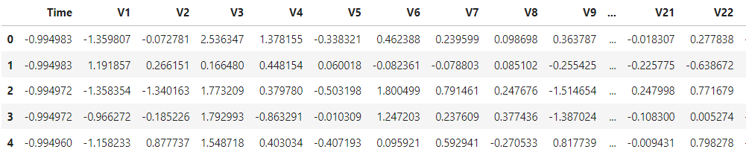

### Splitting the dataset to Train and Test:

Before initiating the Resampling techniques, it's essential to isolate the original dataframe. This step is crucial because, for testing purposes, our objective is to evaluate the model's performance on the original testing set, not on a testing set generated by undersampling or oversampling techniques. Although we split the data when applying UnderSampling or OverSampling techniques, our aim is to train the model using the undersampled or oversampled dataframes to enable pattern detection. However, the model should ultimately be tested on the original testing set to ensure accurate evaluation.

### Model Training on Imbalanced Dataset:

Following the division of the dataset into training and testing subsets, we proceeded to evaluate the performance of Logistic Regression and RandomForest Classifier models on this imbalanced dataset. This assessment aimed to gauge the effectiveness of these models in handling the inherent class imbalance present in the data, providing insights into their suitability for credit card fraud detection tasks.

#### Logistic Regression model results on imbalanced dataset:

Top of Form

Based on the Confusion Matrix analysis, it is evident that the model performs well in predicting non-fraudulent transactions (label 0), as indicated by the high number of true negatives (TN). However, concerning fraudulent transactions (total 98), the model's performance is less satisfactory. Specifically, out of the 98 actual fraudulent transactions, the model correctly identifies 58 (true positives, TP). However, it misclassifies 40 fraudulent transactions as non-fraudulent (false negatives, FN), which is a significant concern.

While the Logistic Regression model achieves a high accuracy score of 0.9991, caution is warranted due to the highly imbalanced nature of the data. The lower precision (0.85), recall (0.59), and F1-score (0.70) for the (label 1) fraudulent class indicate a struggle in correctly identifying fraudulent transactions. Although weighted and macro average scores are higher due to the dominance of the majority class, this doesn't necessarily imply good model fit. Therefore, further adjustments or alternative approaches may be necessary to improve performance, especially in capturing the characteristics of fraudulent transactions.

#### Random Forest Classifier results on imbalanced dataset:

It is one of the ensemble techniques, which inherently handle class imbalance better than individual models.

As compared to the Logistic Regression model, RF classifier has shown significant improvement in predicting fraudulent transactions. We can see model has correctly classified 75 transactions (TP) out of total 98 fraudulents where LR's TP is 58. FN (23) & FP (3) has decreased in RFC compared to LR (40) & (10) respectively.

Logistic Regression model Vs Random Forest Classifier

* Testing Accuracy: The testing accuracy of 0.9995 is slightly higher than the logistic reg accuracy of 0.9991.
* Precision, Recall, and F1-score: For the fraudulent class (label 1), precision has increased from 0.85 to 0.96, recall has increased from 0.59 to 0.77, and the F1-score has increased from 0.70 to 0.85.
* Macro Average: The macro-average precision, recall, and F1-score are 0.98, 0.88, and 0.93 respectively, compared to 0.93, 0.80, and 0.85 in the previous summary.

Overall, the new evaluation metrics show a slight improvement in accuracy and precision for the fraudulent class, while recall has notably increased. The macro-average metrics also show an improvement, indicating a better balance between precision and recall across both classes. However, weighted-average metrics remain unchanged, reflecting there's a still dominance of the non-fraudulent class in the dataset.

### Handling Class Imbalance

In our credit card dataset, the non-fraudulent class significantly outweighs the fraudulent class, resulting in imbalanced data leading to biased models that favour the majority (non-fraudulent) class. Handling this class imbalance is essential for ensuring the effectiveness of our models. Several techniques can help mitigate this issue:

1. **Resampling Techniques:**

* Undersampling: Reducing the size of the majority class to match the minority class.
* Oversampling: Increasing the size of the minority class by duplicating samples or generating synthetic samples.
* Advanced Sampling Techniques: Using advanced techniques like SMOTE (Synthetic Minority Over-sampling Technique) or ADASYN (Adaptive Synthetic Sampling) for oversampling the minority class with more sophistication.

1. **Model Tuning:** Fine-tuning model hyperparameters to optimize performance.
2. **Ensemble Methods:** Harnessing the power of ensemble techniques to combine multiple models for improved accuracy.

### Performing Undersampling using NearMiss:

NearMiss is an undersampling technique commonly used to address class imbalance problems in machine learning classification tasks. It aims to balance the class distribution by reducing the number of samples in the majority class, making it more comparable to the minority class.

Types of NearMiss: There are several variations of NearMiss, including NearMiss-1, NearMiss-2, and NearMiss-3. Each variant employs a different criterion for selecting samples from the majority class based on their proximity to minority class samples.

* NearMiss-1: NearMiss-1 selects samples from the majority class for which the average distance to the k nearest neighbours in the minority class is the smallest.
* NearMiss-2: NearMiss-2 selects samples from the majority class by focusing on the farthest samples from the decision boundary between the two classes. It retains samples that are closest to the minority class but farthest from the majority class.
* NearMiss-3: NearMiss-3 is similar to NearMiss-2 but considers a different criterion for selecting samples. It retains samples from the majority class that are closest to the centroids of the minority class.

To mitigate the class imbalance in our dataset, we utilized the NearMiss-1 undersampling technique to our training dataset. This method equalizes the class distribution by decreasing the instances of Non-fraudulent Transactions to align with the count of Fraudulent Transactions.

Before applying the NearMiss-1 technique, the class distribution was as follows: Counter ({0: 227451, 1: 394}). After applying the undersampling technique, the class distribution became Counter ({0: 394, 1: 394}). This adjustment ensures a more balanced representation of both classes, which is crucial for training effective machine learning models to detect fraudulent transactions.

### Correlation matrices:

Correlation matrices play a crucial role in understanding our data, especially in identifying features that significantly influence whether a transaction is fraudulent. It's essential to use the correct dataframe (such as a subsample) to analyse which features have a strong positive or negative correlation with fraud transactions.

##### Key Points:

* **Negative Correlations:** Features like V17, V14, V12, and V10 exhibit negative correlations. Lower values in these features tend to be associated with a higher likelihood of a transaction being fraudulent.
* **Positive Correlations:** Features such as V2, V4, V11, and V19 show positive correlations with fraud transactions. Higher values in these features are indicative of a higher probability of the transaction being fraudulent.

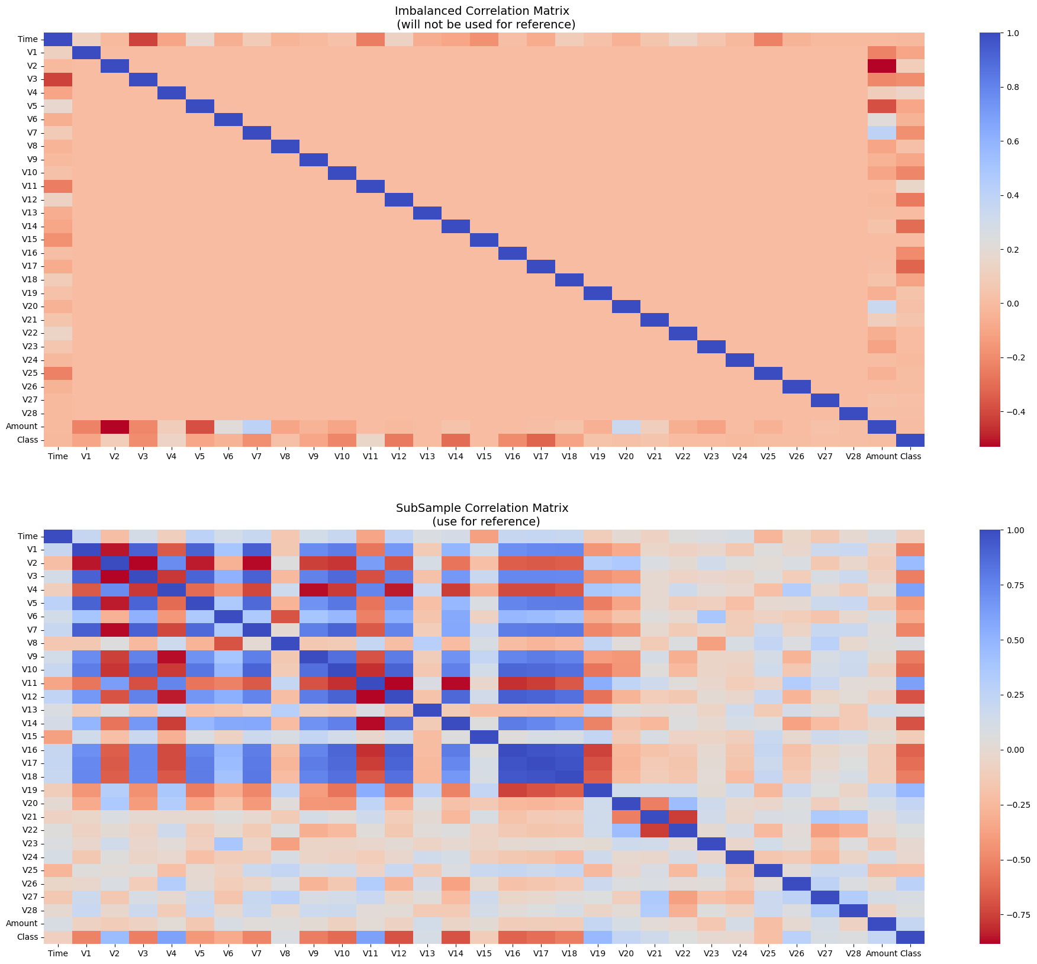

### Results of Models trained on Undersampled data:

Following undersampling of the dataset, various classification models were trained using the balanced data. These models include Logistic Regression, K-Nearest Neighbors (KNN), Random Forest Classifier, as well as boosting models like AdaBoost and XGBoost. The results of these models are presented below.

##### Logistic Regression-

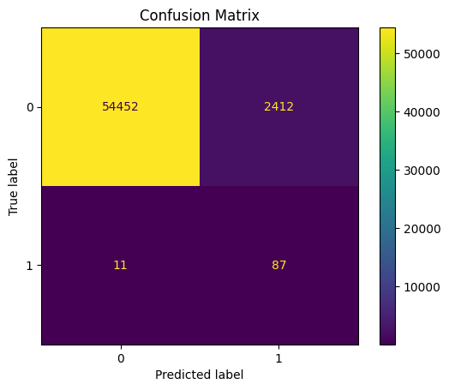

##### K-Nearest Neighbors (KNN)-

##### Random Forest Classifier-

##### AdaBoost Classifier-

##### XGBoost Classifier-

#### Description of Results:

* The precision score for class 0 (representing non-fraudulent transactions) is consistently 100% across all models, indicating that when the model predicts a transaction as non-fraudulent, it is accurate 100% of the time.
* However, there are notable differences in the recall scores. For the XGBoost model, the recall is 29%, for AdaBoost it's 31%, and for Random Forest, it's 24%. This suggests that these models are missing a substantial portion of actual non-fraudulent transactions. In contrast, the logistic regression (LR) model achieves a recall of 96%, while K-Nearest Neighbors (KNN) achieve a recall of 87%, indicating better performance in capturing non-fraudulent transactions.
* The precision score for class 1 (representing fraudulent transactions) is nearly 0% across all models, suggesting that the models do not effectively identify any transactions as fraudulent. However, the recall is notably higher, with scores of 96% for XGBoost, AdaBoost and Random Forest, and 91% for KNN, and 89% for LR. This indicates that the models successfully detect nearly all actual fraudulent transactions.
* The XGBoost, AdaBoost, and Random Forest models exhibit higher f1-scores for non-fraudulent transactions compared to fraudulent ones, with values ranging from 0.38 to 0.47 for class 0 and 0.00 for class 1. For class 0, the f1-score values range from 93% to 98%, with the Logistic Regression model achieving the highest f1-score, followed by K-Nearest Neighbors models. However, for class 1, the f1-score values are considerably lower, ranging from 2% to 7% across these models, highlighting difficulties in correctly identifying fraudulent transactions.
* The testing accuracies for various models are as follows:
  + Logistic Regression: 95.75%
  + K-Nearest Neighbors (KNN): 86.91%
  + Random Forest: 23.82%
  + AdaBoost: 30.71%
  + XGBoost: 29.46%

These values represent the percentage of correctly predicted outcomes on the testing dataset for each respective model. Among these models, Logistic Regression demonstrates the highest testing accuracy, followed by K-Nearest Neighbors. Conversely, Random Forest exhibits notably lower testing accuracy compared to the other models.

Overall, the model shows high recall for fraudulent transactions but poor precision and f1-score, indicating that it is better at identifying fraud but struggles with accuracy in generalizing predictions.

The results below indicate the Area Under the Receiver Operating Characteristic Curve (ROC AUC) for each model.

* Logistic Regression has an AUC of 0.97, indicating that it performs very well in terms of separating the classes, with a high true positive rate and a low false positive rate.
* K-Nearest Neighbors (KNN) have an AUC of 0.91, suggesting they also perform well, but not as well as Logistic Regression.
* Random Forest and XGBoost have an AUC of 0.95, indicating strong performance similar to Logistic Regression.
* AdaBoost has the lowest AUC of 0.65, implying that it performs relatively poorly compared to the other models in distinguishing between classes.

In a ROC AUC plot, higher AUC values correspond to better model performance, with the curve being closer to the top-left corner of the plot. Therefore, the results suggest that Logistic Regression, Random Forest, and XGBoost are the top-performing models, while AdaBoost lags behind in terms of class separation ability.

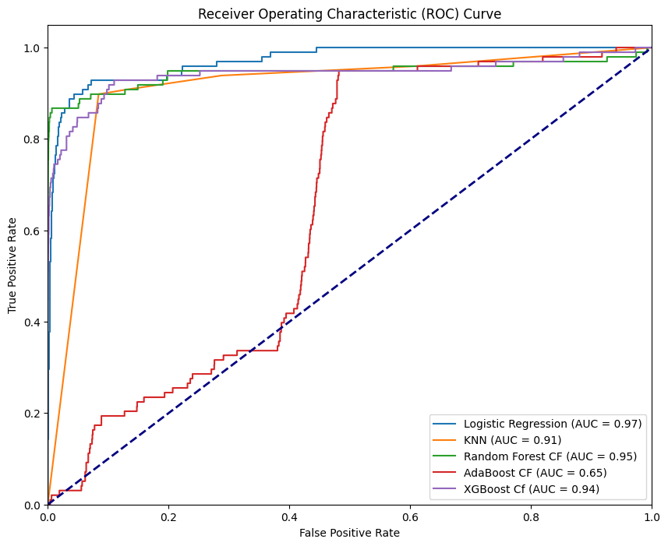

###### The NearMiss undersampling technique did not perform well in our credit card fraud detection scenario for the following reasons:

* Loss of Information: NearMiss aggressively removes majority class samples that are close to minority class samples, leading to a significant loss of valuable information. This can hinder the ability of models to learn complex relationships present in the data.
* Model Complexity: Ensemble methods like Random Forest, AdaBoost, and XGBoost are adept at capturing complex patterns in data. However, when trained on a drastically reduced dataset due to undersampling, these models might struggle to learn effectively, resulting in suboptimal performance.
* Vulnerability to Noise: NearMiss may inadvertently retain noisy or irrelevant minority class samples while removing informative majority class samples. This can introduce noise into the training data, negatively impacting the performance of ensemble methods sensitive to data quality.
* Imbalanced Class Distribution: Despite attempting to balance the class distribution, NearMiss may still leave the dataset imbalanced, with the minority class underrepresented. Ensemble methods may struggle to learn from such imbalanced data, leading to biased predictions and reduced performance.

### Performing Over Sampling : SMOTE (Synthetic Minority Over-sampling Technique)

**We have used here SMOTETomek method**

SMOTETomek is a hybrid resampling technique that combines the over-sampling method Synthetic Minority Over-sampling Technique (SMOTE) with the under-sampling method Tomek Links.

Here's a brief overview of how SMOTETomek works:

* **SMOTE (Synthetic Minority Over-sampling Technique):** This technique generates synthetic samples for the minority class by interpolating new instances between existing minority class samples. It helps address the class imbalance by increasing the number of minority class samples.
* **Tomek Links:** Tomek Links are pairs of instances from different classes that are nearest neighbours of each other. By removing the majority class instances from these pairs, Tomek Links can help clarify the decision boundary between classes and potentially improve the performance of classifiers.
* **Combination:** SMOTETomek combines the strengths of SMOTE and Tomek Links. First, it oversamples the minority class using SMOTE to increase its representation. Then, it under samples both the majority and minority classes using Tomek Links to remove redundant and noisy samples, thereby improving the balance and quality of the dataset.

It can be an effective approach for improving classification accuracy and mitigating the impact of class imbalance.

To address the severe class imbalance in our dataset, we applied the SMOTETomek method to the training dataset with a sampling strategy of 0.75. Before applying the SMOTETomek method, the class distribution was heavily skewed, with the majority class (Non-fraudulent Transactions) dominating the dataset with 227,451 instances, while the minority class (Fraudulent Transactions) had only 394 instances.

After applying the SMOTETomek method, the class distribution was significantly improved, with the number of instances in the minority class increased to 170,588, resulting in a more balanced dataset overall.

### Results of Models trained on Oversampled data:

Following oversampling of the dataset, various classification models were trained using the balanced data. These models include Logistic Regression, K-Nearest Neighbors (KNN), Random Forest Classifier, as well as boosting models like AdaBoost and XGBoost. The results of these models are presented below.

##### Logistic Regression-

##### K-Nearest Neighbors (KNN)-

##### Random Forest Classifier-

##### AdaBoost Classifier-

##### XGBoost Classifier-

#### Description of Results:

* The precision score for class 0 (representing non-fraudulent transactions) is consistently 100% across all models, indicating that when the model predicts a transaction as non-fraudulent, it is accurate 100% of the time.
* However, there are slight differences in the recall scores. For the XGBoost model, Random Forest, and K-Nearest Neighbors (KNN) the recall is 100%, for AdaBoost it's 99%, and for logistic regression (LR) model it's 98% indicating better performance in capturing non-fraudulent transactions.
* The precision score for class 1 (representing fraudulent transactions) is higher for XGBoost 79%, followed by KNN 73% and RandomForest 51%, while LR 9% and AdaBoost 11% suggesting these two models do not effectively identify any transactions as fraudulent. However, the recall is notably higher across all the models with scores ranging from 0.84 to 0.92, This indicates that the models successfully detect nearly all actual fraudulent transactions.
* All the models exhibit higher f1-scores for non-fraudulent transactions compared to fraudulent ones, with values ranging from 0.99 to 1.0 for class 0 and 0.16 to 0.82 for class 1. For class 1, the XGBoost model achieving the highest f1-score of 0.82, followed by K-Nearest Neighbors model with f1-score of 0.78 and RandomForest with f1-score of 0.64. However, for class 1, the f1-score values are considerably very lower for the LR and AdaBoost, highlighting difficulties in correctly identifying fraudulent transactions.
* The testing accuracies for various models are as follows:
  + Logistic Regression: 98.29%
  + K-Nearest Neighbors (KNN): 99.92%
  + Random Forest: 99.83%
  + AdaBoost: 98.67%
  + XGBoost: 99.94%

These values represent the percentage of correctly predicted outcomes on the testing dataset for each respective model. Among these models, XGBoost demonstrates the highest testing accuracy, followed by K-Nearest Neighbors, Random Forest, AdaBoost and Logistic Regression.

Overall, among these all models **XGBoost** shows high macro avg recall and f1-score 0.93 and 0.91 respectively, followed by RandomForest Classifier with macro avg recall and f1-score 0.94 and 0.82 respectively.

The results below indicate the Area Under the Receiver Operating Characteristic Curve (ROC AUC) for each model.

* All these models have an AUC > 0.90 (ranging 0.93 to 0.99) indicating good performance in distinguishing between classes.
* **XGBoost** and **RandomForest CF** has highest AUC of 0.99, showcasing that they have performed very well in terms of separating the classes, with a high true positive rate and a low false positive rate.

In a ROC AUC plot, higher AUC values correspond to better model performance, with the curve being closer to the top-left corner of the plot. Therefore, the results suggest that XGBoost and Random Forest are the top-performing models.

### Hyperparameter tuning the XGBoost model to get best performance:

Hyperparameter tuning involved systematically exploring different combinations of parameters to maximize the model's predictive power.

After optimizing the parameters through hyperparameter tuning, we've identified the XGBoost model that exhibits the best performance across various evaluation metrics including accuracy, precision, recall, and F1-score as follows-

The chosen model has undergone rigorous testing and validation to ensure its robustness and generalization to unseen data. We'll deploy this top-performing model as our final choice for deployment.