PROJECT REPORT – LEARNHUB

1. INTRODUCTION
1.1 Project Overview
LearnHub is a comprehensive mobile-based online learning platform developed using the MERN technology stack.
The system is designed to provide structured digital education through an intuitive and user-friendly interface.
Students can register, browse courses, watch video lectures, access study materials, and track their progress in real time.
With the rapid growth of e-learning, there is an increasing demand for affordable and accessible education platforms.
LearnHub addresses this challenge by offering a scalable, secure, and mobile‑first learning solution.
The architecture follows a client–server model where the React Native mobile application communicates with Node.js and Express.js REST APIs connected to a MongoDB database.
This modular architecture ensures maintainability, scalability, and performance optimization.
1.2 Purpose
The major objectives of LearnHub include:
• Providing anytime‑anywhere learning access.
• Delivering structured course content instead of scattered resources.
• Ensuring secure authentication and personalized dashboards.
• Supporting scalability for future intelligent learning features.
• Promoting affordable digital education for students.

2. IDEATION PHASE
2.1 Problem Statement
Many students rely on disconnected learning sources such as YouTube, blogs, and free tutorials. these platforms lack structured curriculum, centralized tracking, and guided progression.
Paid platforms are often expensive or complex for beginners.
Therefore, a simple, affordable, and mobile‑friendly centralized learning system is required.
2.2 Empathy Map Canvas
Think – Need simple and low‑cost learning.
Feel – Confused by multiple platforms.
Say – Want easy mobile learning.
Do – Search random tutorials online.
2.3 Brainstorming
• Mobile learning application
• Course categories and modules
• Secure login system
• Video‑based learning
• Progress tracking dashboard
• Instructor upload support
• Future AI recommendations
3. REQUIREMENT ANALYSIS
3.1 Customer Journey Map
Install App → Register/Login → Browse Courses → Enroll → Watch Lessons → Track Progress → Complete Course.
3.2 Solution Requirement
Functional Requirements:
• User registration and login
• Course browsing and enrollment
• Video playback functionality
• Progress monitoring
• Admin course management
Non‑Functional Requirements:
• High performance and responsiveness
• Secure authentication and encryption
• Scalable backend system
• User‑friendly mobile UI
3.3 Data Flow Diagram
User → Mobile UI → Backend API → MongoDB → Response → User Interface.
3.4 Technology Stack
Frontend – React Native
Backend – Node.js & Express.js
Database – MongoDB
Authentication – JWT
Testing – Postman & Manual Testing

4. PROJECT DESIGN
4.1 Problem Solution Fit
LearnHub integrates scattered educational resources into a single structured mobile application, improving accessibility, organization, and learner engagement.
4.2 Proposed Solution
A MERN‑based mobile learning system that enables authentication, course access, video streaming, and progress analytics within one secure platform.

4.3 Solution Architecture
Client Layer – React Native mobile interface.
Server Layer – Node.js & Express REST services.
Database Layer – MongoDB collections for users, courses, and progress.
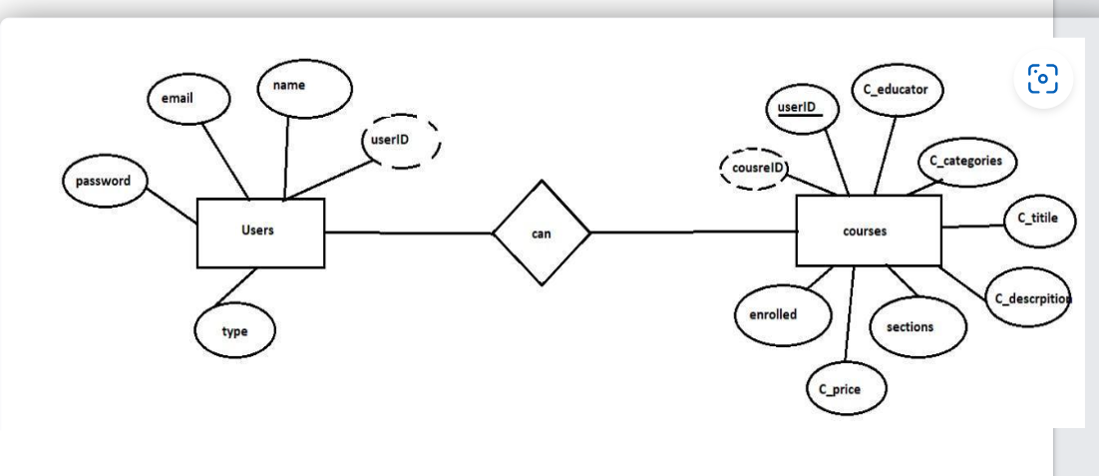
Figure 1: ER Diagram
5. PROJECT PLANNING & SCHEDULING
5.1 Project Planning
Day 1-2 – Requirement analysis and ideation.
Day 2-6 – System design and database schema.
Day 7-15 – Frontend and backend development.
Day 15-20 – Testing, debugging, and documentation.

6. FUNCTIONAL AND PERFORMANCE TESTING
6.1 Performance Testing
The application was evaluated for:
• Login response time
• Course loading efficiency
• Smooth video playback
• API latency handling
Results indicated stable and efficient performance under normal usage conditions.

7. RESULTS
7.1 Output Screenshots
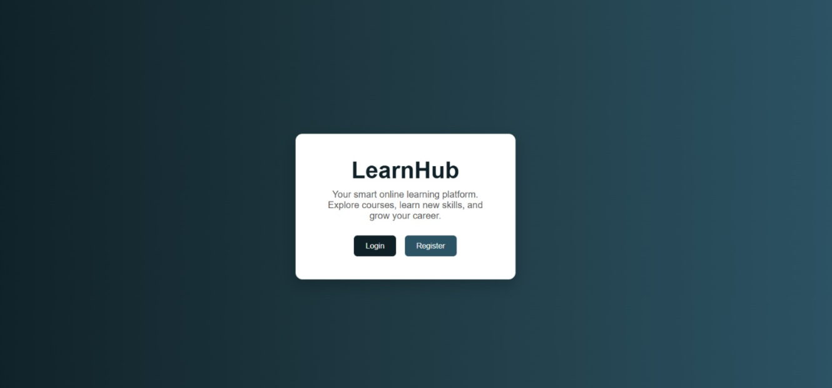
Figure 2: Home page of the learn hub project
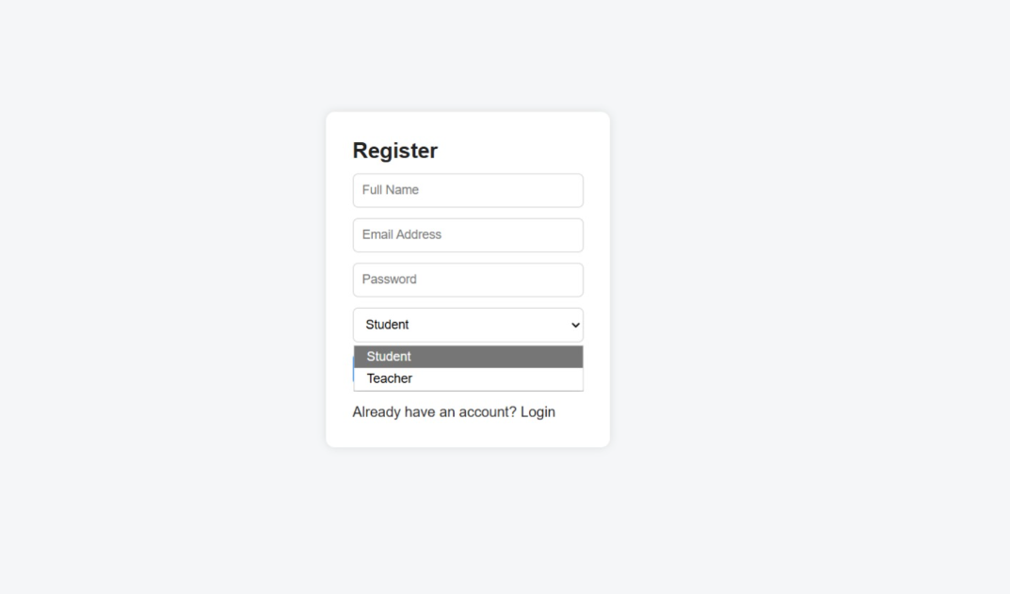
Figure 3: Registration page
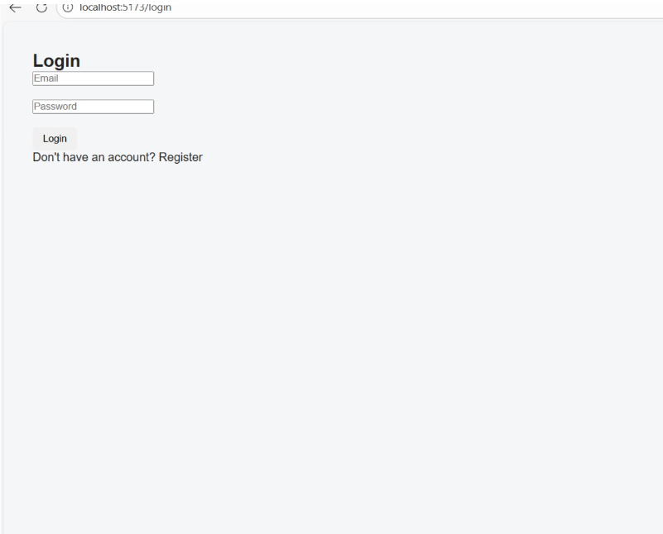
Figure 4: Login page of the website
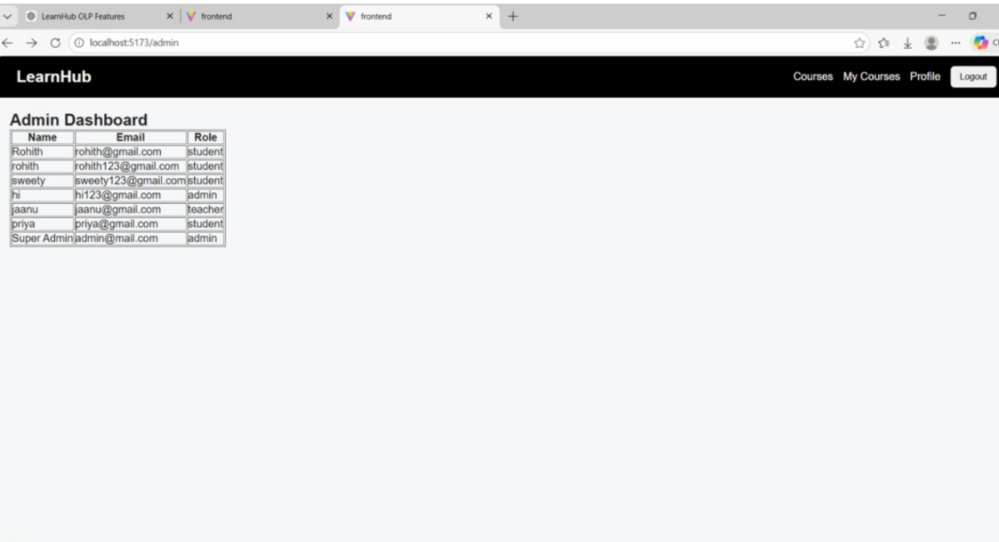
Figure 5: Admin Dashboard
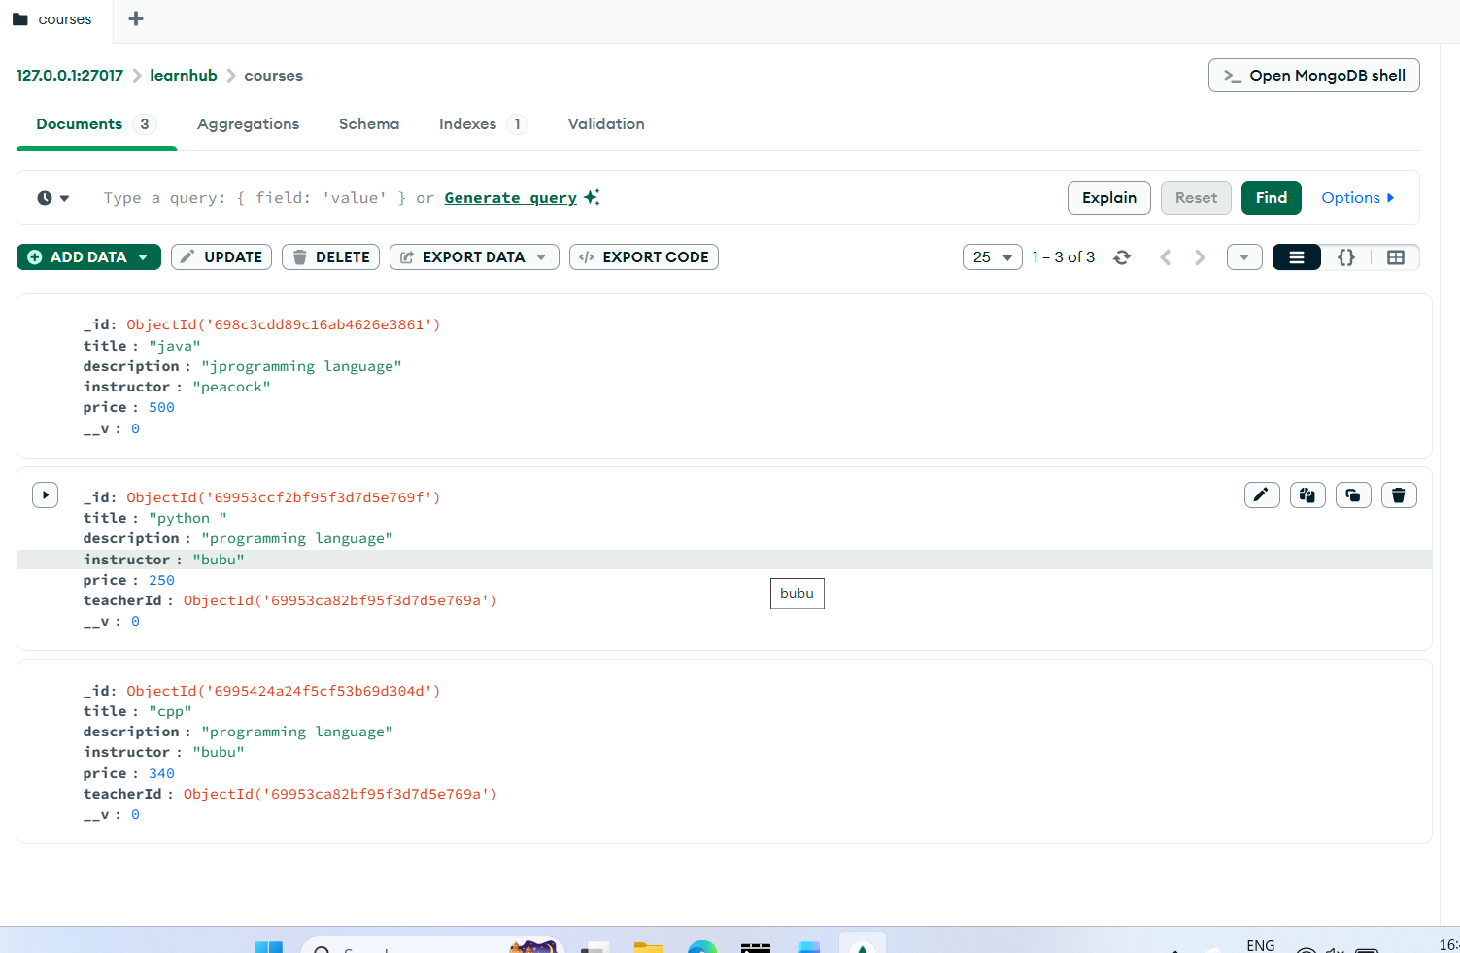
Figure 6: Managing courses in mango db database
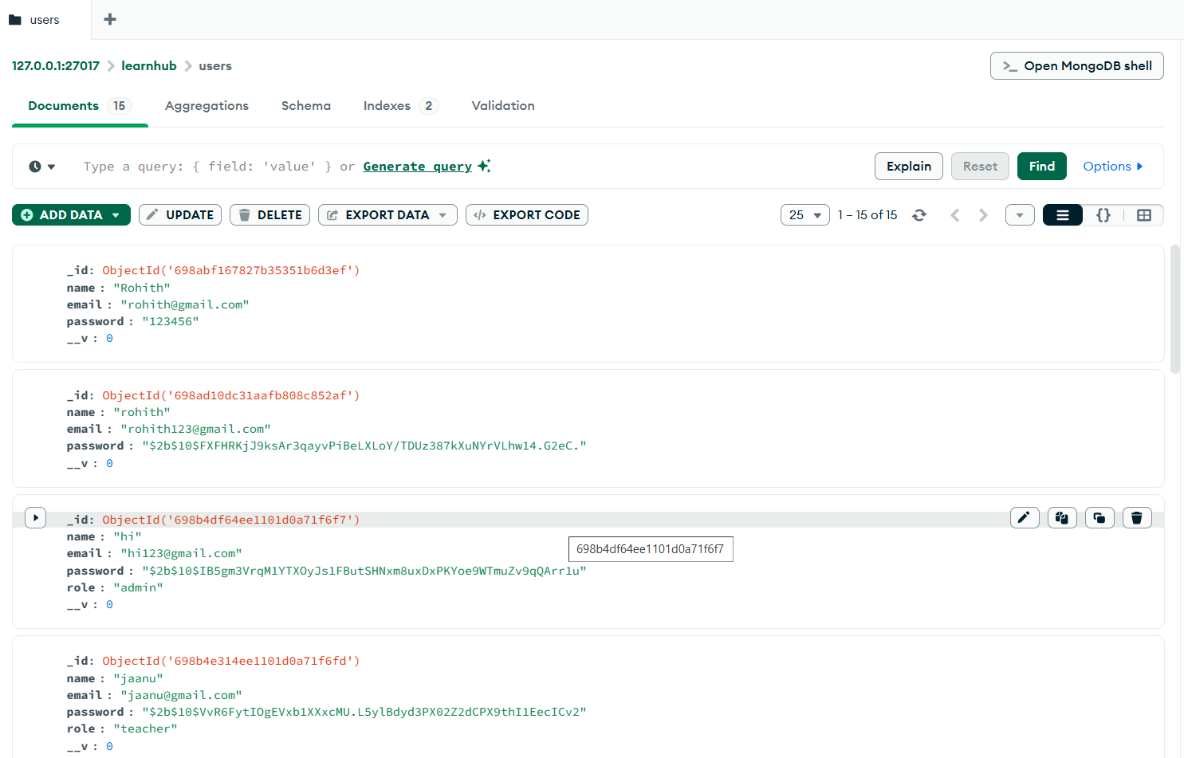
Figure 7: accessing website users
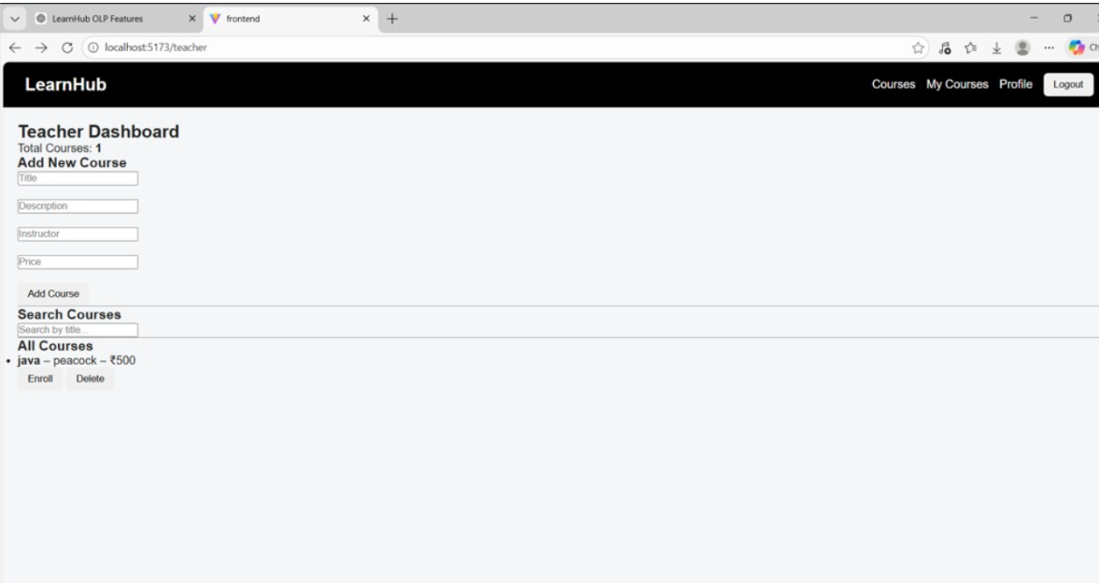
Figure 8: Teacher dashboard
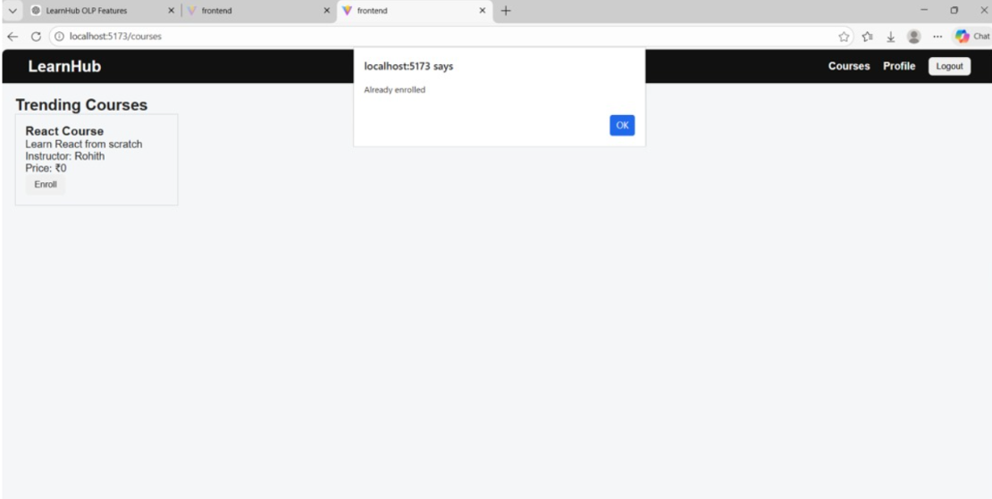
Figure 9: Student dashboard

The developed system successfully displays:
• User authentication screens
• Course listing interface
• Video learning module
• Progress tracking dashboard

8. ADVANTAGES & DISADVANTAGES
Advantages:
• Mobile‑first learning experience
• Structured and organized courses
• Secure authentication
• Scalable MERN architecture
Disadvantages:
• Requires internet connectivity
• Limited advanced AI features in current version

9. CONCLUSION
LearnHub demonstrates a scalable and user‑friendly digital learning platform.
The MERN architecture ensures flexibility, performance, and future expansion capability.
The system effectively improves accessibility and organization in online education.

10. FUTURE SCOPE
• Offline video downloads
• Live virtual classrooms
• AI‑based course recommendation
• Integrated payment gateway
• Multi‑language support
• Analytics dashboard for instructors

11. APPENDIX
Source Code – https://github.com/SanamRohith-18/learnhub
Dataset – Sample course dataset stored in MongoDB (JSON format) containing course title, description, instructor details, and video links.
Project Demo – https://youtu.be/j0JRkAFO1Vs

ADDITIONAL DISCUSSION

System Scalability:
LearnHub is designed with modular APIs allowing horizontal scaling and cloud deployment.
Security Considerations:
JWT authentication, password hashing, and protected routes ensure secure access control.
User Experience:
Minimal navigation, responsive layout, and intuitive design enhance learner engagement.
Educational Impact:
LearnHub promotes self‑paced learning and improves accessibility for students in remote areas.

