**To collect your BIO on one site, you can get it by simply transferring 4₼ to me from the M10 app.**

**+ I QR Code of this site will be sent to you in png format.**

**A similar site and image:**

**SITE –** [**https://linktr.ee/sanansadichov**](https://linktr.ee/sanansadichov)

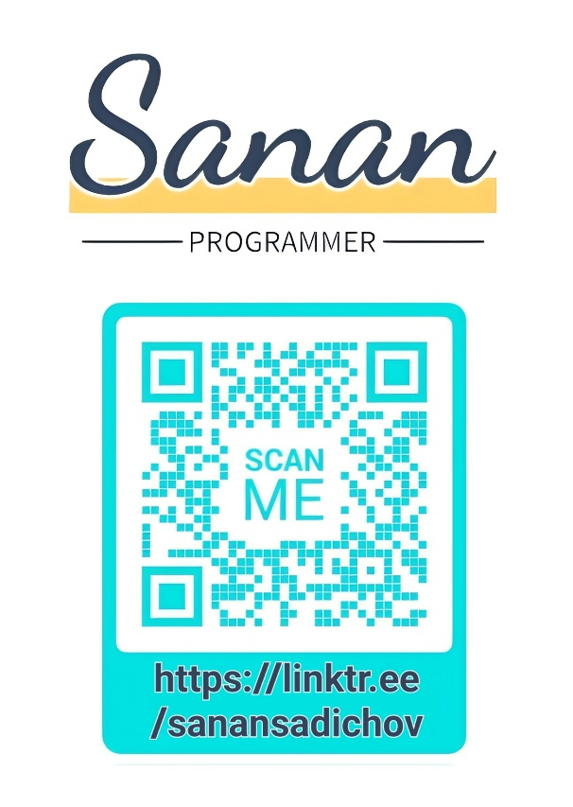**IMAGE –**

**If you have problems with the M10 app, watch this video:** [**https://youtu.be/0MRov1k0RBg**](https://youtu.be/0MRov1k0RBg)

**My phone number: +994 55 671 24 80**

**My Mail Address:** [**sanansadichov@gmail.com**](mailto:sanansadichov@gmail.com)