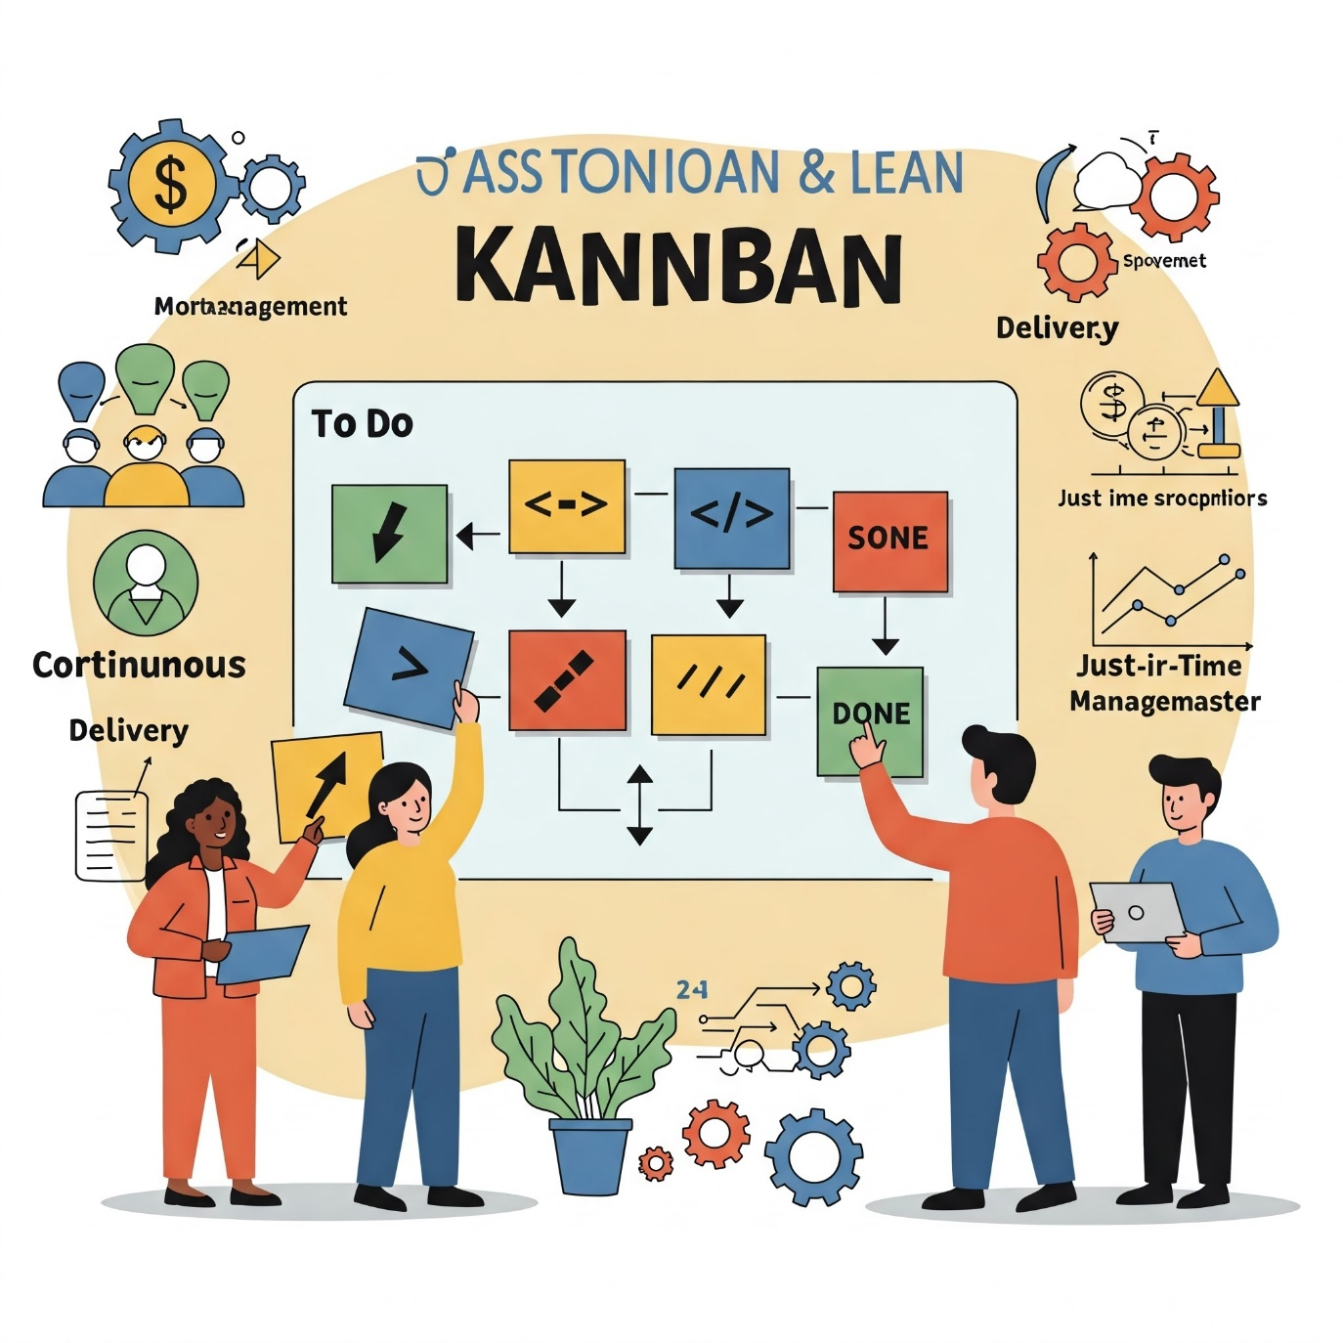

**Kanban:**

Kanban is a **visual management method** used in Agile software development and other workflows. The goal of Kanban is to **increase efficiency** and **optimize flow** by making work visible and focusing on continuous delivery.

The **Kanban system** is based on several key principles:

1. **Visualize the Workflow**: Work items are represented by cards on a Kanban board, which is divided into columns that represent stages of the workflow (e.g., "To Do," "In Progress," "Done").
2. **Limit Work in Progress (WIP)**: Kanban limits the number of tasks allowed in each workflow stage to avoid overburdening the team and reduce multitasking. This helps focus on finishing tasks rather than starting new ones.
3. **Manage Flow**: By ensuring tasks move smoothly from one stage to the next, Kanban helps teams improve their efficiency and predictability.
4. **Make Process Policies Explicit**: Teams define the rules of work (e.g., "A task should be considered complete only after code is reviewed").
5. **Improve Collaboratively**: Kanban encourages regular feedback, retrospectives, and continuous improvement to adapt the process as needed.

**uses of Kanban:**

* Reduces lead time and improves delivery speed.
* Increases visibility, making it easier to track and prioritize work.
* Helps teams identify bottlenecks and areas for improvement.

**Lean Principles:**

Lean is a **philosophy** and **set of principles** focused on maximizing customer value while minimizing waste. It originated in manufacturing but has been applied widely in software development (Lean Software Development).

The **core principles** of Lean are:

1. **Value**: Clearly define what is valuable to the customer and focus on delivering that value.
2. **Value Stream**: Identify all activities required to deliver the product, and eliminate steps that do not add value to the customer (reduce waste).
3. **Flow**: Ensure that work moves smoothly through the process, minimizing delays and bottlenecks. Work should flow without interruption.
4. **Pull**: Use a pull-based system where work is only done when needed. This avoids overproduction and ensures that the team is not overwhelmed.
5. **Perfection**: Continuously improve the process. Teams should constantly look for ways to eliminate waste, increase value, and refine their work processes.

**Uses of Lean:**

* Helps to streamline processes and reduce delays.
* Focuses on delivering high-value work quickly, which improves customer satisfaction.
* Reduces costs by eliminating non-value-adding activities.

**Comparison between Kanban and Lean:**

* **Kanban** is more about **visualizing** work and ensuring a smooth flow through limiting work in progress and making tasks visible. It is a tool to help teams manage their work in real time.
* **Lean** focuses on **eliminating waste** and improving value by optimizing the entire system. It’s more about improving the overall efficiency of processes, which can also include using tools like Kanban.

Both approaches support continuous improvement, adaptability, and a focus on delivering value to the customer.