 

5COSC026C.1 Advanced Client-Side Development (2025) Portfolio Website

# Website Development Progress Diary

Name – I.A.S.N.Perera IIT ID – 20240773

UOW ID – w2120118

## Entry 1 - September 30, 2025

Focus: Initial Planning & Low-Fidelity Design

* Planned the overall website structure (Home, About, Projects, Contact)
* Created low-fidelity digital wireframes for both desktop and mobile layouts.
* Decided on a clean and professional look using a simple grid layout.

Home Page

Low Fidelity Drawing

s

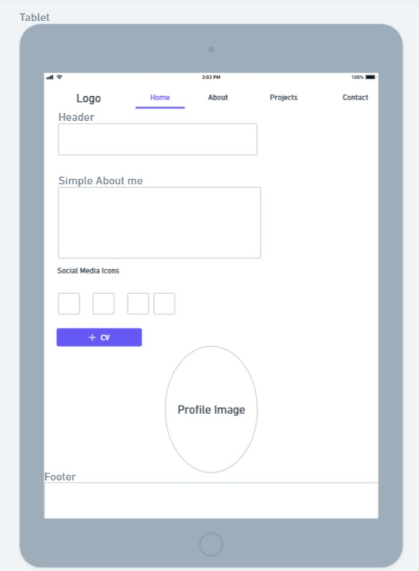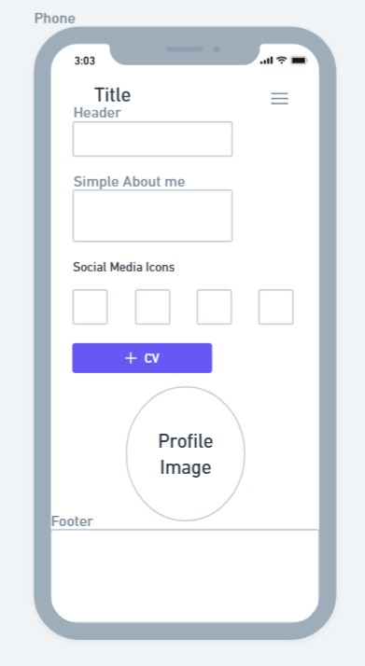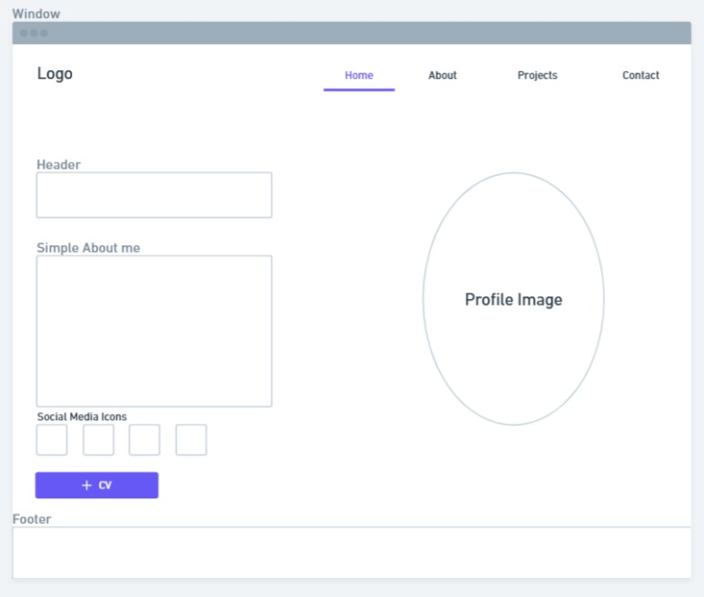

About

Page

Low Fidelity Drawing

s

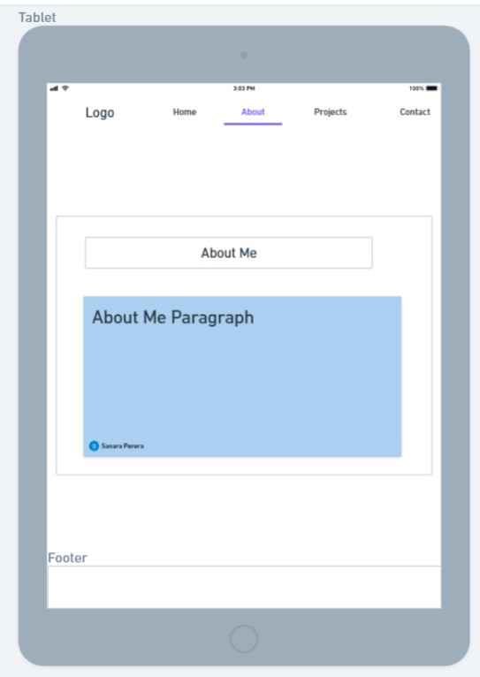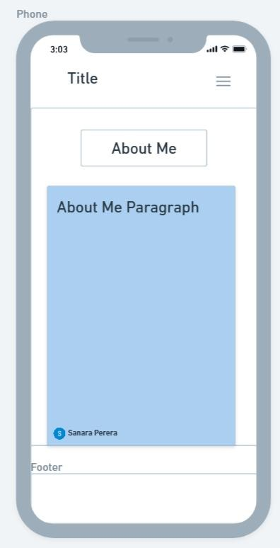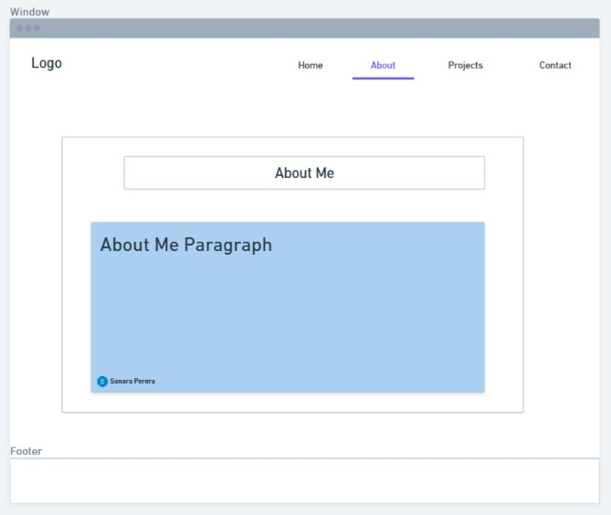

Projects Page Low Fidelity Drawings

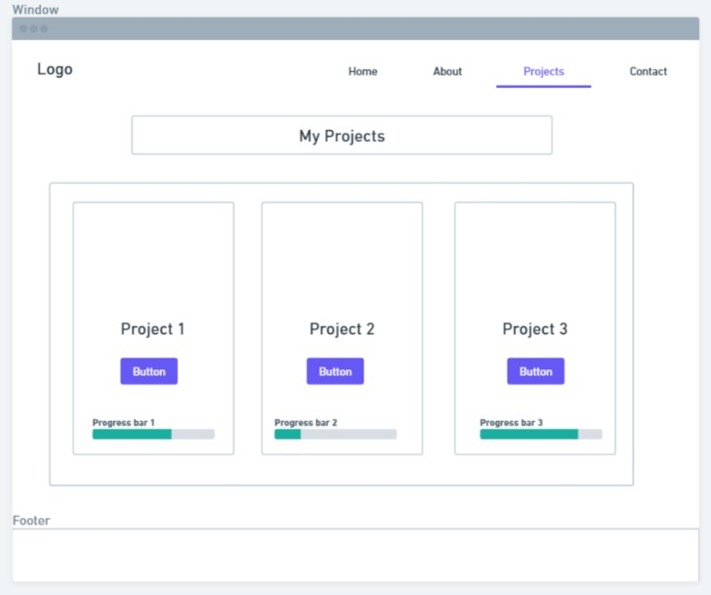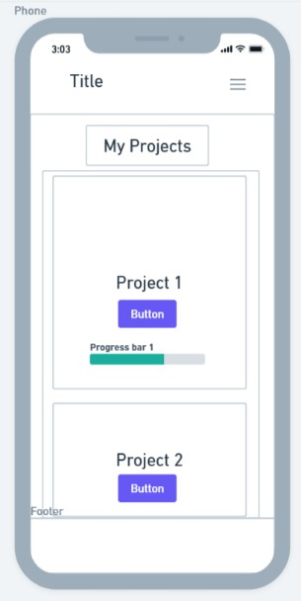

Contact Page Low Fidelity Drawings

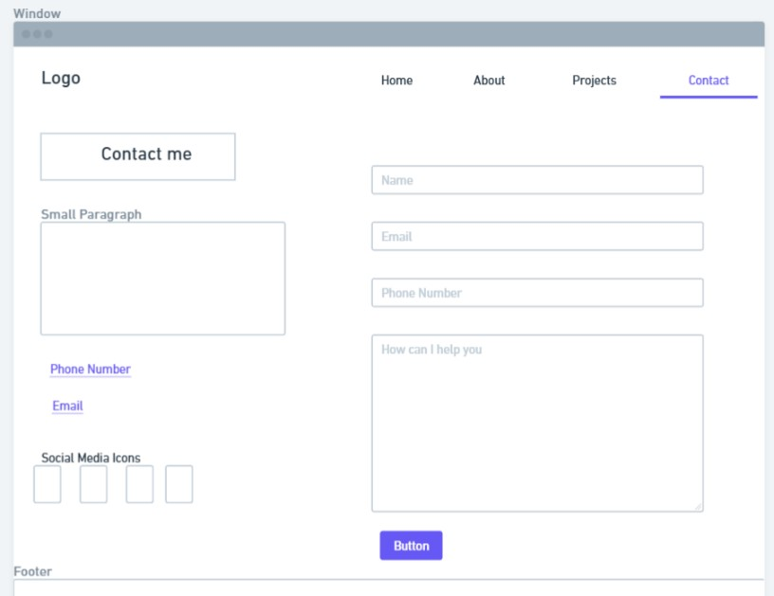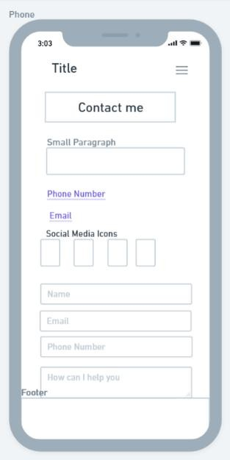

**Summary:**

The focus was on initial planning and low-fidelity design for the website. The overall structure was mapped out, including the Home, About, Projects, and Contact sections. Low-fidelity digital wireframes were created for both desktop and mobile layouts, emphasizing a clean and professional appearance with a simple grid-based design.

## Entry 2 - October 7, 2025

Focus: HTML Structure and Navigation Setup

* Built the HTML base structure for the home, about, project, contact pages.
* Added header, navigation bar, footer.
* Used Boxicons for adding social media icons.
* Implemented the logo using a <span> to create a color accent.
* Ensured all pages link properly through the navigation bar.
* Started planning structural selectors and child combinators for styling.

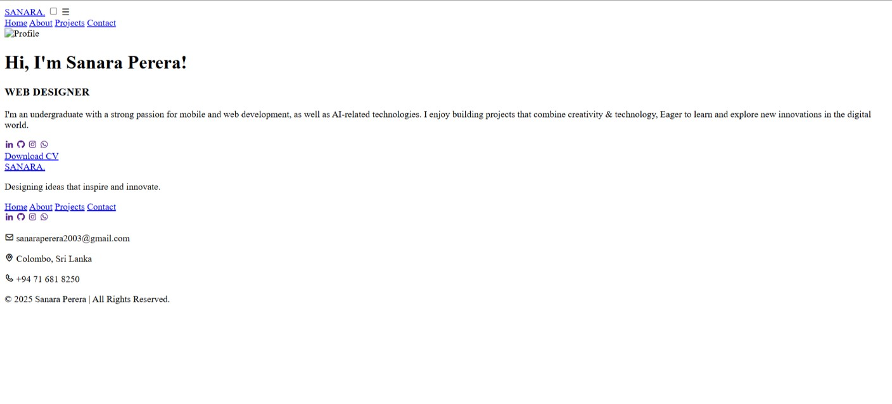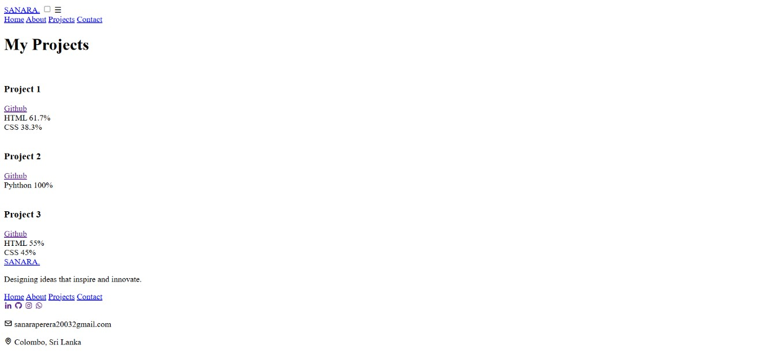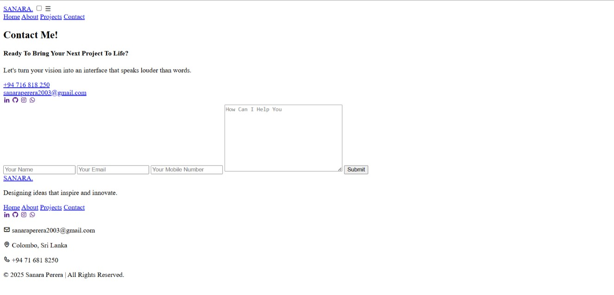

**Summary:**

The focus was on establishing the HTML structure and navigation for the website. The base HTML was built for the Home, About, Projects, and Contact pages, including the header, navigation bar, and footer. Social media icons were added using Boxicons, and the logo was styled with a <span> to create a color accent. All pages were properly linked through the navigation bar, and planning began for using structural selectors and child combinators to enhance styling.

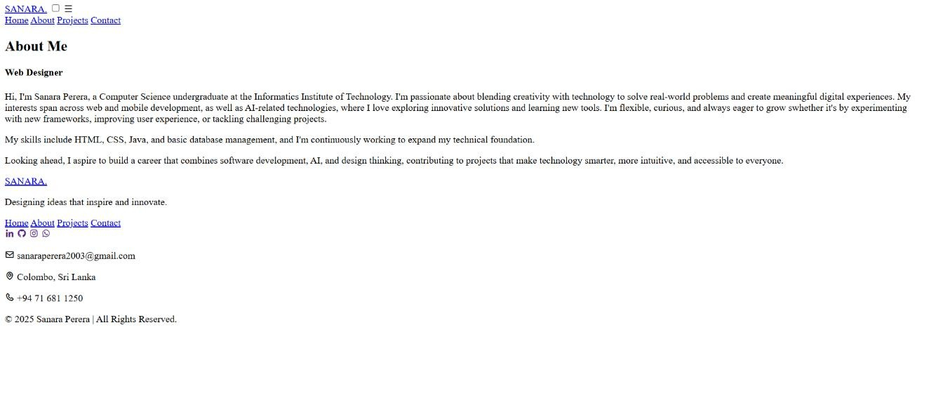

## Entry 3 - October 10, 2025

Focus: CSS Styling & Color Scheme Implementation.

* Added Google Fonts for a consistent and modern typography style.
* Chose a blue color theme to match personal branding.
* Added typing animation to homepage text using keyframes and steps() animation.
* Applied text effects, gradients, and semi-transparent colors, animations.
* Used pseudo-classes (:hover, :active) for interactivity.
* Used CSS animations and gradients to create a subtle, continuously moving background behind the profile image.
* Added CSS to social icons with hover color and shadow effects.
* Implemented shadows, rounded corners, and borders.

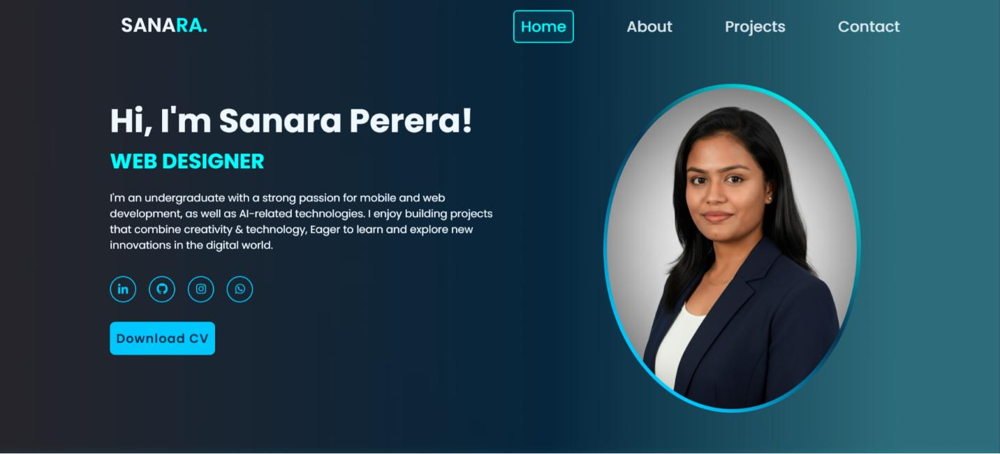

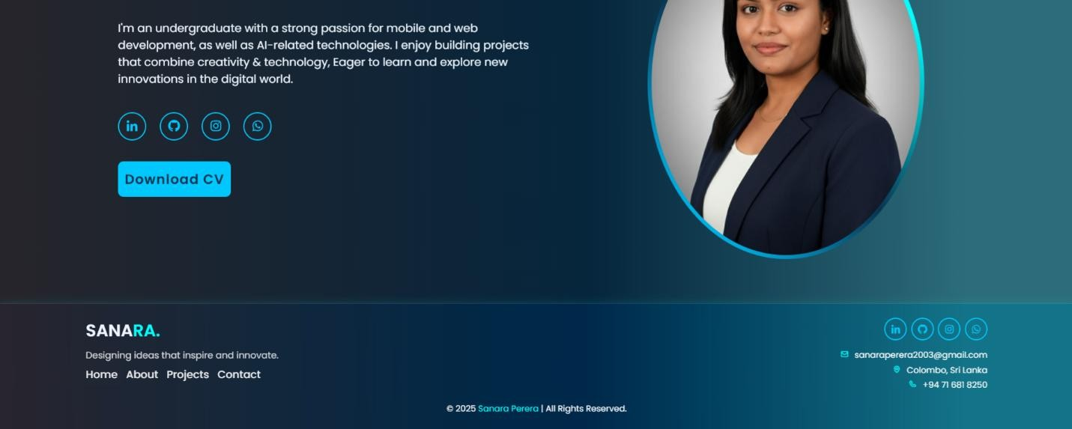

**Summary:**

This phase focused on CSS styling and implementing a cohesive blue color scheme for personal branding. Google Fonts were added for modern typography, while interactive features like typing animations, hover effects, and subtle text and background animations enhanced the user experience. Shadows, rounded corners, borders, and styled social icons were also applied to create a polished and visually engaging design.

## Entry 4 - October 17, 2025

Focus: About and Projects Section Development.

* Completed the About page with descriptive text and section headings.
* Implemented first letter styling (::first-letter) to make first paragraph standout.
* Applied subtle glow effect on second paragraph using text-shadow.
* Added hover effect on About section box with transform: scale and box-shadow.
* Created the Projects section with individual project cards.
* Added progress bars showing language usage percentages.
* Used attribute selectors, nth-child, and negation pseudo-classes for advanced styling.
* Linked buttons to GitHub
* Applied pseudo-elements for generated content on headings.

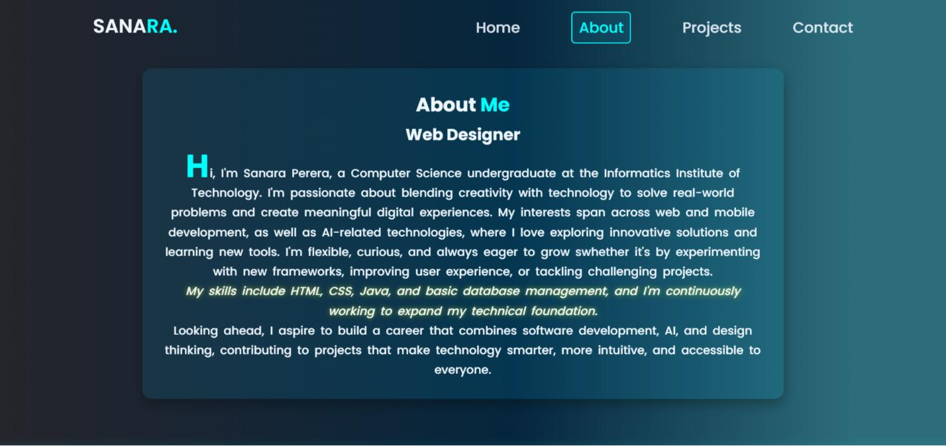

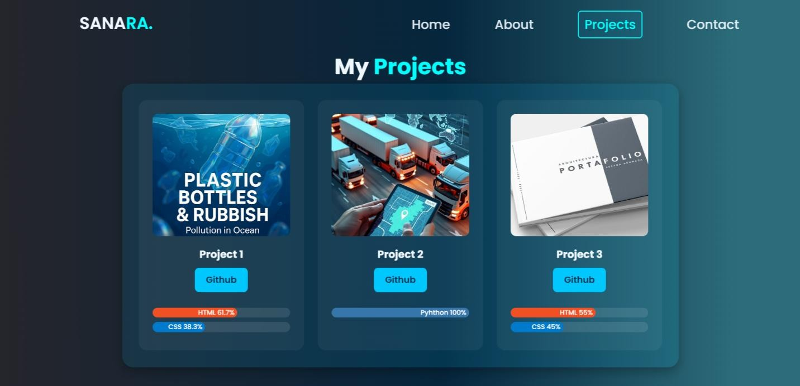

**Summary:**

This phase focused on developing the About and Projects sections. The About page included styled text with first-letter emphasis and a subtle glow effect, along with hover effects on section boxes. The Projects section featured project cards with progress bars, GitHub links, and advanced styling using pseudo-classes, attribute selectors, and pseudo-elements.

## Entry 5 - October 21, 2025

Focus: Contact Page.

* Completed Contact form with input validation using :valid and :invalid pseudo-classes.
* Added functional links for email, LinkedIn, GitHub, and WhatsApp.
* Added submit button hover effects.
* Created two-column grid layout (text + form) for large screens, stacked columns for mobile.
* Added focus effects with border color change and box-shadow.
* Clickable phone number , email links.

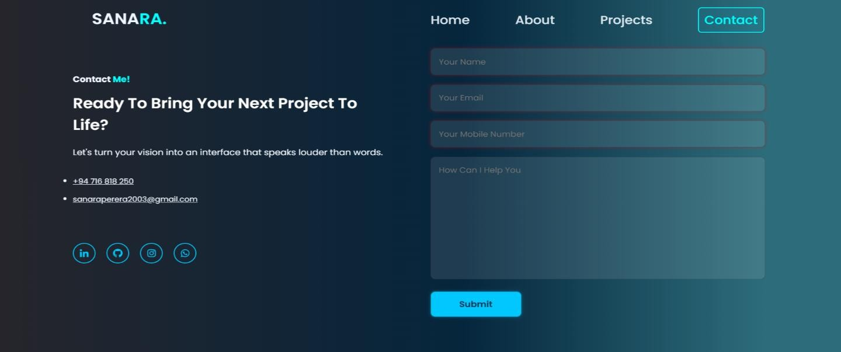

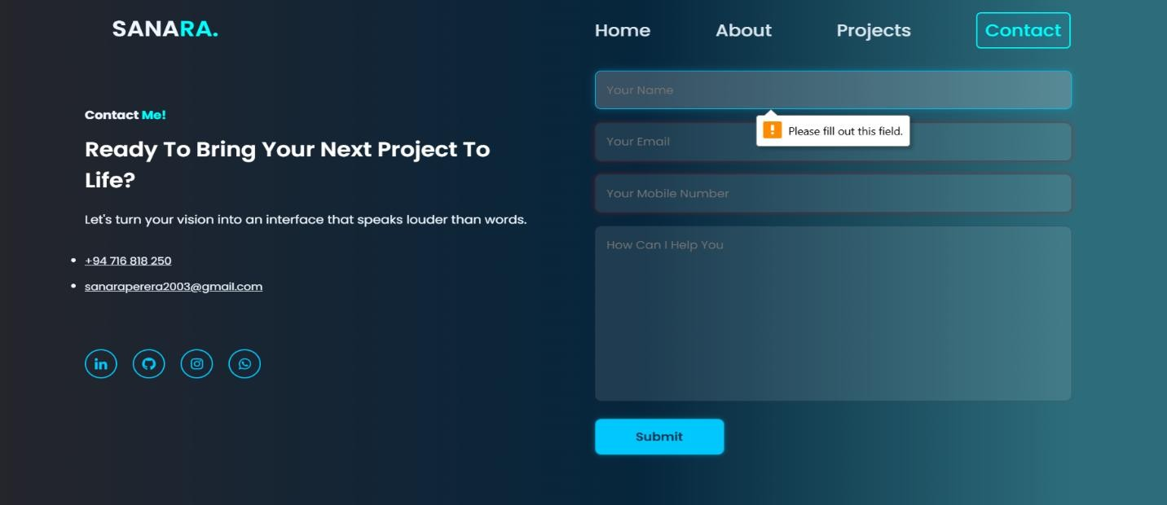

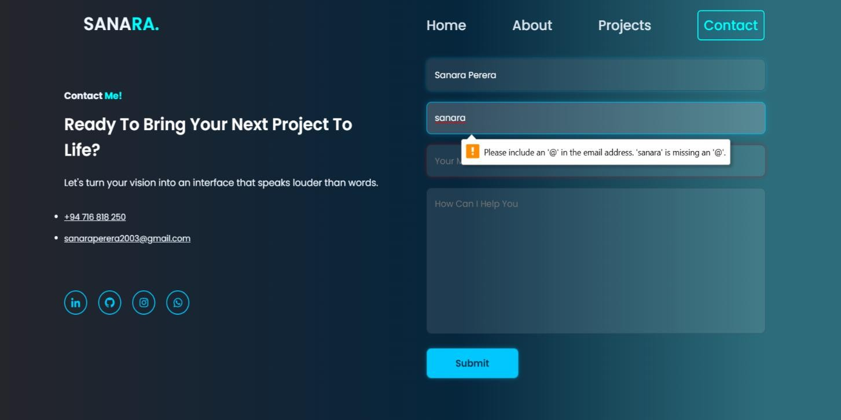

**Summary:**

This phase focused on developing the Contact page. The contact form was completed with input validation using

:valid and :invalid pseudo-classes, along with focus effects on fields. Functional links for email, LinkedIn, GitHub, WhatsApp, and a clickable phone number were added. A responsive two-column grid layout was implemented for large screens, stacking columns on mobile, and hover effects were applied to the submit button.

## Entry 6 - October 28, 2025

Focus: Responsiveness, Media Queries & Final touch

* Designed responsive layouts using media queries for mobile and tablet screens.
* Added a menu toggle checkbox for mobile navigation.
* checked header/navbar with responsive hamburger menu for mobile.
* Adjusted padding, font sizes, and images for smaller screens.
* Ensured layout scalability while maintaining design consistency.
* Reviewed CSS specificity, commenting, and overall code organization.
* Tested smooth navigation between pages and final responsiveness.

**Summary:**

This phase focused on responsiveness and final touches. Media queries were used to create layouts for mobile and tablet screens, including a toggleable hamburger menu for navigation. Padding, font sizes, and images were adjusted for smaller screens to maintain scalability and design consistency. The CSS was reviewed for specificity, organization, and comments, and smooth navigation and overall responsiveness were thoroughly tested.

