Report 1

Sana Zakir Shaikh

2025-07-24

# 📦 Data Cleaning

In this section, we load the dataset, check for missing values, clean column names, and create a combined date column.

```{r setup, include=TRUE} library(readxl) library(janitor) library(dplyr) library(lubridate)

Load data

data <- read_excel(“mobile.xlsx”)

Clean column names

data <- clean_names(data)

Check for missing values

sum(is.na(data)) colMeans(is.na(data)) * 100

Create full date column

data <- data %>% mutate( full_date = make_date(year = year, month = month, day = day) )

# Calculate total sales

data $total_{s}ales<−data$ units_sold * data$price_per_unit

# Plot histogram and density

hist(data$total_sales, main = “Histogram of Total Sales”, xlab = “Total Sales”, col = “skyblue”, breaks = 40)

plot(density(data$total_sales), main = “Density Plot of Total Sales”, xlab = “Total Sales”, col = “darkgreen”, lwd = 2)

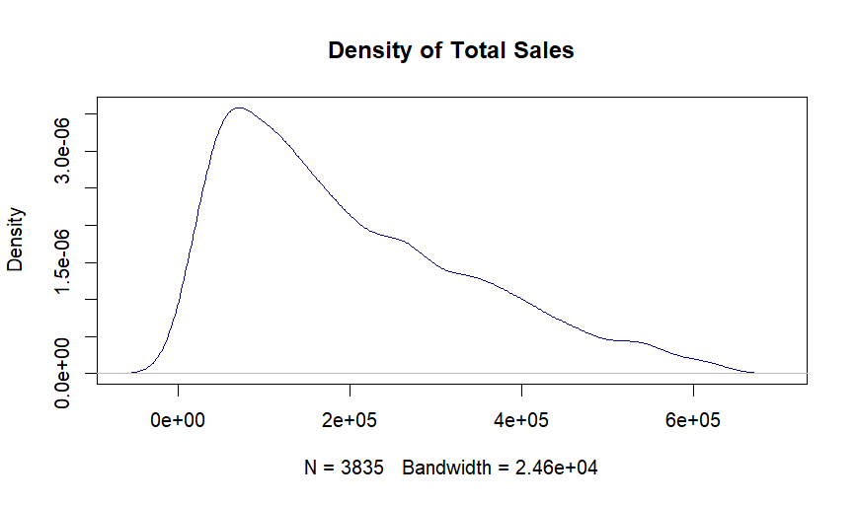

Density Plot - Raw

# QQ plot

qqnorm(data$total_sales, main = "QQ Plot of Total Sales")
qqline(data$total_sales, col = “red”)

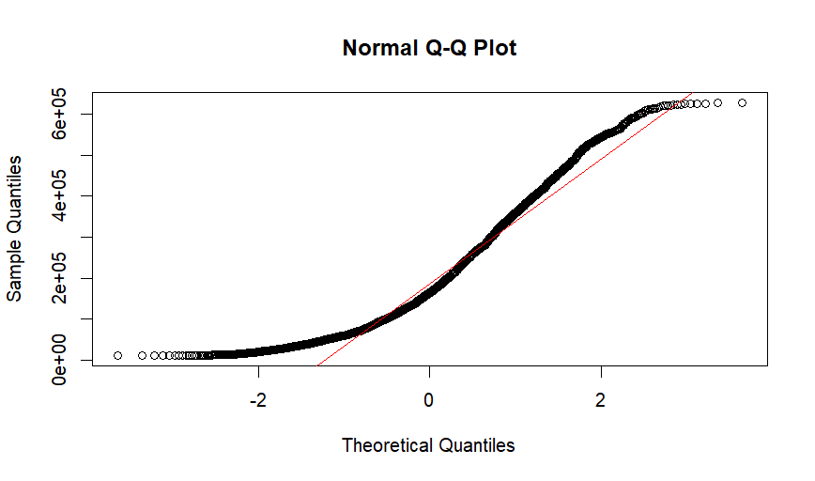

QQ Plot - Raw

data $log_{s}ales<−log(data$ total_sales)

plot(density(data$log_sales), main = “Density Plot After Log Transformation”, xlab = “Log(Total Sales)”, col = “blue”, lwd = 2)

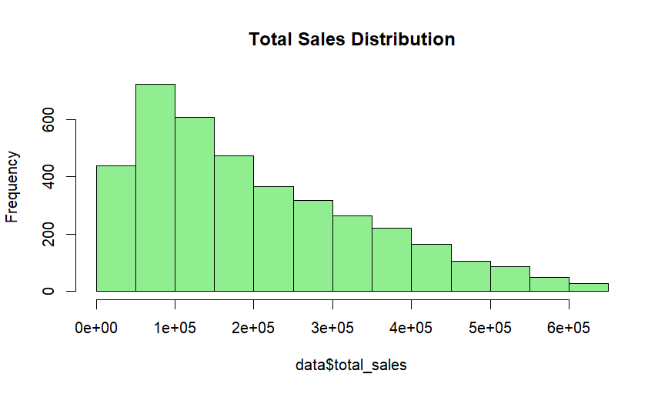

Density After Log Transformation (Left Skewed)

data $sqrt_{s}ales<−sqrt(data$ total_sales) plot(density(data$sqrt_sales), main = “Density After Square Root Transformation”, xlab = “Sqrt(Total Sales)”, col = “purple”, lwd = 2)

## Comparison of Total Sales Transformations

We applied transformations to the Total Sales column to normalize the distribution. Below is a comparison between the original, log-transformed (left-skewed), and sqrt-transformed (approximately normal) distributions.

```{r comparison-density-plots, fig.width=12, fig.height=4, echo=TRUE, message=FALSE, warning=FALSE} # Required Libraries library(ggplot2) library(patchwork)

# Create the three plots

p1 <- ggplot(data, aes(x = total_sales)) + geom_density(fill = “darkgreen”, alpha = 0.6) + labs(title = “Original (Right Skewed)”, x = “Total Sales”, y = “Density”) + theme_minimal()

p2 <- ggplot(data, aes(x = log_sales)) + geom_density(fill = “blue”, alpha = 0.6) + labs(title = “Log Transformed (Left Skewed)”, x = “Log(Total Sales)”, y = “Density”) + theme_minimal()

p3 <- ggplot(data, aes(x = sqrt_sales)) + geom_density(fill = “purple”, alpha = 0.6) + labs(title = “Sqrt Transformed (Nearly Normal)”, x = “Sqrt(Total Sales)”, y = “Density”) + theme_minimal()

# Combine plots side-by-side

p1 + p2 + p3

## Comparison of Distribution Shapes

We observed how different transformations affect the shape of the Total Sales distribution.

Below is the image showing:

* Original (right skewed)
* Log transformed (left skewed)
* Square root transformed (approximately normal)

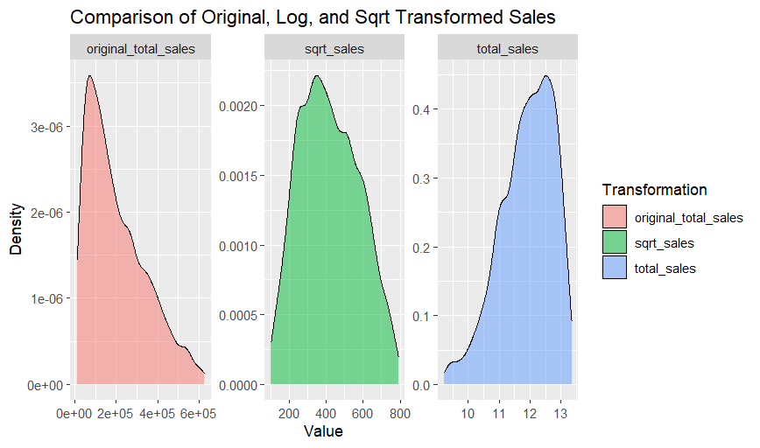

Final Comparison of Density Plots