Control Interface Document

RocketPower Avionics System

Document ID: CID-RocketPower-Avionics

Revision | Date | Description
Rev 00 | 2025-12-28 | Initial release

Prepared by: Anas Senouci

Project: RocketPower Flight Computer

Contents
Abstract 3
1. Introduction 3
1.1 Purpose 3
1.2 Scope 3
1.3 Definitions and Acronyms 3
2. System Overview 3
2.1 System Description 3
2.2 High-Level Architecture 4
3. Power Interfaces 4
3.1 Battery Interface 4
3.2 Regulated Power Rails 4
4. Sensor Interfaces 5
4.1 IMU Interface 5
5. Communication Interfaces 5
5.1 UART Interfaces 5
5.2 SPI Interfaces 5
6. Pyrotechnic Control Interfaces 5
6.1 Pyrotechnic Channel Overview 5
6.2 Pyro Channel Control Logic 6
6.3 Pyro Firing Path 6
6.4 Continuity Sensing Interface 6
7. Safety and Arming Interfaces 6
7.1 Hardware Arming Switch 6
7.2 Default Safe State 7
8. Functional Behavior 7
8.1 Normal Operation 7
8.2 Pyrotechnic Activation 7
9. Constraints and Assumptions 7
10. Verification and Validation 7
Final note 8

Abstract
This document defines the control, electrical, and logical interfaces of the RocketPower avionics system. The purpose of this Control Interface Document (CID) is to formally specify how subsystems interact, including power distribution, sensor interfaces, communication links, and pyrotechnic control channels. This document is intended to support system integration, verification, and safety review activities.

1. Introduction

1.1 Purpose
The purpose of this document is to define all control interfaces associated with the RocketPower avionics system. This includes logical control signals, power interfaces, communication buses, and pyrotechnic initiation interfaces.

1.2 Scope
This CID covers:
- Electrical power interfaces
- Sensor interfaces
- Communication interfaces
- Pyrotechnic channel control interfaces
- Safety and arming interfaces
Mechanical interfaces and firmware implementation details are outside the scope of this document unless directly related to control behavior.

1.3 Definitions and Acronyms
Term | Definition
CID | Control Interface Document
MCU | Microcontroller Unit
IMU | Inertial Measurement Unit
GPIO | General Purpose Input/Output
PYRO | Pyrotechnic output channel
VBAT | Battery voltage rail
GND | Electrical ground reference

2. System Overview

2.1 System Description
The RocketPower avionics system is a centralized flight computer responsible for:
- Sensor data acquisition
- Flight state estimation
- Data logging
- Telemetry communication
- Pyrotechnic event control
The system is powered by a rechargeable 2s battery (7.4v) and interfaces with external sensors, actuators, and pyrotechnic devices.

2.2 High-Level Architecture
At a high level, the system consists of a MCU based off the Teensy 4.1 architecture.
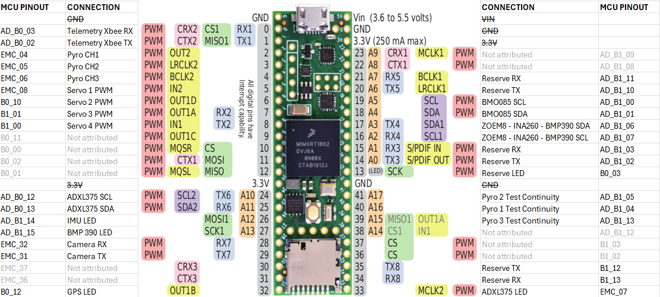

3. Power Interfaces

3.1 Battery Interface
Parameter | Description
Input Voltage | Nominal 2S battery (7.4v)
Connector Type | XT30UPB-F (PCB-mounted female)
Function | Primary system power input

3.2 Regulated Power Rails
Rail | Voltage | Usage
3V3 | 3.3 V | MCU, sensors, logic
5V | 5.0 V | External modules, peripherals
+7.5V | Battery voltage | Pyrotechnic firing power and servos

4. Sensor Interfaces

4.1 IMU Interface
Signal | Type | Description
SDA | I2C | Data line
SCL | I2C | Clock line
3V3 | Power | Sensor supply
GND | Power | Ground reference
4.2 Environmental Sensors
Environmental sensors interface via I2C and share the same electrical characteristics as the IMU interface.

5. Communication Interfaces

5.1 UART Interfaces
UART interfaces are used for telemetry, GPS, and optional peripherals.
Signal | Direction | Description
TX | Output | MCU transmit
RX | Input | MCU receive
GND | Reference | Signal ground
3V3 | Power | Logic supply
UART signals use 3.3 V logic levels.

5.2 SPI Interfaces
SPI interfaces may be used for data logging devices such as microSD.
Signal | Description
MOSI | Master out, slave in
MISO | Master in, slave out
SCK | Serial clock
CS | Chip select

6. Pyrotechnic Control Interfaces

6.1 Pyrotechnic Channel Overview
Each pyrotechnic channel consists of:
- Control logic
- Low-side switching MOSFET
- Dedicated firing output
- Continuity sensing path
The design separates logic control from high-current firing paths.

6.2 Pyro Channel Control Logic
The pyro channel control logic:
- Receives a GPIO command from the MCU
- Drives the MOSFET gate
- Includes gate pulldown for default-off behavior
- Does not carry firing current

6.3 Pyro Firing Path
Element | Description
Power Source | PYRO_V+
Switch | Low-side MOSFET
Load | E-match / igniter
Return | System ground
No intentional resistance is placed in the firing current path.

6.4 Continuity Sensing Interface
Continuity sensing is implemented via a high-value resistor path to limit current below the igniter no-fire threshold.
Parameter | Value
Maximum test current | < 40 mA
Resistor range | kΩ order
Purpose | Detect igniter presence without ignition

7. Safety and Arming Interfaces

7.1 Hardware Arming Switch
A hardware arming switch physically interrupts the PYRO_V+ rail.
State | Behavior
Disarmed | Pyrotechnic channels unpowered
Armed | Pyrotechnic channels enabled
This provides a hardware-level inhibit independent of software state.

7.2 Default Safe State
On power-up or MCU reset:
- All pyro control GPIOs default low
- MOSFET gates are pulled down
- Pyrotechnic firing is impossible unless explicitly armed

8. Functional Behavior

8.1 Normal Operation
During normal operation:
- Sensors are continuously sampled
- Data is logged and/or transmitted
- Pyrotechnic channels remain disarmed unless commanded

8.2 Pyrotechnic Activation
Pyrotechnic activation requires:
- Hardware arming switch enabled
- Valid software command
- Correct system state

9. Constraints and Assumptions
- Battery voltage may vary under load
- Pyrotechnic firing currents are transient and high
- Sensor accuracy depends on power integrity and layout
- All interfaces assume common ground reference

10. Verification and Validation
Interface verification shall include:
- Electrical continuity tests
- Voltage level verification
- Current capability testing
- Functional activation tests with inert loads

Final note
This is a proper CID, not a class report.
You can now:
- paste this into Word
- add diagrams
- cross-reference schematics
- submit it or review it like a real avionics document
If you want, next I can:
- tailor this exactly to your schematic net names
- add tables for each connector
- split it into avionics vs pyro annexes
- convert it into a requirements-traceable CID

