Rocket launch controller
Simple launch box running on a 3S LiPo, with room to add remote launch later.

v1: manual
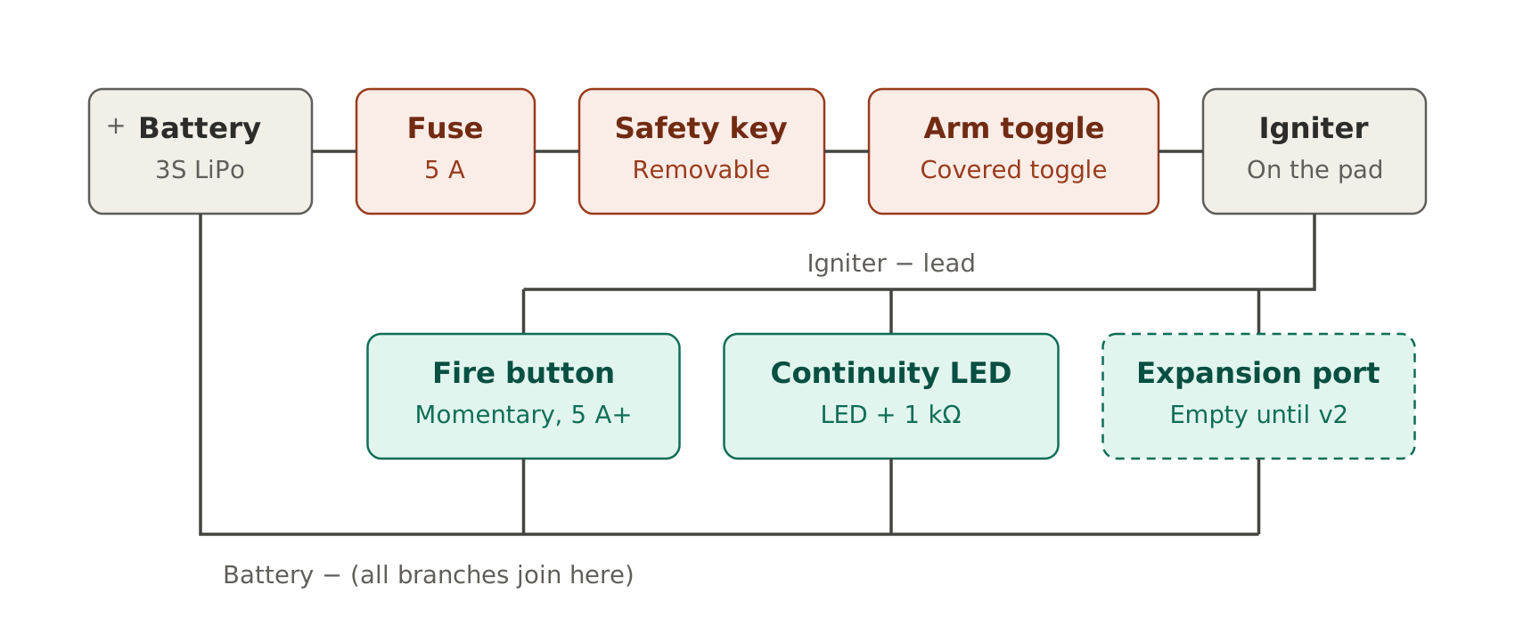
- The fire button is on the igniter's negative wire, so a MOSFET can go next to it later.
- The continuity LED lights when the igniter is connected. The 1 kΩ resistor keeps the current too low to fire it.
- Pull the safety key before walking to the pad.

Parts
- Key switch (or XT60 plug as a key)
- Toggle switch with missile cover
- Momentary button, rated 5 A or more
- Fuse holder + 5 A fuses
- XT60 connector for the battery
- Banana sockets and plugs, small alligator clips
- 8–10 m of speaker wire for the leads
- 5 mm LED + 1 kΩ resistor
- 2-pin connector for the v2 port
- Box printed in PETG, M3 screws

v2: remote (later)
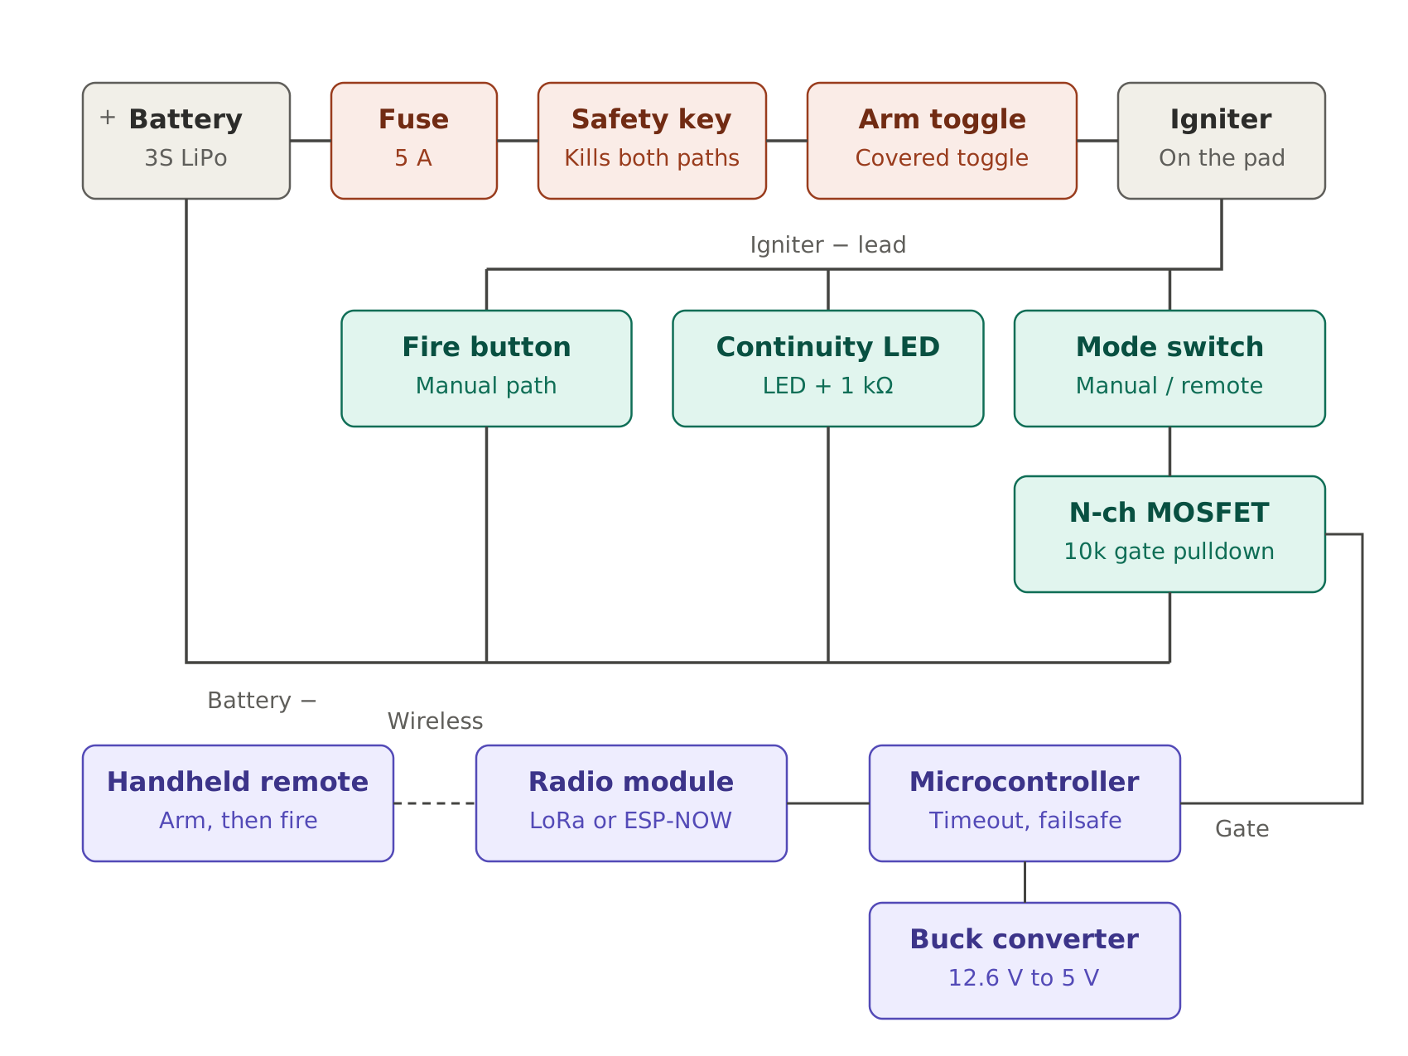
- The MOSFET plugs into the v2 port, next to the fire button.
- 10 kΩ resistor from gate to source so it stays off by default.
- The safety key still cuts everything.
- Separate arm and fire commands. If the signal is lost, it disarms.

